CREATE AND SET UP A LIST

A SharePoint list is a handy tool for sharing contacts, calendar appointments, tasks, or data with team members and site visitors, and provides the underlying structure for organizing information on your site. This course shows you how to create a list and set it up for your team to use.

CREATE A LIST
- Click Settings > Add an app.
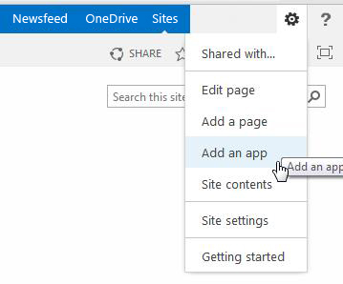
- Search for the list app you want to use and then click the name of the app to create the list. For example, search for “contacts” and then click the Contacts app.
- Type a name for the list in the Name box and then click Create.

ADD AN EXISTING COLUMN TO A VIEW OF THE LIST
- At the top of the list, click the ellipses (…), and then click Modify this View.
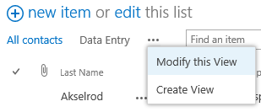
- Select the check box for the column you want to add and then click OK.

CREATE A NEW COLUMN
- At the top of the list, click edit.
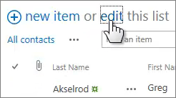
- Click the plus sign (+), and then select the column type from the list that appears.
- Give the column a name and set any other options as necessary.

CREATE A PUBLIC VIEW
- At the top of the list, click the ellipses (…), and then click Create View.
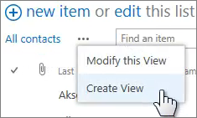
- Choose a view type or start from an existing view.
- On the Create View page, type a name for the view.
- Select the Create a Public View check box.
- Select the columns you want to appear, and use the position numbers to set the order of the columns.
- Set the sorting, filter, and other options, and then click Save.

EDIT A VIEW
- At the top of the list, click the ellipses (…) and then click Modify this View.
- Select or clear the columns you want and use the position numbers to set the order of the columns.
- Reset the sorting, filter, and other options, and then click Save.

SHARE A LIST
You can share a list only if you created the list or the site. If you didn't create the list or site, you can email a link to the list instead.
- Click List > Shared With.
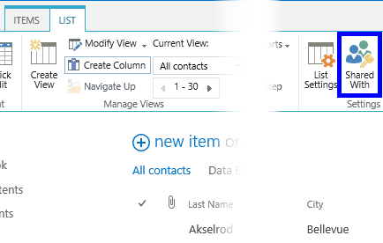
- In the Shared With dialog box, click INVITE PEOPLE.
- Type the names of the people you want to share the list with and then click Share.

EMAIL A LINK TO A LIST
- Click List > E-mail a Link.
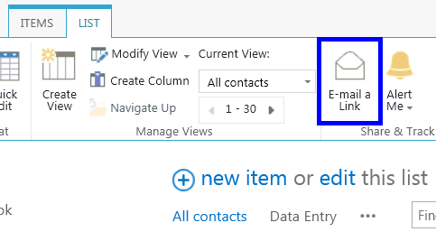
- Click Allow in the warning that pops up to allow your email program to open a new email message.
- A new email message opens with a link to the list included. Add people to the To line, finish the message, and send it.

SET UP AN ALERT
- Click List > Alert Me > Set an alert on this list.
- On the New Alert page, change the title for the alert if you want.
- In the Send Alerts To section, enter the user names or email addresses of people you want alerts to be sent to.
- Set other options in the Change Type, When to Send Alerts, and other sections, and then click OK.

SEE ALSO:
- Introduction to lists
http://office.microsoft.com/en-us/sharepoint-help/introduction-to-lists-HA102771955.aspx
- Create, change, or delete a column in a list or library
http://office.microsoft.com/en-us/sharepoint-help/create-change-or-delete-a-column-in-a-list-or-library-HA102771913.aspx
- Create, change, or delete a view of a list or library
http://office.microsoft.com/en-us/sharepoint-help/create-change-or-delete-a-view-of-a-list-or-library-HA102774516.aspx
- Share a site
- http://office.microsoft.com/en-us/sharepoint-help/share-a-site-HA103456668.aspx
- Create an alert or subscribe to an RSS feed
http://office.microsoft.com/en-us/sharepoint-help/create-an-alert-or-subscribe-to-an-rss-feed-HA102771918.aspx
- Enable and configure versioning for a list or library
http://office.microsoft.com/en-us/sharepoint-help/enable-and-configure-versioning-for-a-list-or-library-HA102772148.aspx

