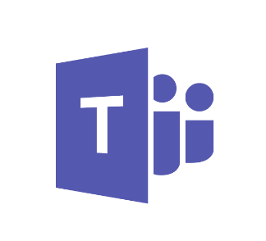

Quick start guide:

Successfully enable Microsoft Teams

In this guide:

Implementation phases for Office 365 and Teams

Technical planning questionnaire

Use this guide to help you plan, implement, and adopt Microsoft Teams in your organization. This guide focuses on enabling collaboration and team communications scenarios. To implement Teams enterprise voice features, check out our [Cloud voice](https://docs.microsoft.com/MicrosoftTeams/cloud-voice-deployment) documentation.

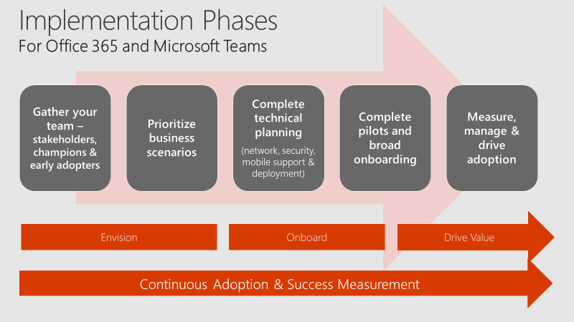

Figure 1: Implementation phases of Office 365 and Teams

# Step 1: Get your people together

Assemble a group of individuals from your business, IT and user communities to act as the stakeholder and decision-making group for your Teams deployment. In smaller organizations this may be 2 or 3 people. Be sure to include individuals from all 3 communities to ensure a successful journey.

# Step 2: Prioritize your business scenarios

Collaboration and communication is about people! Pick the most relevant business scenarios for your organization instead of talking about features and functions. Check out the [Microsoft 365 FastTrack Productivity Library](https://fasttrack.microsoft.com/microsoft365/productivitylibrary) for examples to help you define scenarios for your company. Successful Teams deployments often center around high-velocity teams that work closely together, such as product development, marketing event teams, finance groups, or support organizations. Select one of these scenarios and complete a quick inventory of how these users work today so you can effectively design the Teams experience in a meaningful way for these people.

Best practice:

**Plan Teams with Teams!** Customers who use Teams to plan their deployment ease the change curve for key stakeholders. Consider creating a team called Microsoft 365 Deployment and creating channels for the various workloads you want to deploy. Your team might look something like this:

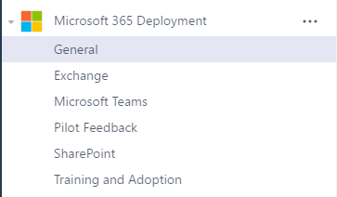

# Step 3: Complete technical planning

Efficient technical planning is the foundation of a great user experience. If your organization has over 50 seats and is participating in an [eligible plan](https://technet.microsoft.com/library/dn783224.aspx), you can use [FastTrack benefits](https://technet.microsoft.com/library/dn783224.aspx?f=255&MSPPError=-2147217396), available at no additional cost to guide you through planning, deployment and service adoption. Or, you can complete this work yourself using our FastTrack Onboarding Wizards, which are available from [FastTrack](https://fasttrack.microsoft.com/) once you sign in with your Office 365 account. The information below will help you complete this step for Teams. At a minimum, you’ll want to review these four articles:

1. [Check your environment's readiness for Teams](https://docs.microsoft.com/MicrosoftTeams/environment-readiness)
2. [Prepare your network for Teams](https://docs.microsoft.com/MicrosoftTeams/prepare-network)
3. [Office 365 URLs and IP address ranges](https://docs.microsoft.com/MicrosoftTeams/office-365-urls-ip-address-ranges)
4. [Guest access in Teams](https://docs.microsoft.com/microsoftteams/guest-access)

In addition, certain organizations may want to review [Overview of security and compliance in Teams](https://docs.microsoft.com/MicrosoftTeams/security-compliance-overview).

# Step 4: Conduct pilots and deploy Teams

In most organizations, you’ll want to conduct an initial Teams pilot with your stakeholders, champions, and select early adopters for one or more of the scenarios you selected above. A pilot gives you valuable information about how Office 365 and Teams are received in your organization. Select an interested group of users and a prioritized business scenario to get started. Figure 2 shows some example scenarios.

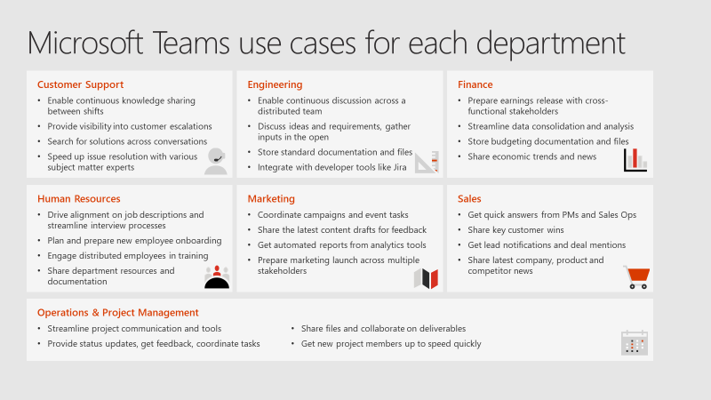

Figure 2: Use case examples for Teams

Once your pilots are complete, you’ll have the feedback you need to plan your broad Teams deployment. Large organizations often deploy in phases to manage the onboarding and training work required to implement a quality employee experience. Be sure your deployment plan integrates your prioritized business scenarios to ensure your employees are getting the most from Office 365 and Teams.

When you’re ready to turn on Teams, read [Office 365 licensing for Teams](https://docs.microsoft.com/MicrosoftTeams/office-365-licensing) to find out how.

Best practice

In smaller organizations (currently fewer than 2500 users), consider enabling Teams for the entire organization, then add all users to a single, company-wide team. Add common reference items and tasks to this team to simplify the collaboration and productivity experience for everyone.

If you use Yammer for broad company collaboration, consider integrating Yammer into the Teams experience. This doesn’t replace the native browser or mobile experience for Yammer but provides an integrated way to stay up-to-date on topics of broad interest across your organization. To learn more, watch [Tech Tip: Community management for Yammer with Microsoft Teams](https://youtu.be/LU-sv-07jcY).

Don’t forget mobile!

As you’re deploying Teams, don’t forget to turn on the mobile experience. Enabling your users to run Office 365 mobile applications can dramatically increase usage and satisfaction. Office, Outlook, SharePoint, Teams, Planner, Yammer, and other popular Office 365 services all offer mobile experiences. As a best practice, [turn on the Teams mobile experience](https://docs.microsoft.com/MicrosoftTeams/get-clients#mobile-clients) at the same time as you deploy the desktop and browser clients.

# Step 5: Measure usage, manage satisfaction, and drive adoption

Deploying software isn’t the only thing required to drive change in your organization. Empowering collaboration is more about people than technology. To successfully drive adoption of Office 365 and Teams, stay focused on your employees’ experience. Here’s a quick checklist of best practices to get you started. Microsoft partners can also help you design the right adoption plan for your organization.

1. **Read** [**Office 365 adoption guidance**](https://aka.ms/successfactors) for best practices. Use our article on creating a [change management strategy for Microsoft Teams](https://docs.microsoft.com/en-us/MicrosoftTeams/change-management-strategy) to document your approach.
2. **Study** [**Office 365 activity reports**](https://support.office.com/article/Activity-Reports-in-the-Office-365-admin-center-0d6dfb17-8582-4172-a9a9-aed798150263) to understand usage across your environment. If you aren’t an Office 365 admin for your company, ask your admin to give you Reports Reader permissions so you can access activity reports.
3. **Capture feedback from your employees** on their experience with Office 365 and Teams. Use a public channel in Teams when your organization has fewer than 2500 individuals. Use a public group in Yammer when your organization is larger than this current membership limit in Teams.
4. **Nurture your champions and highlight your wins.** Reward employees for embracing these new tools and using them in innovative ways that relate to business outcomes for your company. This, above anything, will ensure continued adoption of Office 365 and Teams.

Technical Planning Questionnaire

Use this questionnaire to give you an overview of your existing Office 365 environment. You’ll use the results of this questionnaire to customize the [Plan, Deliver, & Operate Teams Workshop](https://www.microsoft.com/download/55982) for your organization.

|  |  |
| --- | --- |
| Question | Answer |
| Has your organization already deployed other Office 365 workloads? (Exchange Online, SharePoint Online, Skype for Business Online, etc.) |  |
| Has your organization configured a verified domain for Office 365?  If yes, please include the verified domain(s) in your answer. |  |
| Does your organization synchronize identities to Azure Active Directory? |  |
| How is Exchange deployed in your organization? | Exchange Online  Exchange Hybrid  Exchange On-premises  Not deployed |
| How is SharePoint deployed in your organization? | SharePoint Online  SharePoint Hybrid  SharePoint On-premises  Not deployed |
| How is Skype for Business deployed in your organization? | Skype for Business Online  Skype for Business Hybrid  Skype for Business On-premises  Not deployed |
| What Office 365 subscriptions does your organization currently use? | E5  E4  E3  E1  Other |

Use the following tables and text boxes to capture the results of the decisions you make as a part of the Plan, Deliver, Operate Workshop completed for your organization.

|  |  |
| --- | --- |
| Answer | Notes |
| Pilot  Open |  |

|  |  |  |
| --- | --- | --- |
|  | Decision point | What settings for Microsoft Teams will your organization enable? |
|  | Next steps | Document these decisions in the table below. |

| Admin section | Admin setting | Setting |
| --- | --- | --- |
| Tenant-wide settings | | |
| Overall | Turn Microsoft Teams on or off for your entire organization | On  Off |
| General | Show organization chart in personal profile | On  Off |
| General | Use Skype for Business for recipients who don’t have Teams | On  Off |
| General | Allow T-bot proactive help messages | On  Off |
| Email integration | Allow users to send emails to channels | On  Off |
| Email integration | Restricted Sender’s List | On  Off |
| Apps | Allow external apps in Microsoft Teams | On  Off |
| Apps | Enable new external apps by default | On  Off |
| Apps | Allow sideloading of external apps | On  Off |
| Custom cloud storage | Box | On  Off |
| Custom cloud storage | Dropbox | On  Off |
| Custom cloud storage | Google Drive | On  Off |
| Custom cloud storage | ShareFile | On  Off |
| Settings by user/license type (Repeat next section for each license type including Guest) | | |
| Settings by user/license type | License type |  |
| Settings by user/license type | Turn Teams on or off for all users of this type | On  Off |
| Calls and meetings | Allow scheduling for private meeting | On  Off |
| Calls and meetings | Allow ad-hoc channel meetup | On  Off |
| Calls and meetings | Allow scheduling for channel meetings | On  Off |
| Calls and meetings | Allow video in meetings | On  Off |
| Calls and meetings | Allow screen sharing in meetings | On  Off |
| Calls and meetings | Allow private calling | On  Off |
| Messaging | Enable Giphy so users can add gifs to conversations | On  Off |
| Messaging | Content rating | Strict  Moderate  Allow all content |
| Messaging | Enable memes that users can edit and add to conversations | On  Off |
| Messaging | Enable stickers that users can edit and add to conversations | On  Off |
| Messaging | Allow owners to delete all messages | On  Off |
| Messaging | Allow users to edit their own messages | On  Off |
| Messaging | Allow users to delete their own messages | On  Off |
| Messaging | Allow users to chat privately | On  Off |

|  |  |  |
| --- | --- | --- |
|  | Decision Point | Are there any restrictions preventing users from installing the appropriate Teams client on their devices? |
|  | Next steps | If your organization restricts software installation, make sure that process is compatible with Teams.  *Note: Admin rights are not required for PC client installation but are required for installation on a Mac.* |

*.*

|  |  |
| --- | --- |
| Answer | Notes |
| Yes  No |  |

|  |  |  |
| --- | --- | --- |
|  | Decision point | * Have you evaluated your network capabilities for supporting real time media? * If your network has not been properly assessed, or you know it will not support real time media, will you disable video and screen sharing capabilities to reduce network impact and poor Teams experiences? |
|  | Next steps | * Network quality unknown: Follow the [Network Readiness Assessment](https://myadvisor.fasttrack.microsoft.com/CloudVoice/Offers?pageState=NetworkReadiness) guidance to determine if your network is ready for real time media. * Network quality poor: Perform network remediation steps to provide a proper environment for high quality real time media. * Network satisfactory: Ensure all IP addresses and ports are properly accessible. |

*Write your answers here*

|  |  |  |
| --- | --- | --- |
|  | Decision point | What security and compliance features does your organization require? |
|  | Next steps | Document the required security and compliance features in the table below. |

|  |  |
| --- | --- |
| Security and Compliance Feature | Required |
| Auditing and reporting | Yes  No |
| Compliance content search | Yes  No |
| eDiscovery | Yes  No |
| Legal hold | Yes  No |

|  |  |  |
| --- | --- | --- |
|  | Decision point | Does your organization have the required licenses to meet compliance and security business requirements? |
|  | Next steps | Review your organization’s current licensing, and confirm it meets all business requirements for compliance and security. |

*Write your answers here*

|  |  |  |
| --- | --- | --- |
|  | Decision point | * What’s your organization’s plan for onboarding Teams across the organization? (Pilot or Open) |
|  | Next steps | * If onboarding via a closed Pilot, decide if you’ll do so via licensing or targeted communication. * Depending on decision, take steps to make sure only Pilot users are allowed to access Teams (if needed). * Document the guidelines for which users who will (or won’t) have access to Teams below. |
|  | Decision point | Will all Teams users be able to create teams? (recommended) |
|  | Next steps | Modify the default permissions for who can create Office 365 Groups if you need to limit who can create teams. |

*Write your answers here*

|  |  |  |
| --- | --- | --- |
|  | Decision point | Will you develop a plan to raise the awareness about Skype for Business interoperability in Teams? |
|  | Next steps | Document the approach your organization will take regarding end user notification about Skype for Business and Teams interoperability. |

*Write your answers here*

|  |  |  |
| --- | --- | --- |
|  | Decision point | * What’s your change management strategy? * How has your organization handled change management for other technology rollouts? * Who are your executive sponsors, champions, Service Owners or IT admins that will influence how successful Teams is in your organization? * Who will be in your pilot group? |
|  | Next steps | * Establish a change management and adoption strategy for Teams using the best practices. * Introduce the champions, team leaders to your strategy, the [Customer Success Kit](https://www.microsoft.com/download/details.aspx?id=54244) and our [Quick Start guides](https://docs.microsoft.com/MicrosoftTeams/quick-start-guides) to begin building the internal team of Teams champions. |

*Write your answers here*

|  |  |  |
| --- | --- | --- |
|  | Decision point | What initial teams and channels do you want to create for your IT pilot? What team members do you want to add to each team and channel? |
|  | Next steps | Document these in the table below. Add rows as needed. |

|  |  |  |  |  |  |
| --- | --- | --- | --- | --- | --- |
| Team name | Description | Owners | Members | Channels | Privacy |
|  |  |  |  |  |  |
|  |  |  |  |  |  |
|  |  |  |  |  |  |

## Next steps

Work with your assigned FastTrack team to utilize the Technial Onboarding process to configure your tenant with the appropriate settings to implement the decisions made above.

Continue your work with your FastTrack team to get guidance on completing your business pilot and transitioning to broad deployment. At each phase, we’re here to help you get the most from your Teams journey.

## Read more

[Skype for Business to Microsoft Teams Capabilities Roadmap](https://aka.ms/skype2teamsroadmap)

[Teams documentation and practical guidance](https://aka.ms/SuccessWithTeams)

[Usage reports for Teams](https://techcommunity.microsoft.com/t5/Microsoft-Teams-Blog/New-usage-reports-for-Microsoft-Teams/ba-p/132614)

Undelete a team: See [Restore a deleted Office 365 Group](https://support.office.com/%20article/Restore-a-deleted-Office-365-Group-b7c66b59-657a-4e1a-8aa0-8163b1f4eb54)

Restrict who can create teams: See [Manage who can create Office 365 Groups](https://support.office.com/article/Manage-who-can-create-Office-365-Groups-4c46c8cb-17d0-44b5-9776-005fced8e618)

[Teams security & compliance](https://docs.microsoft.com/microsoftteams/security-compliance-overview)

|  |  |  |
| --- | --- | --- |
| Version | Changes | Date |
| 1.0 | Initial release | Mar 14, 2017 |
| 2.0 | Published on Microsoft Download Center | Sep 20, 2017 |
| 3.0 | Updated to Quick start guide | Dec 15, 2017 |

© 2017 Microsoft Corporation. All rights reserved.

This document is provided “as-is”. Information and views expressed in this document, including URL and other Internet Web site references, may change without notice.

This document does not provide you with any legal rights to any intellectual property in any Microsoft product. You may copy and use this document for your internal, reference purposes. You may modify this document for your internal, reference purposes.