Lab B (Module 10)
Implement Auditing

This document is provided “as-is”. Information and views expressed in this document, including URL and other Internet Web site references, may change without notice. You bear the risk of using it.
This document does not provide you with any legal rights to any intellectual property in any Microsoft product. You may copy and use this document for your internal, reference purposes.
© 2011 Microsoft. All rights reserved.

Contents
Task 1 – Modify the Site Collection’s Audit Settings 3
Task 2 – Create Auditable Events 5
Task 3 – Review the Content Viewing Report to Verify the Viewing Event Auditing 7

In this exercise, you enable auditing, create auditable events, and review the audit report.

Task 1 – Modify the Site Collection’s Audit Settings
In this exercise, you modify the site collection’s auditing settings to audit the require events
  - In the Contoso intranet site (open at http://intranet.contoso.com/sites/ECMForTheMassesV3/ if the site isn’t open in your browser) click Site Actions | Site Settings.

      - 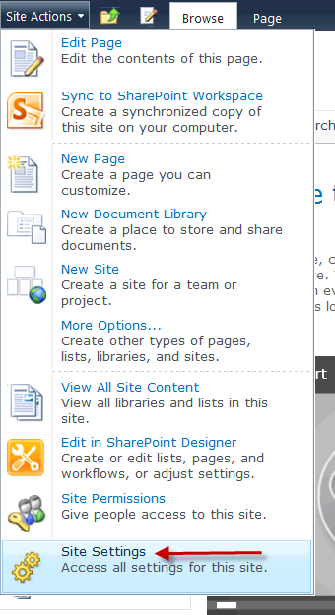
  - When the Site Settings page opens, click the Site Collection Audit Settings hyperlink under the Site Collection Administration section.

      - 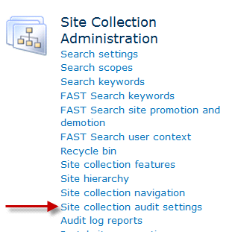

  - When the Configure Audit Settings page opens, select Automatically Trim the Audit Log for This Site.

      - 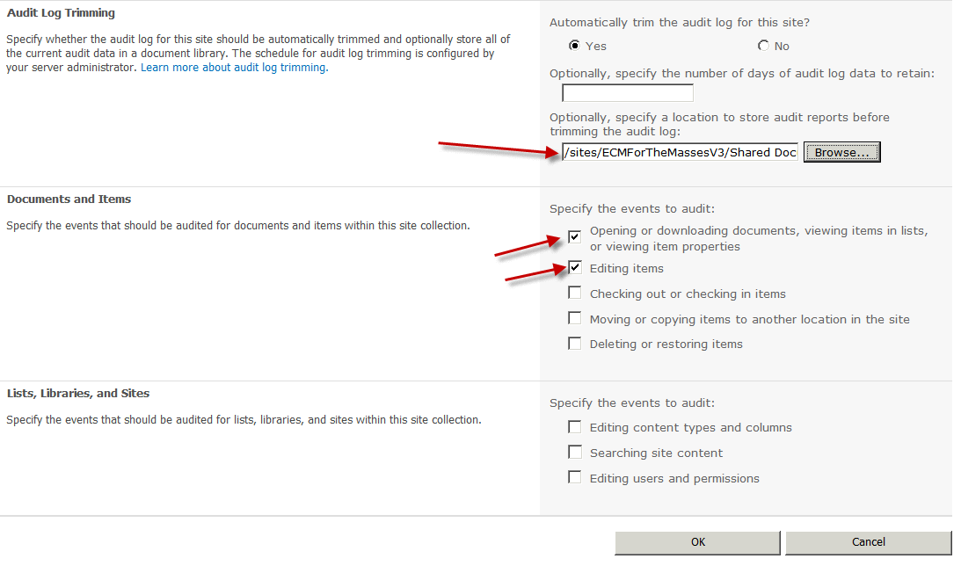
  - Select the following events to audit from the Documents and Items:
    - Opening or downloading documents, viewing items in lists or viewing item properties.
    - Editing items
  - Click OK to save the auditing configuration.

Task 2 – Create Auditable Events
In this task, you work in the M&A site’s new Mergers and Acquisitions library to generate auditable events.
- In the Contoso intranet site (open at http://intranet.contoso.com/sites/ECMForTheMassesV3/MandA/ if the site isn’t open in your browser) click New Mergers and Acquisitions library link located on the left navigation column.
    - 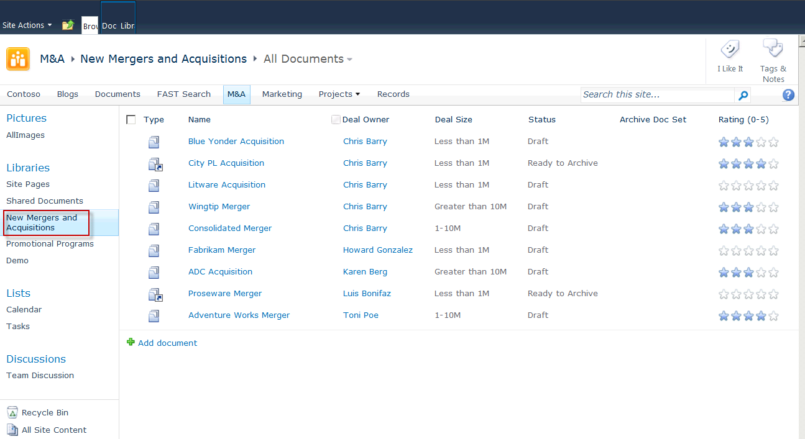
- After you are on the libraries All Items page, click the Wingtip Merger document set link to view the contained documents.
    - 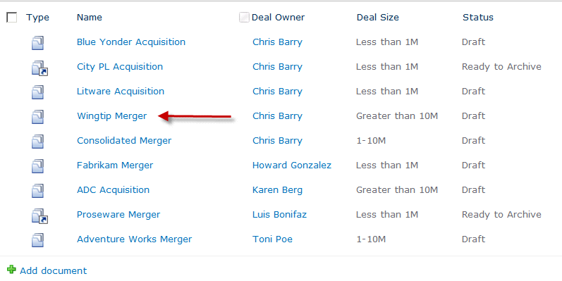
- Hover over the Wingtip Merger – Competitive Analysis link, and select Edit in Microsoft Excel.
    - 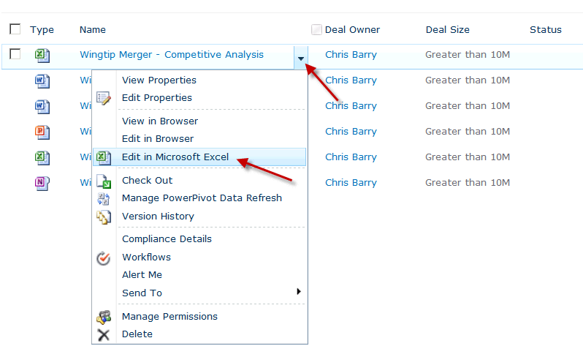
- When the Wingtip Merger – Competitive Analysis document opens in Excel, review the data but do not make any changes.
- Exit Microsoft Excel.
- In the Contoso intranet site (open at http://intranet.contoso.com/sites/ECMForTheMassesV3/MandA/ if the site isn’t open in your browser) click New Mergers and Acquisitions library link located on the left navigation column.
- After you are on the libraries AllItems page, click the Blue Yonder Acquisition document link to view the contained documents.
- Hover over the Wingtip Merger – Financial Analysis link, and select Edit in Microsoft Excel.
- After the document opens, edit the document by clicking in a cell and entering text.
- Click the Excel Save icon located in the upper-left corner of the application.
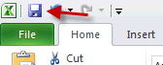
- Exit Microsoft Excel.
- If you are prompted to upload the document to SharePoint, click Close File.
- If you are prompted to check in the document, click Yes.
- If you are prompted to enter Version Comments, enter a comment and click OK.

Task 3 – Review the Content Viewing Report to Verify the Viewing Event Auditing
In this task, you review the site collection audit logs to verify the auditing settings.
  - In the Contoso intranet site (open at http://intranet.contoso.com/sites/ECMForTheMassesV3/ if the site isn’t open in your browser) and clickSite Actions | Site Settings.
  - When the Site Settings page opens, click the Audit Log Reports link.
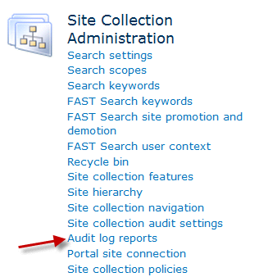
- When the View Auditing Reports page opens, click the Content Viewing report link.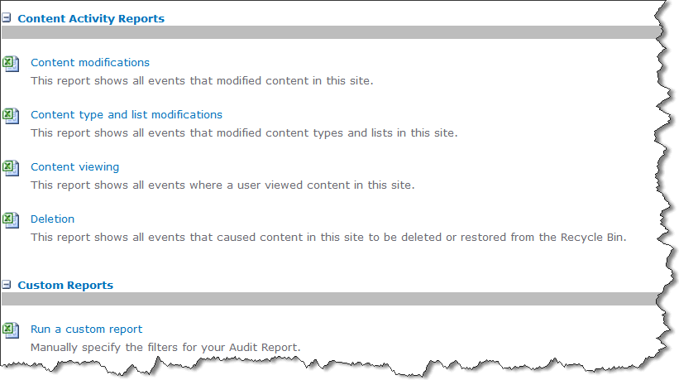
- Click the Browse button and select the Shared Document library. This is where the report will be saved to. Click OK.
- When the Operation Completed Successfully message displays, click the Click Here to View the Report Link to open the report in Excel.
- Scroll down toward the bottom of the Excel report. Locate the entries for the Wingtip Merger documents. There are two entries. One entry is the audit entry for viewing the Competitive analysis page, and the second entry is the audit entry for viewing the Financial Analysis document.
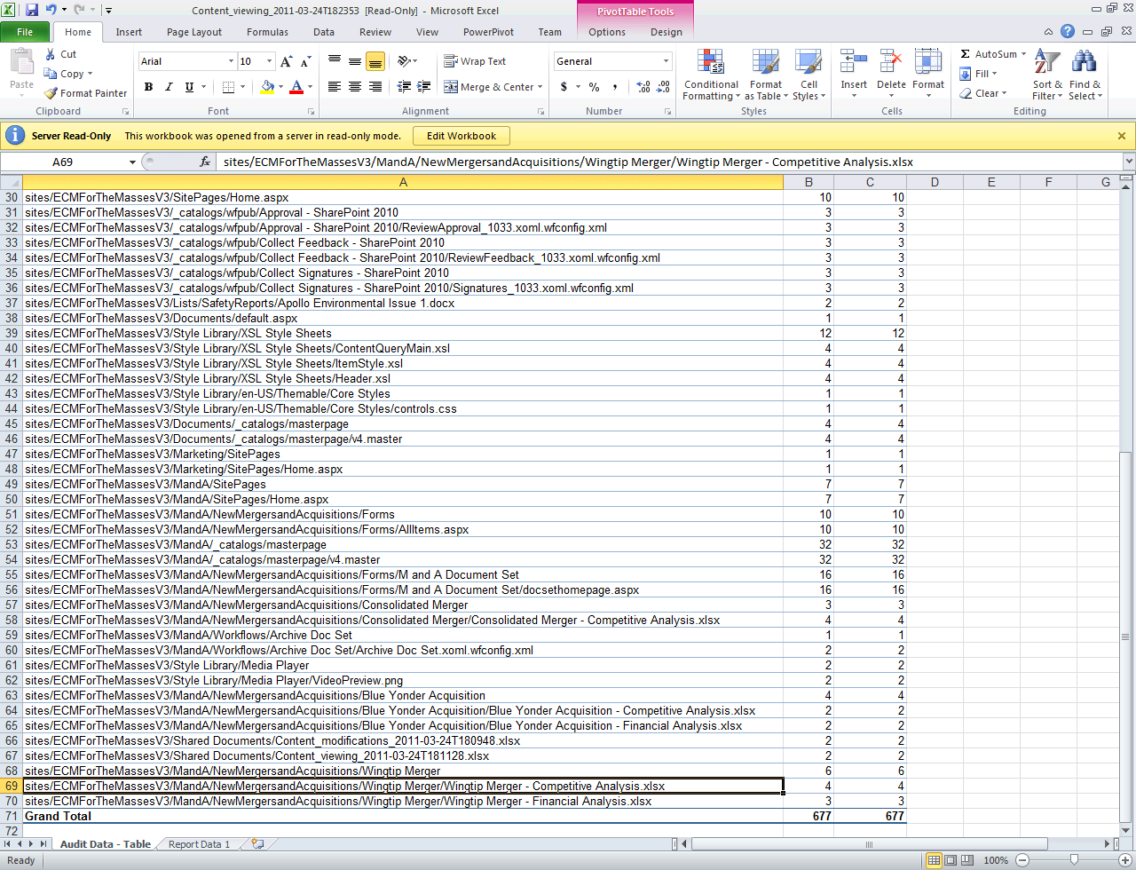
- Open the Contoso intranet site at http://intranet.contoso.com/sites/ECMForTheMassesV3/ if the site isn’t open in your browser. Click Site Actions | Site Settings.
- When the Site Settings page opens, click the Audit log reports link.
- When the View Auditing Reports page opens, click the Content modifications report link.
- Click the Browse button, and select the Shared Documents library. This is where the report will be saved to. Click OK.
- When the Operation Completed Successfully message displays, click the Click here to view the report link to open the report in Excel.
- Scroll down toward the bottom of the Excel report. Locate the entry for the Wingtip Merger document. There is one entry for the Wingtip Merger documents. This entry is for the edit event.
    - 