Lab B (Module 8)

This document is provided “as-is”. Information and views expressed in this document, including URL and other Internet Web site references, may change without notice. You bear the risk of using it.
This document does not provide you with any legal rights to any intellectual property in any Microsoft product. You may copy and use this document for your internal, reference purposes.
© 2011 Microsoft. All rights reserved.

Contents
Exercise 1: Create an Enterprise Search Center and a Custom Search Box Page 3
Exercise 2: Create a Custom Search Results Page 5
Exercise 3: Modify the Search Core Results Web Part to Return Only Documents 6
Exercise 4: Add a Custom Tab to the Search Center and Modify the Search Box Web Part 7
Lab Summary 8

Imagine that users complain about seeing items that are not documents in their search results. They request that you set up a Custom Search Center where they can search for either/all content, people, or just documents. You task is to create a new Search Center and a new tab for only documents. When users select this tab, only items that are documents appear in their search results.

Exercise 1: Create an Enterprise Search Center and a Custom Search Box Page

- Navigate to http://intranet.contoso.com.
- Click Site Actions, and then click New Site.
- In the Create dialog box, click the Search category.
- Select the Enterprise Search Center template.
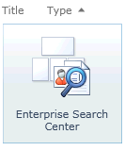

- Enter a Title and a URL Name of JustDocuments and click Create.
- Click Site Actions, and then click More Options.
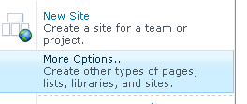

- In the Create dialog box, click the Page category.
- Select the Publishing Page template, and then click the Create button.
- Enter Documents in the Title text box.
- Enter Documents in the URL Name text box.
- Select (Welcome Page – Search box) in the Page Layout section list.
- Click the Create button.
- Click the Save & Close button on the Ribbon.

Exercise 2: Create a Custom Search Results Page

- Click Site Actions, and then click More Options.

- In the Create dialog box, click the Page category.
- Select the Publishing Page template, and then click the Create button.
- Enter a DocumentResults in the Title text box.
- Enter DocumentResults in the URL Name text box.
- Select (Welcome Page – Search results) in the Page Layout section list.
- Click the Create button.
- Click the Save & Close button on the Ribbon.

Exercise 3: Modify the Search Core Results Web Part to Return Only Documents

- Verify that you are on the DocumentResults Search Results page you just created in Exercise 1.
- Click Site Actions, and then click Edit Page.
- Locate the Bottom Zone in the Web Part page.
- Locate the Search Core Results Web Part.
- Hover your mouse over the upper right corner of the Web Part until a down arrow displays. Click the down arrow to display the Web Part menu.
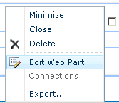
- Click Edit Web Part.
- Locate the Search Core Results tool pane in the upper right corner of the Web Part page. Expand the Result Query Options section.
- Enter IsDocument:1 into the Append Text To Query text box.
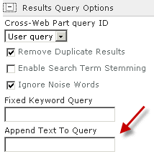
- Click the OK button of the Search Core Results tool pane.
- Click the Save and Close button to save and close the DocumentResults.aspx page.

Exercise 4: Add a Custom Tab to the Search Center and Modify the Search Box Web Part

- Navigate to http://intranet.contoso.com/justdocuments/Pages/default.aspx.
- Click Site Actions, and then click Edit Page.
- Locate the Add New Tab link and click it.
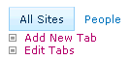
- In the Tabs In Search Pages item dialog, enter a Tab Name of Just Documents.
- Enter documents.aspx in the Page text box.
- Click the Save button.
- Click the Browser Refresh button so the Just Documents tab displays.
- Click Site Actions, and then click Edit Page.
- Locate the Search Box Web Part.
- Click the upper right corner down arrow to display the Web Part menu.
- Click Edit Web Part.
- Locate the Search Box tool pane in the upper right corner of the Web Part page. Expand the Miscellaneous section.
- In the Target search results page URL, enter documentresults.aspx.
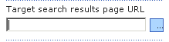
- Click the OK button of the Search Box tool pane.
- Click the Save and Close button to save and close the default.aspx page.

Lab Summary
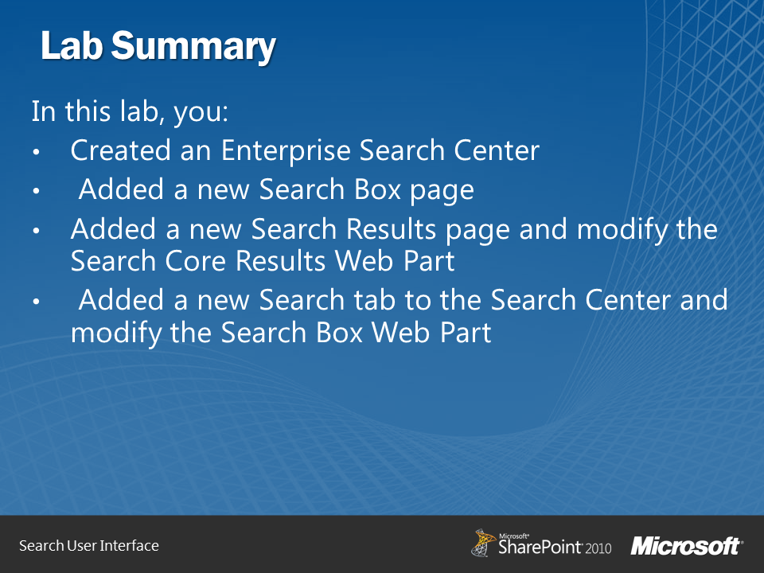
In this lab, you created a new Enterprise Search Center with the URL name of JustDocuments. Then, you created a new Search Box page with a URL name of Documents. Next, you created a new Search Results page with a URL name of document results and modified the Search Core Results Web Part by appending a condition of IsDocument:1 to any query submitted. This ensures that any search results only return documents and excludes other results such as web pages. Lastly, you added a new search tab to the search center called Just Documents. You then modified the Search Box Web Part to submit any search results to the document results search results page. Based on your configuration, when users click on the new Just Documents tab their searches only return documents that match the term submitted.
