Lab B (Module 4)
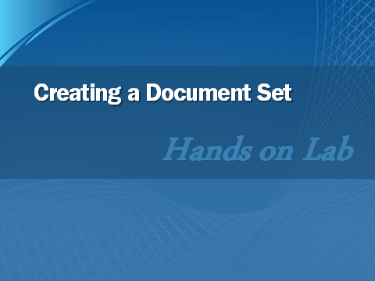

This document is provided “as-is”. Information and views expressed in this document, including URL and other Internet Web site references, may change without notice. You bear the risk of using it.
This document does not provide you with any legal rights to any intellectual property in any Microsoft product. You may copy and use this document for your internal, reference purposes.
© 2011 Microsoft. All rights reserved.

Contents
Task 1: Enable Document Sets 3
Task 2: Create a New Document Set 3
Lab Summary 6

In this lab, you enable the Document Sets feature, configure a Document Library to use the feature, and create a new document set with sample documents.

Task 1: Enable Document Sets
In this task, you enable the Document Sets feature and configure a document library to use a document set.
- Open the http://intranet.contoso.com site in Internet Explorer.
- From the Site Actions menu, choose Site Settings.
- In the Site Collection Administration section, click Site Collection Features.
- Locate the Document Sets feature, and click Activate.
- In the Quick Launch navigation on the left, click Shared Documents.
- Click the Library tab; on the Ribbon, select Library Settings.
- If the Content Types section is not displayed, click Advanced Settings, set Allow management of content types to Yes, and then click OK.
- In the Content Types section, click Add from existing site content types.
- Add the Document Set content type, and then click OK.

Task 2: Create a New Document Set
In this task, you create a new document set, configure its settings, and upload documents.
- Open http://intranet.contoso.comin Internet Explorer.
- In the Quick Launch navigation pane on the left, click Shared Documents.
- Select the Documents tab; then, on the New Document drop-down menu, click Document Set.
- Enter Loan Application in the Name field.
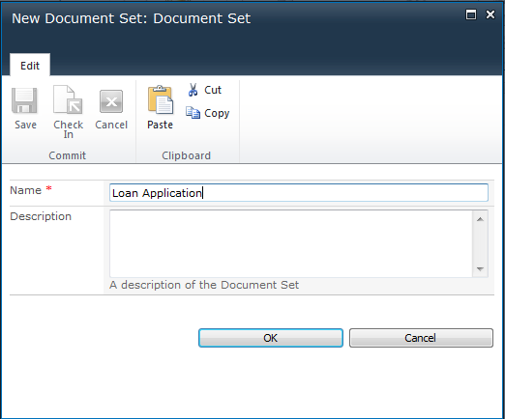
- On the document set welcome page, click Edit Properties. Enter a sample description for the document set, and click Save.
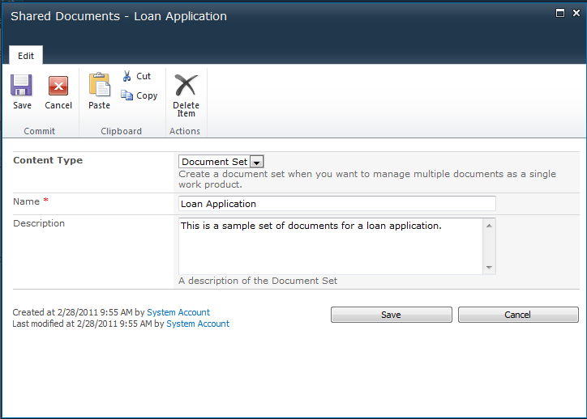
- From the Upload Document drop-down menu in the Ribbon, click Upload Multiple Documents.
- In the Multiple Document Upload dialog window, click Browse for files instead.
- Locate the Module 04 folder at the root of the directory structure, open it, and select all the documents in it. Then, click OK to add the documents to the upload list. Click OK again to upload them into the document set. Click Done when complete.

Lab Summary
