Lab A (Module 3)
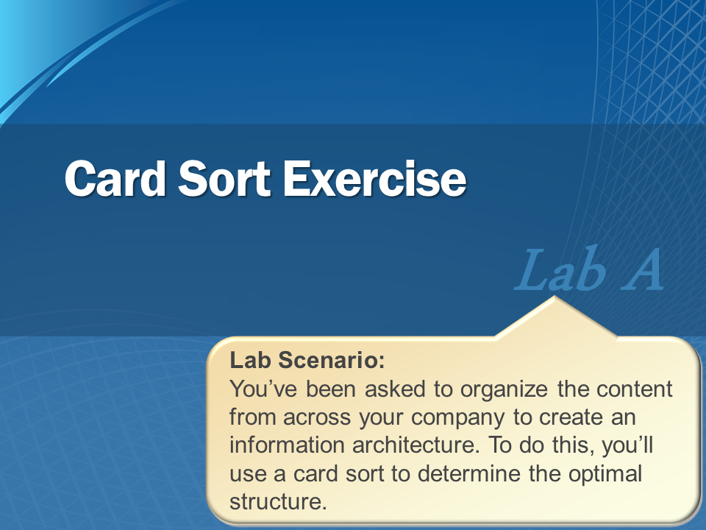
Note: Your instructor may run this lab as a class discussion.

This document is provided “as-is”. Information and views expressed in this document, including URL and other Internet Web site references, may change without notice. You bear the risk of using it.
This document does not provide you with any legal rights to any intellectual property in any Microsoft product. You may copy and use this document for your internal, reference purposes.
© 2011 Microsoft. All rights reserved.

Contents
Exercise 1: Using Card Sort 3
Content Cards to Sort 3
Lab A: Review 5
Questions: 5

Exercise 1: Using Card Sort
Scenario
You’ve been asked to organize the content from across your company to create Information Architecture. To do this you use a card sort to determine the optimal structure.
Guidelines
- You should try to create a maximum of five main categories.
- You may create up to five subcategories per category until you develop an appropriate categorization tree.
- You may not use the department names (included in the beginning of the item for reference) in your content category.
Break into groups and start working for 10 minutes. Then reconvene to further discuss the task.

Content Cards to Sort
[Accounting] Expense Reports | [Administration] Corporate Summary Presentation | [HR] Workers Compensation Claim Responses | [QA] Test Procedures
[Accounting] Purchase Orders | [Engineering] Product Design Specifications | [HR] Employee Details | [QA] Equipment Inspection Reports
[Accounting] Invoices (Accounts Receivable) | [Engineering] Test Reports | [Legal] Contract (Bank) | [Sales] Team Performance Report
[Accounting] Invoices (Accounts Payable) | [Engineering] Plant Diagram (Physical) | [Legal] Contract (Customer) | [Sales] Competitive Performance Report
[Accounting] Purchase Orders | [Engineering] Plant Diagram (Electrical) | [Legal] Contract (Vendor) | [Sales] Proposals
[Accounting] Tax Filings | [Engineering] Plant Diagram (Mechanical) | [Legal] Contract (Partner) | [Sales] Sales Presentations
[Accounting] Financial Reports | [Engineering] Plant Renderings | [Legal] Release | [Sales] Sell Sheets
[Accounting] Closing Reports | [Engineering] Machine Inspection Reports | [Legal] Licenses | [Sales] Catalogs / Line Cards
[Administration] Business Planning Presentations | [Engineering] Interface Specification | [Legal] Building Permits | [Sales] Pricing Contracts
[Administration] Organizational Charts | [HR] Offer Letters | [Legal] Zoning Petitions | [Sales] Prospects
[Administration] Memos | [HR] Exit Interview | [Legal] Wrongful Termination Letters / Responses | [Sales] Client Contacts
[Administration] Board of Directors Meeting Agenda | [HR] Employee Records | [Legal] Case Files | [Sales] Performa P&L
[Administration] Board of Directors Meeting Minutes | [HR] Employee Reviews | [Manufacturing] Bill of Materials | [Sales] Flyers
[Administration] Customer Complaints | [HR] Benefits Information | [Manufacturing] Production Costs | [Sales] Product Images
[Administration] Customer Complaint Responses | [HR] Time cards | [Purchasing] Vendor Quality Report | [Sales] Packaging Inserts
[Administration] Mission Statement | [HR] Union Contract | [Purchasing] Vendor Pricing Agreement | [Sales] Packaging Designs
[Administration] Phone List | [HR] Workers Compensation Claims | [QA] Item Quality Reports | [Shipping] Bills of Lading

Lab A: Review
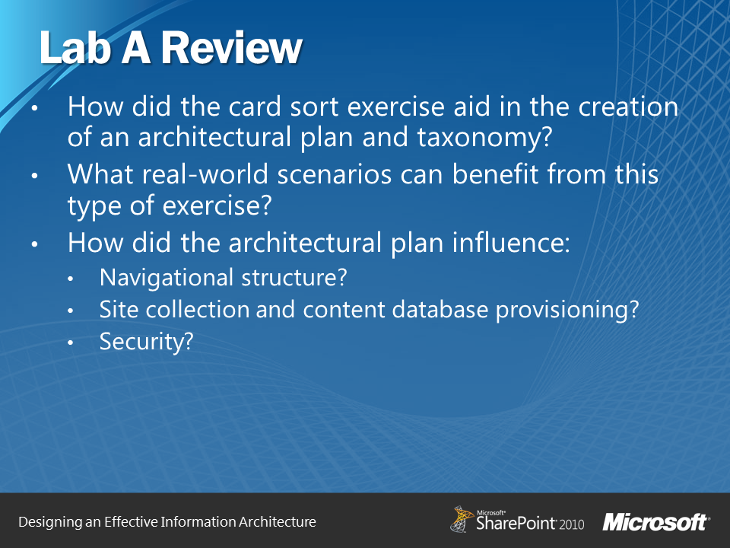

Questions:
- How did the card sort exercise aid in the creation of an architectural plan and taxonomy?
- What real-world scenarios could benefit from this type of exercise?
- How did the architectural plan influence:
  - Navigation structure?
  - Site collection and content database provisioning?
  - Security?

