Hands-On Lab

Collaboration Experiences for Development Teams using Team Foundation Server 2015

Lab version: 14.0.25123.0
Last updated: 4/28/2016

TABLE OF CONTENT
Collaboration Experiences for Development Teams using Team Foundation Server 2015 1
Overview 3
Prerequisites 3
About the Fabrikam Fiber Scenario 3
Exercises 3
Exercise 1: Team Room Collaboration 4
Task 1: Team Rooms Introduction 4
Task 2: Team Room Mentions and Links 6
Task 3: Team Room Events 9
Exercise 2: Lightweight Code Comments 14
Exercise 3: CodeLens 21

Overview
In this lab, you’ll learn about some of the features in Visual Studio 2015 and Team Foundation Server 2015 that enable collaboration experiences for development teams including Team Rooms, Lightweight Code Comments, and CodeLens.

Prerequisites
In order to complete this lab you will need the Visual Studio 2015 virtual machine provided by Microsoft. For more information on acquiring and using this virtual machine, please see this blog post.

About the Fabrikam Fiber Scenario
This set of hands-on-labs uses a fictional company, Fabrikam Fiber, as a backdrop to the scenarios you are learning about. Fabrikam Fiber provides cable television and related services to the United States. They are growing rapidly and have embraced Windows Azure to scale their customer-facing web site directly to end-users to allow them to self-service tickets and track technicians. They also use an on-premises ASP.NET MVC application for their customer service representatives to administer customer orders.
In this set of hands-on labs, you will take part in a number of scenarios that involve the development and testing team at Fabrikam Fiber. The team, which consists of 8-10 people, has decided to use Visual Studio application lifecycle management tools to manage their source code, run their builds, test their web sites, and plan and track the project.

Exercises
This hands-on lab includes the following exercises:
  - Team Room Collaboration
  - Lightweight Code Comments
  - CodeLens

Estimated time to complete this lab: 60 minutes.

Exercise 1: Team Room Collaboration
In this exercise, you will learn about the Team Room feature in Team Foundation Server 2015 (and at visualstudio.com). Team Rooms provide a durable collaboration space where members can chat and view pertinent events, thereby allowing them to remain in loose contact throughout the workday.

Task 1: Team Rooms Introduction
  - Log in as Julia Ilyiana (VSALM\Julia). All user passwords are P2ssw0rd.
  - Launch Internet Explorer from the taskbar and click the TFS Portal button from the favorites bar at the top.
    - 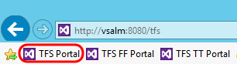
    - Figure 1
    - Launching the team web access site

    - Note: There is also a Web Portal link in the Team Explorer window within Visual Studio.
    - 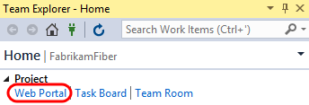

  - Click the Rooms link to navigate to and enter the Default Team Room. If this room does not automatically load, click on the Default Team Room link under the DefaultCollection node.
    - 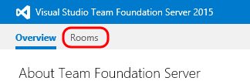
    - Figure 2
    - Navigating to team room

    - Note: There is also a team room tile on the home page of each project.
    - 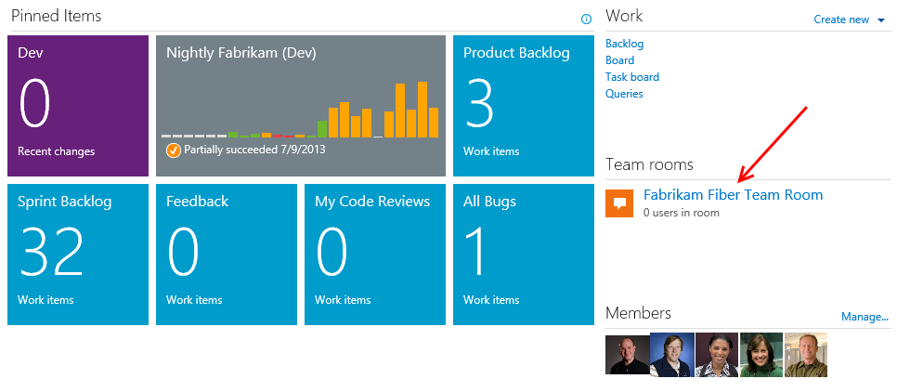

  - This team room was automatically created for the project named Default, hence the name “Default Team Room”. On the left side is the Rooms Explorer pane, which you can use to navigate between team rooms and perform some administrative capabilities. On the right side is the currently selected team room showing the recorded messages and activity for the current day.
    - 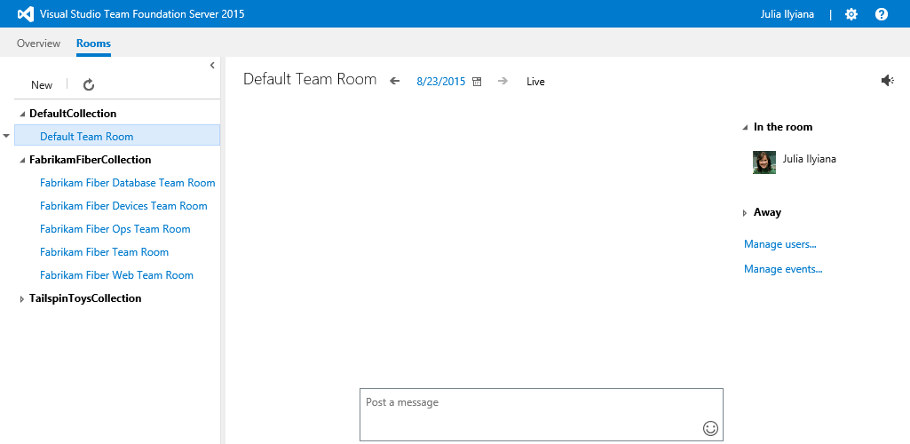
    - Figure 3
    - Default team room

  - Since the team room content is persistent, team members can go back in time to see what happened while they were gone from work. Click the back arrow to the left of the current date.
    - 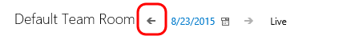
    - Figure 4
    - Selecting previous day in team room

  - It appears that we didn’t miss anything important in the team room, so we can return to the current date by clicking the Live link.
    - 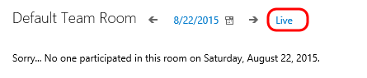
    - Figure 5
    - Returning to the live team room

Task 2: Team Room Mentions and Links
  - Now let’s take a look at some of the types of mentions and links that can be inserted via team room chat. The first type is the team member mention, which can be inserted anywhere by typing the ‘@’ symbol followed by the name. As Julia, try this out by typing “good morning @” into the textbox at the bottom of the window. Note that a list of room members is presented as soon as you type the ‘@’ symbol.
    - 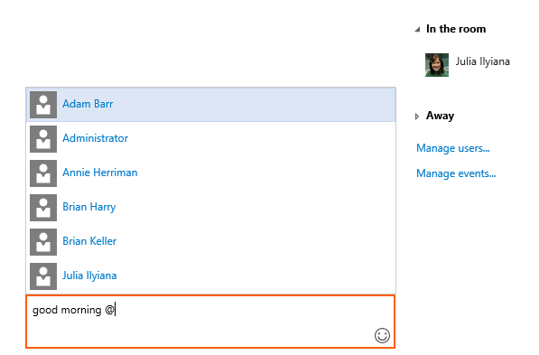
    - Figure 6
    - Creating team member mention

  - Continue typing ‘Brian Keller’ or select his name from the list and then press Enter.
    - 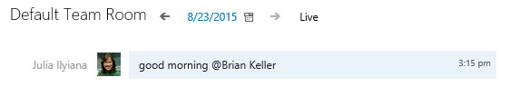
    - Figure 7
    - Team member mention (view from non-target team member)

  - Before we move on, go ahead and get another team member connected to the room using remote desktop. In the new remote desktop window, login with user name “VSALM\brian” and password “P2ssw0rd”. Once connected and logged in, navigate to the Default Team Room as you previously did.
    - Note: You can also RDP to ‘localhost’ from within the VM itself.

  - Note that Brian’s view of the message from Julia renders differently than it would for others since he was the person addressed.
    - 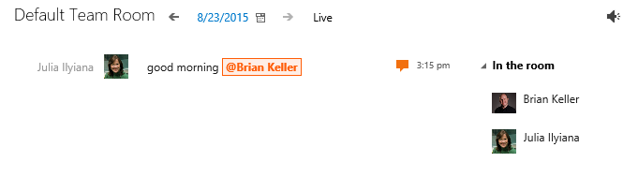
    - Figure 8
    - Team member mention (view from target team member)

  - Another type of mention can be used for referencing project work items. As Julia, add a message to the team that mentions work item #1.
    - 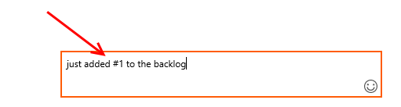
    - Figure 9
    - Creating work item mention

  - Click the work item link from the team room chat to see that it does link to the specified work item.
    - 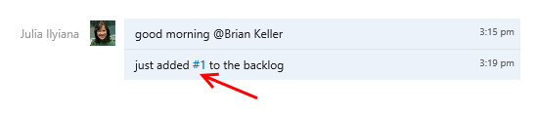
    - Figure 10
    - Hyperlink to work item

    - 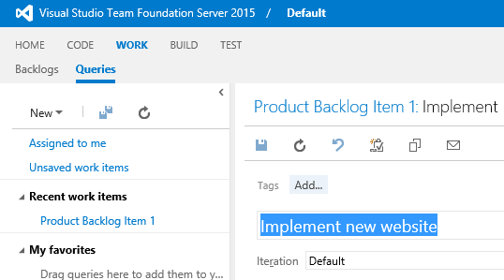
    - Figure 11
    - Work Item view opens in new browser tab

  - Close the tab showing the work item to return to the team room chat.
  - Some other patterns render as links include URLs, UNC network paths, and email addresses.
    - 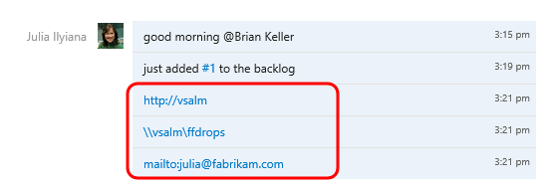
    - Figure 12
    - Other types of links

Task 3: Team Room Events
  - Another key feature of team rooms is that various events can be selected and configured to automatically feed in additional information, thereby providing additional context to active and historical team discussions. Click Manage events… in the Default Team Room.
    - 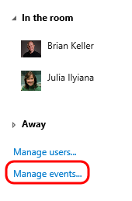
    - Figure 13
    - Manage team room events

  - The Configure Events for Default Team Room window that appears shows four different options, Build Completion, Code Changes, Work Item Updates, and Code Reviews. Build completion events can be setup to appear whenever selected builds complete.
    - 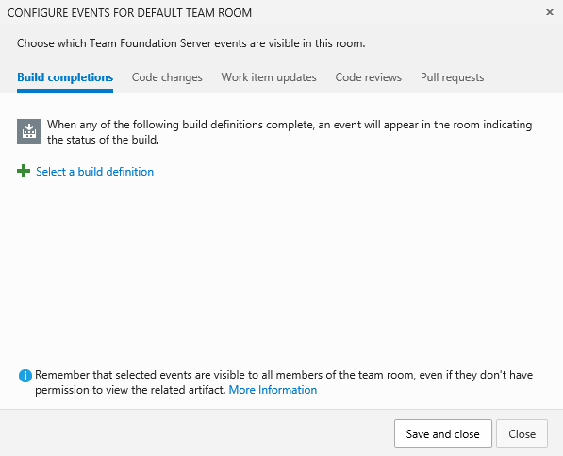
    - Figure 14
    - Configuring build completion events

  - Click the Code Changes tab. These events can be setup to appear whenever code is checked into selected team projects.
    - 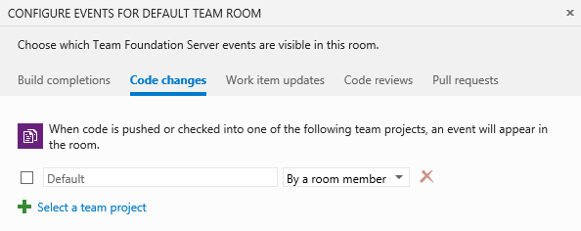
    - Figure 15
    - Configuring code change events

  - Click the Work Item Updates tab. These events can be setup to appear whenever a work item is created or an existing work item has the state or assignment changed. Let’s set this event up by checking the checkbox next to the Default project and then clicking Save and Close to use the default options.
    - 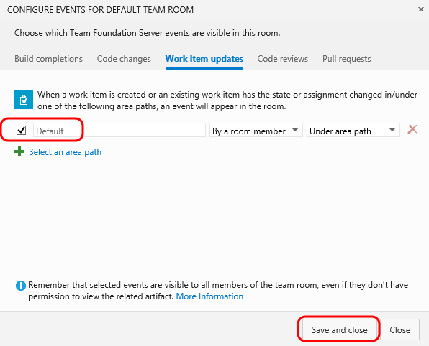
    - Figure 16
    - Configuring work item update events

  - Navigate to work item #1 in TFS web access by clicking the link in the Default Team Room chat window.
    - 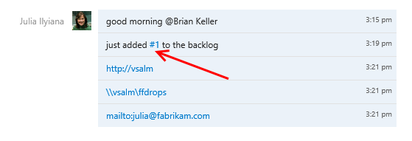
    - Figure 17
    - Hyperlink to work item

  - Change the work item from state New to Approved and then click Save.
    - 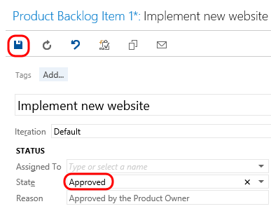
    - Figure 18
    - Updating work item state

  - Return to the Default Team Room and note that an event is raised in the chat window describing the state transition. It should only take a moment for it to show up, but you can also refresh the page after a few minutes if needed.
    - 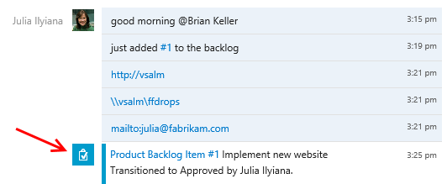
    - Figure 19
    - Work item update notification

  - The Team Room feature has been designed with extensibility in mind, so that will allow development teams to add in custom events and clients in the future. If you are interested in learning more about this extensibility, look at the Team Rooms REST API for more information.

Exercise 2: Lightweight Code Comments
In this exercise, you will learn about the Lightweight Code Comment feature (first introduced with Team Foundation Server 2013), that allows team members to comment on code. This enables interactive or time shifted conversations about code, all from a very nice inline experience in the browser.
  - Log in as Julia Ilyiana (VSALM\Julia) if not already logged in. All user passwords are P2ssw0rd.
  - Launch Internet Explorer from the taskbar and click the TFS FF Portal button from the favorites bar at the top.
    - 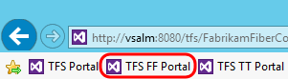
    - Figure 20
    - Launching web access

  - Click the Code tab.
    - 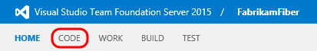
    - Figure 21
    - Navigating to Code

  - Click the Changesets tab. Lightweight code comments can be applied to both changesets and shelvesets.
    - 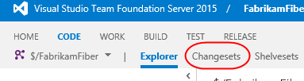
    - Figure 22
    - Navigating to Changesets

  - Load changeset 47 by entering “47” into the changeset search box and pressing Enter.
    - 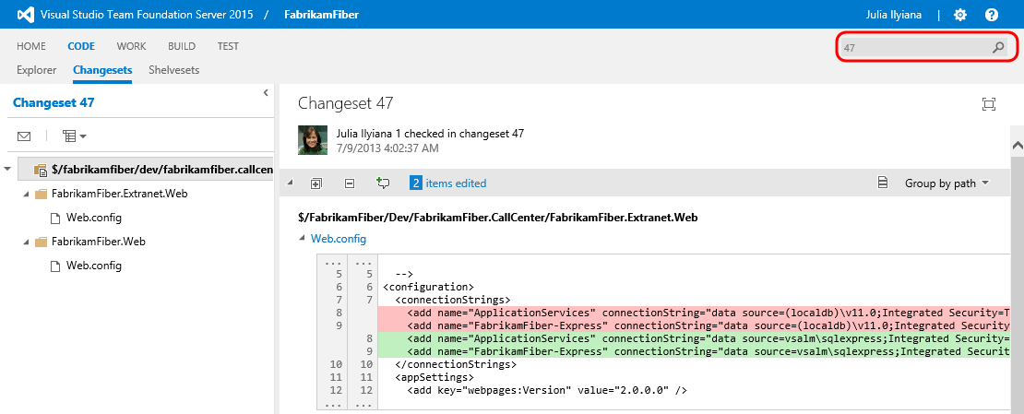
    - Figure 23
    - Changeset link

  - This changeset contains two file edits, with the changes highlighted in the diff viewer.
    - 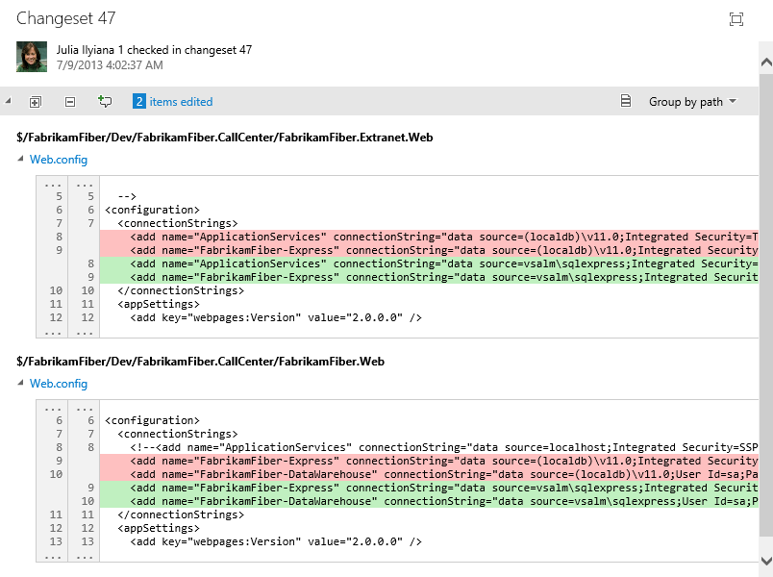
    - Figure 24
    - Diff viewer showing file edits

  - Click the Add Comment button to add a comment to the changeset.
    - 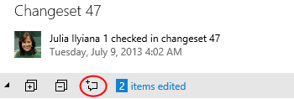
    - Figure 25
    - Comment button location

  - Enter a comment such as “What was the reason for changing the connection strings?” Press Enter when done.
    - 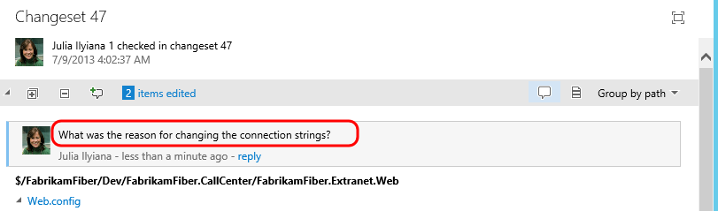
    - Figure 26
    - Adding comment to changeset

  - To comment on a specific file, click the first Web.config link to load that specific edit.
    - 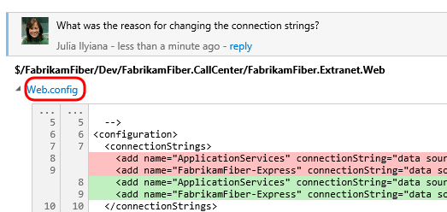
    - Figure 27
    - Loading diff viewer for a specific edit

  - Click the Add Comment button.
    - 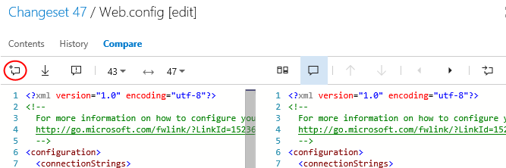
    - Figure 28
    - Add comment button location

  - Add a short comment of your choosing.
    - 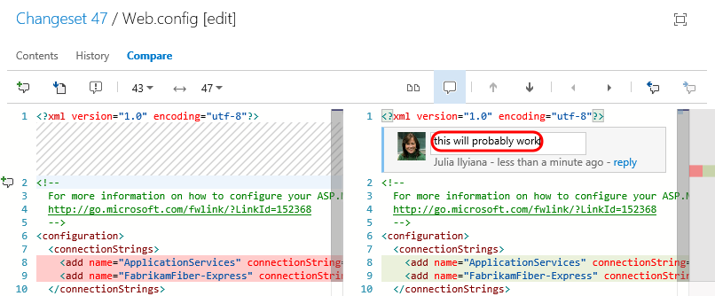Figure 29
    - Comment added to a specific file edit

  - Move the mouse cursor over the lines of the file and note that the same Add Comment button appears in the margin. Go ahead and click that button while holding the mouse cursor over one of the lines to add a line comment of your choice.
    - 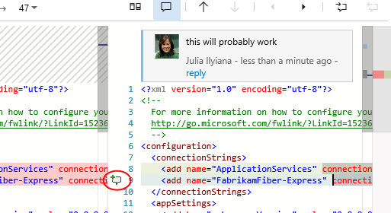
    - Figure 30
    - Adding a line comment

    - 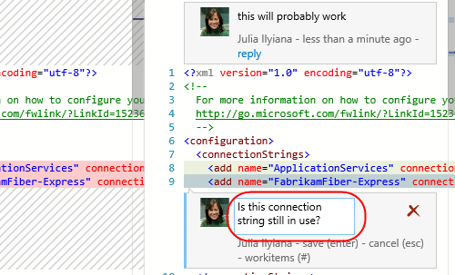
    - Figure 31
    - Example result of adding line comment

    - Note: You can even highlight parts of a sentence and comment on them if desired.

  - Connect to the VM as Brian using the same method that you chose in exercise 1, and then navigate to changeset 47 in the Fabrikam Fiber web portal. Note that you can see the comments left by Julia.
    - 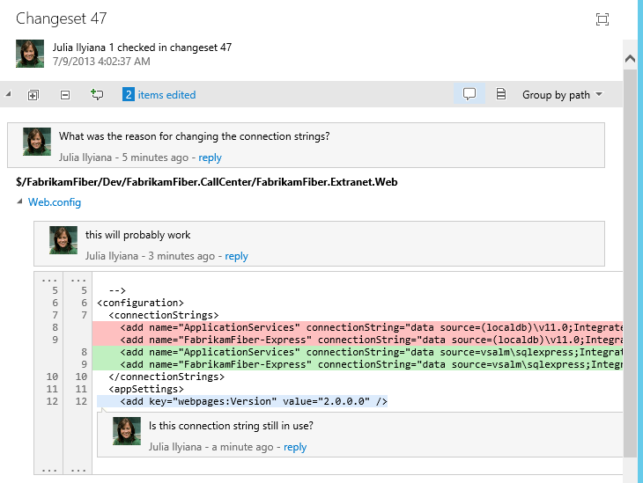
    - Figure 32
    - Viewing comments left by Julia (as Brian)

  - Click reply within Julia’s first comment and leave a response to her question.
    - 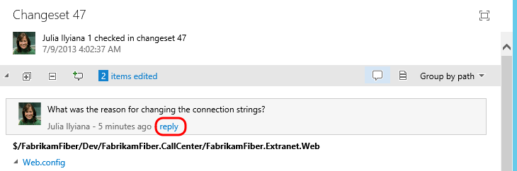
    - Figure 33
    - Replying to Julia (as Brian)

    - 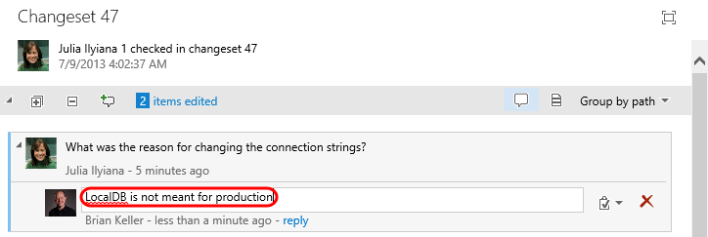
    - Figure 34
    - Result of replying to Julia (as Brian)

Exercise 3: CodeLens
In this exercise, you will learn about the CodeLens feature first introduced with Visual Studio 2013 and Team Foundation Server 2013 that provides code insights about classes, methods, and properties directly within the code editor.
  - Log in as Julia Ilyiana (VSALM\Julia) if not already. All user passwords are P2ssw0rd.
  - Launch Visual Studio 2015 from the taskbar.
  - In Team Explorer – Home, double-click on the first solution listed, “FabrikamFiber.CallCenter.sln”.
    - 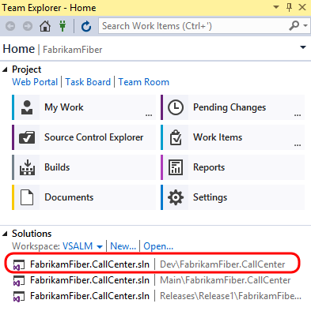
    - Figure 35
    - Loading the Fabrikam Fiber Call Center solution

  - In Solution Explorer, expand the FabrikamFiber.Web | Controllers folder and double-click CustomersController.cs to open it.
    - 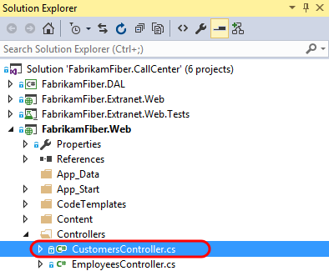
    - Figure 36
    - Opening CustomersController.cs

  - After loading the CustomersController.cs file in the code editor, note that both the class and its methods show a single line of indicators. These indicators are meant to provide developers a heads-up-display of sorts - with information about how the code is being used, tested, and changed.
    - Note: CodeLens is available for managed code only.

    - 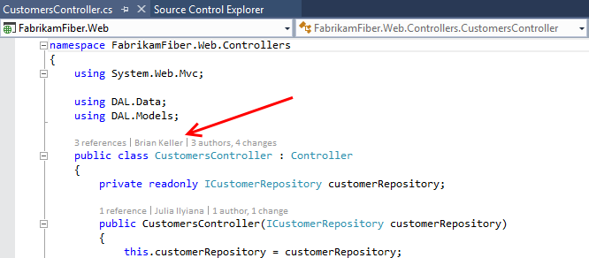
    - Figure 37
    - CodeLens indicators

  - Scroll down to locate the Create method that takes a Customer object as a parameter, and then click the references indicator. This shows other code references to this method.
    - 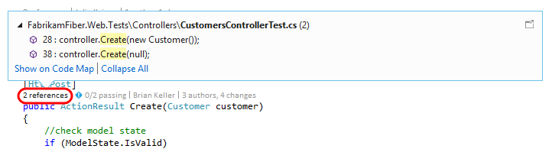
    - Figure 38
    - References indicator

    - Note: You can also hold down the Alt key and press the number key shown above each indicator as a shortcut.
    - 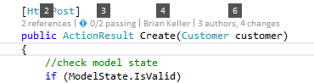

  - If you were to double-click on one of the references, you would be taken to the specified location in code. Press the Escape key instead.
  - Click the Timeline indicator above the same Create method as before. Note that before clicking it, you can see who made the most recent change.
    - 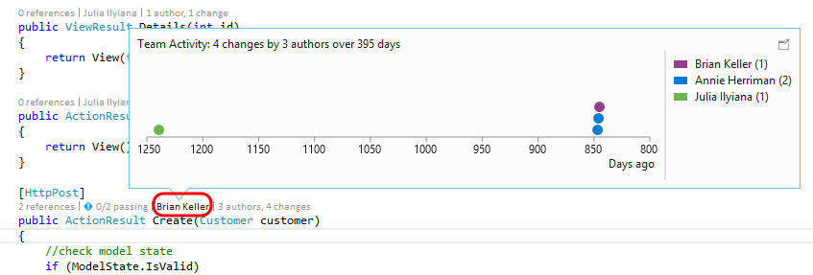
    - Figure 39
    - Author indicator

  - Click the Authors & Changes indicator to view all authors, changeset descriptions, and dates.
    - 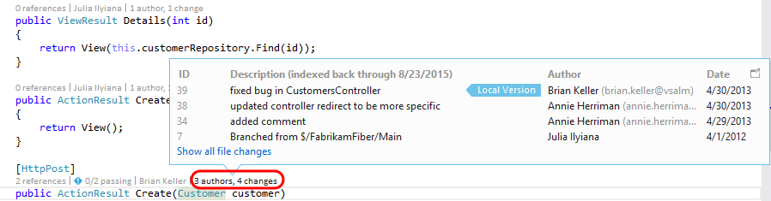
    - Figure 40
    - Author code lens
  - Right-click on one of the rows shown for the expanded Changes indicator. Note that you can choose to view the diff, view the changeset details, track the changset, get this version, or even send email to the author.
    - 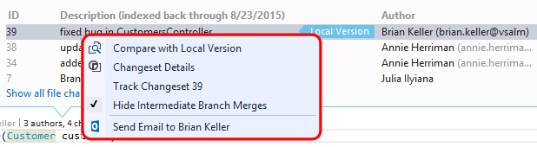
    - Figure 41
    - Additional options for indicator

  - Press the Escape key.
  - Press Ctrl+Shift+B to build the solution.
  - Click the Tested By indicator shown above the Create method. This lens currently shows that associated tests have not been executed.
    - 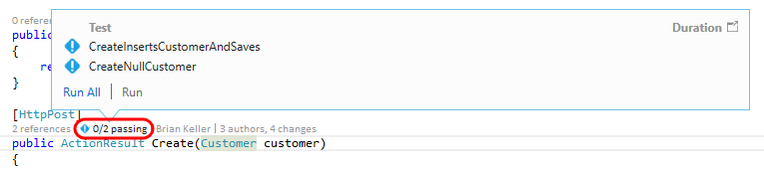
    - Figure 42
    - Tested By indicator

  - Click Run All to execute the tests.
    - 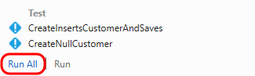
    - Figure 43
    - Running all tests associated with the Create method

  - It appears that one of the tests failed, so click the Tested By indicator once again to see which test is causing a problem.
    - 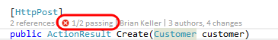
    - Figure 44
    - Tested By indicator showing failed test

  - Let’s take a look at the test itself to determine if the fix needs to happen there or in the Create method being tested. Double-click the CreateNullCustomer test to navigate to the definition.
    - Figure 45
    - Navigating to test source

  - After looking at the CreateNullCustomer test, we can see that it is expecting an ArgumentNullException to be thrown when the Create method is called with a null parameter. Note that there is also a Test Status indicator shown next to the test method itself.
    - 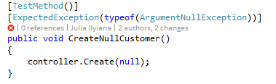
    - Figure 46
    - Test method showing most recent test result indicator

  - Select the indicator showing the failed CreateNullCustomer test to see additional summary information.
    - 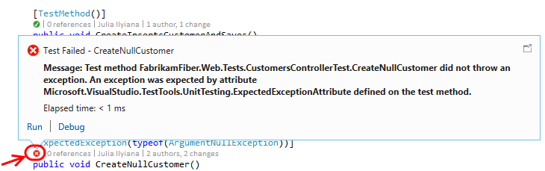
    - Figure 47
    - Viewing test result summary

  - Throwing this exception seems like a reasonable expectation, so let’s go ahead and make the fix in the Create method. Return to CustomersController.cs and add the following code to the beginning of the Create method that takes a Customer parameter.
    - C#
if (customer == null)
    - { throw new System.ArgumentNullException("customer"); }

    - 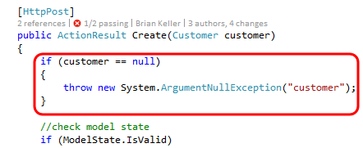
    - Figure 48
    - Fixing the Create method

  - With the fix in place, click the Tested By indicator, single-click on the CreateNullCustomer test, and then click Run to re-run just the failed test.
    - 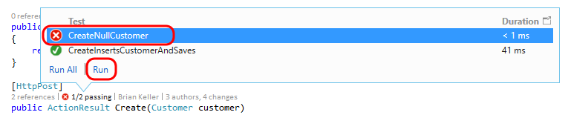
    - Figure 49
    - Re-run tests

  - All tests that reference the Create method now pass.
    - 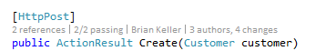
    - Figure 50
    - All tests passing

    - Note: With all tests passing, nothing stands out visually in the CodeLens indicator line. This demonstrates one of the goals of CodeLens - to provide useful information without getting in the way or being distracting. Nevertheless the feature can be customized or even turned off in Tools | Options if desired.
    - 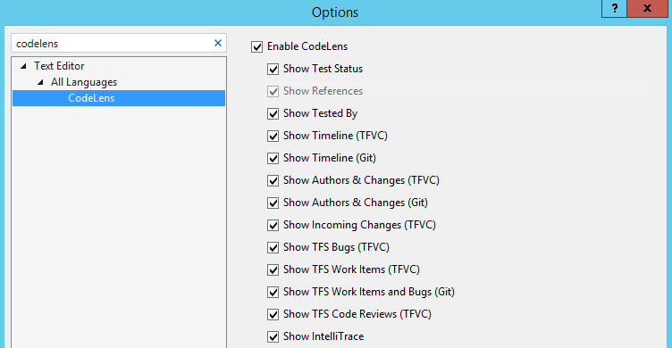

  - As a final note, CodeLens also supports a number of indicators for Git repositories also. This provides author, change and work item indicators that work very similarly to their Team Foundation Version Control counterparts. Unlike the CodeLens support for TFVC, CodeLens for Git is computed solely on the client side. This means that you can use the feature for any Git repository whether it is local, cloned from TFS Git, cloned from GitHub or another Git source.

To give feedback please write to VSKitFdbk@Microsoft.com
Copyright © 2016 by Microsoft Corporation. All rights reserved.

