MICROSOFT PRODUCTIVITY HUB 2010 CUSTOMIZATION GUIDE

Adding Support for Other Products Within The Productivity Hub
The Microsoft Productivity Hub 2010 can be extended to support your own training content, learning roadmaps, and quizzes. This guide provides step-by-step instructions for customizing the 2010 Productivity Hub to incorporate training content for your own products.
To make the changes described below, you will need Administrative (Site Owner) permissions of the Productivity Hub site collection.
This guide is intended for users who are familiar with SharePoint site management functionality and have experience customizing SharePoint lists and navigation menus.

Step 1: Add an Icon for the Product
To get started, navigate to the installed Productivity Hub site in your browser.
Start by adding an icon for the new product to the Site Assets library. The image you select should be square in shape and be at least 135x135 in dimensions to avoid pixilation or distortion. The icon for the product will appear in the header of the product landing page, the forums landing page, and in the product carousel on the home page.
- Click Site Actions > View All Site content from any page.
- Click Site Assets
- From the Documents tab in the toolbar, click Upload Document
- Browse to the image that will be used as the icon, and click OK to upload it to the library.

Step 2: Add The Product to the Products List
Click View All Site content from any page and then click the Products lists to register your new product.
Products List
  - In the default Products list view, click Add New Item from the bottom of the list
  - In the dialog, specify your product title (spaces should be removed), the filename of the icon you added to the Site Assets library, and the full title of the product (with spaces)
  - Click Save
ProductVersions List (optional)
This step is optional and is only needed if you intend to register content for more than one version of the same product.
- From the default list view of the Product Versions list, click Add New Item from the page
- For the title, specify the version (e.g., 3.0 or 2007)
- Reference the Product that you are registering a version for from the drop-down list
- Click Save
[Repeat for each version you intend to support]

Step 3: Add a navigation menu entry for the Product
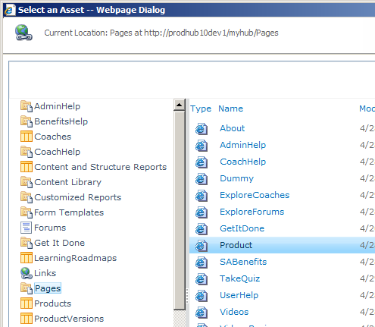
Once the product is registered in the products list, you need to provide a way for users to navigate to the product landing page using the left navigation fly-out menu. To add a menu entry for the product:
- Click Site Actions > Site Settings
- Under Look and Feel, click Navigation
- Under Current Navigation, find and select the Products folder
- Click Add Link… from the toolbar
- Specify a Title (e.g. MyProduct) – this is what appears in the menu
- To specify the URL, click the Browse button
- Choose the Product page from the Pages library

- Append the Product.aspx text in the URL field with ?Product={YourProduct} (e.g., Product.aspx?Product=MyProduct) as shown in the screenshots below
Note: Without this flag, the product landing page will not display content related to your product
- Click OK to close the Navigation link dialog box
- From the Navigation page, you can now move the link up or down in the menu of Products
- Click OK once the link is registered with the Current Navigation
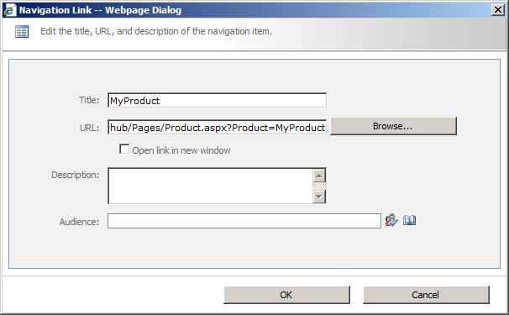

Step 4: Upload content for the Product
With the product list and navigation changes complete, you can now upload content related to your new product and tag it appropriately. Click View All Site content from any page then click Content Library to add content. The following describes the fields you’ll need to fill out when you upload product content to the Content Library.

Field | Description
Title | Use this field to specify the title of the article.
Abstract | Use this field to briefly describe the article in 15 words or less. This abstract field provides the short explanatory text you see in the respective product page. This is not the headline or the resource title.
Difficulty | Specify the difficulty level of the content
IsFeaturedContent | Check this for this article to appear in the Featured Content tab of the bookshelf
AppearsInRotator | Check this for this article to appear in the Featured Video tab of the bookshelf (article must be a video)
ThumbnailImageUrl | Use this if this article is a video and you want to supply a thumbnail image. If you have a thumbnail image, specify the URL to that image. Otherwise, leave this field blank.
IsVideoContent | Check this if this article is a video
Product | Choose your product from the list to associate the content with the product
ProductVersion | Specify a version (in text format) if this content is specific to one version of the product. Otherwise, leave this field blank.

To upload without using the PowerShell Script
You can also manually upload any new content to the Productivity Hub by uploading the content as you would for any SharePoint site collection.
- Select Site Actions>View all Site Content
- Click on the Content Library.
- Select the Documents tab under Library tools
- Select Upload Documents or Upload Multiple Documents from the Upload Document drop down menu.
- Follow prompts to upload your document(s).

Step 5: Add a Learning Roadmap and/or Quiz for the Product
Click View All Site content from any page to register a Learning Roadmap or a Quiz for your new product.
Learning Roadmaps
- In the default list view of Learning Roadmaps, click Add New Item from the page
- Enter a title and link referencing product content, then specify a sequence (e.g. 1) to control the order of the link in the group, associate the learning roadmap item with your product and product version, and give the learning roadmap item a group name (e.g. Getting Started).
- Click Save
Quiz Questions, Quiz Choices (optional)
To register a quiz for your product, add one or more questions to the Quiz Questions list that are related to your product. Once questions have been entered, you must provide response choices in the Quiz Choices list that reference each question (with one of the response choices marked as the correct answer). If there is at least one quiz question registered for your product, a Quiz banner will appear on the product’s landing page.

Step 6: Register Coaches for the Product
Now that you have new product content registered in the Productivity Hub, you should modify or add coaches in the coaches list to associate them to the new product. This association will be reflected in the Coaches page for end users.
To modify the Coaches list, click View All Site content from any page, and then click on the Coaches list.

