Revision 1.0



Developer Topology   
Quick Start Guide

Table of Contents

Introduction 3

Setup Instructions 4

Virtual Machine Setup 4

Host machine hardware requirements: 5

Lync VM names, roles, memory, and IP information. 5

Extracting the VM files to the local computer. 6

Create a Virtual Network. 6

Import the Virtual Machine necessary to complete the task. 7

Verify the Settings of the VM with an internal NIC only. 7

Verify the Settings of the VM with an internal NIC plus an external NIC. 8

Start and log on to the VM. 8

Correcting the topology with your specific LYNC-EDGE configuration. 10

APPENDIX 13

Virtual Machine 180 Day Evaluation Activation 13

# Introduction

This set of Virtual Machines is designed to simulate a complete topology of Lync Server 2010 combined with SharePoint 2010 Enterprise Edition and Exchange 2010 SP1 Unified Messaging. It is complemented with a Terminal Server that has Visual Studio and Microsoft Office 2010 installed, plus other tools needed to build communications and collaboration applications on the Microsoft platform.   
By using Remote Desktop Services of Windows 7 or Windows Server 2008 R2 with audio enabled, you can simulate multiparty communications, by logging on as separate users via the Terminal Services Virtual Machine external NIC.   
In order to enable Audio input and output, Windows’ **Remote Desktop Connection** needs to have the Remote Audio settings configured as follows:

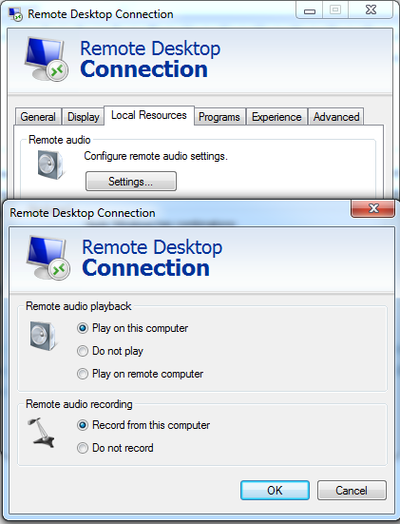

# Setup Instructions

###### Virtual Machine Setup

1. For this demo, you must use Microsoft® Windows Server 2008 R2 with Hyper-V role installed. The VMs were created using Windows Server 2008 R2 Hyper-V. The instructions in this setup guide were created using Windows Server 2008 R2 Hyper-V. The following is a high-level overview of the virtual machine (VM) environment:



###### 

###### Host machine hardware requirements:

| **HOST** | **Requirement** |
| --- | --- |
| Operating System | Windows Server 2008 **R2** (Std or Ent) with Hyper-V enabled |
| CPU | 2.40+ gigahertz (GHz) Dual or any Quad core processor |
| Hard Drive | 7200 RPM or SSD with 150 gigabytes (GB) free space for all 7 VMs |
| Memory | 8 GB (minimum required); 16 GB if all seven (7) VMs are deployed |
| Networking | Enable virtual networking using the instructions in this document |

###### Lync VM names, roles, memory, and IP information.

|  |  |  |  |  |
| --- | --- | --- | --- | --- |
| **Hyper-V  VM Name** | **NetBIOS Name** | **Operating System, Features, and Software** | **RAM** | **IP Address** |
| DC | DC | Windows Server 2008 R2 Domain Controller  & Global Catalog, DHCP, DNS, Certificate Authority | 1024 megabytes (MB) | 192.168.0.18/24* |
| LYNC-SE | LYNC-SE | Lync Server 2010 Standard Edition | 2048 MB | 192.168.0.20/24 |
| EXUM | EXUM | Exchange Server 2010 SP1 Unified Messaging | 2048 MB | 192.168.0.25/24 |
| LYNC-EDGE | LYNC-EDGE | Lync Server 2010 Edge Server | 1536 MB | 192.168.0.23/24  xxx.xxx.xxx.xxx** (External NIC) |
| LYNC-QMS | LYNC-QMS | Lync Server 2010 Quality Monitoring Server | 1536 MB | 192.168.0.30/24 |
| SPS2010 | SPS2010 | SharePoint 2010 Server | 4096 MB | 192.168.0.35/24 |
| TS | TS | Terminal Services Server, with Visual Studio 2010, SDKs, Office 2010 and Lync 2010 (client software) | 2048 MB | 192.168.0.40/24  xxx.xxx.xxx.xxx** (External NIC) |

* /24 represents a 255.255.255.0 subnet

** xxx.xxx.xxx.xxx represents an externally assigned IP address to the External NIC in the virtual machine.

###### Extracting the VM files to the local computer.

1. The self-extracting program allows the VMs to be extracted to a chosen disk location. For the purpose of this setup guide, the C:\ drive will be used to reference VM file locations.
2. Double-click the LYNC2010VHD_DC.exe file to beging the self-extraction.

The self extraction program will extract the VM files to the location specified, for example, C:\LyncDemos unless otherwise specified. For the purpose of this document, the C:\LyncDemos location will be used to refer to the VM location.

1. Continue to “Create a Virtual Network” while the files are being extracted.
2. Repeat for the other remaining *.exe to extract the other Virtual Machines.

###### Create a Virtual Network.

1. On the host computer, click **Start**, click **Administrative Tools**, and then click **Hyper-V Manager**.
2. In Hyper-V Manager, in the Actions pane, click **Virtual Network Manager.**
3. In the Virtual Network Manager wizard, under **What type of virtual network do you want to create?** click **Internal** and then click **Add**.
4. Under **New Virtual Network**, in the **Name** field, type **Lync** **Demo – Virtual Network** and click **Apply**.
5. In the Apply Network Changes window, click **Yes**.
6. Click **OK** to close the window.
7. Repeat the steps to create an external network Adaptor.  
   In Hyper-V Manager, in the Actions pane, click **Virtual Network Manager.**
8. In the Virtual Network Manager wizard, under **What type of virtual network do you want to create?** Select **External** and then click **Add**.
9. Name the New Virtual Network **External Virtual Network**, set the Connection type to external and select your appropriate NIC adaptor in the drop dwon, and allow management operating system to share this network adapter.
10. Press OK and wait for confirmation that the action has successfully completed.

**Wait for the Virtual Machine Files to finish being extracted before continuing.**

###### Import the Virtual Machine necessary to complete the task.

1. In Hyper-V Manager, in the Actions pane, click **Import Virtual Machine**.
2. On the Import Virtual Machine page, click **Browse**.
3. On the Select Folder page, navigate to the location of the extracted VMs (e.g. C:\LyncDemos), click the folder **DC**,and then click **Select Folder**.
4. On the Import Virtual Machine page, click **Import**.
5. An ‘Import Completed with warnings’ dialog box may appear. The warning can be ignored at this time. The VM settings will be verified later in this setup guide.
6. Repeat the steps a-e for the remaining Virtual Machines.

###### Verify the Settings of the VM with an internal NIC only.

1. On the host computer, in Hyper-V Manager, right**-**click **DC**, and then click **Settings**.
2. On the Settings for DC page, verify the VM setting according to the following table:

|  |  |  |  |  |  |
| --- | --- | --- | --- | --- | --- |
| **VM Name** | **Memory** | **Processor(s)** | **IDE Controller 0** | **IDE Controller 1** | **Ethernet Port** |
| DC | 1024 MB | 1 or more | DC.vhd | n/a | **Lync Demo – Virtual Network** |

1. If the settings are correct, click **Cancel** to close the window.
2. If you need to correct the settings, change the appropriate configuration and click **OK**.  
   You can assign as many processors to the Virtual Machine as you have available.
3. Repeat the above steps for the Virtual Machines LYNC-SE, LYNC-QMS, EXUM and SPS2010 of this package.  
   Make sure to configure the memory sizes as per the overview table above of all VMs.

###### Verify the Settings of the VM with an internal NIC plus an external NIC.

1. On the host computer, in Hyper-V Manager, right**-**click **LYNC-EDGE**, and then click **Settings**.
2. On the Settings for LYNC-EDGE page, verify the VM setting according to the following table:

|  |  |  |  |  |  |  |
| --- | --- | --- | --- | --- | --- | --- |
| **VM Name** | **Memory** | **Processor(s)** | **IDE Controller 0** | **IDE Controller 1** | **Ethernet Port 1** | **Ethernet Port 2** |
| LYNC-EDGE | 1536 MB | 1 or more | LYNC-EDGE.vhd | n/a | **Lync Demo – Virtual Network** | **External Virtual Network** |

1. If the settings are correct, click **Cancel** to close the window.
2. If you need to correct the settings, change the appropriate configurations and click **OK**.  
   Make sure to configure the respective memory size as specificied per the overview table of all VMs above.
3. Repeat the above steps for the Virtual Machine TS with the following settings.

|  |  |  |  |  |  |  |
| --- | --- | --- | --- | --- | --- | --- |
| **VM Name** | **Memory** | **Processor(s)** | **IDE Controller 0** | **IDE Controller 1** | **Ethernet Port 1** | **Ethernet Port 2** |
| TS | 2048 MB | 1 or more | TS.vhd | n/a | **Lync Demo – Virtual Network** | **External Virtual Network** |

###### Start and log on to the VM.

1. On the host computer, in Hyper-V Manager, under Virtual Machines, right-click **DC** and click **Connect**.
2. On the DC Virtual Machine Connection, press **CTRL+ALT+END** or click the **Ctrl-Alt-Delete** button  on the tool-bar.
3. If required, Log on as **Fabrikam\Administrator** with a password of **pass@word1**
4. On DC, click **Start** 🡪Administrative Tools 🡪Services**.**
5. In the Services console, verify that all services set to start **Automatically** have started.
6. Repeat the steps above for the remaining virtual machines in this package.  
   Please note that the LYNC-EDGE server will take a long time to boot up, due to inherent errors in the Lync Server topology.  
   See the instructions below to correct the Lync topology.

|  |  |
| --- | --- |
| **Important**: | Services on these Virtual Machine (s) may take several minutes to start. It is also possible that services fail to start. Prior to beginning any demonstration, complete the following procedure to ensure that the environment is functional before the demonstration begins.   1. On Lync-SE, click **Start🡪Administrative Tools🡪Services**. 2. In the Services management console, verify that the **SQL Server (RTC) & (RTCLOCAL)** services are started and verify that the **Lync Server Front-End** service is started.   For any service which is not started, right-click the service and click **Start**.   1. Verify that all services that are set to start **Automatically** have a status of **Started**. The **Windows Licensing Monitoring Service** is the only service that is not required to be Started.   For any service which is not started, right-click the service and click **Start**.   1. Verify that all services that are set to **Automatic (Delayed Start)** have a status of Started. You may need to refresh the console to see the current status.   For any service which does not start within 5 minutes, right-click the service and click **Start**.   1. Close the Services management console. |

###### Correcting the topology with your specific LYNC-EDGE configuration.

1. On the host computer, in Hyper-V Manager, under Virtual Machines, right-click **LYNC-EDGE** and click **Connect**.
2. On the Lync Edge Virtual Machine Connection, press **CTRL+ALT+END** or click the **Ctrl-Alt-Delete** button  on the tool-bar.
3. If required, Log on as **Fabrikam\Administrator** with a password of **pass@word1**
4. Wait for the network to assign a TCP address to both NICs.
5. Open **Network and Sharing Center** by rightclicking on the network icon in the System Tray.
6. Click on the **Public Network** Local Area Connection to get the network details (press the **Details…** button) and write down the **IPv4 Address**.
7. Close the networking windows.
8. Minimize the LYNC-EDGE virtual machine.
9. On the host computer, in Hyper-V Manager, under Virtual Machines, right-click **LYNC-SE** and click **Connect**.
10. On the Lync SE Virtual Machine Connection, press **CTRL+ALT+END** or click the **Ctrl-Alt-Delete** button  on the tool-bar.
11. If required, Log on as **Fabrikam\Administrator** with a password of **pass@word1**
12. Press the Windows **Start** button, go to **All Programs**, **Microsoft Lync Server 2010**. Start the **Lync Server Topology Builder**.
13. In the pop-up window that comes up, select the Download Topology from existing deployment and press OK.

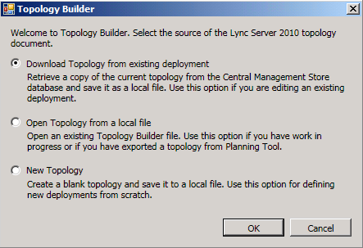

1. In the **Save Topology As** window, select any *.tbxml file and press **Save** and confirm replacing it.
2. Expand the fabrikam.com tree.

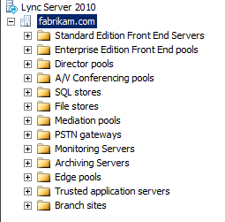

1. Expand the Edge Pools tree, and select the **Lync-Edge.fabrikam.com** node.
2. Select **Edit Poperties…** on the **Actions Pane** on the right.
3. In the **Edit Properties** window, scroll down to **External Settings**, and modify the **IP address** to the IP address you identified in step f.

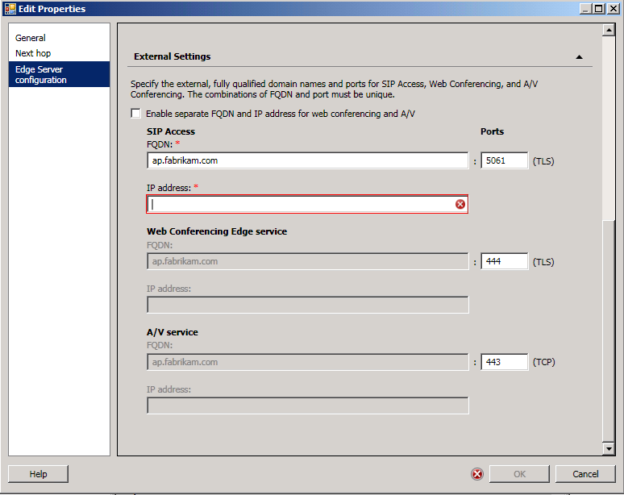

1. Press **OK** to close the **Edit Properties** window.
2. In the **Actions** pane, click **topology…** and select **Publish…**

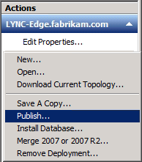

1. In the Publish Topology wizard that pops up, click **Next** and wait till the wizard completes.

All line items should write success in green.

In case the publishing fails with errors, make sure all virtual machines of the topology are actually running. You can shutdown virtual machines only after successfully publishing a complete topology.

1. Re-open the **LYNC-EDGE** virtual machine in the **Hyper-V Manager** by maximizing the minimized window.  
   Restart the **LYNC-EDGE** virtual machine.
2. Once restarted, open the LYNC-EDGE Virtual Machine Connection, press **CTRL+ALT+END** or click the **Ctrl-Alt-Delete** button  on the tool-bar. If required, Log on as **Fabrikam\Administrator** with a password of **pass@word1**
3. In the virtual machine, click **Start** 🡪Administrative Tools 🡪Services**.**
4. In the Services console, verify that all Lync services set to start **Automatically** have started.   
   In case certain Lync services refuse to start, please repeat the steps above and verify if the right external IP address was entered and configured.

## APPENDIX

##### Virtual Machine 180 Day Evaluation Activation

This Virtual Machine (VM) requires activation within 10 days of initial use.

This 180 day evaluation version of Windows Server 2008 R2 will require the VM to have Internet access for activation.

Use the following procedure as an example for configuring the VM in Hyper-V for Internet access.

1. After the VMs have been successfully imported, click the respective virtual machines that do not have an external NIC enabled (DC, LYNC-SE, LYNC-QMS, EXUM and SPS2010) and repeat all steps below.
2. In the Actions pane, click Settings.
3. In the Settings window, under Add Hardware, click Network Adapter and click Add.
4. In the Navigation pane, click the new Network Adapter that is listed as Not Connected.
5. In the results pane, click the Network drop down list and select **External Virtual Network**.
6. Click OK to close the Settings window.
7. Start the VM.
8. If necessary, log on to the virtual machine as Fabrikam\Administrator with a password of pass@word1
9. Wait for the VM to install the new hardware and assignment of a DHCP address from your external network. If you are not using dynamically assigned IP addresses, you must consult your Network Administrator and be assigned a static IP address which can be manually configured in the VM.
10. Click Start, right-click Computer, and then click Properties.
11. In the System Properties window, in the Windows Activation section, click Activate...
12. Activate the VM over the Internet to start the 180 day evaluation.
13. Once Windows Activation has completed succesfully, click Start and click Shut Down.
14. In the Hyper-V Management console, select the respective Virtual Machine just activated.
15. In the Actions pane, click Settings.
16. In the Settings window, in the Navigation pane, click the network adapter connected to the **External Virtual Network**.
17. In the Results pane, click Remove.
18. In the Settings window, click OK.
19. In the Hyper-V Management console, right click Virtual Machine just activated and click Snapshot. This will be the new snapshot you will use which represents the activated 180 day evaluation version of Virtual Machine.
20. Go back to Step 1 and repeat for the remaining VMs (e.g. LYNC-SE, EXUM, SPS2010, & LYNC-QMS).

***NOTE 1*:** The LYNC-EDGE and TS machine already have an external network connection configured, and require an external NIC for their operation. DO NOT REMOVE the external NIC of those virtual machines.

***NOTE 2:*** It is highly recommended that you Stop the DHCP service prior to connecting the DC.VHD to the external network in order to prevent the wrong subnet address of getting published (192.168.0.x).