Implementing Governance in SharePoint 2010

This document is provided “as-is”. Information and views expressed in this document, including URL and other Internet Web site references, may change without notice. You bear the risk of using it.
Some examples depicted herein are provided for illustration only and are fictitious. No real association or connection is intended or should be inferred.
This document does not provide you with any legal rights to any intellectual property in any Microsoft product. You may copy and use this document for your internal, reference purposes.
© 2010 Microsoft Corporation. All rights reserved.

Implementing Governance in SharePoint 2010

Robin Meuré (MVP) and Daniel McPherson (Authors)
zevenseas
Bill Baer (Contributor)
Microsoft Corporation
August 2010
Applies to: SharePoint 2010 Products
Summary: SharePoint 2010 provides a rich set of capabilities that empower business users. For example, Microsoft® SharePoint® 2010 enables users to collaborate with each other, tag and rate content, self-publish, and even develop their own solutions. These new capabilities require clear guidance to both underscore their benefits and realize their potential while maintaining a level of consistency and control within an organization.

Overview
SharePoint 2010 provides a rich set of capabilities that empower business users. For example, SharePoint 2010 enables users to collaborate with each other, tag and rate content, self-publish, and even develop their own solutions. These new capabilities require clear guidance to both underscore their benefits and realize their potential while maintaining a level of consistency and control within an organization.
The challenge for IT organizations is to create an appropriate level of centralized control, while at the same time, avoiding any impact on the business benefits derived by placing power in the hands of end users.
Control can be enforced through workflows and other processes, encouraged through the documentation of best practices, or assured through monitoring and reporting. Effective governance will require the combination of all these, and more, in a way that suits the culture of your organization.
This document focuses on the “back end” of SharePoint Governance – the technical implementation. It provides high-level guidance on the many configuration options SharePoint provides to enable you to manage the environment for the benefit of all. For more information about the “front end” of SharePoint Governance - the business aspect, refer to the following whitepaper: SharePoint 2010 Governance Planning.
For more background information concerning SharePoint governance in general please refer to the following documents:
- SharePoint Server 2010 Governance model
- SharePoint 2010 Governance Planning
- SharePoint Server 2010 Governance Resource Center

Contents
Overview 3
Farm Controls 6
Service Accounts 6
SharePoint Managed Accounts 6
Password Management 6
Changing Accounts 7
Diagnostic Logging 8
Event Throttling 8
Correlation IDs 9
Event Log Flood Protection 9
Trace Logging 9
Usage Data and Health Data Collection 11
Web Analytics 12
Traffic 12
Search 13
Inventory 13
Health Analyzer 14
Timer Jobs 15
Releases and Upgrades 15
Backup 16
Central Administration 16
Scripted Backup 18
SQL Server Database 18
Web Application Controls 19
Content Database Management 19
Supported / Blocked File Types 20
Security Policies 20
Resource Throttling 21
Application Pools 22
Security 22
Reliability 23
Solutions and Features 23
Farm Solution 23
Sandboxed Solutions 24
Search 25
Index file location 25
Content Sources 25
Customization 26
SharePoint Designer 26
Branding 27
Themes 27
Master Pages 27
Site Controls 28
Security and Permissions 29
Access Requests 29
Quotas 29
Storage Limit Quotas 29
Resource Limit Quotas 29
Resource Throttling 29
Lifecycle Management 31
Site Deletion 31
Archiving / Site Backup and Restore 31
Auditing 32
Provisioning and Self Service Site Creation 32
Secondary Owner 32
Managed Paths 33
Multi-Tenancy 33
Conclusion 33
Additional Resources 33
About the Author 34

Farm Controls
This section describes any functionality that is relevant to governance that operates at the farm level. This means that this functionality has an impact on the entire SharePoint environment.

Service Accounts
Many services and components that make up SharePoint Server run under the context of an Active Directory User Account, which is often referred to as a “Service Account”. These accounts are not used to log on interactively because they are reserved for use by Microsoft Windows® Services, Internet Information Services application pools, and SharePoint service instances. For this reason they require a different, and in some ways more challenging, approach to management.
The following sections describe how SharePoint 2010 makes working with Service Accounts easier.

SharePoint Managed Accounts
Managed Accounts are a powerful account management concept that is introduced in SharePoint 2010 and that is specifically designed to simplify the secure management of accounts that are used for services and components.
A Managed Account is an Active Directory Domain Services (AD DS) user account whose credentials (username and password) are managed by SharePoint Server. They are created either during the initial configuration of SharePoint Server or by using SharePoint Central Administration or Windows PowerShell. Once registered, an account can then be assigned to services and components within your SharePoint environment.
The benefit is that you only have to enter the credentials once. From that point onwards credentials are stored in a secure, central location where they can be managed regardless of which components or services they're assigned to. For example, when creating a new Web application in SharePoint Server 2010, you no longer need to enter a user name and password when creating a new application pool. You can simply select from one of the existing Managed Accounts.

Password Management
Managing passwords that are assigned to accounts that are responsible for the various services and components in SharePoint Server has, in the past, been a difficult task. As a result, many organizations used accounts whose passwords were configured to never expire. Because these accounts often had privileged access to SharePoint resources, securing them with a password that never changed could be considered a security vulnerability. Managed Accounts solve this problem.
Using the “Configure managed accounts” link (in the Security | General Security section of SharePoint Server 2010 Central Administration) you can take advantage of functionality that will automatically change expiring passwords on “Managed Accounts” for you, or if you prefer, notify you when a password is about to change. This process integrates tightly with AD DS to ensure that defined account policies (strength, age, and so on) are respected.

Changing Accounts
To change the Managed Account that is being used by a service or component of SharePoint Server, you can use the “Configure Service Accounts” functionality. In the past, a number of these changes could only be done by using the stsadm command-line tool, detailed TechNet documentation, and a series of manual steps. As a result it was error prone.
Configuration (User Interface)
- In Central Administration, click Security and then in the General Security section, click the following items as discussed in the earlier in this article.
  - Configure Managed Accounts

  - Configure Service Accounts
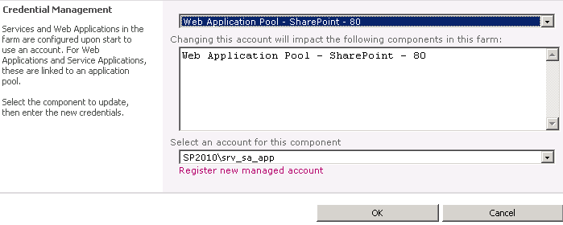
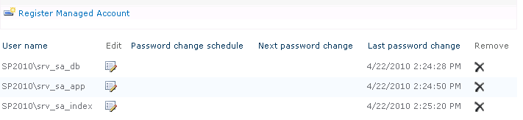
  - Configure password change settings

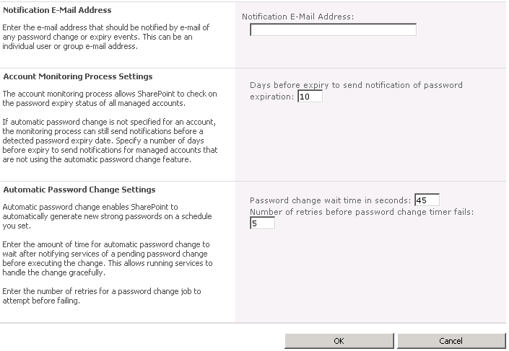

Diagnostic Logging
SharePoint 2010 includes improvements in the management of the Unified Logging Service (ULS) logs that make it easier for administrators to troubleshoot issues. These are described in the following sections.

Event Throttling
Event throttling provides a dial to administrators to enable them to turn up or turn down the events that SharePoint Server logs based on how critical events are. Throttling is broken down into two sections:
- Destination
Log entries can be reported in two places. The first is the Event Log, which is the standard Windows Event Log. Administrators can use the Windows Event Viewer application to view events. The second is the Trace Log, which is a text-based log format that stored on the file system and is specific to SharePoint Server.
- Category
The event throttling dial can be applied to specific categories which map directly to SharePoint functionality. This enables an administrator to increase the logging detail for SharePoint components individually, thereby managing the size of the logs and the amount of information to review.
The default settings for all categories are as follows:
- Event Log: Information
- Trace Log: Medium Level
During normal operation, these settings are an appropriate balance of detail and performance. During substantial reconfiguration of SharePoint Server, the installation of custom solutions, or when SharePoint Server is experiencing issues, the throttling level should be changed to Verbose. This ensures the availability of the maximum amount of information for troubleshooting by enabling the logging of less severe events.
Finally, after completing troubleshooting, logging can be returned to the default by selecting the “Reset to default” option in the throttling drop downs.
Remember: Consider storing log files on a different drive to the SharePoint binaries and system components to ensure the smallest possible impact on performance.

Correlation IDs
Correlation IDs are GUIDs that are assigned to events which occur during the lifecycle of a resource request. This value is surfaced within Error Messages, the ULS logs and tools like the developer dashboard. This value helps an administrator locate and isolate a specific request across the ULS log, Usage Logging database, and Microsoft SQL Server® Profiler for debugging.
Correlation IDs also span machine boundaries. If a request crosses a machine boundary, such as a front-end Web server calling a Web service on an application server, the assigned Correlation ID can provide a complete overview of what transpired throughout the lifecycle of the of the request.

Event Log Flood Protection
New to SharePoint Serve 2010 is functionality that prevents the Event Log from being flooded with large numbers of repetitive events. This is called Event Log Flood Protection. When it is enabled (which it is by default) it will start trimming events after the same one is logged five times within two minutes. At this point it suppresses all further entries and throws a summary event after two further minutes that describes the number of times the event would have been repeated. Administrators can tune these thresholds based on their requirements.

Trace Logging
Trace Logs can quickly consume disk space, especially when configured to use the more verbose output settings. To manage this growth, administrators can implement two types of restriction:
- In Office SharePoint Server 2007 the only restriction you could place on log file growth was to set a value for the total number of log files to be kept. The default was 96 log files. Each log file contained 30 minutes of entries to provide a total of 48 hours of logs. In SharePoint Serve 2010 the overall size of the logs has been dramatically reduced. Administrators determine the number of days that log files should be kept. The default value is 14 days.
- Administrators can also place a limitation on the overall disk space that log files can consume. This is disabled by default, but it provides an additional layer of protection aimed at stopping disks from filling up.
Finally, with SharePoint Server 2010, the folder containing the logs has NTFS compression applied, which means that all SharePoint log files and compressed.
Additional Resources
- What's New: ULS Logging
- Configure diagnostic logging
- ULSViewer
Configuration (User Interface)
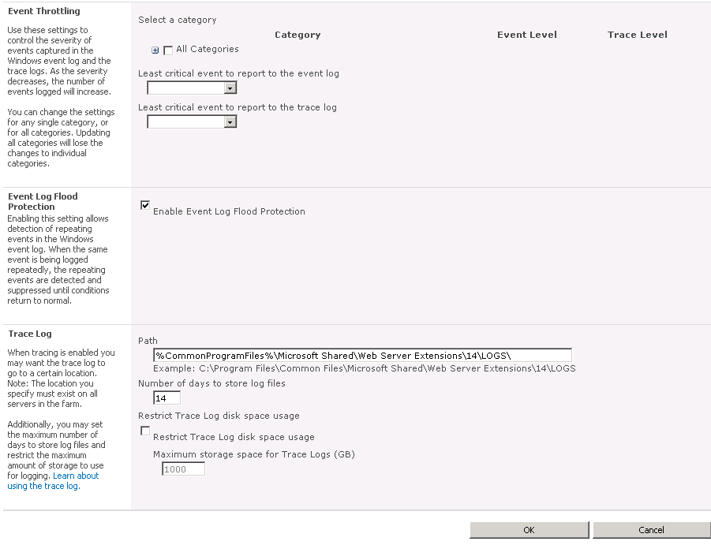
- In Central Administration, click Monitoring and in the Reporting section, click Configure diagnostic logging.

Usage Data and Health Data Collection
In addition to Diagnostic Logging, SharePoint Server 2010 also proactively logs information that is related to the overall health of the farm. An administrator can individually select the events, such as the usage of features, page load times, and search queries, that are monitored.
Because this functionality consumes disk space and has a performance overhead, dedicated disks are recommended to prevent I/O contention and overall performance bottlenecks. Like Diagnostic Logging, care needs to be taken to manage it appropriately. The following options are available to administrators to do this:
- Health Data Collection
Health reports are built by taking snapshots of various resources, data, and processes at specific points in time. The number of Timer Jobs to schedule will depend on the number of events you selected to monitor. The frequency of these jobs can be modified to manage the performance impact.
- Log Collection Schedule
This Timer Job is responsible for collecting Usage Logs from servers in the farm, processing the logs, and then populating a centralized database from which logs can be queried for reporting. Once processed, the logs are deleted from disk, freeing up the space they were consuming. The frequency of this job can be modified to manage the consumption of disk space.
While providing powerful new functionality for administrators, developers and third party vendors can also extend this functionality. This allows for the addition of new types of indicators and the creation of richer reports.
Additional Resources
- Configure usage and health data collection
- Configure SharePoint Health Analyzer timer jobs
Configuration (User Interface)
- In Central Administration, click Monitoring and in the Reporting section click Configure usage and health data collection.

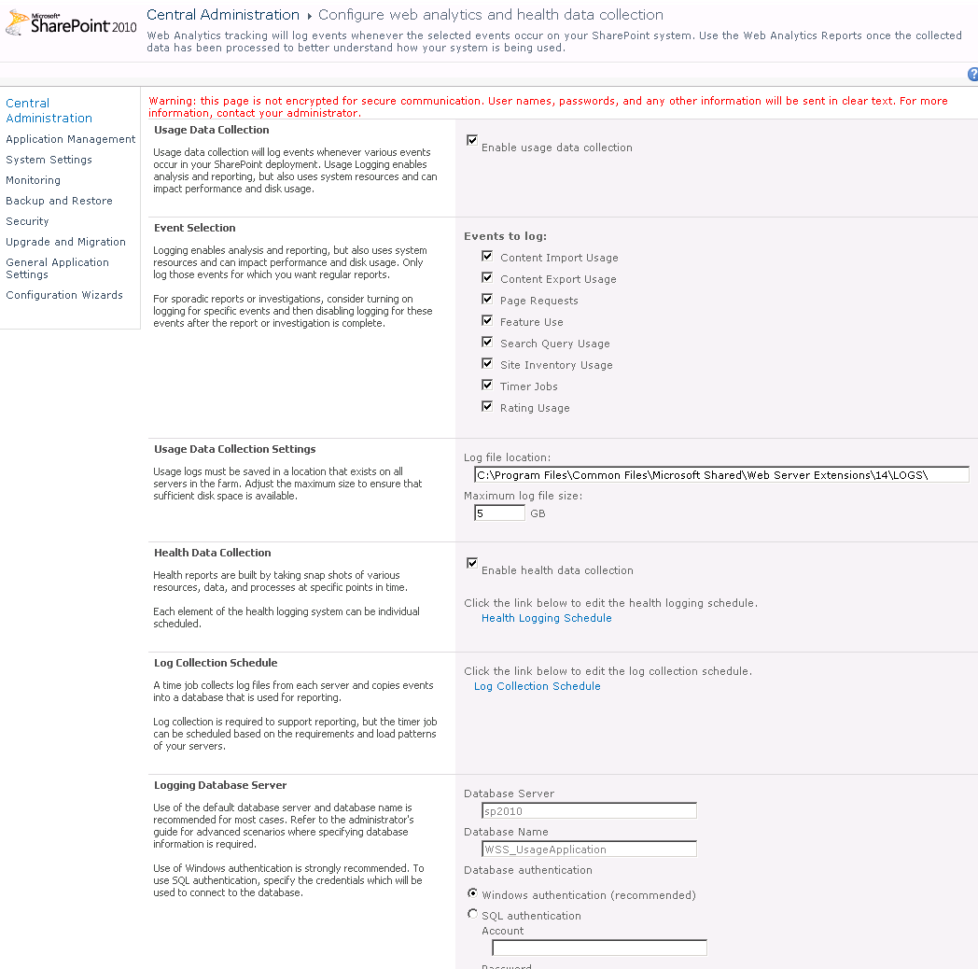

Web Analytics
The reports generated by the Web Analytics functionality in SharePoint provide detailed insight into how your SharePoint environment is being used, and how well it’s performing. Administrators should become familiar with these reports and how they can create their own (directly in the browser) to plan future capacity and to produce benchmarks to compare with future farm configurations.
All of these reports can be used to help you decide if the current architecture remains “fit for purpose”, meaning that it meets the desired service levels.
The reports are divided into three categories and can be reviewed based on Web Application, Site Collection, Site, and Search Service.

Traffic
The traffic reports help administrators answer questions like:
- How much traffic does my farm serve? (# of Page Views)
- Who visits the most often? (Top Visitors)
- How do visitors find your site? (Top Referrers)
In addition, it provides statistics about the “Daily Unique Visitors”, “Top Destinations,” and browsers used, among others. Reviewing the information presented in these reports would, for example, enable you to customize your navigation so that the most commonly accessed information is also the easiest to find.

Search
These reports are focused on helping an administrator understand how people are using search. It does this by answering questions like:
- How many searches are being performed? (# of queries)
- What were people mostly searching for? (Top queries)
- What queries are failing? (Failed queries)
In addition, it provides statistics about “Best Bets”, “Search Keywords,” and more. By using these reports you could, for example, review the most commonly used Search terms and then work with the appropriate people in the organization to match it to a new “Best Bet.” Adding the smarts of people to the smarts of SharePoint Search makes for the best possible search experience.

Inventory
Inventory reports tell administrators about usage, answering questions like:
- How much disk space is being consumed? (Disk usage)
- How many sites have been created? (# of sites)
- What languages are in use? (Languages Usage)
While these reports are useful for capacity planning, they can also help you understand how well your information architecture is performing. For example, John, an administrator at Contoso, is responsible for ensuring that the SharePoint environment remains “fit for purpose” as it grows. John can use these reports to not only understand the state of the environment today but also plot trends which enable him to increase the capacity of the SharePoint farm before it becomes a problem for end users.
Additional Resources
- View Web Analytics reports
Configuration (User Interface)
- In Central Administration, click Monitoring and in the Reporting section click View Web Analytics reports.
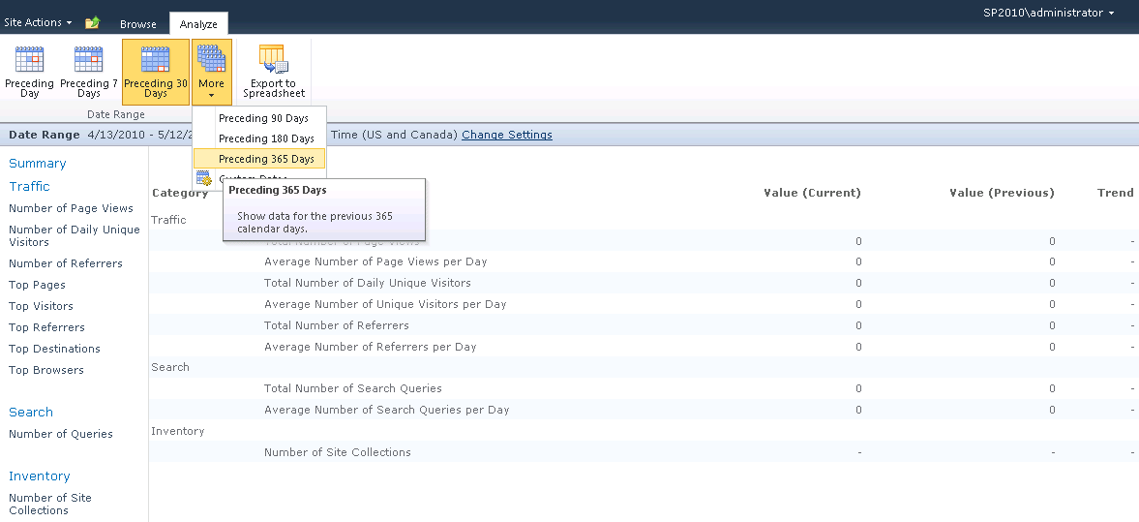

Health Analyzer
As described in the Usage Data and Health Data Collection section of this document, SharePoint Server has features that log and gather detailed statistics about all aspects of the SharePoint environment. The Health Analyzer uses this data to identify possible problems and then proactively researches and recommends solutions.
Many solutions that it finds will include a Repair Now link that users can click to automatically resolve the problem. Others will link to online help which is constantly updated with the latest advice.
Like the “Best Practices Analyzers” available for other products (like Microsoft Exchange), it includes a rule set which administrators can extend and which is continuously compared to the existing settings and metrics drawn from your production environment. Rules are applied across a number of categories, including security, performance, and availability.
Because some rules are not applicable to every environment, an administrator can disable or modify rules to accommodate the needs of an organization.
The following diagram illustrates the output that the Health Analyzer produces. You can see in the “Availability” category that the drives on server “SP2010” are at risk of running out of disk space.
In the security section you can see a recommendation concerning the permissions that are assigned to accounts that are used by application pools. By following the steps outlined in the solution, you’ll have a more secure farm.
Because the Health Analyzer uses a standard SharePoint list, standard functionality such as Alerts and RSS Feeds can be used to ensure that you are immediately notified of any issues and recommendations.
Additional Resources
- Overview of SharePoint Health Analyzer
- Viewing and resolving SharePoint Health Analyzer alerts
- SharePoint Health Analyzer rules reference
Configuration (User Interface)
- In Central Administration, click Monitoring and in the Health Analyzer section, click Review problems and solutions.
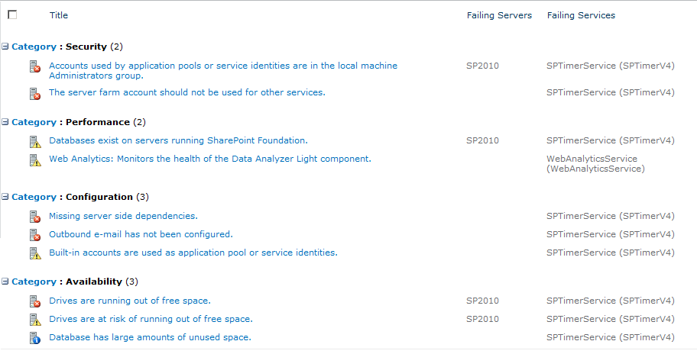

Timer Jobs
Timer Jobs perform tasks on a scheduled basis. For example, timer jobs process usage logs, import profile information from AD DS, and update the Activity Stream. By performing these tasks on a schedule, administrators can minimize the impact on the overall performance of the SharePoint environment. For example, timer jobs can be scheduled to run when SharePoint Server is experiencing its smallest load such as after business hours.
SharePoint 2010 introduces additional flexibility. When you add a new Content Database to a Web application you can nominate a preferred server for the execution of related timer jobs.

Releases and Upgrades
SharePoint administrators are responsible for ensuring that each server in a SharePoint farm is running an identical version of SharePoint Server. This includes service packs, hotfix rollups, and SQL Server database schema versions. Any inconsistencies can result in problems that are difficult to troubleshoot.
This was a challenging task in SharePoint Server 2007 because there was no simple way to determine exactly what version a particular server was running, and in turn, what was missing. With SharePoint Server 2010, administrators have the ability to “Check product and patch installation status”. This page provides a central location for monitoring the build, versions, and status of each component in your server farm.
Additional Resources
- Upgrade and Migration for SharePoint Server 2010
- Verify upgrade and review upgraded sites (SharePoint Server 2010)
Configuration (User Interface)
- In Central Administration, click Upgrade and Migration and then click Check product and patch installation status to check the status of the current farm and front-end servers.
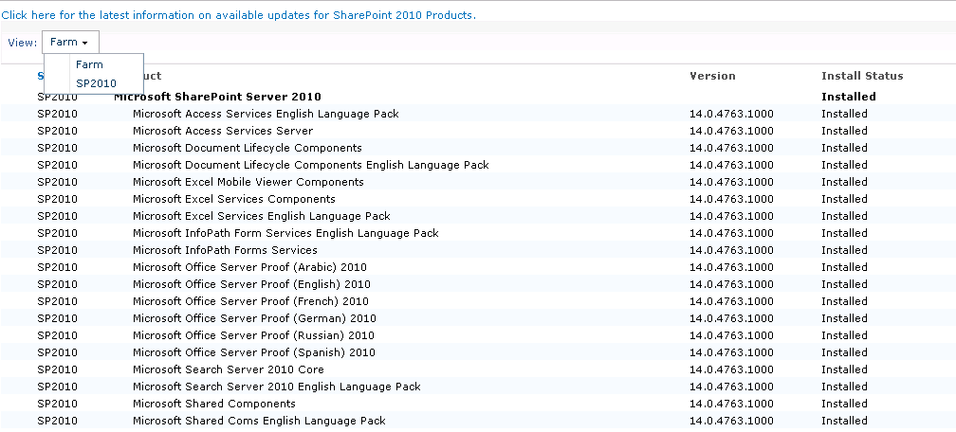
- To check on the databases of the database server, click on “Review database status”
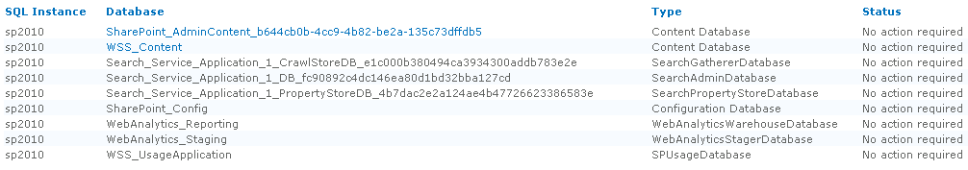

Backup
SharePoint Server offers a number of approaches to backup and restore. Each approach meets a specific requirement. This document will briefly review the three most common approaches:
- Central Administration Backup
- Scripted Backup
- SQL Database Backup

Central Administration
Central Administration includes two types of backup that can be performed and one type of restore.

Farm Backup and Restore
The “Farm Backup and Restore” functionality provides a way to perform unscheduled backup and restore of the entire farm or individual farm components. This screenshot illustrates the various components that can be selected for any one backup.
Although there are far too many items to describe individually in this document, the SharePoint 2010 Farm Backup is far more comprehensive than the SharePoint Server 2007 Farm Backup. It is however worth describing a couple important additions.

Solutions
SharePoint Server 2010 has the option to back up and restore any solutions that are installed on a farm. This overcomes a limitation in SharePoint Server 2007 which required administrators to store and track the specific version of any installed solutions independent of SharePoint Server.

InfoPath Forms Services
Similarly, it’s now possible to create a backup of the configuration of the Forms Services Service Application. This is important if you have administrator-approved forms and are using centrally managed data connection libraries. You no longer have to store and track those forms separately.

Granular backup
New to SharePoint Server 2010 is the ability to perform what is termed a “Granular Backup”. This functionality surfaces capabilities that were previously only available by using the stsadm command-line tool and supports the export of individual lists.
Note: This is a one-way operation. There is no support in Central Administration for restoring or importing from the packages created this way. This would need to be done by using the command line.

Recover from an unattached content database
A useful and powerful addition to the restore capabilities supported by SharePoint Server is the ability to recover data directly from an existing, unattached database. In this case, “unattached” means a Content database that is online in SQL Server, but which has not been attached to a SharePoint Web application.
This is ideally suited to the situation where you would like to restore the contents of a site collection without having to go through the steps of attaching it to a Web application. Its most commonly encountered when you want to restore an earlier version of a document from a previous database backup. By using this feature you can browse through the content of the database and choose to back up a site collection, site, list, or even a single document.

Configuration Settings
New in SharePoint 2010 is the ability to make a backup of the current configuration of various SharePoint components, such as Web applications. Although this has a number of advantages, following are three of the most significant:
- It enables you to test a new configuration, safe in the knowledge that you can roll back to a “Last Known Good” configuration if something doesn’t go according to plan.
- You can use the Configuration backup as a “Template” and restore it to a new environment which ensures the two have identical configurations. This is ideal for setting up development or test environments.
- Provides a way for you to document your configuration so that you have a benchmark for comparison later. This is useful when troubleshooting issues.

Scripted Backup
Scripts provide the greatest control and flexibility when it comes to backing up SharePoint Server. Most administrators prefer to write their own. The new and comprehensive support for Windows PowerShell in SharePoint Server 2010 makes it easy to use and powerful.
Backup procedures that can be completed in Central Administration can also be completed by using Windows PowerShell. This is beyond the scope of this document.

SQL Server Database
In many organizations, mature and disciplined processes already exist for backing up SQL Server databases. SharePoint Server can integrate with these existing processes, effectively “outsourcing” SharePoint content backup to SQL Server.
With that said, this backup is not comprehensive, and it’s recommended that you work together with your SQL Server administrators to ensure that gaps are filled with the use of standard SharePoint backup tools. It’s worth noting that an important “gap” includes the Remote BLOB Storage (RBS) functionality supported in SharePoint Serve 2010. If deployed, care should be taken to ensure this is part of your backup strategy.
Additional Resources
- Backup (SharePoint Server 2010)
- Backup: Stsadm operation (Office SharePoint Server)
- Back up a farm by using SQL Server tools
Configuration (User Interface)
- In Central Administration, click Backup and Restore
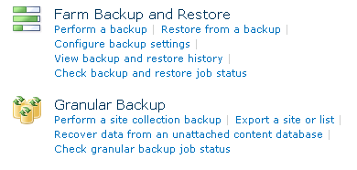
To back up the configuration settings of the farm, in the Farm Backup and Restore section, click Perform a backup, check the Farm checkbox, and then click Next On the next page you can select whether you want to back up content and configuration or only the configuration.
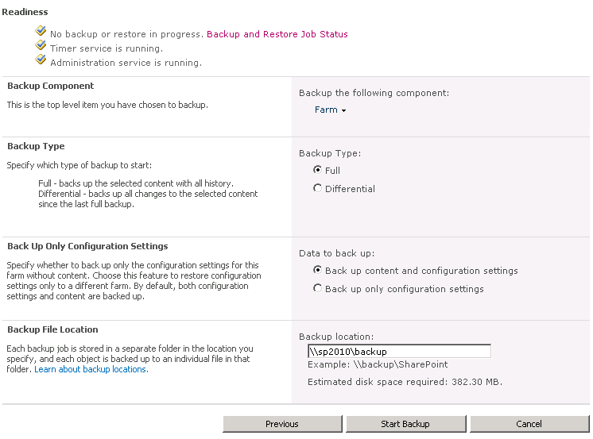

Web Application Controls
The following section describes the configuration options available to administrators and that operate on a per Web application basis.

Content Database Management
All site-based information in SharePoint Server is stored within a “Content Database” and a single Web application is able to support multiple content databases. Careful planning needs to go into the number of site collections that you will store in a single content database and the average size of those site collections (managed by using quotas). This simplified method will then give you an estimate of the maximum size of a content database, which in turn, is an important number to consider when planning your backup/restore strategy. However, proper planning and considerations are important to maintaining a scalable environment.
Additional Resources
- Storage and SQL Server capacity planning and configuration (SharePoint Server 2010)
- Database types and descriptions
- Database management
- Planning and Monitoring SQL Server Storage for Office SharePoint Server: Performance Recommendations and Best Practices (Whitepaper)
Configuration (User Interface)
- In Central Administration click Application Management, and in the Databases section, click Manage content databases.
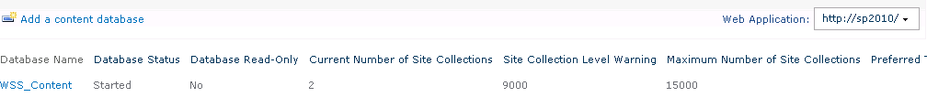

Supported / Blocked File Types
This functionality enables you to stop certain file types from being uploaded to SharePoint sites. The main reason for this functionality is to enforce security by blocking files which have commonly been exploited (for example .vbs and .bat).
Additional Resources
- Manage blocked file types
Configuration (User Interface)
- In Central Administration click Application Management, in the Web Applications section click Manage web applications, select a Web application, and then click the Web Application Blocked File Types icon in the Security group of the ribbon.
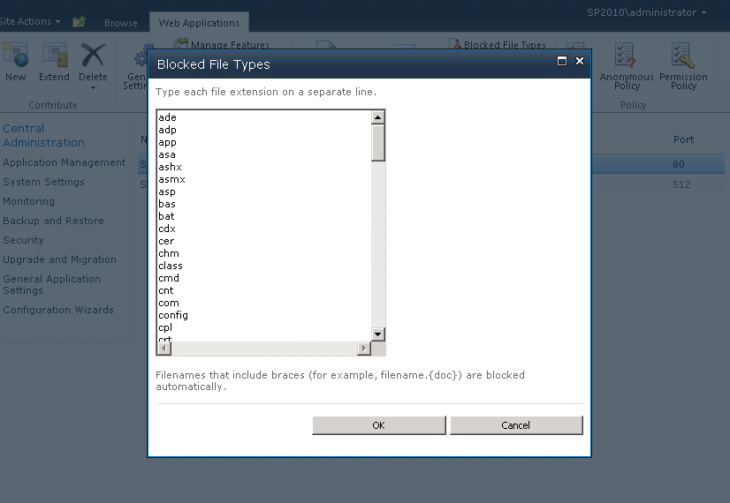

Security Policies
Policies provide a way to permit or deny access to specific user accounts throughout an entire Web application. For example, by default, the Content Access Account, which is used for crawling content, has Full Read access to all content in each Web application.
Policy can also be used to grant support personnel full access to the specific Web applications they are responsible for, without the need to give them administrative access to the farm. For example, John is an administrator at Contoso and works closely with the Collaboration support team on its Team Site deployment. To ensure the support team has the access it needs to help users, John has given the “SharePoint Support” group full control of the Web applications that host Contoso’ s team sites. By taking this approach, the support organization has access to only what it needs and with only the permissions that it needs. This ensures the security and safety of information that is stored in other Web applications that are hosted on the same SharePoint environment.
NOTE
Changing the membership of security policies will result in a security crawl of the environment. To help mitigate such occurrences, consider assigned permissions to groups as opposed to individuals.
Additional Resources
- Manage permission policies for a Web application
Configuration (User Interface)
- In Central Administration click Application Management, in the Web Application section click Manage web applications, select a Web application and in the Policy group of the ribbon click User Policy.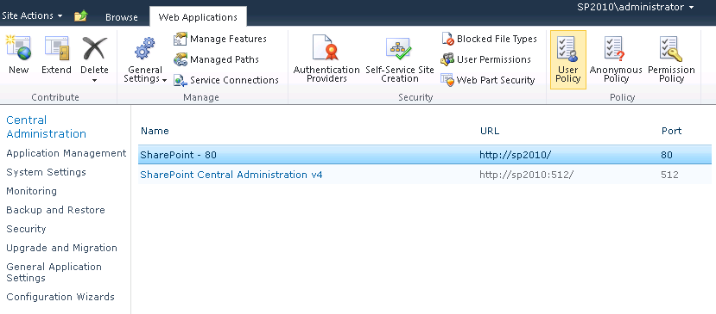

Resource Throttling
“HTTP Request Monitoring and Throttling” is a new feature in SharePoint Server 2010 that can be used to control resource utilization within your server farm (on one or more servers). It helps prevent a server from running out of required resources to serve existing jobs and high priority user requests.
It works by checking a set of performance counters on a server against a set of predefined thresholds. When a threshold is reached, which indicates that a server is under too much load, the feature begins to throttle GET requests.
SharePoint Server 2010 ships with the following HTTP Request Monitoring and Throttling defaults:
Performance Counter | Min | Max
Processor\% Processor Time | 0 | 99
Memory\Available Mbytes | 20 | 3.402823E+38
ASP.NET\Requests Queued | 0 | 500
ASP.NET\Request Wait Time | 0 | 30000

A server enters a throttled state after three successive checks have failed. A server remains in the throttled state until a successful interval has been completed.
Configuration (User Interface)
- In Central Administration click Application Management, click Manage web applications, select a Web Application, in the Manage group of the ribbon click General Settings, and then click Resource Throttling.
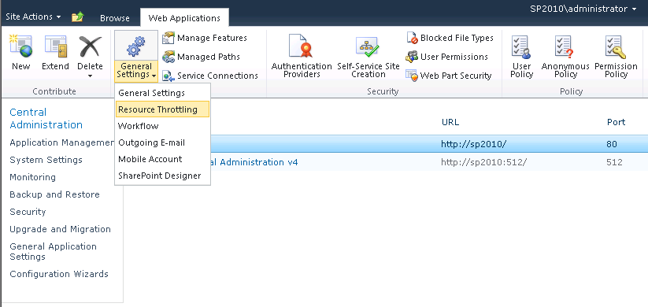

Application Pools
Application pools define the context in which a SharePoint Web application executes. It provides a security boundary and isolates the impact of issues that an application encounters from those running in other application pools. This makes the overall design and continued management of application pools critical to the security and reliability of SharePoint Server.
The following basic guidelines can help you to determine whether or not a Web application should have its own application pool.
- Should the content within the Web application be restricted to only a specific audience?
- Does the Web application host custom applications?
- How critical is the content served by the Web application? Is there a specific service-level agreement (SLA) in place?
- How much memory does your server have? How many application pools are in use?
To help you answer these questions the following sections provide more details about the security and reliability aspects of the design of application pools.

Security
An application pool runs under a specific Service Account which is referred to as the Application Pool Identity. This account has full rights to the information that is contained within the application pool and defines the highest possible privileges available to any executing code.
This is best demonstrated by the SPSecurity.RunWithElevatedPrivileges method in the SharePoint Object Model. This method enables solutions to temporarily impersonate the Application Pool Identity, which is used mostly to access external resources. Once elevated, code can access any information on the server that is secured by using the Application Pools Identity. If that identity were given farm administrator privileges, it would be able to do almost whatever it liked.

Reliability
If an issue is encountered that is specific to a particular application pool (that is, it’s not a farm or SQL Server issue), negative impact will be limited to only those Web applications that are running within the context of that application pool. Web applications that run in different application pools will, generally speaking, be unaffected.
Application pools also provide other capabilities which, when combined, aim to make a Web application, and the overall server it’s running on, more reliable. This includes ensuring there are limits on the amount of memory and CPU that the application pool can consume.
Additional Resources
- Managing Application Pools in IIS 7

Solutions and Features
Because SharePoint Server is a platform it has been designed to accommodate rich customization to meet specific business requirements. Part of the platform provides developers with a Solution Framework that defines how custom code should be packaged to take full advantage of everything SharePoint Server offers.
SharePoint Server 2010 has two types of solutions:
- Farm solutions. These are essentially identical to the solutions that Office SharePoint Server 2007 supported.
- Sandboxed solutions. This is a new type of solution that takes advantage of the new sandboxed execution model.

Farm Solution
Farm solutions are installed by administrators directly on the SharePoint farm itself. Solutions are made up of binaries and artefacts, which after being deployed, are placed in any of the following locations:
- Web Application BIN folder
- Global Assembly Cache (GAC)
- The Solution Hive
Farm solutions can take advantage of the full range of SharePoint customization options described in the SDK. Given this, it’s important that a strict governance process ensures that custom code adheres to a set of standards such as naming conventions, code standards and detailed testing.

Sandboxed Solutions
Sandboxed solutions operate within a single site collection and can be installed by site collection administrators. While they are packaged in a similar way to farm solutions, the artefacts and binaries are never installed physically on servers running SharePoint Server. They are instead hosted and executed with in a virtualized sandbox which ensures the following:
- It cannot run or execute any code considered unsafe.
- Any instability does not affect other applications, even those within the same application pool.
- It has access to only a limited subset of the SharePoint object model.
Although sandboxed solutions are limited in terms of their access to the server, SharePoint administrators will need to implement governance around the following key areas:
- The definitions of resource points that support the calculation of a solutions resource consumption
- The definition of resource quotas which determine the amount of resources that sandboxed solutions can consume in a given site collection
- The creation of “Solution Validators” which, during the upload of a new sandboxed solution, can check to confirm compliance to a set of standards.
Additional Resources
- Sandboxed solutions overview
- Sandboxed solutions administration
Configuration (User Interface)
- In Central Administration click System Settings and in the Farm Management section, click Manage user solutions.
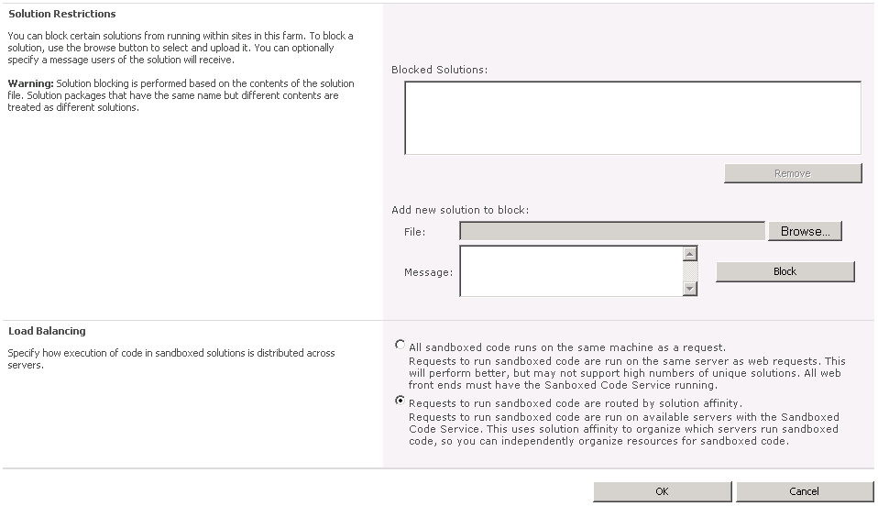

Search
When configuring the search service the following aspects need to be considered.

Index file location
Due to the significant disk traffic generated during crawls, SharePoint Search indexes should be on their own dedicated disks. In terms of disk space consumption, the rule of thumb is that you will need around 30% of the total corpus.

Content Sources
A content source defines one or more locations which contain content that is to be added to a SharePoint index and a schedule of when content should be crawled. Generally you should keep the number of content sources to the minimum required in order to meet your indexing requirements.
Content sources can now be assigned a priority, either “High” or “Normal.” Content sources set at the High priority are processed first. For example, Contoso has a relatively small team site which contains the most recent news about the company. Given the timeliness of the information, it’s important that these can be found in search as soon as possible. By creating a dedicated content source, setting it to index frequently, and giving it a High priority, it will be prioritised above the overall intranet indexing process.
Additional Resources
- Manage search topology
- Enterprise search administration
Configuration (User Interface)
- In Central Administration click General Application Settings, in the Search section click Farm Search Administration, click the name of the Search Service application, click on Content Sources on Quick Launch, and then edit the desired content source.
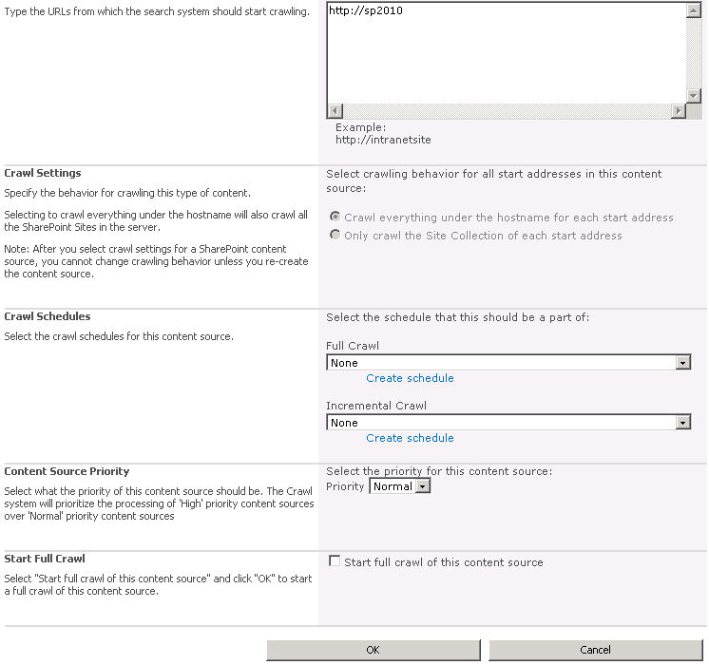

Customization
While business can benefit by allowing users to customize SharePoint Server, in many cases administrators would like the option to limit some types of customization.

SharePoint Designer
A number of restrictions on the use of Microsoft SharePoint Designer can be made on both a per Web application and per site collection basis. These are described below:
- Allow the use of SharePoint Designer.
- Allow users to detach pages from the original page layouts.
- Allow users to modify the master page and page layouts.
- Allow the management of the URL structure.
Note: If you allow users to modify the master page and page layouts, users can override the standard look and feel that you have implemented.
Additional Resources
- Enable or disable declarative workflows (SharePoint Server 2010)
- Getting Started with SharePoint Designer 2010
Configuration (User Interface)
- In Central Administration click Application Management, in the Web Applications section click Manage Web Applications, and select the Web Application that you want to configure. In the Manage group of the ribbon click General Settings, and then click SharePoint Designer.
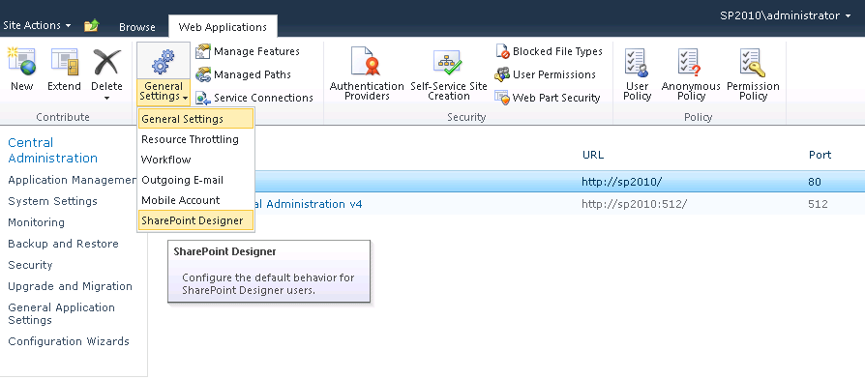

Branding
SharePoint Server provides different ways to approach the exercise of branding sites. This is beyond the scope of this document; however the following resources provide detailed guidance.

Themes
Theming provides the simplest way of customizing the look and feel of a SharePoint site. SharePoint Server ships with several standard themes and you can create and upload new ones by using Microsoft PowerPoint® 2010 in addition to other Office 2010 client applications.
In many cases, themes work against an organization's desire to have standard SharePoint site branding. In this case a SharePoint administrator can disable the theming functionality on a Web application basis by unchecking the Apply Themes and Borders permission.

Master Pages
SharePoint Server 2010 now allows Application Pages to reference a custom Master Page. This means that even pages located in the _Layouts folder and that are used by all sites in the farm can adopt a standardized look and feel. This functionality can be enabled per Web application by using General Settings.
Additional Resources
- Plan for using themes
- Page Layouts and Master Pages
- Master Pages
Configuration (User Interface)
- In Central Administration click Application Management, in the Web Applications section click Manage web applications and select the Web application that you want to configure. In the Manage group of the ribbon click General Settings, and then click General Settings.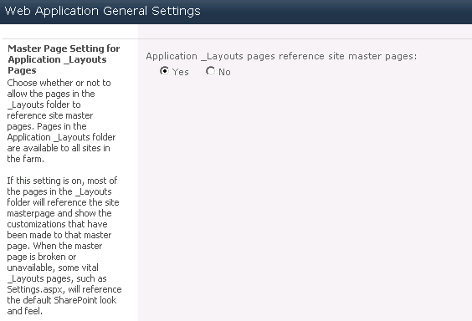
- To disallow the use of themes, in the Security group of the ribbon, click User Permissions.
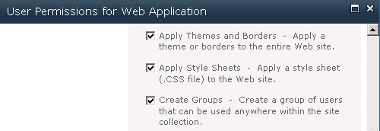

Site Controls
This section of the document highlights aspects of governance that apply directly to sites and site collections.

Security and Permissions

Access Requests
Access requests make it easy for people to request access to sites to which they are currently denied. Users simply click a Request Access link, which then generates an email message to the site administrator. This message includes a link to the site permissions, where, with just a single click, the user is granted access.

Quotas
Quotas are an important way of keeping your SharePoint environment under control. Quotas do this by placing an upper limit on resource consumption. The design and implementation of quotas is an important step and one that is more easily done at the outset before the usage of SharePoint sites have begun to grow.
Remember: The default values provide a good guide as to the levels SharePoint considers to be acceptable in terms of resource consumption, and care should be taken before increasing.

Quotas also play an important role in capacity planning by setting a fixed upper limit on resource consumption, which can then be increased over time and as the farm grows.

Storage Limit Quotas
Storage quotas are all about placing a restriction on the total amount of storage that a single site collection can consume. You can have any number of quotas with varying upper limits, and these can be applied to site collections at any time.

Resource Limit Quotas
Sandboxed solutions introduce the concept of “Resource Limit Quotas.” These govern the overall use of resources by sandboxed solutions within a single site collection on a daily basis. A Resource Limit Quota is made up of a number of points; each point maps back to a unit of resources. This complex topic is beyond the scope of this document; however the type of resources that it measures includes the following:
- Abnormal Process Termination Count
- Process CPU Cycles
- Process IO Bytes
- SharePoint Database Query Count
Just as with storage quotas, you can define multiple templates and apply them to site collections as required.

Resource Throttling
While we previously discussed Resource Throttling at the Web application level, it has also been introduced at the site collection level. The introduction of Resource Throttling is designed to allow SharePoint Server to more gracefully manage specific operations that are known to consume significant amounts of resource.
Large List Optimization
The most common example of a large list is a query that returns more than 5,000 items. Administrators now have tools that enable them to restrict the execution of these operations, whether executed as part of a custom solution or created by using the SharePoint UI. This includes the following:
- Maximum number of items a database query can involve at any one time.
- Maximum number of Lookup, Person/Group, or workflow status fields that a database query can involve at one time.
- Maximum number of unique permissions that a list can have at one time.
Additional Resources
- Create, edit, and delete quota templates
- Manage site collection storage limits
- Plan quota management
- Manage lists and libraries with many items
- Performance and capacity test results and recommendations (SharePoint Server 2010)
- SharePoint Server 2010 capacity management: software boundaries and limits
Configuration (User Interface)
- To manage quotas, in Central Administration click Application Management and in the Site Collections section, click on Specify quota templates. 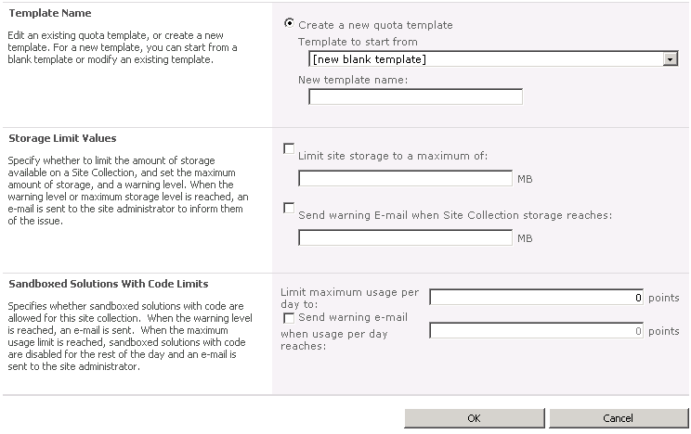
- To configure the Large List optimization, in Central Administration click Application Management, in the Web Applications section click Manage web applications, select the Web application that you want to configure. In the Manage group of the ribbon click General Settings, and then click Resource Throttling.
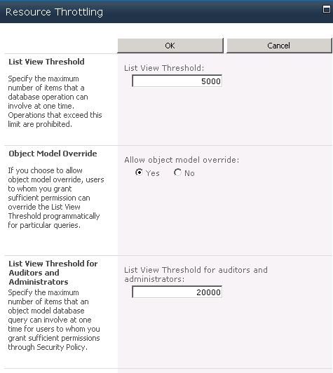

Lifecycle Management
Deleting information is as important as creating it. This section of the document explains just a few of the important elements that should be considered when you define your site lifecycle.

Site Deletion
SharePoint provides a “Site Use and Confirmation and Deletion” capability that enables you to set a policy that deletes site collections automatically after a certain period of time. This process always involves site administrators and provides them with an opportunity to override the deletion process. The actual configuration of site deletion is done on a per Web application basis.

Archiving / Site Backup and Restore
Unfortunately SharePoint Server doesn’t provide a standard mechanism for archiving sites before deletion. However, based on the strategy that you define as part of your site lifecycle, a custom solution can be built to meet your requirements by using the SharePoint API.
For example, a custom solution could check for collaboration sites that have not been used for more than six months and automatically back them up before deleting them from the collaboration Web application. Furthermore, sites could then be automatically restored to the archive Web application as read-only for users to recover documents that they may be missing.
Additional Resources
- Manage unused Web sites
Configuration (User Interface)
- In Central Administration click Application Management, in the Site Collections section click Confirm site use and deletion.
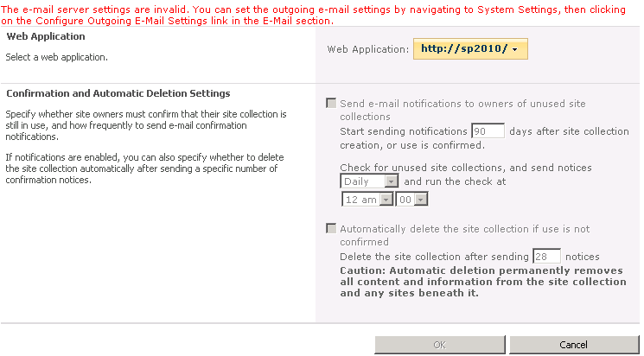

Auditing
Auditing adds a detailed layer of tracking operations that end-users perform on list items, documents, lists, document libraries, and Webs. This is typically done to ensure compliance with regulations or to protect secure or restricted information.
Auditing should be enabled only where needed. It comes with significant overhead. Not only does it increase processing that is required to track all actions of a user, but auditing also results in significant storage growth. The second issue can be managed by using functionality introduced with SharePoint 2010 called “Audit Trim Logging,” which trims the audit log to a more manageable size.

Provisioning and Self Service Site Creation
Self-service site creation is a powerful feature that makes it easy for users to create their own SharePoint sites without involving a SharePoint administrator. The feature is enabled on a per Web application basis, and once turned on, can be accessed by end-users via a URL (_layouts/scsignup.aspx).

Secondary Owner
When enabling self-service site creation you have the option to require a secondary owner. This option can make it easy to manage sites if employees leave an organization, in the process potentially leaving sites they own without a site administrator. An assigned secondary owner is someone who can reassign those permissions.

Managed Paths
You can use managed paths to create a logical distinction between site collections within a single Web application. By default SharePoint Server places all team sites under a Managed Path named “sites”, for example:
http://webapplication/sites/sitecollection
You can create a small number of managed paths. For example, if your organization wanted to create a number of employee blogs, it could create the “Blogs” managed path like so:
http://webapplication/blogs/sitecollection

Multi-Tenancy
SharePoint Server 2010 introduces a significant new set of capabilities that are designed to make it easier for organizations to partition and manage any number of customers on a single, common, SharePoint infrastructure. This is called “multi-tenancy”, which traditionally has been most commonly required by hosters, organizations that provide SharePoint as a service.
An expectation is that the new functionality in SharePoint Server 2010 might encourage more enterprise customers to utilize these capabilities to meet their business requirements and centralize IT costs. For example, it's easier to bill divisions within an organization based on their usage, offer new SharePoint properties faster, and manage fewer resources for offerings.
A full discussion of governance as it relates to multi-tenancy is outside the scope of this document. For more information, see Hosting Environments for SharePoint 2010 Products.

Conclusion
SharePoint Server 2010 provides a robust collection of capabilities that are designed to help meet an organization’s governance plans and features to support to its implementation. This document provides an overview of the capabilities that relate to governance and manageability. However, governance is an on-going process and should be a critical component of the overall lifecycle of a solution.

Additional Resources
Track or block SharePoint Server 2010 Installations

About the Author
Robin Meuré is a SharePoint Services MVP who works as a technical SharePoint consultant for Rapid Circle, the Dutch representative of zevenseas. He’s spent the last six years translating business requirements into SharePoint solutions across a broad range of industries. He is at his best brainstorming and implementing solutions that take a pragmatic approach to the cost effective delivery of SharePoint applications. Visit Robin’s blog at http://community.zevenseas.com/blogs/robin.
Daniel McPherson has been involved in SharePoint since attending the first public announcement of project “Tahoe” at the Microsoft Technical Briefing in January 1999. It has had a profound impact on his career, taking him to the doorstep of hundreds of companies, of all shapes and sizes, in a range of industries and in over 25 different countries. He’s worked on projects that create solutions, evaluate possibilities, deploy to tens of thousands of users, and had to fix problems when the sirens are sounding. After 10 years at Microsoft, spent mostly in Microsoft Consulting Services, he co-founded zevenseas (www.zevenseas.com), a boutique consultancy focused solely on the SharePoint platform, and is having more fun than ever before. He blogs at: http://community.zevenseas.com/blogs/daniel.
Bill Baer is a Technical Product Manager and Microsoft Certified Master for Office SharePoint Server 2007 in the SharePoint product group in Redmond, Washington. Bill was previously a Hewlett-Packard Technology Solutions Group MVP with a background in infrastructure engineering and enterprise deployments of SharePoint Products and Technologies. Bill Baer is active in the SharePoint community through evangelism (http://blogs.technet.com/wbaer), fellowship engagements, and events such as TechEd, TechReady, and SharePoint & Office Developer Conferences.

