Hands-On Lab

Code Discovery using the Architecture Tools in Visual Studio Enterprise 2015

Lab version: 14.0.23107.0
Last updated: 8/5/2015

TABLE OF CONTENT
Code Discovery using the Architecture Tools in Visual Studio Enterprise 2015 1
Overview 3
Prerequisites 3
Exercises 3
Exercise 1: Introduction to Dependency Graph Generation 3
Exercise 2: Introduction to Dependency Graph Navigation 10
Exercise 3: Working with Graph Nodes and Grouping 19

Overview
In this lab, you will learn how to generate and navigate dependency graphs with Visual Studio Enterprise 2015 in order better understand and communicate system architecture.

Prerequisites
In order to complete this lab, you will need the Visual Studio 2015 virtual machine provided by Microsoft. For more information on acquiring and using this virtual machine, please see this blog post.

Exercises
This hands-on lab includes the following exercises:
  - Introduction to Dependency Graph Generation
  - Introduction Dependency Graph Navigation
  - Working with Graph Nodes and Grouping

Estimated time to complete this lab: 30 minutes.

Exercise 1: Introduction to Dependency Graph Generation
In this exercise, you will learn how to generate a dependency graph that shows relationships between application assembly types (such as calls, inherits from, returns, and so on), as well as external assembly types.
  - Log in as Julia (VSALM\Julia). All user passwords are P2ssw0rd.
  - Launch Visual Studio 2015 from the taskbar and open Team Explorer.
  - Select the Connect to Team Projects button.
    - 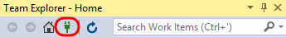
    - Figure 1
    - Connecting to a different team project

  - In Team Explorer – Connect, double-click on the Tailspin Toys project.
    - 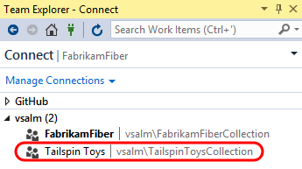
    - Figure 2
    - Loading the Tailspin Toys project

  - In Team Explorer – Home, double-click on the third TailspinToys solution (associated with the Main branch).
    - 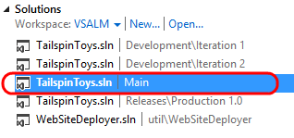
    - Figure 3
    - Loading Tailspin Toys solution

  - Rebuild the solution (Build | Rebuild Solution from the main menu). This step may take a few minutes to complete, and you can ignore any warnings.
  - The quickest way to get started is to generate a dependency graph for the entire solution. Create a new dependency graph (Architecture | Generate Code Map for Solution). The dependency graph is stored in a Directed Graph Markup Language format (hereafter referred to as DGML), which allows you to work with it using Visual Studio as well as other standard tools.
    - Note: Generating the dependency graph for all projects in the solution may initially take a minute to complete. When you generate a dependency graph for the first time, a code index is created for all the dependencies that are found, which helps improve the performance of subsequent operations.

    - 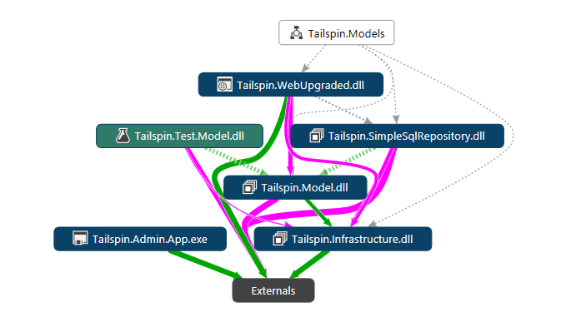
    - Figure 4
    - Dependency graph for entire solution

  - At this point, we only have a view of the dependencies between assemblies that are part of the solution and external assemblies. Lines of varying thicknesses represent the magnitude of relationship interdependencies between assemblies, with thicker lines equating to more relationships. Each assembly node shown can be dynamically expanded to show contained children, which we will explore during the next exercise.

    - Note: The generated dependency graph views that you see may be different from the screenshots shown in this lab manual. You may need to perform additional zooming, scrolling, and visually search for objects specified in the lab steps.

  - Color-coding for graph links make it easier to quickly understand the relationship between nodes. Click the Legend button to get an idea of what the link colors represent.
    - Figure 5
    - Legend button

    - 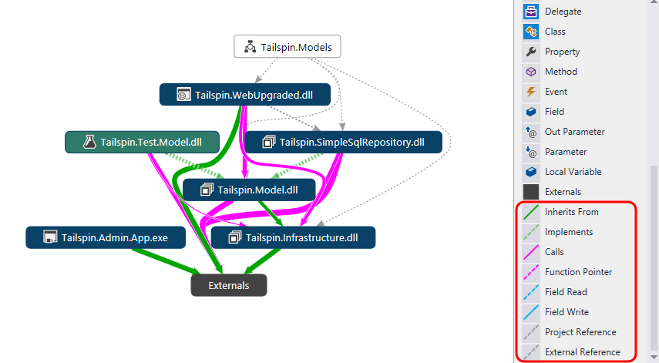
    - Figure 6
    - Legend showing link color meaning

  - Clear the current diagram by pressing Ctrl + A and then the Delete key.
  - You can also create a dependency graph with a narrower scope to start with by using Solution Explorer. This will allow you to select only those types or members that you want to see, and then create a new graph or add those items onto an existing graph.
  - Let’s say we are interested in looking at the dependencies and other relationships of the Product class within the Tailspin.Model project. Narrow the scope of Solution Explorer by right-clicking on the Tailspin.Model project node and selecting the Scope to This option.
    - 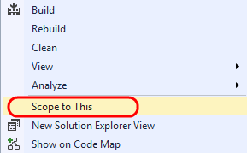
    - Figure 7
    - Scoping Solution Explorer to a specific project

  - In the Solution Explorer search box, enter “Product” to perform a search. This will quickly locate and highlight code that contains the search string.
    - 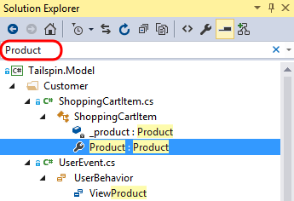
    - Figure 8
    - Searching for text found within solution types and members

  - Select the results of the search by clicking somewhere within the search results and then pressing Ctrl + A.
    - 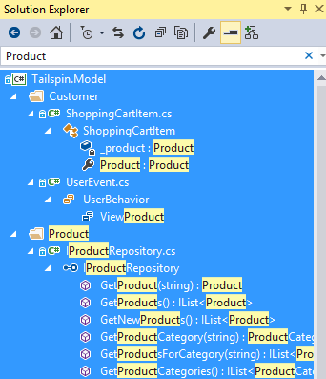
    - Figure 9
    - Selecting all search results

  - In the Solution Explorer toolbar, select the Show on Code Map button.
    - 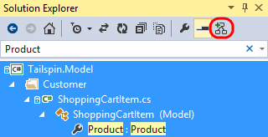
    - Figure 10
    - Adding selected types and methods from Solution Explorer to the active graph

  - The resulting graph shows the selected Product related classes, members, and their relationships to each other. Your graph may look slightly different.
    - 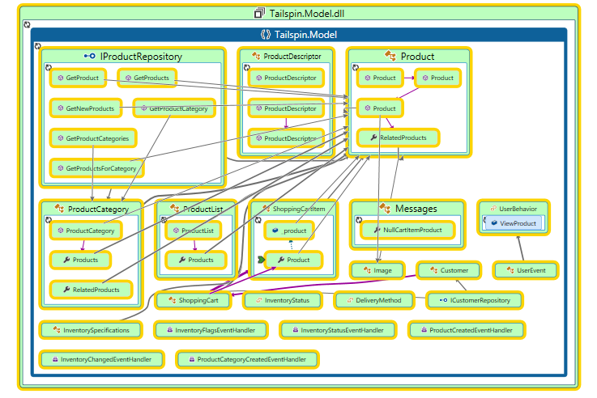
    - Figure 11
    - Graph showing selected types and members

    - Note: You can also drag and drop types and members from the Solution Explorer window to a graph.

  - Another method to generate or add to a dependency graph is to use the Object Browser, which provides fine-grained control over navigation and selection of types and members. Open Object Browser from the View menu.
    - 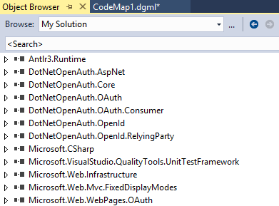
    - Figure 12
    - Object Browser initial view

  - Let’s say that we want to see how Product related types and methods from the Tailspin.Model project relate to the Tailspin.Web project. In Object Browser, search for “Tailspin.Web” (or simply scroll down to locate).
    - Figure 13
    - Searching for Tailspin namespace

  - Right-click on each namespace that begins with “Tailspin.Web” and then select the Show on Code Map option.
  - The result of merging the new types with the existing graph results in a view that provides some insight into how the web application relates to the Product-related classes from the Tailspin.Model project.
    - 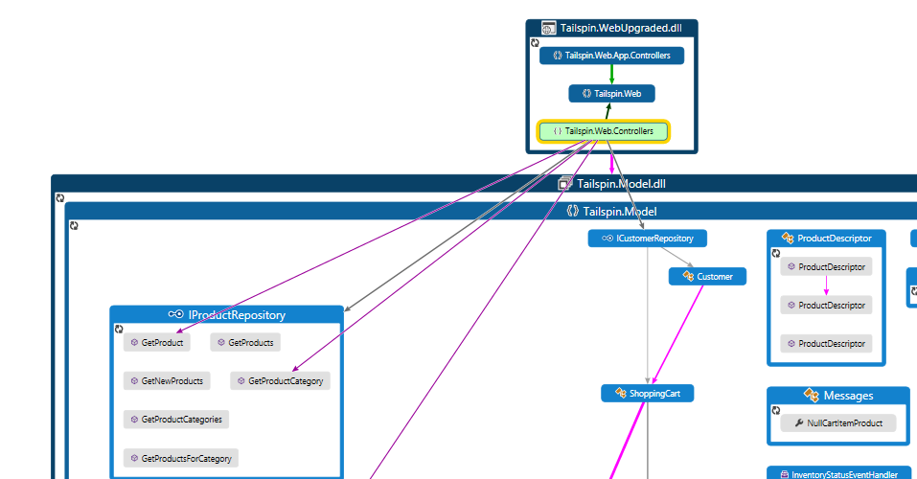
    - Figure 14
    - Partial graph view showing how selected entities relate

Exercise 2: Introduction to Dependency Graph Navigation
In this exercise, you will learn more about how to manipulate and navigate dependency graphs.
  - Starting with the graph that we produced during the last exercise, expand the Tailspin.Web.Controllers namespace and zoom in / pan as necessary to get a good view of the HomeController class node.
    - Note: Zoom using the buttons on the graph toolbar or by simply using the mouse scroll wheel. Pan with the mouse by dragging a blank portion of the graph.

  - Select the HomeController class node and hold the mouse cursor over the relationship lines until you find the one with a Target Node of IProductRepository. It may be useful to zoom in with the mouse scroll wheel.
    - 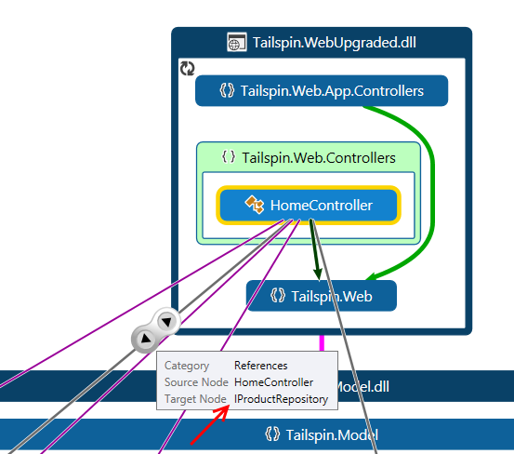
    - Figure 15
    - Browsing relationships between graph nodes

  - The navigation control that appears when hovering over a relationship line exposes two actions that allow you to navigate to either the source or target node. Click the arrow that points away from the HomeController class node to navigate to the IProductRepository.
    - 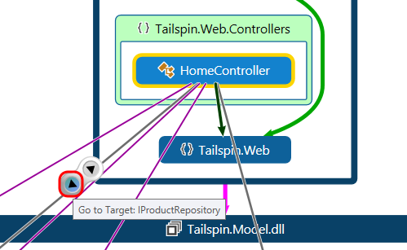
    - Figure 16
    - Navigating to another graph node

  - Use the Zoom To Fit button from the graph toolbar to fit everything to the visible screen.
    - Figure 17
    - Location of Zoom To Fit button

  - You should now be able to see how the HomeController class is related to the IProductRepository interface -- by calling GetProduct and GetProductCategory.
    - 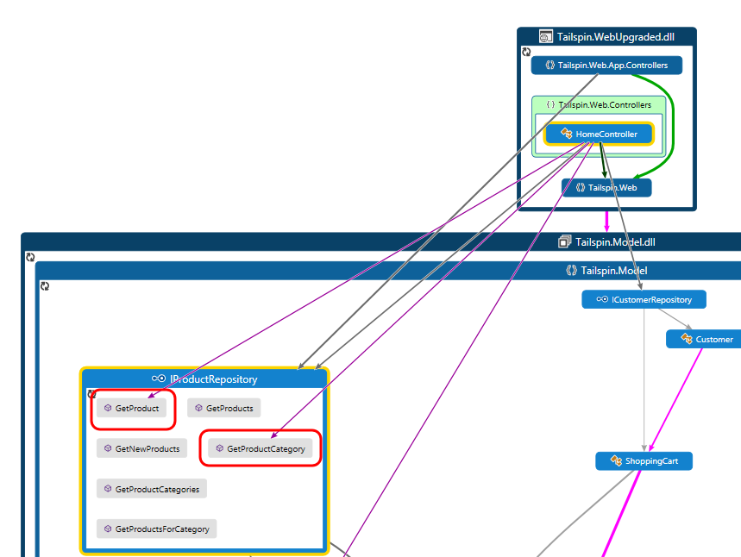
    - Figure 18
    - Dependency graph showing how HomeController class uses IProductRepository

  - You can also navigate from the graph directly to the associated code. Double-click on the HomeController node to load HomeController.cs in the code editor window.
    - 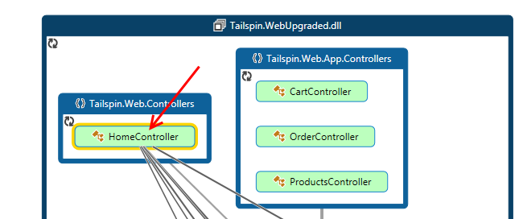
    - Figure 19
    - Navigating from graph to source

  - Here you can see exactly how the methods defined by the interface are being utilized in code.
    - 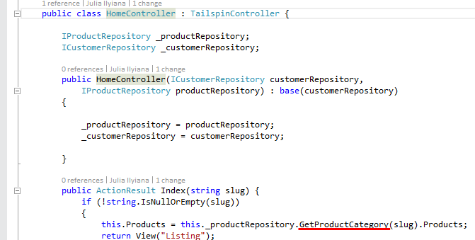
    - Figure 20
    - Code view for HomeController

  - You can also use the Code Map feature to help facilitate simultaneous navigation and visualization of code. Building upon existing functionality such as directed graphs, it allows you to navigate your source code and add selected classes, members, fields, and so on directly to a graph view. For example, right-click on the Index method within the HomeController class and select the Show on Code Map option from the context menu.
  - The default behavior when navigating to source is to place the dependency graph in a secondary tab group so that both the source code and graph are visible at the same time. This helps facilitate additional simultaneous navigation and visualization. Also, note that a green arrow pointer is shown next to the Index node in the graph view and that the Index method definition is highlighted in the source editor window.
    - 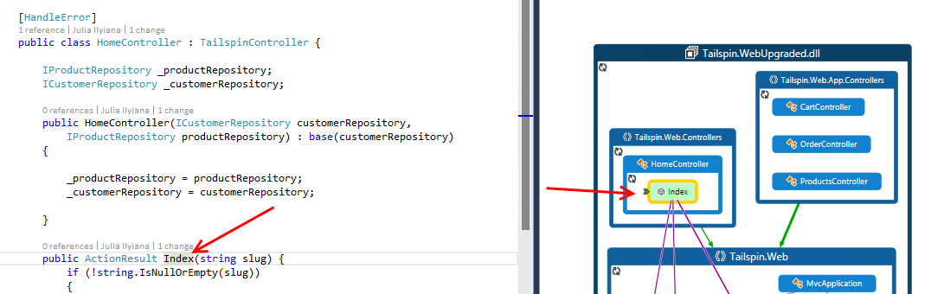
    - Figure 21
    - Code Map functionality in action

    - Note: When using the Code Map feature, it is beneficial to make both the graph and the source code visible at the same time by either using tab groups or by floating the graph view and placing it in its own window (if using a multi-monitor setup). Visual Studio automatically does this for you in some circumstances, but if you already have a directed graph open in the same tab group as the source file, they will remain in the same tab group.

  - Place the cursor on the line that defines the HomeController class once again and note that the Code Map feature also updates the graph view by showing a green arrow next to the HomeController node.
    - 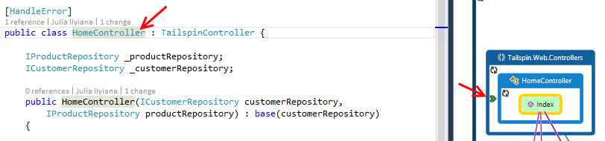
    - Figure 22
    - Code Map keeps code and graph view in sync

  - The Code Map feature also exposes a number of other visualization features through the code editor. Right-click on the Index method definition and select Show Related Items on Code Map | Show Methods This Calls. In a more complicated method, this would help show how a piece of code interacts with its own class, other architectural layers of the application, and external code.
    - 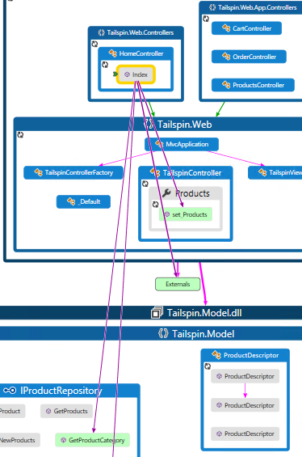
    - Figure 23
    - Graph showing methods called by Index method

  - Select Window | Close All Documents to clean up the view, selecting No when prompted to save changes.
  - Now let’s take a look at how we can navigate a graph to determine how we are using external assemblies. Generate a new dependency graph from Architecture | Generate Code Map for Solution.
  - Expand the Externals group to expose the external assemblies used by the Tailspin application.
    - 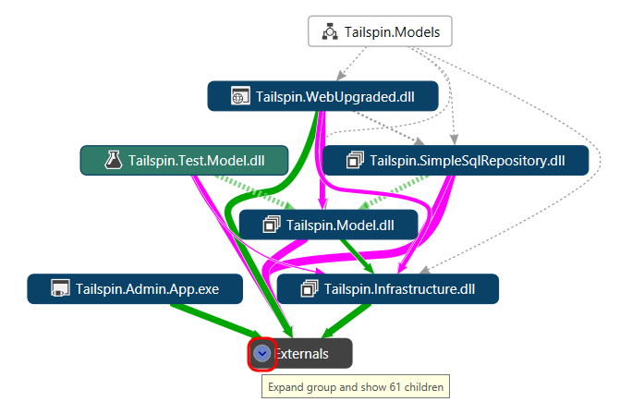
    - Figure 24
    - Expanding the Externals group

  - Zoom into and expand the System.Web.dll node within the Externals group so that you can see all of the used namespaces.
    - 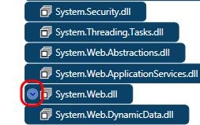
    - Figure 25
    - Expanding the System.Web.dll node

  - Find and expand the System.Web.Routing node to view the types contained within.
    - 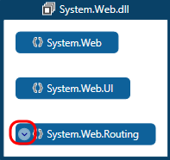
    - Figure 26
    - Expanding the Systm.Web.Routing node

  - Select the RouteTable class node to view its relationship lines.
    - 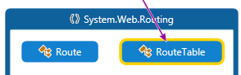
    - Figure 27
    - RouteTable class node showing incoming relationship

  - Find and select the relationship line with a Source Node of Tailspin.WebUpgraded.dll. We could simply use the arrow buttons to navigate to the source node as we did before, but this time let’s creating a new graph that just contains the relationships that we are currently interested in looking at. To create the new graph, shift-click the center + button.
    - 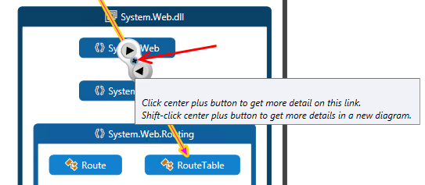
    - Figure 28
    - Creating a new graph showing selected relationship

  - In the resulting graph, we can see that the MvcApplication.Application_Start method calls the get_Routes method (actually the RouteTable.Routes property).
    - 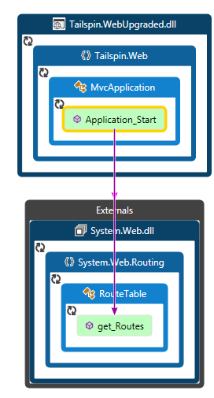
    - Figure 29
    - Graph showing selected relationship

  - Close the contributing links diagram (named ContributingLinks1.dgml) without saving changes.

Exercise 3: Working with Graph Nodes and Grouping
In this exercise, you will learn how to reduce dependency graph complexity by removing unwanted nodes, adjusting the grouping of nodes, and modifying graph node properties.
  - If continuing from the previous exercise, close the contributing links graph and return to the original dependency graph. Then right-click somewhere on the graph and select Group | Collapse All. If needed, you can regenerate the graph by selecting Architecture | Generate Code Map for Solution.
    - 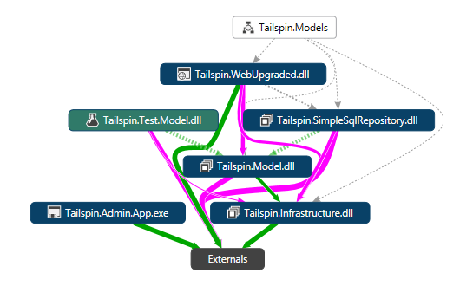
    - Figure 30
    - Dependency graph for entire solution

  - Expand the Externals node from the dependency graph to expose the external assemblies used by the Tailspin application.
    - 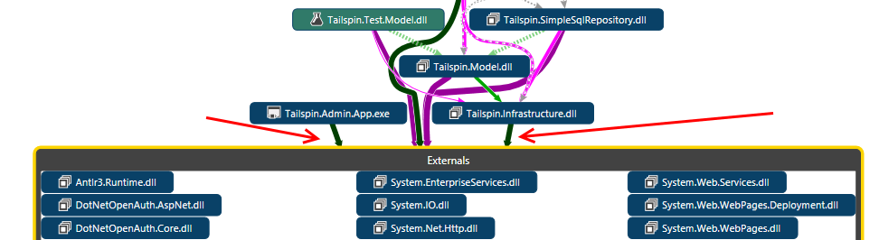
    - Figure 31
    - Expanded Externals group showing incoming relationships

    - Note: The relationship lines connected to the Externals group stop at the boundary of the group. The purpose of this is to reduce the visual complexity of the dependency graph. If you remove the Externals grouping, you will be able to see all the direct relationship lines between external and internal assemblies as well as more detail between assemblies currently grouped within Externals.

  - Select the mscorlib.dll assembly node and press the Delete key to remove it from the graph. The rationale behind removing this node, as well as many other commonly used external assemblies and types, might be that it adds too much noise to the graph and makes it difficult to navigate efficiently.
    - 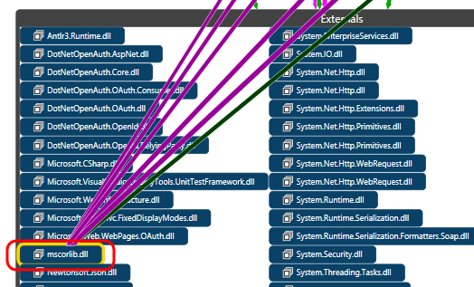
    - Figure 32
    - Removing a node from the graph

  - Select the Externals group, right-click and select Group | Remove Group. This will remove the grouping but not the graph nodes contained within.
    - 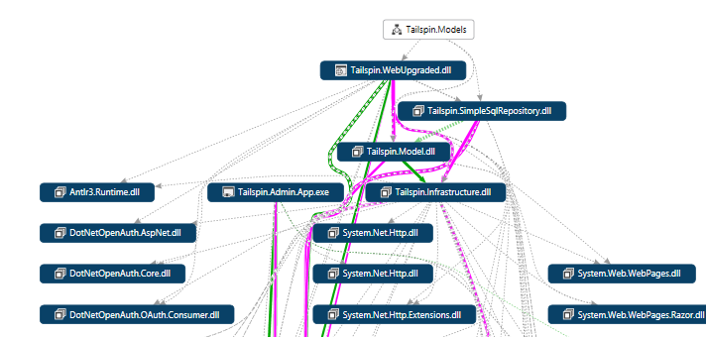
    - Figure 33
    - Partial view of dependency graph

  - Although the removal of the Externals group gives us a better idea of what is going on, it makes it difficult to distinguish between the application assemblies and those that were previously grouped as Externals. This can be fixed by adding a node property to give external assemblies a different color. Click the + button on the Legend panel and select Node Property | Is External.
    - Note: Select the Legend button from the graph toolbar if necessary.

    - 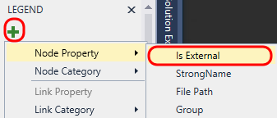
    - Figure 34
    - Creating a node property that targets IsExternal

  - The Is External node property is added to the Legend panel. Left-click on the gray box to the right of the Is External property and select the Background… option to load the Color Set Picker window.
    - 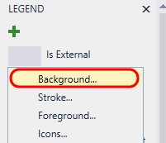
    - Figure 35
    - Modify the background color based on IsExternal property

  - In the Color Set Picker window, select the True drop down and pick the color red (or another color other than blue) and select the OK button.
    - 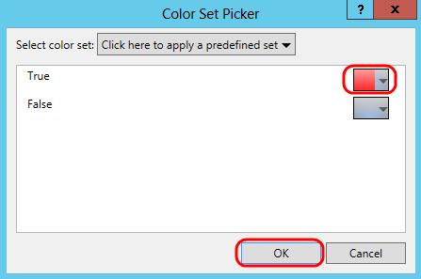
    - Figure 36
    - Select a different color for this property when it is True

    - 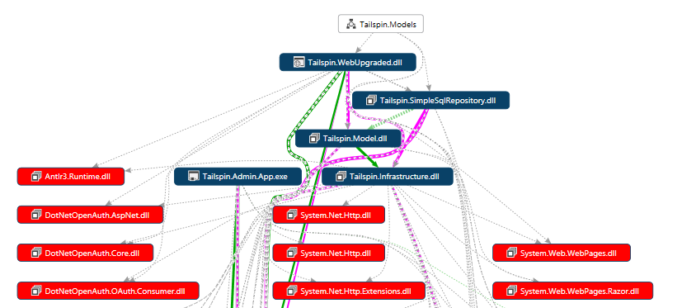
    - Figure 37
    - Dependency graph showing external assembly nodes in red

To give feedback please write to VSKitFdbk@Microsoft.com
Copyright © 2015 by Microsoft Corporation. All rights reserved.

