Using the Download Manager

General Operation
Accepting the Security  Certificate | Depending on the browser and platform you use, you may be asked to accept a security certificate the first time you use the Download Manager. If the web site has provided for alternative links to download files, you can still download the files—just not using the Download Manager – if you choose not to accept the certificate
List Window | When you use the Download Manager, you’ll see one of two windows when the download begins. You may see the List window:
 | 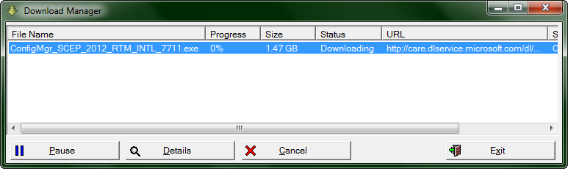
Downloading Multiple Files | This window lists all the current downloads. You can download multiple files at the same time, and you can select files in the list on which to take further actions.
Pause, Resume | You can select from the list of downloads to pause, resume from pause, or cancel the download. If you click Pause, the button changes to Resume.
Pause, Exit, Resume | If you exit, the download manager will place an icon on your desktop that allows you to resume the download later. You can resume the download at any point later, even after you turn the computer off and on.  If the file changed at the download site, you’ll be informed of that by a message when you resume download. When you resume, your default browser—the application associated with HTML files—is used. You can override use of the default browser, if desired, by using the “Open with” operating system functionality (for example, in Windows, right-click the file and select Open With).  If you started the download with Browser B, you’ll want to pick it up and complete it with Browser B.
Remove, Delete | If you select a completed download in the list, you’ll see a Remove button. This button removes the file from the list. If you click it, you’ll also be asked if you want to Delete the file from your target disk.
Summary Window | If you click the Detail button, you’ll see the Summary window. You may see this window when the download begins, depending on how the Web site set things up.
 | 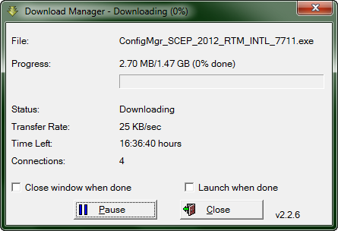
Launch, or Close Window When Done | You can pause and resume downloading using the Summary window. If you check  the Launch When Done box, the Download Manager will attempt, once the download is completed, to launch or open the file with its associated application. Check the Close box to close this window once the download completes.

Tips and Tricks
- If you have previously downloaded files using the Download Manager (DLM), it is sometimes helpful to remove them before starting a new download (remove, deleted section above)
- If you close the DLM in the middle of a session, this will pause the download, and place an icon on your desktop. To resume your download, click the icon.

- If you have completed a download and the icon still sits on your desktop, click a blank spot of your desktop and press F5 (refresh). This should clear it from the desktop.

