Organize and configure a sharePoint library
There are several ways to organize and manage your SharePoint libraries. This intermediate course teaches you how to create and use folders, sort and filter with columns, create custom views of items in the library, and how to restrict access to a library.

Create folders in a library
- Navigate to the library you want to create a folder in.
- On the Files tab, choose New Folder.
- Enter a name for the folder and choose Save.
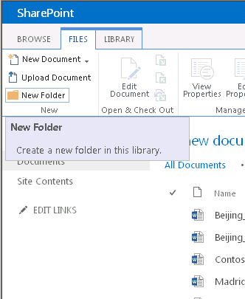
Add columns to a library
- Navigate to the library you want to add columns to.
- On the Library tab, choose Library Settings.
- Scroll down to the Columns section and choose Add from existing site columns.
- Under Available site columns, choose and add the columns you want in your library, and then choose OK.
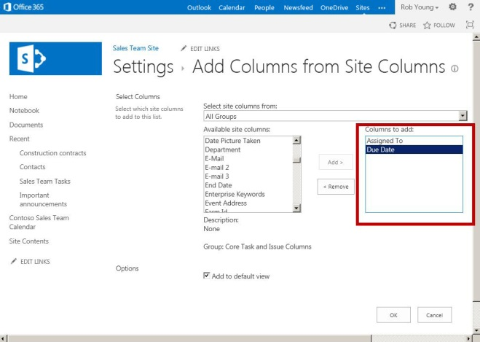

Create a custom view of items in your library
- Navigate to the library you want to create a view for
- On the Library tab, choose Create View.
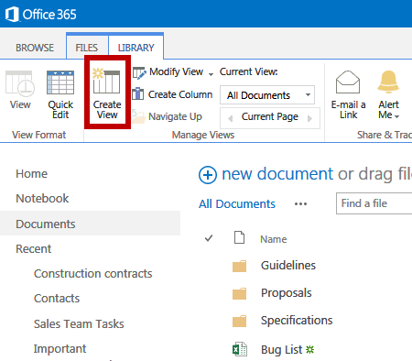
- If you want to start from an existing view, choose the view under Start from an existing view.
- On the Settings page, type a name for the view.
- Choose Create a Personal View in the Audience section if you don’t want others to use this view.
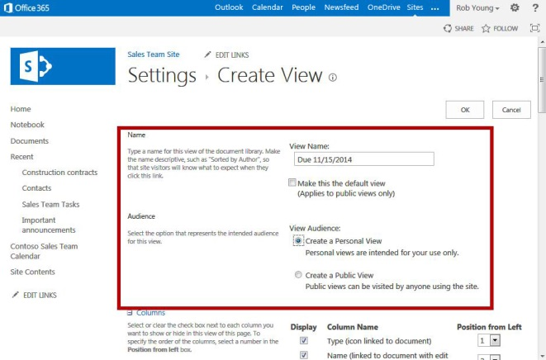
Create a custom view of items in your library (cont.)
- Under the Filter section, choose Show items only when the following is true.
- In the field drop down box, select the column you want to add, Due Date for example.
- In the next field, choose a condition such as is equal to, for example.
- In the next field, enter a date you will later filter by, such as 11/15/2014, for example.
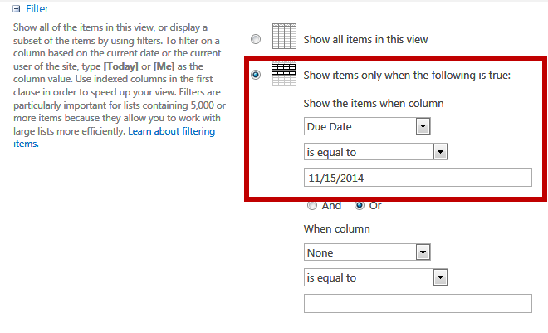
- Finally, in the Folders section of the page, choose Show all items without folders. This option enables you to look at files across folders in a library.
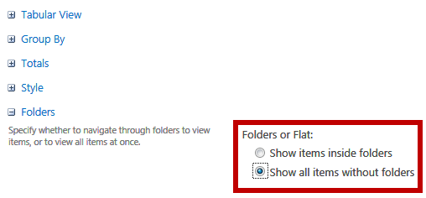
- Choose OK. The new view appears displaying all files having 11/15/2014 under the Due Date column, regardless of what folder they are in.
CONTROL WHO HAS ACCESS TO YOUR SHAREPOINT LIBRARY
- Navigate to the library you want to share with colleagues.
- On the Library tab of the ribbon, choose Library Settings.
- On the Settings page choose the Permissions for this document library link.
- If the library inherits permissions from a parent site, choose Stop Inheriting Permissions on the Permissions tab.
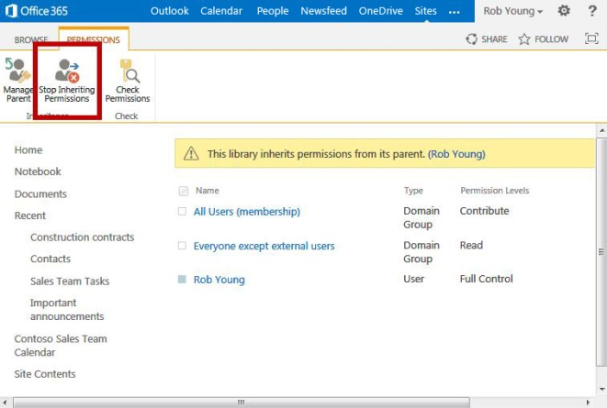
- Click OK on the message that appears.
- In the Share dialog box, type the names or email addresses of those who will have access to the library.
- Optional: Add a short message to tell them about the library, and then select Share.
- To remove permissions that existed before you stopped inheriting permissions, select those groups or users and then choose Remove User Permissions.
IMPORTANT: Make sure you have permissions to your own library.
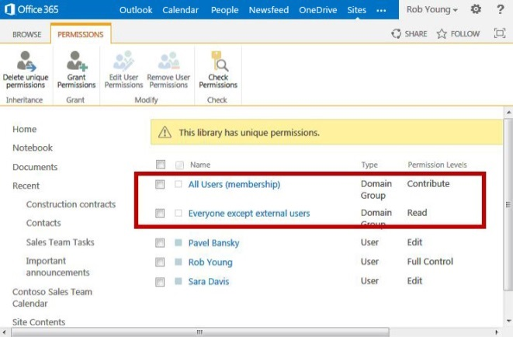
- Now, only the people that you added in the Share dialog have access to the documents in the library.
SEE ALSO:
- Sync OneDrive for Business or SharePoint site libraries to your computer
http://office.microsoft.com/en-us/support/sync-a-library-to-your-computer-HA102832401.aspx
- Manage lists and libraries with many items
http://office.microsoft.com/en-us/office365-sharepoint-online-enterprise-help/manage-lists-and-libraries-with-many-items-HA101967267.aspx?CTT=1

