FOLLOW A DOCUMENT OR WEBSITE IN YOUR ORGANIZATION
Follow a document to see notifications in your newsfeed when someone updates the document or shares it with others, and to keep the document handy in a followed documents list. Follow a site to keep it accessible in a list of followed sites and to see site feed activity in your own newsfeed.
Note that the capabilities described here depend on whether your organization has set up and customized personal sites and profiles.

FOLLOW A DOCUMENT
Before you can follow a document, you need permission to access it. You’re granted this permission when another person shares the document with you. Typically, you can follow documents in a Shared with Everyone folder.
To follow a document:
- Browse to a document library on a SharePoint or Office 365 team site.
To browse to your personal library, click OneDrive in the header.
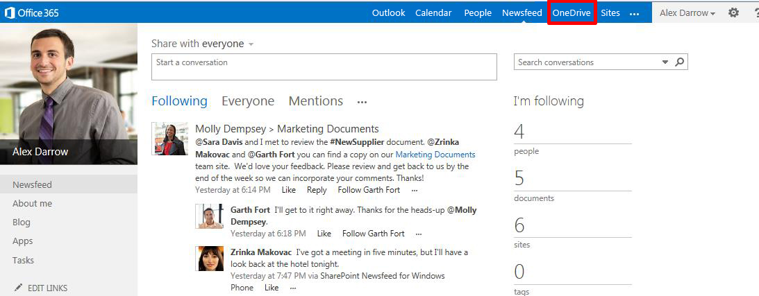
- Click the library or folder that contains the document or other file you want to follow.
- Click the ellipses (…) next to the document.
- Click Follow.
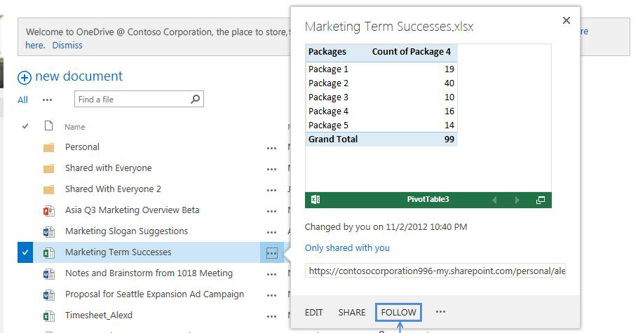

FIND A DOCUMENT THAT YOU FOLLOW
- Click OneDrive in the header from a SharePoint or Office 365 site.
- Click Followed Documents in the Quick launch on the left.
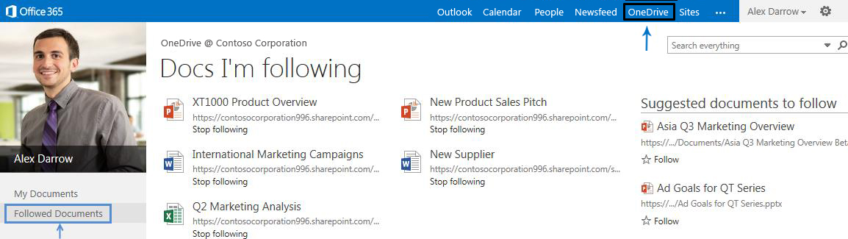
Or, click Newsfeed in the header and then click the number for documents under I’m following.
Your followed documents appear under Docs I’m following.
FOLLOW A WEBSITE
- Go to a SharePoint site that you want to follow.
- Click Follow in the top right of the page.
- If the site has a newsfeed, to stay up to date with site news, look for updates from the site feed in your own newsfeed.
FIND A WEB SITE THAT YOU FOLLOW
- Click Sites in the header.
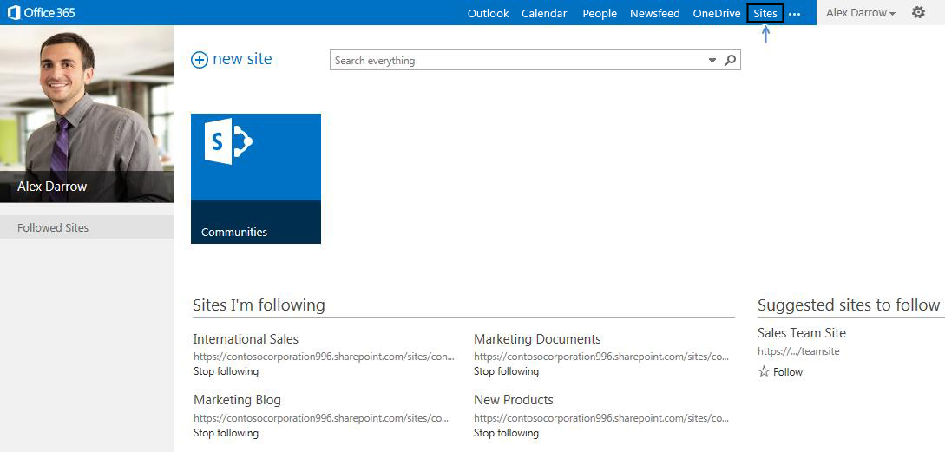
Or, click Newsfeed in the header and then click the number for sites under I'm following.
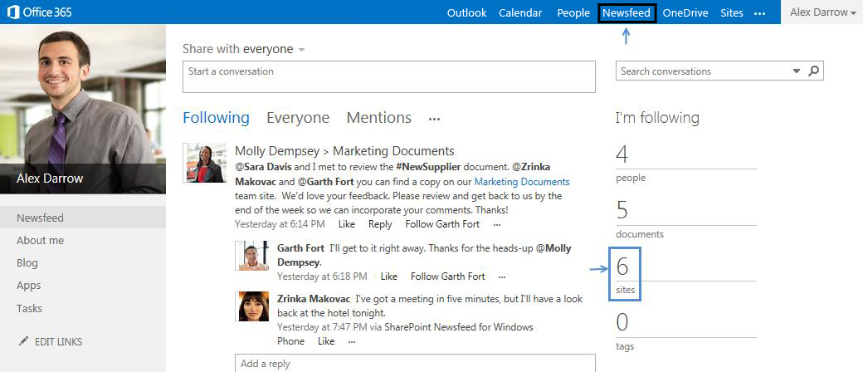
Your followed sites appear under Sites I’m following.

SEE ALSO:
- Follow documents to track them
http://office.microsoft.com/en-us/office365-sharepoint-online-small-business-help/follow-documents-to-track-them-HA102785928.aspx
- Follow sites that interest you
http://office.microsoft.com/en-us/office365-sharepoint-online-enterprise-help/follow-sites-that-interest-you-HA102785930.aspx?CTT=1
- Video: Follow documents
http://office.microsoft.com/en-us/redir/VA102897380.aspx
- Video: Follow a SharePoint site
http://office.microsoft.com/en-us/redir/VA102897383.aspx

