Post to the newsfeed

Start conversations with people in your organization by posting to a newsfeed, either on your personal site, or in team site newsfeeds.

Create a simple post
- Click in the Start a conversation box.
- Type your message.
- Click Post.

Add a picture to a post
- Click in the Start a conversation box.
- Type a message (optional).
- Click the camera button.
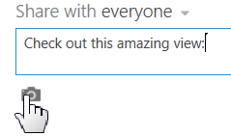
- Browse to the picture you want and click Open.
- Click Upload.

Add a link to a document to a post
- Go to the SharePoint library that has the document.
- Click the ellipses menu to open the document callout.
- Copy the document URL.
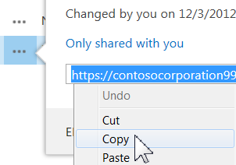
- Click Newsfeed at the top of the page (or go to the team site newsfeed you want).
- Click in the Start a conversation box.
- Right-click and paste in the document URL.
- Click in the Display As box, type the words you want to appear as the document link, and click the check mark.
- Click Post.
Add a weblink to a post
- Go to the web page you want to link to.
- Copy the web page URL.
- Click Newsfeed at the top of the page (or go to the team site newsfeed you want).
- Click in the Start a conversation box.
- Right-click and paste in the web page URL.
- Click in the Display As box, type the words you want to appear as the weblink text, and click the check mark.
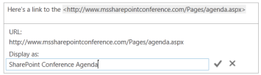
- Click Post.
Add a video to a post
Use the same procedure as described above for “Add a weblink to a post.”

Mention someone in a post
- Click in the Start a conversation box.
- Type a @ character.
- Start typing the name of the person you want to mention.
- Select the name if you see it in the list.
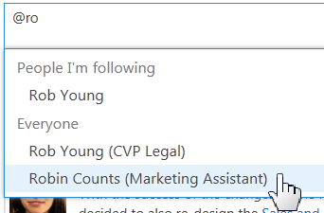
- Finish the post and then click Post.
Add a hashtag to a post
- Click in the Start a conversation box.
- Type a # character.
- Start typing the tag you want to add.
- If available, select an existing tag from the list.
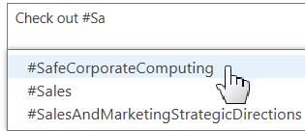
- Finish the post and then click Post.

SEE ALSO:
- Post something to everyone
http://office.microsoft.com/redir/HA102785948.aspx
- Add features to a newsfeed post
http://office.microsoft.com/redir/HA10278575.aspx
- Follow tags to get information about topics that interest you
http://office.microsoft.com/redir/HA102785925.aspx
- Follow people to keep track of their activities
http://office.microsoft.com/redir/HA102785944.aspx
- What items appear in your newsfeed
http://office.microsoft.com/redir/HA102785941.aspx

