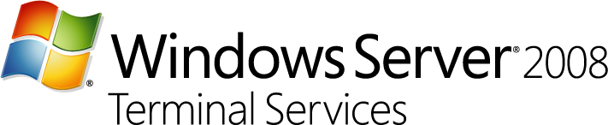

Servicing Branch Offices with Terminal Services

Abstract:
Windows Server 2008 Terminal Services helps you provide applications to the branch office through centralized servers that minimize most management difficulties without limiting overall performance and autonomy of the remote location. This document discusses Windows Server 2008 Terminal Services and how it can deliver a cost-effective solution for delivering applications to branch offices.
Document Published: January, 2008

Disclaimer

The information contained in this document represents the current view of Microsoft Corporation on the issues discussed as of the date of publication. Because Microsoft must respond to changing market conditions, it should not be interpreted to be a commitment on the part of Microsoft, and Microsoft cannot guarantee the accuracy of any information presented after the date of publication.

This White Paper is for informational purposes only. MICROSOFT MAKES NO WARRANTIES, EXPRESS, IMPLIED OR STATUTORY, AS TO THE INFORMATION IN THIS DOCUMENT.

Complying with all applicable copyright laws is the responsibility of the user. Without limiting the rights under copyright, no part of this document may be reproduced, stored in or introduced into a retrieval system, or transmitted in any form or by any means (electronic, mechanical, photocopying, recording, or otherwise), or for any purpose, without the express written permission of Microsoft Corporation.

Microsoft may have patents, patent applications, trademarks, copyrights, or other intellectual property rights covering subject matter in this document. Except as expressly provided in any written license agreement from Microsoft, the furnishing of this document does not give you any license to these patents, trademarks, copyrights, or other intellectual property.

©2008 Microsoft Corporation. All rights reserved.

Microsoft, SharePoint, Windows, Windows Server, and Windows Vista are either registered trademarks or trademarks of Microsoft Corporation in the United States and/or other countries.

The names of actual companies and products mentioned herein may be the trademarks of their respective owners.

Introduction

For many businesses, maintaining dispersed branch offices generates significant operational costs and administrative challenges. Although businesses are well-aware of these issues, they are often constrained by one simple prerequisite—distributed networks. Managing a distributed network and supporting branch offices can be a daunting task for most IT departments. Branch workers need applications and systems that are secure and available. Updates need to be more easily managed and compliant. With limited local IT support and limited network bandwidth in the branch office scenario, IT professionals need solutions that are strategic, yet cost-effective.
That’s where Terminal Services steps in to help bridge the gap between IT Pros and the branch offices they support.
Windows Server® 2008 Terminal Services uses presentation virtualization to make it possible to run an application in one location but control it in another. Terminal Services helps you provide services to the branch office through centralized servers that minimize most management difficulties without limiting overall performance and autonomy of the remote location.

Benefits for Branch Infrastructure

Organizations that are daunted by the complexity of an application rollouts to their branch environments will benefit from Windows Server 2008 Terminal Services. Providing access to applications via Terminal Services accelerates deployment. The same is true of organizations who not able or willing to re-write applications for delivery over the Web. Terminal Services allows organizations to make existing applications “Web-enabled” for branch or remote employees. Terminal Services provides centralized access to individual applications that are integrated with the local user’s desktop—looking, feeling, and behaving like local applications. Organizations can provide more secure access to centralized applications or desktops, and other resources from the Internet, by using HTTPS, without needing to provide access via a Virtual Private Network (VPN) or opening up unwanted ports on firewalls. This reduces the complexity needed to provide secure remote access to applications and data for users in branch offices or other remote locations.
By using Terminal Services, you can improve the branch office users' experience without significant increases with the setup and maintenance costs—and without adding to the complexity of IT tasks in a distributed environment.
Terminal Services features in Windows Server 2008 enable you to reduce application management at the branch and centrally manage applications—helping you to lessen the burden of local support tasks in branch offices.
- Application deployment and maintenance can be greatly accelerated and on-going management simplified. Instead of updating applications on each individual desktop, only the single shared copy on the server needs to be installed initially and updated/patched.
- Optimize the broadband or WAN connection between the branch office and the enterprise data center improving employee efficiency.
- With Terminal Services, new applications can be deployed to a wide variety of clients, including clients on which the new application is not able to run natively. PC hardware upgrades aren’t required to deploy new applications.
- Since applications are not installed locally, Terminal Services enables more streamlined desktop OS images on PCs, accelerating your organizations ability to adopt new operating systems such as Windows Vista® , which can lower management costs.
- Deliver application to branch users via a secure Web page or the corporate portal, such as one running on Microsoft Office SharePoint® Portal Server, without installing applications on every PC in the branch.
With Terminal Services, your employees will see a consistent set of applications, and can access their own data regardless of location.

How Windows Server 2008 Can Help

For Windows Server 2008, Terminal Services includes new features and functionality that enables simplified IT management while enhancing the end-user experience when connecting remotely to a Windows Server 2008 terminal server. The user experiences is the same “in-office” experience you deliver at your headquarters—even with limited branch IT support and minimal network bandwidth.

Terminal Services RemoteApp
Users can access RemoteApp™ programs over an Internet connection through a VPN, or you can deploy Terminal Services RemoteApp (TS RemoteApp) together with Terminal Services Gateway (TS Gateway) to help secure remote access to the programs. Figure 1 is the RemoteApp Manager interface for deploying RemoteApp applications.
RemoteApp programs are accessed remotely through Terminal Services. Instead of being presented to the user in the desktop of the remote terminal server, the RemoteApp program is integrated with the client's desktop, running in its own resizable window with its own entry in the taskbar (Figure 2). Users can run RemoteApp programs side-by-side with their local programs. If a user is running more than one RemoteApp program on the same terminal server, the RemoteApp programs will share the same Terminal Services session.
In Windows Server 2008, users can access RemoteApp programs in several ways, depending on the deployment method that you choose. They can:
- Access a link to the program on a Web site by using TS Web Access.
- Double-click a Remote Desktop Protocol (.rdp) file that has been created and distributed by their administrator.
- Double-click a program icon on their desktop or Start menu that has been created and distributed by their administrator with a Windows Installer (.msi) package.
- Double-click a file where the file name extension is associated with a RemoteApp program. This can be configured by their administrator with a Windows Installer package.

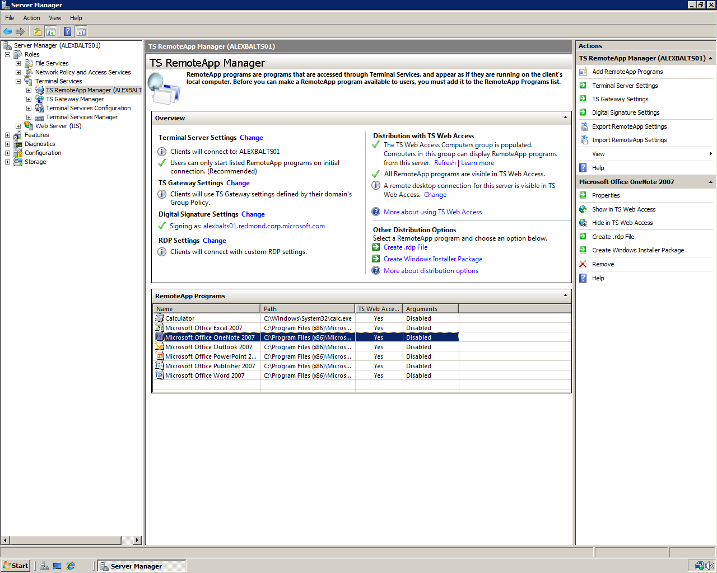
Figure 1. RemoteApp Manager Interface.

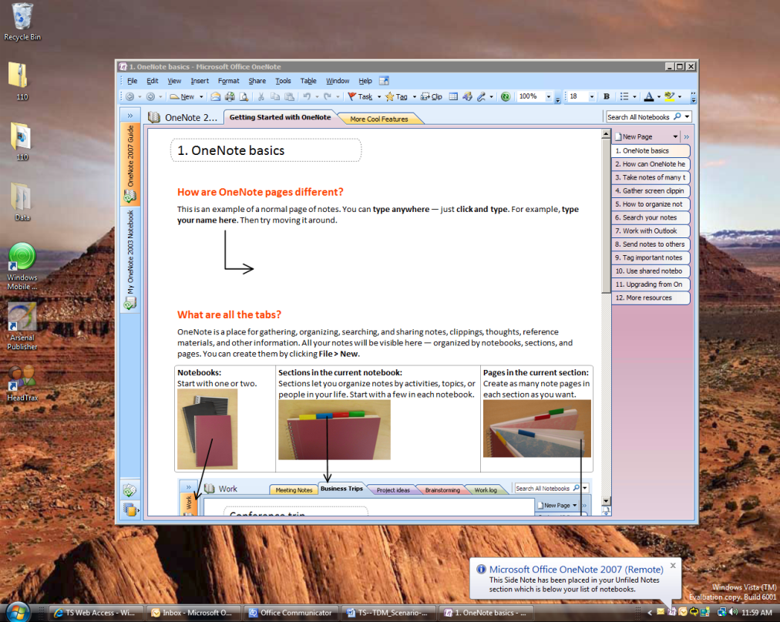
Figure 2. RemoteApp seamlessly integrates with the Windows Vista Desktop.

Terminal Services Web Access
Terminal Services Web Access (TS Web Access) provides a simple and easy to use website that allows user to launch connections to their TS RemoteApp programs, Terminal Servers desktops and to the remote desktop of any server and client computer that has remote desktop enabled.
For an administrator, TS Web Access is easy to configure and to deploy. Earlier versions of Terminal Services did not provide a mechanism to dynamically update a Web site with a list of RemoteApp programs. Now when you deploy TS Web Access, the list of RemoteApp programs that appears in the TS Web Access Web Part is dynamically updated. The list is populated from the RemoteApp Programs list of a single terminal server. Then, an administrator can specify the data source that will be used to populate the list of RemoteApp programs. The Web Part is populated with all RemoteApp programs that are configured for Web access on that server's RemoteApp Programs list.
RemoteApp programs can be deployed from a single terminal server or farm, or a link to the full terminal server desktop, directly through TS Web Access. All RemoteApp programs on the terminal server or farm that are configured for TS Web Access will appear on the TS Web Access Web site.
For access to RemoteApp programs and desktops from an internet connected client TS Web Access is used in conjunction with TS Gateway to provide easy, HTPS based, connections that can easily traverse the Internet and firewalls.
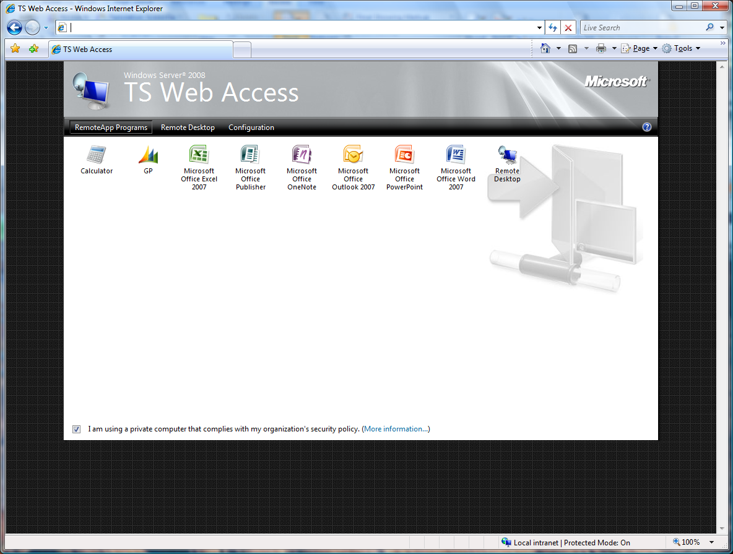
Figure 3. TS Web Access Interface. Applications appear on a Web page and can be launched simply by double-clicking the application icon.

Terminal Services Easy Print
In The Terminal Services Easy Print driver is a feature in Windows Server 2008 that enables users to reliably print from a TS RemoteApp program or from a desktop session to the correct printer on their client computer. It also enables users to have a much more consistent printing experience between local and remote sessions.
The Terminal Services Easy Print driver offers the following functionality:
- Increased reliability of Terminal Services printing for both RemoteApp and remote desktop sessions
- Support for legacy and new printer drivers without the necessity of installing vendor printer drivers on the terminal server
- Scalability improvements over Windows Server 2003 in terms of printer enumeration performance.
- Enhanced available printer capabilities. The Terminal Services Easy Print driver provides rich and complete printer capabilities in remote sessions. All of the physical printer driver's capabilities are available for use when a user views the printing preferences.

Terminal Services Gateway
Windows Server 2008 Terminal Services Gateway (TS Gateway) is a role service that enables authorized remote users to connect to resources on an internal corporate or private network, from any Internet-connected device. The network resources can be either a terminal server running RemoteApp programs or computers with Remote Desktop enabled.
TS Gateway uses RDP over HTTPS to help form a secure, encrypted connection between remote users on the Internet and the internal network resources on which their productivity applications run.
The TS Gateway Manager snap-in console enables you to configure authorization policies to define conditions that must be met for remote users to connect to internal network resources. For example, you can specify who can connect to network resources, what network resources (computer groups) users can connect to, whether client computers must be members of specific Active Directory® security groups, and whether clients need to use smart card authentication or password authentication, or whether they can use either method.
Figure 4 illustrates a TS Gateway architecture.
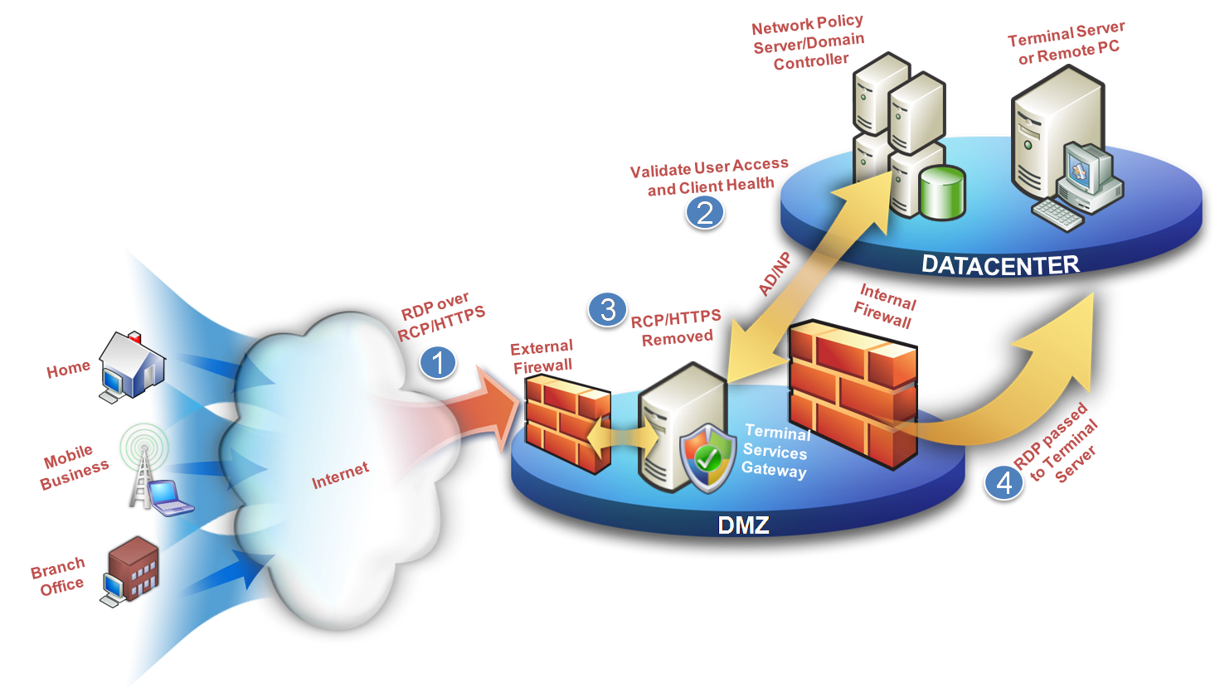
Figure 4. TS Gateway Architecture.

Remote Desktop Protocol
Terminal Services delivers applications and data via the Remote Desktop Protocol (RDP), an optimized transport mechanism low bandwidth. Traditional client server applications that slow end-user productivity over a slow network connection, receive a performance boost when delivered via Terminal Services to remote users.
For many scenarios, especially those with high graphic content, the new 32bit color mode ensures maximum color clarity whilst offering in many scenarios less bandwidth than 24bit color mode offered by RDP.
With new Advanced RDP compression (set using group policy on the terminal server) it is possible to reduce RDP bandwidth in knowledge worker scenarios, by up to 50%. Note that enabling this setting requires an extra 8MB per connected user.

Display Data Prioritization
Display data prioritization automatically controls virtual channel traffic so that display, keyboard, and mouse data is given a higher priority over other virtual channel traffic, such as printing or file transfers. This prioritization is designed to ensure that your screen performance is not adversely affected by bandwidth intensive actions, such as large print jobs.
With display data prioritization, the default bandwidth ratio is 70:30. Display and input data will be allocated 70 percent of the bandwidth, and all other traffic, such as clipboard, file transfers, or print jobs, will be allocated 30 percent of the bandwidth.

Related Material

For more information, visit the following:
Windows Server 2008 Terminal Services
http://www.microsoft.com/windowsserver2008/terminal-services/default.mspx
Windows Server 2008
http://www.microsoft.com/windowsserver2008/default.mspx
Core Infrastructure Optimization
http://www.microsoft.com/business/peopleready/coreinfra/default.mspx
Microsoft’s Virtualization Strategy
http://www.microsoft.com/virtualization/default.mspx
What’s New in Terminal Services for Windows Server 2008
http://technet2.microsoft.com/windowsserver2008/en/library/e82ace33-9f7e-4034-8267-f475d0afefc01033.mspx?mfr=true
Licensing Windows Server Terminal Services – Step by Step Guide
http://technet2.microsoft.com/windowsserver2008/en/library/4b4dd54a-46df-4b18-813f-2424cbc865031033.mspx?mfr=true

