Enterprise Search: A View from the Crawl Space
The search journey

By Jeff Fried

Enterprise search technology is incredibly useful and powerful, but very few people understand how to apply it well. Perhaps because search looks so simple on the outside, or perhaps because of the universal familiarity with web search, enterprise search is generally poorly understood. There are many misconceptions and misunderstandings about enterprise search, and in many organizations the first comment you hear about an intranet is, "the search is useless."

We can do better. Enterprise search technology is now very capable, and it isn't that hard to set it up and maintain it correctly. I've been at hundreds of places with high quality search—places where everyone could find the information they needed quickly and easily.

Enterprise Search: A View from the Crawl Space is meant to help. This column (this is the first article) will focus on real-world perspectives and practical techniques for succeeding with Microsoft Enterprise Search. I'll provide articles on a regular basis that cover a wide range of topics, and I'll try to have useful tips in each article, no matter where you may be on the spectrum of search sophistication.

When search works well, people use it. Improving search quality will increase its utilization, and it makes people more effective at their jobs. An intranet project I worked on grew from 2.3 searches per week per employee to 34 over the course of 4 months—simply by consolidating from eight search centers to one, adding effective refiners, and deploying people search in SharePoint Server 2010. A search=driven application powering fraud investigations for a 30 person group at a major bank currently runs at 410 searches per week per user—and it has reduced the average investigation time from 2.5 days to less than one. With great enterprise search, organizations can quickly respond to market changes, innovate, and accelerate their time to market. Without good search, people drown in their own information.

Search is not a 'one size fits all' endeavor
I'm often asked to help companies with their search strategy, which I find both rewarding and fun. The concept of stages of search adoption usually comes up—I am a big fan of doing things a piece at a time and building on a successful project to accomplish even more. But people are commonly looking for a standard map, a step-by-step path to success in search that everyone can use. Unfortunately, I strongly believe there is no single right answer. The search journey follows some common patterns from organization to organization, but it varies. Here are some example questions that illustrate what I mean:

- Should I start with search on my intranet, or on a search-based application that serves a specific group of users?
That depends—the search-based application will typically have a more concrete business mandate and ROI, but intranet search can be simpler and more out-of-the-box. Either way, the first project will provide a basis for other projects to build on.

- Should I start by indexing the content I have in SharePoint sites, or with content in some other system?
That depends—it is usually best to tackle a simple source as a warmup and then go for the system that has the most valuable content. Adding sources one at a time is always a good idea.

- Should I start with SharePoint search and move to FAST later, or start with FAST now?
That depends on the sophistication and scale of your search needs. In some cases, you may never need FAST search; you may even start with Search Server Express. In others, it's better to deploy FAST up front.

- Should I update search along with my move to SharePoint 2010, or implement search first?
That depends on the timing and complexity of your SharePoint 2010 upgrade.

- Should I implement a single instance of search organization-wide, or use local instances in different business units or geographies?
That depends—although a single instance usually provides the simplest platform to build on, it may not be feasible or desirable in some cases.

You get the idea. Search is not a 'one size fits all' endeavor. Once you get into it, you find that there's a myriad of different applications for search, and many different technologies and techniques at play under the hood. So the evolution of search at a given organization can take a variety of paths.

Ground rules that help anywhere in the search journey

Even though the search journey doesn't follow a single recipe, there are some ground rules that really apply in all cases. These are simple, and applying them consistently pays off in spades.

Start projects with envisioning and out-of-the-box search
… and work iteratively from there. Don't start with a detailed set of wireframes or an information architecture. Once you get an initial set of content indexed and findable, it will be much easier to understand the nature of the data and how different content sources relate to each other (or don't). Then the information architecture work becomes easier. By exploring using the OOB UI, you'll get a much clearer view of what needs to be changed. Regular iterations (in many cases weekly or biweekly updates) help move a project along quickly and transparently.

The graphic below illustrates a search project done in three phases, over the course of 10 weeks. The first phase creates a usable prototype and is the basis from which the system's information architecture and sizing is done. This may seem backward, but it's an effective approach—these tasks are easier when there is a system to reference and measure.

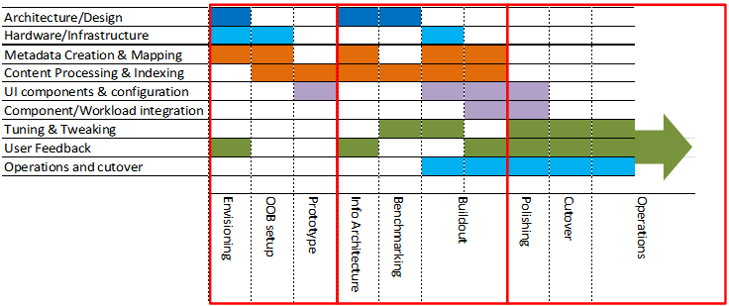

The flip side of working in this agile manner is that you shouldn't be afraid to change things, even to throw things away. It is very easy to change the search UI through themes, Web Parts, add-ons, and XSLT—before considering custom code. Recrawling content is generally straightforward, so changing metadata or managed property settings is not something to be wary of.

Make search administration someone's job
This may seem obvious, but it is very often overlooked. Content has a tendency to grow organically, and a "gardener" who can see when weeds are out of control or when something needs pruning, is indispensable. This needn't be a full-time job—it may only take an hour or two a week. But it is a different role than a system administrator and is a change of pace for a typical SharePoint administrator.

Search administration starts with the search analytics reports. They're not obvious—they are part of the Site Collection Web Analytics Reports, not at the site level, and you have to use Central Admin to get to them. They are meant to serve the site admin / search admin perspective. One example, the Top Queries report, is shown below.

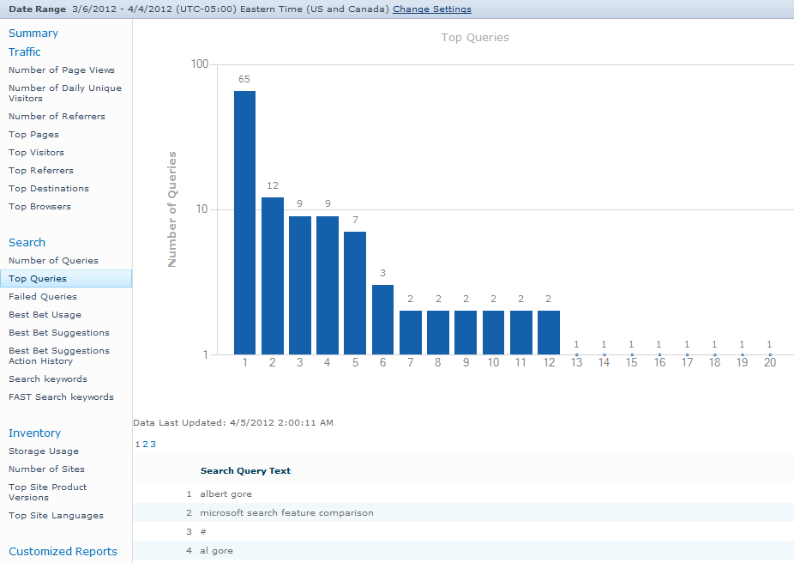

To learn more, see the following on TechNet:
- View Web Analytics reports (SharePoint Server 2010)
- Plan keywords, synonyms, and Best Bets (SharePoint Server 2010)

Understanding what users are looking for, what content is indexed, and what queries should have keyword treatment (such as Best Bets and synonyms) is the heart of the search administration job. We'll be talking about this role more in future articles and providing tips for success in this job.

The search administration reports are much more focused on the system administrator viewpoint (query latency, crawl throughput. etc). You can read about these on TechNet at Use search administration reports (SharePoint Server 2010). While the search administration reports are in fact useful for the search administrator to know about, the search analytics reports are the ones to look at first and foremost.

Enlist the users
Search is used frequently by pretty much everyone in most organizations. It is very close to the end user, and the expectations are typically pretty high—conditioned by everyday experience with web search. (Web search is usually regarded as a good experience and some users say "I just want it like Google," although enterprise search is a different animal in many ways. It is also daunting to a search administrator to realize that google.com has over 3,500 people tweaking the content processing and query treatment.

In the context of an enterprise, enlisting the users means asking them for feedback. The simple technique of putting up a survey on the search page goes a long way. It's quite simple to set up a survey in SharePoint 2010—for example, see Amol Ghuge's blog entry How to create a survey in SharePoint 2010. I recommend putting a visible but inobtrusive link on the search results page, such as:
and then connecting this to a simple form that collects feedback into the survey list:
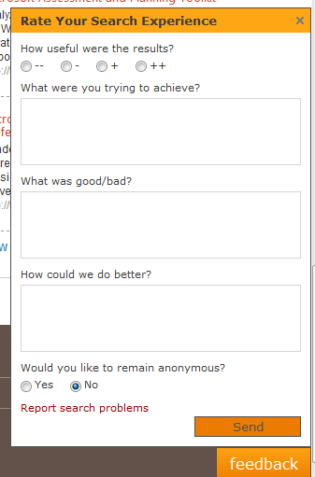

The simple act of asking for feedback goes a long way because even if users don't enter anything it shows that you care. For those users who are frustrated with search, this gives them a way to vent—and gives you an invaluable source of information.

It's important to let real end users test and evaluate the system during the deployment project—ideally through several iterations of improvement. Just as there is no single right answer for a search strategy, there's usually not a single right answer for any given search. Relevance is a subjective judgement, and there are many little things that can make the difference between a bad user experience and a good one. Enlisting users to help in the project will teach you what works well and what doesn't. "If the user can’t find it, it ain’t there” is very much true for search applications , and designers of search applications sometimes forget that their users tend to be less technical than the themselves.

Enlisting the users also means finding champions and enthusiasts among your users who know the domain and the content. These champions need not know much about search or SharePoint, but if you make it easy for them to improve the search experience, they will help you. Often these are the same people who you are working with on other SharePoint projects, but sometimes you will come across someone who is passionate about the content and its findability. They might even seem like pests at first, but don't shut them out. One organization I worked with had a woman obsessed about seemingly minor issues in their internal infopedia. Simply by meeting with this user and arming her with knowledge of how search worked and giving her access to synonyms and Best Bets administration, she became a powerful advocate and ally for the IT group. She in turn gained visibility inside the organization that helped her career advancement.

End user help for this kind of administration can be found at Add keyword terms with Best Bets on Office.com.

Wherever you are in the search journey, take the next step

If you are just getting started with enterprise search and SharePoint, you'll find it pretty simple to get up and going. If you are embarking on your first search-based application, you can create a winning solution by keeping the basic ground rules in mind.

If you have been running search for awhile, don't get complacent. The most common mistake made with search projects is to leave them alone after go-live. Unlike many technologies, search is ever-changing—the content changes constantly, the topics people are looking for change regularly, and even the language they use drifts over time. Since you have a search administrator (see the ground rules above) the day-to-day changes are in hand. But check on the overall picture of search every quarter or so. You will discover new business requirements and new applications for search.

An increasing number of larger organizations have a "Search Center of Excellence"—a group that implements search projects and helps others do so. These organizations often field dozens of search-based applications over time—on the same search platform, usually shared content. As I mentioned near the beginning of this article, when search works well, people use it. I find that successful search projects tend to create an appetite for more search—the search journey gets richer and richer as you progress.

Fielding great search—search that users love, search that makes everyone much more effective—isn't hard. It just requires awareness of the technology, sensitivity to the users, and a commitment to continual improvement. There is no silver bullet and no single right answer. There are, however, ground rules and practices that work, and techniques proven to help.

In future articles, we'll cover a wide range of topics, focusing on these ground rules, practices, and techniques. We'll take your questions and suggestions, too—just send them to itspdocs@microsoft.com. SharePoint includes some amazing search technology, and you can apply it in your organization to provide great search.

Coming up next—The search UX: One search center to rule them all?

About the author
Jeff Fried is CTO of BA Insight, focused on strategic applications of search technology. He came to BA Insight from Microsoft where he served as technical product manager for all Microsoft enterprise search products. Jeff is a frequent speaker and writer in the industry, holds 15 patents and has authored more than 50 technical papers, and has led the creation of pioneering offerings in next-generation search engines, networks, and contact centers. He is a co-author of two new books: Professional SharePoint 2010 Development and Professional Microsoft Search: FAST Search, SharePoint Search, and Search Server.

