Service Mapping
Microsoft Operations Framework (MOF)

Version 1.0

Published: March 2010
For the latest information, please see
microsoft.com/technet/SolutionAccelerators

Copyright © 2010 Microsoft Corporation. All rights reserved. Complying with the applicable copyright laws is your responsibility. By using or providing feedback on this documentation, you agree to the license agreement below.

This documentation is licensed to you under the Creative Commons Attribution License. To view a copy of this license, visit http://creativecommons.org/licenses/by/3.0/us/ or send a letter to Creative Commons, 543 Howard Street, 5th Floor, San Francisco, California, 94105, USA. When using this documentation, provide the following attribution: The Microsoft Operations Framework 4.0 is provided with permission from Microsoft Corporation.

This documentation is provided to you for informational purposes only, and is provided to you entirely "AS IS". Your use of the documentation cannot be understood as substituting for customized service and information that might be developed by Microsoft Corporation for a particular user based upon that user’s particular environment. To the extent permitted by law, MICROSOFT MAKES NO WARRANTY OF ANY KIND, DISCLAIMS ALL EXPRESS, IMPLIED AND STATUTORY WARRANTIES, AND ASSUMES NO LIABILITY TO YOU FOR ANY DAMAGES OF ANY TYPE IN CONNECTION WITH THESE MATERIALS OR ANY INTELLECTUAL PROPERTY IN THEM.

Microsoft may have patents, patent applications, trademarks, or other intellectual property rights covering subject matter within this documentation. Except as provided in a separate agreement from Microsoft, your use of this document does not give you any license to these patents, trademarks or other intellectual property.

Information in this document, including URL and other Internet Web site references, is subject to change without notice. Unless otherwise noted, the example companies, organizations, products, domain names, e-mail addresses, logos, people, places and events depicted herein are fictitious.

Microsoft, Active Directory, Excel, SQL Server, SharePoint, Visio, Windows, Windows PowerShell, and Windows Server are either registered trademarks or trademarks of Microsoft Corporation in the United States and/or other countries.

The names of actual companies and products mentioned herein may be the trademarks of their respective owners.

You have no obligation to give Microsoft any suggestions, comments or other feedback ("Feedback") relating to the documentation. However, if you do provide any Feedback to Microsoft then you provide to Microsoft, without charge, the right to use, share, and commercialize your Feedback in any way and for any purpose. You also give to third parties, without charge, any patent rights needed for their products, technologies and services to use or interface with any specific parts of a Microsoft software or service that includes the Feedback. You will not give Feedback that is subject to a license that requires Microsoft to license its software or documentation to third parties because we include your Feedback in them.

Contents
Introduction 1
Intended Audience 1
What Is a Service Map? 1
How Are Service Maps Used? 1
Service Maps: What They Are and Are Not 3
Service Map Content and Structure 4
Content 4
Structure 6
Software Stream 7
Hardware Stream 7
Services Stream 8
Customers Stream 8
Settings Stream 9
Service Relationships and Dependencies 9
Building Service Maps 11
Steps in Building Service Maps 11
1. Identify the Team 11
2. Define the Mapping Template 12
3. Determine the Appropriate Level of Resolution 12
4. Select Services for Mapping 13
5. Gather Data and Draw the Service Maps 13
6. Establish Service Relationships 14
7. Maintain the Service Maps 15
Content Considerations 16
Key Considerations for Service Mapping Programs 16
Using Service Maps 17
Scenario: Using Service Maps to Create and Control Services 20
Getting Started with Service Maps 24
For More Information 24
Feedback 24
Acknowledgments 25

Introduction
This document is intended to introduce the content, structure, development, usage, and benefits of service maps. It will:
- Show you a service map. It will show you an example of a complete service map, including the typical content and structure.
- Demonstrate how to build service maps. It will provide detailed guidance on how to get started building a service map as well as considerations on how to take a programmatic approach to mapping services in your service delivery organization.
- Suggest how to use service maps. It will provide examples of how service maps are used, by whom, and why.

Intended Audience
This document is intended for those who have a basic understanding of Microsoft® Operations Framework (MOF) concepts and terminology and who are familiar with Microsoft products and technologies. While this prerequisite knowledge is not essential to comprehend service mapping, it is helpful.

What Is a Service Map?
A service map is a graphical display of a service that illustrates the various components upon which successful delivery of that service relies. These components generally include hardware, software, and configurable settings or roles, as well as customers and other services. A Microsoft-developed best practice, a service map is a communications tool that illustrates the “what” of a service (its components and their relationships) as a basis for managing the “how” of a service (how the service is delivered and controlled to ensure expected availability, capacity, security, and manageability).
Service maps are useful in documenting an environment because:
- They present a service-centered view of the environment, organizing technical capability in business-oriented terms.
- They more readily facilitate understanding of complex systems and component dependencies than text-based documents for both technical staff and customers.

How Are Service Maps Used?
To illustrate the potential uses of a service map, consider the example of a collaboration service built with Microsoft SharePoint®. In this example, the SharePoint collaboration service is critical because it supports several key business processes. As a result, within its service level agreement (SLA), the service delivery organization has committed to a minimum level of availability for the service with the customers of the service.
To effectively manage this service requires adequate knowledge and understanding of the components of that service. Consider these scenarios:
- You are a Service Level Manager being asked by the business for higher availability. Will the existing components support this level of service?
- You are a Configuration Administrator trying to assess the impact of a change to a hardware component within the service. How will you predict the upstream and downstream impact?
- You are a Problem Analyst attempting to diagnose the root cause of a problem related to the service. How do you efficiently trace the cause downstream?
- You are a Test Manager developing a testing plan for a new release of the service. How do you identify all the components you need to test?
To help answer these questions, you could potentially reference component-level technical documents, but they might not clearly illustrate interrelationships. Or you could probably get good information from the service delivery teams responsible for the relevant components, assuming you know the correct teams.
A service map of the SharePoint collaboration service would be valuable in all these scenarios. With a well-defined service map, you would be able to quickly plot the major components underpinning the SharePoint collaboration service to help users answer the above questions. The map might not answer every question, but it should help point you to relevant component-level technical documentation and to the right teams.
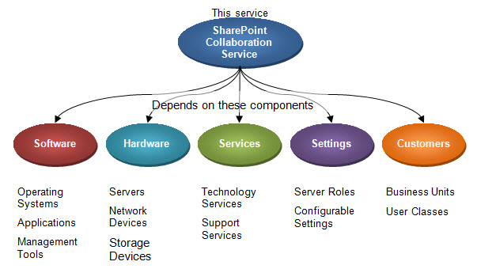
Figure 1. A service and its component dependencies
Consider these scenarios again, this time equipped with the service map in Figure 1 for reference:
- You are a Service Level Manager being asked by the business for higher availability. The service map will help you identify the key components and dependencies that require investigation so you can then consult the proper teams to make a clear determination about the feasibility of the request.
- You are a Configuration Administrator trying to assess the impact of a change to a hardware component within the service. You can reference the service map to identify the relevant upstream and downstream components and the teams responsible so that you can accurately predict the impact.
- You are a Problem Analyst attempting to diagnose the root cause of a problem related to the service. You can reference the service map to trace the root cause of the problem downstream and then involve the appropriate teams in the diagnosis and resolution process.
- You are a Test Manager developing a testing plan for a new release of the service. The service map will help you identify the components to include in testing and the teams you’ll want to involve in the testing process.

Service Maps: What They Are and Are Not
A service map is:
- A valuable reference tool at all levels of a service delivery organization and across all phases of the service management lifecycle that demonstrate relationships and dependencies better than many other documents, such as architecture diagrams and configuration specifications.
- A communication tool, the value of which is to connect the user quickly with the resources—people and information—needed to make the best decisions.
A service map is not:
- A replacement for other key reference documents such as architecture diagrams and configuration specifications.
- A graphic representation of a configuration management system.
- A replacement for a service catalog.
As organizations become better at developing and using service maps, they may create more sophisticated service maps that incorporate additional information and functionality, making them more than reference tools. However, it’s important to note that the fundamental purpose of a service map is orientation—and they can provide great value doing this alone.

Service Map Content and Structure
This section illustrates the basic components and construction of a service map.

Content
As illustrated in Figure 1, service maps are graphical depictions of a service decomposed into its smaller component parts. Most services can be decomposed into the five component categories, or “streams,” shown in Figure 2. (Note that Figure 2 illustrates the component categories, but not the relationships among them, which will be described later.)
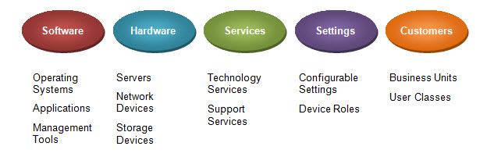
Figure 2. The five component streams
These five streams are likely to capture most information on the components required to manage a service, although they may be modified or appended to best suit the needs of a particular service or organization.
Table 1 outlines the typical components within each stream and the potential data sources for each.
Table 1. Components Within Service Map Streams
Stream | Typical components | Potential data sources for this service map stream | Example components
Software | All software associated with a given service including the core application itself, any supporting or dependent applications, network and control software, maintenance software, and versioning information. | Software data usually comes from service catalogs or software portfolios. This also includes any dependent software related to the service being mapped. | Windows Server® 2008 SP2 x64
Hardware | All servers, network devices, storage equipment, and desktop PCs required for a service to function, including model and configuration information where appropriate. | Hardware data can be identified through the configuration management system (CMS) or other similar sources of configuration data. | HP DL 385 G2
Stream | Typical components | Potential data sources for this service map stream | Example components
Services | Other services upon which the primary service depends. Upstream services feed required input to the service in question, while downstream services are fed output from the primary service. For example, a service like Exchange or SharePoint will typically rely on several downstream services such as Active Directory®, Backup, and Service Desk. | Service catalogs and service portfolios are a good source for this type of data. | DNS and Help Desk/Call Center/Level-1
Settings | The configurable settings needed for the service to function effectively. | Configuration diagrams are an excellent source for setting data since they typically include details about settings or roles of other dependent equipment such as server or network devices. | Server roles such as Index Server, Query Server, and Database Server  Domain authenticated to gateway IP address
Customers | The consumers of the service and relevant information about them such as department, location, and means of contact. This could include specific business units, geographical regions, or classes of users (such as “Executives”). | Design packages created during requirements analysis or the design phase of the service management lifecycle are excellent sources of customer data. Service owners and the service level manager may also be able to provide data about customers. | Accounts payable department

Structure
Building on the SharePoint example, Figure 3 represents a complete service map for the SharePoint collaboration service. The brainstorming diagram template in Microsoft Visio® drawing and diagramming software has been used to create the map with the overall SharePoint service as the main element and the five streams as the service’s primary branches. Within each stream, there are additional branches for each component. Components are numbered and color coded to illustrate the respective teams responsible for the components and all the associated information about them.
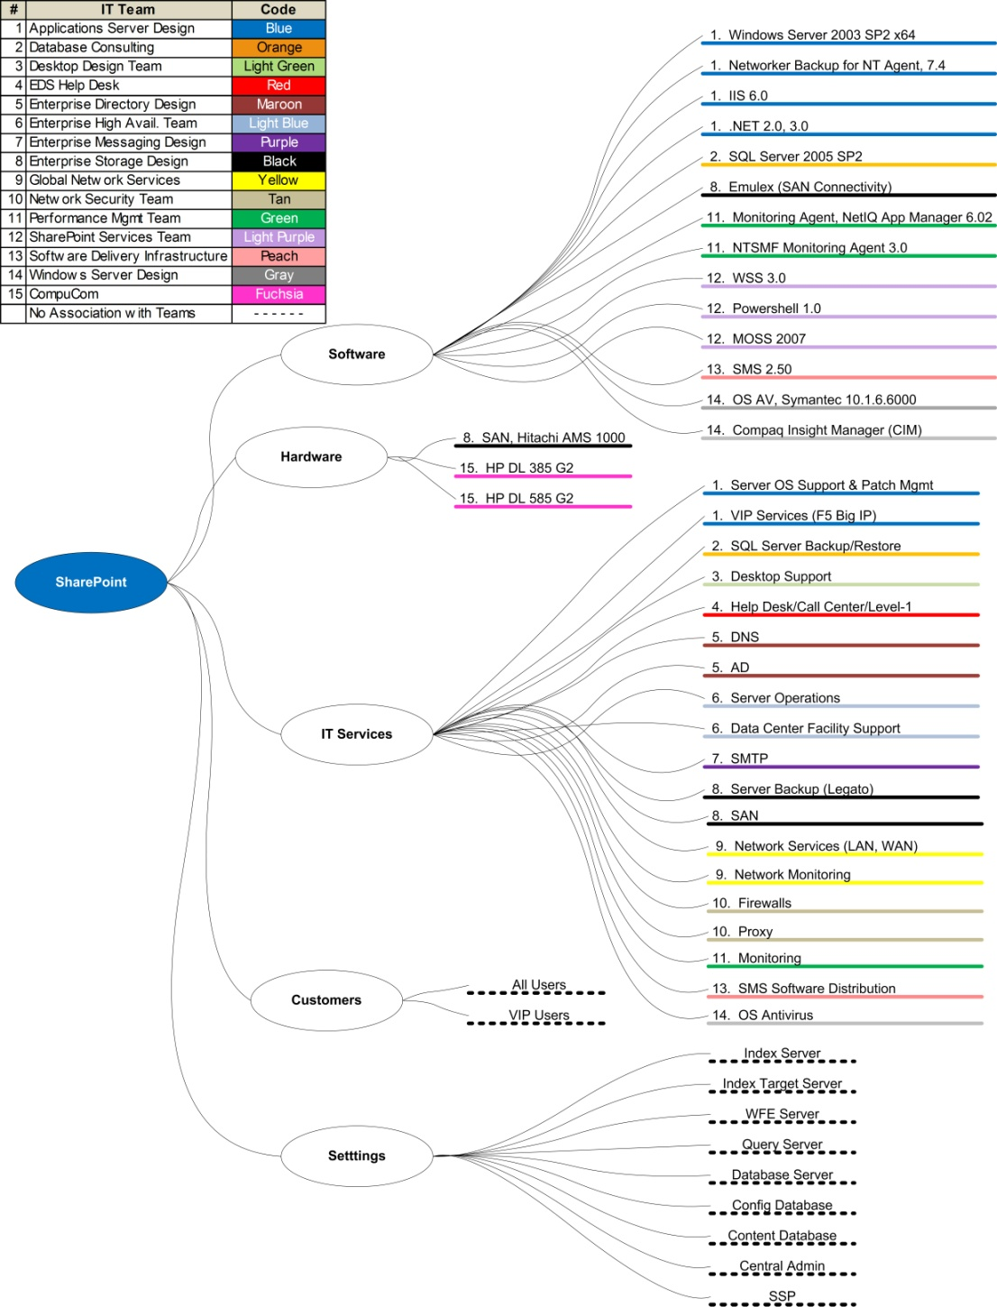
Figure 3. A sample service map for SharePoint
At a glance, a reader can learn a great deal about this service, as illustrated in Figure 5 below. In reviewing this section, keep in mind the fundamental purpose of the service map as an orientation tool and not necessarily an in-depth reference diagram.

Software Stream
The reader will see that the service’s operating system is Windows Server® 2003 SP2 x64; the Web server software is Internet Information Server (IIS) 6.0; and the database server is Microsoft SQL Server® 2005 SP2. A reader will also see that Compaq Insight Manager is used to monitor components of the service and that this tool is owned by the Windows Server Design team.
Figure 4. Software stream

Hardware Stream
A reader can see that the service’s SAN is a Hitachi AMS 1000 and that it runs on two HP DL 385 G2 servers. The reader can also see that the SAN is owned by the Enterprise Storage Design team and that CompuCom is responsible for the two servers.
Figure 5. Hardware stream

Services Stream
A reader will see that SharePoint depends on several technology services (such as Active Directory, DNS, SMTP, and Network Services) and several operational services (such as Desktop Support, Server Operations, and Data Center Facility Support).
Figure 6. Services stream

Customers Stream
A reader can also see that SharePoint serves two classes of user: All Users and VIP Users.
Figure 7. Customers stream

Settings Stream
Finally, a reader will see that the services’ configurable settings include several server roles (such as Index Server, Index Target Server, and WFE server).
Figure 8. Settings stream

Service Relationships and Dependencies
The interdependent nature of services makes visualization of upstream and downstream service dependencies vital to the understanding required to perform the work needed to ensure the reliability of a service. Service maps can be especially useful in assessing and communicating the upstream impacts of changes as well as being a helpful diagnostic tool when working on an incident or problem.
For example, the SharePoint service map example shown in Figure 9 indicates Active Directory as a downstream service, meaning the performance of the SharePoint service depends on the performance of the Active Directory service. The Active Directory service has its own set of hardware, software, service, setting, and customer components as illustrated in its own service map.
Figure 9. How a service is underpinned by supporting services and how this is represented in a set of linked service maps
Consider a Configuration Analyst attempting to assess the impact of a hardware change to the Network VLAN service (a downstream service to Active Directory that is, in turn, a downstream service to SharePoint). Taking the Network VLAN service down temporarily will therefore affect the availability of Active Directory and ultimately SharePoint. Since that downtime may adversely affect the SharePoint SLA, planning this change may need the input of the SharePoint Service Level Manager.
As you can see, service maps can be used as communication tools in the planning phase of services that help highlight relationships and dependencies as a basis for designing for reliability; they can also act as reference documents for support and maintenance activities that are conducted during the live operation of a service. Communicating via service maps starts with their construction; the following section shows you how.

Building Service Maps
An individual service map is a useful tool for the teams responsible for a certain service. Building a single service map is usually quick and straightforward, but its value is typically limited to the scope of that service. Most service managers will want to build a set of related service maps to effectively illustrate the relationships and dependencies among services and components throughout either a segment of the environment or possibly the entire enterprise. While individuals can and should build service maps to communicate services and their dependencies where there is a value in doing so, building an effective set of related service maps typically requires a team and additional planning and other considerations to ensure consistency and accuracy.

Steps in Building Service Maps
This section outlines the seven-step team approach necessary to build and maintain more complex, multi-layered service maps.

Figure 10. A seven-step team approach to building and maintaining service maps

1. Identify the Team
Building a service map requires a thorough knowledge of the target service. Even in smaller environments, services can be very complex, so it’s best to approach building service maps as a team effort since it is unlikely one person will possess all the information needed to build a complete and accurate map.
One person should lead the mapping effort for each service. The leader will facilitate the key design decisions, lead data gathering, and draw the map. Other members of the team will supply information for the map and check the map to ensure accuracy.
The team leader should possess:
- A clear understanding of the concept and application of service maps.
- A clear understanding of the established standards for service maps.
- Moderate knowledge of the service’s components.
- The ability to organize and facilitate design dialogue with other staff members.
- Adequate knowledge of the selected mapping software.
Building a set of service maps will require defining a mapping template, determining the proper level of resolution, selecting the services to be mapped, gathering the data, and drawing the maps. Upon completion, the maps will need periodic maintenance to ensure their accuracy. All these steps are described in detail in the following sections.

2. Define the Mapping Template
Drawing or mind-mapping software is well suited to building service maps. The sample SharePoint map was built using the brainstorming diagram template in Visio.
If desired, multiple maps can be created, each with its own tab in a single Visio document, and be linked to demonstrate cross-service dependencies.
When starting a service mapping initiative, it’s important to establish some standards to ensure consistency among all maps. People reading maps will have an easier time interpreting them if all maps follow a common form. Standards should be set in the following areas:
- Stream names. As noted previously, the Hardware, Software, Services, Settings, and Customers categories should address most services, although some organizations may prefer to modify or append these. The important thing is to standardize the names so all maps are consistent.
- Naming guidelines. Some guidelines on naming components should also be established, once again to ensure consistency among maps. These guidelines include:
  - Hardware. Hardware components should be referenced consistently, such as brand, model name/number, and type (such as Hitachi AMS 1000 SAN).
  - Software. Include version numbers and patch levels (where applicable) for software components.
  - Services. Services will interrelate, so it’s necessary to establish a consistent set of service names whether for technology services (such as Active Directory, SMTP, or DNS) or operational services (such as Desktop Support or Network Monitoring).
  - Naming standards. Establish a standard, numbered and/or color-coded list of team names, as well as standard customer names, and consistent names for settings.
- Map layout and orientation. Establish basic guidelines for how a service map should look. Consider whether landscape or portrait orientation is more effective and the orientation (top to bottom, left to right) of the streams. Consistent layout and orientation will make the maps easier to navigate.

3. Determine the Appropriate Level of Resolution
The level of resolution for a service map refers to the amount of detail featured. Determining the most appropriate level of resolution is driven by considering the potential uses of the map and therefore how much detail will be needed to support those uses.
Maps with less detail are easier to build and maintain. They are best for low-urgency planning and decision-making purposes where users need basic orientation on major service components and dependencies. Maps with more detail are more valuable, but they are also more challenging to build and maintain. They are more useful in high-urgency activities like incident diagnosis.
Determining the best resolution level for a given service map requires consideration of the likely audiences and users of the service map and the ways in which they will apply it. (See “Using Service Maps” later in this document for examples.)
When approaching service mapping, keep in mind that service maps will not necessarily replace other reference documents in the environment and should not be developed with the intent that they will be the most comprehensive representation of a service. For most audiences, service maps will illustrate the essential relationships and dependencies of a service more effectively than most other reference documents, but other documents will be better at describing component details.

4. Select Services for Mapping
Service selection depends on the maturity of services and service management processes in the organization. Mapping should ideally be driven by selections in the service portfolio and should reflect the topmost customer-facing services provided by the organization. The idea is to begin mapping at the very top of the service supply chain and to then progress downward. This approach will highlight the many downstream services that are also candidates for mapping.
In the absence of a true service portfolio, it’s typically best to begin mapping with the organization’s most stable and mature services because these are likely the clearest. Likely candidates include messaging and major line-of-business (LOB) applications.
It’s important to note that mapping services is not the same as defining services. Mapping services can be a useful technique within an overall service cataloging program, but a set of service maps is not a substitute for a service catalog. Mapping evolving or vaguely defined services will probably be challenging, although it may help foster constructive discussions and mutual understanding about service structure, requirements, and parameters.

5. Gather Data and Draw the Service Maps
Drawing the service map is best done iteratively. The first iteration can be rough and will help the team begin to visualize the service components. Successive iterations will refine the map. The role of the architect in this stage is to organize the proper participants and draw the map in accordance with established standards.
In addition to discussions with staff, automated discovery or inventory tools are helpful in mapping services because they can help ensure a complete and accurate listing of hardware, software, and settings. For example, the Microsoft Assessment and Planning (MAP) Toolkit can perform a secure, agentless, network-wide inventory and can report on Windows® client and server operating systems and their hardware.
At the end of each iteration, the architect and team need to evaluate the map and decide if it’s complete. This is a subjective decision that should consider the following questions:
- Does the map reflect all known components in each stream? Has everything been identified?
- Are all components accurate? Are they named in accordance with the established standard?
- Are component owners accurate? Are they named in accordance with the established standard?
- Is there enough detail to satisfy the anticipated uses of the map?
When first embarking on a service mapping initiative, it’s a good idea to map one service completely before moving to other services. Use the first map as intended for a short time and determine if any adjustments are needed before building additional maps.

6. Establish Service Relationships
One of the most useful aspects of service maps is the way they illustrate the relationships among services. To take full advantage of mapping these dependencies, an approach is needed to effectively illustrate these relationships in a simple way.
One approach is to create a dependency matrix like the example in Figure 11. This matrix lists all services on each axis, with primary services on the top and dependent services on the side. For each primary service, each dependent service is checked. When created in Microsoft Excel® spreadsheet software, service names can by hyperlinked to individual service map documents.
Service Dependency Matrix
SharePoint
Exchange
Mobility
SQL Server
Active Directory
SMTP
LAN
WAN
DNS
SharePoint
Exchange
X
X
Mobility
SQL Server
X
Active Directory
X
X
X
SMTP
X
LAN
X
X
WAN
X
X
X
X
DNS
X
X
X
X
Dependent
Services
Primary Services
Figure 11. A service dependency matrix in Excel
When looking at a primary service, the reader will see all dependent services. From the example in Figure 11, it is apparent that SharePoint depends on Exchange and Active Directory. When looking at a dependent service, the reader will see all the primary services that in turn depend on that dependent service. The example above shows that Active Directory is depended on by SharePoint, Exchange, and Mobility.
Another approach to mapping relationships in service maps is to hyperlink the maps to one another, either in pages or tabs within the same document or among documents (see Figure 12). This feature is available in technical drawing products like Visio. In this approach, a shape representing a component on one map is linked to a page detailing that component.
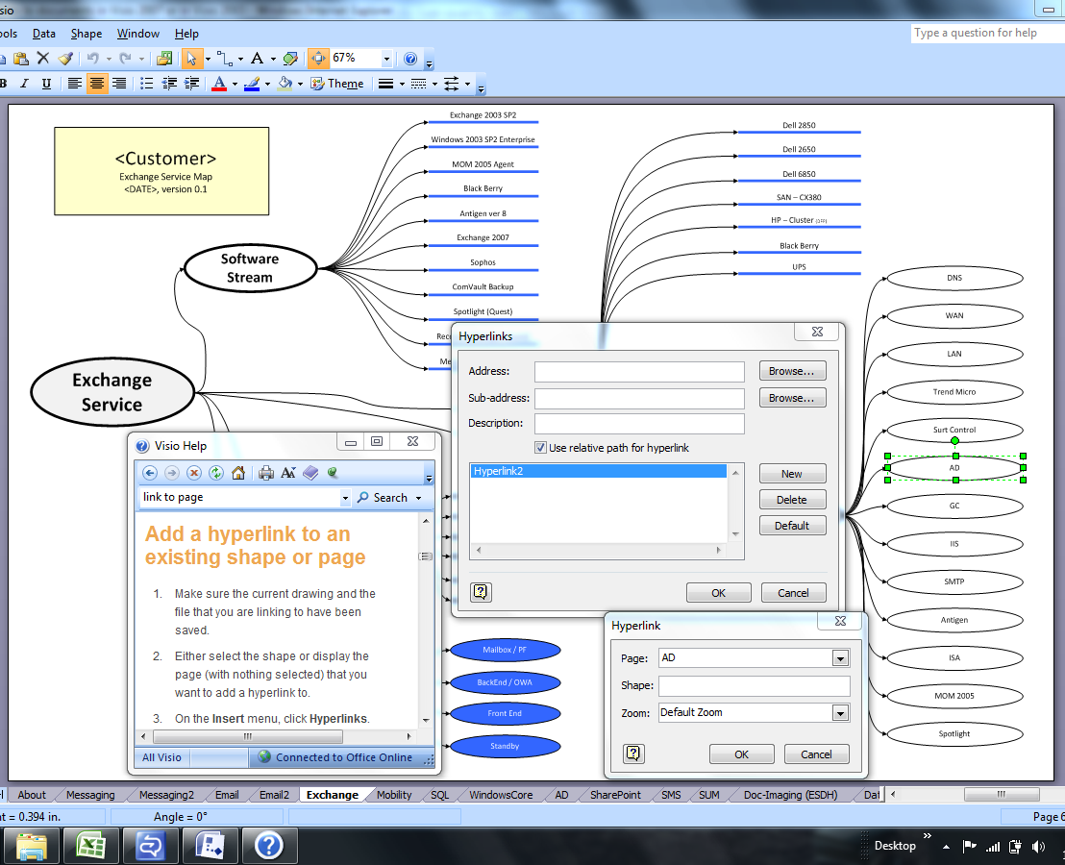
Figure 12. Linking shapes in a service map to a page detailing that component in Visio
Using the examples in the dependency matrix, the Exchange and Active Directory service components on the SharePoint map would be hyperlinked to the Exchange and Active Directory service maps respectively. The Active Directory map would contain hyperlinks to the WAN and DNS maps. Using this approach, a reader beginning on the SharePoint map could move quickly through the maps for the entire SharePoint service supply chain.
Both approaches could be used in concert to provide both a consolidated view (service dependency matrix) and a detailed view (hyperlinked service maps). In any case, all relevant documents must be stored in a suitable location accessible by all potential users.

7. Maintain the Service Maps
Because services evolve over time, service maps will need to be updated periodically to ensure their accuracy. It’s also possible that the organization itself may change over time and therefore the teams responsible for service components may change as well.
Maintenance of service maps requires the following:
- Each service map should be assigned an owner with responsibility for keeping it up to date. The original architect is a good candidate.
- A regular (quarterly or semi-annual) review of each service map should be undertaken by the owner to ensure the map’s accuracy. This review should include verifying any hyperlinks between documents.
It’s advisable to make service map updates a required deliverable in the change management process. As authorized changes are implemented, corresponding service maps are updated. Service maps should be versioned, and any changes to them should be logged in accordance with organizational document management standards.

Content Considerations
As noted earlier, the ways in which service maps are to be used should ultimately dictate their content and structure. Consider the following as you contemplate your service maps:
- Including non-production environments. It may be useful to capture the components of non-production environments (for example, development or test environments) on service maps, depending on their relationships to production components, their criticality, and their complexity.
- Highlighting component criticality. Distinguishing between critical and non-critical components may be useful in some cases, particularly where service maps will be used in high-urgency activities. This could be done simply by color-coding and/or making the component names for critical components bold.

Key Considerations for Service Mapping Programs
As noted at the beginning of this section, service mapping is most useful when undertaken programmatically with the principal intent of highlighting and documenting service relationships and dependencies; such a programmatic approach requires several key considerations. While an enterprise mapping program doesn’t need to be substantial in terms of time, effort, and resources, it does need to be set up wisely and managed carefully to deliver full value. As such, consideration of the following items is important:
- Define clear objectives and a compelling value proposition. Like any program or project, an enterprise mapping program needs a clear set of objectives and an agreed value proposition. These desired outcomes need to plainly communicate why this is a compelling investment of time and resources, looking ahead to how the maps will be used.
- Establish appropriate sponsorship and commitment. Like any enterprise-wide service initiative, an enterprise mapping program needs appropriate sponsorship and adequate commitment within the organization. The right people and/or teams need to demonstrate visible sponsorship for the initiative, including reinforcement of the program’s defined objectives and value proposition. Sponsorship and commitment is not limited to the highest-ranking members of the organization; the people and teams expected to create, use, and maintain the service maps need to be particularly committed to their success.
- Ensure strong leadership and communication. An enterprise mapping program needs a strong, versatile leader with a clear understanding of the program’s objectives and value proposition. This person must also possess the ability to both manage the program’s activities and evangelize its benefits. This person is not necessarily building service maps, but he or she needs to clearly understand how maps are built and help the various leaders accomplish their work effectively. This person can also help ensure consistency and quality across all maps.
- Set a sensible scope and approach. When embarking on an enterprise mapping program for the first time, careful selection of scope and approach is important. The best approach is typically a phased one in which services are mapped in small increments with adequate intervals in between for piloting. This approach allows the program to produce deliverables more quickly, helps build competence in the organization in both building and using service maps, and identifies potential adjustments and improvement opportunities.

Using Service Maps
Service maps can be used throughout the organization and across all phases of the service management lifecycle to provide insight and support decision making. It’s important to note that service maps are fundamentally visual communication and reference documents intended for facilitating, expediting, and enhancing planning, operations, and support activities. Their primary benefit is in getting people—both internal staff and customers and users—up to speed more quickly on the basic moving parts of a service. However, service maps are not intended to replace other reference documents and resources (for example, architectural diagrams, service catalogs, or configuration specifications) and should be used in concert with them. So who uses service maps and in what ways?
As shown in the Table 2, the Team SMF in MOF defines a set of seven accountabilities, which are a way of organizing service delivery work that ensures that the right work gets done—because someone is held accountable for whether it gets done.
Table 2. Accountabilities and Role Types
Accountability | Associated role types | Important to these SMFs
Support | Customer Service Representative, Incident Resolver, Incident Coordinator, Problem Analyst, Problem Manager, Customer Service Manager | Customer Service  Problem Management
Operations | Operator, Administrator, Technology Area Manager, Monitoring Manager, Scheduling Manager, Operations Manager | Operations  Service Monitoring and Control
Service | Supplier Manager, Portfolio Manager, Account Manager, Service Level Manager | Business/IT Alignment
Compliance | IT Executive Officer, IT Manager, Risk and Compliance Manager, Assurance and Reporting, Internal Control Manager, Legal, IT Policy Manager | Governance, Risk, and Compliance
Architecture | Architecture Manager, Reliability Manager, Architect | Reliability: Confidentiality, Integrity, Availability, Capacity, Continuity
Solutions | Solution Manager, Program Manager, Developer, Tester, Product Manager, User Experience, Release Management, Operations Experience, Test Manager | Envision  Project Planning  Build  Stabilize  Deploy
Management | IT Executive Officer, IT Manager, IT Policy Manager, IT Risk and Compliance Manager, Assurance and Reporting, Change Manager, Configuration Manager | Financial Management  Business/IT Alignment  Operational Health MR  Service Alignment MR  Portfolio MR  Release Readiness MR  Governance, Risk, and Compliance  Change and Configuration  Policy: Policy Governance, Security, Privacy, Partner and Third-Party Relationships, Knowledge Management, Appropriate Use  Team

Each of the accountabilities has a set of role types associated with it; a role type is a generic description of a role that might be found in an organization. The goal of a role type is to offer something recognizable so organizations know how that position might map to existing roles.
So how are service maps useful within accountabilities and role types? Table 3 describes some potential uses of service maps organized by MOF SMFs and accountabilities.
Table 3. Potential Service Map Uses by SMF and Accountability
For this process or SMF | In this accountability | Service maps help service managers do this work
Business/IT Alignment | Management | Illustrates upstream and downstream dependencies within service portfolios to aid in defining SLAs, OLAs, and UCs.
Reliability | Architecture | Serves as a checklist to help ensure the technologies upon which the service is dependent are able to achieve reliability requirements.  Highlights single points of failure that undermine availability.  Supports disaster recovery planning.
Policy | Management | Helps identify the presence or absence of required policies for service components.
Financial Management | Management | Facilitates development of charging approaches.  Ensures identification of customers and cost components.  Helps ensure that service accounting and budgeting cover all service components.
Envision | Solutions | Captures a current state view of the service that provides the basis for planning the future state.
Project Planning | Solutions | Ensures identification of all relevant stakeholders when planning service-related projects.

For this process or SMF | In this accountability | Service maps help service managers do this work
Build | Solutions | Identifies the various documents needed within the service, whether at the overall service level or the component level.
Stabilize | Solutions | Identifies the service components that require testing.  Supports development of appropriate integration and performance testing strategies.
Deploy | Solutions | Supports development of deployment strategies for overall services and individual components.  Supports development of patch management strategies.
Operations | Operations | Facilitates identification of the key tasks required for day-to-day operation of the service.  Supports role design and automatable task identification.
Service Monitoring and Control | Operations | Facilitates identification of components requiring monitoring.  Supports development of thresholds and actionable alerts.
Customer Service/  Incident Management | Support | Supports incident categorization scheme design, development of appropriate escalation paths, incident diagnosis.
Problem Management | Support | Suggests approaches to structuring the known error database.  Shows organizational responsibility for proactive trend analysis.
Governance, Risk, and compliance | Compliance | Facilitates identification of risks within individual services and across multiple related services.  Highlights components with compliance requirements.
Change and Configuration | Management | Facilitates identification of service components under change management.  Aids in assessing change impact within the service and across multiple related services.  Highlights the stakeholders to be involved in change-related communications and authorizations.  Supports development of configuration management baselines.  Facilitates identification of configuration item (CI) owners.  Supports development of approaches to maintaining up-to-date configuration data.  Helps determine the optimal scope of CIs.
Team | Management | Helps ensure adequate coverage of all accountabilities across the service.

Scenario: Using Service Maps to Create and Control Services
This scenario shows how a service map can function as a starting point for creating and controlling services as distributed applications in Microsoft System Center Operations Manager and System Center Service Manager.
Figure 13 depicts the service map for the HRWeb service.
Figure 13. HRWeb service map
With this map as a guide, an Operations Manager Administrator or Management Pack Developer would create a workload management pack that defines the HRWeb service as a distributed application to Operations Manager. The Administrator would then import the management pack into Operations Manager. Once imported, the Administrator and service support personnel will be able to monitor and control the state of the HRWeb service within Operations Manager as a distributed application. Figure 14 shows the HRWeb distributed application in the Operations Manager console after the import of the management pack.
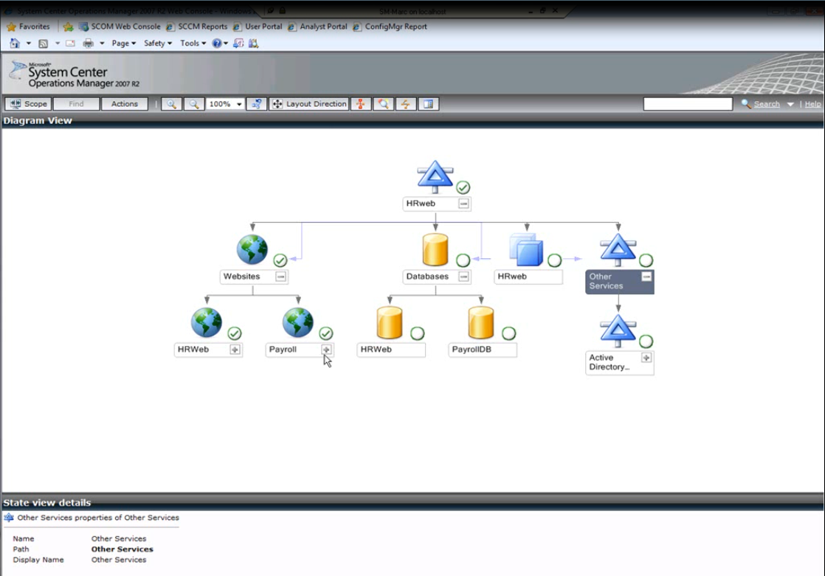
Figure 14. The distributed application HRWeb in the System Center Operations Manager Web console

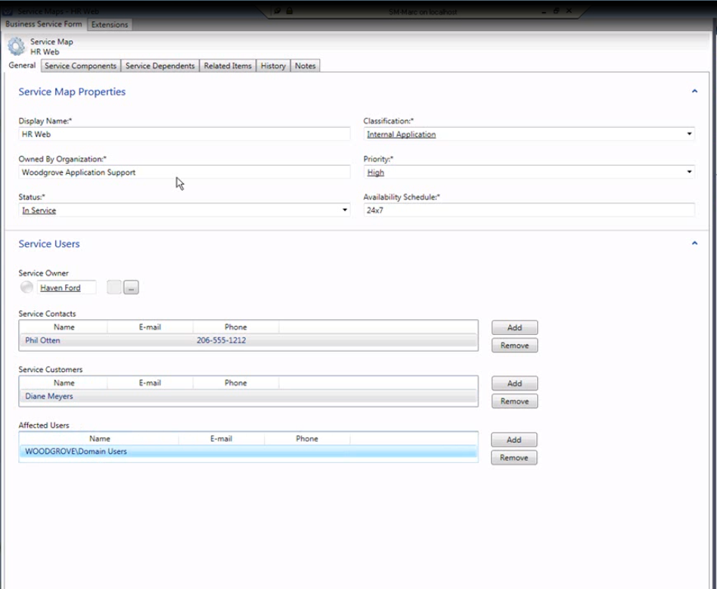
Figure 15. The service map properties form in the System Center Service Manager console
In a similar way, the Operations Manager Management Pack Developer can create or acquire and then import workload management packs that describe distributed applications, including definitions for Exchange, SharePoint, Active Directory, System Center Virtual Machine Manager, and System Center Operations Manager.
A key benefit of managing and controlling services as distributed applications in System Center Operations Manager is that Operations Manager automatically detects new components of a service deployed through its discovery capability. Through the connector to its sister product, System Center Service Manager, it will put those components into the Service Manager configuration management system (CMS).
System Center Operations Manager provides a graphical view of the service and again, through the connector, pushes the service context into the Service Manager CMS, which enables you to see the components in a hierarchical view. In addition, the service can then be managed by various workflows (incident, problem, change, knowledge, and asset management) in Service Manager, which will track the history of work items (incident tickets, change requests, problem tickets, knowledge articles, and asset information) related to the service against the service components. For example, when resolving an incident, a support analyst views the service map information within the CMS to identify the dependent technical components and the business metadata.
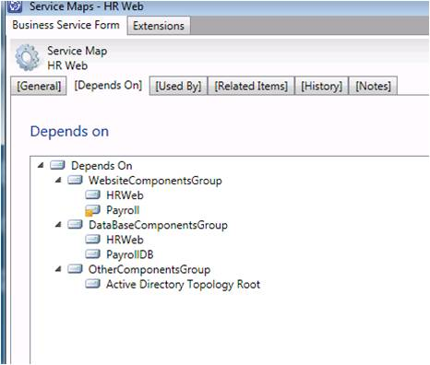
Figure 16. The HRWeb service map in the Service Manager console
Finally, if a service component generates an alert through the connector from Operations Manager to Service Manager, an incident will automatically be generated. When analysts view the ticket, the service context information can provide them with a good understanding of the impact of the incident and sufficient information for a potential root cause analysis.
When imported into System Center Operations Manager, management packs can discover the distributed application hierarchy of a service and its service components. The System Center Operations Manager Administrator can then import those same management packs into System Center Service Manager, and the distributed applications and the service components will flow automatically into the Service Manager CMS.

The distributed applications become a kind of business service in Service Manager, and additional metadata (such as service owner, service customers, operating hours, business criticality, and classification) can be captured about them. So you see that by starting with a service map (the logical view of the service) with System Center Operations Manager, you can physically implement it using software that supports visualization and control of the service.
Table 4. How Service Maps and Microsoft System Center Service Manager Can Help You Meet Your Service Management Challenges
Service management challenge | How service maps and System Center Service Manager can help
Identifying service dependencies for applications and services. Identifying the possible failure points in applications and services requires knowledge of all the dependencies for those applications and services. | System Center Service Manager can import service maps from System Center Operations Manager and extend them to include relevant business, user, and service information. Service maps in System Center Service Manager show how issues affect services, perform root cause analysis faster, and quickly identify the right course for remediation.
Responding more rapidly to changes in business requirements. Providing a data center that can adapt to changing business requirements is essential to modern operations. An organization wants a predictable, compliant, and repeatable process for responding to new requirements. Performing proper change-management processes requires that the organization accurately assess risk by identifying the affected components, the configuration settings to be monitored, the approval process for performing changes, and the corresponding activities required to perform the change. | IT pros can use the predefined templates, integrated CMS knowledge, and service maps in System Center Service Manager to ensure an efficient and effective change-management process for the organization. System Center Service Manager is highly extensible. Use the authoring tool and the Windows Workflow Foundation to create custom, automated activities that execute workflows, code, and automated scripts using the Windows PowerShell™ command-line interface—all without having to write custom code.

Getting Started with Service Maps
These three steps will help you get started with service maps:
- Gather and review service map examples, including those that exist in your organization or examples provided by Microsoft or third parties, for services for which you have primary responsibility and for services that are dependent on the services that you own. Evaluate the layout, the naming conventions, the level of resolution, and the way in which relationships are identified.
- Using the guidance in this document, create and communicate a service map for the services you own to those who depend on those services.
- Share the results with your colleagues and, using the guidance in this document, evaluate the potential applications of service mapping in your organization. Consider who else would benefit from receiving your service maps, based on when, where, and how they add value throughout the service management lifecycle.

For More Information
For more information on MOF:
- Visit http://www.microsoft.com/mof.
For more information on System Center Service Manager:
- Visit the System Center Service Manager home page at http://www.microsoft.com/systemcenter/en/us/service-manager.aspx.
- Obtain the System Center Service Manager download from Microsoft Connect at https://connect.microsoft.com.
- Visit the System Center team blog at http://blogs.technet.com/systemcenter.
For more information on System Center Operations Manager:
- Visit http://www.microsoft.com/systemcenter/opsmgr/default.mspx.

Feedback
Please send comments and feedback to MOF@microsoft.com. To keep current with the latest releases and beta review programs, please subscribe to our news feed at http://www.microsoft.com/mof.

Acknowledgments
The Microsoft Operations Framework team acknowledges and thanks the many people who participated in the development and review of Microsoft Operations Framework Service Mapping. The following people were either directly responsible for or made a substantial contribution to the writing and development of this guide.

Contributors
Joe Coulombe, Microsoft
Jerry Dyer, Microsoft
Mike Kaczmarek, Microsoft
Don Lemmex, Microsoft
Betsy Norton-Middaugh, Microsoft
David Pultorak, Pultorak & Associates, Ltd.
Peter Quagliariello, Pultorak & Associates, Ltd.

Writers and Editors
Jude Chosnyk, GrandMasters
Ruth Preston, Pultorak & Associates, Ltd.
Pat Rytkonen, Volt Technical Services

