Licensing Microsoft Server Products in Virtual Environments

December 2009

Table of Contents

Summary 2
What’s New in this Brief 2
Definitions 3
Server 3
Instance 3
Run an Instance 3
Assigning a License 4
Operating System Environment (OSE) 4
Physical and Virtual Processors 5
I – Overview 6
II – Details and Examples for the Server Licensing Models and Clarifications
for Specific Products 10
II.a. – License by Running Instance 10
Moving Instances of Software 12
Reassigning a Software License 13
Virtual Processors Have the Same Number of Cores and Threads as Physical Processors—
Each Fraction of a Virtual Processor Counts as a Full Virtual Processor 14
II.b. – External Connector Licenses (ECs) Licensed Per Server, Not Per Instance or OSE 16
II.c. – Device Client Access Licenses (CALs) Licensed Per Device, Not Per OSE on that Device 17
II.d. – Management Licenses Licensed Per Managed OSE or Per User 18
II.e. – Per Processor Products Licensed by Virtual Processor When Used in Virtual OSEs 19
II.f. – Run Multiple Instances of Windows Server 2008 R2 on a Server under a Single License 21
II.g. – Run Any Number of Instances of Windows Server 2008 R2 Datacenter on a Server
Licensed by Physical Processors 23

Summary
The purpose of this white paper is to give an overview of Microsoft® licensing models for the server operating system and server applications under virtual environments. It can help you understand how to use Microsoft server products with virtualization technologies, such as Microsoft Hyper-V™ technology, Microsoft Virtual Server 2005 R2, or third-party virtualization solutions provided by VMWare and Parallels.
Although much of the information in this white paper also applies to licenses purchased from channels other than Microsoft Volume Licensing, some differences exist. As a result, we recommend that you review the license terms that accompanied your software if you acquired licenses through a means other than a Microsoft Volume Licensing agreement.

What’s New in this Brief
- This is an update to the “Licensing Microsoft Server Products in Virtual Environments” Volume Licensing brief published in August 2009.
  - Updated references to Windows Server 2008 R2 throughout.
  - Updated diagrams with current products.

Definitions

Server
A server is a physical hardware system capable of running server software. A hardware partition or blade is considered to be a separate physical hardware system, and, therefore, a separate server.
Figure 1 – Different types of servers.
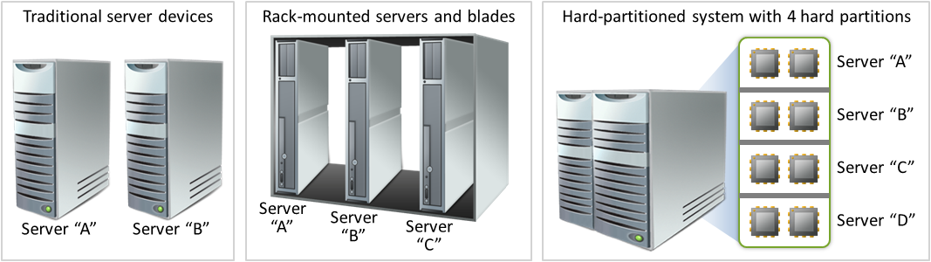

Instance
An instance of software is the set of files that make up the software, stored in executable form and ready to run. You create an instance of software by executing the software’s setup or install procedure, or by duplicating an existing instance. Instances of software can run on physical or virtual hardware systems.
Examples:
- An installed copy of the Windows Server® 2008 R2 operating system on a hard disk is an instance of Windows Server 2008 R2.
- An installed copy of Microsoft Exchange Server 2007 within a virtual hard drive (VHD) (or other image format) file is an instance of Exchange Server 2007.
- A VHD file with Exchange Server 2007 installed on top of Windows Server 2008 R2 contains an instance of Windows Server 2008 R2 and an instance of Exchange Server 2007. Copying that VHD file creates another instance of Windows Server and another instance of Exchange Server. Deploying that VHD file to another server creates an instance of Windows Server and an instance of Exchange Server on that server.

Run an Instance
You run an instance of software by loading it into memory and executing one or more of its instructions. Once this has occurred, an instance is considered to be running (whether or not its instructions continue to execute) until it is removed from memory.

Assigning a License
To assign a license simply means that you designate that license for one device or user. This designation avoids sharing a license across more than one device or user at the same time. For example, after you have assigned a software license to a server, you are permitted to run the software on that server. You may use whatever manual or technical method that works for you to ensure that you have the correct number of licenses to cover your software use.
Figure 2 – Assigning a license.
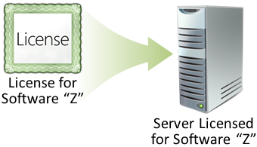

Operating System Environment (OSE)
An “operating system environment” is an instance of an operating system, including any applications configured to run on it. More specifically, an operating system environment is:
- All or part of an operating system instance, or all or part of a virtual (or otherwise emulated) operating system instance that enables separate machine identity (primary computer name or similar unique identifier) or separate administrative rights, and
- Instances of applications, if any, configured to run on the operating system instance or parts identified above.
Two types of operating system environments exist: physical and virtual. A physical operating system environment is configured to run directly on a physical hardware system. Please note that the operating system instance used to run hardware virtualization software (e.g., Microsoft Virtual Server or similar technologies) or to provide hardware virtualization services (e.g., Microsoft Hyper-V or similar technologies) is considered part of the physical operating system environment. A virtual operating system environment is configured to run on a virtual (or otherwise emulated) hardware system. A physical hardware system can have either or both of the following:
- one physical operating system environment
- one or more virtual operating system environment(s)
Use of technologies that create virtual OSEs does not change the licensing requirements for the operating system and any applications running in the OSE.

Physical and Virtual Processors
A physical processor is a processor in a physical hardware system. Physical OSEs use physical processors. A virtual processor is a processor in a virtual (or otherwise emulated) hardware system. Virtual OSEs use virtual processors. For licensing purposes, a virtual processor is considered to have the same number of threads and cores as each physical processor on the underlying physical hardware system.
Figure 3 – Physical and virtual hardware systems and resources.
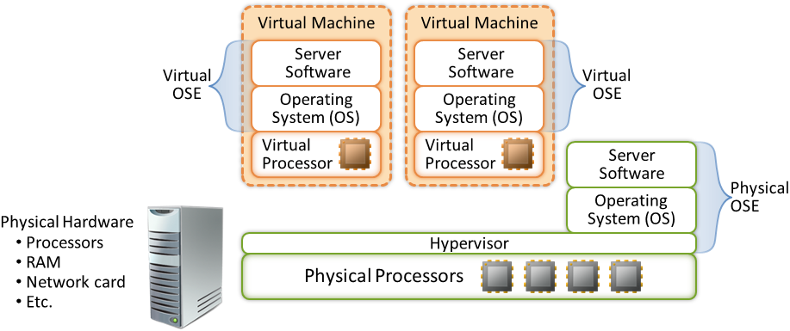

I – Overview
The following summary provides an overview of the licensing models and how virtualization affects them. Your review of this white paper should not be a substitute for careful review and understanding of your rights and obligations as described in your Microsoft Volume Licensing agreement.

Products | Licensing
All products in each of the Microsoft Server licensing models in the Volume Licensing Product Use Rights (PUR), for example:  Windows Server 2008 R2  Exchange Server 2007  Microsoft System Center Configuration Manager 2007 R2 | Use terms for each software license specify the number of instances of software that you may run on a particular server at a time, rather than the number of copies of the software that you may install and use on your server.  Each software license allows you to create and store any number of instances of the software on any of your servers or storage media to make it easier for you to run those instances on any of your licensed servers.  Before you use the software under a license for a server product, you must assign that license to a server.  Each hardware partition or blade is a separate physical hardware system, and, therefore, a separate server.  In general, you may reassign software licenses for server products, but not on a short-term basis (i.e., not within 90 days of the last assignment). However, they may be reassigned sooner if you retire the licensed server due to permanent hardware failure. In addition, for certain server software licenses, under certain conditions, there is a new rule for license mobility within a server farm. For the server farm definition and more information about the server software license mobility rule, including the list of eligible server and EC licenses, please read the Application Server License Mobility Volume Licensing brief.  You may not separate software to run it in more than one OSE under a single license, unless expressly permitted—even if the OSEs are on the same server.
Products in the Microsoft Server OS and Microsoft Server/CAL licensing models of the PUR, for example:  Windows Server 2008 R2  Exchange Server 2007  Microsoft SQL Server® 2008 | Each external connector license (EC) allows any number of external users to access any number of instances of the server software on a particular server, even if those instances are run under multiple licenses for the software. Note that SQL Server does not have an EC.  Each Client Access License (CAL) allows any number of OSEs on a particular device (e.g., client device) to access licensed instances of the corresponding server software. You do not need a separate device CAL for each OSE on a device.  For Windows Server 2008 and Windows Server 2008 R2 you do not need a CAL to access an instance of the server software running on the physical OSE if that instance is being used solely to:  - Run hardware virtualization software,  - Provide hardware virtualization services,  - Run software to manage and service operating system environments on the licensed server.  CALs and ECs permit access to your instances of earlier versions, but not later versions, of the server software, unless stated otherwise in the PUR. If you are accessing instances of an earlier version run pursuant to downgrade rights, you may use CALs and ECs that correspond to the version of the software you are running.  In general, you may reassign an EC license, but not on a short-term basis (i.e., not within 90 days of the last assignment). However, you may reassign an EC license sooner if you retire the server to which it was assigned due to permanent hardware failure. In addition, under certain conditions, there is a new rule for EC license mobility within a server farm. For the server farm definition and more information about the server software license mobility rule, including the list of eligible server and EC licenses, please read the Application Server License Mobility Volume Licensing brief.
Products in the Management Servers licensing model of the PUR, for example:  Microsoft System Center Operations Manager 2007 R2  Microsoft System Center Configuration Manager 2007 R2  Microsoft System Center Data Protection Manager 2007 | Each server management license allows one server OSE on a specific device to be managed by the server software. You need a separate server management license to manage each server OSE.  Each client management license allows one non-server (e.g., client) OSE on a specific device to be managed by the server software. You need a separate client management license to manage each non-server OSE. In addition, you may opt to license “per user.” In this case, for one user, each client management license allows any number of client OSEs on that user’s device(s) to be managed by the server software.  Each System Center Server Management Suite Enterprise (SMSE) license allows up to four OSEs on a licensed device to be managed by the server software. If you are managing four virtual OSEs on the licensed device and the physical OSE is being used solely to run hardware virtualization software, provide hardware virtualization services, and run software to manage and service operating system environments on that device, then you may also manage the physical OSE. These use rights apply to use of the SMSE license with versions of the corresponding System Center products released on or after July 1, 2009. For products released prior to that date, customers may continue to manage OSEs on the licensed device as permitted in the product use rights for those products.  If you assign one System Center Server Management Suite Datacenter (SMSD) license for each processor on the device you wish to manage, you may manage any number of OSEs on that licensed device. A minimum of two SMSD licenses need to be assigned to a device.  Each device-based Core CAL or Enterprise CAL suite license allows any number of client OSEs on a specific device to be managed by the server software.
Products in the Per Processor licensing model of the PUR, for example:  Microsoft BizTalk® Server 2006 R2  SQL Server 2008  Microsoft Internet Security and Acceleration (ISA) Server 2006 | Software run in a virtual OSE is licensed based on the number of virtual processors used by that virtual OSE, rather than all the physical processors in the server. For licensing purposes, a virtual processor is considered to have the same number of threads and cores as each physical processor on the underlying physical hardware system.  If you run the software in virtual OSEs, you need a license for each virtual processor used by those virtual OSEs on a particular server, whether the total number of virtual processors is less than or more than the number of physical processors in that server.  If you run the software in a physical OSE, you need a license for each physical processor used by the physical OSE.  You may run any number of instances in licensed physical or virtual OSEs.

Microsoft also provides expanded use rights for certain editions of Windows Server 2008 R2, SQL Server 2008, and BizTalk Server 2006 R2. These expanded use rights are summarized in the following table. They apply only to the specific editions described.

Products Impacted | Use Rights
Windows Server 2008 R2 Standard | Each software license allows you to run, at any one time, one instance of the server software in an OSE on one server. If the instance you run is in a virtual OSE, you may also run an instance in the physical OSE solely to run hardware virtualization software, provide hardware virtualization services, or run software to manage and service OSEs on the licensed server. We refer to this in shorthand as 1+1.
Windows Server 2008 R2 Enterprise | Each software license allows you to run, at any one time, four instances of the server software in four OSEs on one server. If all four instances you run are in virtual OSEs, you may also run an instance in the physical OSE solely to run hardware virtualization software, provide hardware virtualization services, or run software to manage and service OSEs on the licensed server. We refer to this in shorthand as 1+4.
Windows Server 2008 R2 Datacenter and Windows Server 2008 R2 Itanium Based Systems | After the number of licenses equal to the number of physical processors on a server are acquired and assigned, you may run on that particular server: One instance of the server software in the physical OSE, and any number of instances of the server software in virtual OSEs.
SQL Server 2008 (licensed Server/CAL) Workgroup and Standard | Each software license allows you to run any number of instances of the server software in one physical or virtual OSE on a particular server at a time.
SQL Server 2008 (licensed Server/CAL) Enterprise | Each software license allows you to run any number of instances of the server software in one physical OSE and any number of virtual OSEs on a particular server at a time.
BizTalk Server 2006 R2 Enterprise Edition and SQL Server 2008 Enterprise (licensed Per Processor) | As an alternative to the model described above, after the number of licenses equal to the number of physical processors on a server are acquired and assigned, you may run any number of instances of the server software in the physical OSE, and any number of instances of the server software in virtual OSEs.

II – Details and Examples for the Server Licensing Models and Clarifications for Specific Products
The following sections provide details and examples for server licensing models and clarify enhancements for specific products.

II.a. – License by Running Instance

All products in the Microsoft Servers licensing models are licensed by running instance. Each license gives you the right to run a certain number of instances of the software on a specific server at a time.
The use rights specify that you must first “assign” an acquired software license to a specific server. After the license has been assigned:
- That server is the “licensed server” for that software license.
- You may run instances of the software on the licensed server as specified in the product use rights for the product.
- You may create and store any number of instances of the software on any of your servers or storage media.
For example, each license for Exchange Server grants you the right to run one instance of Exchange Server at a time. That instance may be run in a physical or virtual OSE, but only on the licensed server. However, you may create or store any number of instances of Exchange Server on any of your servers or storage media. As Figure 4 below illustrates, if you assign an Exchange Server license to server A, you may run one instance of Exchange Server in one physical OSE (Figure 4 – A) or in one virtual OSE (Figure 4 – B).
Figure 4 – Running an instance of Exchange Server in a physical or virtual OSE.
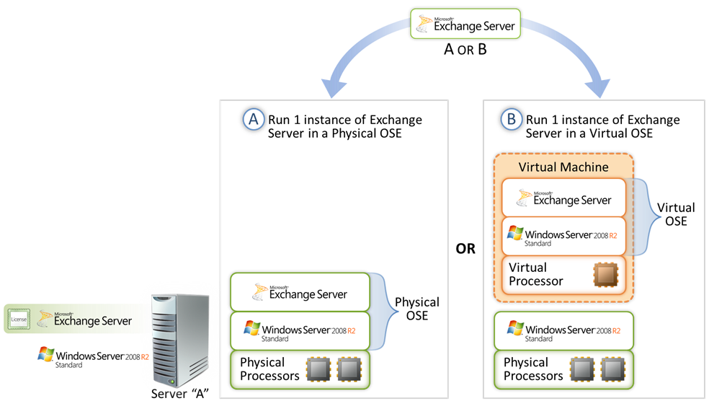
In Figure 5 below, the storage area network (SAN) contains six virtual hard drive (VHD) files, each with an instance of Windows Server 2008 R2 and an instance of Exchange Server. Two VHD files are deployed from the library onto the server at a time, depending on the domain that needs the support of additional instances. This SAN scenario illustrates the deployment flexibility enabled by the licensing model. Instead of eight licenses, you need assign only two licenses for Windows Server 2008 R2 Standard to server A because only two instances of Windows Server 2008 R2 Standard are running at a time.
Similarly, instead of eight licenses, you need assign only two licenses for Exchange Server because only two instances of Exchange Server are running at a time. By assigning those licenses to server A, you are also able to create any number of instances of Windows Server 2008 R2 Standard and Exchange Server on any of your servers or storage media, including a server’s hard disk or the SAN.
It is worthwhile to underscore the fact that you can assign more than one license to a server to have the right to run more instances. For example, in the figure below, two Windows Server 2008 R2 Standard licenses have been assigned to the server. Each license permits you to run an instance in a virtual OSE and an instance in a physical OSE. If you assign two licenses to the server, you may run two instances in virtual OSEs at the same time. While you also have the rights to run an instance in the physical OSE for each license, for technical reasons only one instance can run at a time in the physical OSE.
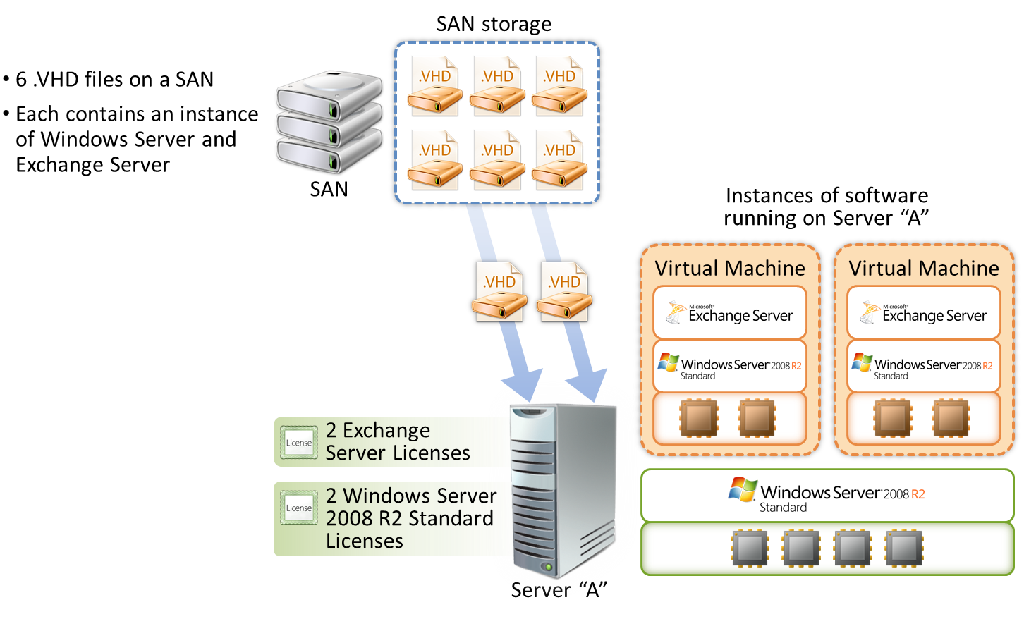
Figure 5 – Applying the licensing model to a SAN scenario.

Moving Instances of Software
The ability to move instances of the software is ideal for data centers, where workloads move from one server to another. Regardless of whether a data center uses server blades, rack-mounted servers, or virtualization technology, it is easy to move an instance of software between licensed servers.
For example, in Figure 6 below, server A and server B have each been assigned one license for Windows Server 2008 R2 Standard and one license for Exchange Server 2007. Originally, one instance of Exchange Server is running on server A. If Server A becomes overloaded, you can choose to move the running instance of Exchange Server to server B, since server B also has an Exchange Server license assigned to it. However, you may run only one instance of Windows Server 2008 R2 Standard and one instance of Exchange Server on server A at a time. Similarly, you may run only one instance of Windows Server 2008 R2 Standard and one instance of Exchange Server on server B at a time.
In addition, for certain server software licenses, under certain conditions, there is a new rule for license mobility within a server farm. For the server farm definition and more information about the server software license mobility rule, including the list of eligible server and EC licenses, please read the Application Server License Mobility Volume Licensing brief.
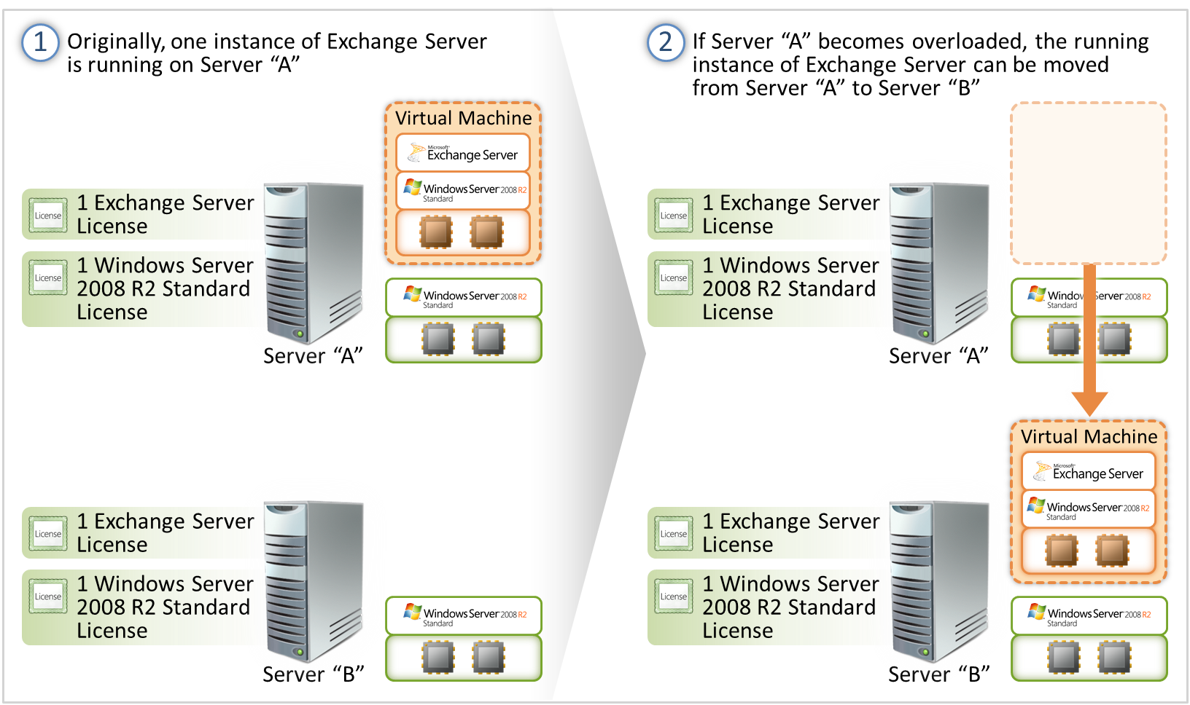
Figure 6 – Moving instances of software from one server to another.

Reassigning a Software License
Moving an instance of software from one server to another is not the same as reassigning a software license from one server to another. Moving an instance of software means to move the software bits from one server to another. Reassigning a software license means to assign that license to another server so that it becomes the server licensed to run that software.
For example, in Figure 7 below, the instances of Windows Server and Exchange Server move from server A to server C and the licenses to run those instances are reassigned from server A to server C. If the licenses are not reassigned, server C cannot run the instances. By reassigning the licenses, however, server C is now the new server licensed to run the instances and Server A is no longer the licensed server.
Figure 7 – Reassigning a software license from one server to another.
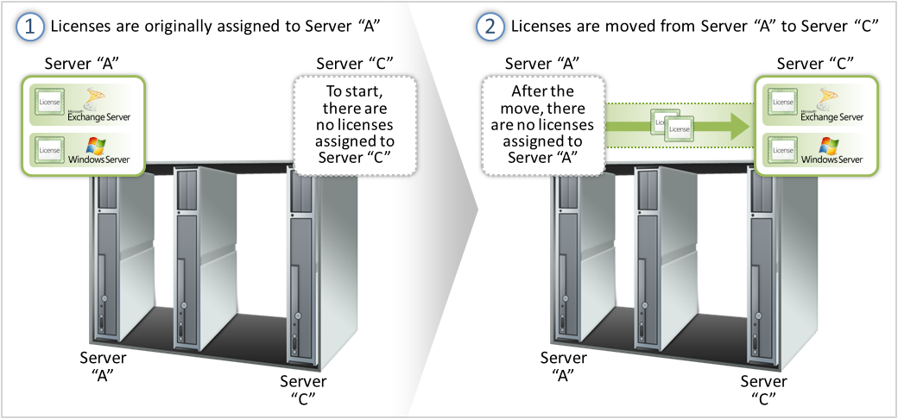
In general, as a Microsoft Volume Licensing customer, you may reassign software licenses for products in the Microsoft Servers licensing models, but not on a short-term basis. “Short-term basis” means more frequently than within 90 days of the last assignment (or reassignment). You may, however, reassign software licenses sooner if you retire the server sooner due to permanent hardware failure. In Figure 7, for example, if server A is retired due to permanent hardware failure, you may then reassign the licenses for Windows Server and Exchange Server to server C.
In addition, for certain server software licenses, under certain conditions, there is a new rule for license mobility within a server farm. For the server farm definition and more information about the server software license mobility rule, including the list of eligible server and EC licenses, please read the Application Server License Mobility Volume Licensing brief.

Virtual Processors Have the Same Number of Cores and Threads as Physical Processors—Each Fraction of a Virtual Processor Counts as a Full Virtual Processor

This section is relevant if you are using Per Processor products on multicore processor systems. To boost reliability and performance, virtualization technology can allocate resources from separate physical processors in the server to create a virtual processor for use by a particular OSE. Virtual processors are considered to have the same number of threads and cores as each physical processor in the underlying physical hardware system. Microsoft adopted this definition to enable you to take advantage of the licensing policy we announced in 2004 for multicore processors. If the physical processors in the server have two cores, each virtual processor also has two cores from a licensing perspective, even if the cores are allocated from separate physical processors.
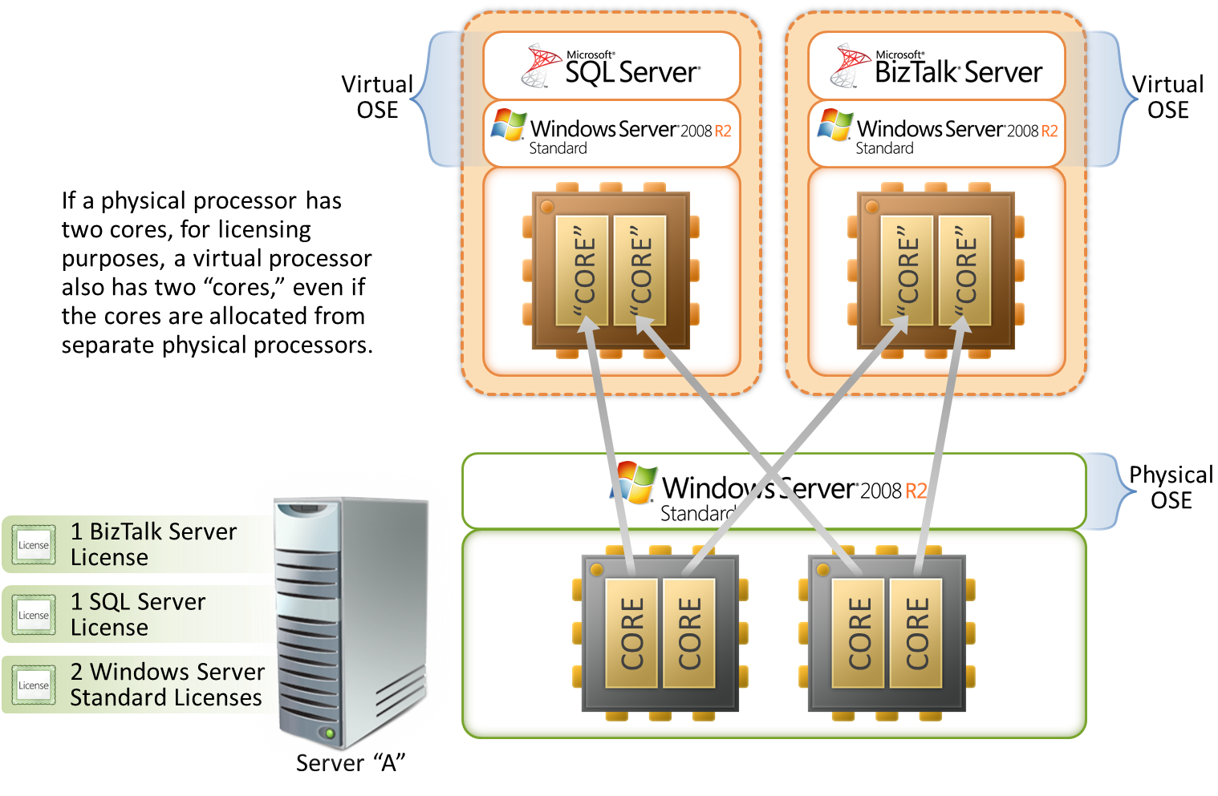
For example, in Figure 8 below, the virtual processor used by the virtual OSE on the left is allocated a core from physical processor 1 and a core from physical processor 2. Although that virtual processor is using cores from different physical processors, it is considered to be a single virtual processor because it has the same number of cores as the physical processors in the server. Consequently, you only need one license each for SQL Server (licensed Per Processor) and BizTalk Server for server A.
Figure 8 – The allocation of cores to virtual processors.

However, if a virtual OSE uses only a fraction of a virtual processor, the fraction counts as a full virtual processor. As demonstrated in Figure 9 below, the licensing requirements do not change if you choose to allocate only a single core to each virtual OSE; a full license is required for SQL Server and a full license is required for BizTalk Server.
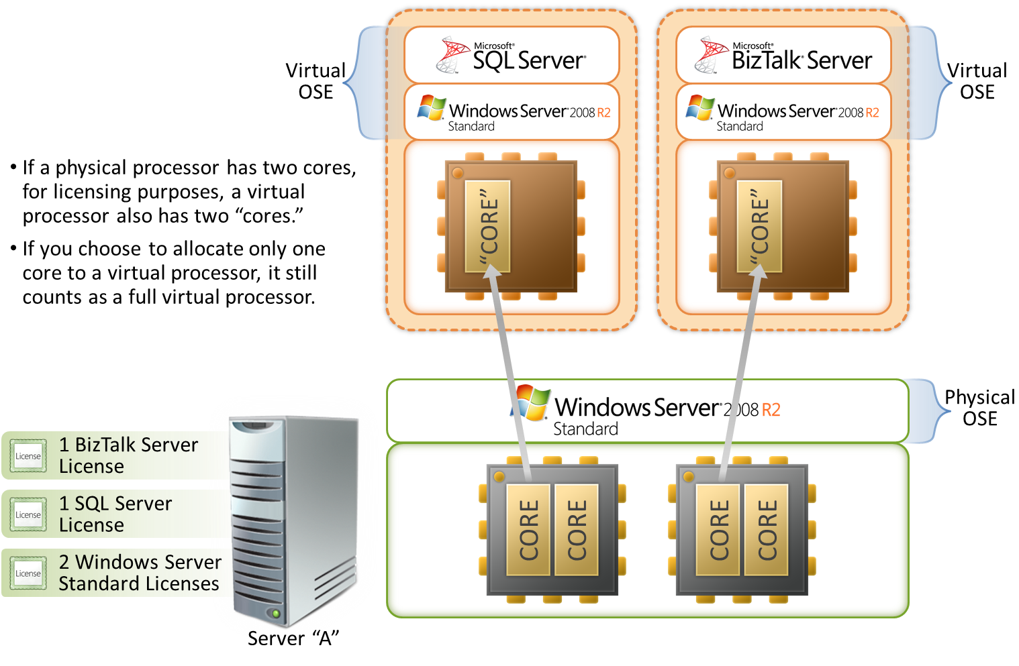
Figure 9 – Virtual OSEs that use only fractions of a virtual processor.

II.b. – External Connector Licenses (ECs) Licensed Per Server, Not Per Instance or OSE

For products in the Server OS and Server/CAL licensing models, each EC assigned to a server allows any number of external users to access any number of licensed instances of the server software on that server. You do not need a separate EC for each instance of the software, or for each OSE on that server. As demonstrated in Figure 10 below, even if server A is running multiple instances of Windows Server 2008 R2, you need only one EC for any number of external users to access Windows Server 2008 R2 on server A. It does not matter whether those instances of Windows Server 2008 R2 are run under one or many licenses.
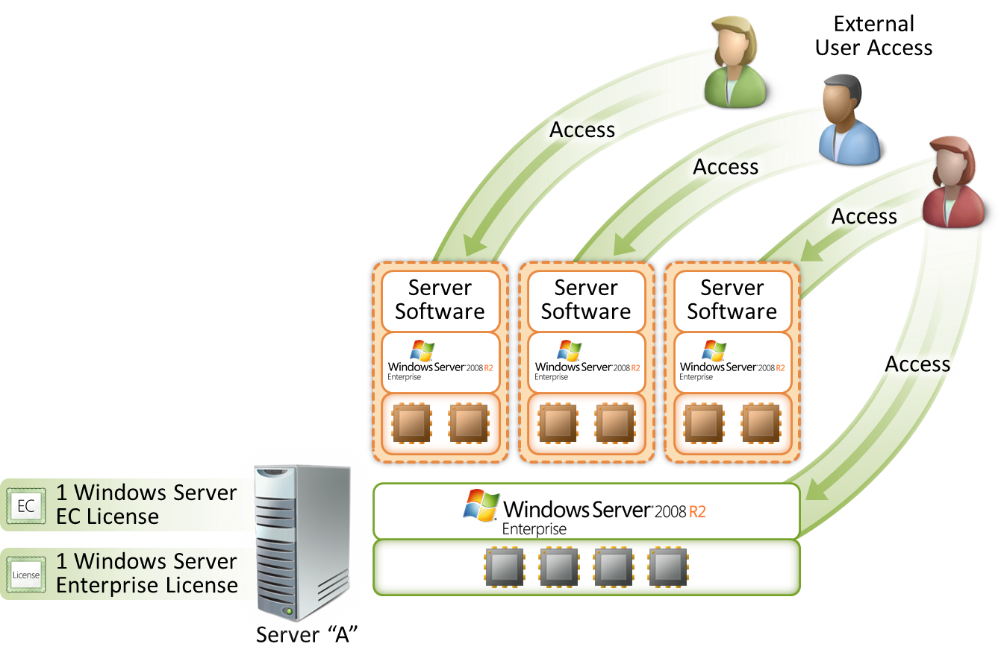
Figure 10 – ECs licensed per server, not per instance or OSE.

ECs permit access to your instances of earlier versions, but not later versions, of the server software, unless stated otherwise in the PUR. If you are accessing instances of an earlier version run pursuant to downgrade rights, you may use ECs that correspond to the version of the software you are running.
Reassignment of EC licenses. In general, you may reassign an EC license, but not on a short-term basis (i.e., not within 90 days of the last assignment). However, you may reassign an EC license sooner if you retire the server to which it was assigned due to permanent hardware failure.
In addition, under certain conditions, there is a new rule for EC license mobility within a server farm. For the server farm definition and more information about the server software license mobility rule, including the list of eligible server and EC licenses, please read the Application Server License Mobility Volume Licensing brief.

II.c. – Device Client Access Licenses (CALs) Licensed Per Device, Not Per OSE on that Device

You only need one device CAL for each device that accesses the server software, regardless of the number of OSEs on the device. As demonstrated in Figure 11 below, even if the desktop PC has multiple OSEs, and each of those OSEs is separately accessing Windows Server 2008 R2 on servers B and C, you need only one CAL for the desktop PC.
Figure 11 – Device CALs licensed per device, not per OSE on that device.
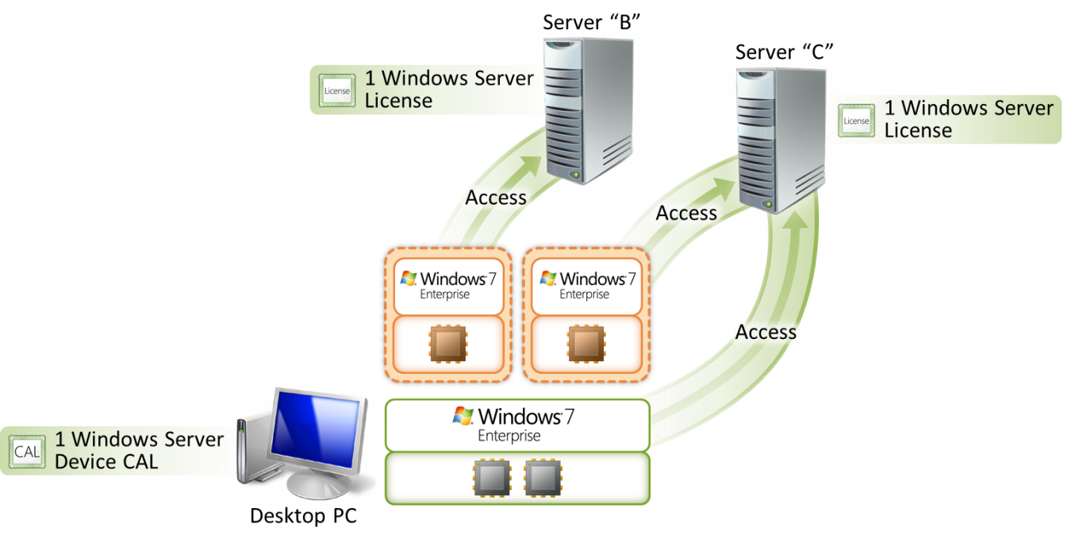
CALs permit access to your instances of earlier versions, but not later versions, of the server software, unless stated otherwise in the PUR. If you are accessing instances of an earlier version run pursuant to downgrade rights, you may use CALs that correspond to the version of the software you are running.

II.d. – Management Licenses Licensed Per Managed OSE or Per User

Each management license allows one OSE on a specific device to be managed by the server software. You need a separate management license for each OSE you need to manage. For example, in Figure 12 below, server A is running more than one OSE. System Center Operations Manager 2007 (SC Operations Manager), which is running on server B, is managing each of the OSEs in server A. In this case, you need one management license for each OSE on server A, for a total of four management licenses. You also need a SC Operations Manager server license for server B, which is the server that is doing the management.
Another option would be to assign a System Center Server Management Suite Enterprise (SMSE) license to Server A. This allows up to four OSEs on a licensed device to be managed by the server software. In addition, if you are managing four virtual OSEs on the licensed device and the physical OSE is being used solely to run hardware virtualization software, provide hardware virtualization services, and run software to manage and service operating system environments on that device, then you may also manage the physical OSE. These use rights apply to use of the SMSE license with versions of the corresponding System Center products released on or after July 1, 2009. For products released prior to that date, customers may continue to manage OSEs on the licensed device as permitted in the product use rights for those products.
If you assign one System Center Server Management Suite Datacenter (SMSD) license for each processor on the device you wish to manage, you may manage any number of OSEs on that licensed device. A minimum of two SMSD licenses need to be assigned to a device.
For client OSEs, you may also opt to license “per user,” in which case each client management license allows any number of client OSEs on a user’s device to be managed by the server software.
Finally, the Core CAL and the Enterprise CAL Suites permit any number of OSEs on a client device to be managed by SC Configuration Manager. The Enterprise CAL Suite also permits any number of OSEs on a client device to be managed by SC Operations Manager.
Figure 12 – Management licenses licensed per managed OSE.
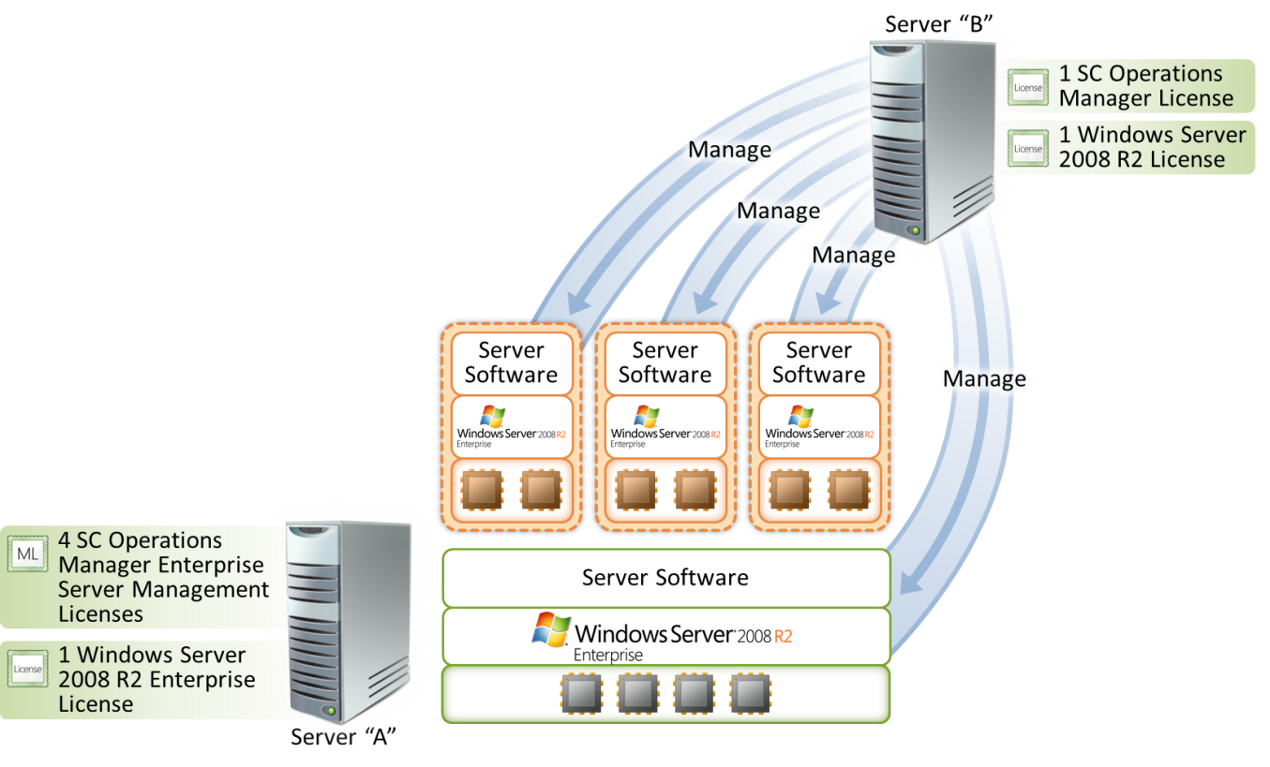

II.e. – Per Processor Products Licensed by Virtual Processor When Used in Virtual OSEs

In virtual environments, all products in the Per Processor licensing model are licensed by virtual processor. If you run the software in virtual OSEs, you need a license for each virtual processor used by those OSEs on a specific server, rather than all the physical processors in the server. If you run the software in physical OSEs, you need a license for each physical processor used by the physical OSE.
To license a server appropriately, you must follow three steps for each Per Processor product running on the server:
Count the number of physical processors the physical OSE in which the software will run is using.
Count the number of virtual processors each virtual OSE in which the software will run is using. (A virtual processor is considered to have the same number of threads and cores as each physical processor on the underlying physical hardware system. Fractions of virtual processors count as full virtual processors.)
Add the numbers together and assign that number of licenses to the server on which the software will run.
After the server has been appropriately licensed, you may run any number of instances of the software in any number of physical and virtual OSEs on the licensed server.
Similar to hardware partitioning, the licensing model treats virtualization technology as a means of assigning and allocating processors to a specific workload. For example, to determine the required number of licenses for SQL Server Standard (licensed Per Processor) for server A in Figure 13 below (assume each processor is a single core processor):
Step 1—There are no instances of SQL Server Standard running in the physical OSE. The count for this step is zero.
Step 2—There are instances of SQL Server Standard running in two separate virtual OSEs. Each of those virtual OSEs is using one virtual processor. The count for this step is two.
Step 3—To license server A appropriately for SQL Server Standard, you must assign it two SQL Server Standard licenses.
Figure 13 – Licensing Per Processor products by virtual processor.
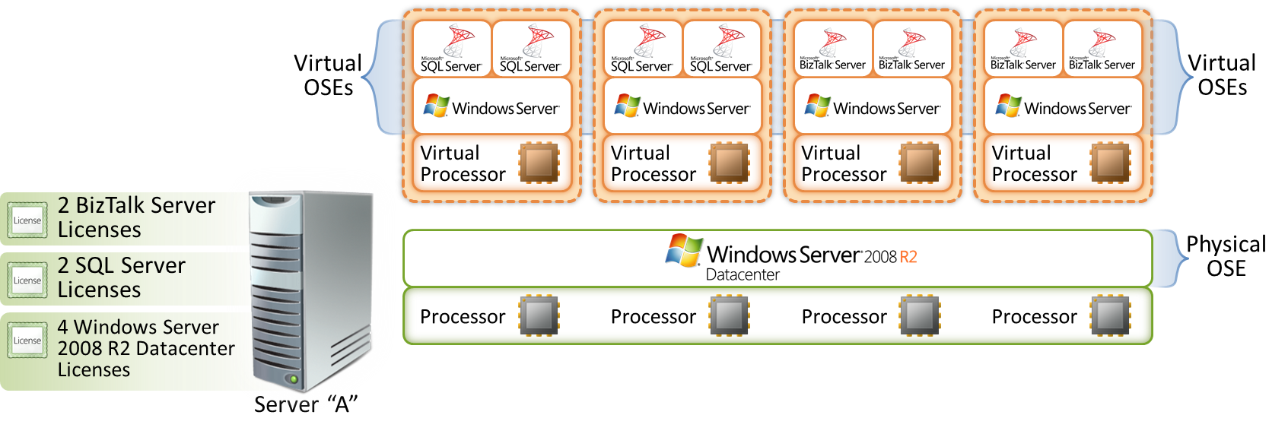
Similarly, to count the number of licenses for BizTalk Server for server A:
Step 1—There are no instances of BizTalk Server running in the physical OSE. The count for this step is zero.
Step 2—There are instances of BizTalk Server running in two separate virtual OSEs. Each of those virtual OSEs is using one virtual processor. The count for this step is two.
Step 3—To license server A appropriately for BizTalk Server, you must assign it two BizTalk Server licenses.
The number of licenses required is not affected by the number of instances of the software running in a particular OSE. It is based on the number of physical or virtual processors used by each OSE running the software.
Under this model, you may find that you assign more virtual processors to virtual OSEs than the total number of physical processors in the server. For example, in Figure 14 below, SQL Server Enterprise is running in five virtual OSEs, each of which is using one virtual processor. Assigning five SQL Server Enterprise licenses to server A is one way to license it appropriately. However, SQL Server 2008 also provides an alternative for SQL Server Enterprise. With SQL Server Enterprise, you may license all the physical processors on a server and then you may run any number of instances in OSEs on that server without licensing the virtual processors. This would be the most cost-effective way to license the scenario below. BizTalk Server 2006 R2 Enterprise Edition has the same licensing option.
Finally, instead of acquiring six Windows Server 2008 R2 Standard licenses, you could acquire four Windows Server 2008 R2 Datacenter processor licenses, one for each physical processor. You would then have the right to run any number of Windows Server instances on the licensed server. You could also acquire two Windows Server 2008 R2 Enterprise licenses, which provide the right to run up to eight (four for each license) Windows Server 2008 R2 instances in virtual OSEs at the same time.
Figure 14 – More virtual processors than physical processors.
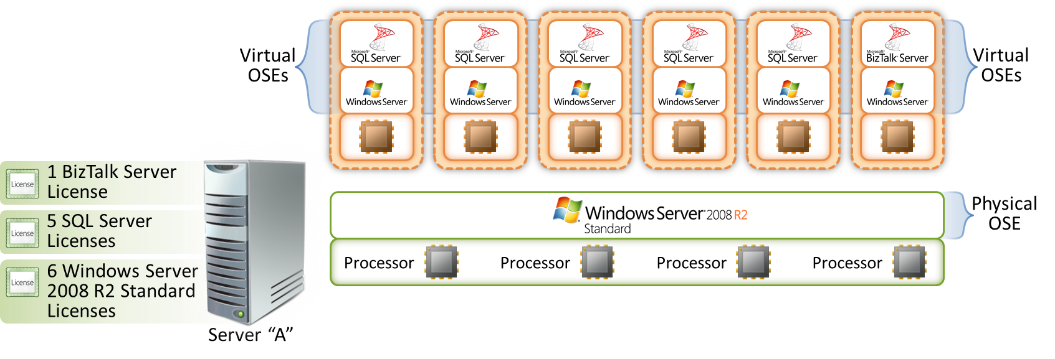
Instances of Per Processor products on servers that are not using virtualization technology run in the physical OSE of the server, and a license is required for each physical processor in the server. For example, in Figure 15 below, you need four processor licenses for SQL Server because there are four physical processors in the server. The number of licenses required is not affected by the number of instances of the software running in a particular OSE. It is based entirely on the number of physical or virtual processors used by the OSE running the software.
Figure 15 – Licensing Per Processor products running in the physical OSE.
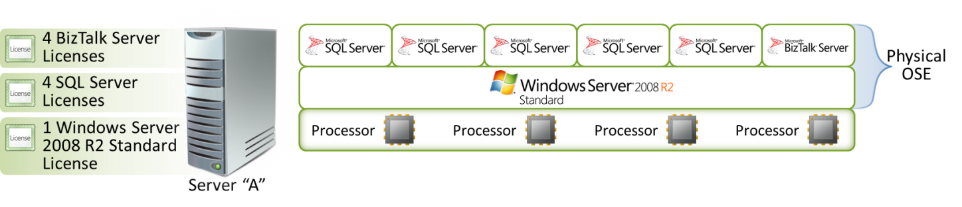
As discussed above, both BizTalk Server 2006 R2 Enterprise Edition and SQL Server 2008 Enterprise have expanded use rights. If you license all of the physical processors on a server, you may run any number of instances of the server software in the physical OSE and any number of instances of the server software in virtual OSEs. In this case, you do not need to license virtual processors. For example, by assigning four licenses of SQL Server Enterprise to a server with four physical processors, you may run any number of instances of SQL Server Enterprise in the physical and virtual OSEs.

II.f. – Run Multiple Instances of Windows Server 2008 R2 on a Server under a Single License

A single license for Windows Server 2008 R2 Enterprise allows you to run multiple instances of the software on a server. Each software license allows you to run, at any one time, four instances of the server software in four OSEs on one server. If all four instances are running in virtual OSEs, you may also run an instance in the physical OSE solely to run hardware virtualization software, provide hardware virtualization services, or run software to manage and service OSEs on the licensed server.
In addition, you may run instances of Windows Server 2008 R2 Standard or even prior versions of Windows Server Standard or Windows Server Enterprise in place of the instances of Windows Server 2008 R2 Enterprise in any of the OSEs. For example, in Figure 16 below, server A is running five separate instances of Windows Server in five separate OSEs. Server A’s physical OSE is running an instance of Windows Server 2008 R2 Enterprise. Two of server A’s virtual OSEs are running instances of Windows Server 2008 R2 Standard, one is running an instance of Windows Server 2003 R2, and another one is running one instance of Windows Server 2008 R2 Enterprise. By assigning a Windows Server 2008 R2 Enterprise license to server A, you may run all five instances on server A under that single license.
Figure 16 – Windows Server 2008 R2 Enterprise lets you run up to five instances on a server.
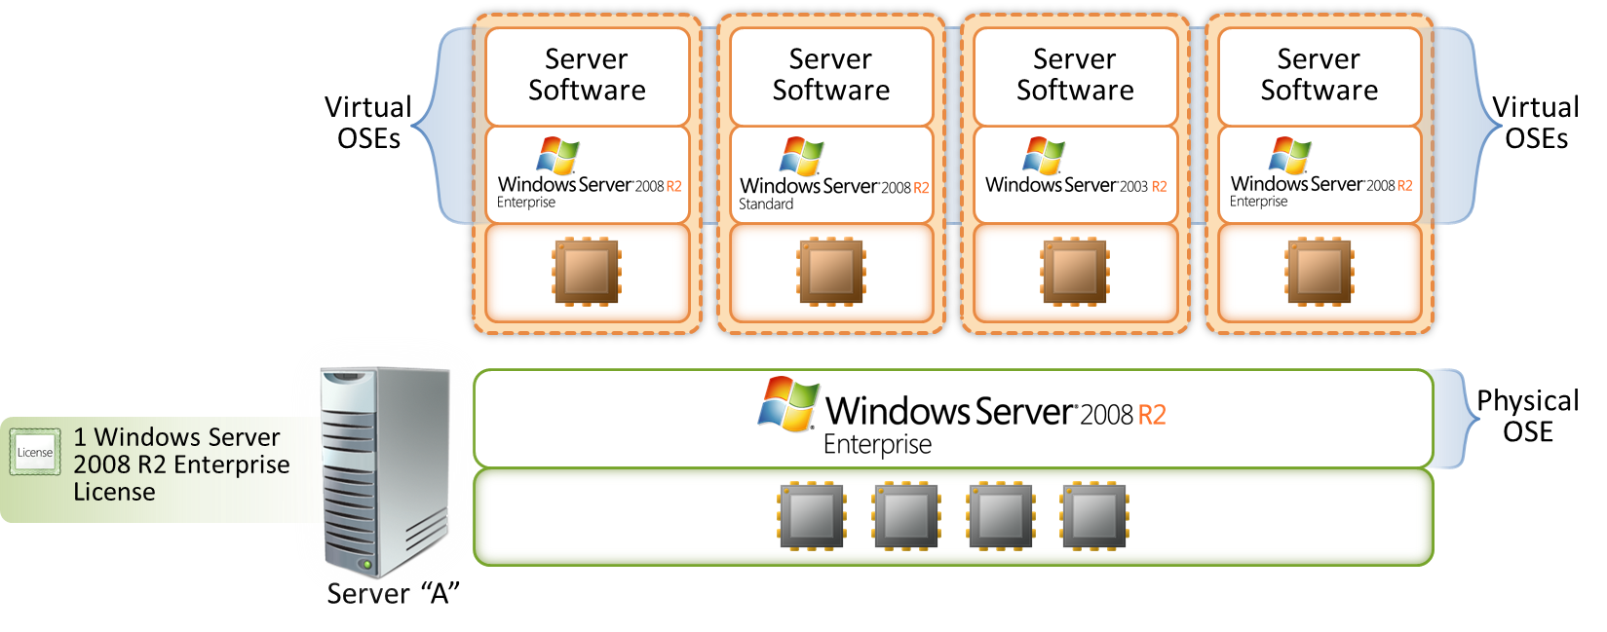

Almost everything discussed above applies to Windows Server 2008 R2 Standard. However, unlike Windows Server 2008 R2 Enterprise, each license for Windows Server 2008 R2 Standard allows you to run only one instance in the physical OSE and one instance in the virtual OSE. If you run the two instances, the instance running in the physical OSE is restricted to running hardware virtualization software, providing hardware virtualization services, or running software to manage and service OSEs on the licensed server. Also, if the server is licensed for Windows Server 2008 R2 Standard, you cannot run Windows Server 2008 R2 Enterprise in place of Windows Server 2008 R2 Standard on the server. You may run prior versions of Windows Server Standard only.
As stated above, in Figure 16, if you decide to run all five permitted instances under a license for Windows Server 2008 R2 Enterprise, the instance running in the physical OSE is restricted to running hardware virtualization software, providing hardware virtualization services, or running software to manage and service OSEs on the licensed server. In other words, in this situation, you can run any software in the physical OSE as long as it is used solely to manage or directly support the management of the virtual OSEs on the licensed server. When running all five instances at the same time, you may not run software in the physical OSE for any other purpose.

Finally, if you have a server running an instance of Windows Server 2008 R2 in a physical OSE, you need a Windows Server 2008 CAL to access that instance, except in the case where that instance is being used solely to:
i) Run hardware virtualization software,
ii) Provide hardware virtualization services,
iii) Run software to manage and service operating system environments on the licensed server.
However, note that you need appropriate CALs to access any virtual OSEs and Microsoft applications that are running on the server.

So in a situation where you are running Windows Server 2008 R2 in the physical OSE and Windows Server 2003 in virtual OSEs and you are using the physical OSE solely to i) run hardware virtualization software, ii) provide hardware virtualization services iii) run software to manage and service operating system environments on the licensed server, you do not need CALs to access the Windows Server 2008 R2 instance. You do need, however, Windows Server 2003 CALs to access any of the virtual OSEs.

II.g. – Run Any Number of Instances of Windows Server 2008 R2 Datacenter on a Server Licensed by Physical Processors

Windows Server 2008 R2 Datacenter enables you to run any number of instances of the software on a server, as described below. Each server must be licensed according to how many physical processors are in the server. (Virtual processors are not used for the licensing of Windows Server 2008 R2 Datacenter) After you have determined the number of licenses required, you must assign those licenses to the server, at which point you may run the following at any one time:
- One instance of the server software in the physical OSE, and
- Any number of instances of the server software in virtual OSEs

In addition, you may run instances of Windows Server 2008 R2 Standard, Windows Server 2008 R2 Enterprise, or even prior versions of Windows Server instead of Windows Server 2008 R2 Datacenter in any of the OSEs. As shown in Figure 17 below, server A is running six separate instances of Windows Server in six separate OSEs. Server A’s physical OSE is running an instance of Windows Server 2008 R2 Datacenter. One of server A’s virtual OSEs is running an instance of Windows Server 2008 R2 Standard, one is running an instance of Windows Server 2008 R2 Enterprise, one is running an instance of Windows Server 2003 R2 Standard Edition, and one is running an instance of Windows Server 2008 R2 Datacenter.
Figure 17 – Windows Server 2008 R2 Datacenter lets you run any number of instances on a server.
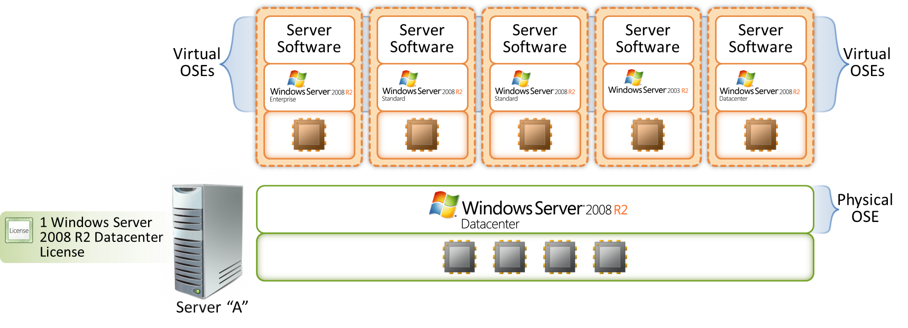

In general, it is much easier to consolidate on Windows Server 2008 R2 Datacenter than it is on Windows Server 2008 R2 Standard or Windows Server 2008 R2 Enterprise.
Although Windows Server 2008 R2 Datacenter is licensed by physical processor, Client Access Licenses are still required for access.

© 2009 Microsoft Corporation. All rights reserved.
This document is for informational purposes only. MICROSOFT MAKES NO WARRANTIES, EXPRESS OR IMPLIED, IN THIS DOCUMENT. This information is provided to help guide your authorized use of products you license; it is not your agreement. Your use of products licensed under your volume license agreement is governed by the terms and conditions of that agreement. In the case of any conflict between this information and your agreement, the terms and conditions of your agreement control. Prices for licenses acquired through Microsoft resellers are determined by the reseller.

Software licenses refer to the license for the software bits. To license a product appropriately, you might also need additional licenses (e.g., Client Access Licenses, external connector licenses, management licenses. Please refer to the Product Use Rights document for Volume Licensing customers.)
Each hardware partition or blade is a separate physical hardware system, and, therefore, a separate server.
You can create instances of the software only to exercise your right to run instances of the software. You do not have the right, for example, to create instances of the software to make them available for distribution outside your organization.
In Figure 7, servers A and C are probably running on virtualization technology. For clarity, the license count in this example and illustration does not show the instances of Windows Server 2008 R2 running in the physical OSE.
For more information on this policy, please visit http://www.microsoft.com/licensing/highlights/multicore.mspx
Please also see the details and examples for Windows Server 2008 R2 Enterprise: Each license allows the user to run 1+4 instances of the software on a server; or for Windows Server 2008 R2 Datacenter: The user may run any number of instances of the server software on a server for and to which the appropriate number of processor licenses have been acquired and assigned (one per processor).
Each hardware partition or blade is a separate physical hardware system, and, therefore, a separate server.
Each hardware partition or blade is a separate physical hardware system, and, therefore, a separate server.
In Figure 11, the desktop PC is running on virtualization technology. For clarity, since this is not the subject demonstrated in this illustration, the licenses necessary to allow for multiple instances of Windows Vista Enterprise are not shown.
The multiplexing rule applies to CALs, even with virtualization technology. In Figure 11, if servers B and C are used to pool access for multiple devices or users, each of those end users and devices requires a CAL. Please see “Multiplexing” in the Universal License Terms of the PUR.

