“Ensuring project teams have the skills required for both implementation and ongoing management and maintenance of new technologies is essential to maximizing the value organizations receive from their technology.”
– Cushing Anderson, IDC vice president, IT Education and Certification research
Without question, the condition of the economy is having a fundamental impact on how companies conduct business. While organizations are looking to cut costs and reduce risks wherever possible, they’re also turning to IT to maximize the efficiency of their existing assets.
Yet, while IT is playing a more crucial role than ever before, IT project success rates “remain abysmal,” according to IDC. The best way to reduce the risks of these projects, according to the same research, is developing the skills of the team. Almost 30 percent of the respondents to the study said the skill of the project team was the most important factor in IT project success.
In fact, there’s a strong correlation between skills development and IT project success. On average, organizations that spent 8 percent of project budget on training met their objectives 85 percent of the time; those spending 10 percent met objectives 100 percent of the time.
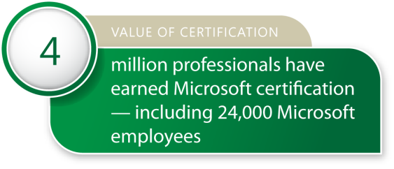
The economy makes skills development critical for individuals as well. Certification, as an industry-recognized validation of skills, is a proven differentiator—whether the individual is a seasoned IT professional looking to demonstrate his or her value to the organization, or someone looking to break into the industry for the first time.
Over the last 17 years, Microsoft has invested heavily in skills development—and certification as a validation of skills—because it knows, from third-party and its own research, that the training and certification process drives satisfaction—and improving customer satisfaction is a core value for Microsoft.
After a period of downturn, the demand for IT certification has increased dramatically. Microsoft alone has experienced 24 percent growth over the last year—reflecting the growing acceptance and importance of certification in the learning process. For IT professionals, Microsoft training and certification ranks second as a satisfaction driver (after eLearning).
As a leader in the certification industry with more than 4 million IT professionals having earned certifications to date (including over 24,000 employees), Microsoft has spent considerable time and effort in conducting and commissioning research to quantify the true value of skills development. It has also used research to validate the relevance of its certification program, resulting in significant improvements to better address the needs of IT professionals.
And those modifications come at a time when the IT industry is facing significant challenges.
The IT challenge
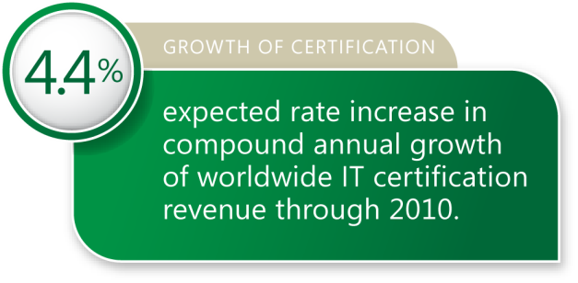
In addition to the significant challenges the economy presents, IT organizations are confronted by two major trends: the imminent mass retirement of baby boomers, which will deplete the ranks of U.S. IT staffs, and a shortage in trained replacements due to a smaller crop of college graduates with IT degrees. The number of undergraduate computer science majors fell by 40 percent between 2000 and 2004, and there has been a 70 percent decline in interest in pursuing the major.
The lack of skilled IT professionals is already being felt. According to a Gartner study, 40 percent of operational downtime is due to operator error—attributable to a significant lack of training on core systems.
Additionally, there are several studies that suggest there will be a significant gap in the next five to ten years between the demand for and supply of IT professionals with the right technical skills. An IDC study places that gap at 40 percent.
The lack of qualified employees is driving a significant need for skills development and certification, which is reflected in the 24 percent growth for the certification industry last year. IDC forecasts increased global spending on the IT education and training market through 2012 and an increasing demand for IT skills that will drive the need for more certification.
At the same time, there’s a growing body of research that confirms the positive impact certification has on IT organizations.
Certification improves organizational performance
A study conducted by IDC looked at the organizational performance of more than 2,000 IT teams, examining the relationship of team performance to the percentage of the team certified on a variety of technologies. The study states: “Unequivocally, certification, as a measure of skill, showed a positive correlation to performance improvement.”
In the areas of general service excellence and specific measures of task-level performance, certification made a measurable impact:
Certification leads to faster implementations
“The ‘badge of honor’ I received upon earning certification was an incredibly effective way to market myself. I could now clearly demonstrate that I was proficient in that particular technology.”
– Joey Gurango, Chief Technology Officer,
Gurango Software, The Philippines
The Gurango Software Corporation differentiates itself from its competitors by giving the highest priority to Microsoft certification as a means for determining internal promotion, motivating 90 percent of its employees to hold at least one certification. With this selling point, Gurango Software has successfully closed an impressive rate of business deals. In addition, the company credits Microsoft certification in helping deliver shorter development cycles and faster implementations.

- Sixty percent of managers surveyed believe the skill of the team contributed most to the success of technology function.
- Seventy-five percent of managers believe that certification is important to team performance.
- Sixty-six percent of managers believe that certification improves the level of service and support offered to IT end users/customers.
- Team performance increases every time a new team member is certified.
- Concentration certification in a team is clearly linked to team capability and performance.
- With a sufficient percentage of team members certified, IT operational performance can increase up to an average of 11 percent. The research suggests that about 25 percent of IT professionals hold some form of relevant certification.
The IDC study concludes: “Certifications represent rigorous and meaningful bodies of knowledge and deliver tremendous value to near-term organizational success for companies using them as a component of talent development. And while each new certification increases team performance, “average” functional proficiency only occurs when a team has more than 40 percent of the team certified. At the same time, high-performing teams spend less time deploying and fixing solutions and spend more time maintaining and improving the systems they operate.”
Similar work conducted by IDC on behalf of Microsoft in 2006 reported similar conclusions in relationship to the performance of Microsoft certified teams: “Teams that I have studied certified by Microsoft meet similar performance benchmarks,” said IDC’s Cushing Anderson.
In a 2006 customer satisfaction survey conducted for Microsoft, 63 percent of hiring managers felt certified professionals were more productive than their non-certified peers. A 2007 survey reported that 38 percent of MCPs surveyed (up from 32 percent a year earlier) feel their ability to be more productive on the job was directly attributable to certification. And for IT professionals, Microsoft training and certification ranks second as a satisfaction driver (after eLearning).
Proactively developing team skills, according to an IDC study, is the best way to improve organizational performance: “Training represents one concrete step IT managers can take to assure project teams possess the skills necessary to reduce failure risk, decrease costs, and increase project effectiveness.”
Driven to earn certification
Microsoft commissioned research to better understand the current IT market, how certification can best serve it and the perceived value of certification. The study initially surveyed nearly 1,500 certified and non-certified IT professionals globally; follow-up research is being conducted on an ongoing basis.
Through the course of the research, three common themes consistently arose which led to the development of a framework to describe how IT professionals perceive value of certification. These three themes, or pillars, are the driving factors supporting certification for all certification audiences: certified individuals, non-certified individuals, organizations, learning partners, and academia.
The pillars:
Relevance
Relevance addresses the issues of immediate applicability, productivity, and skill validation. In an industry where change is constant, the workforce must have the skills to do its job more efficiently. Both certified and non-certified professionals demand that any educational activity have immediate application to their job situation and/or compensation.
Journey
Certification is increasingly viewed as a key reflection of an individual’s progression in competency, not a one-off investment motivated by short-term economic gain. Each stage of the career or business lifecycle is marked with its own unique issues. Through offering IT solutions beneficial across all stages and engaging with individuals as they progress, certification maintains credibility and motivates IT professionals and developers to continue learning.
Credible certification
“I respect the people that make the effort to earn certifications because it takes a lot of studying, a lot of hard work, experience, drive and desire. So, if somebody is willing to put forth that effort, I respect that.”
– Keith Terry, IT manager, Seattle

Community
One of the key benefits of certification is affiliation with the certifying organization and access to a professional community of peers. Community is the premier way for Microsoft to engage with its customer base.
The three pillars can be viewed as a pyramid similar to Maslov’s hierarchy of needs. Beginning with “relevance,” individuals need to see a connection between education activity and job situation or pay scale. As professionals move beyond that into the “journey” stage, the role of certification becomes more about showing progress and abilities. Finally, successful completion of the certification process allows them access to the “community,” where they can take advantage of the networking and professional growth opportunities enjoyed by being a member of a community spawned by the organization responsible for the certification.
The research confirms that the value of certification is the entire process of learning, validation, and involvement in the IT community.

Relevance: credibility, productivity, collaboration
What are people’s perceptions about certification? While satisfaction with certification had some room for improvement, respondents still had a strong belief in its value—regardless of whether they were certified or non-certified professionals. At a high level, the two main themes that drive relevancy are that certification should:
- Enable productivity and collaboration, and
- Validate skill sets and drive individual credibility.
The New Microsoft Certifications
The new Microsoft certification program provides shorter certification paths that are targeted to specific job roles or technologies, so individuals can more quickly acquire relevant credentials to prove their expertise.
There are four series of credentials:
- Microsoft Certified Technology Specialist (MCTS)
- Microsoft Certified IT Professional (MCITP) and Microsoft Certified Professional Developer (MCPD)
- Microsoft Certified Master (MCM)
- Microsoft Certified Architect (MCA).
The new credentials make the path for individuals more targeted and allow individuals to choose a certification path as either Technology Specialist or Professional and display specific skills directly on the certification logo.

The perception is that certification makes an IT professional credible. “Microsoft certifications are like a gold standard. They give credibility to your skill set and provide a better know-how as to manage and deploy IT solutions.”
One way Microsoft is helping increase relevance is through its new certification program, which emphasizes both the primary technology skill set and the job role of the individual. The program’s shorter certification paths allow individuals to more quickly acquire relevant credentials to prove their expertise.
The new certifications support IDC’s guidance that companies need to “invest in shorter, portable training. As we recommended last year, because the worldwide workforce is becoming increasingly mobile and less time is available for employees to attend classroom-based training or sit online for extended periods, IT training vendors must invest in formats that make shorter training an appropriate option.”
Performance-based testing
While there was a perception among respondents that certification tests are static in nature, the new certifications counter that.
Microsoft is currently piloting a new performance-based testing system. Performance-based testing exams imitate the functionality of product components or environments, complete with error messages and dialog boxes. They analyze an individual’s behavior while solving the issues, so they test and validate that individual’s real-world skills. By making exams more connected to a real-world experience, Microsoft makes certification more relevant to IT professionals and hiring managers.
Relevancy also means providing certification for the newest technologies as soon as they become available. Certification on Microsoft Virtualization Solutions is a good example.
Microsoft Virtualization is a key part of Dynamic IT, which is an environment that helps organizations respond to business challenges. Microsoft now offers coursework that lets people earn certification on virtualization and show they have trained on and demonstrated real-world skills in Microsoft virtualization technologies.
Developed by customers
Training, experience, validation
“I’m really interested in getting my Microsoft certification, not just for a possible salary increase, but for the training, the experience, the confidence that I know what I’m doing, and the actual piece of paper that says I know what I’m doing.”
– Alex Brooks, IT manager, Seattle

Microsoft ensures its certifications are relevant by developing them with the help of its customers. All exams are beta tested by IT professionals to ensure their relevancy. The certification has multiple versions and is constantly refreshed to reflect the changes in the technology landscape.
Microsoft certification is also in the process of being certified by the American National Standards Institute (ANSI)—a first in the certification industry for an individual IT vendor. ANSI has been the administrator and coordinator of the United States private sector voluntary standardization system for more than 90 years and is the primary organization in the country to assess and promote the integrity of those standards.
ANSI certification will provide one more level of confidence that Microsoft certification meets the highest standards in the industry.
Relevance for all constituencies
For certifications to be relevant they must be relevant to every key segment in the IT community: hiring managers, individuals, and customers/partners.
Hiring Managers. For hiring managers, certification provides a common, industry-recognized framework to evaluate candidates. In a 2007 IDC whitepaper sponsored by Microsoft on making pre-hire assessments, there was a strong relationship between productive employees and Microsoft certification. The study found that Microsoft Office Specialist-certified employees needed less supervision than non-certified employees, and that certified employees had greater credibility in general. From a hiring manager standpoint, the dual benefits of increased staff productivity and making better hiring decisions point to an obvious return on employee development.
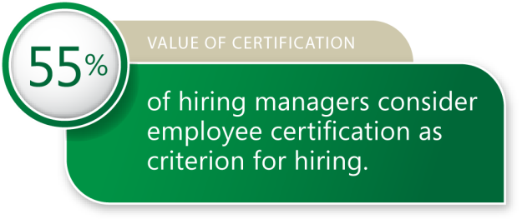
The 2006 MCP Customer Satisfaction Survey found that 63 percent of hiring managers feel that certified individuals are somewhat or far more productive than their non-certified counterparts. In addition, 55 percent of hiring managers think certification is a criterion for hiring, while 46 percent see certification as a criterion for promotion.
Individuals. For individuals who want to significantly differentiate themselves from their peers, developing and validating their skills through certification has never been more important. Certified professionals can troubleshoot better, are more effective and more productive. In the IDC white paper, overall individuals with certification were more valuable to the organization. “Tests of general ability and certifications are strongly correlated to divergent thinking abilities, suggesting that individuals who achieve success with these measures cope better with changing work roles and are more adaptive and innovative.”
Walking The Talk
“We need to walk our talk and demonstrate that our certifications provide incredible value to the productivity of a workforce. By having everyone obtain certification, we send a message to our customers and partners that we are serious about building a world-class sales organization and that we want them to have the best resources available to them to address their business needs.”
– Microsoft COO Kevin Turner

Customers/Partners. You can’t make the case for the relevance of certification if you’re not willing to “eat your own dog food.” Microsoft has set a goal to certify every employee worldwide—with over 24,000 earning certifications already. Microsoft requires all its partners to be certified on its technology as well.
Fighting fraud, protecting privacy
Because partners and customers look to Microsoft to deliver the highest quality exams and certifications, Microsoft takes seriously the importance of protecting the investment certified professionals make in achieving professional certification.
Microsoft makes every effort to ensure its exams are secure and that certified professionals have rightly earned their title. Microsoft has a team focused on preventing and addressing exam fraud, piracy, and any other illegal exam and certification activities. All violations of the rules for the certification program are reviewed, addressed, and action is taken.
Relevance of certification addresses the issues of immediate applicability, productivity, and skill validation. As individuals move beyond that, they begin to see certification as an ongoing complement to their career development, a continual journey of learning and advancing skill levels.
Journey: staying current, advancing careers
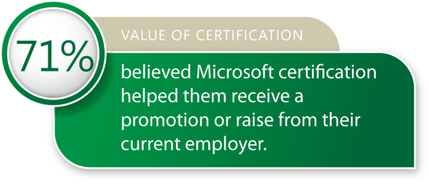
As individuals advance in their careers, certification begins to develop into a tool that adds value across all stages of an individual’s career path. While some respondents to the survey said that certification declined in importance once you get a job offer, the study also revealed that certification was a key driver for staying current on the latest technologies and being eligible for pay raises and promotions. Fifty-six percent of respondents who achieved Microsoft certification in order to improve their marketability/billable rates indicated that they accomplished this goal. Seventy-one percent stated that they believed Microsoft certification helped them receive a promotion or raise from their current employer.
The study found that nothing replaces experience to prospective employers—and the best validation is Microsoft certification. Certified professionals stand to gain more pay as well as being viewed as more productive and valuable. According to Redmond Magazine’s 2006 survey of compensation for Microsoft IT professionals, 43 percent of respondents reported a salary increase as a result of Microsoft certification. More than 40 percent of respondents said that Microsoft certification was a factor in improving their ability to find or keep a job, or led to a promotion.
Microsoft research conducted in Europe also found a positive connection between salaries and certification. In France, the average salary for a non-certified developer was 30,811€ ($45,440 US), while a developer with one or several Microsoft Certified Professional designations earned on average 35,235€ ($51,965 US). In Germany, a non-certified developer earns on average 37,042€ ($54,630), while certified ones earn 44,166€ ($65,137).
Skills development is more important than ever, as the pace of technological change is relentless. Microsoft provides a framework that can be used to stay current by providing the opportunity to evolve through a series of certification levels. From a standpoint of personal benefits that flow from certification, refer to the diagram below:
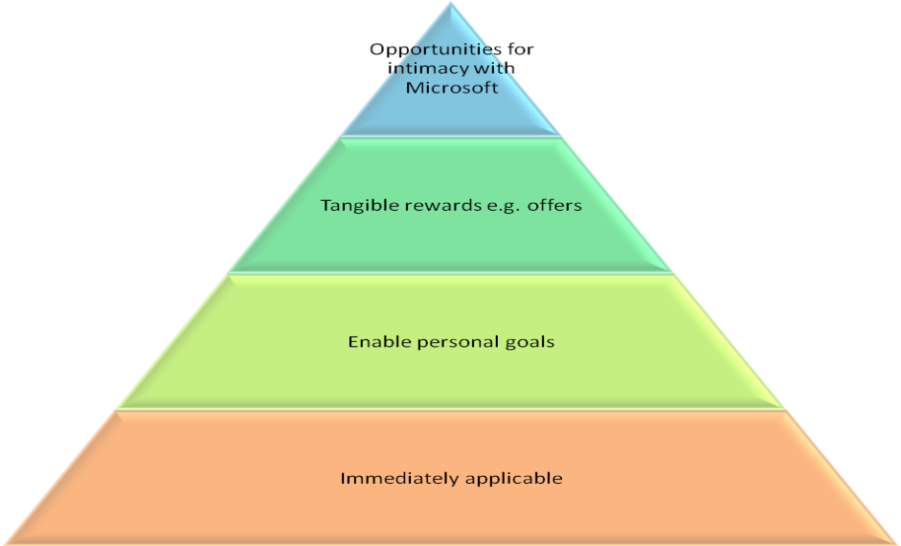
As individuals move up the pyramid, they move through the three pillars. Initially, the focus is on earning certification to get a job (relevance). Then, the benefits of certification are to achieve goals and advance their career in the journey stage. Finally, at the community stage, the individual views certification as a channel to richer relationships with peers and Microsoft.
A myth of certification
There is a myth that IT professionals who earn certification leave the organization quickly thereafter for better jobs. In fact, certification leads to higher job satisfaction and better employee retention.
Forty-three percent of respondents to an IDC Web-based survey in 2006 found hiring managers said that investing in employee development reduces turnover, probably because employees have increased job satisfaction and feelings of increased engagement.
An MSEmploy study,which analyzed the resumes of 15,526 IT professionals in France and Germany, found that those with one or more MCPs were 15 percent more stable, and those with full certifications were 24 percent more stable in their jobs than their peers with no certifications.
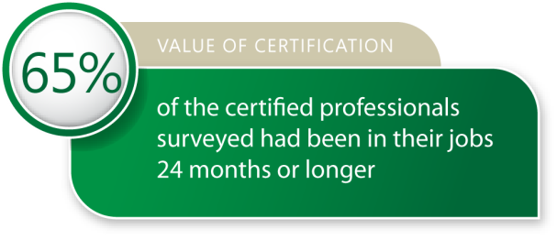
In a recent Zoomerang study, 65 percent of the certified professionals surveyed had been in their jobs 24 months or longer; 77 percent had been in their jobs one year or longer.
Certification improves staff stability, which is a good criterion for companies to evaluate the ROI of their training investment.
The journey of learning, skills improvement, and career advancement is made all the more fulfilling because of the certification process—and once certified, you become part of a vibrant community of your peers.
Community: networking, personal growth, exclusive resources
Microsoft Certified Professionals form a unique community with Microsoft as its hub. Individuals can take advantage of the networking and professional growth opportunities, which, according to the research, is a much more poignant aspect of the value of certification that was previously envisioned.
Certified individuals have access to exclusive resources
“I like the exclusive resources for certified professionals. You’ve proven that you understand the concept, so Microsoft can give you more resources that you’re qualified to use.”
– Brent Black, IT manager, Seattle

Microsoft also recognizes that the community is an important way to engage with its customer base. Certification has become a valuable channel for deeper engagements that lead to improved customer satisfaction. Through direct communication with individuals in the community, people can provide suggestions to improve the program, communicate new ideas to Microsoft, and work together to increase the satisfaction of the structure and content of Microsoft certification. Additionally, through this forum, Microsoft works with the industry to drive the value of certification, so that the awareness and perceived value of certification increases.
The most significant benefit of membership in the community is the access to a group of like-minded professionals who can act as resources to each other and provide support on a professional level. For partners, an important benefit is the ability to get partner level access to Microsoft systems, which enables access to unique resources and people that would otherwise be unavailable.
The research revealed sentiments that people wanted to be involved in the community pillar at the higher levels of the needs hierarchy. When asked about ways that Microsoft could improve its certification process, one respondent indicated a desire for “. . . a level of relationship [where] the advanced guys give back to the community or attend events for free or serve as mentors on behalf of Microsoft.”
Respondents also wanted to have access to Microsoft and feel like they were being treated better if they had certification. These feelings demonstrate the importance of developing a robust community around certification, which is what Microsoft has done.
For example, one benefit of the community is in the development of the certification itself. The role of the community in certification is not well known in some areas—many don’t realize that if you are Microsoft Certified you can also participate in the process of building new certifications. Microsoft continually reaches out to its MCP community for help in creating new certifications so MCPs can partner with Microsoft professionals and other technical experts in developing and testing beta exams.
Once individuals are established in their careers, community elements become more important as they are resourced more. A close affiliation with Microsoft and access to the professional community that surrounds it is the sense of community that is important to certified professionals.
Certification validates skills
“It is a validation of the skill set, not only for the employee’s self-confidence, but for management’s confidence in that employee. And that’s key. If you have somebody that you brought into your team from within the organization and turn them loose on SMS to manage an 8,500-machine environment, management would really like to know that they have the skills it takes.”
– Brent Black, IT manager, Seattle

Global shifts in IT increase demand for certification
Globally, IT is facing challenges. The aging workforce is a key trend worrying employers worldwide. In the U.S., vendors will be competing for an increasingly smaller pie as the overall U.S. workforce struggles to replace retiring baby boomers. Over the next 12 years, only five million people will enter the U.S. workforce while 25 million will be retiring. As experience leaves a company, retaining or replacing knowledge will be critical.
Outside of North America, shortages of IT and other technical skills will lead to accelerated corporate training initiatives and global sourcing for buyers in the United States, Canada, Western Europe, and Asia/Pacific. Increasing demand will likely result in job migration from lower-paying occupations to higher-paying professions, particularly in the fields of networking and application development.
In Asia specifically, there is a prevalence of IT outsourcing. China is now granting 600,000 science and engineering degrees per year and India is granting 400,000. Twenty-six percent of Japan’s population is over 55.The India-based National Association of Software and Services Companies (Nasscom) estimates that India will face a shortfall of 500,000 IT professionals by 2010.
What does this mean for certification? Multiple studies suggest there will be a wide gap in the next five to ten years between the demand for people who work in IT and the supply of workers with the right technical skills.
Certification increases business 80 percent
“Having certified individuals within the company awards the organization with hard evidence which serves to outshine competitors.”
- Joy Rathnayake, Senior Software Engineer
IronOne Technologies
Sri Lanka
IronOne Technologies, a software design and development company which specializes in outsourced IT services, has increased its businesses 80 percent by winning new projects on the basis of certification. IronOne Technologies is a preferred partner for projects involving Microsoft Global Services and Asia Consulting Services thanks to their various areas of expertise with certified employees.
Rathnayake, who leads IronOne’s .NET team, stresses that having certified staff gives the company hard evidence of skill sets which then lead to project wins and increased businesses.

A 2008 study commissioned by the Computing Technology Industry Association that surveyed more than 3,500 IT managers in 14 countries found that there are gaps in several critical technical areas. There is a wide gap between the IT security skills that organizations want and the corresponding skills that workers bring to the job.
Among organizations surveyed in nine countries with established IT industries (Australia, Canada, France, Germany, Italy, Japan, the Netherlands, United Kingdom, and United States), 73 percent identified security, firewalls, and data privacy as the IT skills most important to their organizations. But just 57 percent said their IT employees are proficient in these security skills.
The gap is even wider in five countries where the emergence of a strong IT industry is relatively recent: China, India, Poland, Russia, and South Africa. Among respondents in these countries, 76 percent identified security as the top skill their organizations need, but just 57 percent said their current tech staffs are proficient in security.
Because of the lack of qualified employees available, there’s a significant—and increasing—need for training and certification.
Certification drives satisfaction, productivity
From the wealth of research conducted this decade on the value of certification, it is clear that the need for dynamic certification programs is stronger than ever and that the growth rate will continue to rise.
According to IDC, “When all factors that impact team performance are considered (including turnover, motivation, installed technology, experience, and certification), training and team skill have the most significant impact. Consequently, well-trained teams derive more benefit from their technology investments than undertrained teams. When teams are sufficiently trained, their functional performance can be dramatically improved.”
Microsoft certification reflects and validates real-world skills and experiences while improving the performance of IT professionals, developers, and information workers. It adds value across all stages of an individual’s career path, so it is valuable for job seekers, new and advanced skill building, and upward career growth. Being Microsoft certified means being part of the larger IT community with exclusive access to valuable Microsoft resources and benefits, and opportunities to connect with a wide network of certified professionals.
By driving certification among industry professionals, Microsoft has realized a strong connection between customer satisfaction and certification. Microsoft is intensely interested in continuing to improve customer satisfaction and will continue to utilize the certification path to invest in this channel. As evidence of this commitment, Microsoft Learning plans to train more individuals on its technologies, with the goal of continuing to grow the numbers of certified professionals.
Microsoft certification is continually updated and measured for relevance in the marketplace, so it remains an effective tool for job satisfaction and career growth. Certification training provides skills that professionals can immediately apply in a work situation. With the new certifications, Microsoft has structured its training to provide the flexibility to learn the way individuals prefer.
Microsoft continually invests to ensure that its certification is credible and valued in the marketplace.
Skills development improves performance, employability
Skills development is crucial for success in today’s economic climate. As IDC states: “During difficult economic periods when pressure increases to produce more with less, IT managers may see training programs as a place to cut costs. But cutting training will backfire. IDC shows an undeniably tight link between training, team skill and project success.”
For individuals, skills development validated by certification is a key differentiator that significantly improves employability. Certification provides a framework that can help individuals learn at all stages of their careers, not just in the lead-up to getting the first job in IT. Microsoft certification is relevant across all stages of an individual’s career. Certification helps people stay current. Research also shows that Microsoft certification helps give clarity to people in planning their future career goals.
Finally, earning certification is the key to a vibrant community of certified professionals and access to unique Microsoft resources. Being Microsoft certified raises the credibility of a professional’s skills. Microsoft certification ensures that partners can stay current on all Microsoft technologies so they can better service customers.
Microsoft certification programs develop and validate real-world IT skills, support the certified community by providing access to unique resources, and offer a life-long career path of IT skills development.

IDC, “Average IT Project Success: How Successful Do You Want To Be?” January 2009, IDC #216169, Volume: 1
ibid
ibid
Microsoft Metrics That Matter
Tom Kucharvy, “North America's IT staffing 'time bomb': managing the demographic shift,” Ovum, 28 September 2007
The Higher Education Research Institute at the University of California
Gartner Security Conference presentation: Operation Zero Downtime, D. Scott, May 2002
IDC whitepaper sponsored by Cisco Learning Institute, “Networking Skills in North America: Trends, Gaps, and Strategies,” Doc #210587, May 2008
IDC, “Worldwide and US IT Education and Training 2008-2012 Forecast Growth Through Situation Tenuous,” Doc #211332, March 2008
“Impact of Training: Functional Excellence Leads to Operational Productivity,” IDC, Doc# 215762, Dec. 2008
Microsoft Learning (2007). Microsoft Certified Professional (MCP) customer satisfaction study (2007 ed.). Redmond, WA: Various
Metrics That Matter
IDC, “Impact of Training on Project Success,” January 2009, IDC#216168, Volume; 1
Intrepid Consultants, “Microsoft Learning, Value Of Certification: Market Intelligence Meta-Analysis,” 2008
Intrepid Consultants, Microsoft Learning Value of Certification study, June 2008
“Worldwide and U.S. IT Education and Training 2008-2012 Forecast : Growth Though Situation Tenuous,” IDC, Doc #211332, March 2008
Cushing Anderson, IDC White Paper sponsored by Microsoft, “Preventing Bad Hires: The Value of Objective Prehire Assessment,” IDC, Doc # 204941, January 2007
ibid
2007 Microsoft Certified Professional (MCP) Customer Satisfaction Study
MSEmploy Study, 2008
IDC White Paper sponsored by Microsoft, “Preventing Bad Hires: The Value of Objective Prehire Assessment,”, Doc # 204941, January 2007
MSEmploy survey, February 2008, MSEmploy.com
Zoomerang, “Prometric IT Candidate Study”
Intrepid Consultants, Microsoft Learning Value of Certification study, June 2008
Tom Kucharvy, “North America's IT staffing 'time bomb': managing the demographic shift,” Ovum, 28 September 2007
Tom Kucharvy, “North America's IT staffing 'time bomb': managing the demographic shift,” Ovum, 28 September 2007
http://www.certmag.com/read.php?in=3515
http://www.certmag.com/read.php?in=3515
IDC, “Worldwide and US IT Education and Training 2008-2012 Forecast Growth Through Situation Tenuous,” Doc #211332, March 2008
IDC, “Impact of Training on Project Success,” January 2009, IDC#216168, Volume: 1

