Hyper-V Hosting Guidance:

Using and Licensing Microsoft® Server Products in
Hyper-V Virtual Hosting Scenarios

Microsoft Hosting Guidance
Friday, January 08, 2010

Version 3.0

The information contained in this document represents the current view of Microsoft Corporation on the issues discussed as of the date of publication. Because Microsoft must respond to changing market conditions, it should not be interpreted to be a commitment on the part of Microsoft, and Microsoft cannot guarantee the accuracy of any information presented after the date of publication.
This White Paper is for informational purposes only. MICROSOFT MAKES NO WARRANTIES, EXPRESS, IMPLIED OR STATUTORY, AS TO THE INFORMATION IN THIS DOCUMENT.
Complying with all applicable copyright laws is the responsibility of the user. Microsoft grants you the right to reproduce this white paper, in whole or in part, specifically and solely for the purpose of understanding licensing implications for hosting scenarios using virtualization.
Microsoft may have patents, patent applications, trademarks, copyrights, or other intellectual property rights covering subject matter in this document. Except as expressly provided in any written license agreement from Microsoft, the furnishing of this document does not give you any license to these patents, trademarks, copyrights, or other intellectual property.

© 2009 Microsoft Corporation. All rights reserved.
Microsoft, Active Directory, Hyper-V, SharePoint, SQL Server, Windows, the Windows logo, Windows PowerShell, Windows Server, and Windows Vista are trademarks of the Microsoft group of companies.
All other trademarks are property of their respective owners.

Contents
List of Acronyms 1
Changes in this version of the whitepaper 2
Outsourcing and non-outsourcing 2
Introduction of Prior Version Rights in SPLA 2
Conversion options for SPLA partners 3
Hosting Scenarios and Licensing Considerations 4
Licensing of Various Windows Server Editions 5
Windows Server 2008 R2 Enterprise 6
Windows Server 2008 R2 Datacenter 6
Use of Central Storage 6
Use of Other Non-Microsoft Virtualization Technologies 6
Hosting Scenarios 7
Scenario 1: Unmanaged Dedicated Server as Host with One or More Guests 7
Scenario 2a: VDS – Unmanaged 8
Scenario 2b: VDS – Managed 8
Scenario 3: Outsourcing Scenario: Virtual Dedicated Servers 10
Scenario 4: Shared Hosting Configurations 10
Scenario 5: Running Desktop Systems as Hyper-V Guests 10
Scenario 6: Using End-Customer Licenses on the Guest 11
Running Microsoft SQL Server 2008 with Hyper-V 12
SQL Server 2008 Express 12
SQL Server 2008 Web 12
SQL Server 2008 Workgroup 12
SQL Server 2008 Standard 12
SQL Server 2008 Enterprise 12
Scenario-based licensing matrix 14
Microsoft System Center Products in a Hosting Environment 16
Microsoft System Center Virtual Machine Manager 2008 R2 17
Using Other System Center Products to Manage the Hosting Environment 18
Licensing FAQ 20
The software may be used only to support public and Internet accessible 21
• Web pages 21
• Web sites 21
• Web applications 21
• Web services 21
References 23

List of Acronyms
Acronym | Meaning
DC | Datacenter
DNS | Domain Name System
LOB | Line of Business
OEM | Original Equipment Manufacturer
OS | Operating System
OSE | Operating System Environment
SAL | Subscriber Access License
SAN | Storage Area Network
SCCM | System Center Configuration Manager
SCDPM | System Center Data Protection Manager
SCOM | System Center Operations Manager
SKU | Stock Keeping Unit
SMSE | Microsoft System Center Server Management Suite Enterprise
SMSD | Microsoft System Center Server Management Suite Datacenter
SPLA | Services Provider License Agreement
SPUR | Services Provider Use Rights
VDS | Virtual Dedicated Server
VHD | Virtual Hard Disk
VL | Volume Licensing
VM | Virtual Machine
VMM | Microsoft System Center Virtual Machine Manager
BYOL | Bring Your Own License

Changes in this version of the whitepaper

Outsourcing and non-outsourcing
Beginning with the July 2009 SPUR, an important change was made that distinguishes the software as being Outsourcing or Non-Outsourcing With this change, Hosting Providers frequently will fall under the “non-outsourcing” definition for offers like shared web hosting of public sites. But may fall under the outsourcing definition, if offering a service such as a Dedicated Server or Virtual Dedicated Server that is hosting Microsoft Exchange for the use of the customer’s employees. The following is the definition of outsourcing as beginning with the July 2009 SPUR

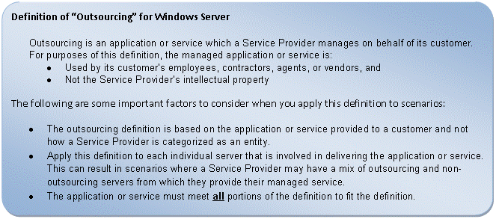

Introduction of Prior Version Rights in SPLA
Prior to July 2009, SPLA only provided rights to the most current version of products. Beginning with the July 2009 SPUR, SPLA partners have the right to run either the most current version or any prior version of the software. Example: being licensed for Windows Server 2008 R2 allows use of Windows Server 2008, Windows Server 2003 or any prior version of Windows Server. Being licensed for Windows Server 2008 does not allow use of Windows Server 2008 R2. Note that anonymous mode no longer applies to licensing.

Conversion options for SPLA partners
Service Providers who were SPLA providers prior to July 2009:
If a Service Provider wants to continue with the pre-July 2009 Windows Server use rights, the Service Provider must:
- Continue offering their software service with that version of Windows Server.
- Continue to report the same stock-keeping units (SKUs) that were listed in the SPLA price list prior to July 2009.
New SPLA partners as of July 2009:
- New SPLA partners signing SPLA after July 1, 2009, must report the new Windows Server SKUs (July 2009 price list onwards) and adhere to the July 2009 SPUR—no matter what Windows Server product version is running.
Additional Details:
- Pre-July 2009 SKUs cannot be used with the July 2009 use rights.
All SPLA partners can start using the new July 2009 SPUR.

Hosting Scenarios and Licensing Considerations
This white paper documents common hosting scenarios using Windows Server® 2008 R2 Hyper-V™ virtualization technology and Microsoft SQL Server® database management software with the Microsoft Services Provider License Agreement (SPLA). The SPLA has two licensing models – Per Processor and Per Subscriber (via a Subscriber Access License, or SAL). Some products are available through both licensing models. In a virtual environment, there are no new restrictions on the number of instances running under the SAL licensing model. However, the Per-Processor model introduces new considerations, which are outlined in this white paper.
In the context of Hyper-V, a physical server (called a host) can be used to create numerous virtual machines or virtual servers (called guests). Each guest runs its own operating system (OS), independent of other guests. Operating systems such as Windows Server 2000 SP4, Windows Server 2003, Windows Server 2008 (Web, Standard, Enterprise and Datacenter), Windows Server 2008 R2 (Web, Standard, Enterprise and Datacenter) SUSE Linux Enterprise, and so forth, can run as a guest OS. However, the host OS must be Windows Server 2008 R2 (Standard, Enterprise, or Datacenter). For a list of supported virtual guests, please visit the following link: http://www.microsoft.com/windowsserver2008/en/us/hyperv-supported-guest-os.aspx

The primary focus of this paper is how to license different editions of Windows Server 2008 and SQL Server 2008 in a virtualized hosting environment that is leveraging the SPLA model. We will outline the SPLA licensing implications for some common Hyper-V-based virtualized hosting scenarios. These scenarios include:
- Unmanaged dedicated server with Hyper-V
- Virtual dedicated server (VDS) for Web scenarios
- Virtual dedicated server with line-of-business (LOB) scenarios (using Windows Server guests in authenticated mode)
- Use of virtualization in shared hosting scenarios
- Desktops as Hyper-V guests
- End customers running Microsoft products using the customers own licenses on the guest OS

In addition to these common scenarios, we present how the Microsoft System Center family of products can be used to help manage the virtualized hosting environment and the associated licensing implications.

Licensing of Various Windows Server Editions
Windows Server 2008 R2 is licensed on a per-processor basis: When reviewing the table below, please bear in mind that a license for each processor is needed. While there is no technical limitation on the number of guests you can run on the Standard, Enterprise, or Datacenter editions, the number of licenses required as part of the host license vary by edition. The following table indicates the number of guests included for free in the license of the host. If additional guests over the allowed limit are run on any edition, then additional licenses are required.
Furthermore, the Active Directory® service is included with certain editions of Windows Server 2008 R2. This affects the licensing in specific hosting scenarios. The use of Active Directory for the Windows Server host and guest OS is allowed only with the Web, Standard, Enterprise and Datacenter editions
The table below provides only a general licensing overview of Windows Server 2008. Depending on the scenario and which edition of Windows Server 2008 R2 is installed on the host, numerous licensing scenarios exist. These are described in the following sections.

Host Edition | Guests Included in Host SPLA | Allowed Guest Types
Windows Web Server 2008 R2 | 0 | None
Windows Server 2008 R2 Standard | 1 | Windows Server 2008 R2 Standard*
Windows Server 2008 R2 Enterprise | Up to 4 per licensed server | Windows Server 2008 R2 Enterprise*  Windows Server 2008 R2 Standard*
Windows Server® 2008 R2 Datacenter | Unlimited guests | Windows Server 2008 R2 Datacenter*  Windows Server 2008 R2 Enterprise*  Windows Server 2008 R2 Standard*  Windows Web Server 2008 R2*
Table 1: *Guest licenses and guests types for various Windows editions include rights to prior versions of same edition(ex Server Standard 2003 in place of Server Standard 2008 R2), other languages and platform version x86 vs. amd64.

Edition Comparison by Server Role

Windows Server 2008 R2 Enterprise
As you can see in the table, if licensing a Windows Server R2 2008 Enterprise host, up to 4 guests are included in the initial license. If a fifth guest is added to the server, an additional license for Windows Server 2008 R2 Standard Edition will need to be reported. However, if five to eight guests are running, then, it may be less costly to report them as two Windows Server 2008 R2 Enterprise licenses. This process of purchasing additional licenses can be continued as more and more guests are added, up to the physical capacity of the host. When hosting with Windows Server 2008 R2 Enterprise, the guest may be Windows Server 2008 R2 Enterprise or Windows Server 2008 R2 Standard.

Windows Server 2008 R2 Datacenter
With Windows Server 2008 Datacenter, you may run unlimited guests (up to what the hardware will support). Windows Datacenter edition allows you to install and run any down edition or down version of Windows Server for the guest operating system.
In most cases, for Hosting Providers, Windows Server 2008 R2 Datacenter edition provides the least costly alternative to run Hyper-V based virtual environments. In subsequent sections, this paper outlines the various benefits of Datacenter edition.

Use of Central Storage
In many scenarios, Hosting Providers use central storage to manage guest images as virtual hard disks, or VHDs. This storage is typically based on a storage area network (SAN) or Windows® Storage Server 2008, which is an OEM-only product used as a cost-effective substitute for a SAN. At this time, Windows Storage Server is not available in a SPLA. The use of central storage does not affect the licensing for SQL Server software.

Use of Other Non-Microsoft Virtualization Technologies
This document applies equally well to other virtualization technologies such as VMware and XenSource when using Windows Server as a host or guest OS. However, Microsoft does not make claims on how those technologies are licensed, and use of those technologies does not diminish the number of licenses required for Microsoft products. Please consult the vendor of those virtualization technologies for their licensing requirements.

Hosting Scenarios

Scenario 1: Unmanaged Dedicated Server as Host with One or More Guests
In this scenario, a hosting provider offers a physical server as a host enabled with Hyper-V. The end customer purchases a dedicated server offering and can create any number of guests using Hyper-V Server Manager. The administration of the physical server and virtual instances is performed by the end customer.
If the employees, contractors, agents or vendors of the end customer are using the server software then it is outsourcing. If the server software is serving only external users of the end users (not employees, contractors agents or vendors) then it can be non-outsourcing. If the usage is mixed, it defaults to outsourcing.
If the Hosting Providers use Microsoft System Center Virtual Machine Manager (VMM), through delegation they could provide the ability for end customers to manage guests through the VMM Self-Service Portal. Note that the VMM Self-Service Portal requires Active Directory.
Figure 1 depicts an example of an “unmanaged” Hyper-V configuration where all management and administration of the hosts and virtual guests is performed locally on the server. In this scenario, the hosting provider is hosting a dedicated Hyper-V-enabled server and allowing the customer to directly access the host (typically via Terminal Services).
The number of guests and the type of guest installed is dependent on the edition of Windows Server 2008 R2.
As depicted in Figure 1, Hosting Providers may wish to install and expose System Center Virtual Machine Manager to allow customers to manage their virtual guests. Please see “Microsoft System Center Products in a Hosting Environment” in this document for information on minimal deployments of VMM in a hosting environment.
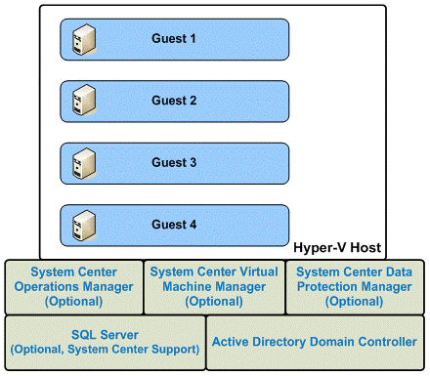
Figure 1: Unmanaged Hyper-V
Scenario 2: Virtual Dedicated Server (VDS)
In a VDS scenario, a hosting provider uses a Windows Server 2008 R2–based server with Hyper-V as a host for one or more guests. These guests can run Windows Server or Linux operating systems. Each guest is offered as a virtual dedicated server to end customers. Each guest has a guaranteed set of resources, which can be specified when it is created. If the employees, contractors, agents or vendors of the end customer are using the server software then it is outsourcing. If the server software is serving only external users of the end users (not employees, contractors agents or vendors) then it can be non-outsourcing. If the usage is mixed, it defaults to outsourcing.
The end customer has complete control of the guest and its OS. The VDS can be accessed via Terminal Services or Remote Desktop Sessions. The hosting provider or the end customer also can install a control panel on the guest to manage the hosting environment on the VDS. From an end-customer perspective, a VDS looks and feels like a dedicated server, where patching, software loading, and so forth do not affect other guests on the server.
In order to improve the manageability of these servers, Microsoft offers the System Center Server Management Suite Enterprise, which may be leveraged to offer the same managed services to the hosting provider’s customers. For example, when provisioning, System Center Virtual Machine Manager (VMM) may be used for provisioning either the managed or un-managed server.
The System Center Server Management Suite Enterprise includes the following products that can simplify the management of hosted guests and provide value-added services to the hosting provider:
- System Center Virtual Machine Manager (VMM)
- System Center Operations Manager (OpsMgr)
- System Center Data Protection Manager (DPM)
- System Center Configuration Manager (SCCM)
As depicted in Figure 2, Hosting Providers may wish to install and expose System Center Virtual Machine Manager to allow customers to manage their virtual guests. Please see “Microsoft System Center Products in a Hosting Environment” in this document for information on minimal deployments of VMM in a hosting environment.

Scenario 2a: VDS – Unmanaged
In this scenario, the hosting provider allows the end customer to have full management of the guest operating system. Loading software, patching, backups, and such would be handled by the customer. This option is similar to one discussed in Section 1/Figure 1.

Scenario 2b: VDS – Managed
In a managed scenario, the hosting provider may offer one or more value-added services related to the management of the guest to its customers. These value-added services may either be included in the base pricing of the hosted offer or included as an additional charge. One benefit for Hosting Providers is that these servers can be centrally managed by another server running virtual machine management software such as Microsoft System Center Virtual Machine Manager. Value-added services may include:
- Managed services – such as SQL Server administration
- Guest server software – patching, security updates, installs
- Utilities – disk and storage management
- Backup/Restore
- Domain Name Services (DNS)
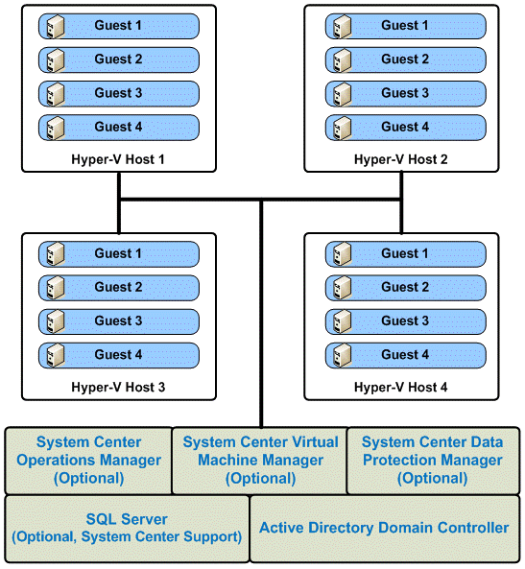
Figure 2: Managed Hyper-V
System Center Virtual Machine Manager requires membership in Active Directory; however, VMM can manage non-Active Directory hosts and guests. For more information about configuring Active Directory, see “Windows Server System Reference Architecture” in the References section of this document.
System Center also requires a Microsoft SQL Server database for storage. Hosting Providers may choose to use an existing SQL Server installation or create a dedicated server, depending on their needs. As Hosting Providers increase the number of guests they manage, high-availability configurations of SQL Server, Active Directory, and System Center products may be utilized. See “Windows Server System Reference Architecture” and “System Planning and Design” in the References section of this document for more information.
Another optional component that may be very useful in a Hyper-V hosting environment is System Center Operations Manager. Operations Manager can be used to monitor the health of the host servers, domain controllers, and SQL Server software, as well as the guest systems.

Scenario 3: Outsourcing Scenario: Virtual Dedicated Servers
In scenarios where the guest system is used by the end customer’s employees, the recommended host is Windows Server 2008 R2 Enterprise for Outsourcing or Datacenter for Outsourcing, which accommodates up to four Windows guest systems per fully licensed host or unlimited Windows guests, respectively. (More than four Windows guests can run on the Enterprise edition, but more licenses must be added and reported.)
Other Outsourcing configurations also may include hosting for Microsoft Exchange Server, Microsoft Office SharePoint® Server, or other applications that are operated for use by the employees or associates of the hosting customer.
End customers cannot bring their own licensees (BYOL) for use on a VM running as a guest on a host that has VMs from other customers. See scenario 6 to understand where end customers can bring their own licenses.

Scenario 4: Shared Hosting Configurations
In this scenario, the hosting provider is using a server as a host and creates one or more guests to host one or more Web sites for shared hosting scenario. The end users are not exposed to virtualization. Some Hosting Providers are using virtualization in this manner to provide better isolation for Web sites. For example, if a server hosts 2,000 Web sites, a hosting provider can create four guest virtual machines, each with 500 sites. If the users are not employees, agents or representatives of the customer, the non-Outsourcing edition may be used. Enterprise or Datacenter edition may be used in this scenario.
End customers cannot bring their own licensees (BYOL) to a shared hardware environment. See scenario 6 to understand where end customers can bring their own licenses.

Scenario 5: Running Desktop Systems as Hyper-V Guests
This scenario is currently not allowed under SPLA.

Scenario 6: Using End-Customer Licenses on the Guest
Hosting Providers frequently ask if end-customer-owned licenses (such as Small Business Server, SQL Server, Exchange Server, or other server applications acquired through Microsoft Select or Enterprise Agreements) can be relied upon for licensing the guest. Currently, these scenarios are not allowed in the SPLA for shared use in either the host or virtual environment. All licenses for the guest must be reported by the service provider using the SPLA.
In a non-Hyper-V-based virtualized environment, an end customer can bring in their own license if they have a dedicated hosted server. They cannot apply their license if the server is shared among multiple customers. The Figure below illustrates the scenario where the end customer can or cannot use their software licenses.

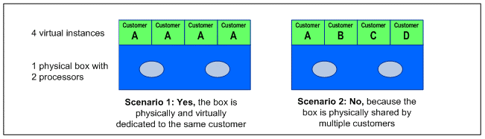
Figure 3: End-Customer License on Guest
If a server is physically and virtually dedicated to the same customer, then the end customers can install their own licenses. An example is a managed or unmanaged dedicated server. However, if the box is physically shared by multiple customers, even though, they may own Virtual Machines running on the box, they are not allowed to bring their own software licenses for Microsoft Products.

Running Microsoft SQL Server 2008 with Hyper-V
Hosting Providers typically offer SQL Server to customers as part of their hosting offers. There are five different SQL Server 2008 editions available: Express, Web, Workgroup, Standard, and Enterprise. (See Table 1 to compare features.) SQL Server 2008 is licensed either per processor or per SAL. Virtualization does not affect the number of SALs required.

SQL Server 2008 Express
SQL Server 2008 Express is a free, downloadable version that has most commonly used features but limitations on size of database (4 GB), number of CPUs (1), and amount of RAM it can leverage (1 GB). SQL Server 2008 Express is a good option for starter Web sites and for development-related activities. There are no limitations or restrictions on the number of instances that can be run on any physical or virtual server.

SQL Server 2008 Web
SQL Server 2008 Web is a new version specifically geared for the hosting industry. It may be used only to support public and Internet-accessible Web sites, pages, applications, and services.
SQL Server 2008 Web is licensed on a per-processor basis. The licenses required are based upon the number of processors (or sockets) used, up to a maximum of four processors per server. To run instances on the host, a license is required for each physical processor that the host operating system uses. To run instances of SQL Server 2008 Web on guests, a license is required for each virtual processor that each of those guests uses.

SQL Server 2008 Workgroup
SQL Server 2008 Workgroup is a less attractive than SQL Server 2008 Web. Therefore, we recommend Hosting Providers to consider using the Web edition.

SQL Server 2008 Standard
SQL Server 2008 Standard is licensed either on a per-processor basis or a per subscriber (SAL) basis. The licenses required for the host are based upon the number of physical processors used, up to a technical maximum of four processors on a server. To run instances on the host, a license is required for each physical processor that the physical operating system uses. To run instances of SQL Server 2008 Standard on guests, a license is required for each virtual processor that each of those guests uses.

SQL Server 2008 Enterprise
SQL Server 2008 can be installed on high-end servers with up to 128 processors. In a Hyper-V-based virtualized environment, SQL Server 2008 Enterprise offers a unique licensing benefit. If it is licensed for the host, then each guest running on that host may also run any number of instances of SQL Server Enterprise. This provides cost advantages, as the cost of SQL Server Enterprise may be amortized among the guests running on that host.
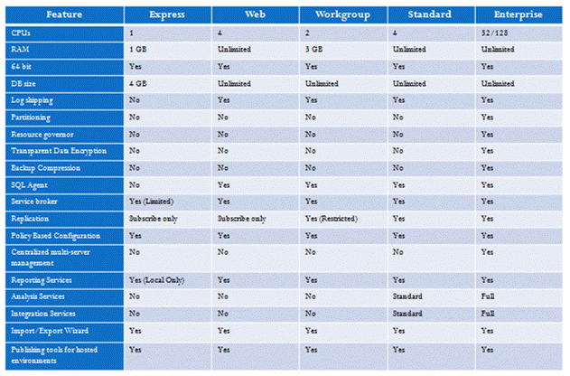
Table 2: SQL Server 2008 features by edition.

Scenario-based licensing matrix

The following tables summarize the different permutations and combinations of Windows Server 2008 R2 and SQL Server 2008 in a virtualized environment using Hyper-V. Each row lists the scenario in which the server is being used, and the columns list the editions. A “y” means yes, this combination of (row, column) is allowed; an “n” means no, this combination is not allowed. A number in a cell indicates the number of licenses allowed or included with the base license; “UL” implies unlimited licenses.

High Level Scenario Based View
 | Windows Server 2008 R2 |  |  |  | SQL 2008
Scenario | Web | Std | Ent | DC | Web | Std | Ent
Phy. Dedicated | y* | y | y | n | y* | y | y
Vir. Dedicated | Y* | y | y | n | y* | y | y
Phy. Shared | y | y | y | n | y* | y | y
Vir. Shared | y | y | y | n | y* | y | y
Shared - SharePoint (WSS) | y | y | y | n | n | y | y
Exchange Server | n | y | y | n
Dynamics - CRM Server | n | y | y | n
Database - Web | y | y | y | n
Database - Std | n | y | y | n
Database - Ent | n | y | y | n

Table 3: Hosting Scenarios * Only for Web pages, Web sites, Web applications, Web services,POP3 mail serving.

Hardware-Centric View for Dedicated Hosts
 | Windows Server 2008 R2
Processors | Web | Std. | Ent. | DC
One | y | y | y | y
Two | y | y | y | y
Four | y | y | y | y
Eight or more | n | n | y | y
Table 4: Dedicated Host: Hardware View

Hardware-Centric View for Hyper-V Host
 | Windows Server 2008 R2
Processors | Web | Std. | Ent. | DC
One | n | y | y | y
Two | n | y | y | y
Four | n | n | y | y
Eight or more | n | n | n | y
Table 5: Hyper-V-Based Host: Hardware View

 | Hyper-V Guest Windows Server 2008 R2
Windows Server 2008 Based Host | Web | Std. | Ent. | DC
Web | n | n | n | n
Standard | n | y | n | n
Enterprise | n | y | y | n
Datacenter | y | y | y | y
Table 6: Hyper-V Guest:

Hyper-V Guest – Licenses
Windows Server 2008 R2
Host | Web | Std. | Ent. | DC
Web | 0 | 0 | 0 | 0
Standard | 0 | 1 | 0 | 0
Enterprise | 4 | 4 | 4 | 0
Datacenter | UL | UL | UL | UL
Table 7: Hyper-V Guest: Licenses Included with Host License

SQL Server 2008 Editions | SQL Server 2008 running on Hyper-V Guest
 | Web | Std. | Ent.
Web | 1 | 0 | 0
Standard | 1 | 1 | 0
Enterprise | UL | UL | UL
Table 8: Hyper-V Guest Database: Licenses Included with Host License

Microsoft System Center Products in a Hosting Environment
Microsoft System Center is a collection of multiple products that will help Hosting Providers manage their virtual as well as physical environment. In particular, the four products that are of interest to Hosting Providers are:
- System Center Virtual Machine Manager 2008 R2(VMM)
- System Center Operations Manager 2007 R2 (OpsMgr)
- System Center Data Protection Manager 2007 (DPM)
- System Center Configuration Manager 2007 (SCCM)
All System Center products can be installed on Windows Server 2008 R2 Standard or Enterprise Edition software in a physical or virtual environment. The installations require the hosting provider to separately acquire a licensed copy of the Operating System and SQL Server 2005 or SQL 2008 as these are not included part of the System Center license (except for those System Center with SQL Server Technology products that are available). Please note that SQL Server is included with the System Center products that have “with SQL” included in the product name.
System Center Virtual Machine Manager is a product that is designed specifically to help manage Hyper-V installations. A brief overview of licensing requirements for SC-VMM is described next:

Microsoft System Center Virtual Machine Manager 2008 R2
Hosting Providers planning to do a large-scale virtual deployment will benefit from use of Microsoft System Center Virtual Machine Manager 2008 R2. VMM can be deployed in multiple topologies. The simplest topology is to install all necessary components of VMM on a single server—or even on a guest virtual machine. Alternatively, to scale out, each VMM component can be installed individually on separate servers. The different server roles and components needed for a simple VMM topology are provided in Figure 4.

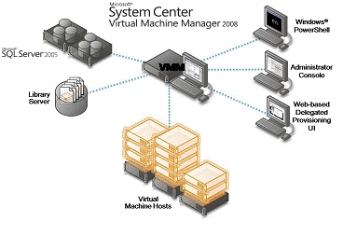
Figure 4: Server roles and components for a simple Virtual Machine Manager–based topology
Table 10 describes the topology from a software licensing perspective.

Server Role | Software Installed | Software License Needed
Hyper-V Host | Windows Server 2008 R2 Standard, Enterprise or Datacenter | Windows Server 2008 R2 Standard, Enterprise, or Datacenter
Hyper-V Management Node  Data Storage  Web-Based Provisioning  Admin Console  Library Server | Windows Server 2008 R2 Standard or Higher  SQL Server 2005 Standard or Workgroup Edition System Center Virtual Machine Manager | Windows Server 2008 R2 Standard or higher as may be deployed or SQL Server 2005 Standard or Workgroup as may be deployed. Please note that SQL Server is only included with the System Center products that have “with SQL” included in the product descriptor.  System Center Server Management Suite Enterprise SAL (per managed device or host server) or System Center Server Management Suite Datacenter*
Active Directory Domain Controller | Windows Server 2003 or 2008 R2 Standard | Windows Server 2008 Standard Edition
Table 9: Required Licensing for Hyper-V Host, Per Server Role (*Allowed if already licensed under SPLA)

*A stand-alone version of VMM is also available, which can be acquired instead of the System Center Suite Enterprise or System Center Suite Datacenter. System Center Suite Enterprise (SMSE) permits the management of a maximum of 4 OSEs per licensed physical device. The System Center Suite Datacenter (SMSD) license permits the management of unlimited OSEs for the licensed device. The licensing for SMSE is based on the device; the licensing for SMSD is based on physical processors in the managed device.
Reference topologies are available for download in the Resources section of this document. The minimal single machine configuration for VMM is available in the following document:
http://download.microsoft.com/download/4/5/a/45ab5519-26cd-4ea4-91a3-50ec391e7e18/HardwareReqs_Final.pdf

Using Other System Center Products to Manage the Hosting Environment
Microsoft System Center products such as System Center Operations Manager, System Center Configuration Manager, and System Center Data Protection Manager provide Hosting Providers with the ability to better manage the virtual as well as the dedicated environment. All of these products run on Windows Server 2003 and Windows Server 2008 R2 with a software update (that is, a Service Pack). Please check the installation instructions of each product for details.
In Figure 6 below, we illustrate one way in which different components within System Center can be installed to manage the virtual environment.
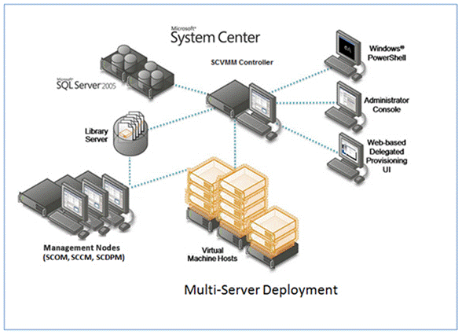
Figure 5: A Typical System Center Deployment

Table 10 shows the software and licenses needed to deploy the configuration illustrated in Figure 5.

Role | Software Installed | Software License needed
Hyper-V Host | Windows Server 2008 R2 Standard or Enterprise | Windows Server 2008 R2 Standard, Enterprise, or Datacenter
Web Based Provisioning  Admin Console  Library Server  VMM Controller | Windows Server 2008 R2 Standard Edition or Higher  System Center Virtual Machine Manager | Windows Server 2008 R2 Standard, Enterprise, or Datacenter  System Center Server Management Suite Enterprise SAL or System Center Virtual Machine Manager SAL
Management Node | Windows Server 2003 Standard or Higher  System Center Operations Manager  System Center Configuration Manager  System Center Data Protection Manager | Windows Server Standard or Enterprise as may be deployed  Note: SMSE SAL includes licenses for SC-OM, SC-CM, SC-DPM and SC-VMM.
Data Storage | Windows Server 2003 * or 2008 R2 Standard or Higher  SQL Server 2005 | Windows Server Standard, Enterprise or Datacenter  SQL Server 2005 Standard
Active Directory Domain Controller | Windows Server 2003 or 2008 Standard | Windows Server Standard Authenticated
Table 10. Required Licensing for Hosting with System Center Management Products (*Allowed if already licensed under SPLA)

Licensing FAQ
Can Windows Web Server 2008 R2 be used as a host OS on a Hyper-V-based server?
No. Windows Web Server 2008 R2 does not have a Hyper-V role. It can be used only as a guest. Only the Datacenter, Enterprise, and Standard editions of Windows Server 2008 R2 with the Hyper-V option can be used as a Hyper-V host OS.
For Windows Server 2008 R2 Standard (or any other edition), can the “included” licensed guest be any version of Windows Server?
Not necessarily. For each edition of Windows Server on the host, the following guest restrictions apply:
- Windows Server Standard: Included guest can only be Windows Server Standard.
- Windows Server Enterprise: Included guests can only be Windows Server Enterprise or Standard. However, deploying a different product in the guest than the host requires an additional license.
- Windows Server Datacenter: Included guests can be Windows Server Datacenter, Enterprise, Standard, or Web.
Is the software for Windows Server Datacenter available only from an OEM?
Windows Server Datacenter fulfillment media is currently available on SPLA price lists. Because of the down edition rights for Windows Server Datacenter, Hosting Providers may deploy Windows Server Enterprise, Standard, or Web, and report Windows Server Datacenter in their SPLA.
Is there a limit on how many guests I can run when I license Windows Server Enterprise? What if I run all Linux guests?
The Windows Server Enterprise license includes up to 4 guests; additional licenses are required if you have more than four Windows Server guests. If you are running Linux, you need to determine the licensing requirements for Linux from your Linux vendor. Microsoft does not place limitations on the number of Linux-based guests a hosting provider may run.
Does the use of Windows Server Datacenter as a platform for SQL Server change the number of licenses required for SQL Server as indicated in the SPUR? For example, if I have 50 SQL Server instances running on their own virtual machines (i.e., guests) in a Windows Server Datacenter cluster, how many SQL Server licenses do I report?
This depends on the edition of SQL Server:
- The use of Windows Server Datacenter does not diminish the number of licenses required for SQL Server as spelled out in the SPUR.
- With SQL Server Enterprise, you must acquire a license for each physical processor on the server, which allows you to run an unlimited number of virtual instances on the same server.
- For SQL Server Standard or Web to run instances in virtual operating system environments, a license is needed for each virtual processor that each of those virtual operating system environments uses.
What are the licensing implications of clustering? Do I pay for only the active nodes? Are passive nodes charged as well?
For SQL Server in an active/passive configuration, passive nodes do not need to be reported.
For Windows Server cold disaster recovery, the cold VM does not need to be reported. In cold disaster recovery scenarios, the machines must be physically turned off or not running, except in some testing scenarios. In warm disaster recovery with failover, you need to license both Window Server licenses.
Please note that the Passive nodes cannot have more processors than the active nodes.
What are the scenarios supported by SQL Server 2008 Web Edition?

The software may be used only to support public and Internet accessible

Web pages

Web sites

Web applications

Web services
It may not be used to support line of business applications (e.g., Customer Relationship Management, Enterprise Resource Management and other similar applications).
Can we allow Remote desktop access to guest or host virtual machines? If so, how many sessions can be allowed?
For all Windows Server 2008 Editions, for testing, maintenance, and administration access purposes, each instance running in an operating system environment, you may also permit up to two (2) other users to use or access the server software to directly or indirectly host a graphical user interface (using the Windows Server 2008 Terminal Services functionality or other technology). This use is for the sole purpose of testing, maintenance, and administration of the licensed products. These users do not need Windows Server 2008 Terminal Services SALs. For Datacenter the number increases to 5 other users for each instance running in the physical host and 2 other users for each instance running in a virtual operating system environment.
If all virtual machines on a physical host are used by the same customer A, can the physical host be licensed through SPLA and the virtual machines through the end user’s Select (Plus) or Enterprise (Subscription) Agreement? Example: the Service Provider uses SPLA for Windows Server Enterprise and offers 4 virtual machines to customer A, and customer A brings in his own licenses for Exchange, SQL Server and Office SharePoint Server.
If the physical box itself is only being used by one specific end-customer, we will consider this box to be a dedicated environment for that customer, regardless of how many virtual instances that customer is using on that box. Within a dedicated environment, an end-customer is allowed to use his own internal use licenses (Select, Open, EA, etc.) Using such internal use licenses is not allowed in a shared hosting environment (e.g. Multiple end-customers access and use the same physical machine, regardless of whether or not those customers have their own dedicated virtual instances on that physical machine)

Please explain the difference between a virtual processor and a physical processor.
Just as a physical server utilizes one or more physical processors, a virtual server or guest utilizes one or more virtual (or logical) processors. Hyper-V technology makes use of virtual processors in the guest operating system.
From a licensing perspective, certain products like Windows Server are licensed according to the number of physical processors (sockets). Other products such as SQL Server are licensed according to the number of virtual processors. Hyper-V may mix and match the physical cores from different processors to create a virtual processor. An example is illustrated in Figure 10.

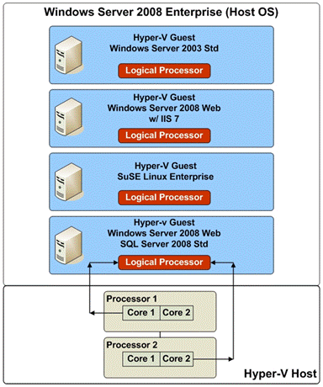
Figure 6: Construction of Logical (or Virtual) Processors
For reliability and performance, Hyper-V technology may allocate resources from separate physical processors in the server to create a virtual processor for use by a particular guest operating system environment. For licensing purposes, virtual processors are considered to have the same number of threads and cores as each physical processor in the underlying physical hardware system. Microsoft is adopting this definition to enable Hosting Providers to take advantage of the licensing policy we announced in 2004 for multicore processors. Microsoft generally considers multicore and hyperthreaded processors to be a single processor, regardless of the number of cores and/or threads they contain.

References

Windows Server System Reference Architecture
http://www.microsoft.com/technet/solutionaccelerators/wssra/raguide/default.mspx
Licensing Document: SPUR
http://www.microsoftvolumelicensing.com/userights/DocumentSearch.aspx?Mode=3&DocumentTypeId=2

Infrastructure Planning and Design
- System Center Operations Manager 2007

- System Center Virtual Machine Manager 2008

- Internet Information Services 7.0

- Selecting the Right NAP Architecture

- Infrastructure Planning and Design Series Introduction

- Microsoft Application Virtualization

- Selecting the Right Virtualization Technology

- Windows Deployment Services

- Windows Server 2008 Active Directory Domain Services

- Windows Server 2008 Terminal Services

- Windows Server Virtualization (for Windows Server 2008 Hyper-V and Virtual Server 2005 R2 SP1)
http://www.microsoft.com/downloads/details.aspx?FamilyId=AD3921FB-8224-4681-9064-075FDF042B0C&SAMI_Campaign_Name=IPD062708RTM_IPDDL&displaylang=en

System Center Virtual Machine Manager 2008 Overview
http://download.microsoft.com/download/6/f/8/6f8a7125-041a-46f9-a9ec-362b13fe0445/VMM2008_White_Paper_Draft3.6_FINAL.pdf

