Microsoft Corporation

SharePoint Composites Handbook
  - A guide to creating business solutions with no code

By Mark Gillis
Version 2.0 November, 2012

Summary
This handbook is intended for:
- Power users, who want to create simple-to-develop, no-code solutions so they can rapidly respond to business needs.
- IT Technical staff, who want to develop solutions and prototypes with little or no code.
- Decision makers, who want to understand the benefits of SharePoint Composites for businesses of all shapes and sizes.
- Anyone, who wants to dramatically improve business productivity and become more agile in the workplace.

Location
No code solutions using SharePoint 2013 Composites (http://msdn.microsoft.com/en-us/sharepoint/fp161345)
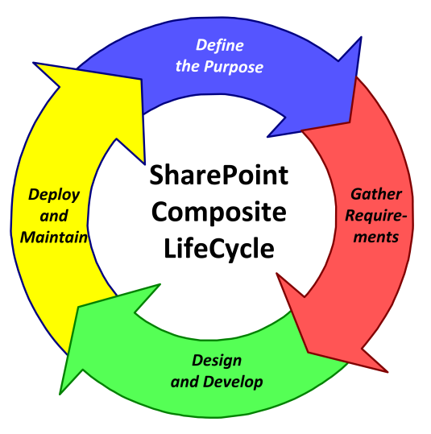
SharePoint Composites make collaboration-based business solutions easier, faster, and better.
Copyright
The information contained in this document represents the current view of Microsoft Corporation on the issues discussed as of the date of publication. Because Microsoft must respond to changing market conditions, it should not be interpreted to be a commitment on the part of Microsoft, and Microsoft cannot guarantee the accuracy of any information presented after the date of publication.

This white paper is for informational purposes only. MICROSOFT MAKES NO WARRANTIES, EXPRESS, IMPLIED, OR STATUTORY, AS TO THE INFORMATION IN THIS DOCUMENT.
Complying with all applicable copyright laws is the responsibility of the user. Without limiting the rights under copyright, no part of this document may be reproduced, stored in, or introduced into a retrieval system, or transmitted in any form or by any means (electronic, mechanical, photocopying, recording, or otherwise), or for any purpose, without the express written permission of Microsoft Corporation.

Microsoft may have patents, patent applications, trademarks, copyrights, or other intellectual property rights covering subject matter in this document. Except as expressly provided in any written license agreement from Microsoft, the furnishing of this document does not give you any license to these patents, trademarks, copyrights, or other intellectual property.

Unless otherwise noted, the example companies, organizations, products, domain names, e-mail addresses, logos, people, places, and events depicted herein are fictitious, and no association with any real company, organization, product, domain name, e-mail address, logo, person, place, or event is intended or should be inferred.

© 2014 Microsoft Corporation. All rights reserved.

All trademarks are property of their respective owners.

Contents
Part I: SharePoint Composite Fundamentals 6
What is a SharePoint Composite? 6
Why you should start creating SharePoint Composites 7
The SharePoint customization continuum 8
Understanding how SharePoint Composites scale and evolve 9
Building solutions on the SharePoint platform 10
Office 2013 integration points 13
Using apps for SharePoint and apps for Office 16
Social computing and sharing 17
Part II: The SharePoint Composite solution life cycle 19
Define the purpose 19
Identify the requirements 20
Users and stakeholders 20
Business logic 21
Data and documents 22
Content types 26
User interface requirements 27
Data presentation 29
Mobile experience 32
Software requirements 33
Technical requirements 33
Design and develop 33
Deploy and maintain 34
Part III: Common SharePoint Composite design patterns 35
Browser-based customization 35
Just edit the page 35
Embed an Excel workbook 36
Add Web Part connections 36
Dynamic diagrams 38
Form-centric solutions 39
List and form library forms 40
The InfoPath Form Web Part 41
Business process and workflows 41
Out-of-the-box workflows 42
SharePoint Designer workflows 42
Projects 43
Using the project site 43
Find all your work in one place 44
When projects grow bigger 44
Managing documents and content 45
Document Information Panels 45
Structured documents 46
Media assets 46
Document management 47
Records management and compliance 50
Publishing sites 51
Design Manager 51
Intranet site 51
Internet Business 52
Public Web site 52
Access apps 53
Start with templates and tables 53
Automatically create a beautiful user interface 53
Effortlessly store data into SQL Server 54
Do advanced customization 54
Business intelligence 55
Overview of BI 55
Self-service BI with Excel and Excel Services 56
Interactive visualization with Power View 59
Data modeling with PowerPivot 59
Enterprise dashboards and scorecards with PerformancePoint Services 61
Operational reports with SQL Server Reporting Services 62
Line-of-Business data integration 63
Two classic BCS scenarios 63
Getting there is half the fun 64
Surface external data in SharePoint products 67
Surface external data in Office products 69
Pushing the SharePoint Composite envelope 71
Using JavaScript 71
Using Web Services and REST 72
Appendices 73
The Fabulous 40 73
Summary of Web Parts 77
Visio diagrams that support the solution life-cycle 83

Part I: SharePoint Composite Fundamentals

What is a SharePoint Composite?

Your organization has chosen and deployed Microsoft SharePoint Products 2013, and you’re on a mission to use and evangelize its many benefits. As you promote and adopt SharePoint Products 2013 throughout your business, you find the need to help users change old habits. Instead of storing files in network or e-mail folders, you gradually move them to SharePoint libraries for central management. Instead of routing documents in e-mail, you send links so that all users see the same and latest copy of the file in a shared library. Instead of attaching a spreadsheet of tables in e-mail, you use a list and list views to easily share and update the same data. Instead of manually performing routine business processes, you are using workflows to streamline regular tasks. Gradually, you are moving key project, content, and process information from individual e-mail accounts, personal computers, network drives, and sticky notes to SharePoint Products 2013 so that your teams and business can collaborate much more effectively.

But, is there more? Yes there is, and it’s called SharePoint Composites.

SharePoint Composites enable you to rapidly create solutions by assembling, connecting, and configuring the basic building blocks of functionality available in SharePoint Products 2013, and in many cases, Microsoft Office 2013. A SharePoint Composite combines data, documents, and business process in a useful, productive way.
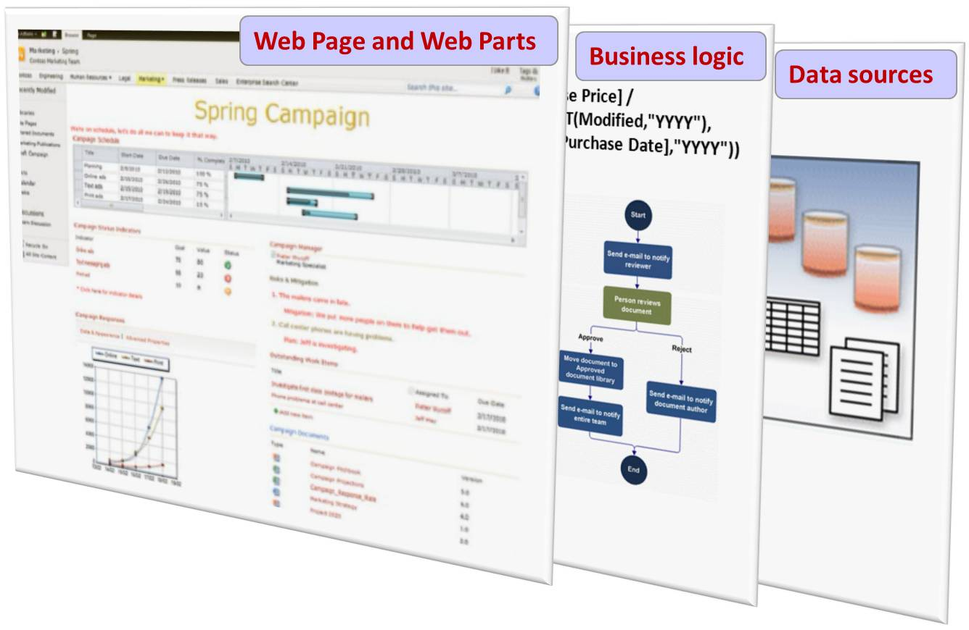
Think of a SharePoint Composite like a wood composite: Pre-engineered layers merged together to provide a solution that is practical, inexpensive, easy to maintain, and good for your environment
In most cases, these solutions do not require code. Now there’s nothing wrong with writing code. But here’s a motto you might live by from now on: “Let’s not write code until we have to write code.”

In short, a SharePoint Composite is a “do-it-yourself” business solution. A SharePoint Composite could be as simple as a custom Web Page that uses a site list and several connected Web Parts to track mileage in a small business. Or, a SharePoint Composite could be as sophisticated as a corporate-wide absence reporting system connected to a Human Resource database by using Business Connectivity Services. A SharePoint Composite bears close resemblance to the often-used term, “mashup”. A mashup is a quick Web application that incorporates data into a simple, visual, and interactive solution. However, the term “composite” emphasizes the breadth and depth of solutions you can build on the SharePoint Products 2013 platform.

Why you should start creating SharePoint Composites

Here are the main reasons why you should consider creating a SharePoint Composite.

To leverage existing investments Just using out-of-the-box SharePoint Products 2013 saves you time, money, and resources. These are the tangible benefits for which you can readily see the cost savings to your business. But, creating a SharePoint composite can make you and your workforce more productive. Those are the intangible benefits that affect your bottom line and successfulness every day.

To help eliminate content and data silos SharePoint Products 2013 is all about connection, collaboration, and helping to create a “shared brain” within your organization. The more you work in a cross-functional manner, the more you utilize the resources you already have, the more you realize the benefits of synergy and unification.

To unlock the value of Line-of-Business (LOB) data With a SharePoint Composite based on Business Connectivity Services (BCS), you can work with data from other business systems as if the data lived within your SharePoint sites. Create, read, update, delete, and search the data using external content types and external lists. Surface enterprise data in Microsoft Excel 2013 and Microsoft Word 2013. Search across all your valuable business information. Work offline and synchronize your changes when you reconnect by using Microsoft Outlook 2013.

To rapidly create a business solution without dependence on technical staff You don’t need to be a programmer to assemble these building blocks. Without code, you can create highly customized sites and solutions, share data-driven Visio diagrams, and publish Microsoft Access 2013 Access apps. Use Microsoft SharePoint Designer 2013 and Microsoft InfoPath 2013 to design and build declarative solutions based on workflows and forms. You’ll be surprised by how many of your business challenges can be resolved with a code-free solution.

Because you’re a power user Sometimes called a citizen developer, power users see colleagues struggling to do their work, think to themselves, “There has to be a better way”, and see a problem that requires a solution they can create. Advances in software, usability, and standards has made this a growing trend. For more information, see Gartner Says Citizen Developers 25 % of New Business Applications by 2014.

Because they are IT friendly Both end users and IT want to tackle that proverbial project backlog and improve the overall business. But, there is a traditional struggle with the paradox of user responsiveness and empowerment versus IT control and governance. SharePoint Composites help resolve this paradox in an effective way. Solutions are visible and integrated into your organization’s information infrastructure, and therefore are easier to deploy, manage, maintain, and ensure compliance.

Because they are developer friendly Starting a new application from scratch is expensive, time-consuming, and risky. Enhancing a familiar, working solution is often a preferred path. From the perspective of a developer, a SharePoint Composite is like a working prototype that lays the foundation for an application, and that now needs to scale up to potentially thousands of users or millions of rows. Perhaps, you only need to add a custom Web Part. Or, you may need to revise the SharePoint Composite as a solution with custom, managed code. Either way, the upgrade path is clear and smooth.

The SharePoint customization continuum

SharePoint Products become an integral part of your business, and are meant to be continually used, customized, and enhanced. You could think of using SharePoint products along a customization continuum.

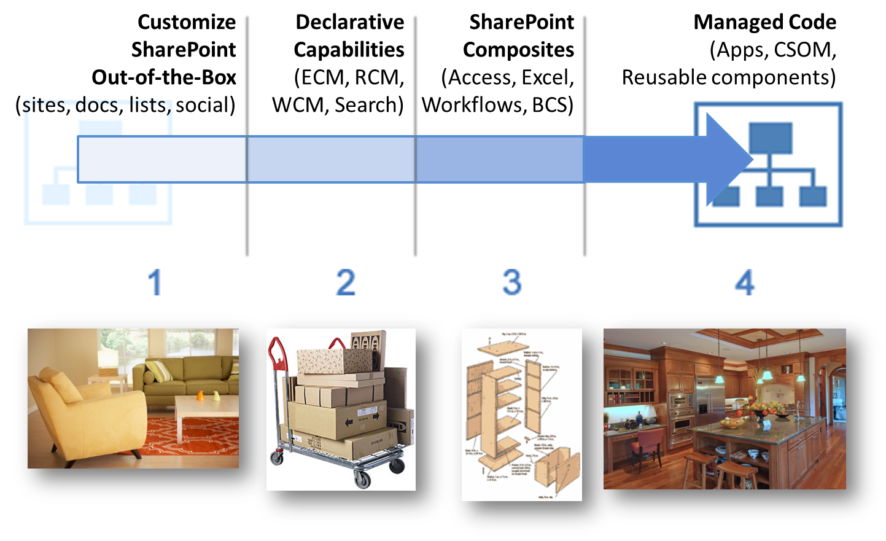
Right away, you can start getting work done by adding content to sites, lists, libraries, and notebooks, share content, engage in social computing, coauthor documents, meet through Lync, and create pages and sites. It’s like moving in to a new home and buying furniture to get your house “up and running”.

Next, you take on a major capability (sometimes called workload) like managing corporate documents with a taxonomy or building an Internet Business to promote and sell products. You can declaratively and prescriptively build many of these solutions, but of course it takes some time and often requires a team, including administrators, with the right skillset. This is like buying furniture that requires some assembly; you save money, but may kill an evening or two.

Now, you decide to tackle a few SharePoint Composite solutions to solve some key problems and issues in your company. Perhaps you create an Access app to track customer contacts, build a BI dashboard by using Excel and Excel Services, or implement an RFP workflow. This is like building your own furniture, but guided by detailed woodworking plans and maybe an instructional video. You achieve a critical success, but you kill a few more evenings and maybe a weekend or two.

Finally some solutions, because of size, complexity, and significance, require a managed code solution, such as custom Web Parts, a program that aggregates list data across many sites, or a set of much-needed apps published to the App Catalog. This is like remodeling your kitchen to exacting standards. You spend money, but enjoy your evenings and weekends by entertaining and feeding friends and family.

Understanding how SharePoint Composites scale and evolve

There’s virtually no limit to the type of SharePoint Composites you can create, but it’s best to think of them as existing within a sliding scale or spectrum of business solutions.
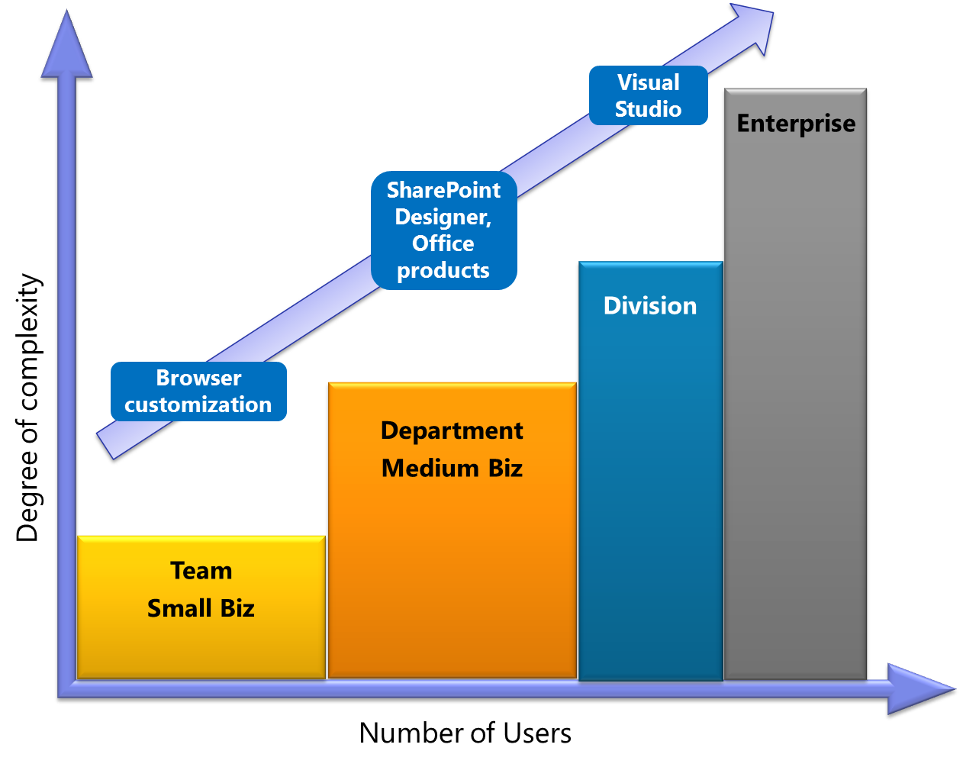
SharePoint Composites occupy a sweet spot in the spectrum of business solutions
SharePoint Composites are like tee shirts: they come in small, medium, and large. The size and scope of your solution may depend on a number of factors including how many users, how much data, how many sites, how complex the logic, how elaborate the presentation, and how involved the interactions.

Furthermore, a SharePoint Composite may start off small, but can grow in an organic way. As these solutions evolve and scale from simple to advanced, and from small to large, there is usually an increase in cost, sophistication, and capacity.

Here’s how a typical SharePoint Composite, expense reporting, might evolve over time.

Version | Number of employees | Type | Amount of Code | Expense report features | Time to complete | Comments
1.0 | 1 to 25 | Small Business  Enterprise  Team | None | Mileage re-imbursement automatically calculated based on a list, list form, and formulas | Two days | A quick solution
1.1 | 26 to 50 | Small Business  Enterprise  Workgroup | None | Trip re-imbursement based on an InfoPath form with validation and rules | Two weeks | An enhanced solution
1.2 | 51 to 200 | Midsize Business  Enterprise  Department | Low | InfoPath form converted to an Excel template; Document Information Panel; reporting with Excel Services. | Two weeks | A further enhanced solution
2.0 | 201 to 500 | Midsize Business  Enterprise  Division | Custom Web Part and Workflow action. | Enhanced user interface with advanced approval workflow. | One month | A major improvement expanded to more employees
2.1 | 501 to 1,000 | Enterprise | An app | Added connection to new direct deposit, credit card system | One month | A further major improvement expanded to more employees
3.0 | 1,001 plus | Large Enterprise | A complete, managed code solution | Integrated, company-wide expense report system | Four months | A robust, scalable solution

Building solutions on the SharePoint platform

A software platform provides a set of layers that help you get better value from your business solutions portfolio. Typically, software platforms comprise four layers:
- User Interface Presents data, content, and the results of business logic to the user. Branding, design, navigation, visualization, and interaction all play an important role in making the application useful, easy-to-use, and satisfying.
- Business Logic Provides a middle tier for calculations and rules, and connects multiple systems and applications with each other. Handles transactions between applications and systems, and defines business processes through workflow services.
- Data Sources Provides services to store, retrieve, and analyze application data. Database systems process application transactions, collect information from multiple systems, and provide tools for reporting and analysis.
- Infrastructure Forms the foundation of a platform. Infrastructure provides core security, virtualization, identity, access, and networking services.
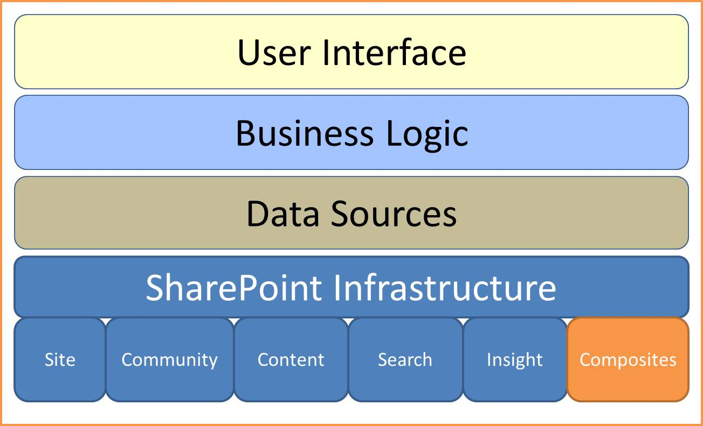
The SharePoint platform is a unified common platform for team, divisional, intranet, extranet, and internet sites. The capabilities provided are extensive, and the infrastructure is broadly-based. The capabilities available to you depend on your unique environment, whether you have an on premises, online, or hybrid (on premises and online) installation, and the software licenses you have purchased. In an on-premises installation, these capabilities are also dependent on the enabling of SharePoint Features and Services, which allow you to activate or de-activate functionality at the site, site collection, Web application, or farm level.

There are six basic SharePoint capabilities, each of which bundles a related set of features. Five of these capabilities form the basis for the sixth capability which is SharePoint Composites. Think of these capabilities as the set of building blocks, SharePoint Products 2013 as the platform infrastructure, and SharePoint Composites as the way to assemble, connect, and configure these building blocks into collaborative business solutions. The following table summarizes the six SharePoint capabilities.

Capability | Out-of-the-Box Features
Sites | Deliver a single infrastructure to provide portal and collaboration capabilities across intranet, extranet, and internet sites:  - Lists, libraries, views, Quick Edit, column types, content types  - Site and page creation, customization, themes, drag and drop, Site Notebook  - Site and site collection management, permissions management  - Surveys and discussion boards, RSS and alerts  - Formulas and functions, Web Parts, workflows  - Personalization, standards, and accessibility  - Ribbon user interface, easy web editing, cross-browser support  - Office Web Applications, mobile experiences, Usage Analytics  - Large list scalability and management, various site templates  - Multi-Lingual user interface  - project site template, task lists, workspace, timeline, summary, and “All my tasks in one place”  - Public Website (online-only)
Social | Locate and interact with people through social networking:  - Wikis and blogs, Organization Browser  - Personal site and profile  - Expertise finder  - Social feedback, tagging, trending tags, and content ratings  - Community sites, reputation, ratings, and moderation  - Ask Me About , follow, newsfeed  - One-click sharing  - People, organization relationships, photos and presence
Content | Manage content of all types:  - Documents Managed metadata, taxonomies, Documents Sets and Document IDs, Information Rights Management (IRM), Word, PowerPoint, and Translation Automation Services  - Records Content Organizer, general compliance and archiving, advanced routing, in-Place records management, holds and eDiscovery, and preservation hold library  - Rich media Digital assets, Asset picker, Asset Library, Media Web Part  - Web content Enterprise Wikis, publishing sites, cross-site publishing, structured content, page layouts, and field controls; Branding, themes, and custom master pages; Publishing Workflow approval; Content Search Web Part; Multilingual Variations; Web Analytics; Internet Business features, such as Catalog, Topic Pages, Design Manager, and metadata navigation.
Search | Find content including information in LOB database systems:  - Scoped search by site, list, or library  - Refinement panel, Search Center  - Advanced search, Boolean queries, and content properties  - Results based on people, ratings, tags, and metadata-based navigation  - Many Search Web Parts, including Content Search  - Document Previews, Expertise Search, Video Search, and Visual Best Bets
Business  Intelligence | Create business intelligence by transforming raw data into actionable information:  - Business Intelligence Center and Data Connection Library  - Excel, Excel Services, PowerPivot, Power View  - Slicers, Filters, Timeline Slicer, Filter Search, and Quick Explore  - PerformancePoint Services: Key Performance Indicators (KPIs); Scorecards, Reports, Dashboards and Dashboard Designer  - SQL Server Reporting Services and Reporting Web Part
Composites | Rapidly create business solutions by using the following:  - Browser-based customizations and workflows  - SharePoint Designer 2013 and InfoPath 2013 power tools  - InfoPath Forms Services, Browser forms, custom forms, and Forms on Spreadsheets  - Business Connectivity Services, Access Services, Excel Services, and Visio Services  - Low-code enhancements (JavaScript, Web Services, REST, and so on)

Office 2013 integration points

Office 2013 and SharePoint Products 2013 are often described as “better together” and this is no more apparent than with SharePoint Composites. Office 2013 products are designed for client computers, provide unparalleled richness and speed, in many cases work online and offline, and therefore are often the best way to create and design documents from simple to sophisticated. On the other hand, SharePoint Products 2013 provides the best way to share and collaborate with this content, and lightly edit the same content, for example by using Office Web Applications.

Like any good handyman, you know your tool set but you particularly value your power tools, because they help you get the job done smoothly and quickly. You also learn to use these power tools so you can maximize your effectiveness. Two Office 2013 products are the power tools you need to create SharePoint Composites: SharePoint Designer 2013 and InfoPath 2013.

The following tables summarize the key integration points between SharePoint Products 2013 and Office 2013. These integration points directly support the creation of SharePoint Composites or indirectly facilitate their design and development.

Directly supports SharePoint Composite solutions

Integration Point | Customer Benefit
Advanced SharePoint customization | SharePoint Designer 2013 is a power tool that covers a wide area of functionality:  - Enhance Lists and libraries with custom forms and integrate different data sources.  - Create Workflows (See Business Logic)  - Create external content types (See Line-of-Business data integration)  - Customize Web Parts, such as changing Web zone layouts, creating connections between Web Parts on different pages, and making connections with multiple values.  - Add custom actions, such as links, icons, and scripts to the SharePoint Ribbon, toolbar, and list item menus by using the Custom Action builder.  - Save a site as a template and deploy the site as a packaged solution.
Web Forms | InfoPath 2013 is a power tool that cuts a wide swath and includes the following:  - List forms  - Form library forms  - The InfoPath Form Web Part  - External list forms (See Line-of-Business data integration)  - Workflow forms (See Business process and workflows )
Document Information Panels | - In Word 2013, Microsoft Excel 2013, and Microsoft PowerPoint 2013, automate capture of metadata by using a Document Information Panel to make information more discoverable and re-usable.  - In Word 2013, automatically include information entered in the document by using Quick Parts and field controls.
Workflows | - Automate the design of business processes by using Microsoft Visio 2013, SharePoint Designer 2013, and Visual Studio 2012, all of which work together as an integrated toolset.  - Create reusable workflows and workflows attached to content types.  - Display active workflows in a visual format.
Web diagrams | Using Visio 2013, do the following:  - Publish Visio diagrams to the Web to share diagrams in the browser.  - Ensure consistency and accuracy of workflows with diagram validation.  - Integrate with the Process Repository to store, share, and reuse business process diagrams.  - Connect diagrams from one or more refreshable data sources (such as Excel 2013) and publish them to SharePoint.  - Create highly visual solutions by using the Visio Web Access Web Part connected to other Web Parts.
Business intelligence for everyone | - Share analysis and results across the organization by publishing Excel spreadsheets to a SharePoint site by using Excel Services.  - Create Excel dashboards by using conditional formatting, sparklines, and slicers.  - Selectively publish parts of a worksheet, hide formulas, and define parameters.  - Connect the Excel Web Access Web part to other Web Parts.  - Use PowerPivot for Excel to combine data from multiple sources and manipulate large data sets with millions of rows.  - Use Power View for compelling visualizations.  - Publish and share this analysis by using PowerPivot for SharePoint.
Access apps | Using Access 2013, do the following:  - Publish data, forms, expressions, and macros as a SharePoint app.  - Easily store data on a backend SQL Server database, on premises or online, and derive many performance and scalability benefits.  - Get started quickly with many templates.  - Securely publish Access apps to the Web so IT managers can meet requirements for data compliance, backup, and audits.
Integrate Line-of-Business (LOB) data with Business Connectivity Services (BCS) | - Word 2013 Expose LOB data in Document Information Panels and as Word document properties, and insert it into documents.  - Excel 2013 Export LOB data to Excel for further data analysis and visualization.  - Outlook 2013 Map external list data to a native Office item type such as a contact or task.  - Visio 2013 Link data from an external list to a diagram and it’s shapes.  - InfoPath 2013 Create forms to update business data from a back-end system.

Indirectly supports SharePoint Composite solutions

Integration Point | Customer Benefit
Office Backstage | - Obtain SharePoint information: view metadata, interact with workflows, access author profiles, and so on.  - Add custom actions to suit custom needs.
Lists and Libraries | - Save Office documents directly to SharePoint sites.  - Import Excel data to a SharePoint list.  - Open or check out Office files from a SharePoint library.  - Save a document to SharePoint Products 2013 from Office 2013 products with versioning.  - Automatically discover SharePoint document libraries to make saving content easier and more intuitive by using Connect to Office.  - Open, edit, and update Office files from a SharePoint site.  - Use Slide Libraries to share and reuse PowerPoint slides.  - Track project work using SharePoint project tasks lists.
Blogging | - Conveniently post to a SharePoint blog by using a Word template.  - Quickly check your spelling, add hyperlinks, add pictures and tables, format the text, and then upload your blog post to your site from Word 2013.
Coauthoring | - Simultaneously edit Word documents and PowerPoint presentations stored in SharePoint, and comment upon Visio diagrams.  - Simultaneously edit Office Web Excel spreadsheets, Office Web OneNote Notebooks, Word Web App, and PowerPoint Web App in a Web browser.
E-mail and Calendars | - Participate in online discussions by using e-mail messages.  - Display SharePoint and Outlook calendars side-by-side.  - Manage SharePoint alerts and RSS Feeds.  - Use Site Mailboxes to provide everyone on your team access to a team folder, calendar, and task list by using the combined power of Outlook, Exchange, and SharePoint; automatically store attached documents in a document library.
Site Themes | - Apply PowerPoint themes to SharePoint sites and make customization of sites easier.
Office Web Apps | - View and make light edits to Word documents, Excel spreadsheets, PowerPoint presentations, and OneNote Notebooks by using a browser.  - Preserve document formatting and content when changes are made in the browser as well as the client computer.  - Easily embed Excel workbooks on a Web page.  - Embed PowerPoint presentations on websites that anyone can view without requiring PowerPoint installed.
Online/Offline | - From Access 2013, read and write native lists and work with all SharePoint data types by creating a two-way connection.  - From Excel 2013, export SharePoint lists to an Excel Table, and create a one-way data connection.  - From Outlook 2013, read and write Contact, Task, Calendar and Discussion Lists, as well as synchronize Document libraries.  - From Project 2013, synchronize a SharePoint task list with a Project task list.  - From Visio 2013, synchronize SharePoint task lists with a PivotDiagram.  - From OneDrive for Business, synchronize documents in SharePoint libraries with your computer  - From SharePoint Workspace 2010, take lists and libraries offline, and automatically synchronize changes when they occur either on the client or the server.
Mobile | - Use Office Mobile to view and edit Office documents on SharePoint from a mobile device.

Using apps for SharePoint and apps for Office

If you have a smart phone, you’re familiar with the concept of an app, a stand-alone program designed to complete certain tasks and to solve a specific problem. Think of an app as a mini-application that is self-contained, and easy to purchase, install, monitor, rate, and remove.

There are two types of apps you will find useful when using SharePoint Products 2013 and when planning a SharePoint Composite solution:
- Apps for SharePoint Apps for SharePoint can do many things, from extending the Ribbon and menus with new functionality to providing an immersive experience on a Web page. Typical examples include event planning, contract lifecycle management, a quick survey tool, and a “Contact us” form for a public Web site.
- Apps for Office Apps for Office extend Word, Excel, and Outlook with new features that have multiple form factors. These features can be inserted inline, displayed as task panes, or activated automatically with a selection. Typical examples include an Excel app with a table of National Parks integrated with Bing maps, a Word app that integrates online encyclopedias into a task pane, and an Outlook app that books a meeting based on a selected person’s name.
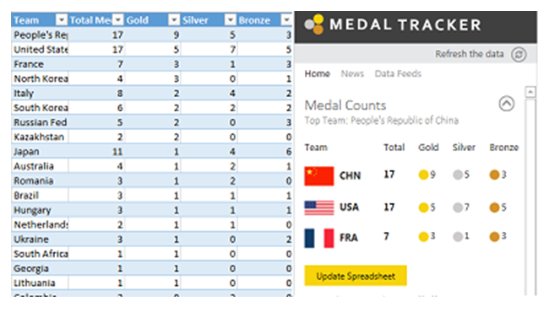
The Medal tracker app tracks Olympic medal winners by team, event, and athlete.
To see how this Medal Tracker app was created, see Designing the Medal Tracker Template.

Apps are created by developers (either third-party or from your own organization) by using Visual Studio 2012 or Office 365 Development Tools (previously called NAPA). Apps are also based on modern Web standards, such as HTML5, CSS3, Oauth, and OData.

Now you might think that only developers can create apps, but you would be wrong. Power users can also create apps by using Office Access 2013. An Access app is a SharePoint app. Therefore, you can create a SharePoint Composite solution as an Access app or incorporate an Access app, just like any app, into a broader SharePoint Composite solution. For more information, see Access apps.

You can find, purchase, and download apps from the following locations:
- The SharePoint Store.
- The Office Store.
- An App Catalog, which can be set up by your administrator for your organization as a private store.

To summarize, apps are perfect for getting focused chores done, addressing immediate needs, completing every-day tasks, and integrating into your SharePoint Composite solutions.

Social computing and sharing

When you plan and create a SharePoint Composite solution, social computing and sharing can aid you in practical ways. For example, you can find people with needed skills, advertise to others what your skills are, and build relationships based on common interests. Also, when you create a SharePoint Composite solution, you often want to advertise it, share it, and make it available to users to promote it’s visibility and adoption.

Social computing and sharing go hand-in-hand:
- Social computing enables you to share immediate knowledge and ideas, connect with colleagues, and easily find experts. When you network with people by using the computer network, you stay connected, in touch, and “in on the buzz”, often in a spontaneous and even serendipitous way. Each SharePoint user has access to three information hubs on the global navigation bar: Newsfeed, Sites, and OneDrive. These hubs are fully integrated into the SharePoint experience. In addition, Communities greatly enhance the traditional use of discussion boards, wikis, and blogs to collect and share institutional knowledge.
- Sharing of sites, documents, and lists to internal and external users lets you quickly and easily open up your site content to others who need access, but in a safe manner. In SharePoint Online, you can readily invite people outside of your company, such as vendors, trusted business partners, and customers, to view, share, and work with content on your sites.

The following SharePoint features comprise social computing and sharing.

Newsfeed If you’re familiar with popular social networking sites, you’ll feel right at home using Newsfeed. The Newsfeed page provides quick access to the lists of people, documents, sites, and tags you’re following through threaded conversations that you and others can post to and sorted according to your needs and interests:
- Newsfeed shows what you’re currently following: posts, people, documents, sites, and tags.
- Everyone shows conversations started by people at your company.
- Mentions shows only posts in which you are mentioned.
- Activities shows only a feed of your current activities, just as it appears on your “About me” page.
- Likes shows all items you have “liked.”
Sites Sites is the location where you quickly access your personal site and the sites you are following, and is the place where you manage your social computing activities. Several easy-to-use, and self-explanatory sections, What’s New, Documents, About Me, Recent, and My Tasks place up-to-date social information at your fingertips and help you filter volumes of social data down to just what is essential and useful for you. For social computing to work well, it greatly helps when each SharePoint user develops and maintains their user profile through the About Me section.

OneDrive OneDrive for Business provides a quick way to not only access personal and shared documents, but synchronize these documents with a computer folder so you can have convenient access to them when offline or away from your corporate network.

Communities The Community sites template offers a forum experience to categorize and cultivate deep discussions with a broad group of people across organizations that can share and leverage their expertise. The template helps organize and categorize discussions, enroll members, manage content, reward top contributors, and retain conversation history. You can customize the look and feel by changing the background picture, themes, page content, category descriptions, images, and so on. Community sites can be private, closed, or open to the public.

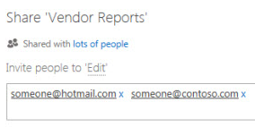
Sharing By using the new Share dialog box, collection administrators or site owners can optionally share their sites, libraries, lists, documents, or items with internal users and in SharePoint Online with external users who sign in with a Microsoft ID. You can also use this dialog box to control permissions on what you share. Sharing is turned on by default, but can be enabled or disabled by administrators, who can also quickly remove existing guests from sharing as needed, for example when they no longer need access.

Part II: The SharePoint Composite solution life cycle

Although you may not be a programmer, if you want to create a SharePoint Composite solution, you still need to think like a programmer. Like any solution or application, carefully planning and designing a SharePoint Composite solution is a good idea. Because SharePoint Products 2013 provides a complete infrastructure to build upon and Office 2013 products are often familiar tools to you and your users, you are already well ahead of the typical solution life cycle. However, It’s often best not to use a formally structured process, if only because it would be so time-consuming. A better approach is to use an agile or RAD (rapid application development) life cycle that promotes quick design and short, frequent iterations.

An agile life cycle is a good fit for developing SharePoint Composite solutions because it:
- Let’s you start slow, and proceed step-by-step.
- Provides low overhead.
- Enables mid-course corrections.
- Makes progress visible to users and stakeholders.
- Allows for immediate testing and verification.
- Still has potential for growth into a more formal solution.

Don’t forget to use the variety of features and tools that SharePoint Products 2013 provides for you to plan and design your solution. Instead of doing everything yourself, find expertise across your business to help vet your design, solve a specific problem, or enlist support. Instead of creating a lot of formal documents, create a project site that you can use to quickly gather requirements, obtain user feedback (commenting, prioritizing, ratings, and so on), communicate midcourse corrections, and report issues and problems. As you develop your solution, keep track of all your notes and communications in a Wiki site, and then convert it to a help or support system if need be.

Finally, don’t forget to use Visio diagrams to help you think about, analyze, and communicate your ideas, such as swim lanes, fishbone diagrams, and brainstorming figures. For more information, see Visio diagrams that support the solution life-cycle.

Define the purpose

The first step of any life cycle is to define the purpose of the solution and assess the overall business context. A good place to start is a simple goal statement followed by a brainstorm for potential solutions and ideas. Then, ask yourself some key questions:
- Is there an element of risk to this solution and do you need to do a formal risk analysis?
- Is this a “skunk-works” solution, or do you have a formal process that might require sign off?
- Is there an app or third-party solution that could do the job? Be thoughtful when adopting a third party product or custom-built solution. Make sure that product issues and bugs can be quickly fixed and that custom code doesn’t inhibit smooth upgrades.
- What is the environment you are in? Are there political issues, changes in process, or adoption concerns that you may need to deal with?
- Is there a learning curve for products and technologies that you or your users need to address?
- What is the value proposition? What makes this solution compelling, useful, and cost-beneficial?
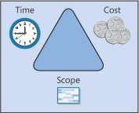
- What are the overall constraints and how should they be balanced as illustrated by the classic resource triangle:
  - Time (or duration)
  - Cost (or budget)
  - Scope (the amount of work)
- Try to understand how your solution fits into the overall IT governance plan of your organization. Governance is a set of policies, roles, responsibilities, and processes that guide, direct, and control the cooperation between users and IT to achieve business goals and comply with laws, such as Sarbanes Oxley. Your organization might have strict controls to protect sensitive information and work or loose controls to encourage adoption and creativity. Governance can vary depending on whether you are working at a team, group, department or organizational level.

Ultimately, you want make a go/no-go decision and not commit yourself too early without considering all the major consequences.

Identify the requirements

Now that you have decided to go for it, there are a basic set of requirements you want to identify before you start to design and develop your solution:
- Users and stakeholders
- Business logic
- Data and documents
- Content types
- User interface requirements
- Data presentation formats (grids, forms, reports, dashboards, scorecards, charts, and diagrams)
- Mobile experience
- Software requirements
- Technical requirements

Let’s take a look at each requirement in more detail.

Users and stakeholders

Identifying users and stakeholders up front helps you in a number of ways, whether its specifying tasks, designing the right user interface, getting buy-in, understanding training and documentation needs, or finding resources. Don’t overlook stakeholders who are in different organizations such as IT, Marketing/Sales, and Legal. Users can be just about anybody and anyplace. You goal is to understand them and fit the solution to their personality profile.

In a collaboration-based business solution, there are two main types of users:

User Type | Description
Information workers | Users whose primary job is to process information. They usually have one or more dedicated computers. There are several types:  - Individual contributors, who create and edit new content, collaborate with co-workers, and need access to data and documents.  - Project leaders, who create a project and maintain information about tasks, issues, and so on, and drive processes and work.  - Decision-makers, who view rolled-up information, summary data, secure information, and who also do strategic work or presentations.  - Small business users, who might be professionals, work at home and on the road, and don’t have access to IT staff.
Deskless Workers | Users who either do not have access to their own computer, or it’s secondary in nature to their primary job role. They require e-mail, use browsers, do light collaboration, and occasional editing. Examples include:  - Manufacturing floor workers  - Retail associates  - Bank tellers  - Call center workers  - Healthcare clinicians  - Retail POS workers  - Seasonal workers

Business logic

Business logic entails the following considerations: What are the day-to-day rules that must be enforced in the solution, and what is the workflow for the business process.

Business rules

When designing your solution and when iterating that design, you need to define and capture business rules so that your solution aligns with the business and the actions that are taken in your solution are consistent with the way the business is run. For example, you might require:
- All meals must be ordered within 14 days of conference.
- The Price equals the sum of items multiplied by the quantity of each item plus sales tax and delivery charge if outside the free delivery zone.
- You must be a permanent employee to get a benefit or attend an event.
- Orders can only be placed on items in stock.
- Product codes must be valid when entered.
- Customer account must be active, not suspended or closed.
- Don’t delete a customer that has currently-opened orders.

There are several ways to implement rules without using code:
- Calculated columns The use of calculated columns based on functions provides a lot of flexibly for encoding business rules and simplifying your technical requirements. By adding a calculated column to a list or library, you can create a formula that includes data from other columns and performs functions to calculate dates and times, to perform mathematical equations, or to manipulate text. For example, on a tasks list, you can use a column to calculate the number of days it takes to complete each task, based on the Start Date and Date Completed columns. For more information, see Introduction to data calculations.
- Excel 2013 formulas and functions Excel functions are reliable, time-tested routines that you don’t have to re-invent and that can encapsulate logic and rules. Formulas are calculations you create for your business needs. For more information, see Overview of formulas and Excel functions (by category).
- Access 2013 expressions If your solution uses Access 2013, you’ll find that the Expression Builder greatly simplifies your expression creation experience. You spend less time memorizing expression names and syntax, and more time focusing on building your formulas. You’ll find the Macro Designer is an intuitive way of creating advanced business logic in a declarative manner. Finally, data macros use an event model, similar to that of triggers in Microsoft SQL Server 2012, to enable reliable enforcement of data rules. You can use these features to help build an Access app. For more information, see Access SQL and expressions reference.
- InfoPath 2013 rules Rules control the behavior of a form by performing actions that take place based on conditions within the form, or events that take place when filling out a form. For example, display a message inside a dialog box, set a field value, validate input, and query or submit data to SharePoint or a database. These rules can be triggered by changing the value in a control, clicking a button, or opening or submitting a form. For more information, see Introduction to rules.

Business workflows
All businesses engage in common, everyday processes that involve some combination of human tasks and document collaboration that are often manual and time-consuming, but could be largely automated to improve efficiency. Examples include approval of formal documents, team creation and review of specifications and proposals, and signature gathering.
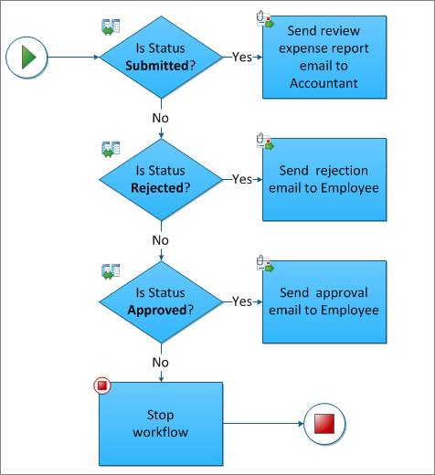
A classic example of a business workflow is expense report approval which requires several people working together to assemble content that adheres to a formal financial process and requires approval by authorized employees.
You can create automated workflows that manage the simplest to the most complex business processes in an organization. Workflows do this by automating both business application processes and human collaborative processes. Business application processes might update one data source when another data source changes. Human collaborative processes might send a document to an employee's manager for approval.

Automated workflows streamline:
- Synchronous operations For example in a lending library solution, a workflow is used to handle checkout and due date reminders for assets. Once an item is checked out, the workflow automatically sends a due date reminder when the item becomes due.
- Asynchronous operations For example, a project owner creates a project, milestones, tasks, and budget entries, and then tracks progress over time. The project owner has frequent access across all pieces of information, while task owners act on the data when their work schedules allow.

For more information, see Business process and workflows.

Data and documents

Information is critical to efficiently run any enterprise, and data is the life-blood that supports it. Most enterprises spend major resources gathering, storing, updating, accessing, analyzing, reporting, and managing data and documents. In a collaboration-based SharePoint Composite, you need to give equal consideration to your data as well as your document needs. Essentially, there are three types of information:
- Structured data This type of data can be organized into tables, easily updated, sorted, filtered, and queried, and is commonly stored in flat files, lists, and databases. Structured data may also be hierarchical in nature. Structured data also includes metadata, often defined as “data about data”. Metadata gives meaning and constraint to the data, and includes column headers, data types and formats, and basic validation rules. Examples of structured data include purchase orders, statistics, inventories, budgets, and sales.
- Unstructured data This type of data is information that is stored in documents and presentations, and that cannot be automatically converted into structured data. Examples of unstructured data include memos, letters, publications, policies, proposals, specifications, slides, and resumes.
- Semi-structured data This type of date contains structured data combined with a modest amount of unstructured data, such as comment and memo fields, document attachments, and document properties. Examples of unstructured data include status reports, formalized Request for Proposal (RFP) documents, performance reviews, and product catalogs.

When working with data and documents in a SharePoint Composite, there are several major areas of consideration.

SharePoint lists

A SharePoint site usually includes many default lists, including Links, Announcements, Contacts, Issue Tracking, Surveys, and Tasks, that you can use as a focal point for a business solution. In many cases, these default lists can provide quick, effective solutions with little or no modifications. For example, you can use: Surveys, which include conditional branching and page breaks, for employee and customer satisfaction assessments, and Issue Tracking, which has versioning and version-history storage, for deeper analysis of workgroup projects and common work tasks.

Lists are rich and flexible and have many built-in features that provide a robust way to store, share, and work with structured and semi-structured data. You can:
- Include many types of data, such as dates, pictures, formulas and calculations based on other columns, append-only fields (useful for logging and tracking applications), and lookup fields where you can select a value from another list field.
- Create list views to organize, sort, and filter data in different and specific ways; change the metadata, such as adding and deleting columns, and modifying validation rules; and use lists consistently across SharePoint sites with content types, site columns, and templates.
- Create custom lists, display the data in Web Parts and pages, and import, export, and link to data from other programs, such as Excel 2013 and Access 2013.
- Track versions and detailed history, require approval to modify data, use item-level and folder security, check-in and check-out lists, and automatically stay informed about changes by using alerts and RSS feeds.

For more information, see Introduction to lists.

SharePoint libraries

A SharePoint library is a location on a SharePoint site where you can create, collect, update, and manage documents with team members and other employees. Each library displays a list of documents and key metadata about those documents, which helps people use the files and work together, and each library provides useful features such as checking documents in and out, creating major and minor version numbering and tracking, and using rich policy, auditing, and workflow features. You can create and manage documents, pictures, presentations, forms, and other types of files in a library. Finally, you can use the default Shared Documents library, customize this library for your purposes, or you can create your own additional libraries.

One important goal of your solution design is to organize the library for easy access. There are basically two approaches: columns and folders.
- Columns Customize the library by adding columns to classify content, and then create views with different columns, sorts, and filters.
- Folders Organize lots of documents by using folders that have a meaningful descriptive name, such as “RFP Proposal” or “Project Submissions” to help users locate documents. You can also specify default metadata on a per-folder basis by using the Column Default Value setting so you can synchronize metadata changes on multiple items all at once.

For more information, see Introduction to libraries.

The Document Process Life Cycle

You can envision a document as going through a Document Process Life Cycle. Here are the potential phases to think about when designing your solution.
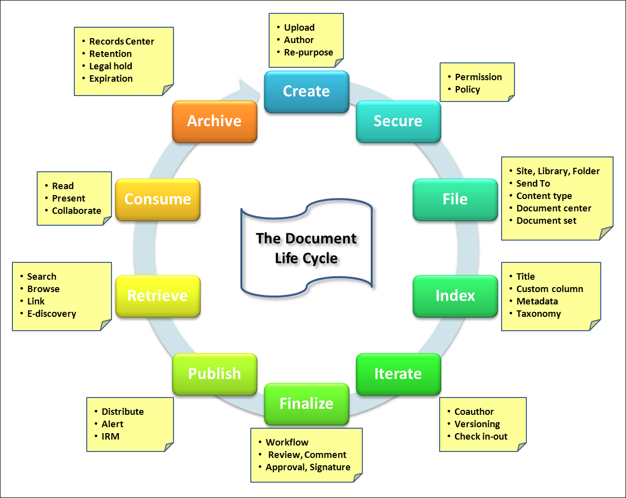
Data modeling

Data modeling boils down to identifying all the columns and data types you need for your solution and what are the key data relationships between each list or table you have identified. Key questions to ask are:
- What data and data types do you need?
- Will you only use data from native lists, or do you need to create external lists from data sources outside of SharePoint Products 2013, such as SQL Server 2012 or through a Web service?
- Will you need to import or export the data?
- Where will your store your data?
- What are the relationships between the data so you can create lookups and enforce the relationship (also called referential integrity)?
- How will you verify and validate the data?
- Do you need to do special data operations, such as bulk updates or complex aggregations?

Tip A simple way to do a bulk update is to open a list in datasheet view (Quick Edit), and copy/paste the data into the grid. Also, if you link the list to an Access 2013 database on your computer, you can run Action queries to append, update, and delete many items.

For more information about the data types you can create in a list or library, see Site column types and options.

Lists are often like database tables. Aim to create a list that is a collection of named columns and multiple items and that stores information about a single subject, such as employees. Each column of the list is uniquely named and contains information about the subject, such as an employee's first name or address. The rows of the table contain occurrences of the subject, such as all the current employees in the company. A single value is stored in the intersection of an item and column, and is a single fact, such as “Seattle”. Finally, make sure you can sort and filter items and columns without changing the meaning of the list.
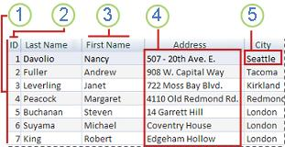
A list represents a single subject — a person, place, thing, event, or concept.
Each item is unique and has a primary key, such as a badge number, or the Item ID.
Each column has a unique, short, and meaningful name.
All the values in a column are similar in meaning and format.
Each value in the list represents a single fact.

You may need several lists with relationships between them that bring the data together. For example, Employees belong to departments. In this scenario, you would create two lists Employees and Departments. Then you would create a Lookup column in the Employees list that “looks up” that specific employee’s department in the Departments list.

Well-defined lists and clear relationships between those lists make it easier to:
- Save space and improve performance, because repeating and redundant data is physically removed.
- Update data accurately and maintain the integrity of the data.
- Sort, filter, create calculated columns, and summarize data.
- Create views of you data in a variety of ways to answer expected and unanticipated questions.

For more information, see Create list relationships by using unique and lookup columns.

Managing lists and libraries with many items

When a list or library has a large number of items, you need to carefully plan, organize, and account for how data is accessed. By planning and using key list and library features, you can ensure that you and other users quickly find information without adversely affecting the performance of the rest of your site.

You can store a lot of data and files in lists and libraries. But if a query or database operation exceeds a resource throttle or limit, you may be blocked from doing this operation because accessing that many items could adversely affect other users of the site. Fortunately, there are a set of straightforward strategies and basic features you can use to achieve the results you want to prevent you from exceeding these throttles and limits. All users can circumvent the limit during a dedicated time window, and with appropriate permission you can also use a higher limit through code.

For more information, see Manage lists and libraries with many items.

Content types

Content types enable site users to quickly create specialized kinds of content by using the New Item or New Document command in a list or library. Content types are useful because they provide site owners a way to ensure that content is consistent across sites and for a single list or library to contain multiple item types or document types. Site owners can pre-configure specific details about the content when they set up content types for a site, list, or library.

Site owners can define content types for list items, documents, or folders. The settings for a content type can specify:
- The columns (metadata) that you want to assign to items of this type (including Managed Metadata columns).
- The custom New, Edit, and Display forms to use with this content type.
- The workflows that are available for items of this content type.
- The custom solutions or features that are associated with items of this content type.
- The information management policies that are associated with items of this content type.
- The Document Information Panel, that displays in compatible Microsoft Office programs for items of this content type.
- The document template for new items of this type (such as Word, Excel, and PowerPoint).

You may find it useful to define content types for some of your content if your content meets any of the following criteria:

If this is true: | Content types may be useful to you in the following ways:
You have specific types of documents that have a standardized format or purpose and you want them to be consistent across your organization. | Configure site content types for these types of documents at the top-level site in your site collection so that they are available for use across all subsites. This way, all users in your organization will be creating these documents in consistent ways.
You have specific templates people must use for specific kinds of documents. | Add these document templates to the relevant content types so that all new documents created from the content type will use the template.
There is a standard set of information you like to track for specific types of documents or items. | Add columns to your content type to track this information. If any of the information is especially vital, you can designate those columns as required. You can also provide default values for specific columns when you configure the content type.
There is a defined business process for how specific types of documents are always handled or reviewed. | Consider configuring workflows for specific content types. You can use workflows to manage business processes like document review or approval.

After you identify content for which you might want to define content types, you should think about where you want to define content types. If you define site content types at the top-level site in your site collection, they will be broadly available for reuse in lists and libraries in all subsites of the top-level site. Individual site owners can also define site content types for their sites, although these content types will be available for use in lists and libraries only on that site and any sites under it. Additionally, you can share content types across SharePoint Online site collections by designating a specific site as a hub for content type publishing. Content type publishing helps organizations manage content and metadata consistently across their sites because content types can be created and updated centrally, and updates can be published to multiple subscribing site collections.

When planning content types, you might find it helpful to create a spreadsheet or table that captures the information you want to include when you define your content types. For example, you could start by creating something basic like the table below, and then adapting it to include whatever additional information you might find useful to track, such as the sites or teams who will be using the content types:

New Content Type | Parent content type | Columns | Document Template | Workflows | Information Management Policies
Specify the name of the content type you want to create. | Specify the parent content type from which it will be created | List the new or existing column you want to add to the content type. | Specify whether there will be a document template associated with the content type. | Specify whether there will be any workflows associated with the content type. | Specify what information management policies might apply to this content type.

For more information, see Introduction to content types and content type publishing.

User interface requirements

Most SharePoint Composite solutions do not require advanced skills in Web page design, and there a number of SharePoint features which make this important step much easier to do and, in many cases, from the browser.

Choose a site template
When you create a new site, you start by selecting a site template to base your site on. Site templates contain lists, libraries, pages, and other elements or features that support the needs of a solution. When you create a new site from a template, you can start using the site right away or customize the site so that it meets your needs. Team, Project, and Community sites are the most common sites, but there are other sites to consider depending on your needs.

Create a portal, a workspace, or a dashboard
There are several types of pages that you might create in your SharePoint Composite solution: portal pages, workspaces, and dashboards.

A portal page is content-focused, and might do the following:
- Aggregate information from a wide variety or sources.
- Refresh content regularly to engage users.
- Use many data types, including text, images, videos, graphics, and animations.

A workspace is task-focused, and might do the following:
- Prioritize and highlight project or customer data to help you make effective decisions.
- Display an up-to-date work schedule and meeting information to quickly plan your day.
- Get quick access to business news, local weather, and your favorite Web sites to focus your Web browsing.

A dashboard reports information, and might do the following:
- Consolidate data from different data sources and create a report.
- Analyze and aggregate data (for example, sums, totals, or counts).
- Summarize key KPI information that you want to see at the beginning of each day.

Create page content and navigation
From the browser you can edit SharePoint pages that have varied layouts, richly formatted text, and diverse objects such as images and media. These features help you create pages that are more compelling and informative. Design Manager offers even more options for editing pages.
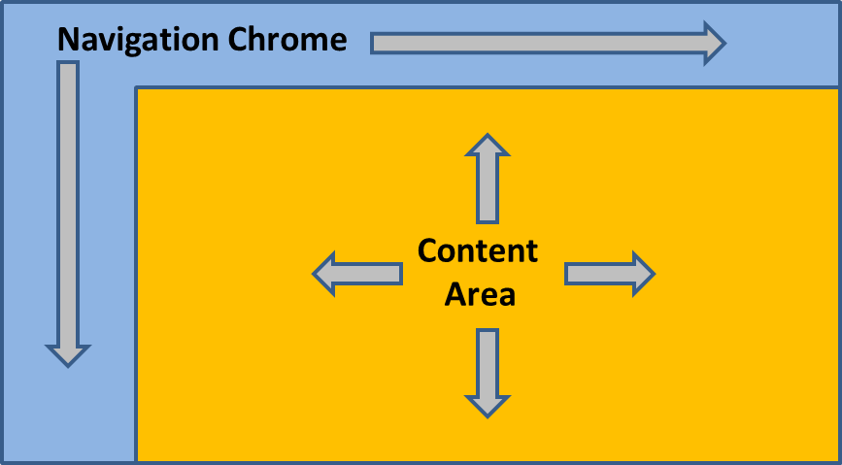
Think of the page structure as a wireframe that contains a content area and navigation chrome. Many page navigation decisions are easy to implement. The top link bar helps users of your site navigate to other sites in the site collection by displaying a row of tabs at the top of pages in the site. The Quick Launch contains links to select lists and libraries of the current site and can optionally contain links to subsites and pages of the current site. You use the Quick Launch to navigate between different areas of your site, such as between a list and a library or from a parent site to a subsite. Lastly, the tree view is a navigation option that provides a hierarchical view of the lists, libraries, and subsites. The tree view is displayed to the side of most pages of the site, below the Quick Launch, but is disabled by default. If your site has a complex hierarchy, the tree view can make it easier for the users of your site to navigate between content in the site hierarchy, such as between a library in the current site and a list in a subsite.

Add Web Parts
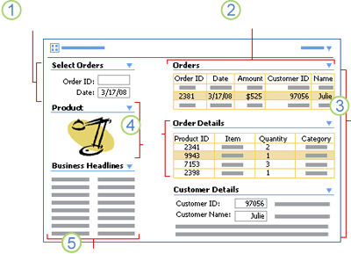
You can handle much of the dynamic, data-driven aspects of a modern Web page by using Web Parts. A Web Part is a modular unit of information that forms the basic building block of a page. You can add Web Parts to pages or to Web Part zones in a Web Part Page and then customize the individual Web Parts to create a unique page for your site users. You can use Web Parts to consolidate data, such as lists and charts, and Web content, such as text and images, into a dynamic information display that is built around a common task or special interest. Pages and Web Part Pages often contain several Web Parts that are connected so that you can dynamically display data and content to see the results that you want.

For example, you can create a Web Part Page called Customer Orders that you use to display critical information. You get a call from a customer who has a question about an order, does not remember the order ID number, but does remember the date when the order was placed. You can use a Web Part Page to do the following.

Look up an order by order ID number or, in this case, the order date.
Display all orders by date.
Select the correct order, based on the customer's name, and look up order and customer details.
Select a line item (in this case, the lamp), and display a product picture to confirm the customer's question.
Scan for late-breaking business news that is pertinent to the customer's order.

For more information, see Summary of Web Parts.

Personalize the page
A useful technique is to use the Filter By User Web Part or the Me function to customize the display of content based on who is currently using the page. This is especially useful for solutions used by Human Resources groups. Information workers, project leads, and managers might also require different views relevant to their activities. The task owners want to see all issues assigned to them, for example, while the project owner wants to see all past due issues.

Data presentation

Because SharePoint Composites can work with data in a variety of ways, it’s helpful to clearly understand the basic data presentation formats that you can use and combine in your solution.

Data Grids
The simplest way to work with data is often by using a data grid. A data grid is a tabular display of data in columns and rows that lets you easily sort, filter, query, and manipulate the data. Data grids also provide a way to obtain the correct set of data for your business solution from several data sources. For some users, a data grid is enough to effectively work with the data. For other users, you need more user-friendly ways to manage the data, such as forms, reports, and dashboards. You can create and use data grids by using Quick Edit, Access datasheets, and Excel tables.
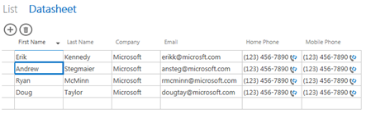
Quick Edit provides a data grid for viewing and editing data for many types of lists. You may find Quick Edit more convenient and powerful than the standard list view. It displays the contents of a list or a document library in rows and columns that you can directly edit on the page.

Forms
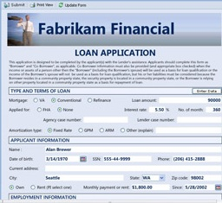
Structured and semi-structured data often needs updating and changing, and that's where forms come in to play. A form, whether printed or online, is a document or program component designed with a standard structure and format that makes it easier to gather, capture, organize, and edit data. Forms are windows through which users see and access your data. Online forms contain instructions, formatting, labels, and blank spaces for entering data, much like a printed form. Online forms also contain controls that display data or make it easier for users to enter or edit data, perform an action, or make a selection, such as list boxes, option buttons, and command buttons. A visually attractive form makes working with the data more pleasant and more efficient, and helps prevent incorrect data from being entered. You can create and use forms by using SharePoint list forms, InfoPath forms, Access views, and Excel forms.

Reports
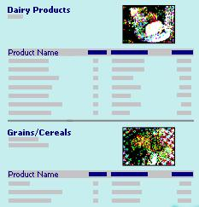
Structured and semi-structured data is commonly made available to users through business reports. A report is the presentation of data transformed into formatted and organized information according to specific business requirements. Examples of reports include budget forecasts, sales summaries, phone lists, mailing labels, and product catalogs. Reports can be a simple one-page synopsis or a hierarchical display of extensive data. A report may also contain subreports, vary based on parameters that are passed to it, and be highly interactive so that users can sort, filter, and drill down on or even drill through the data.

By using reports, information workers can make good business decisions by helping them to answer questions, focus on objectives, find best alternatives, devise correct strategies and tactics, determine consequences and trade-offs, and assess unknowns and risks. You can create and use a wide variety of reports by using Access 2013, Excel 2013, SQL Server 2012 Reporting Services, and InfoPath 2013 (by using form merging).

The following table provides suggestions on fitting a report to the type of user.

Type of user | Example | Report actions
Casual users | Frontline workers | Read standard, simple reports and access reports through simple displays, such as flowcharts.
Moderate users | Managers and information workers | Read detailed reports, customize and interact with reports by filtering, sorting, and setting parameters, and create ad hoc queries and reports.
Power users | Data and business analysts | Create and customize reports, work with Online Analytical Processing (OLAP) PivotTable reports, use report authoring tools, conduct statistical analysis, and perform analytics using data-mining tools.

Dashboards
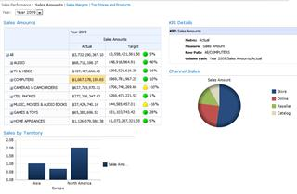
Dashboards are a vital business-intelligence technique that combines reporting and analytics to visualize critical information at the enterprise, departmental, and group level. Dashboards often use a number of Web Parts to create a unified view of scattered information throughout the site in one place.

There are three types of dashboards: operational dashboards used to monitor daily work for employees, tactical dashboards for analysis of data and monitoring of monthly and quarterly activities, and strategic dashboards for long-term enterprise management. Dashboard data can be quantitative, such as order amounts, market share, profits, support calls, manufacturing defects, or Web page hits. Or dashboard data can be qualitative, such as Top 10 customers, key issues, current tasks awaiting completion, and critical news updates.

Dashboards can be characterized in many ways, for example by:
- Role, such as strategic, analytical, and operational.
- Data type, such as quantitative and non-quantitative.
- Business function, such as Sales, Finance, Marketing, Manufacturing, and Human Resources.
- Scale, such as enterprise-wide, departmental, team, and individual.
- Refresh schedule, such as monthly, weekly, daily, hourly, or immediate.
- Nature, such as static or Interactive.
- Display, such as graphical, textual or integrated.

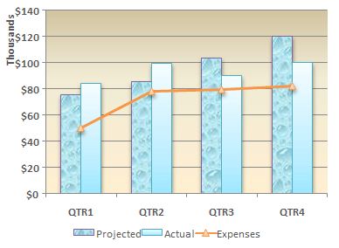
Charts
Charts are used to display series of numeric data in a graphical format to make it easier to understand large quantities of data and the relationship between different series of data. The two primary ways to use charts in a SharePoint Composite solution are by using Excel Services and Power View. However, if your solution includes the use of SQL Server Reporting Services, you can also create reports that contain charts, as well as maps and other diagrams.

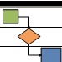
Diagrams
Because of the data connection and refresh capabilities of Visio diagrams, diagrams are now a first-class citizen when it comes to presenting data. You can:
- Publish Visio diagrams to the Web to share rich, compelling visuals, shapes, and processes.
- Connect diagrams from one or more data sources (such as Excel 2013) and publish them to SharePoint. Real-time data within the shapes can be refreshed.
- Create highly interactive, visual solutions by using the Visio Web Access Web Part connected to other Web Parts.

Mobile experience

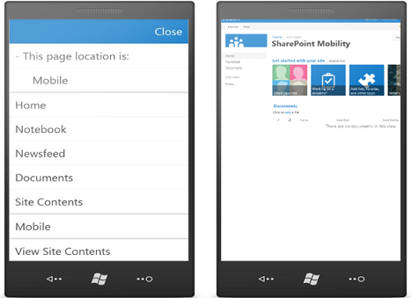
Even when you’re on the go, you still want to read, edit, share, and follow SharePoint content. That’s where mobile devices come in. Although developing mobile solutions requires coding by a developer, there are mobile features built into SharePoint Products 2013 that you can leverage when you design and create a SharePoint Composite solution.

You can access all your documents, whether your sites are on premises or online, and you can lightly edit the documents to make last-minute changes by using the Office Web Apps in the Office Hub. The Office roaming service also makes it easy to locate your most recent documents, the ones you most likely need. Search results are based on all available site content, not just your local phone, and includes documents, feeds, sites, and people. “All My Work in One Place” can be delivered on a mobile device as well. You can review your tasks, update task status, edit notes, create new tasks, and delete tasks. This keeps you productive wherever you are.

You can also follow some sites, such as team and project sites, which can be configured with different views, including the mobile-specific, contemporary view that trims site content to the most important links or the full desktop view if your device has a larger display.

The contemporary view of a SharePoint site offers enhanced features including:
- Menu button Contains the convenient commands, View Site Contents, Sign Out, and Close.
- Switch to PC View Displays the full desktop view of a site.
- Navigation window Presents a single menu with breadcrumbs, top navigation, and quick launch navigation from the full desktop view of the site, and a link to All Site Content.
- Tap-to-open links All hyperlinks display text or icons on a wide strip to make it easier to follow a link.
- Pagination Automatically paginate lists with more than 20 items.
- New and edit functionality Create and edit list items such as tasks and other list items.

Here are additional ways you can benefit from using mobile devices in your SharePoint Composite solutions:
- Browse and update an Access app or InfoPath form.
- Keep a workflow going smoothly by completing an assigned task.
- Check dashboards and scorecards for the latest data and share with colleagues, partners, or customers.
- Keep up or catch up with teams, sites, and blogs.
- Keep a close eye on projects as they approach a deadline to make sure it runs smoothly.
- Quickly access documents related to an upcoming meeting.
- Locate a proposal, update a customer name, and forward it to a client.
- Share a picture on OneNote or write a quick post to share with your team.
- Stay in touch with colleagues by reading and responding to informative news, questions, and other
- social information.
- Follow people, documents, and teams and projects of interest.

Note Because mobile phones run on different platforms, the experience and the feature coverage varies. For more information, see Supported mobile device browsers in SharePoint 2013.

Software requirements

SharePoint Products 2013 and Office 2013 are available in a number of different product editions each of which provides a greater subset of features. It’s important to understand which product you need, so you have the features you require to create your solution. Another consideration is whether or not your infrastructure is on premises, online, or a hybrid installation. Most but not all on-premises features are available in SharePoint Online service, whereas there are some features only available in the SharePoint Online service.

For SharePoint Products 2013, the on-premises editions are:
- SharePoint Foundation 2013
- SharePoint Server 2013, Standard
- SharePoint Server 2013, Enterprise

For SharePoint Products 2013 the main online editions are:
- Office 365 for professionals and small businesses
- Office 365 for enterprises

For the Office 2013 family of products the editions are:
- Office Standard 2013
- Office Professional Plus 2013
- Office Visio 2013
- Office Project 2013

Technical requirements

Depending on your site and needs, you may need to work closely with your IT department to customize your SharePoint installation. The following is a short, but critical list of considerations:
- Security elements to control user access to sites and site content including SharePoint groups permission levels (also called roles), and permissions inheritance. For more information, see Introduction: Control user access with permissions.
- Features and Services to activate.
- Special performance and capacity planning.
- Data connection files, libraries, and trustworthiness.
- Central Administration settings and configurations.
- Authorization, authentication, and user identity management.

Design and develop

Once the wheel was invented, the idea of using a round object to transport people and goods was widely adopted. Overtime, the wheel was improved upon and different types of wheels, or “wheel patterns” were created. There’s no need to reinvent the wheel and there’s no need to re-invent a SharePoint Composite solution. There’s a pattern or combination of patterns that fits your solution and helps ensure that you have made the right set of choices and tradeoffs, confirms that you are on the right track, and makes sure you are not using the wrong type of wheel. That’s what Part III: Common SharePoint Composite Design Patterns is all about (and why this section seems so short).

Deploy and maintain

Deploying a SharePoint Composite solution is a relatively simple process because it’s usually a matter of displaying or publishing one or more Web pages. Alternatively, you can save an entire SharePoint site as a template, and then deploy it where you wish. Another big advantage to using SharePoint Products 2013 is that there are a number of features and tools that make it easier to maintain your solution. Here are some things to think about:
- Deploy the solution If you want to distribute your solution as a site, you can save it as a template to the Solution Gallery for the site collection. Everything that you create as part of the solution is saved in the template, and then you or an IT administrator can activate the template so it can be created just like any other site template. A site template is also useful when you want to move from a test to a production environment. For more information, see Save a SharePoint site as a template.
- Promote the solution Help people to know that the solution is available. Use alerts, announcements, e-mails, blog posts, site newsletters, or other online social computing techniques that will make your solution go viral.
- Train your users Make your solution quickly successful by educating users on how to use your solution and what are its benefits. Use PowerPoint Web Access, video demos, podcasts, or online training.
- Solution help and support Keep your solution working and on track. Create and update a help wiki, set up a discussion board or list to track issues and bugs, provide backup resources to your Enterprise Help desk in a subsite, regularly e-mail rotating tips, add tooltips to important commands, write a Frequently Asked questions (FAQ) Web page, or create an online suggestion box for feedback and ideas.

Part III: Common SharePoint Composite design patterns

The following sections describe fundamental SharePoint Composite design patterns. A design pattern is a practical way to organize the basic SharePoint building blocks and Office 2013 products according to common types of business solutions and appropriate product technology. A pattern helps to organize your thinking and planning. A pattern also fits a typical scenario and helps you understand how that scenario is similar to your needs.

But, a pattern is not a strait-jacket, and, with some experience, may be adapted and combined to fit your unique and specific requirements. After doing your up-front analysis, you may end up adopting just one pattern. Or, you may end up combining patterns in a unique way. Whatever the case, it’s a good idea to read or browse through all the patterns to make sure you are getting the big picture, understanding all your options, and making good choices.

Once you understand the basic patterns, go to the No code solutions using SharePoint 2013 Composites page (http://msdn.microsoft.com/en-us/sharepoint/fp161345) to find sample solutions, such as hands-on-labs, walkthroughs, demos, case studies, articles and other resources. Use these sample solutions to find practical, real-world models that can help you create your own solutions, adopt best practices, and learn needed skills.

Browser-based customization

There’s no better place to start creating a SharePoint Composite solution than in the browser. Editing the page, adding links, creating lists and libraries, embedding workbooks, inserting Web Parts and making Web Part connections can go a long way towards creating a useful solution.

For more ideas and examples, see The Fabulous 40.

Just edit the page

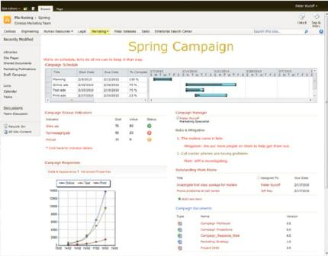
Just by editing the contents of a Web page and adding a few Web Parts, you can create a simple SharePoint Composite solution. You can instantly add and update text, tables, images, and links by using the SharePoint ribbon, and you’ll find the editing experience is familiar, especially if you use Word 2013. Once you have captured data in a list or documents in a library, you can quickly add them by using the List View Web Part to display important or current information.

A common approach is to plan your page layout as several container boxes, and then adjust the size and format of the Web Parts to fit into one page without requiring users to scroll horizontally. You can modify the Web Part chrome and toolbar or even minimize the Web Part to save space. When you add a List view Web Part, consider first creating a view that limits the columns, sorts the data, and filters it to just the subset of data you need for your purpose. Of course, it’s easy to iterate the design until you get it just right.

Additional easy to use SharePoint lists include: Calendars, Tasks, and Links. Additional easy to use Web Parts include Summary Links, RSS Viewer, Image Viewer, Page Viewer, Get Started with your site, and the Picture Library Slideshow.

Here are some common tasks and ideas:
- Use Announcements to let your department or team know about an upcoming event, post important breaking news, or discuss a facilities issue such as new construction.
- Use Calendars to list your organization’s holiday schedule, track upcoming vacation schedules, or
- track your organizations training events.
- Use the shared OneNote notebook to capture daily todo items, critical ideas, and key documents, like a shared whiteboard with your team.
- Use Links to track news sites (stock, partner, and distributor sites) or provide links to other intranet sites.
- Display a library of policies and procedures, frequently used forms, meeting agendas, and current reports
- Use team discussions to display the latest posts and the hottest topics.
- Display images, such as the company logo, a team photo, or pictures of morale events and holiday parties.
- Use the Page Viewer Web Part to display an embedded site, folder or document of interest to the team.

Embed an Excel workbook

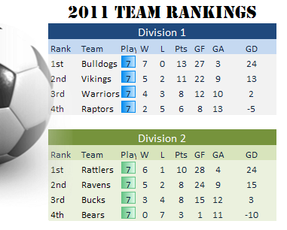
Although all Office Web Apps can be useful in a SharePoint Composite solution, the Excel Web App adds something more. You can embed spreadsheets on sites and blogs to add visual interest and page dynamics. For example, a small Travel Web site can display top destinations, prices, and related data as a table that customers could sort and filter for their own needs, a non-profit could graphically show a fund drive progress in real-time, or the company soccer team can display its latest standings.

You can also customize how the Excel workbook is embedded by resizing the frame, displaying only specific charts and tables, allowing interactivity, or specifying an active cell. It’s a simple matter of making selections from the What to Show dialog box, copying the HTML code, and adding it your Web page, by editing the HTML source or by using the Content Editor Web Part.

Add Web Part connections

Adding Web Part connections takes page and site customization to the next level. From the browser or SharePoint Designer 2013, you can connect Web Parts to present alternate views of your data or documents, perform related calculations, or filter one Web Part by using values from another Web Part. For example, you can select from a list of top-selling products in a Filter Web Part, and then simultaneously display the current inventory level as a table in one Web Part, a bar chart of sales revenue over the past five years in a second Web Part, and a sales summary over the past year in a third Web Part.
A Web Part connection is a way to pass data from one Web Part to another Web Part and synchronize their behavior

Advanced Web Parts that you can connect together in a variety of flexible and useful ways include List View, Filter, Excel Web Access, Visio Web Access, InfoPath Form, Content Search, Project Summary, and Timeline Web Parts. The following table summarizes the most common types of Web Part connections you can make.

Form view  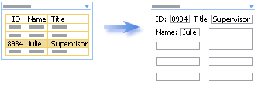 | Summary and detail  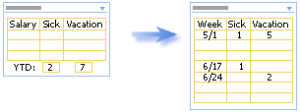
Alternate field view  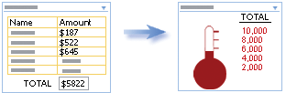 | Search and filter  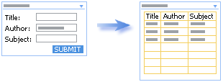
Calculate  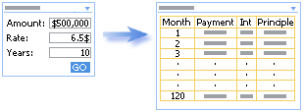 | Data enhancement  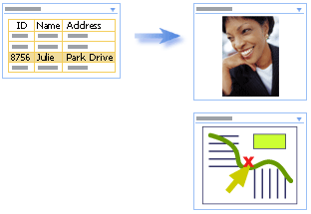
Alternate list view  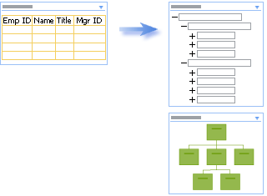 | Alternate item view  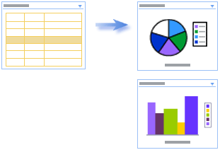
Master and detail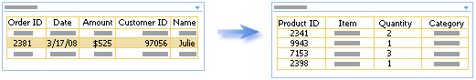

Dynamic diagrams

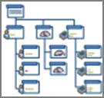
Most of us are not graphic designers, but perhaps secretly wish to be one because we know how powerful graphics are in communicating and persuading others. Whether you’re creating an organizational chart, a network diagram, or a business process, by using Visio Professional 2013, you can unleash the latent graphic designer within. You can make your diagrams more appealing and professional-looking in seconds with features like:
- Modern, pre-drawn shapes, intelligent templates, and sample drawings.
- Quick Shapes, a Mini toolbar, a dynamic grid to add and align shapes, auto connect and drag to connect.
- Formatting tools and design options and a rich gallery of themes.
- Quick Styles that can be added to a shape to make it standout and theme variations for greater flexibility over look and feel.
- Automatic layout adjustments so you can insert and delete shapes with little impact.
- Large and complex diagrams that can be simplified by using sub processes and containers to group related shapes visually and logically, and to link across pages.

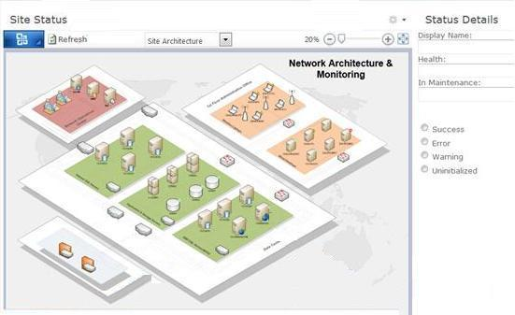
Once your diagram is created, you can then publish and share diagrams by using Visio Services, which supports central access to Visio diagrams. Use the Visio viewer for sharing interactive, browser-based diagrams (pan and zoom in the online diagram, follow hyperlinks in shapes, and so on). Users with Visio Professional 2013 installed on their computer can also open the diagram in Visio Professional 2013.

Furthermore, you can connect Visio Diagrams to data, so you can put information in context and make it more meaningful. Diagrams that are linked to data can be refreshed automatically or by the user. Connectable data sources include Excel 2013, SQL Server 2012, SharePoint Lists, OLE DB/ODBC, external lists, and Data Connection Libraries. Once the data connection is made, you can link data to shapes: Display data fields as callouts next to a shape, position fields in boxes below a shape, place fields of data directly on top or to the side of a shape, insert legends to clarify your data graphics, and communicate what the visuals (icons, colors, bar graphs) in a diagram mean and how they map to your data.

Data-driven diagrams are very useful and can help identify trends and exceptions at a glance. Examples include healthcare metrics on a hospital floor, retail metrics on a store layout, network health status on an IT network, and an organizational chart with metrics for each individual.

Form-centric solutions

All businesses gather data of some kind, and the success of any business process relies on the quality and integrity of that data. Common business solutions that use forms include: data gathering, such as a help desk Web site, a procurement center, or an employee hiring center; ad hoc business processes, such as issue tracking, tasks lists; or collecting user information in a workflow.

As an alternative to a list form, you can use InfoPath 2013 to create, edit, and design forms. Lists can use InfoPath forms for their New Item, View Item, and Edit Item forms. InfoPath 2013 makes it easy to completely change the layout and appearance of forms. InfoPath forms achieves this by letting you standardize, customize, and optimize the process of gathering data without writing any code.

You can use InfoPath forms on a client computer or in the browser. The major benefit of creating browser forms is that users who fill out the forms do not have to have InfoPath 2013 installed on their computers. Many but not all controls can be used in a browser form. For more information, see InfoPath features unavailable in Web browser forms.

Using InfoPath 2013, you can design and deploy sophisticated forms quickly and efficiently. Familiar tools (varied fonts and styles, spelling checker, table designer, clip art, Ribbon interface , and so on) help minimize training time and speed forms creation. The following are some key features that help you create first-class forms:
- Update shared data via browser forms (list forms, form library forms, external list forms, and workflow forms).
- Connect an InfoPath Form Web Part to other Web Parts.
- Use Quick Publish functionality to publish forms in a single click.
- Create calculated fields, default values, conditional formatting, and out-of-the-box rules, all with declarative logic.
- Add custom data validation that ensures that users cannot submit forms that contain incorrect data.
- Design multiple views, which simplify the form-filling experience by splitting forms into multiple pages or creating separate views optimized for specific users or tasks.
- Add data connections to other sources such as SharePoint lists or Web services to get supporting data into your forms.
- Use pre-built layout sections and form templates, so you don’t need to define all parts of the form from scratch.

List and form library forms

You have two design choices when creating applications that will incorporate InfoPath forms:

List forms You can create InfoPath forms based on SharePoint lists. There are a number of reasons why you might want to replace native list forms with InfoPath forms including the following:
- Multiple form views
- Data validation
- Auto-population of fields
- Conditional display of controls, sections and views
- Generating automatic, derived and computed values

Form library forms A form library is a SharePoint document library that uses an InfoPath form as its default content type. New forms created in the form library and individual forms that are filled out by users are stored as XML files in the library, one XML file for each form. You would use Form library forms if your solution requires any of the following features:
- Complex schemas Complex information models that incorporate both repeating one-to-many, and many-to-many relationships.
- XML files Information is captured in the form as XML data, which means other applications can easily read and process the information.
- Property promotion Specify that the values of the form automatically populate as columns in the library.

Comparing list and form library forms There are important functional differences between these two types of forms:
- Schema The schema structure for a list form is flat, it is not possible to build hierarchical information sets with grouped and nested items, and you cannot apply repeating, optional, or choice behavior to individual elements or groups, as you can with Form library forms.
- Controls List forms support only a subset of Web browser controls, essentially because lists are non-hierarchical, whereas Form library forms support all Web browser controls. The following controls are not supported in list forms:
- Bulleted List, Numbered List, Plain List
- External Item Picker, File Attachment
- Optional Section, Repeating Section, Repeating Table
- Choice Group, Choice Section
- XML List forms store data in the list columns, and do not generate an XML document as does a Form library form.

The InfoPath Form Web Part

The InfoPath Form Web Part provides numerous ways to create a SharePoint Composite solution. You can insert one or more InfoPath browser forms (list or Form library) that have been published onto any SharePoint page as Web Parts, and then interactively connect them together by sending and receiving data. There are essentially two ways you can use the InfoPath Web Part:
- Connection-based, where Web Parts communicate using part-to-part connections, such as connecting the InfoPath Form Web Part with an Excel 2013, Visio 2013, or custom Web Part.
- List-based, where Web Parts communicate and connected to one or more related lists. List forms are not stored in a Form library, but rather in the list folder structure, and list forms are, in fact, InfoPath Web Part forms behind the scenes.

For example, when filling out a new customer requirement form, you can automatically fill in the contact information with data from a Customers list by selecting an item in the Customers List Web Part and sending the values into the fields of the requirement form based on the InfoPath Form Web Part.

You can also pass data from the InfoPath Form Web Part in one of three ways: a new InfoPath rule action, the Update button in the Ribbon, and by using the Submit button control on the form. To pass one or more fields as input or output parameters, you define the parameter fields by using either the Publishing wizard or the Form Options dialog box. In the form, you can use the following controls and buttons:
- Text Box, Rich Text Box
- List Box, Drop-Down List Box, Combo Box
- Check Box, Option Button
- Date Picker, Date and Time Picker

Business process and workflows

As we have seen, a SharePoint workflow introduces application logic to your business processes without requiring you to write code. Workflows provide a powerful tool for modeling and automating business processes inside the context of a SharePoint list, library, or site. Such a business process can be as simple as a document approval process with a single approver, or as complex as virtually any structured business process.

SharePoint Products 2013 provides an integrated set of tools that work well together to help you create the glue that binds a business process into an automated workflow:
- Start first by looking at out-of-the-box workflows you can edit from the browser.
- Alternatively, you can start the design and sharing of workflows by using Visio 2013 with its flowchart templates that can be exported to SharePoint Designer 2013.
- Then, move up to the powerful yet intuitive workflow designer in SharePoint Designer 2013 that is designed around rules consisting of sets of conditions and actions.
- Finally, use Visual Studio 2012 for advanced development, such as adding a custom action.

Out-of-the-box workflows

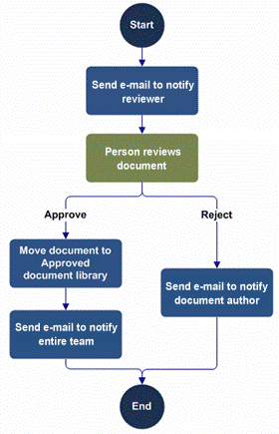
A great place to start is with the most popular workflows, which capture 80% of all approval scenarios and are available out of the box:
- Approval Workflow Routes a document or item that is saved to a list or library to a group of people for approval. By default, the Approval workflow is associated with the document content type and it is thus automatically available in document libraries.
- Collect Feedback Workflow Routes a document or item that is saved to a list or library to a group of people to collect their review feedback. By default, the Collect Feedback workflow is associated with the document content type and it is thus automatically available in document libraries.
- Collect Signatures Workflow Routes an Office document that is saved to a list or library to a group of people to collect their digital signatures. By default, the Collect Signatures workflow is associated with the document content type and is automatically available in document libraries for documents or workbooks that contain signature lines.
- Publishing Approval Workflow Automates the routing of content approvers for review and approval of content on publishing sites where the publishing of new and updated web pages is tightly controlled.

Without even using SharePoint Designer 2013, you can customize these workflows in a wide variety of ways. These workflows are event-driven, and all of the important events in the workflow are surfaced in the workflow editor, both for each task in the process and for the process as a whole. For example, you can easily add conditions and actions to define what happens when each task is assigned, expired, or completed.

SharePoint Designer workflows

Using SharePoint Designer 2013, you can revise and enhance the out-of-the-box workflows or just start from scratch. You now have two ways to author workflows in SharePoint Designer 2013; the traditional text-based workflow designer and a new visual designer based on Microsoft Visio 2013 and the Visio workflow shapes. Furthermore, you can dynamically switch back and forth between the text-based and visual designers while editing the same workflow. This gives you the ability to use the designer that best fits your authoring style.
- Visual designer You can visually design your workflows by dragging, dropping, and connecting shapes directly. Moreover, you can set all the properties of a workflow action in the new visual workflow designer — just select the shape and then click the action tag. Also, if you click Properties on the action tag, the property grids for conditions and actions appear in the visual designer, just as they do in the declarative workflow designer. The visual designer "lights up" and becomes available if you have Visio 2013 installed on your client computer and the site in which you are designing workflows resides on a server that is based on Windows Workflow Foundation 4.
- Text-based designer The traditional text-based workflow editor lets you add and modify elements of a workflow in a structured and descriptive manner using a textual diagram to format the workflow and various dialog boxes to enter values. You can also cut, copy, and paste sections, undo and redo operations, and drag and drop information in a familiar way.

The following are the basic building blocks of a SharePoint workflow that you can create by using SharePoint Designer 2013:
- Stages Model workflows as containers of logically grouped conditions and actions. For example, if you build a help desk solution based on changes to a Status field (Opened, Assigned, Resolved, Confirmed, Closed), each value can correspond to a distinct stage. Stage transitions let you move freely between stages.
- Loops Group conditions and actions that you want the workflow to process repeatedly, either a specific number of times or until an exit condition is true. A loop can also be nested inside another loop.
- Steps Group conditions and actions so that one set of rules can be evaluated and performed before a second set.
- Events Start or initiate a workflow. A change to a data source—such as a new item created or an item changed—is one type of event. Another type of event is one activated by a user, a workflow participant.
- Actions Do something useful. An action is the most basic unit of work in a workflow. For example, you can send an email, check an item in or out of a list, send items for approval, copy an item from one list to another, do a calculation, assign items for approval, utility actions to manipulate strings and dates, lookup a person’s manager in the Active Directory, set permissions on a list item, and manage Document Sets.
- Conditions Determine when a workflow runs or an activity is performed.
- Variables Store different types of data in a workflow, including initiation form parameters and local variables, and at a later point reference that data using workflow lookups.
- Email editor When your workflow sends an email message, you can format that message by using a standard formatting toolbar to the workflow email editor. You can choose specific users and specify variables in the text to customize the text.
- Forms Collect information from workflow participants at predefined times in the workflow. Gather information from users when they start the workflow, create association forms to associate the workflow with a list or content type, and add forms for custom tasks associated with the Tasks list. When designing forms, you can use list forms (.aspx pages) or custom InfoPath forms (.xsn pages).
- Web Services Integrate data and values from Web Services and data sources, such as OData and SQL Azure, within workflows. For example, you can now create a workflow that loads data into a list from the SQL Azure MarketPlace, or update columns with data calculations based on values external to SharePoint.

With one click, you can validate a workflow diagram against a set of rules to make sure the diagram is logical and properly constructed. This ensures accuracy and consistency in diagrams. You can check for common errors and support diagramming standards across your organization.

Projects
A project is a collection of related tasks scheduled for completion. It’s unique, team-oriented, time-limited, and based on a specific product, service, or result. The average project involves 4 to 5 people and lasts six months. Typical examples include:
- An architect who designs home remodels that last for a few months, require iteration with the clients, and occur in parallel with several other projects.
- An instructional designer who contracts with vendors to create and deliver course material, and while in development, needs the content to be limited to project members only.
- A power user developing a medium-size SharePoint composite solution with two other employees he found through social computing and who wants a fast way to collaborate, share, and get the job done.

Occasionally, projects evolve into bigger projects and require the advanced features that only Project 2013 and Project Server 2013 for on premises or Project Pro for Office 365 and Project Online for online provide.

Using the project site

You can bring all tasks, status, communications, data, documents, and timelines into one place, the project site. Using this powerful site template, project managers can quickly get a sense of what’s going on in a project, and team members can quickly see how their work fits into the overall context. Think of a project site as a light-weight, web-based, project collaboration tool. Regardless of the project methodology you use, project sites can make projects more successful and much easier to manage.
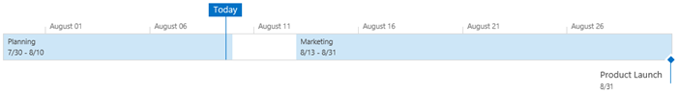
You begin with a standardized form to define the project’s name, description, site location, visibility, and compliance settings. Then you quickly build out tasks, assignments, schedules, calendars, and meetings. As your team grows and solidifies, you discover and integrate new team members, detect presence to communicate, and make liberal use of Lync 2013. Over time, you add ideas and brainstorming notes to OneNote notebooks, project documents to libraries, item updates to lists, and make any and all necessary adjustments to keep everything organized and on track. Additional key components of project sites include the following:
- Task List Define tasks, assignments, start/end dates, priorities, milestones, and status, and visualize them with a Gant Chart. Add structure to your task list by easily indenting and out-denting items for greater clarity, and even attach related documents.
- Timeline Illustrate dates and deliverables with a high level timeline view to keep everyone informed and organized at-a-glance. Customize and style the timeline view by changing fonts, colors, dates, tasks, and milestones.
- Project Summary Keep everyone (team members and stakeholders) in the loop by communicating project status at-a-glance with the Project Summary Web Part on the homepage. This Web Part also allows you to view tasks and events, list items and people, and show a countdown to the next major milestone.
- Site mailbox Include a site mailbox that acts as a dedicated project e-mail center to aggregate and organize content on the site.

Find all your work in one place

You are often involved in several projects at once. Of course, don’t forget to include yourself as one of those projects, because you need to manage your own personal tasks by capturing your actions, to-dos, items, and deadlines. Wouldn’t it be nice to see at a glance all the things you need to do across projects together in one place?

My Tasks aggregates all tasks assigned to you in SharePoint, Outlook, and Project into one experience and enables you to organize, update, and manage both personal, assigned, and timesheet tasks alike. It provides a consolidated view that was previously scattered across many lists, sites, and products. It’s now a lot easier to decide what to do next based on time, schedule, and priority. For more information about My Tasks see Social computing and sharing.

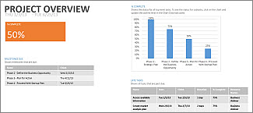
When projects grow bigger

Sometimes the scope of a project grows into something larger, and needs a greater level of control, structure, and reporting.

Using Project 2013 (on premises) or Project Pro for Office 365 (online), you can synchronize a task list and then create up-to-date reports with charts and tables to better analyze your project, and then share the results with others. If you are a project manager or do a lot of project management as part of your job, you’ll find lots of efficiencies in using the rich client interface that Project provides.

As part of Project Server 2013 (on premises) or Project Online (online), Project Web App can accomplish much more. For example, capture, submit, approve, and reject timesheet data (including non-project time and tasks), set up a workflow for manager approval of progress, and rollup multiple projects to find what you need to focus on right now. Additional capabilities include effectively managing project resources, such as equipment and rooms, and displaying dashboards that show project health and key risks.

For more information, see Get started with Project Web App.

Managing documents and content

SharePoint Products 2013 blends the worlds of traditional content management, social computing, and search to deliver an Enterprise Content Management (ECM) platform that is accessible to everyone, and that could be dubbed “ECM for the masses”. ECM helps companies manage documents throughout their lifecycle from creation to disposition and comprises the following areas:
- The Document Information Panel
- Structured documents
- Media assets
- Document management
- Records management and compliance

Document Information Panels

The Document Information Panel displays in Word 2013, Excel 2013, and PowerPoint 2013 for documents stored in a SharePoint library. By using a Document Information Panel, users can track and edit metadata for a document even as they continue to work in the document. The panel is actually an InfoPath form that is hosted and displayed within a document. You do not need InfoPath 2013 installed on your computer to see the panel, but you do need InfoPath 2013 to design or customize the panel.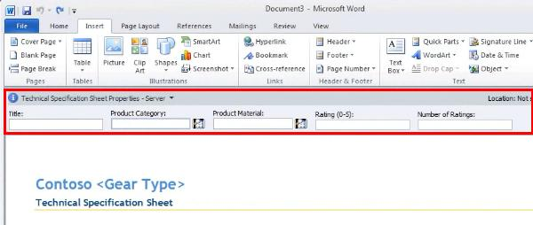
By customizing the Document Information Panel, you can also add business logic, such as data validation, or add custom properties that are important to your organization. In addition, by creating a template part to contain common fields, you can organize the efficient reuse of Document Information Panels in different Office document types across your organization.

To use a Document Information Panel, you may need to first activate the Developer tab on the Ribbon in the programs where you want to use the Document Information Panel. You can then specify the location of the Document Information Panel by using a URL. In addition, you can choose to display the Document Information Panel by default when the document is opened and whether the custom properties that you created are visible by default.

Structured documents

Take the next step up from a Document Information Panel and create a structured document. Structured documents control where content can appear on a document, what kind of content can appear in the document, and whether the content can be edited. Examples of structured documents include:
- A legal document that contains legal language that should not be edited.
- A standard cover page for a business proposal that requires an author to enter title, e-mail address, phone number, and name.
- An invoice that automatically includes up-to-date customer data.
To create a structured document in Word 2013, you use content controls which enable you fix the position of content, specify the kind of content (text, date, picture, and so on), highlight with color, and control editing. You can also automatically link the content controls to corresponding external data columns.

Media assets

You can add media in various ways, such as uploading and embedding, using the video field control or the Content Query Web Part in a published site, or by using the Media Web Part to play and stream media. The Media Web Part also enables you to seek or play either an uploaded file or one from a remote location that can’t be downloaded because of its size. You can also embed videos from external locations, such as YouTube. Video formats that are supported include HTML 5 and Silverlight.

SharePoint Products 2013 also enables management and presentation of multimedia content through the use of the Asset Library. Like any library, you can have views, content types, workflows, and policies. But the Asset Library specifically supports the following features:
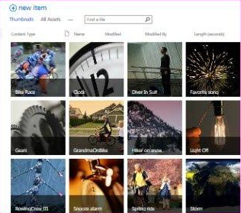
- Digital asset content types The Asset Library is pre-configured to support the content types for image, video, and audio files. These content types include new columns that enable you to track metadata that is specific to rich media assets.
- Thumbnail–centric views The default view for the Asset library is the Thumbnails view, which displays small thumbnails of the assets in the library. This view makes it easy to quickly browse for image and video files. You can also capture and change a different thumbnail.
- Image previews When you move your pointer over an asset in the Thumbnails view, a preview window displays a larger version of the image, as well as image properties. You can take actions on the asset from the preview window.
- Automatic metadata extraction for image files When you upload image files to an Asset Library, existing metadata for the file can be extracted and promoted to corresponding columns in the library.
- Podcasting support through RSS You can use the RSS feature of the asset library to set up podcasting for audio or video files stored in the Asset Library. Site users can subscribe to the RSS feed for the library to receive new content as it is added via podcast.
- Asset picker Pick the right video from a library by using the asset picker.
- Discover media You can preview videos directly from a search results page and refine the video listing based on properties such as video length or when the video was uploaded.
- Manage media Each uploaded video has its own player page that contains metadata about the video, such as the video owner and related documents. For example, you might include a lab workbook with a training video. From the player page, you can access the Manage Renditions tab to manage different resolutions and encoding formats, or audio dubbings in different languages.

The following table summarizes common ways to manage media assets in the Asset library.

Scenario | Description
Team site | Any team member can upload assets to the library for other team members to view and use. The content is managed as needed by contributors, and uses very little workflow or policy for its addition to and management in the library. Team members use content in the library by viewing, downloading, and inserting it into their work products, such as documents or presentations.
Divisional portal | Any contributor or designer can upload logos and images to the library for other people to view and use. The content is generally managed as needed by contributors, and uses minimal workflow or policy for its addition to and management in the library. For example, the divisional portal library might have multiple contributors but only a few approvers. Authors and Web designers of the site use content in the library by viewing, downloading, and inserting it into their work products, such as documents or presentations.
Corporate brand library | Store branded corporate assets such as logos, artwork, and other digital assets, and use moderate-to-heavy workflows and policies to manage the content. Creative teams can submit digital assets to the asset library where they are reviewed and published. Content stewards manage and edit the digital assets to ensure that they have been correctly tagged and organized. Information worker consumers and extranet partners who have to access to official, authorized corporate logos or brand assets use the library to find the content they need.
Corporate archive | An archive that catalogs pictures, video, documents, and other assets that have historical value to an organization. Users can submit current and past items, which are collected, scanned, organized, and tagged by curators who manage the library so that other users can browse, search, and view archived content.

Document management

SharePoint Products 2013 includes a broad collection of capabilities that simplify and streamline how companies manage documents. You can apply features across an entire deployment, regardless of its size, and ensure that policies are consistently and effectively implemented as shown in the following image and table. 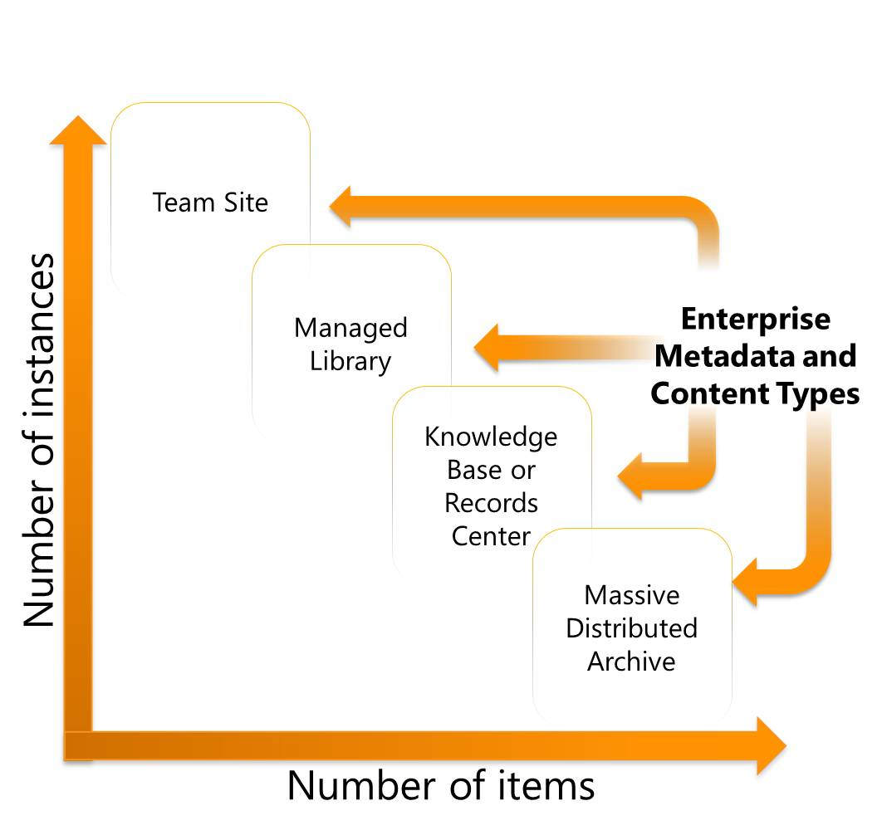
Scale | Who manages? | How added? | Comments
Team Site  (100 to 200) | No manager | Ad hoc uploads | - Small projects and teams; Created ad hoc throughout the enterprise; Lightweight  - Example: library for storing a small team’s work in progress docs or projects
Managed Library (100,000 plus) | Informally by subject owner | Upload, iterate | - Structured library per division; Enforced metadata capture  - Examples: RFP library for a sales force; Spec library for an engineering team; Brand images repository for marketing
Knowledge Base or Records Center (One Million plus) | Dedicated content stewards | Formal  Submission | - Archival; Finished work product; broad consumption  - Example: Knowledge management repository
Massive, Distributed Archive (Millions) | Dedicated content stewards | Formal Submission | - Biggest scale  - Example: Corporate records archive

Managed metadata
Managed metadata is a way to centrally define taxonomies that can be leveraged within and across farms to classify and find content quickly. Managed metadata helps bring structure out of the chaos of documents. As companies worldwide receive increasing amounts of unstructured content, people are having more difficulty finding desired content with full text searching and basic keyword terms. However, if content owners tag documents with metadata, providing accurate details on the nature of the information, people can find that content more easily. Managed Metadata helps people easily tag content with metadata through auto completion and taxonomy-browsing tools. Using that metadata improves the process of finding content by providing search refiners and metadata-driven navigation. People can use metadata-driven navigation from within SharePoint sites or through Office 2013 products to find the content they need without knowing where it is stored.
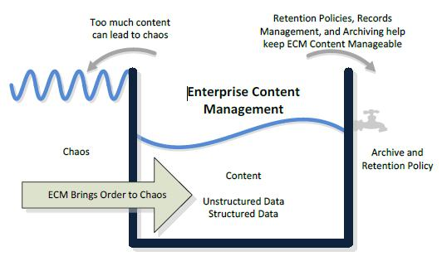
Document Sets
Users often create multiple documents that support a single case or project. By using Document Sets, you can group all of these documents into a single entity that shares metadata properties, applies to workflows, and enables versioning as a whole. Examples include a pitch book (document, presentation, and spreadsheet) created in response to each request for proposal (RFP), or a standard set of documents related to design, testing, and fabrication of a manufactured product.

Each Document Set also has a customizable welcome page that displays shared metadata properties and can be used to display standard processes, workflow stages, and other set of related information. This Welcome Page is configurable per Document Set type defined, so that different Document Set templates can have their own unique Welcome Page.

Document IDs
In any content management repository or collaboration environment, content is often reorganized or moved. Hyperlinks to documents no longer work, which causes frustration and loss of efficiency. Document IDs are a way to assigns documents a unique identification number. Each document has a “permalink” based on its unique ID, which lets people retrieve the document regardless of where it is within a SharePoint deployment. The ability to assign a document a unique identification number people can use to retrieve the document later, even if it is moved.

Records management and compliance

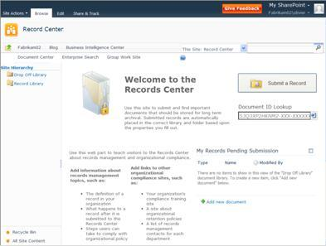
You can declare all content within SharePoint Products 2013 as records, and manage either a central records archive or support in-place records management. Records compliance makes it easier to adhere to corporate policy and increase accuracy of content classification, and makes it easier for records managers to manage and monitor records management solutions. All users can participate in a governed, compliant content management lifecycle, and expertly balance user experience with process policies, including location-based policies and multisite disposition policies.

Three main areas are part of the records management content area.
- Content Organizer Where should new content be saved and how should it be classified? The Content Organizer addresses these challenges with, a rules-based classification engine that promotes consistent classification of content based on content type and specific metadata properties. Site owners can create rules to drive content to specific Document Libraries and folders, where they inherit access control policy, default metadata values, and specific retention schedules. Advanced routing provides the ability to submit documents to SharePoint sites and let the system determine which library or folder it should be saved to using the document’s metadata and other rules.
- In-Place records management You can declare a record in a team site and prohibit any future changes. After a document is declared as a record, it is locked from future editing or deletion. Records are denoted by a lock image on the file and continue to reside with other content in the same document library. These official records can now reside within the same document libraries that contain other documents users collaborate upon. This helps you achieve compliance everywhere, which means that any document/record can be managed from SharePoint Retention policies to move information to an archive, backup or simply delete it. Users can declare a document as an in-place record either manually or automatically by using workflow activities. It’s even possible for users to continue working on the content while the state of the content is preserved at the time of the declaration.
- Holds and eDiscovery The Hold and eDiscovery feature enables organizations to locate and suspend items such as documents, images, pages, from expiration policies. You would typically use this feature for items that are subject to events such as litigation, audits, or investigations. Furthermore, when placing a hold on an item you have the option to lock it down so it cannot be edited or deleted.
- Discovery Center When there is a new need for discovery, such as a legal case or an audit, you can create a new case by building eDiscovery queries across multiple SharePoint farms, Exchange servers, and file shares. From this one Discovery Center you can create a case, define a query, search for content, and track statistics related to the case. Finally, you can use the Discovery Download Manager to export the results, including documents, lists, pages, Exchange tasks, contacts, and e-mail messages, for later import into a review tool.

Publishing sites

Publishing sites are well-architected, professional-looking Web sites intended for a wide and general audience. A new tool, called the Design Manager, helps you build published sites the way you want and with the Web design tools of your choice. There are three types of SharePoint published sites:
- An intranet site (on premises and online) that has a tightly managed navigation structure and provides authored content, such as a human resources site or a divisional portal page.
- An Internet business site (on premises-only) that promotes products and services to customers, such as a pixel-perfect marketing presence site or a product catalog.
- A public Web site (online-only) that acts as an attractive, public-facing storefront for your business.

Design Manager

If you are a site designer, you build a Web site architecture composed of pages, themes, navigation, and content through a controlled publishing process, and with input from business analysts and decision-makers. Design Manager helps leverage your expertise in HTML, CSS, and JavaScript. First, you design HTML master pages and HTML page layouts with starter templates in your HTML editor of choice. Then, you convert that HTML file to an ASP.NET master page. Finally, you add key functionality to your pages, such as a search box or navigation control. Design Manager contains many ready-to-use Web Parts and controls, and the Snippet Gallery makes it easy to discover, configure, and insert these components.

For more information, see What's new with SharePoint 2013 site development.

Intranet site

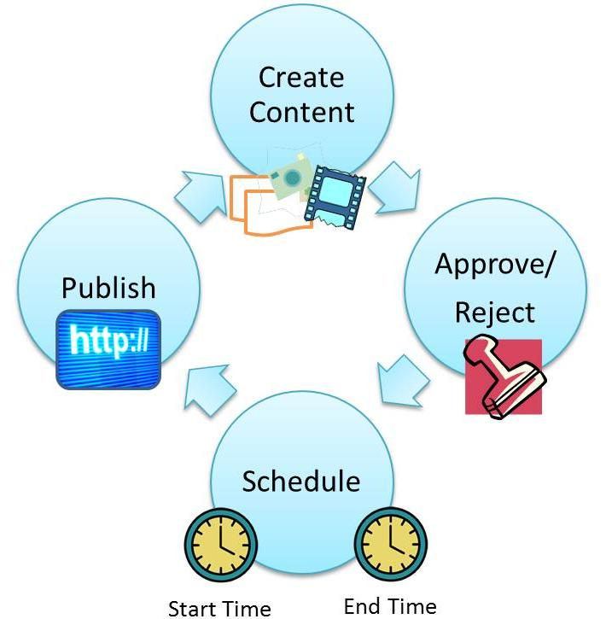
SharePoint Products 2013 are unique in that they provide a unified platform for team, divisional, intranet, and Internet sites. You usually want to implement a well-thought out information architecture that balances the right freedoms and controls to create a successful experience for your creators and users. Key considerations include the following:
- Authoring Create rich web pages and use built in Web Parts to add audio and video, all in a controlled authoring environment.
- Navigating Create a navigation structure, use metadata-based navigation, and supplement navigation using Web Parts.
- Branding Ensure a consistent look and feel by creating and maintaining a unique site brand, including custom master pages, page layouts, custom CSS, field controls logos, themes, and styles. This effort is most likely performed by a professional Web designer.
- Content targeting Display a dynamic set of content based on custom queries that you build with the Content Query Web Part. Your query can specify content based on the list or library where it resides, its content type, the audience viewing the content, and so on (for example, you can create the query to display a list of all of the documents associated with a particular author, regardless of content type.
- Variations Provide for multi-lingual audiences through variations, configure either machine or human translation, and single source multi-lingual web sites by authoring once and publishing everywhere.
- Workflow Control the production, deployment and retirement of content and content types with a customizable, out of the box publishing workflow that is specifically designed for the publishing cycle and that ensures that only the people with the required permissions can add and edit content on the site.

For more information, see Features enabled in a SharePoint Online publishing site and About publishing-enabled site templates.

Internet Business

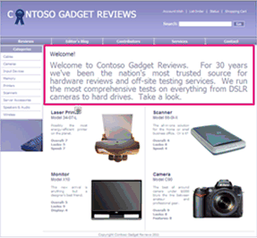
Most medium to large scale organizations want to tap the power of a great Web site by connecting with customers, engaging them with great content, and generating revenue. To do this, you need to build dynamic and flexible Web pages that respond quickly to market changes based on real-time data. Internet Business sites are based on proven and familiar SharePoint technology, such as taxonomies, Search, lists, and Web Parts, and this makes it much easier to wire together a fast and fluid Internet Web site. The main components are:
- Cross-site publishing Reuse content across multiple site collections and SharePoint farms.
- Catalogs Incorporate lists into your publishing sites, whether for products, service offerings, or knowledge bases.
- Search Crawl and index catalog content, build queries and rules to focus results, and use refiners (color, price, ratings, and so on) to help customers quickly filter results.
- Managed navigation Structure navigation in a dynamic and adaptable way based on your own business taxonomy and what you want the customer to see.
- Display templates Control the format with display templates in three contexts (Control, Group, and Item) to map the content presented in a clean, organized way, based on Search results, and dynamically display based on, for example, user buying or browsing habits.
- Content Search Web Part Aggregate content across sites and farms based on content queries and predefined display templates or “skins” and with a minimum time lag because the Search index is used.
- Analytics Track and analyze how customers use your site, and through deep integration with the search engine, obtain recommendations based on page views and unique items per day.

Public Web site

The Public Website in Office 365 is part of SharePoint Online, and you can customize it similar to the way you customize a publishing page in SharePoint. You can add and edit web pages, images, videos, Web Parts, and apps. All of this can be done using just your web browser. You can also use Design Manager for advanced website design or creating a new design from scratch. The Public Website in Office 365 is a powerful way to create an online presence for your business or organization without being a professional web designer. When you finish customizing your website, you can apply your own custom domain to it, for example, www.yourcompany.com. Customers and partners can now easily find you online and learn about your products or services.

For more information, see Video: Get started with your public website.

Access apps

Use Access 2013 to create great database solutions with an SQL Server backend database, without relational expertise, and in record time. Easily package, distribute, and monitor the solution as a SharePoint app, because an Access app is a SharePoint app. Start by selecting a template, complete with default views, basic commands, and built-in navigation, so you can start using your app right away.

You may not even have to create your solution as there may be Access apps available in the SharePoint Store, Office store, or your App Catalog that just might fit the bill. Getting an app from a store is a quick way to start using a database that’s been professionally designed for a specific purpose.

Access apps are a shining example of a SharePoint Composite solution. Here are the basic steps for creating one.

Start with templates and tables

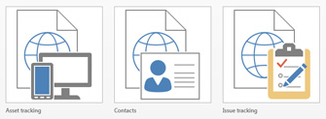
Included with Access are a set of templates that you can use to jump start your app, and if you don't see what you're looking for, you can search for additional templates. Each template includes all the tables, fields, and relationships needed to create a working app and to rapidly create the database structure.

Automatically create a beautiful user interface

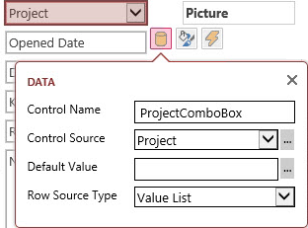
Create views that have a consistent, appealing, and modern look-and-feel. The view designer provides an accelerated way to create a solution. Update properties by using contextual callouts with simple text and drop-down boxes conveniently next to each section or control. Themes are simple to do and coordinated with SharePoint themes through the generation of a custom CSS file. There’s more:
- Default views The default List/Details and Datasheet views provide the essential fill-out a form and tabular experience to capture and find data. The List/Details view makes it easy and consistent to filter and navigate the records contained in the view by using a smart search box. The Datasheet view behaves like a spreadsheet so you can sort and filter data with familiar dialog boxes.
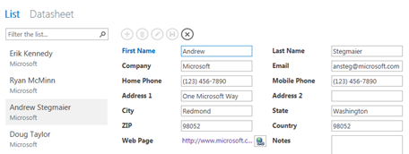
- Built-in navigation Save yourself the trouble of making switchboards. Table names show up on the left edge of the window, and the views for each table appear across the top. All apps have a similar navigation structure, making it easier for people to learn and switch between apps.
- Action Bars Use clean-looking buttons for adding, editing, saving, and deleting items. The predefined actions automatically perform specific tasks. If you hover over an action button, its functionality is displayed.
- Powerful controls The Related Items Control provides a quick way to list and summarize data from a related table or query. The AutoComplete Control looks up data from a related table and acts like a combo box with instant search. Popup views get you related information in one click of a hyperlink, such as viewing employee details from an employee tasks list.

Effortlessly store data into SQL Server

Having SQL Server as the backend database significantly improves the performance and scalability of Access apps. For on-premises, the SQL Server database can be configured to live behind the firewall. For online, the database is an SQL Server Azure database enabled with a free account and lots of free storage.

Not only data, but Access objects are stored in the SQL Server database in the following way: tables as tables, queries as views, parameter queries as table-valued functions, macros as triggers and stored procedures, and validation rules as check constraints. Even the views, which are HTML and JavaScript, are stored as text in system tables.

Do advanced customization

You’re not limited to default behaviors, and of course, you can do even more:
- Add fields Update the table in the Table Designer by adding fields, and if you haven't edited the view, it’s updated automatically.
- Create Lookups Delve into the pre-defined schema with the Lookup Wizard and modify or create your own relationships.
- Customize a view When you add controls, such as Autocomplete, Button, Combo box, and Hyperlink, just drag and drop them and other controls adjust the layout and snap in place in a smart way.
- Add other views Add a Summary view which rolls up and aggregates data. Add a Blank view to start from scratch. Use the Web Browser control to add content to your Blank view, such as a Bing Map or another SharePoint page.
- Import or link data After you’ve created your app, import data (such as Excel, Access, ODBC, Text, and SharePoint lists) or perhaps link to a SharePoint list (read-only) to create additional relationships.
- Build expressions Use the Expression Builder to create sophisticated business logic without code. Spend less time memorizing expression names and syntax, and more time focusing on building your formulas.
- Use macros Add action macros to buttons, pick a new icon, and adjust the icon position. For example you could add a button that applies a filter to a datasheet view and a button that clears all filters. Add a UI macro to open another view or create a new record. Events such as On Click, On Current, On Load, and After Update are available on various controls. Add data macros (On Insert, On Update, and On Delete) to create, edit, and delete records. For example, If you add a phone number field, use a data macro to lookup contact information and then add it to a another table. Finally create standalone macros, which can take parameters, to do more sophisticated operations.
- Create reports Create traditional Access reports in a desktop database on the client computer. Just click a button and a separate database is created with links to all the tables you have created in your Access app. From there, you can create Access reports. Desktop databases still have all the powerful features, such as VBA, that has made Access such a popular way to run a business.

Business intelligence

Almost every day, users explore, analyze, visualize, and model data in many ways by:
- Combining data from different sources (invoices, databases, spreadsheets, the Web, and so on).
- Creating interactive reports, summarizing data, and presenting it to teams in meetings.
- Drawing conclusions, discovering insights, spotting trends, and supporting decision making.
- Improving data quality, using advanced functions, and combining large data sets into Data Models.
- Creating charts, conditionally formatting tables, and constructing scorecards and dashboards.
- Building PivotTable reports, organizing hierarchical data, and drilling down to data sets.
- Crafting “What If” tools, such as financial and manufacturing, that make predictions based on inputs.

You do these activities so that you and your business become more intelligent.

Overview of BI

Business Intelligence (BI) solutions help understand the health of the organization and can directly impact the bottom line by measuring specific operations. Decision makers also need reliable, secure access to data to do their job effectively, tools to browse and analyze data and view reports, and the ability to create their own analytic and reporting experiences. Here are some common business questions that business intelligence is designed to help answer:
- How are the sales territories performing by country and region?
- How does this quarter’s performance compare to the same quarter last year?
- Our customer satisfaction score is below target. What is the reason?
- Based on the trends of this product line, can we predict how the product will sell six months in the future?
- What products do our customers buy together?

Business Intelligence turns raw, sometimes voluminous data into visual and interactive information, which in turn provides key insights about a business. The goal of business intelligence is to improve organizations by providing business insight to all employees, leading to better, faster, and more relevant decisions. Insights help to make good decisions that lead to best actions.
The Business Intelligence Center
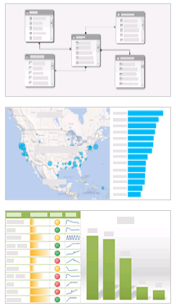
A great place to start building BI solutions is the Business Intelligence Center site. The Business Intelligence Center is a pre-built site template that is optimized to help you manage the all the working elements of business intelligence reporting. You can see examples, such as an Excel Services workbook for analysis and charts. In addition, special-purpose libraries are ready for you to use to create data connections, manage content for PerformancePoint Services, and store finished dashboards.

The Business Intelligence Toolset

In addition to Excel 2013 and SharePoint Server 2013, SQL Server 2012 SP1 often plays a vital role as a primary external data source for the business intelligence capability, especially SQL Server 2012 Analysis Services, which provides hierarchical data, and is often the backend for Line-of-Business data systems, and SQL Server Reporting Services, which is used to build and deliver reports and data feeds.

There are a number of products that work closely together to deliver business intelligence solutions on many different levels as shown in the following table.

Goal | Primary Product
Self-service BI | Excel 2013 and Excel Services
Interactive visualization | Power View in Excel and SharePoint Server 2013
Advanced data modeling | PowerPivot in Excel and SharePoint Server 2013
Enterprise dashboards and scorecards | PerformancePoint Services
Operational Reports | SQL Server Reporting Services

Self-service BI with Excel and Excel Services

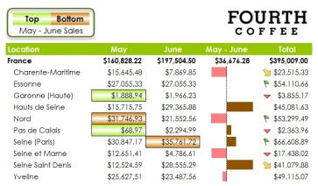
To anyone doing business analysis, Excel 2013 is “comfort food” and the tool of choice for viewing, manipulating, analyzing, and reporting about organizational data. Excel spreadsheets are the predominant technology in use today for the following critical business scenarios:
- Accounting Use the powerful calculation features of Excel 2013 in many financial accounting statements, such as, a cash-flow statement, income statement, or profit and loss statement.
- Budgeting Create any type of budget, whether personal or business, such as a marketing, event, or retirement.
- Billing and sales Create common template-based forms, such as sales invoices, packing slips, or purchase orders.
- Reporting Summarize your data analysis in reports, such as project performance, forecasting, tabular reference, or actual-budgeted-variance data.
- Planning Create professional and useful planners, such as a weekly classes, marketing research, year-end taxes, or weddings.

Excel 2013

The following key Excel features make Excel 2013, in and of itself, a first-class business intelligence tool and effectively enable you to create your very own dashboards. Highlights include:
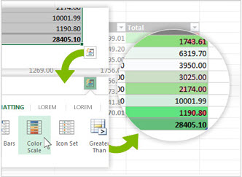
- Conditional formatting Color scales, data bars, cell values, top or bottom ranked values, above or below average, and formula-based ways to visually highlight tabular data.
- Sparklines Compact cell graphs to help spot trends.
- Quick Analysis Show your data in a chart, table or PivotTable in two steps or less. Preview your data with conditional formatting, totals, or charts, and make your choice stick with one click.
- Flash Fill Automatically fills down columns following patterns in your data, such as addresses, full names, and ID numbers.
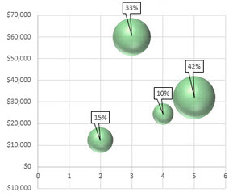
- Recommended charts Intelligently picks the most suitable chart for your data, like Column, Line, Pie, Bar, Area, Scatter, Stock, Surface, Doughnut, Bubble, and Radar. Afterword, fine tune charts with the Format object pane.
- Quick Explore Quickly drill up and down hierarchical levels of data and then instantly create views.
- Slicers and Timelines Graphically filter data in Excel tables and PivotTables to focus on specific information of many data types. Timelines are like slicers and filter by days, weeks, months, and years.
- Inquire Do you trust the spreadsheets you have inherited or do you need to carefully inspect them because it’s critical to your business? Then use the Inquire add-in for Excel 2013 to identify potential issues: visually diagram relationships between workbooks, worksheets, and cells; clean up excess cell formatting that is causing performance issues; fix broken links, and detect one-off formulas that may cause unintended mistakes; quickly find hidden sheets, columns, and cells; identify incorrect formulas, and compare changes between spreadsheet versions.

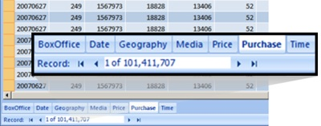
Many of the PowerPivot features that required a separate add-in in Excel 2010 are now built right in to Excel 2013. For example, you can now import, relate, and manage large amounts of data from many data sources (including REST and Windows Azure Marketplace) into a Data Model. A Data Model is a collection of tables and their relationships that reflects the real-world relationships between business functions and processes, such as how Products relate to Inventory and Sales. You can also create calculated fields, which are custom columns you add to a Data Model. For example, you can concatenate values from two separate columns to produce a single string value that displays in a third column. Excel automatically loads data into the xVelocity in-memory analytics engine (formerly called VertiPaq), for extremely fast calculations and data portability. All Excel users can now build Data Models, which they can use as the basis for PivotTables, PivotCharts, and Power View reports.

Excel Services

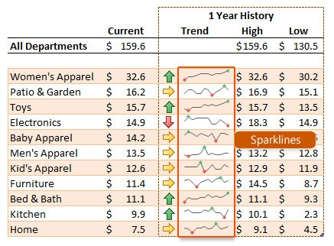
The combination of Excel 2013 and Excel Services gives users browser-based access to a server-calculated version of an Excel spreadsheet displayed in high-fidelity and with much of the functionality and interactivity you have on your client computer. You can do this with data stored in the workbook, or connected to external data sources, including and especially SQL Server Analysis Services. One critical and achievable goal is to maintain a “single version of the truth” for smooth collaboration when it comes time to reconcile the numbers.

To enable and enhance a variety of SharePoint Composite solutions, the Excel Web Access Web Part is connectable, so you can also drive the results of your workbook by receiving values from other Web Parts, including and especially the List View, InfoPath, and Visio Web Access Web Parts. You can do the following:

Connection | Description
Get Workbook URL From | Display different workbook content based on the location of a workbook in a document library.
Get Named Item From | Get a value from another Web Part to control the portion of the workbook displayed, such as a chart or a named range.
Get Filter Values From | Get one or more values from a Filter Web Part or InfoPath Web Part.

Interactive visualization with Power View

Power View is an interactive data exploration, visualization, and presentation experience that encourages intuitive ad-hoc reporting. You can use Power View in Microsoft Excel 2013 on a separate sheet and in SharePoint Server 2013 as Excel workbooks published in the PowerPivot Gallery both on premises and online. A Power View report is always ready for reporting duty because you’re working with real data; you don’t need to preview your report to see how it looks.

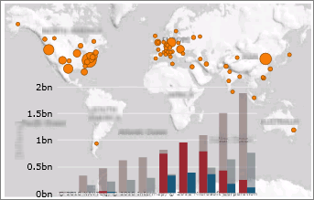
Here’s a few things you can do to explore, analyze, and present data in a powerful and compelling way:
- Create the right visualizations You can quickly create a variety of visualizations, from tables and matrices to pie, bar, and bubble charts and sets of multiple charts. For every visualization that you want to create, start with a table, which you then easily convert to other visualizations to find one best illustrates your data. Power View draws the table in the view, displaying your actual data and automatically adding column headings.
- Quickly create other visualizations Click another visualization type on the Design tab. Power View only enables the charts and other visualizations that work best for that data in that table. For example, if Power View doesn’t detect any aggregated numeric values, then no charts are enabled.
- Filter data in many ways Power View uses the metadata in the underlying Data Model to understand the relationships between the different tables and fields in a workbook or report. Because of these relationships, you can use one visualization to filter and highlight all the visualizations in a sheet or view. Or, you can display the filters area and define filters that apply to an individual visualization or to all the visualizations in a sheet or view.

Power View must be seen in action to be believed. For demos of Power view, see Power View in Microsoft BI.

Data modeling with PowerPivot

The combination of PowerPivot for Excel and SharePoint enables self-service business intelligence, which describes an accelerated way to create a shared business intelligence solution with lots of data and without the overhead involved in creating an enterprise-wide system.

PowerPivot for Excel (SQL Server PowerPivot for Excel Add-in)

Using the same Data Model, PowerPivot in Excel Add-in provides an environment for more advanced data modeling for business and data analysts. Features include:
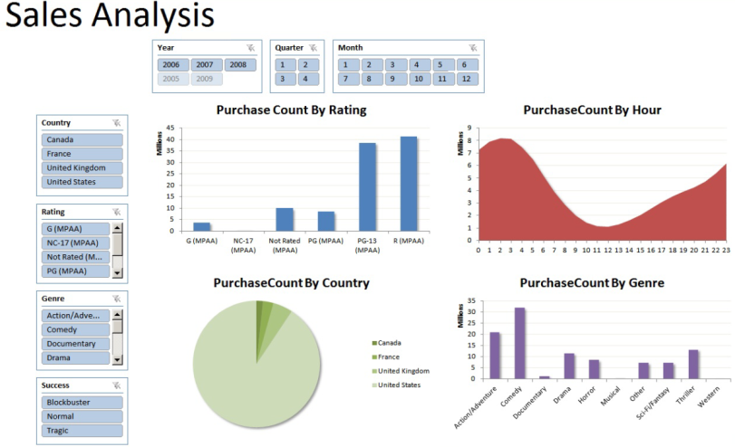
- Flexible management Filter unnecessary data when you import it, rename tables and columns, create relationships using drag and drop in Diagram View, and apply formatting (to be used in Power View and PivotTable reports).
- OLAP Create user-defined hierarchies and perspectives to use throughout a workbook.
- Data Analysis Expressions (DAX) Add custom aggregations, calculations, and filters to your report. DAX is an expression language for use with PowerPivot for Excel, and is similar to Excel formulas. However, rather than working with cells, ranges, or arrays as in Excel 2013, DAX works only with tables and columns.
- Measures Create a dynamic, aggregated calculation that is displayed in the value area of the PivotTable. Its value depends on the current selection of items in rows and columns and in the report filter. Measures differ from calculated columns in that the calculated column values persist in the PowerPivot data whereas Measure are calculated at query time and do not persist.
- KPIs Define key performance indicators (KPIs) to use in PivotTables. A KPI is a quantifiable measurement, such as monthly gross profit or quarterly employee turnover, which is used to monitor an organization's performance.
- BISM Upgrade the Data Model to a BI Semantic model (BISM) to put partitioning and security on it.

PowerPivot for SharePoint (SQL Server PowerPivot for SharePoint Add-in)
PowerPivot for SharePoint provides centralized management of workbooks, manages data queries, and provides the necessary infrastructure to manage, secure, refresh, and monitor these PowerPivot reports efficiently. IT can improve operational efficiencies by tracking PowerPivot usage patterns over time, discovering mission-critical applications, and improving system performance by adding resources. PowerPivot for SharePoint consists of the following feature areas:
- Ease of content management Data and the presentation layout are kept in the same workbook. By storing workbooks in a library, you also reap the benefits of any document, including workflows, retention policies, versioning, approval workflow, and any other activities supported in a document library.
- PowerPivot Gallery This is a special document library, based on Silverlight, that you can use it to preview and open workbooks from a central location, and see worksheets in the workbook as thumbnails with current data and without even opening the workbook.
- PowerPivot Management Dashboard Several tools for configuring the Service application and monitoring usage are included in a management dashboard accessible to farm and service administrators in Central Administration.
- SharePoint Services Upon installation, two new SharePoint Services are created: the PowerPivot System Service that manages the application database, load balancing, usage data collection, automatic data refresh, and so on; and SQL Server Analysis Services, which runs the xVelocity in-memory analytics engine, loads the PowerPivot models in the Excel workbook stored in the SharePoint library, and manages the data within those workbooks so that they can be used by multiple users through a browser with Excel Services.
- Schedule and refresh operations To keep the workbook up to date and relevant, you can automate a refresh schedule for each data source in the workbook. When you enable data refresh, a timer job runs every minute. If the workbook is not checked out or in edit mode, the data refresh job saves the new data to the workbook.

Enterprise dashboards and scorecards with PerformancePoint Services

PerformancePoint Services is a set of features, components, and tools that collectively help you create enterprise-wide business intelligence solutions for performance monitoring and scorecards. In these solutions, users can do integrated analytics for monitoring, analyzing, and reporting on the business, and make informed business decisions that align with company-wide objectives and strategy. Using PerformancePoint Services, you can build sophisticated key performance indicators (KPIs), filters, scorecards, reports, and dashboards, that bring together data from multiple data sources (including Analysis Services, SQL Server tables, SharePoint lists, Excel Services, and PowerPivot workbooks). Surprisingly, you can do these sophisticated operations with little or no code.

PerformancePoint Services provides a wide variety of capabilities, and includes the following:
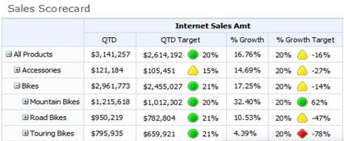
- Scorecards A scorecard is a special kind of report that provides a high-level snapshot of performance for a group or an organization. A scorecard resembles a table that usually has Target and Actual value columns and one or more key performance indicators (KPIs). Scorecards display a collection of KPIs and the performance targets for those KPIs to show progress toward achieving specific goals. Scorecards can even have “multiple actuals”, meaning that a single KPI can represent status that is based on data that comes from more than one measure and more than one data source, all in one row.
- Key Performance Indicators (KPIs) An essential element of a scorecard is a key performance indicator (KPI), which is a visual cue (such as up and down arrows, stop light signals, and colored circles) that communicates the amount of progress made toward an important business goal. KPIs are valuable for teams, managers, and businesses to evaluate quickly the progress made against measurable goals and to make good decisions based on three fundamental questions: What am I ahead or behind on?, How far ahead or behind am I?, and What is the minimum I have completed?
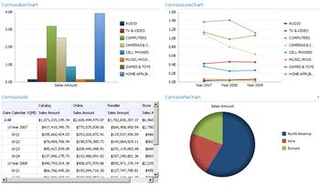
- Filters Filters enable users to interactively modify the view of a dashboard to get just the results they need. You often want to see specific departments, regions, or periods, top 10 or bottom 5 values, and values sorted in ascending or descending order. Because you are working with a lot of data when creating an enterprise-wide business intelligence solution, it’s vital that you can create filters that are fast, flexible and re-usable between different dashboards. You can create many types of filters, including cascading filters, custom table, MDX query, member selection, and named set. And you can use different filter display methods including: list, tree, multi-select tree, and calendar control. Finally, you can use a filter search to quickly narrow down a list of items
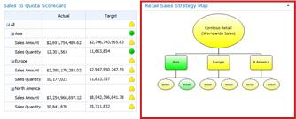
- Strategy Map A strategy map is a report view that can show relationships between objectives, goals, and key performance indicators (KPIs), coupled with a Visio diagram where the color of each shape in the diagram is determined by the indicator that is connected to it. For example, a scorecard might show that Asia is on target overall, off target for the Sales Amount measure, and on target for the Sales Quantity measure. In the Visio diagram, the shape for Asia is colored in green, the shape for Sales Amounts is colored in yellow, and the shape for Sales Quantity is colored in green.
- PerformancePoint Dashboards You use PerformancePoint Dashboard Designer to create dashboards, and then publish them to a SharePoint site. Dashboard Designer is a free download that is part of PerformancePoint Services. PerformancePoint dashboards can include features and functionality that set them apart from many other kinds of dashboards. For example, you can configure a PerformancePoint dashboard so that information is displayed depending on what you click in the dashboard. And, you can create dashboards that display information from a variety of sources, including reports that are hosted on other servers. Once you are done, it takes just one click to deploy and publish the dashboard.

Operational reports with SQL Server Reporting Services

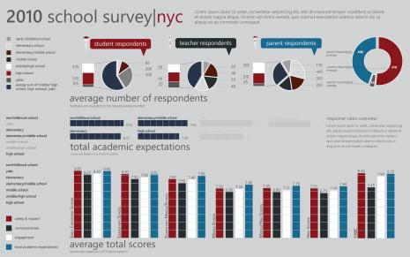
Microsoft SQL Server Reporting Services provides a complete platform designed to support a wide variety of reporting needs. Configuring, developing, and managing the database and data warehouse infrastructure requires an IT department of course, but power users and business analysts can use Report Builder to create reports in a wide variety of formats including data feeds.

These reports are scheduled on a daily, weekly, or monthly basis, delivered and targeted to users in a controlled fashion, highly readable, sometimes parameterized, and often printed. The emphasis is less on interactivity and more on getting needed data into the right hands so users, such as shop-floor supervisors, loan officers, and line managers, can get day-to-day work done.

A popular feature is data alerts which detect critical changes, such as inventory levels or credit ratings. Alerts have flexible rules, are easy to schedule, and can include the relevant data in the alert message for fast action. You can create alerts when you author reports and even users can create them directly on the report data.

Line-of-Business data integration

There’s a lot of data inside your SharePoint sites, but a lot more data outside those sites. But this external data is often like a secluded island that is restricted to privileged folks, or just plain hard to get to. Wouldn’t it be nice to work with that external data as if it was inside your SharePoint sites, as well as your Office products so that you can leverage a familiar interface and further enhance your business? That’s what Business Connectivity Services (BCS) is all about.
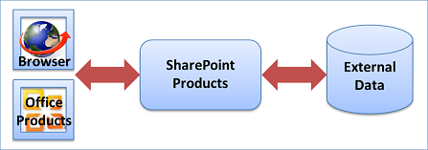
BCS enables secure, efficient, read/write access to this wide variety of external data. This is done through a comprehensive framework that provides standard user and programming interfaces. Furthermore, you can create a wide range of business solutions, both no-code, SharePoint Composite solutions for simple to intermediate activities and code-based solutions for advanced needs. For example, you can:
- Create a SharePoint external list of employee personnel data stored in a back-end database that users can read and write, similar to a native SharePoint list.
- Connect up-to-date customer data in your organization’s Enterprise Resource Planning (ERP) system as a set of Outlook contacts and even provide offline access.
- Create an event planning solution that links to a controlled Line-of-Business application, but uses a SharePoint calendar for all to see.
- Create a Microsoft Silverlight application with a cool visual user interface that works with external data from the Web.

In short, Business Connectivity Services lets you connect to, interact with, and unlock the value of external data.

Two classic BCS scenarios

Here are two scenarios that illustrate the effective use of Business Connectivity Services in a SharePoint Composite solution.

Help Desk A large enterprise has a help desk, which provides internal technical support. Support requests and the technical support knowledge base are stored in an external database, but are fully integrated in a SharePoint site by using external lists and the Business Data Web Parts. Information workers can also view their current requests in Microsoft Outlook 2013 online. Tech support specialists can view requests assigned to them in Outlook 2013 online and offline access. Workflows automatically manage support issues through each stage: Opened, Assigned, Escalated, Resolved, and Closed. Managers on the technical support team, with appropriate permission, can view dashboards that display help desk reports indicating the number of support issues assigned to each support specialist, the most current or critical issues, and the number of support incidents that are handled by each support specialist during a given time period. Managers can also export the data to Microsoft Excel 2013 for further detailed analysis using conditional formatting and charts.

Customer contracts and contact information You have a document library that contains customer contracts. However, all your customer information is maintained in a Line-of-Business application (such as SAP or Microsoft CRM) which has a data source that is external to SharePoint products. You would like to track the customer’s contracts in the document library, but ensure that related customer information is up-to-date and not unnecessarily duplicated. You can do this by adding one or more external data columns to the library to associate the appropriate customer name and phone number with each contract stored in the library. The external data column makes it easy to enter or update the correct information and automatically retrieves the customer information from the external data source. In this scenario, you could also create a structured Word document that promotes the values of the external data columns to a Word document so you can edit the values in the Document Information Panel or by using Word content controls.

Getting there is half the fun

Business Connectivity Services is like a big umbrella that encompasses many SharePoint and Office features. But it doesn’t work “out-of-the-box” because every external data source is unique and each organization has specific needs. Once you lay the groundwork, on premises or online, you can surface the external data inside SharePoint products and Office products. When working with external data, you typically go through three distinct phases:

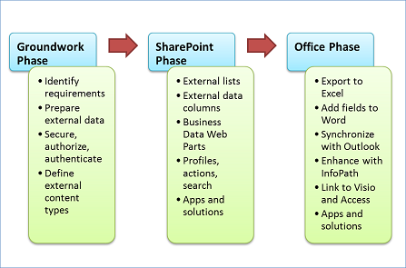
The groundwork phase During this phase, you plan, prepare, and set up how to access the external data. This usually means working closely with an administrator and sometimes a developer to understand what needs to happen. Important goals are identifying business and technical requirements, preparing the external data source, ensuring secure access to the data by using the Secure Store Service, and scoping the overall solution. A pivotal goal is creating an external content type, which is a detailed package of connections, metadata, and other information used to retrieve the external data.

The SharePoint phase Once the groundwork has been laid, you can now surface the external data in SharePoint products in a variety of ways, including external lists, external data columns, Business Data Web Parts, workflows, search results, profile pages, actions, Apps for SharePoint, and code-based SharePoint components or solutions.

The Office phase Once you have created access to the external data in SharePoint products, you can now surface the data in a variety of Office products (including Excel, Word, Outlook, Visio, Access, and InfoPath), Apps for Office, and code-based Office components, add-ins, or solutions.

Which hat do you wear?
Developing a solution based on external data is usually a team-effort and the way you work depends upon your role:
- Users Assemble simple solutions by using the basic capabilities of SharePoint products and Office products.
- Power Users Create simple to intermediate, no-code business solutions and often require business analyst skills to understand the database systems and the overall business processes in the organization.
- Administrators Manage user permissions and security for several different SharePoint components including the external content type and the external database. A critical activity involves setting up Secure Store Service target applications, mapping of credentials, and determining the best authentication methods.
- Developers Create a variety of custom solutions that range from targeted, reusable components to advanced code-based solutions.

Laying the groundwork
Whatever external data solution you decide to create, you need to create a strong foundation, and that means: getting and setting up the right software, choosing and preparing an external data source, turning on SharePoint services and accounts, and creating an external content type.

Know your SharePoint environment

When you use or create an external data solution, there are differences in features and functionality that you should be aware of based on your SharePoint environment:
- On premises If you create a solution in which your users and your solution are entirely on premises, then all Business Connectivity Services features are supported.
- Online If you are using SharePoint Online (Plan 2, E3, and E4) in Office 365, then a subset of features are available. For example, external lists, Business Data Web Parts, and the Event framework are supported, but profile pages, actions, and the Connector framework are not. Furthermore, you can only connect to these data sources: WCF, Web Services, OData, and SQL Server Azure.
- Hybrid Your organization may already have significant investments in on-premises data sources, such as Line-of-Business applications and ERP systems. But your organization may also be in a hybrid SharePoint environment, in which some employees are on premises and some are online. In a Hybrid environment, you can also create a hybrid external data solution so that users in the cloud can access an on-premises data source. For example, a user can complete an expense report while on a business trip by using SharePoint Online, and the charges can be immediately reconciled with an on-premises SAP system. You can connect to any supported on-premises data source, but you must use OData Services and extensive development and configuration may be required.

Choose your external data wisely

You can work with a wide variety of external data sources, including databases, Enterprise Resource Planning (ERP) Systems, and OData.
- Databases Organizations and companies of all shapes and sizes depend on databases for their daily operations. Databases contain a wide variety of data types including text, numbers, images, and documents, and have many purposes including financial, manufacturing, insurance, and data-driven company Web sites. Common supported databases include: Microsoft SQL Server, Oracle, IBM DB2, and any database that complies with ODBC or OLE DB interface standards.
- ERP systems ERP systems integrate Line-of-Business data and processes across an entire organization and perform many of the fundamental activities for any business including: Finance and Accounting,
- Human resources, Customer relationship management (CRM), Manufacturing, Supply chain, and Project management. Common supported ERP systems include SAP, Duet, Microsoft Dynamics, Siebel, and JD Edwards.
- OData The Open Data protocol (OData) provides a REST-based standard for Create (Post), Read (Get), Update (Put), and Delete (Delete) operations that access Web Services. Think of OData as the web-based equivalent of ODBC and OLE DB. Data is returned either in XML or JavaScript Object Notation (JSON) format. Common OData sources include familiar Web sites (such as Amazon, E-bay, Azure Data Market, and Netflix), databases, and even other SharePoint sites.

Practice safety first

It’s especially vital that an external data solution be secure because the data is often critical to a business and must not be viewed or changed by the wrong users. Also, there are many ways to secure data and you want your solution to be simple as well as safe. Fortunately, there are ways to minimize complexity, primarily by using the Secure Store Service.

In a nutshell, securing your external data requires answering two basic questions:
- Who are you? This is also called authentication and it is the process of verifying your identity by obtaining your credentials (your username and password).
- What are you allowed to do? This is called authorization and it is the process of determining what tasks you can do on which items of data by obtaining the list of permissions you have been granted.

The Secure Store Service stores and maps credentials. This makes it easier to use an external data source by logging in just once. For example, if you are logged into your SharePoint site with one set of credentials, but want to access an external list based on a Siebel application that uses another set of credentials, an administrator can set up the Secure Store Service to automatically map the two sets of credentials so that you don’t have to log in again. The Secure Store Service also helps manage the infamous "double hop" issue, where each authentication requires a “hop” between two computers, and which can be compromised, unless steps are taken to prevent it.
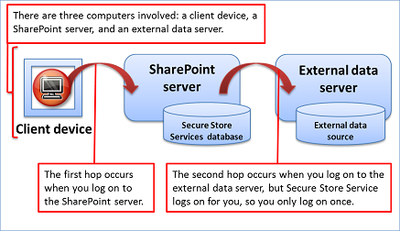
Set the cornerstone: external content types

External content types are at the heart of any external data solution. They are like a broker between you and the external data source. A typical external content type is an organized package of information that contains the following:
- Connection information to the data source, such as the location, name, and authenticate modes.
- A definition of the table, fields, primary and foreign keys, validations, and data types (also called metadata).
- The data operations you can do, such as Create, Read, Update, Delete, and Query (also called CRUDQ).
- Other information and behaviors, such as mapped Office data types or the enabling of offline synchronization.
- Various filters, which query the data and help isolate the results, and limits to improve performance.
- The identity field and display columns for an external content picker used to retrieve external data throughout the user interface.
- An association based on primary and foreign keys between two related tables, such as Orders and Customers.

You can define and update the external content type in a declarative way and then publish it to the Business Data Connectivity metadata store by using Microsoft SharePoint Designer 2013.

Surface external data in SharePoint products

Now that you have created a solid and safe foundation for your external data, here’s what you can do with it in SharePoint products.

Read and write data in external lists

An external list is a key building block for SharePoint solutions based on external data. You can read and write external data with the familiar experience of using a SharePoint list. An external list looks and behaves a lot like a native list, but there are some differences in behavior. For example, you can create views and use calculated values with formulas, but not attach files or track versions.

Add external data columns to lists and libraries

You can combine external data columns with other columns in a native list or library. Because an external data column is added to a native list or library, all related list or library features work, including versioning, approvals, check-in and check-out, and file attachments.

Let’s say you have created a picture library that contains photos of the products your organization sells. You can add an external data column to the library that accesses the product name, product code, and current price from an external database. Because your company rules and processes require any changes to product information only be made through the database system, you specify that the external data is read-only when you create the external content type. But now more people in your organization can easily see all the common product information together in one library view.

Create solutions with Business Data Web Parts

The Business Data Web Parts are designed to work with data from an external list and you can combine these Web Parts in useful ways to create a site workspace or dashboard. For example, you can connect the List and Item Web Parts so that when you select an expense report item in the List Web Part, such as Thursday’s charges, the item details are displayed in the Item Web Part, such as the hotel, travel, and meal charges.

Use external data in a profile page, action, or search

Profile pages, actions, and search are closely-related features:
- Profile pages By default, Business Connectivity Services automatically creates a profile page based on the external content type. A profile page is a Web page that displays information from a single row of external data, based on an ID field, such as all the individual fields about a specific customer. The default profile page is actually a Web page that contains the Business Data Item Builder and a Business Data Item Web Parts connected together. The Item Builder Web Part analyzes the URL query string parameter of the profile page, for example, http://contoso/Customer.aspx?CustID=345, and passes the CustID value to the Data Item Web Part, which then displays all the corresponding customer fields. You can create your own profile page to show custom information, or an administrator can customize the profile page for you.
- Actions You can even perform an action based on the profile page to do something useful. For example, you can create an action that combines address information about the customer with Bing maps to view the customer’s location or get directions. You can create an action either based on the URL query string parameter of the profile page or through custom code. Or, a developer can write custom code that enables you to update employee information in a back-end database.
- By default, you use an action when you click the View Profile action command in a Business Data Actions or Business Data List Web Part. When using an external data column, you can also run the action from a menu command.
- Search Finally if you want, an administrator can enable search of external data. The external data can be crawled and indexed just like internal SharePoint data, but with security trimming to ensure that only the appropriate users can click and see the search results, displayed by using a profile page. By integrating SharePoint search into external data systems, users can find data they otherwise would not be able to locate. For example, if you know the company a customer works for, but have forgotten their name, you can search by the company name to help you find the customer’s profile page.

Use external data in workflows

Workflows provide a powerful tool for modeling and automating business processes based on a SharePoint list, library, or site. These business processes can be as simple as a document approval process with a single approver, or as complex as any structured business process. Although you cannot directly associate a workflow with an external list, you can create the following:
- Native list workflows A workflow associated with a native list that reads or updates data from an external list by using the Create List Item, Update List Item, and Delete List Item actions. For example, you can update an external list item whenever a native list or library item changes. You can use other actions with external lists, such as the Set Workflow Variable to modify an external list field. You can also use an external list item as a destination for a task process, but the link to the task does not display a title for the external list item.
- Site workflows Site workflows do not require an event trigger to start and can be manually started. To prevent unauthorized access, workflows that access external lists always run in a service account, even with an authentication mode that uses impersonation.

Surface external data in Office products

Now that you have surfaced the data in SharePoint products, here’s what you can do with it in various Office products.

Analyze external data in Excel

You can export data from an external list to Excel 2013 and keep the data synchronized. For example you may want to maintain a product inventory in an external list so that it’s easy to share and update, but also do periodic inventory analysis in Excel 2013. The external data that is exported to Excel 2013 is determined by the current external list view, the filters defined on the external content type and in the external list, and the language settings for the SharePoint site.

Add external data to Word documents

By adding external data columns and a Word template with content controls to a document library, you can also make it easy and efficient to enter accurate, up-to-date data in a Microsoft Word 2013 structured document. Let’s say you have a document library that contains customer contracts. However, all your customer information is maintained in a Line-of-Business application, such as SAP. You can track the customer’s contracts in the document library, but ensure that related customer information is up-to-date and not unnecessarily duplicated.

Synchronize external data in Outlook

If an external list contains customers, tasks, appointments, or posts, you can connect the list with Outlook 2013. Once connected, you can view, edit, and print the data using the familiar Outlook user interface. If the data is contact information, such as customers, you can even call them, send them e-mail messages, and make meeting requests. The synchronization of the data is two-way or bi-directional. Changes made in Outlook 2013 are automatically synchronized with the external data source. Changes made to the external data source are synchronized with the items in Outlook 2013, although a refresh operation may be needed.

Enhance external data access with InfoPath forms

There are a number of reasons why Microsoft InfoPath 2013 is useful to use with external data:
- Working with complex data types If a field of external data is hierarchical, such as an address field that contains Street, City, and Postal code as a subfields, then you cannot work with this field in the SharePoint form for an external list, and in fact it is not even created. However, you can convert the SharePoint form to an InfoPath form to create and update the fields by using InfoPath 2013.
- Embedding an External Item Picker Control You can drag and drop the External Item Picker control onto an InfoPath form, link it to the external list as a secondary data source, and make it easy for a user to select an item based on a unique field, such as a Customer Name or Product ID.
- Adding Rules to forms You can add declarative rules to forms to perform additional business logic, such as validation and calculations. For example, you can ensure a country/region code is valid by using a rule, or U.S. postal code is valid by using a Web Service.

Add external data to published Visio diagrams

Using Microsoft Visio 2013, you can link data from an external list to a diagram and it’s shapes. You can then publish the diagram to a SharePoint document library as an interactive Web drawing so users can display the diagram and view the associated external data. There are three ways to link rows of data to shapes in your drawing. You can link rows to existing shapes one at a time, you can link the rows to shapes automatically, or you can create shapes from the data.

Import and refresh external data in Access

Microsoft Access 2013 is a landing pad for all types of data and external data is no exception. You can import an external list to your Access database on your client computer and periodically refresh the data. The data is read-only. The basic steps to follow are:

Pushing the SharePoint Composite envelope

Although a SharePoint Composite is often designed and developed by a power user or business analyst, there is not a hard and fast line between a SharePoint Composite no-code solution and an application that is partly or completely coded by a programmer. As we have seen, one of the benefits of a SharePoint Composite is that it can incrementally evolve into a programmed solution, and that from a developer point-of-view, it is like a working prototype that can form the basis for an enterprise-scale solution.
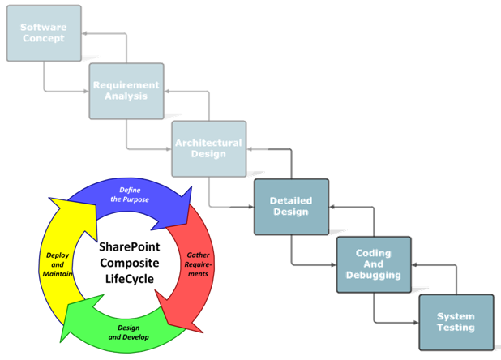
A SharePoint Composite can help shorten the traditional application development lifecycle
Although using managed code is obviously beyond the scope of this document, there are several ways you can use Web-based code to enhance your SharePoint Composite solution including JavaScript, Web Services, and REST.

Using JavaScript

A SharePoint page is a Web page, and so you can use JavaScript to add functionality and improve the user interface. Although you can simply edit a page to add JavaScript in the browser or SharePoint Designer 2013, one useful, maintainable approach is to add a text file containing JavaScript stored in a library by using the Script Editor Web Part. Examples of using JavaScript on a SharePoint page include custom navigation menus, tabbed pages, and hiding of SharePoint controls.

Visio 2013, Excel 2013, and the Media Web Part, all have JavaScript Object Model extensions that let you perform a number of useful tasks and detect user interaction. For example:
- In an Excel Services Web Part or even an embedded workbook on a Web page, you can validate cell entry, create a drop-down list, or click a cell and pass a parameter to another Web Part, among other actions.
- In a Visio drawing, you can capture a click event, highlight and annotate shapes, navigate and refresh the diagram, and read shape data.
- In the Media Web Part, by using the createMediaPlayer method, you can dynamically specify which asset in an Asset library to load based on page parameters and content, and control the play, pause, and seek operations of the media.

Using Web Services and REST

A Web service is a standard method for communication between Web sites using SOAP (Simple Object Access Protocol) to exchange information in XML format. It uses an interface language called WSDL (Web Services Description Language). For example, you can use SharePoint Designer 2013 or InfoPath 2013 to include data from a Web Service.

REST (Representational State Transfer) is a special type of Web service that processes XML representations of Web information using stateless operations. A client requests information from a server that responds to the request. The information is often a document or a portion of a document. For example, you can incorporate REST data by:
- Using SharePoint Designer 2013 to create a List View Web Part based on list data from another site.
- Creating an InfoPath form to enhance the requested REST data source with functions and rules.
- Adding and refreshing a REST data source in PowerPivot to combine it with other data sources.
- Displaying portions of an Excel workbook, such as a chart or named range, on a Web Part page or even within a Word document.
- Using the Excel Web Service functions to retrieve REST data and manipulate the data on a spreadsheet.

Appendices

The Fabulous 40
The following application templates provide many useful examples of SharePoint Composite solutions. They will give you lots of great ideas and practical suggestions. It’s important note that these templates were created for Windows SharePoint Services 3.0, but have not been officially upgraded to SharePoint Products 2013.

Datasheet | Description
Clinical Trial Initiation and Management | Helps teams manage the process of tracking clinical trial protocols, objective setting, subject selection and budget activities. The site provides useful Office Word 2007 templates as well as the capability to create, track and assign tasks and issues related to a particular clinical trial.
Absence Request and Vacation Schedule Management | Helps employees manage requests for out of office days. Team members post days they will be unavailable and can use the system to assign their responsibilities to others during those days. The application template helps team leaders manage requests for vacation and provides dashboards showing which users are signed up for a set of responsibilities.
Board of Directors | Provides a single location for an external group of members to store and locate common documents such as quarterly reviews, shareholder meeting notes and annual strategy documents. The template also tracks tasks, issues and calendar items so board members have a single location to view information relevant to them.
Contacts Management | Helps teams manage contact information that needs to be shared among team members. The application template allows teams to enter contact information through a Web-based interface or through Outlook. When used in conjunction with Outlook, team members can subscribe to receive updated contract information whenever other users make changes to a contact.
Document Library and Review | Helps people manage the review cycle common to processes like new product specification, publication, knowledge management and project plan development. It combines the functionality of a version-tracking document library with a threaded discussion list to provide a feedback and revision system. This template is intended for teams that need a central location for document review, discussion, revision control and approval.
Request for Proposal | Helps manage the process of creating and releasing an initial RFP, collecting submissions of proposals and formally accepting the selected proposal from amongst those submitted. The site also helps simplify the process of notifying individuals about the status of the RFP and submitted proposals.
Sales Lead Pipeline | Helps teams manage the sales pipeline by tracking leads, opportunities, contacts, and accounts. Through role-based dashboards, team members can track sales information, assign open opportunities and gain visibility into the status of overall leads entered into the application template.
Team Work Site | Provides a place where project teams can upload background documents, track scheduled calendar events and submit action items that result from team meetings. The site also tracks the creation and purpose of sub-teams as well as enables discussion of topics created by members of the team.
Budgeting and Tracking Multiple Projects | Helps project teams track and budget multiple, interrelated sets of activities. The template provides project management tools such as project creation, assignment of new tasks, Gantt Charts and common status designators. It helps team members consolidate the status of multiple projects into a single view, tracking progress against a set project budget and timeline.
Bug Database | Helps development teams collect and track information about bugs in their code. The template allows bugs to be logged with information such as reproduction steps, category, comments, priority and severity of the bug. Bug categories can specify category owners so users can quickly determine the appropriate bug owners.
Call Center | Helps teams manage the process of handling customer service requests. The application template helps teams manage service requests from issue identification to cause analysis and resolution. Role-based dashboards display relevant information for each service request and a knowledge base can help track related documents and items previously used to solve past call center issues. Management focused dashboards track performance with metrics such as average resolution time and service request performance history.
Case Management for Government Agencies | Helps case managers track the status and tasks required to complete their work. When a case is created, standard tasks and documents are created which are modified based on the work each case manager has completed.
Change Request Management | Helps users track risks associated with a design change. Team members can submit a change request, notifying stakeholders of the risks involved with the change. The application template allows a team member to approve or reject the request.
Classroom Management | Helps instructors and students organize and store information related to a particular class. The site includes document libraries to store assignments and lecture notes as well as calendars and announcement capability to enable communication from instructor to students.
Discussion Database | Provides a location where team members can create and reply to discussion topics. Discussions are organized by categories, which are created by a site manager, and can be linked to Office Outlook 2007 via an RSS feed.
Employee Activities Site | Helps manage the creation and attendance of events for employees. Activity owners use the site to review proposals for new activities and create event calendar items. Employees use the site to sign up as well as track which activities they’ve attended in the past.
Equity Research | Helps teams collaborate on researching stocks and other equities. It provides a central location for teams to store documents, post links, track news, and hold discussions related to the equities tracked by the site.
Event Planning | Helps teams organize events efficiently through the use online registration, schedules, communication and feedback. Role based dashboards offer specific information for various event members such as speaker, guest, staff, vendor, and delegate and attendee home pages.
Job Requisition and Interview Management | Demonstrates the power of collaboration by helping a recruiter streamline the process of filling job openings within a company. The template helps the recruiter manage requisitions, capture referrals and resumes and coordinate interviews. The application template enables people to input their candidate feedback centrally and track hire / no hire recommendations.
Knowledge Base | Helps teams manage the information that is resident within their organization. The template enables team members to upload existing documents or create new ones using Web-based content creation tools. Items are tagged with relevant identifying information so that others can more easily find the documents and learn from the collective knowledge in their organization. The template can be utilized in a top-down approach, where a centralized knowledge department pushes down relevant content to the rest of the business, or a bottom-up approach, where knowledge is captured and shared by all users as a normal part of doing business.
Manufacturing Process Management | Helps teams to model and track manufacturing processes as well as tasks and issues that arise in the upkeep of these processes.
Physical Asset Tracking and Management | Helps teams manage requests and tracking of physical assets. An asset manager approves asset requests and manages the properties of the assets in the system, such as location, condition, manufacturer, model, current owner and estimated value.
Product and Marketing Requirements Planning | Enables teams to manage the process of collecting and documenting requirements for new products. The site provides several Office templates providing useful techniques for Marketing, Product and Steering committee actions as well as a template for meeting notes and financial information.
Room and Equipment Reservations | Helps teams manage the utilization of shared meeting rooms and equipment. The application template enables team members to identify times when specific rooms and/or equipment are available and place a reservation for a specified time.
Timecard Management | Helps teams track hours spent working on various projects. The site enables team members to punch in on a particular project and punch out when they cease work. The system automatically generates the time worked by project, and can show managers who is working on a particular project, total hours versus budgeted time and the details of who worked on each project entered into the site.
Business Performance Reporting | Helps organization managers track the satisfaction of customers through a combination of surveys and discussions. Surveys can be sent via Office InfoPath 2007 which are then consolidated by the template to give an overall response to a series of questions.
Competitive Analysis Site | Helps teams organize information about competitors and their products. The site provides useful Office documents to perform SWOT and other useful competitive analysis techniques. Links to industry, company and product news can also be included to provide a single location for all competitive information.
Compliance Process Support Site | Helps both teams and executive sponsors to manage compliance implementation endeavors. The site allows users to specify control tasks required to meet regulation requirements as well capture compliance issues as they arise. The application template contains document libraries used by team members to store related files as well as a calendar to track key audit dates.
Disputed Invoice Management | Helps accounts payable departments track open invoices including the potential savings associated with paying the invoice early. The site includes useful templates for analyzing the reasons invoices are being disputed as well as tracking who to contact for more information.
Employee Self-Service Benefits | Provides tools for an organization to inform employees about available benefits as well as enabling them to enroll for each benefit.
Employee Training Scheduling and Materials | Helps instructors and employees manage courses and related materials. Instructors can use the site to add new courses and organize course materials. Employees use the site to schedule attendance at a course, track courses they've attended and to provide feedback.
Expense Reimbursement and Approval Site | Helps manage elements of the expense approval process, saving time for approvers. Employees can enter expense information into the application template. Approvers can then review the information and manage the payment approval. Users monitor the status of their reimbursement request through a filtered view listing their outstanding requests.
Help Desk | Helps teams manage the process of handling service requests. Team members use the application template to identify a service request, manage identification of the root cause and track solution status. The application template provides role-based dashboards displaying information relevant to customer service representatives and managers, including performance history.
Integrated Marketing Campaign Tracking | Helps marketing managers track the implementation and success of outbound marketing activities. The template allows a manager to create marketing activities and track the results of those activities, such as responses generated and sales completed. The template contains multiple methods of analyzing the success of the campaigns including automated calculations and Office Excel 2007 templates for more detailed analyses.
Inventory Tracking | Helps organizations track elements associated with inventory. The application template helps managers track inventory levels by capturing manual input of updated inventory information. Users are notified when each part reaches the reorder quantity and helps these users manage customer and supplier information such as historical inventory levels.
IT Team Workspace | Helps teams manage the development, deployment and support of software projects. The application template allows users to update information on projects, tasks, issues, milestones and bugs. It also includes help desk functionality, making it easy for team members to guide service requests from initiation to resolution. Role based dashboards provide relevant information to team members, such as unassigned tasks and performance history.
Lending Library | Helps people manage the physical assets in an organization's library. The application template tracks general properties about the physical assets and which user has currently checked out the asset. It also provides a librarian dashboard to help identify currently available and overdue assets. Automated email notifications can be sent to borrowers who have an overdue item.
New Store Opening | Helps a team manage the opening of new store locations or re-modeling of existing store location. The site provides a single location to manage tasks, issues, and documents for all store opening processes, enabling end users to view relevant information and providing project manager’s insight across the entire project.
Project Tracking Workspace | Helps small team projects manage project information in a single location. The application template provides a place where a team can list and view project issues and tasks. Functionality is provided to help drive project status reporting, including assignment of new tasks, Gantt Charts and common status designators.
Sports League | Helps an intra-company league administrator manage a baseball league. The site tracks team information, players, captains and scheduled team activities such as games, practices and social events. Team members can enter in game results and perform analysis at a team, game or individual player level. The site also enables discussions between league members through a League Discussion board.

Summary of Web Parts
The following is a comprehensive list of all Web Parts that are available in SharePoint Products 2013. Keep in mind the following: the availability of a Web Part depends on the SharePoint tier you have installed, whether or not a SharePoint Feature or Service has been activated, and whether you are using SharePoint Products 2013 on-premises or online.

Web Part | Description
Blog
Blog Archives | Provides quick links to older blog posts.
Blog Notifications | Provides quick links to register for blog posts notifications using Alerts or RSS feed.
Blog Tools | Provides blog owners and administrators with quick links to common settings pages and content lists for managing a blog site.
Business Data
Business Data Actions | Displays an action of an external list.
Business Data Connectivity Filter | Filters the contents of a connected Business Data Web Part by using a list of values from an external list.
Business Data Item | Displays an item from an external list.
Business Data Item | Builder Creates a Business Data item from parameters in a URL query string and provides it to other Business Data Web Parts.
Business Data List | Displays a list of items from an external list.
Business Data Related List | Displays a list of child items related to a parent item from an external list.
Excel Web Access | Displays an interactive Excel workbook as a Web page.
Indicator Details | Displays the details of a single Status Indicator. Status Indicators display an important measure for an organization and may be obtained from other data sources including SharePoint lists, Excel workbooks, and SQL Server Analysis Services KPIs. This Web Part is deprecated.
Status List | Shows a list of Status Indicators. Status Indicators display important measures for your organization, and show how your organization is performing with respect to your goals. This Web Part is deprecated.
Visio Web Access | Enables viewing and refreshing of published Visio diagrams.
Community
About this community | Displays the community description and other properties like established date. Enabled on Community sites or any other site that has Community Features turned on.
Join | Provides the ability for non-members of a community site to join the community. The button hides itself if the user is already a member. Enabled on Community sites or any other site that has Community Features turned on.
My membership | Displays reputation and membership information for the current visitor of a community site. Enabled on Community sites or any other site that has Community Features turned on.
Tools | Provides community owners and administrators with quick links to common settings pages and content lists for managing a community site. Enabled on Community sites or any other site that has Community Features turned on.
What's happening | Displays the number of members, topics and replies within a community site. Enabled on Community sites or any other site that has Community Features turned on.
Content Roll up
Categories | Displays categories from the Site Directory.
Content Query | Displays a dynamic view of content from your site. Enabled in Publishing sites.
Content Search | Shows items that are results of a search query. By default, shows recently modified items from the current site. You can change this setting to show items from another site or list by editing the Web Part and changing its search criteria. As new content is discovered by search, this Web Part will display an updated list of items each time the page is viewed.
Memberships | Displays your site and distribution list memberships. Enabled on your personal site.
My Links | Displays your links. Enabled on your personal site.
My SharePoint Sites | Displays documents authored by you on sites where you are a member and sites of your choice. Enabled on your personal site.
My Tasks | Shows all my personal and project tasks
My Workspaces | Displays sites created under your personal site. Enabled on your personal site.
Project Summary | Displays information about a project in an easy to read overview. Enabled on project sites.
Relevant Documents | Displays documents that are relevant to the current user
RSS Viewer | Displays an RSS feed.
SharePoint Documents | Displays documents authored by the user where the user is a site member. Enabled on your personal site.
Site Aggregator | Displays sites of your choice.
Sites in Category | Displays sites from the Site Directory within a specific category.
Summary Links | Creates links that can be grouped and styled. Enabled in Publishing sites.
Table of Contents | Displays the navigation hierarchy of your site. Enabled in Publishing sites.
Timeline | Shows a high level view of data from another Web Part or tasks list. Enabled on project sites.
Term Property | Displays the specified property of a Term.
WSRP Viewer | Displays portlets from web sites using WSRP 1.1.
XML Viewer | Transforms XML data using XSL and shows the results.
Document Sets
Document Set Contents | Displays the contents of a Document Set.
Document Set Properties | Displays the properties of the Document Set.
Filter
Choice Filter | Filters the contents of Web Parts using a list of values entered by the page author.
Current User Filter | Filters the contents of Web Parts by using properties of the current user.
Date Filter | Filter the contents of Web Parts by allowing users to enter or pick a date.
Filter Actions | Synchronizes the display of two or more Filter Web Part results.
Page Field Filter | Filters the contents of Web Parts using information about the current page.
Query String (URL) Filter | Filters the contents of Web Parts using values passed via the query string.
SharePoint List Filter | Filters the contents of Web Parts by using a list of values.
SQL Server Analysis Services Filter | Filters the contents of Web Parts using a list of values from SQL Server Analysis Services.
Text Filter | Filters the contents of Web Parts by allowing users to enter a text value.
Form
HTML Form | Connects simple form controls to other Web Parts.
InfoPath Form | Displays an InfoPath browser-enabled form.
List and Library
List View | Displays a list or library view.
Media and Content
Content Editor | Enables the use of rich text content.
Get Started with your site | Displays a set of tiles with common SharePoint actions.
Image Viewer | Displays a specified image.
Media | Embed media clips (video and audio) in a web page.
Page Viewer | Displays another Web page in an IFRAME.
Picture Library Slideshow | Displays a slideshow of images and photos from a picture library.
Script Editor | Inserts HTML snippets or scripts.
Silverlight | Displays a Silverlight application.
PerformancePoint
PerformancePoint Filter | Displays PerformancePoint filters that can be linked to other Web Parts to provide an interactive dashboard experience.
PerformancePoint Report | Displays PerformancePoint reports that can be linked to other Web Parts to create an interactive dashboard experience.
PerformancePoint Scorecard | Displays a PerformancePoint scorecard that can be linked to other web parts, such as filters and reports, to create an interactive dashboard experience.
PerformancePoint Stack Selector | Displays the PerformancePoint Stack Selector so that all PerformancePoint Web Parts, such as filters and reports, contained in the same zone will be automatically stacked and made selectable.
Project Web App
Approval Center | Displays task updates for approval and rejection submitted to you by team members.
Basic Info | Displays a list that may consist of project custom fields, project summary fields, and project inherent fields such as project name, description, or owner. The list is editable when used within the Project Detail Pages infrastructure.
Details | Drill down into projects on the server.
Get Started with Project Web App | Contains actions about how you get started with the Project Web App site.
Issues | Displays active issues that are assigned to you.
My Queued Jobs | Displays queue status for jobs generated by you.
My Schedule | Displays a calendar view of tasks assigned to you.
My Tasks | Displays tasks assigned to you.
My Timesheet | Displays your timesheet information.
Project Center | Displays a list of projects on the server.
Project Fields (Backwards Compatible) | Displays all enterprise custom fields except fields whose behavior is controlled by workflow. Use this Web Part to emulate the "Edit Project Properties" page used in Microsoft Office Project Server 2007. Can only be used within the Project Detail Pages infrastructure.
Project sites | Displays a list of project sites that are available to each user. Can only be used within the Project Detail Pages infrastructure.
Project Strategic Impact | Displays the business driver ratings information for a project. Can only be used within the Project Detail Pages infrastructure.
Resource Assignments | Displays assignment information where the resources have been assigned.
Resource Center | Displays a list of resources on the server.
Risks | Displays active risks that are assigned to you.
Team Tasks | Displays team assignments.
Track your work | Displays a list of user item reminders.
Workflow Status | Displays workflow status information for a project. Can only be used within the Project Detail Pages infrastructure.
Reports
Report Viewer | Displays SQL Server Report Server reports (.rdl).
Search
Find by Document ID | Finds a document by its Document ID.
Refinement | Refines search results.
Search Box | Displays a search box so users can search for information.
Search Navigation | Navigates among search verticals.
Search Results | Displays search results and the properties associated with them.
Taxonomy Refinement Panel | Refines search results on term set data. To use this Web Part, you must also have a Search Data Provider Web Part on this page and use Managed Navigation.
Search-Driven content (on premises-only)
Catalog-Item Reuse | Reuses or republishes the content of an item from a catalog.
Items Matching a Tag | Displays items that are tagged with a term and matching the page navigation context.
Pages | Displays items derived from the Pages content type.
Pictures | Displays items derived from the Picture or Image content type.
Popular Items | Displays items recently viewed by many users.
Recently Changed Items | Displays items recently modified and helps site users track the latest activity on a site or a library.
Recommended Items | Displays content recommendations based on usage patterns for the current page.
Videos | Displays items derived from the Video content type and sorted by number of views.
Web Pages | Displays items derived from the Page content type.
Wiki Pages | Displays items derived from the Wiki Page content type.
Social Collaboration
Activity Feed | Displays a user's most recent conversations and activities. Enabled on your personal site.
Ask Me About | Shows a list of keywords that others can ask me questions on. Enabled on your personal site.
Colleagues | Provides a list of all colleagues a user has shared with others and an entry point for the profile owner to manage the list of colleagues. Enabled on your personal site.
Contact Details | Displays details about a contact for this page or site
In Common with You | Displays what is in common between you and the user. Enabled on your personal site.
Note Board | Enable users to leave short, publicly-viewable notes about this page.
Organization Browser | Displays each person in the reporting chain in an interactive view optimized for browsing organization charts.
Recent Activities | Displays my recent activities. Enabled on your personal site.
Recent Blog Posts | Displays the most recent blog posts for the user. Enabled on your personal site.
Site Feed | Contains mini-conversations on a group site. Enabled on your personal site.
Site Users | Displays a list of the site users and their online status.
Tag Cloud | Displays the most popular subjects being tagged inside your organization.
User Tasks | Displays tasks that are assigned to the current user.
Whereabouts | Displays Whereabouts information.
What's New | Displays a list of your colleagues and their recent changes. Enabled on your personal site.

Visio diagrams that support the solution life-cycle

Here are common diagrams that are used throughout any solution life-cycle.

Description | Diagram | Description | Diagram
Brainstorming Create a graphical representation of thought processes for planning, problem solving, and decision making. |  | Business Process Modeling Notation (BPMN) Create a flowchart that follows the Business Process Modeling Notation 1.2 standard. | 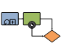
Cause and Effect Create a fishbone or Ishikawa diagram to systematically review factors that affect or contribute to a given situation. | 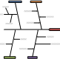 | Cross-Functional Flowchart Show the relationship between a business process and the organizational or functional units, such as departments, that are responsible for steps in that process.
Fault Tree Analysis Create a Fault Tree diagram to document business processes. | 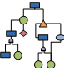 | SharePoint Workflow Create an annotated workflow diagram for SharePoint Products 2013 Workflows that can be exported for configuration to SharePoint Designer 2013. | 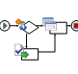
Six Sigma Create a Six Sigma flowchart or house of quality diagram. |  | Workflow Create a diagram of information flow, business process automation, business process re-engineering, accounting, management, and other human resources tasks.
Total Quality Management (TQM) Create a cause and effect, top down or cross-functional process flow diagram for business process re-engineering and continuous improvement. | 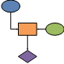 | Database Model Document and design a database using Integration Definition for Information Modeling (IDEF1X) and relational notations. | 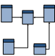
Value Stream Create a value stream map to illustrate the flow of material and information in a lean manufacturing process. | 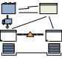 | Wireframe Create a medium-fidelity wireframe diagram for software application prototyping and design.

