SharePoint Server 2010
SharePoint 2010 Virtualization Guidance and Recommendations

DISCLAIMER
This document is provided “as-is”. Information and views expressed in this document, including URL and other Internet Web site references, may change without notice. You bear the risk of using it.
Some examples depicted herein are provided for illustration only and are fictitious. No real association or connection is intended or should be inferred.
This document does not provide you with any legal rights to any intellectual property in any Microsoft product. You may copy and use this document for your internal, reference purposes.
© 2011 Microsoft Corporation. All rights reserved.

Table of Contents

Overview 4
Virtualization Using Hyper-V 4
Prerequisites for Hyper-V 8
Why Virtualize SharePoint? 9
Hardware Consolidation 9
Ease of Management and Provisioning 9
Testing and Development 10
Business Continuity and Availability 10
Planning a Virtual Deployment 10
Hardware and Software Requirements 13
Physical and Virtual Topology 13
High Availability 18
Virtualization of SharePoint Components 23
Best Practices for Virtual Processor, Memory, Disk, and Network 25
Managing the Virtual SharePoint Environment 27
Performance Test Results 29
Hardware Sets 29
Virtual Machine Scale-Up 31
Single-Host Scale-Out 33
Virtual vs. Physical 39
VM Scale-Out 43
Physical Scale-Up 47
Licensing 49
Conclusion 50
Additional Resources 51
Customer Evidence 51
Online Resources 51

Overview
Modern multi-tiered applications such as Microsoft® SharePoint® Server® 2010 require the deployment of multiple services, such as web servers, application servers, and database servers. In many corporate environments, these services are deployed on separate physical servers to help ensure effective response times, high availability, and scalability with business needs. Yet, this approach can result in underused resources, as hardware sits idle and consumes space, power, and support while “waiting for something to happen.” By deploying physical hardware to support each component and service of SharePoint Server, organizations risk increased costs and more complex management.
With virtualization technologies, organizations can consolidate workloads across multiple underused servers onto a smaller number of servers. Having fewer physical machines can help to reduce costs through lower hardware, power, and management overhead.
The call for higher availability, greater flexibility, and improved manageability is the driving force behind the virtualization of the SharePoint infrastructure. Microsoft Windows® Server® 2008 R2 with Hyper-V™ supports SharePoint virtualization with a powerful toolset that can help to reduce operational costs and increase performance with a flexible SharePoint farm design that is not possible with a traditional physical deployment.
This white paper illustrates best practices for virtualizing SharePoint Server 2010 on Windows Server 2008 R2 with Hyper-V. Technical decision makers, such as architects and systems administrators, can use this information to design, architect, and manage a virtualized SharePoint infrastructure.

Virtualization Using Hyper-V
Microsoft Hyper-V is a virtualization technology for x64-based systems such as Windows Server 2008 R2. Hyper-V is a hypervisor—a layer of software between the server hardware and operating system that allows multiple operating systems to run on the host computer at the same time.
Hyper-V creates partitions that maintain isolation between each guest operating system. The virtualization stack runs in the root partition and has direct access to hardware devices. The root partition then creates child partitions, which host guest operating systems. A root partition creates child partitions using the hypercall application programming interface (API).

Figure 1 provides a high-level overview of the architecture of a Hyper-V environment running on Windows Server 2008 R2.
Figure 1: High-level overview of the Hyper-V environment
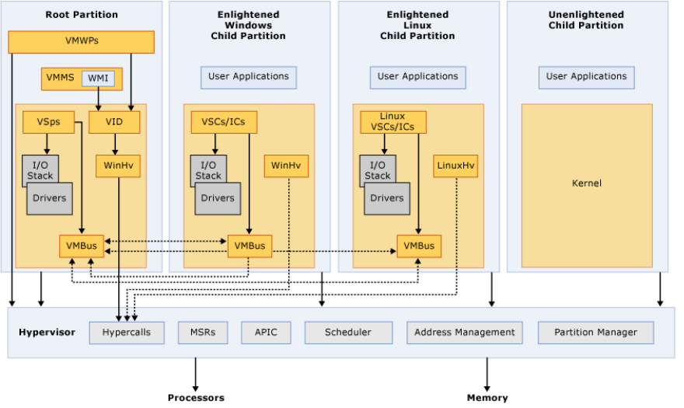
Acronyms and terms used in this diagram are defined below:
- APIC: Advanced programmable interrupt controller—a device that allows priority levels to be assigned to its interrupt outputs.
- Child Partition: Partition that hosts a guest operating system. The Virtual Machine Bus (VMBus) or hypervisor provides all access to physical memory and devices by a child partition.
- Hypercall: Interface for communication with the hypervisor. The hypercall interface provides access to the optimizations that the hypervisor provides.
- Hypervisor: A layer of software that sits between hardware and one or more operating systems. The hypervisor’s primary job is to provide isolated execution environments called partitions. The hypervisor controls and arbitrates access to underlying hardware.
- IC: Integration component—an element that allows child partitions to communicate with other partitions and the hypervisor.
- I/O stack: Input/output stack.
- MSR: Memory service routine.
- Root Partition: Partition that manages machine-level functions, such as device drivers, power management, and device hot addition/removal. The root (or parent) partition is the only partition that has direct access to physical memory and devices.
- VID: Virtualization infrastructure driver—provides partition management services, virtual processor management services, and memory management services.
- VMBus: Channel-based mechanism used for communication between partitions and device enumeration on systems with multiple active virtualized partitions. The VMBus is installed with Hyper-V Integration Services.
- VMMS: Virtual Machine Management Service—responsible for managing the state of all virtual machines in child partitions.
- VMWP: Virtual machine worker process—a user mode component of the virtualization stack. The worker process provides virtual machine management services from the Windows Server 2008 instance in the parent partition to the guest operating systems in the child partitions. The Virtual Machine Management Service generates a separate worker process for each running virtual machine.
- VSP: Virtualization service provider—resides in the root partition and provides synthetic device support to child partitions over the VMBus.
- VSC: Virtualization service client—a synthetic device instance that resides in a child partition. VSCs use hardware resources provided by VSPs in the parent partition. They communicate with corresponding VSPs in the parent partition over the VMBus to satisfy a child partition’s device I/O requests.
- WinHv: Microsoft Windows® Hypervisor Interface Library—essentially a bridge between a partitioned operating system’s drivers and the hypervisor. WinHv allows drivers to call the hypervisor using standard Windows calling conventions.
- WMI: Windows management instrumentation. The Virtual Machine Management Service exposes a set of WMI-based APIs for managing and controlling virtual machines.

Enhanced Features for Hyper-V in Service Pack 1
The new release of Windows Server 2008 R2 Service Pack 1 (SP1) includes tools and updates that enhance the virtualization technologies. One of the most notable changes in SP1 is Dynamic Memory. With Dynamic Memory, Hyper-V treats memory as a shared resource that can be reallocated automatically among running virtual machines. This means that Hyper-V can provide more or less memory to a virtual machine in response to changes in the amount of memory required by the workloads or applications running in it. As a result, memory can be distributed more efficiently—making it possible to run more virtual machines at the same time on one computer.
Dynamic Memory distributes memory based on:
- Startup RAM: Specifies the amount of memory required to start a virtual machine. The memory allocated to a virtual machine does not fall below this value. Startup RAM identifies a sufficient value to allow the guest operating system in a virtual machine to start.
- Memory Buffer: This buffer is determined using a specific formula—the amount of memory Hyper-V attempts to assign to a virtual machine compared to the amount of memory actually needed by the applications and services running inside the virtual machine (memory buffer = memory demand × percent of configured memory buffer).
- Maximum RAM: Specifies the upper limit for how much physical memory can be allocated to a virtual machine. The memory allocated to a virtual machine can never increase above this value.
- Memory Weight: Memory weight (sometimes referred to as “memory priority”) identifies how important memory is to an individual virtual machine.
As shown in Figure 2, Dynamic Memory is implemented in the management operating system through a user-mode VSP that communicates through the VMBus with a kernel-mode VSC in a virtual machine.
Figure 2: Implementation of Dynamic Memory
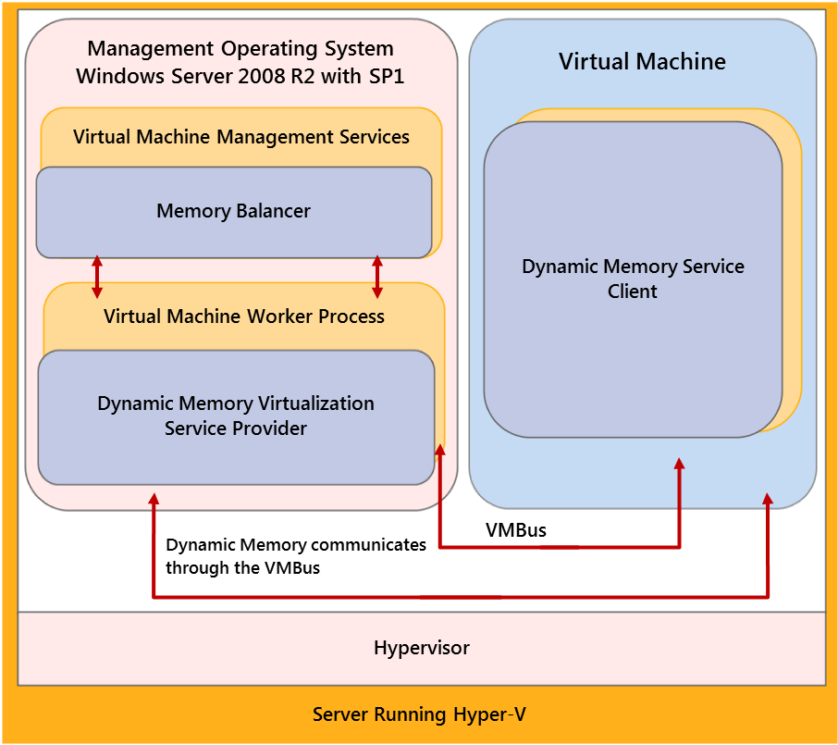
Important components in this diagram are defined below:
- Memory Balancer: Balances memory resources across running virtual machines. The memory balancer gathers information about memory pressure and memory weight for each virtual machine. Using this information, it determines when and how memory changes are made and coordinates those changes with the virtual machines.
- Dynamic Memory Virtualization Service Provider: Communicates with the memory balancer and the Dynamic Memory VSC running in the virtual machine to perform memory operations. The Dynamic Memory VSP receives memory pressure metrics from the VSC and forwards them to the memory balancer. There is a Dynamic Memory VSP for each corresponding Dynamic Memory VSC.
- Dynamic Memory Virtualization Service Client: Adds and removes memory from virtual machines. In addition, the Dynamic Memory VSC communicates the memory pressure in the virtual machine back to the VSP.

Recommended Best Practice
Do not configure too high of a value for the startup RAM setting on a virtual machine. As implemented in Windows Server 2008 R2 SP1, Dynamic Memory can never decrease the memory allocated to a virtual machine below the value of the startup RAM.

Server Virtualization Validation Program
Microsoft launched the Server Virtualization Validation Program (SVVP) to help improve customer support for running Windows Server on virtualization technologies. Customers can benefit from Microsoft support as part of the regular Windows Server technical support framework. To receive technical support, customers must meet the baseline requirements:
- Microsoft operating system currently covered by the program:
  - Windows Server 2008 R2
  - Windows Server 2008
  - Windows Server 2003 SP2
  - Subsequent service packs for the versions above
- Valid Windows Server licenses
- Active technical support agreement with Microsoft and the virtualization vendor
- Running on a validated third-party virtualization solution
- Running on a system logo qualified for either Windows Server 2008 or Windows Server 2008 R2
- Virtual machine containing Windows Server does not exceed the maximum virtual processors and memory validated with the virtualization solution
For more details on SVVP, go to Server Virtualization Validation Program (http://go.microsoft.com/fwlink/?LinkId=125375).

Prerequisites for Hyper-V
Hyper-V requires specific hardware. You can identify systems that support the x64 architecture and Hyper-V by searching the Windows Server catalog for Hyper-V as an additional qualification. For more information, see the Windows Server catalog (http://go.microsoft.com/fwlink/?LinkId=111228).
To install and use the Hyper-V role, you need the following:
- x64-based processor: Hyper-V is available in x64-based versions of Windows Server 2008, specifically, the x64-based versions of Windows Server 2008 Standard, Windows Server 2008 Enterprise, and Windows Server 2008 Datacenter.
- Hardware-assisted virtualization: This feature is available in processors that include a virtualization option, specifically, Intel Virtualization Technology (Intel VT) or AMD Virtualization (AMD-V).
- Hardware-enforced data execution prevention (DEP): This feature must be available and enabled. Specifically, you must enable the Intel XD bit (execute disable bit) or AMD NX bit (no execute bit).

Additional Considerations
The settings for hardware-assisted virtualization and hardware-enforced DEP are available in the BIOS. However, the names of the settings may differ from the names identified above. For more information about whether a specific processor model supports Hyper-V, check with the computer manufacturer.
Also, remember that if you modify the settings for hardware-assisted virtualization or hardware-enforced DEP, you may need to turn the computer’s power off and then back on. Simply restarting the computer may not apply the changes to the settings.

Recommended Best Practice
Windows Server 2008 R2/Microsoft Hyper-V Server 2008 R2 is recommended. Windows Server 2008 R2 Enterprise provides the scalability necessary to meet the most demanding Microsoft SharePoint Server 2010 deployments. It also includes improved scale-up and performance capabilities, such as Live Migration for moving a running virtual machine from one cluster node to another, enhanced processor support, improved virtual machine storage, and richer networking support.

Why Virtualize SharePoint?
Virtualizing SharePoint and its server components can provide many business and technical benefits. With virtualization, you can consolidate hardware and ease server management and provisioning—helping to promote cost savings, business continuity, and agile management. Moreover, SharePoint virtualization is ideal for organizations that have more than one SharePoint farm, such as those with high availability production, testing, and development environments. The remainder of this section describes additional benefits of SharePoint virtualization in greater detail.

Hardware Consolidation
Hardware consolidation essentially allows you to run different SharePoint servers and various server components sharing the same hardware set. Hardware consolidation yields a variety of benefits:
- Resource utilization and balancing: With SharePoint virtualization and the built-in enhancements of the Hyper-V 64-bit multiprocessor and multicore technology, you can run multiple workloads on different, isolated virtual machines—helping to use and balance resources more efficiently. Because you manage only a single physical server that runs isolated virtual machines, it is easier to provision and balance various resources, such as RAM and disk space, for different SharePoint server components.
- Reduced costs for physical infrastructure, maintenance, power, and cooling: Server consolidation reduces server count, which, in turn, reduces the cost of SharePoint infrastructure and maintenance. Consequently, cooling needs and power consumption are also reduced. From the perspective of environmental sustainability, SharePoint virtualization can be a major contributor to the Green IT movement.
- Less physical space: By virtualizing SharePoint farms, you can provide required capabilities with fewer servers, thereby freeing up space originally allotted for servers.

Ease of Management and Provisioning
Typically, virtualization enables you to run several virtual machines on a single physical server, which can ease the management and provisioning of virtualized SharePoint farms. Microsoft provides tools to help you manage and provision different SharePoint server components in a virtual environment. Microsoft System Center Virtual Machine Manager (VMM) 2008, part of the System Center Server Management Suite, provides SharePoint administrators with the ability to manage multiple virtual hosts; quickly provision servers and farms that run SharePoint Server; and migrate physical servers to virtual ones.

Testing and Development
Testing and development on a SharePoint infrastructure requires replicated and simulated environments. Because these environments need low disk I/O and memory, all components of SharePoint Server, including the Microsoft SQL Server® database server, typically can be virtualized. Using System Center VMM, SharePoint administrators can easily manage multiple testing and development SharePoint farms. With System Center VMM, administrators also can easily replicate virtual servers, allowing them to run even at the time of replication with the VMM physical-to-virtual (P2V) and virtual-to-virtual (V2V) capabilities; this can help to greatly decrease administrative overhead.

Business Continuity and Availability
To ensure business continuity, servers must be highly available so that working environments always seem transparent, as if no incident has ever occurred. To facilitate high availability in SharePoint virtual environments, Hyper-V uses Network Load Balancing (NLB), a clustering technology that detects a host failure and automatically distributes the load to active servers. You can use the Hyper-V built-in clustering technology to help provide high availability in your SharePoint virtual farm.

Planning a Virtual Deployment
With Windows Server 2008 R2 Hyper-V, you can run multiple operating systems on a single physical machine through server virtualization; this can simplify the creation of test environments, thereby saving time and money. When considering a virtualized SharePoint deployment, it is important to understand that virtualization does not provide parity with physical machines without proper planning. With such planning, it is possible to achieve optimum performance, as expected from a physical SharePoint farm.
To help effectively plan and prepare an environment for virtualization, Microsoft provides a variety of resources for IT professionals, such as new Infrastructure Deployment Planning (IPD) Guides and the Microsoft Assessment and Planning (MAP) Toolkit for Hyper-V:
- Infrastructure Deployment Planning Guides: The IPD Guides (http://go.microsoft.com/fwlink/?LinkId=199973) present an easy-to-follow, step-by-step process for infrastructure design of virtualization hardware and management software—including how to determine the scaling and architectural limits of each component.
- Microsoft Assessment and Planning Toolkit: The free MAP Toolkit is an agentless tool that collects inventory of an existing heterogeneous server environment, determines which servers are underutilized, and generates server placements and virtualization candidate assessments for Hyper-V implementation. Download the MAP Toolkit (http://go.microsoft.com/fwlink/?LinkId=209200). MAP Toolkit for Hyper-V (http://go.microsoft.com/fwlink/?LinkId=217471) provides more details about the MAP Toolkit.

Figure 3 shows the critical design elements for a successful implementation of Windows Server 2008 Hyper-V for server virtualization.
Figure 3: A well-planned implementation of Windows Server 2008 Hyper-V for server virtualization
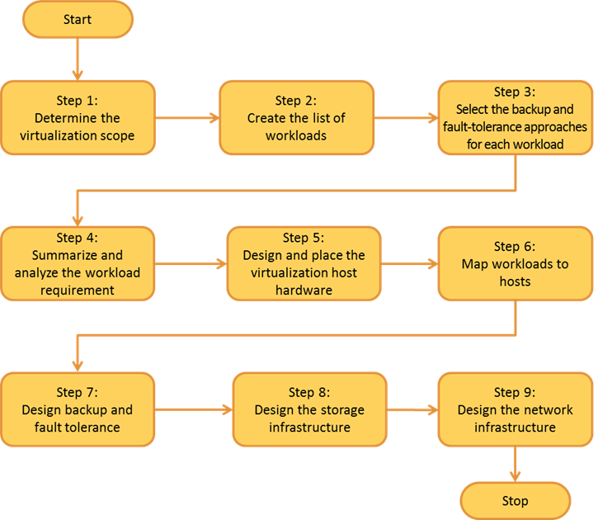
Planning for a SharePoint deployment largely focuses on the physical architecture. In virtualized deployments, each virtual machine should be viewed as a physical machine. The physical architecture, consisting of one or more servers and the network infrastructure, enables you to implement the logical architecture for a SharePoint Server solution. After the SharePoint physical architecture has been decided, you can plan the Hyper-V virtualization server deployment around it.
After planning a physical farm, you have all the information necessary to design virtualization architecture. To plan a virtual farm, you follow nearly the same steps as you would for a physical farm. Most, if not all, requirements for deploying SharePoint Server 2010 on physical servers also apply to virtual machines. Any decisions you make, such as minimum processor or memory requirements, have a direct bearing on the number of virtualization hosts needed, as well as their ability to adequately support the virtual machines identified for the farm.
In reality, the architecture likely will change as you move through the deployment phase of the system life cycle. In fact, you may determine that some farm server components are not good candidates for virtualization. For more information about the components of SharePoint Server that are good candidates for virtualization, see the Virtualization of SharePoint Components section of this document.

Hardware and Software Requirements
The hardware and software requirements for virtualizing SharePoint Server 2010 and its components are described in the table below. Note: The basic hardware requirements for enabling virtualization also apply to third-party virtualization technologies that are certified by Microsoft.
Component | Requirements
Hardware | Processor: Virtualization technology (Intel VT) or AMD virtualization (AMD-V) technology
 | Hardware-enforced data execution prevention (DEP) available and enabled
Software (one product required) | Windows Server 2008 R2 (all editions except for Windows Server 2008 R2 for Itanium-based systems, Windows Web Server 2008 R2, and Windows Server 2008 R2 Foundation)
 | Windows Server 2008 (all editions except for Windows Server 2008 for Itanium-based systems, Windows Web Server 2008, and Windows Server 2008 Foundation)
 | Microsoft Hyper-V Server 2008
 | Hyper-V Server R2
SharePoint Server 2010 deployment requirements are the same for physical and virtual machines. In addition, they apply both to installations on a single server with a built-in database and to servers running SharePoint Server 2010 in a multiple server farm installation. To learn more about hardware and software requirements for SharePoint Server 2010, see the “Hardware requirements—Web servers, application servers, and single server installations” section of Hardware and software requirements for SharePoint Server 2010 (http://go.microsoft.com/fwlink/?LinkId=217474).

Physical and Virtual Topology
As previously noted, SharePoint deployment planning emphasizes physical architecture, so for virtualized deployments, you should view each virtual machine as a physical machine. The physical architecture enables you to implement the logical architecture for a SharePoint Server solution. The physical architecture is typically described in two ways:
- Size: Can be measured in several ways, such as the number of users or documents, and is used to categorize a farm as small, medium, or large.
- Topology: Uses the idea of tiers or server groups to define a logical arrangement of farm servers.

The following table describes possible mapping of physical-to-virtual architecture in the context of SharePoint virtualization.
Deployment Specifications
Server | Memory | Processor | Disk
Virtual Host | 24GB RAM | 2 quad-core  (8 cores) | C: drive-OS, Windows Server 2008 R2 with Hyper-V, 50GB dedicated volume  D: drive-Dedicated volume for OS VHDs  E: drive-500GB dedicated volume for SQL Server database VHDs  F: drive-100GB dedicated volume for SQL Server log VHDs
SQL Server | 12GB RAM | 4 virtual processors | C: drive-OS, fixed-size VHD (100GB)  D: drive-Fixed-size VHD (100GB) for SQL Server logs  E: drive-Fixed-size VHD (500GB) for SQL Server data
SharePoint Web/Query/App | 10GB RAM | 4 virtual processors | C: drive-OS and transport queue logs, fixed-size VHD (100GB)  E: drive-Fixed-size VHD (100GB) for indexing and querying
The farm architecture shown in Figure 4 is cost effective and can be scaled out easily according to need. After the figure, some examples of possible virtual architecture for SharePoint farms are included.
Figure 4: Example of farm architecture
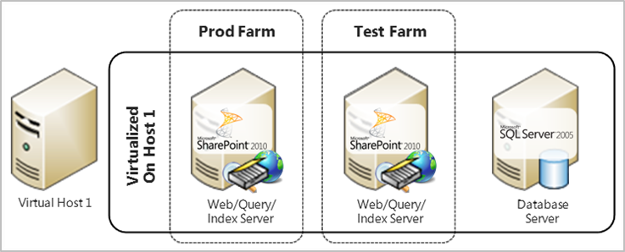

Virtual Architectures for Small-to-Medium Farms
The starting point for replacing a physical farm with a virtual farm is to use two to four physical host servers. For each host, the number of servers that can be deployed is dictated by available memory, CPU, disk, and network resources. Figures 5 and 6 show example deployments where the web and application server components are deployed to a virtual environment.
Figure 5: Virtual architecture using two cores
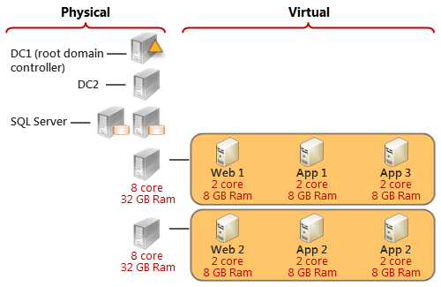
In this example, be aware of the following:
- The minimum resources for CPUs and RAM represent starting points for the farm. Because only two cores are reserved for each virtual image, this example is appropriate for proof-of-concept or development environments in which performance is not an issue. Reserve enough spare resources to reallocate based on performance monitoring.
- SQL Server is deployed to physical servers, instead of virtual servers.
- Web servers and application servers are redundant across the two host servers.
- Three web servers are deployed to the virtual environment for high availability.
- The domain controllers for Active Directory® Domain Services domain controllers are deployed to physical servers.
For pilot testing and production environments, a minimum of four cores is the recommended starting point for virtual machines. Figure 6 illustrates a virtual environment that uses fewer virtual machines.
Figure 6: Virtual architecture using four cores
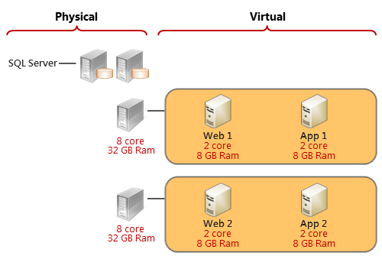
This example represents a starting-point environment. You may need to add resources, depending on the usage pattern of the farm.

Virtual Architectures for Medium-to-Large Farms
Using larger host servers, you can allocate more resources to virtual images. Figure 7 shows an implementation that uses more CPUs and RAM.
Figure 7: Virtual architecture using additional CPUs and RAM
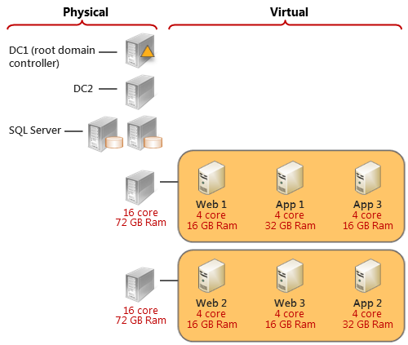
If the benefits of virtualizing SQL Server outweigh the performance tradeoffs, SQL Server also can be deployed as a guest, as shown Figure 8.
Figure 8: Virtual architecture with SQL Server deployed as a guest
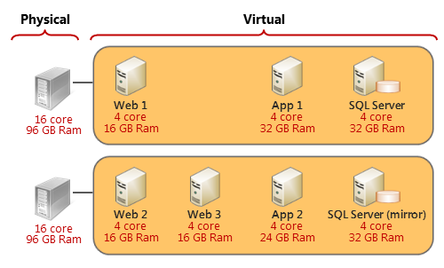
In this example, be aware of the following:
- Only one instance of SQL Server is deployed to each host. For small and medium virtual environments, it is recommended that you do not deploy more than one SQL Server guest per host.
- Both host servers include more memory to accommodate the number of virtual servers, including SQL Server.
If a particular server component consumes so many resources that it adversely affects the overall performance of the virtual environment, consider dedicating a physical server to it. Depending on an organization’s usage patterns, such a component may include a crawl server, the server that imports profiles, the Microsoft Excel® Services application, or another heavily used service (Figure 9).
Figure 9: Virtualized architecture with a dedicated physical crawl server
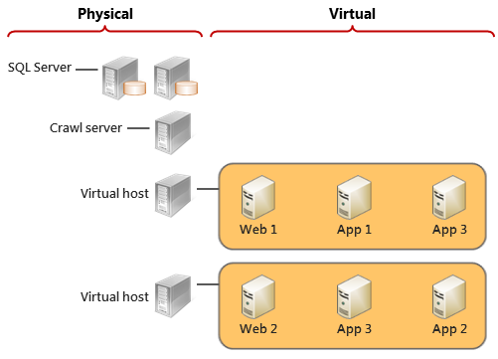
In this example, be aware of the following:
- SQL Server is deployed to physical servers. Remove SQL Server from the virtual environment before you remove application server components.
- The crawl component is deployed to a physical server. In some environments, a different server component may be a candidate for deployment to a physical server, depending on usage.

High Availability
Before you virtualize SharePoint farms, it is a good idea to think about how you will achieve high availability of virtualized servers, which server components should be virtualized, and what the architecture of the virtualized farm should be.

Planning for High Availability in SharePoint
With high availability, users expect to always be able to access the system, which has been designed and implemented to ensure operational continuity. High availability for Hyper-V is achieved with the Windows Server 2008 Failover Cluster feature. High availability is impacted by both planned and unplanned downtime, and failover clustering can significantly increase the availability of virtual machines in both of these categories.
More information about host and guest availability is as follows:
- Host Availability: The Windows Server 2008 Failover Cluster can be configured on the Hyper-V parent partition (host) so that Hyper-V child partitions (virtual machines or guests) can be monitored for health and moved between nodes of the cluster. This configuration has the following key advantages:
  - If the physical machine on which Hyper-V and the virtual machines are running needs to be updated, changed, or rebooted, the virtual machines can be moved to other nodes of the cluster. The virtual machines can be moved back once the physical machine returns to service.
  - If the physical machine on which Hyper-V and the virtual machines are running fails (for example, motherboard malfunction) or is significantly degraded, the other members of the failover cluster take ownership of the virtual machines and bring them online automatically.
  - If a virtual machine fails, it can be restarted on the same Hyper-V server or moved to another Hyper-V server. Because this is detected by the Windows Server 2008 Failover Cluster, recovery steps are taken automatically based on settings in the virtual machine’s resource properties. Downtime is minimized due to automated detection and recovery.
- Guest Availability: Guest availability focuses on making the workload that is being run inside a virtual machine highly available. Common workloads include file and print servers, IIS, and line-of-business (LOB) applications. Analyzing high availability needs and solutions for workloads inside virtual machines is the same as on standalone servers. The solution depends on the specific workload. Guests that are running Windows Server 2008 can use the Windows Server 2008 Failover Cluster feature to provide high availability for their workloads.

Configuring Virtual Machines for High Availability
Hyper-V uses Cluster Shared Volume (CSV), a failover clustering method available in Windows Server 2008 R2, to make virtual machines highly available. The CSV feature can simplify configuration and management for Hyper-V virtual machines in failover clusters. With CSV, on a failover cluster that runs Hyper-V, multiple virtual machines can use the same Logical Unit Number (LUN) (disk) yet fail over (or move from node to node) independently of one another. CSV can provide increased flexibility for volumes in clustered storage; for example, it allows you to keep system files separate from data to optimize disk performance, even if both are contained within virtual hard disk (VHD) files. The prerequisites to use CSV are:
- The Windows Server 2008 Failover Cluster feature must be configured for each node of the cluster.
- The Hyper-V role must be installed. Hyper-V updates should be installed and the role configured for each node of the failover cluster. Hyper-V has an update package that installs the Hyper-V server components and another that installs the Hyper-V management console. Once the updates are installed for the Hyper-V server components, the role can be added through Server Manager or ServerManagerCMD.
- You must have shared storage available to the virtual machines. The storage can be managed by the failover cluster as a built-in physical disk resource type, or you can use a third-party solution to manage the shared storage. Of course, the third-party solution must support the Windows Server 2008 Failover Cluster feature.
Configuring a virtual machine to be highly available is simple with the High Availability Role Wizard (under Failover Cluster Management). Still, Hyper-V virtual machines have several key components that must be considered when they are managed as highly available:
- Failover Cluster Nodes: Each physical server that is part of a failover cluster is called a node. For host clustering, the failover cluster service runs in Windows Server 2008 on the parent partition of the Hyper-V system. This allows the virtual machines that are running in child partitions on the same physical servers to be configured as highly available virtual machines. The virtual machines that are configured for high availability are shown as resources in the failover cluster management console.
- HA Storage: Highly available virtual machines can be configured to use VHDs, pass-through disks, and differencing disks. To enable the movement of virtual machines between failover cluster nodes, there needs to be storage (appearing as disks in Disk Management) that can be accessed by any node that might host the virtual machine and that is managed by the failover cluster service. Pass-through disks should be added to the failover cluster as disk resources, and VHD files must be on disks that are added to the failover cluster as disk resources.
- Virtual Machine Resource: This is a failover cluster resource type that represents the virtual machine. When the virtual machine resource is brought online, a child partition is created by Hyper-V and the operating system in the virtual machine. The offline function of the virtual machine resource removes the virtual machine from Hyper-V on the node where it was being hosted, and the child partition is removed from the Hyper-V host. If the virtual machine is shut down, stopped, or put in saved state, this resource will be put in the offline state.
- Virtual Machine Configuration Resource: This is a failover cluster resource type that is used to manage the configuration information for a virtual machine. There is one virtual machine configuration resource for each virtual machine. A property of this resource contains the path to the configuration file that holds all information needed to add the virtual machine to the Hyper-V host. Access to the configuration file is required for a virtual machine resource to start. Because the configuration is managed by a separate resource, a virtual machine resource’s configuration can be modified even when the virtual machine is offline.
- Virtual Machine Services and Applications Group: For a service or application to be made highly available through failover clustering, multiple resources must be hosted on the same failover cluster node. To ensure that these resources are always on the same node and that they interoperate appropriately, the resources are put into a group that the Windows Server 2008 Failover Cluster refers to as “Services or Applications.” The virtual machine resource and the virtual machine configuration resource for a virtual machine are always in the same Services or Applications group. There may also be one or more physical disk (or other storage type) resources containing VHDs, configuration files, or pass-through disks in a Services or Applications group.
- Resource Dependencies: It is important to ensure that the virtual machine configuration resource is brought online before the virtual machine resource is brought online (started), and that the virtual machine configuration resource is taken offline after the virtual machine resource is taken offline (stopped). Setting the properties of the virtual machine resource so that it depends on the virtual machine configuration resource ensures this online/offline order. If a storage resource contains the file for the virtual machine configuration resource or the virtual machine resource, the resource should be made dependent on that storage resource. For example, if the virtual machine uses VHD files on disk G: and disk H:, the virtual machine resource should be dependent on the configuration file resource, the resource for disk G:, and the resource for disk H:.

The table below shows deployment specifications for a virtualized farm architecture for high availability.
Deployment Specifications
Server | Memory | Processor | Disk
Virtual Hosts | 48GB RAM | 2 quad-core  (8 cores) | C: drive-OS, Windows Server 2008 R2 with Hyper-V, 50GB dedicated LUN  D: drive-Dedicated LUN for VHDs  Raw volume-100GB dedicated LUN for SQL Server logs  Raw volume-2TB dedicated LUN for SQL Server databases
SQL Servers | 16GB RAM | 4 virtual processors | C: drive-OS, fixed-size VHD (50GB)  D: drive-Pass-through dedicated LUN (100GB) for SQL Server logs  E: drive-Pass-through dedicated LUN (2TB) for SQL Server data
SharePoint Web and Service Application Servers | 12GB RAM | 2 virtual processors | C: drive-OS, fixed-size VHD (100GB)
SharePoint Search/Query Servers | 12GB RAM | 2 virtual processors | C: drive-OS, fixed-size VHD (100GB)  D: drive-Fixed-size VHD (200GB) for indexing and querying
SQL Witness Server | 2GB RAM | 1 virtual processor | C: drive-OS, fixed-size VHD (50GB)
The farm architecture shown in Figure 10 is optimized for high availability.
Figure 10: High availability farm architecture
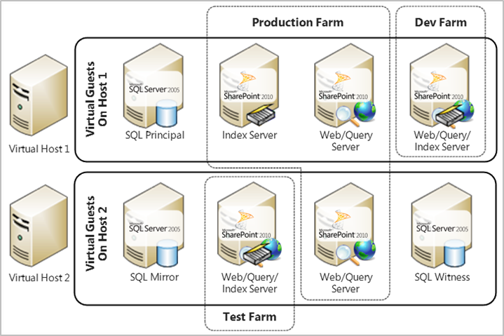

Using Live Migration for High Availability
The Live Migration feature of Windows Server 2008 R2 Hyper-V can help to provide optimal uptime for virtual machines and enable a dynamic IT infrastructure. Live Migration makes it possible to move running virtual machines between Hyper-V physical hosts with no impact on availability to users. It also allows IT professionals to perform maintenance on Hyper-V servers without scheduling a time for running virtual machines. For more details on Hyper-V Live Migration configuration and requirements, see Hyper-V: Live Migration Network Configuration Guide (http://go.microsoft.com/fwlink/?LinkId=217484).

High-Level Process
The high-level process for using Live Migration involves the following steps:
- Configure Windows Server 2008 R2 Failover Cluster.
- Connect both physical hosts to networks and storage.
- Install Hyper-V and failover clustering on both physical hosts.
- Enable CSVs.
- Make the virtual machines highly available.
- Test a Live Migration.
For detailed, step-by-step instructions, see Hyper-V: Using Live Migration with Cluster Shared Volumes in Windows Server 2008 R2 (http://go.microsoft.com/fwlink/?LinkId=139667).

Recommended Best Practices
To maximize your success with Live Migration, consider the following tips:
- Set up a CSV for virtual machine storage in a cluster where Live Migration will be used.
- Remember that a cluster will support the number of nodes divided by two simultaneous Live Migrations. For example, a 16-node cluster will support eight simultaneous Live Migrations with no more than one Live Migration session active from every node of the cluster.
- Dedicate a 1GB Ethernet connection for the Live Migration network between cluster nodes to transfer the large number of memory pages typical for a virtual machine.
- Find vendor-validated cluster configurations through The Microsoft Support Policy for Windows Server 2008 Failover Clusters link (http://go.microsoft.com/fwlink/?LinkId=160335) on the Failover Clustering web site (http://go.microsoft.com/fwlink/?LinkId=150047).

Example
This example illustrates how to manage the high availability of a virtual SharePoint infrastructure with Live Migration during planned downtime, such as hardware and software maintenance. Here, Host 1 needs a software update and, thus, restarts the host server. Without Live Migration, the user is disconnected from the virtual machine while Host 1 completes the rebooting process and runs all needed services. In contrast, with Live Migration, high availability can be maintained without a dropped network connection or perceived user downtime. The process for Live Migration in this example is as follows (Figure 11):
- Create a virtual machine on the target server (Host 2).
- Copy memory pages from Host 1 to Host 2 through the Ethernet.
- Complete the final state transfer:
  - Pause the current virtual machine.
  - Move storage connectivity from Host 1 to Host 2 through the Ethernet.
- Run the new virtual machine from Host 2.
- Update software on Host 1 and restart as needed (without worrying about the user connectivity).
Figure 11: Using Live Migration to maintain high availability
Before Live Migration | Live Migration In-Progress | After Live Migration
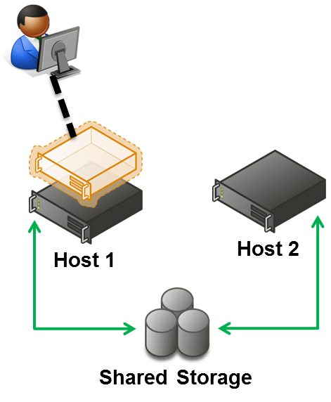 | 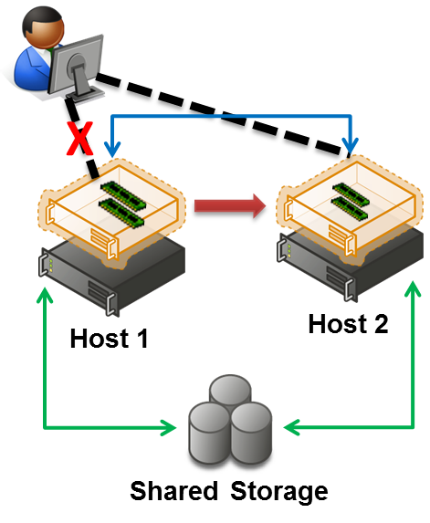  Green = Storage  Blue = Networking | 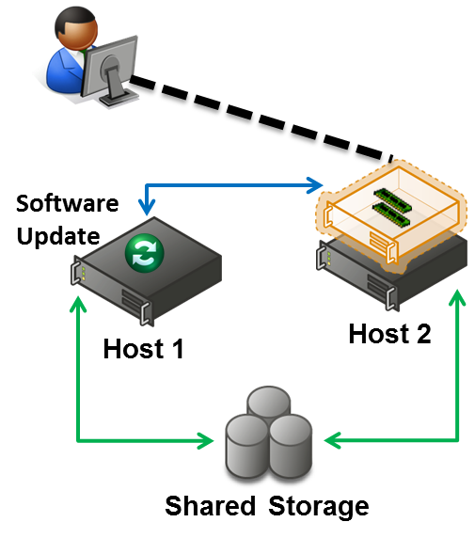  Green = Storage  Blue = Networking

Virtualization of SharePoint Components
Each SharePoint component operates in a different way, and each demands different memory and disk requirements. It is important to note that all SharePoint components and services are not ideal candidates for virtualization. Each SharePoint component has a different impact on server performance, and some have higher disk I/O requirements than others, which can affect virtualization performance.
When building a scalable SharePoint farm, it is important to understand what scenarios can yield the greatest benefits from virtualizing SharePoint components. Likewise, you must analyze the memory, processor, and disk requirements for each SharePoint component to determine if virtualization is the right strategy for deploying it. Some key SharePoint components, as well as best practices for virtualizing them, are as follows:
- Web Server: The responsibility of this component in a SharePoint farm is to respond to user requests for pages. It is a good candidate for virtualization, with a few considerations:
  - Consider using hardware load balancing over software load balancing. Hardware load balancing offloads CPU and I/O pressure from the web server component to the hardware layer, thereby improving availability of resources to SharePoint.
  - Do not host all web servers on the same physical host. To maintain hardware redundancy, split these virtual machines over a minimum of two physical host machines. If one physical host fails, the remaining web server can take over the load.
  - Ensure separate virtual network adaptors are provisioned so that you can dedicate virtual network adapters to transport different types of traffic within the SharePoint farms.
  - In small farms, this component can be shared on a server with the query component.
- Query Component: The query component is responsible for responding to search requests from the web server and for maintaining a propagated copy of the index stored on the query server’s local file system. It is a good candidate for virtualization, with these considerations:
  - The index server is heavy read/write, while query server constantly updates its own copy of the index. Therefore, conflict with the underlying disk can slow read I/O for the query servers in your farm. This means that you should not put your query and crawl components on the same underlying physical disk.
  - It is preferred to dedicate physical volumes on the underlying Storage Area Network (SAN) infrastructure by using either the Hyper-V Pass-through Disk feature or fixed-disk VHDs on that LUN, instead of dynamically expanding VHDs.
- Index Server: The index server’s responsibility is to maintain an up-to-date index by crawling the index corpus by using the configured incremental and full-crawl schedules. Enhancing index server suitability for virtualization may entail increasing the memory that the physical host server has available—thereby taking advantage of consolidation effects with other workloads. Alternatively, the virtualized index server can be moved to a larger system to host it side-by-side with other workloads of the SharePoint farm. In short, virtualization of the index server is situation dependent on the available infrastructure as well as the deployment goals of the SharePoint farm. Ideally, the index server remains physical, and there are a few considerations for virtualizing it:
  - Give the most amount of RAM.
  - Use the index server as the dedicated crawl server.
  - Prefer physical LUN on SAN to VHD.
- Database Server: The database server is responsible for storing, maintaining, and fetching data for other server components and services. This server has the highest amount of disk I/O activity and often has very high memory and processor requirements. Your organization’s requirements will determine if you choose physical or virtual deployment options, but ideally, virtualization of the database server is not recommended. Reasons to avoid virtualizing the database server are as follows:
  - Virtualization introduces latency downstream in the application and UI server components of a SharePoint farm. If every data request takes more time, the scenario quickly becomes a challenge, especially when a single transaction needs multiple round trips for completion.
  - The database server experiences heavy CPU, memory, disk I/O, and NIC usage.
  - If overall performance evaluation or virtual machines are not adequately specified, end users may experience slower response times and, in background processes, slower performance of long-running operations, which can increase operation timeouts.
- Other Components: Other components and services, such as Excel Services and document conversion services, are good candidates for virtualization. These services are similar to the web server in that as resource requirements of individual applications increase, additional servers can be added to the farm.
For more information about virtualizing Microsoft SharePoint Server 2010 server components and services, see Plan virtual architectures for SharePoint Server (http://go.microsoft.com/fwlink/?LinkId=201233).

Best Practices for Virtual Processor, Memory, Disk, and Network
Important differences exist between physical hardware and the virtual implementation of hardware that hosts your SharePoint farm. This subsection discusses recommendations and key considerations for the virtual processor, memory, disk, and network to be involved in SharePoint virtualization.

Virtual Processor
- Configure a 1:1 mapping of virtual processors to logical processors for best performance; any other configuration, such as 2:1 or 1:2, is less efficient.
- Be aware of the virtual processor limit for different guest operating systems, and plan accordingly.
- Be aware of “CPU-bound” issues; the ability of processors to process information for virtual devices will determine the maximum throughput of said devices (for example, virtual NICs).
Figure 12 depicts the best practice processor ratio for virtualization (1:1 mapping).
Figure 12: Best practice for processor ratio for virtualization (1:1)
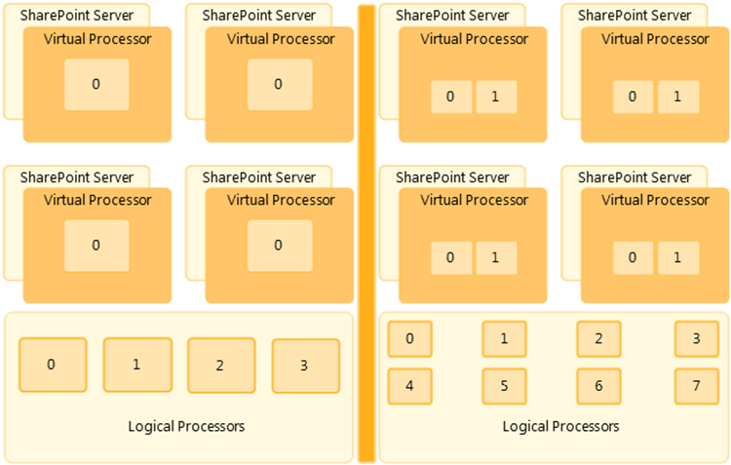

Memory
- Configure an adequate amount of memory for Hyper-V guests.
- Be aware of the page file/swap file. The disk is always slower than RAM. Ensure enough memory is allocated to each virtual machine.
- Remember Non-Uniform Memory Access (NUMA). NUMA boundaries are memory limits on physical hosts; virtual sessions can be split across NUMA nodes if those sessions are allocated large amounts of RAM. NUMA boundaries exist at the hardware level and vary by processor and motherboard vendor. In general, the more NUMA nodes a virtual guest is spread across, the fewer gains in performance will be realized. Therefore, it is very important to plan for proper allocation of memory to the virtual session without crossing NUMA boundaries.
Below is an example of how to allocate memory for virtual guests without breaking it across NUMA nodes:
  - Divide the total amount of RAM in the host server by the number of logical processors (physical processors × number of cores) in the host server.
  - Calculate the optimal memory for a virtual session to avoid NUMA (optimal memory = amount of RAM divided by number of logical processors).
  - In this example, one Hyper-V host has 72GB of RAM with two quad-core processors:
    - Optimal Memory = 72GB RAM / 8 logical processors (2 physical processors x 4 cores)
    - So, for each virtual session, 9GB is the optimal memory that should be allocated to a single session to obtain maximum benefit in performance.

Disk
- Avoid using differencing disks and dynamically expanding disks. These disks grow as data is written to them, meaning that you can run out of storage space quickly. Instead, use fixed-size VHDs for virtual machines, which allocate a certain amount of space on the underlying physical storage. Using fixed-size VHDs, you can ensure that there will be enough storage space.
- Be aware of the underlying disk read/write contention between different virtual machines to their virtual hard disks.
- Ensure SAN is configured and optimized for virtual disk storage.
- For more information on planning for disk storage, see Planning for Disks and Storage (http://go.microsoft.com/fwlink/?LinkId= 188007).

Network
- Ensure that integration components (“enlightenments”) are installed on the virtual machine.
- Use the network adapter instead of the legacy network adapter when configuring networking for a virtual machine.
- Remember that synthetic drivers are preferred to emulated drivers, as they are more efficient, use a dedicated VMBus to communicate to the virtual NIC, and result in lower CPU and network latency.
- Use virtual switches and VLAN tagging to help improve security and performance and to create an internal network among virtual machines in your SharePoint farm. Associate SharePoint virtual machines to the same virtual switch.

Managing the Virtual SharePoint Environment
Microsoft System Center Virtual Machine Manager (VMM) 2008 R2 can help to:
- Centralize management of physical and virtual IT infrastructure.
- Increase server utilization.
- Optimize dynamic resources across multiple virtualization platforms.
VMM offers a management solution that monitors and controls both physical and virtual machines, as shown in Figure 13.
Figure 13: VMM capabilities for handling a virtual infrastructure
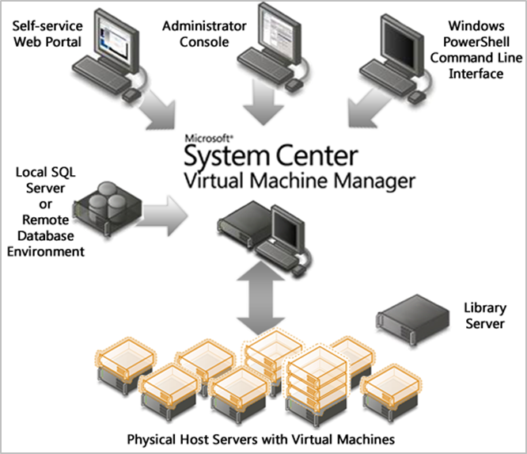
VMM takes resource utilization a step further with end-to-end support for consolidating physical servers. It can help you overcome key pain points in the consolidation process, as follows:
- Provides insight into how workloads perform in the old environment: VMM uses data gathered from System Center Operations Manager to assess the workloads that are optimal candidates for consolidation. This holistic insight differentiates VMM from competing products and can give you greater confidence when migrating from a physical to virtual infrastructure.
- Provides more efficient storage management: VMM support for the Windows Server 2008 R2 CSV allows files for multiple virtual machines to be stored on the same LUN. This can simplify storage management by radically reducing the number of LUNs required by the VMM-managed virtual machines.
- Facilitates P2V conversion: Converting physical machines to virtual machines can be a slow and error-prone process that requires administrators to halt the physical server. However, with VMM, P2V conversions are routine. VMM simplifies P2V conversion tasks by providing an improved P2V wizard and taking advantage of the Volume Shadow Copy Service in Windows Server 2008, Windows Server 2003, Windows XP, and Windows Vista. Virtual machines can be created by using block-level disk access speed without shutting down the source physical server.
- Provides V2V conversion: VMM also supports the conversion of VMware virtual machines to the Microsoft virtual machine format. With VMM, you can convert virtual machines directly from ESX Server hosts. The VMM V2V conversion can convert either an entire VMware virtual machine or just the disk image file. The V2V conversion process performs all modifications required to make the converted virtual machine bootable. Unlike the P2V conversion, the V2V conversion is an offline operation.
- Takes the guesswork out of virtual machine placement: VMM can help you easily identify the most appropriate physical host servers for virtualized workloads. This Intelligent Placement technology not only can make administrative tasks easier, but also can help to ensure that data center resources are deployed properly and align with business goals. Intelligent Placement in VMM inputs host system data, workload performance history, and administrator-defined business requirements into sophisticated algorithms. The resulting Intelligent Placement ratings provide easy-to-understand ranked results that can take the guesswork out of the placement task and help to ensure that workloads are spread across physical resources for optimum performance. Intelligent Placement can be used with Microsoft Windows Server hosts and VMware ESX Servers.
- Helps to fine-tune virtual and physical infrastructure: After the virtual infrastructure is in place, VMM provides a central console from which you can monitor and fine-tune the infrastructure for ongoing optimization. With the VMM administrator console, you can tune virtual machine settings or migrate virtual machines from one host to another in order to optimize the use of physical resources. VMM also works with System Center Operations Manager so that both physical and virtual infrastructure can be managed comprehensively.

VMM as a Management Tool
The VMM 2008 R2 management console provides rich functionality that can be used to manage SharePoint Server in a virtualized environment. A distributed, virtualized SharePoint farm can be tightly managed, and the management console can be used to move guest sessions between one or more hosts that also are performing other virtualization tasks. VMM can be a useful management tool in many ways:
- Self-Service Portal: VMM includes a web-based self-service portal that enables SharePoint administrators to delegate the rights to create new guest sessions. This portal can be used by other system administrators to allow developers, for example, to provision their own test SharePoint server sessions or to allow quality assurance (QA) testers to provision guest Microsoft Windows and Microsoft Office client sessions for testing. Overall, the self-service portal can reduce the SharePoint administration overhead.
- Virtual Server Templates: With VMM, you can define a library of templates and virtual machines that can be used to provision new SharePoint sessions. For example, a Windows Server 2008 R2 server template can be created with the right amount of memory and virtual processors, plus a pair of virtual hard drives for the operating system and index files. With SharePoint binaries installed on that system, it then can be turned into a template that can be used to provision new SharePoint farm members or even entirely new farms.
- VMM Template Options: With VMM template options, a server created from a template can be automatically added to a domain and validated with a valid server key; it also can have a script run after first login. For example, a custom Microsoft Windows PowerShell™ script can be run automatically after login to join the SharePoint template server to an existing farm or to create a new farm entirely.

Health Monitoring
It is necessary to monitor virtual machines in the farm, as well as virtualization servers, to help ensure that health and performance levels meet both operational standards and service level agreements. System Center Operations Manager 2007 R2 provides an end-to-end monitoring and reporting system that you can use to monitor SharePoint Server 2010. The monitoring features can help you to understand how the SharePoint Server 2010 system is running, analyze and repair problems, and view metrics for the sites. For more details about health monitoring, see Monitor health and performance of a virtual environment (http://go.microsoft.com/fwlink/?LinkId=217493).

Performance Test Results
The performance of SharePoint virtualization depends on many parameters, including different configurations of hardware sets. To study performance variables like throughput, latency, and scalability, the Microsoft product team carried out a variety of tests. This section discusses the results.

Hardware Sets
Two hardware sets were used during the tests: Configuration 1 and Configuration 2 (Figures 14 and 15).

Hardware Set 1 - Configuration 1
Count | Role | CPU | RAM | Network | Storage
4 | SQL Server  Hyper-V host  Physical server | 4x Intel X7450 @ 2.4 GHz  (24 cores, non-HT) | 128 GB | Dual GbE | SAN
8 | Load controller  Load client  DC (virtual) | 2x Intel X5550 @ 2.66 GHz  (8 cores, HT) | 72 GB | Dual GbE | SAS (RAID 1/5/6)
1 | Load balancer

Figure 14: Configuration 1 hardware set
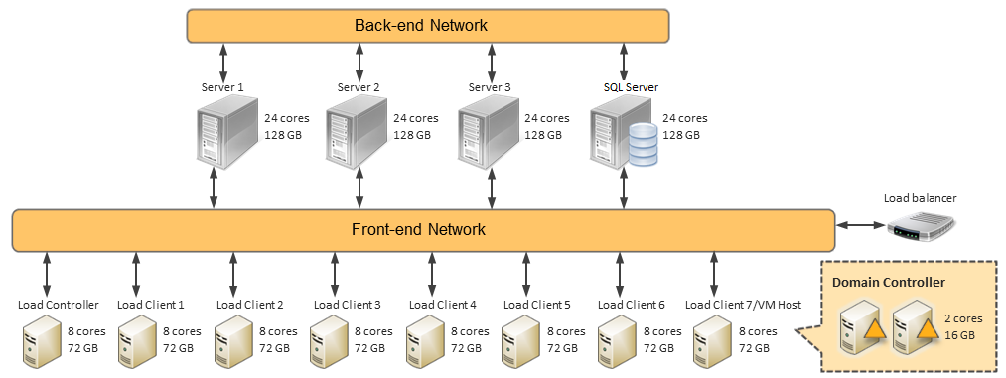

Hardware Set 2 - Configuration 2
Count | Role | CPU | RAM | Network | Storage
5 | SQL Server  Hyper-V host  DC (virtual)  Physical server | Intel L5520 @ 2.26 GHz  (8 cores, HT) | 48 GB | Dual GbE | SAS  (RAID 10)
5 | Load controller  Load client | Intel 5150 @ 2/66 GHz  (4 cores, non-HT) | 32 GB | Dual GbE | SAS  (RAID 10)
1 | Load balancer
Figure 15: Configuration 2 hardware set
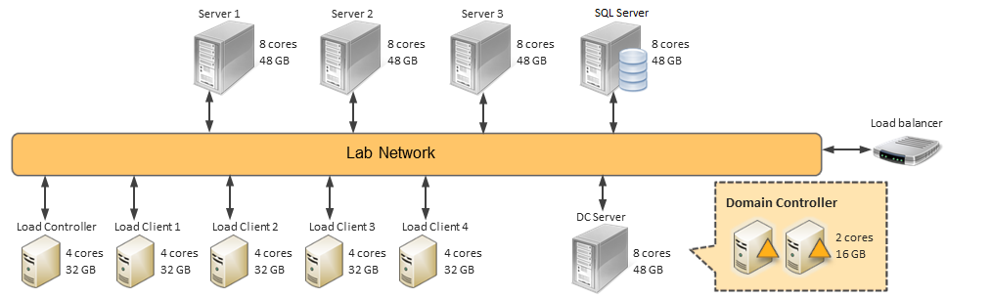

Virtual Machine Scale-Up
Test Case 1: Is performance affected by the virtual machine configuration (core/memory allocation)?
Scenario 1: Using Hardware Set 1 – Configuration 1
Virtual Machine Host Configuration  24 core (non-HT)  128GB RAM  Dual GbE NICs  SAN storage | Virtual Machine Configuration  4 cores each  Dual NICs  2 volumes (pass-through)

Variables | A | B | C | D
Memory Per VM (MB) | 2048 | 4096 | 8192 | 15000
Web Server Count | 4 | 4 | 4 | 4
Web Server Virtual? | Yes | Yes | Yes | Yes
APP Count | 3 | 3 | 3 | 3
APP Virtual? | Yes | Yes | Yes | Yes
VM Hosts | 2 | 2 | 2 | 2
Web Server/APP VMs mixed? | No | No | No | No
SQL Server “Power” | 100% | 100% | 100% | 100%
Results | A | B | C | D
Max Passed RPS | 259 | 267 | 267 | 260
RPS Per VM | 65 | 67 | 67 | 65
Avg. Response Time (ms) | 281 | 277 | 307 | 312
Web Server Host Logical CPU Usage (%) | 54 | 61 | 59 | 59
APP Host Logical CPU Usage (%) | 2 | 1 | 1 | 1
SQL CPU Usage (%) | 12 | 12 | 12 | 12
VSTS Controller CPU Usage (%) | 1 | 1 | 1 | 1
Avg. VSTS Agent CPU Usage (%) | 2 | 3 | 2 | 3
Per-Web Server Data | A | B | C | D
% Committed Bytes In Use | 44 | 24 | 13 | 8
Avg. % Time in GC | 5 | n/a | 0 | n/a
Memory Pages/sec | 40 | 36 | 32 | 31
Avg. HDD Latency (ms) | 4 | 4 | 4 | 4
Avg. HDD Throughput (KB/s) | 34 | 31 | 35 | 43
Avg. Total FE NIC Traffic (MB/s) | 8 | 10 | 8 | 10
Avg. Total BE NIC Traffic (MB/s) | 5 | 7 | 6 | 7

Conclusion: Beyond 4GB, there is no benefit to allocating additional memory to the virtual machine (with this workload).

Single-Host Scale-Out
Test Case 1: What happens to throughput/latency as the number of virtual machines increases on a single host?
Test Case 2: What are the bottlenecks when oversubscribing?
Scenario 1: Using Hardware Set 1 - Configuration 1
Virtual Machine Host Configuration  24 core (non-HT)  128GB RAM  Dual GbE NICs  SAN storage | Virtual Machine Configuration  4 cores each  Dual NICs  2 volumes (pass-through)

Variables | A | B | C | D | E | F | G | H
Memory Per VM (MB) | n/a | n/a | 15000 | 15000 | 15000 | 15000 | 15000 | 15000
Web Server Count | 1 | 2 | 3 | 4 | 5 | 6 | 7 | 8
Web Server Virtual? | n/a | n/a | Yes | Yes | Yes | Yes | Yes | Yes
APP Count | n/a | n/a | 3 | 3 | 3 | 3 | 3 | 3
APP Virtual? | n/a | n/a | Yes | Yes | Yes | Yes | Yes | Yes
VM Hosts | n/a | n/a | 2 | 2 | 2 | 2 | 2 | 2
Web Server/APP VMs mixed? | n/a | n/a | No | No | No | No | No | No
SQL Server “Power” | n/a | n/a | 100% | 100% | 100% | 100% | 100% | 100%
Results | A | B | C | D | E | F | G | H
Max Passed RPS | n/a | n/a | 219 | 260 | 275 | 288 | 288 | 247
RPS Per VM | n/a | n/a | 73 | 65 | 55 | 48 | 41 | 31
Avg. Response Time (ms) | n/a | n/a | 236 | 312 | 311 | 308 | 314 | 375
Web Server Host Logical CPU Usage (%) | n/a | n/a | 45 | 59 | 69 | 85 | 94 | 94
APP Host Logical CPU Usage (%) | n/a | n/a | 1 | 1 | 1 | 1 | 1 | 1
SQL CPU Usage (%) | n/a | n/a | 11 | 12 | 12 | 15 | 14 | 13
VSTS Controller CPU Usage (%) | n/a | n/a | 1 | 1 | 1 | 1 | 1 | 1
Avg. VSTS Agent CPU Usage (%) | n/a | n/a | 2 | 3 | 3 | 2 | 3 | 3
Per-Web Server Data | A | B | C | D | E | F | G | H
% Committed Bytes In Use | n/a | n/a | 9 | 8 | 8 | 9 | 8 | 8
Avg. % Time In GC | n/a | n/a | 5 | n/a | n/a | n/a | 2 | n/a
Memory Pages/Sec | n/a | n/a | 25 | 31 | 33 | 27 | 24 | 24
Avg. HDD Latency (ms) | n/a | n/a | 4 | 4 | 5 | 5 | 7 | 6
Avg. HDD Throughput (KB/s) | n/a | n/a | 46 | 43 | 67 | 34 | 21 | 19
Avg. Total FE NIC Traffic (MB/s) | n/a | n/a | 11 | 10 | 8 | 7 | 6 | 7
Avg. Total BE NIC Traffic (MB/s) | n/a | n/a | 8 | 7 | 6 | 5 | 3 | 5

Conclusion:
- A 1:1 mapping of logical cores to virtual cores produces maximum throughput.
- There is a negative benefit to oversubscribing (with this workload).
- There is no observed bottleneck (other than CPU).

Scenario 2: Using Hardware Set 2 - Configuration 2 (HT on)
Virtual Machine Host Configuration  8 core (HT on)  48GB RAM  Dual GbE NICs  SAS | Virtual Machine Configuration  4 cores each  Single NIC  2 volumes (VHD)

Variables | A | B | C | D
Memory Per VM (MB) | 8192 | 8192 | 8192 | 8192
Web Server Count | 1 | 2 | 3 | 4
Web Server Virtual? | Yes | Yes | Yes | Yes
APP Count | 1 | 1 | 1 | 1
APP Virtual? | Yes | Yes | Yes | Yes
VM Hosts | 2 | 2 | 2 | 2
Web Server/APP VMs mixed? | No | No | No | No
SQL Server “Power” | 100% | 100% | 100% | 100%
Results | A | B | C | D
Max Passed RPS | 143 | 270 | 264 | 310
RPS Per VM | 143 | 135 | 88 | 78
Avg. Response Time (ms) | 258 | 227 | 234 | 231
Web Server Host Logical CPU Usage (%) | 25 | 48 | 67 | 86
APP Host Logical CPU Usage (%) | 0 | 0 | 0 | 2
SQL CPU Usage (%) | 9 | 15 | 16 | 22
VSTS Controller CPU Usage (%) | 3 | 5 | 6 | 5
Avg. VSTS Agent CPU Usage (%) | 13 | 26 | 26 | 34
Per-Web Server Data | A | B | C | D
% Committed Bytes In Use | 15 | 15 | 14 | 13
Avg. % Time in GC | n/a | n/a | n/a | n/a
Memory Pages/sec | 28 | 33 | 26 | 29
Avg. HDD Latency (ms) | 1 | 1 | 2 | 3
Avg. HDD Throughput (KB/s) | 888 | 50 | 36 | 34
Avg. Total NIC Traffic (MB/s) | 26 | 33 | 18 | 25

Scenario 3: Using Hardware Set 2 - Configuration 2 (HT off)
Virtual Machine Host Configuration  8 core (HT off)  48GB RAM  Dual GbE NICs  SAS | Virtual Machine Configuration  4 cores each  Single NIC  2 volumes (VHD)

Variables | A | B | C | D
Memory Per VM (MB) | 8192 | 8192 | 8192 | 8192
Web Server Count | 1 | 2 | 3 | 4
Web Server Virtual? | Yes | Yes | Yes | Yes
APP Count | 1 | 1 | 1 | 1
APP Virtual? | Yes | Yes | Yes | Yes
VM Hosts | 2 | 2 | 2 | 2
Web Server/APP VMs mixed? | No | No | No | No
SQL Server “Power” | 100% | 100% | 100% | 100%
Results | A | B | C | D
Max Passed RPS | 146 | 248 | 261 | 256
RPS Per VM | 146 | 124 | 87 | 64
Avg. Response Time (ms) | 440 | 240 | 238 | 239
Web Server Host Logical CPU Usage (%) | 49 | 94 | 92 | 96
APP Host Logical CPU Usage (%) | 1 | 0 | 2 | 0
SQL CPU Usage (%) | 8 | 15 | 15 | 20
VSTS Controller CPU Usage (%) | 4 | 5 | 4 | 4
Avg. VSTS Agent CPU Usage (%) | 18 | 27 | 25 | 26
Per-Web Server Data | A | B | C | D
% Committed Bytes In Use | 15 | 14 | 13 | 13
Avg. % Time in GC | n/a | n/a | n/a | n/a
Memory Pages/sec | 35 | 37 | 34 | 36
Avg. HDD Latency (ms) | 0 | 1 | 1 | 2
Avg. HDD Throughput (KB/s) | 46 | 42 | 37 | 38
Avg. Total NIC Traffic (MB/s) | 37 | 22 | 27 | 15

Conclusion:
- The Configuration 1 hardware can support oversubscription of SharePoint workloads without significant penalty.
- HyperThreading increases the compute headroom by 10-25 percent, depending on the level of oversubscription.

Virtual vs. Physical
Test Case 1: What is the throughput/latency gain/loss when virtualizing a server?
Test Case 2: What virtual configuration produces equivalent throughput/latency to a “bare metal” configuration with the same hardware?
Scenario 1: Using Hardware Set 1 - Configuration 1
Virtual Machine Host Configuration  24 core (non-HT)  128GB RAM  Dual GbE NICs  SAN storage | Virtual Machine Configuration  4 cores each  Dual NICs  2 volumes (pass-through)

Variables | A (virtual) | B (physical)
Total Web Server Cores | 24 | 24
Total Web Server Memory (MB) | 90000 | 24576
Web Server Count | 6 | 1
Web Server Virtual? | Yes | No
APP Count | 3 | 3
APP Virtual? | Yes | Yes
VM Hosts | 2 | 1
Web Server/APP VMs mixed? | No | No
SQL Server “Power” | 100% | 100%
Results | A (virtual) | B (physical)
Max Passed RPS | 288 | 345
Passed RPS/core | 12 | 14
Avg. Response Time (ms) | 308 | 261
Web Server CPU Usage (%) | 85 | 94
APP VM Logical CPU Usage (%) | 1 | 2
SQL CPU Usage (%) | 15 | 17
VSTS Controller CPU Usage (%) | 1 | 1
Avg. VSTS Agent CPU Usage (%) | 2 | 3
Per-Web Server Data | A (virtual) | B (physical)
% Committed Bytes In Use | 9 | 9
% Time in GC | n/a | 6
Avg. HDD Latency (ms) | 5 | 4
Avg. HDD Throughput (KB/s) | 34 | 44
Avg. FE NIC Traffic (MB/s) | 42 | 60
Avg. BE NIC Traffic (MB/s) | 27 | 9

Conclusion:
- The RPS difference between physical and virtual is approximately 20 percent (with this workload).
- The RPS/latency difference between physical and virtual is approximately 42 percent (with this workload).
- Given the same hardware, there is no virtual configuration capable of matching the performance of “bare metal.”

Scenario2: Using Hardware Set 2 - Configuration 2
Virtual Machine Host Configuration  8 core  48GB RAM  Dual GbE NICs  SAS | Virtual Machine Configuration  4 cores each  Single NIC  2 volumes (VHD)

Variables | A (virtual) | B (virtual) | C (physical)
Total Web Server Cores | 8 | 8 | 8
Total Web Server Memory (MB) | 16384 | 16384 | 49152
Web Server Count | 2 | 2 | 1
Web Server Virtual? | Yes | Yes | No
APP Count | 1 | 1 | 1
APP Virtual? | Yes | Yes | Yes
VM Hosts | 2 | 2 | 1
Web Server/APP VMs mixed? | No | No | No
HyperThreading | On | Off | On
Results | A (virtual) | B (virtual) | C (physical)
Max Passed RPS | 270 | 248 | 319
Passed RPS/core | 135 | 124 | 40
Avg. Response Time (ms) | 227 | 240 | 192
Web Server CPU Usage (%) | 48 | 94 | 84
APP VM Logical CPU Usage (%) | 0 | 0 | 0
SQL CPU Usage (%) | 15 | 15 | 20
VSTS Controller CPU Usage (%) | 5 | 5 | 5
Avg. VSTS Agent CPU Usage (%) | 26 | 27 | 31
Per-Web Server Data | A (virtual) | B (virtual) | C (physical)
% Committed Bytes In Use | 15 | 14 | 8
% Time in GC | n/a | n/a | n/a
Memory Pages/sec | 33 | 37 | 37
Avg. HDD Latency (ms) | 1 | 1 | 1
Avg. HDD Throughput (KB/s) | 50 | 42 | 142
Avg. Total NIC Traffic (MB/s) | 33 | 27 | 68

Conclusion:
- The RPS difference between physical and virtual is approximately 18 percent (with this workload).
- The RPS/latency difference between physical and virtual is approximately 40 percent (with this workload).

VM Scale-Out
Test Case 1: What happens to throughput/latency as the number of virtual web servers increases?
Test Case 2: Is scale-out affected by the virtual machine configuration?
Test Case 3: What are the bottlenecks when scaling out virtually?
Scenario 1: Using Hardware Set 1 - Configuration 1
Virtual Machine Host Configuration  24 core (non-HT)  128GB RAM  Dual GbE NICs  SAN storage | Virtual Machine Configuration  4 cores each  Dual NICs  2 volumes (pass-through)

Variables | A | B | C
Memory Per VM (MB) | 15000 | 15000 | 15000
Web Server Count | 6 | 12 | 12
Web Server Virtual? | Yes | Yes | Yes
APP Count | 3 | 3 | 3
APP Virtual? | Yes | Yes | Yes
VM Hosts | 2 | 3 | 3
Web Server/APP VMs mixed? | No | No | Yes
SQL Server “Power” | 100% | 100% | 100%
Results | A | B | C
Max Passed RPS | 288 | 562 | 738
Avg. Response Time (ms) | 308 | 389 | 288
Avg. Host Logical CPU Usage (%) | n/a | n/a | 58
Avg. Web Server Host Logical CPU Usage (%) | 85 | 83 | n/a
APP Host Logical CPU Usage (%) | 1 | 1 | n/a
SQL CPU Usage (%) | 15 | 30 | 41
VSTS Controller CPU Usage (%) | 1 | 2 | 2
Avg. VSTS Agent CPU Usage (%) | 2 | 5 | 7
Per-Web Server Data | A | B | C
Avg. % Committed Bytes In Use | 9 | 9 | 9
Avg. % Time in GC | n/a | 3 | 5
Avg. Memory Pages/sec | 27 | 28 | 30
Avg. HDD Latency (ms) | 5 | 5 | 5
Avg. HDD Throughput (KB/s) | 34 | 30 | 32
Avg. FE NIC Traffic (MB/s) | 7 | 7 | 10
Avg. BE NIC Traffic (MB/s) | 5 | 5 | 6

Conclusion:
- SharePoint Server can scale linearly to at least 3 hosts and 12 virtual web servers.
- Maximum throughput is achieved by mixing server components per host (with this workload).
- There is no observed bottleneck (other than CPU) scaling out against this workload.

Scenario2: Using Hardware Set 2 - Configuration 2 (HT on)
Virtual Machine Host Configuration  8 core (HT on)  48GB RAM  Dual GbE NICs  SAS | Virtual Machine Configuration  4 cores each  Single NIC  2 volumes (VHD)

Variables | A | B | C
Memory Per VM (MB) | 8192 | 8192 | 8192
Web Server Count | 3 | 6 | 9
Web Server Virtual? | Yes | Yes | Yes
APP Count | 3 | 3 | 3
APP Virtual? | Yes | Yes | Yes
VM Hosts | 2 | 3 | 4
Web Server/APP VMs mixed? | No | No | No
SQL Server “Power” | 100% | 100% | 100%
Results | A | B | C
Max Passed RPS | 264 | 374 | 588
RPS Per VM | 88 | 62 | 65
Avg. Response Time (ms) | 234 | 186 | 194
Web Server Host Logical CPU Usage (%) | 67 | 52 | 51
APP Host Logical CPU Usage (%) | 0 | 0 | 1
SQL CPU Usage (%) | 16 | 30 | 47
VSTS Controller CPU Usage (%) | 6 | 7 | 8
Avg. VSTS Agent CPU Usage (%) | 26 | 38 | 60
Per-Web Server Data | A | B | C
% Committed Bytes In Use | 14 | 15 | 14
Avg. % Time in GC | n/a | n/a | n/a
Memory Pages/sec | 26 | 26 | 33
Avg. HDD Latency (ms) | 2 | 3 | 3
Avg. HDD Throughput (KB/s) | 36 | 38 | 29
Avg. Total NIC Traffic (MB/s) | 18 | 21 | 13

Conclusion:
- SharePoint Server can scale linearly to at least 4 hosts and 9 virtual web servers.
- The SQL Server configuration has twice the processing power required to service the highest performing configuration tested.

Physical Scale-Up
Test Case 1: What is the throughput/latency when scaling up physical hardware to 24 cores?
Scenario 1: Using Hardware Set 1 - Configuration 1
Virtual Machine Host Configuration  24 core (non-HT)  128GB RAM  Dual GbE NICs  SAN storage | Virtual Machine Configuration  4 cores each  Dual NICs  2 volumes (pass-through)

Variables | A | B | C | D | E
Web Server Cores | 4 | 8 | 16 | 24 | 24
Web Server Memory (GB) | 4 | 8 | 16 | 24 | 128
Web Server Count | 1 | 1 | 1 | 1 | 1
Web Server Virtual? | No | No | No | No | No
APP Count | 3 | 3 | 3 | 3 | 3
APP Virtual? | Yes | Yes | Yes | Yes | Yes
VM Hosts | 1 | 1 | 1 | 1 | 1
Web Server/APP VMs mixed? | No | No | No | No | No
SQL Server “Power” | 25% | 25% | 25% | 100% | 100%
Results | A | B | C | D | E
Max Passed RPS | 91 | 132 | 285 | 345 | 334
Passed RPS/core | 23 | 17 | 18 | 14 | 14
Avg. Response Time (ms) | 930 | 685 | 318 | 261 | 284
Web Server CPU Usage (%) | 99 | 91 | 96 | 94 | 89
APP Host Logical CPU Usage (%) | 2 | 1 | 1 | 2 | 1
SQL CPU Usage (%) | 17 | 25 | 52 | 17 | 18
VSTS Controller CPU Usage (%) | 1 | 1 | 1 | 1 | 10
Avg. VSTS Agent CPU Usage (%) | 2 | 3 | 4 | 3 | 3
% Committed Bytes In Use | 29 | 17 | 11 | 9 | 4
% Time in GC | n/a | n/a | n/a | 6 | 6
Memory Pages/sec | 28 | 25 | 46 | 55 | 41
Avg. HDD Latency (ms) | 3 | 2 | 3 | 4 | 3
Avg. HDD Throughput (KB/s) | 51 | 50 | 69 | 44 | 55
Avg. Total FE NIC Traffic (MB/s) | 10 | 22 | 37 | 60 | 68
Avg. Total BE NIC Traffic (MB/s) | 8 | 20 | 28 | 9 | 21

Conclusion: SharePoint can scale linearly to at least 24 cores.
For more information about performance optimization, see Optimizing Performance on Hyper-V (http://go.microsoft.com/fwlink/?LinkID=132849).

Licensing
Before you start planning for virtualization, you need to understand the concept of an “operating system environment” (OSE). An OSE is an instance of an operating system, including any applications configured to run on it. In greater detail, an OSE is all or part of an operating system instance—or all or part of a virtual (or otherwise emulated) operating system instance—that enables:
- Separate machine identity (primary computer name or similar unique identifier) or separate administrative rights.
- Instances of applications, if any, configured to run on the operating system instance or parts identified above.
Two types of OSEs exist: physical and virtual (Figure 16). A virtual OSE is configured to run on a virtual (or otherwise emulated) hardware system. Use of technologies that create virtual OSEs does not change the licensing requirements for the operating system and any applications running in the OSE.
Figure 16: Physical and virtual operating system environments
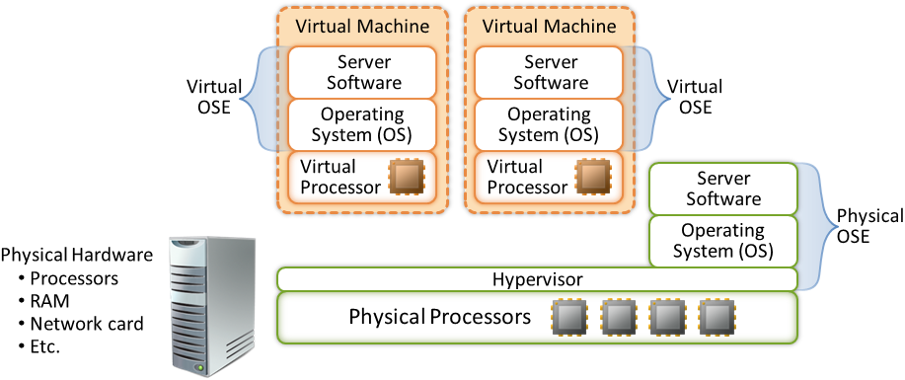
The Windows Server operating system licensing model for physical multicore processor systems is based on the number of physical processors installed on the hardware. This model extends to virtual processors configured for a virtual machine running on a virtualization server. For licensing purposes, a virtual processor is considered to have the same number of threads and cores as each physical processor on the underlying physical hardware system.

Server licensing for virtualization is as follows:
Products Impacted | Use Rights
Windows Server 2008 R2 Standard | Each software license allows you to run, at any one time, one instance of the server software in an OSE on one server. If the instance you run is in a virtual OSE, you may also run an instance in the physical OSE solely to run hardware virtualization software, provide hardware virtualization services, or run software to manage and service OSEs on the licensed server. This is called, in short, “1+1.”
Windows Server 2008 R2 Enterprise | Each software license allows you to run, at any one time, four instances of the server software in four OSEs on one server. If all four instances you run are in virtual OSEs, you may also run an instance in the physical OSE solely to run hardware virtualization software, provide hardware virtualization services, or run software to manage and service OSEs on the licensed server. This is called, in short, “1+4.”
Windows Server 2008 R2 Datacenter and Windows Server 2008 R2 Itanium-Based Systems | After the number of licenses equal to the number of physical processors on a server is acquired and assigned, you may run on that particular server: one instance of the server software in the physical OSE, and any number of instances of the server software in virtual OSEs.

Conclusion
Virtualizing business-critical applications like Microsoft SharePoint Server 2010 can deliver significant benefits, including cost savings, business continuity, and agile management. Microsoft SharePoint Server 2010 can be virtualized by using Microsoft Windows Server 2008 R2 with Hyper-V or other virtualization solutions that have been tested by Microsoft.
Microsoft recommends Windows Server 2008 R2 with Hyper-V or Microsoft Hyper-V Server 2008 R2 as a virtualization platform for SharePoint deployments for several reasons, including:
- Together, these products can improve and scale up performance capabilities and features, such as Live Migration and better processor support, storage, and networking support.
- New enhancements in Windows Server 2008 R2 SP1 (like Dynamic Memory and RemoteFX) can help to deliver an optimal virtualization solution.
Hyper-V supports complete SharePoint virtualization, although the SharePoint Server components to virtualize depends on an organization’s unique needs. For easy management and provisioning of server farms, Microsoft offers System Center Virtual Machine Manager 2008 (in the Microsoft System Center Server Management Suite), which provides agility in P2V and V2V conversions.
Successful SharePoint virtualization projects require solid planning and decision making, especially when considering critical farm architecture and deployment options. This white paper provides insights and best practices to help you make these decisions.

Additional Resources
For more information about SharePoint virtualization, explore the customer evidence and visit any of the online resources.

Customer Evidence
“We expect to consolidate an additional 75 servers using Hyper-V, which will lead to a cost savings of more than $325,000 annually.” - Robert McShinsky, Senior Systems Administrator, Dartmouth-Hitchcock Medical Center

“We are very confident that the Hyper-V can help us grow in the future, that we can get the scalability and the performance we need.” - Tore Fribert, Co-CIO, SaxoBank

“We are excited to use Hyper-V to rapidly deploy a load-balanced and clustered SharePoint infrastructure for less money and in less time than we could before.”
- Tom Brauch, SharePoint Hosting Pioneer and President, Fpweb.net

Online Resources
Windows Server 2008 R2 SP1
http://go.microsoft.com/fwlink/?LinkID=93110
Microsoft Virtualization Home
http://go.microsoft.com/fwlink/?LinkID=127022
How to Install the Hyper-V Role
http://go.microsoft.com/fwlink/?LinkID=119204
About SharePoint Server 2010
http://go.microsoft.com/fwlink/?LinkID=167990
Virtualization Planning (SharePoint Server 2010)
http://go.microsoft.com/fwlink/?LinkID=194755
Windows Server Virtualization TechNet Site
http://go.microsoft.com/fwlink/?LinkID=211308

