

**RD Gateway Capacity Planning in Windows Server 2012**

Microsoft Corporation

Published: April 2013

Abstract

Remote Desktop Gateway (RD Gateway) enables authorized remote users to connect to Remote Desktop Protocol (RDP) accessible resources on the corporate network, from any Internet-connected device by using the Remote Desktop Connection (RDC) client. This whitepaper contains scalability results, testing methodologies, analysis, and guidelines for RD Gateway. It describes the most relevant factors that influence the capacity of a given deployment, methodologies to evaluate capacity for specific deployments, and a set of experimental results for different combinations of usage scenarios and hardware configurations.



Copyright Information

*The information contained in this document represents the current view of Microsoft Corporation on the issues discussed as of the date of publication. Because Microsoft must respond to changing market conditions, it should not be interpreted to be a commitment on the part of Microsoft, and Microsoft cannot guarantee the accuracy of any information presented after the date of publication.*

*This White Paper is for informational purposes only. MICROSOFT MAKES NO WARRANTIES, EXPRESS, IMPLIED OR STATUTORY, AS TO THE INFORMATION IN THIS DOCUMENT.*

*Complying with all applicable copyright laws is the responsibility of the user. Without limiting the rights under copyright, no part of this document may be reproduced, stored in or introduced into a retrieval system, or transmitted in any form or by any means (electronic, mechanical, photocopying, recording, or otherwise), or for any purpose, without the express written permission of Microsoft Corporation.*

*Microsoft may have patents, patent applications, trademarks, copyrights, or other intellectual property rights covering subject matter in this document. Except as expressly provided in any written license agreement from Microsoft, the furnishing of this document does not give you any license to these patents, trademarks, copyrights, or other intellectual property.*

* 2013 Microsoft Corporation. All rights reserved.*

*Microsoft, Hyper-V, Windows, and Windows Server are trademarks of the Microsoft group of companies.*

*All other trademarks are property of their respective owners.*

Table of Contents

Section 1: Test Environment and Lab Setup 2

Hardware 2

Lab Setup 3

Test Tools 4

Section 2: Testing Methodology 4

Defining response time 4

Defining Knowledge Worker Scenarios (KW & KW+) 4

Scenarios 5

Section 3: Test Results and Analysis 5

Scenarios 5

RD Gateway running inside a Physical machine test 6

RD Gateway Running inside a Virtual machine test 7

Section 4: Summary 9

Appendix 10

Related Links 10

Knowledge Worker Script 10

Knowledge Worker Plus 11

Test Script Flow Chart 13

# Section 1: Test Environment and Lab Setup

### Hardware

The following servers were tested for Remote Desktop Services capacity planning data:

**Remote Desktop Client #1:**

* HP ProLiant DL370
* Dual Proc-Xeon E5504 @ 2 GHz (8 core total)
* 24 GB RAM
* Windows Server 2012 Datacenter Operating System
* HP NC375i Integrated Quad Port Multifunction Gigabit NIC (1 port used)

**Remote Desktop Client #2:**

* Dell PowerEdge R710
* Dual Proc-Xeon E5620 @ 2.40GHz (8 core total w/ Hyper-Threading)
* 24 GB RAM
* Windows Server 2012 Datacenter Operating System
* Broadcom BCM5709C NetXtreme II Gigabit NIC (1 port used)

**Remote Desktop Client #3:**

* HP ProLiant DL385
* Dual Proc-AMD Opteron 6134 @ ~2.3 GHz (8 core total)
* 16 GB RAM
* Windows Server 2012 Datacenter Operating System
* Broadcom BCM5709C NetXtreme II Gigabit NIC (1 port used)

**Remote Desktop Session Host:**

* HP ProLiant DL370
* Dual Proc-Xeon E5504 @ 2 GHz (8 core total)
* 24 GB RAM
* Windows Server 2012 Datacenter Operating System
* HP NC375i Integrated Quad Port Multifunction Gigabit NIC (1 port used)

**RD Gateway server / Server running Hyper-V:**

* HP ProLiant DL370
* Dual Proc-Xeon E5504 @ 2 GHz (8 cores total - 4M Cache, 2.00 GHz, 4.80 GT/s Intel® QP)

Intel® Turbo Boost Technology **No**

Intel® Hyper-Threading Technology **No**

Intel® Virtualization Technology (VT-x) **Yes**

* 24 GB RAM
* Windows Server 2012 Datacenter Operating System
* HP NC375i Integrated Quad Port Multifunction Gigabit NIC (4 ports used)

**Virtual Machine (RD Gateway Running on Hyper-V server):**

* The virtual machine is on the server running Hyper-V is installed on the RD Gateway server
* 10 GB Virtual RAM
* 4 Virtual NICs
* 4 Virtual Processors

### Lab Setup

All the tests use the setup as illustrated in Figure 1, unless specified otherwise.

The configuration consists of three Remote Desktop Connection clients, one RD Gateway server and one Remote Desktop Session Host (RD Session Host) server. All three clients are part of one workgroup while the RD Gateway server and the RD Session Host server are part of another workgroup. The RD Gateway server has a network card with four ports, directly connected to each of the clients and to the RD Session Host server.



Figure 1 - Test setup configuration

### Test Tools

The RD Gateway scalability tests were run using two tools; TSGSClient.exe, and TSGSServer.exe. These tools allow simulated loads on a server to be easily placed and managed. These tools do not impact testing because there is no change to the flow on the gateway for the connections. This was done to simplify the hardware requirements required if full client connections were created.

* **TSGSServer.exe:** A low level server to simulate an RD Session Host that runs on the RD Session Host server and listens on the specified port (Port 1234 in testing). The application waits for incoming connections. Once connection is established TSGSServer.exe reads all incoming packets and sends back the number of packets specified on the command line.
* **TSGSClient.exe:** A low level client to simulate Remote Desktop Connections that runs on the Remote Desktop client computer and establishes a connection to TSGSServer.exe through RD Gateway using the same published RD Gateway APIs as Remote Desktop Connection using HTTP, UDP or RPC-HTTP (RPC calls are wrapped into the HTTP protocol packets). On the client side, a new instance of TSGClient.exe is launched for each connection. After the connection is established, TSGClient.exe sends and receives packets based on the different test scenarios.

# Section 2: Testing Methodology

### Defining response time

Response time is the key metric used to calculate the performance of RD Gateway. Response time is the time taken for a data packet to travel from the Remote Desktop Client through the RD Gateway server to the RD Session Host server and back to Remote Desktop Client. In our tests, a timer is started on the Remote Desktop Client, TSGSClient.exe in this case, before the “send” call for the data packet, thus ensuring that the time taken for constructing the data packet is not included. The timer is stopped as soon as the packet sent by the server, TSGSServer.exe, is received. For the purposes of testing, only one data packet is sent at a time.

User surveys have established a threshold of less than 200 ms as acceptable response times for Remote Desktop Services. As RD Gateway adds overhead, it was determined that the additional overhead should be no more than 20% of response time to the remote computer. This means that the RD Gateway server should not add more than 40 ms of delay.

These tests are run on a private network: hence network delays, RTT time here can be assumed to be 0 ms. The processing times on the client and the server are negligible. Hence the response time measured in our tests is equal to the time taken for RD Gateway processing and should be less than 40 ms, which we defined as a suitable threshold.

### Defining Knowledge Worker Scenarios (KW & KW+)

Knowledge worker scenarios are user scenarios developed on the basis of **SQM** (Software Quality Metrics) data. This data was used to create scenarios based-on typical knowledge workers using Remote Desktop Services and MS Office applications.

We ran the knowledge worker scenario in a Remote Desktop Services environment and studied the data flow pattern. Based on the data flow pattern, we determined that the average data flow per-connection is 60 bytes from the client to the server and 365 bytes from the server to the client, with an average of 7 packets every second. This knowledge worker (KW) scenario includes the office applications Word, Excel and Outlook and Internet Explorer. We have used these data flow patterns for the scalability tests.

The knowledge worker plus (KW+) user profile scenario includes IE plus Multimedia content along with the other Office applications Word, Excel and Outlook. This scenario has an average per-connection data flow of 32 bytes from the client to the server and 824 bytes from the server to the client at an average of 37 packets every second.

Knowledge worker user profile scenarios have a slightly different data profile when the gateway uses a UDP-enabled connection, as some RDP data will flow over UDP and some over HTTP. To approximate this scenario, UDP and HTTP have distinct data profiles as follows:

|  |  |  |  |  |
| --- | --- | --- | --- | --- |
|  | **Protocol** | **Packets per sec** | **C->S bytes** | **S->C bytes** |
| **KW** | *HTTP Only | 7 | 60 | 365 |
|  | HTTP | 2.5 | 91 | 390 |
|  | UDP | 4.3 | 46 | 504 |
| **KW+** | *HTTP Only | 37 | 32 | 824 |
|  | HTTP | 3.2 | 81 | 468 |
|  | UDP | 34 | 27 | 871 |

Table 1 - Knowledge Worker Scenarios

* HTTP Only -> HTTP or RPC over HTTP

### Scenarios

* Knowledge worker (Each scenario run using UDP, HTTP and RPC over HTTP):
  + Knowledge Worker user profile: WinWord, Excel, Outlook , Internet explorer
  + Knowledge Worker Plus user profile: WinWord, Excel, Outlook, Internet explorer plus Multimedia
* KW and KW+ running on RD Gateway Server running on a physical machine Test
* KW and KW+ running on a RD Gateway Server running on a virtual machine Test

# Section 3: Test Results and Analysis

### Scenarios

The scenarios used for testing are automated and simulate user behavior. Although the scripts used in these scenarios simulate tasks that a normal user could perform, the users simulated in these tests do not stop—they never reduce their activity level. The simulated clients type at a consistent rate, pause as if looking at dialog boxes, and scroll through mail messages as if to read them, but they never stop working as if interrupted and do not take breaks. The tests assume a rather robotic quality, with users using the same functions and data sets during a thirty-minute period of activity. This approach yields accurate but conservative results. For each scenario test, connections are opened at 5 second intervals (2 seconds for the VM GW deployment) from each client in a round robin manner, each simulating a user connecting to an RD Session Host server.

### RD Gateway running on a Physical machine test

In this test, the RD Gateway role is installed on a physical machine. The computer has four network adapters. 20 GB of memory and 8 processors are allocated.

|  |  |  |
| --- | --- | --- |
| Number of Connections vs Connections Attempted | User-Network Profile | RD Gateway Transport |
| 2272 vs. (2500) | KW | RPC-HTTP |
| 4556 vs. (5000) | KW | HTTP |
| 4725 vs. (5000) | KW | UDP |
| 736 vs. (870) | KW+ | RPC-HTTP |
| 1495 vs. (1950) | KW+ | HTTP |
| 1300 vs. (1950) | KW+ | UDP |

Table 2 - Connections per scenario used

For the capacity numbers recorded in Table 2, the CPU utilization is at %100 for the KW user profile scenarios.  
For the KW+ user profile records, the RD Gateway CPU consumptions are in the following figures.

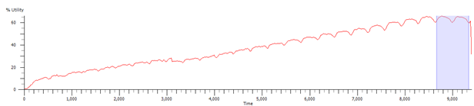

Figure 2 - UDP KW CPU consumption (with Physical GW deployment)

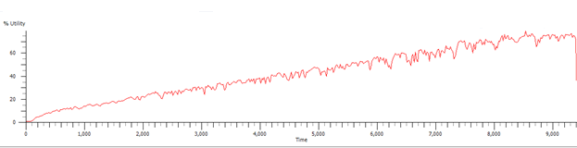

Figure 3 - HTTP KW CPU consumption (with Physical GW deployment)

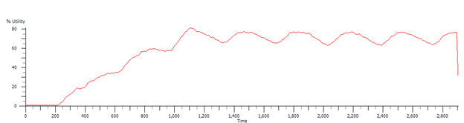

Figure 4 - RPC-HTTP KW CPU consumption (with Physical GW deployment)

### RD Gateway Running on a Virtual machine test

In this test, the RD Gateway role is installed on a virtual machine. The virtual machine has four network adapters which are bound to the virtual machine host machine’s adapters. 10 GB of Random Access Memory and 4 Virtual Processors are allocated to the virtual machine.

|  |  |  |
| --- | --- | --- |
| Number of Connections vs Connections Attempted | User-Network Profile | RD Gateway Transport |
| 1622 vs. (1800) | KW | RPC-HTTP |
| 3128 vs. (3450) | KW | HTTP |
| 3276 vs. (3450) | KW | UDP |
| 377 vs. (600) | KW+ | RPC-HTTP |
| 990 vs. (1365) | KW+ | HTTP |
| 931 vs. (1365) | KW+ | UDP |

Table 3 - Connections Attempted

For all the capacity numbers in Table 3, the virtual machines’ CPU is pegged at %100.  
The CPU resource consumption of the VM Host during the KW+ VM GW deployment runs are as follows:   
  
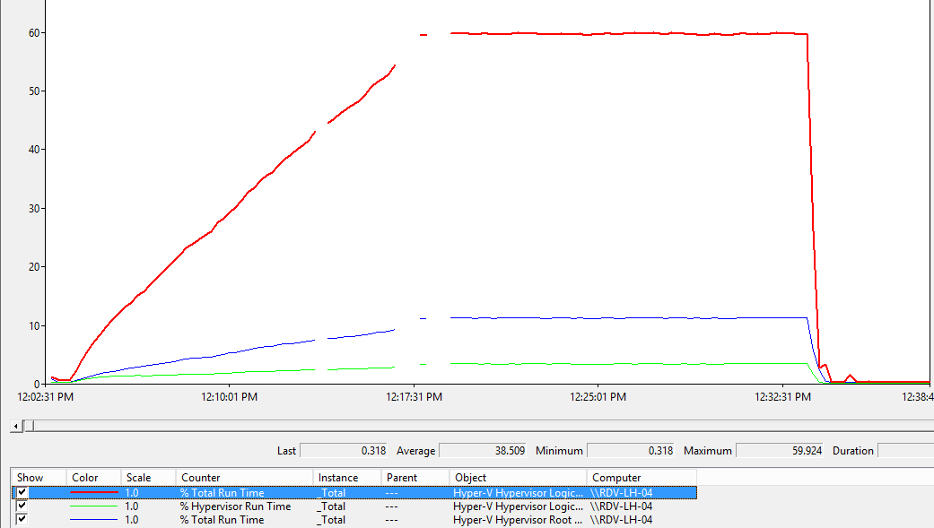

Figure 5 - Scenario Knowledge Worker + Using UDP

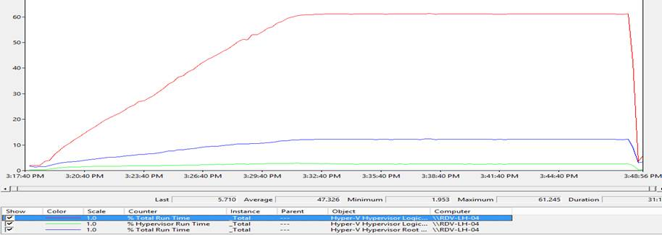

Figure 6 - Scenario Knowledge Worker + Using HTTP

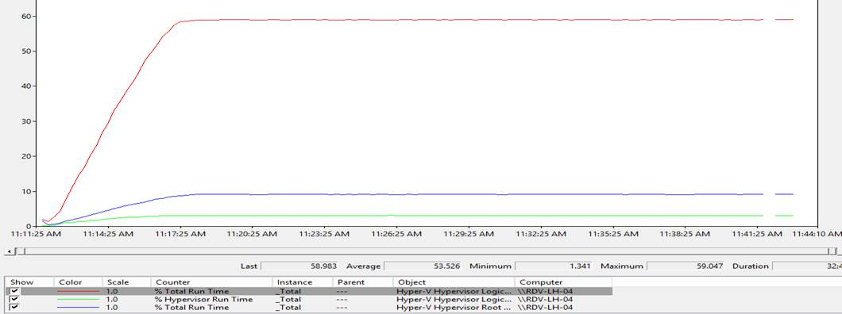

Figure 7 - Scenario Knowledge Worker + Using RPD over HTTP

# Section 4: Summary

The test results indicate that the actual number of users that a specific server configuration can support varies depending on the processor type, and the user scenario (typing speed, applications used, and frequency). In addition to the performance results outline by the tests, UI rendering for an applications can also impact the number of connections.

It is observed that on both RD Gateway running on a virtual machine and physical machine RD Gateway deployments, the HTTP and UDP protocols are both more efficient concerning scaling the solution (which is also the default configuration for Windows Server 2012) than RPC over HTTP. Another important note about RPC over HTTP is that the capacity of the RD Gateway server is restricted because of the capabilities of the Internet Information Server (IIS).

Regarding the impact of deploying the RD Gateway as a standalone physical server versus deploying as a virtual machine running on a Hyper-V server, the tests demonstrate, RD Gateway running on a virtual machine test results are proportional to the results with RD Gateway running inside a physical machine. Thus, the overall performance expected from an RD Gateway running on virtual machine is the same as an RD gateway running on a physical machine

# Appendix

### Related Links

For more information, please refer to the following links:

Remote Desktop Services Gateway  
http://technet.microsoft.com/en-us/library/dd560672(WS.10).aspx

Deploying Remote Desktop Gateway Step-by-Step Guide  
 http://technet.microsoft.com/en-us/library/dd983941(WS.10).aspx

What's New in Remote Desktop Services for Windows Server 2008 R2  
http://technet.microsoft.com/en-us/library/dd560658(WS.10).aspx

Configuring the Remote Desktop Gateway Server

<http://technet.microsoft.com/en-us/library/cc754191.aspx>  
  
Gateway Settings:

* Self-signed certificate is used.
* Local server running NPS for all tests except for a test with RD CAPs that are stored on a central Network Policy Server.
* Low level client and server uses port 1234 for communication; all ports are allowed in the RD RAP for the RD Gateway.
* All users allowed access in the RD CAP.
* RD RAP policy set to allow access to Any network resource
* Password authentication is used.

### Knowledge Worker Script

Typing Speed = 35 words per minute

Definition: **The Knowledge Worker (KW)** scenario includes creating and saving Word documents, printing Excel spreadsheets, communicating by e-mail in Outlook and browsing Web pages in Internet Explorer. The following workflow details the scenario.

* Connect User “smcxxx”
* **Start (Outlook) -** Send new e-mail messages
* Send a new appointment invitation
* Send a new e-mail message
* Minimize Outlook
* **Start (Word) -** Start and exit Word
* **Start (Microsoft Excel)** - Start and exit Excel
* loop(forever)
* **Start (Word) -** Type a page of text and print
* Open a Word document
* Type a page of text
* Modify and format text
* Check spelling
* Print
* Save
* Exit Word
* **Start (Microsoft Excel)** - Load Excel spreadsheet, modify, and print it
* Load Excel spreadsheet
* Modify data and format
* Print
* Save
* Exit Excel
* **Switch To Process, (Outlook) -** send e-mail,read message, and respond
* Send e-mail to other users
* Read e-mail and respond
* Minimize Outlook
* **Start (Internet Explorer) -** Load presentation and run slide show
* Loop (2)

URL http://tsexchange/tsperf/new/samplemsn/www.msn.com/msn.html

URL http://tsexchange/tsperf/new/msnmoney/money.msn.com/msnmoney.html

* End of loop
* Exit Internet Explorer
* End of loop

### Knowledge Worker Plus

Typing Speed = 35 words per minute

Definition: **The Knowledge Worker Plus (KW+)** scenario includes creating and saving Word documents, printing Excel spreadsheets, communicating by e-mail in Outlook and browsing Web pages in Internet Explorer which have some multimedia content. The following workflow details the scenario.

* Connect User “smcxxx”
* **Start (Outlook) -** Send new e-mail messages
* Send a new appointment invitation
* Send a new e-mail message
* Minimize Outlook
* **Start (Word) -** Start and exit Word
* **Start (Microsoft Excel)** - Start and exit Excel
* loop(forever)
* **Start (Word) -** Type a page of text and print
* Open a Word document
* Type a page of text
* Modify and format text
* Check spelling
* Print
* Save
* Exit Word
* **Start (Microsoft Excel)** - Load Excel spreadsheet, modify, and print it
* Load Excel spreadsheet
* Modify data and format
* Print
* Save
* Exit Excel
* **Switch To Process, (Outlook) -** send e-mail,read message, and respond
* Send e-mail to other users
* Read e-mail and respond
* Minimize Outlook
* **Start (Internet Explorer) -** Load presentation and run slide show
* Loop (2)

URL http://tsexchange/tsperf/WindowsServer.htm   
URL http://tsexchange/tsperf/Office.htm  
URL http://tsexchange/tsperf/MSNMoney.htm

* End of loop
* Exit Internet Explorer
* End of loop

Test Script Flow Chart

