Lab B (Module 7)

This document is provided “as-is”. Information and views expressed in this document, including URL and other Internet Web site references, may change without notice. You bear the risk of using it.
This document does not provide you with any legal rights to any intellectual property in any Microsoft product. You may copy and use this document for your internal, reference purposes.
© 2011 Microsoft. All rights reserved.

Contents
Exercise 1: Create a Keyword and a Best Bet 3
Task 1: Create a New Keyword 3
Task 2: Create an Sssociated Best Bet for the Keyword 4
Exercise 2: See How the Best Bet Impacts Search 4
Task 1: Execute a Keyword Search and Check the Best Bets 4
Lab B - Summary 5

Consider this scenario. As a site owner on your internal team site, you know that team members often search on the term tasks to find possible tasks to work on. Because the word tasks is a term used in many sites, lots of results with the word tasks in them might be returned that are not relevant to the team members. You need to create a keyword and Best Bet term for tasks to ensure that team members are shown the tasks list in the current site at the top of the search results.

Exercise 1: Create a Keyword and a Best Bet
Keywords and Best Bets are manually configured by a site collection administrator and are a great way to target important information in your search results. When a user enters a keyword into the search box, the Best Bets are displayed as part of the search results at the top of the page marked by a yellow star.
The main tasks in this exercise are as follows:
- Create a new keyword.
- Create an associated Best Bet for the keyword.

Task 1: Create a New Keyword
- In your browser, navigate to your home page of your site: URL:http://intranet.contoso.com
- Click Site Actions, and then click Site Settings.
- In the Site Collection Administration section, click the Search Keywords link.
- In the Manage Keywords page, click the Add Keyword link.
- In the Add Keyword page, in the Keyword Information section, enter tasks into the Keyword Phrase text box.

Task 2: Create an Sssociated Best Bet for the Keyword
- In the Add Keyword page, in the Best Bets section, click the Add Best Bet link.
- In the Add Best Bet dialog, enter: http://intranet.contoso.com/lists/tasks/allitems.aspx in the URL text box
- Enter in Team Tasks in the Title text box.
- Click the OK button, and then click the OK button in the Add Keyword page.
You should now see your keyword show in the list on the Manage Keywords page.

Exercise 2: See How the Best Bet Impacts Search
When a user enters a keyword into the search box, the Best Bets are displayed as part of the search results at the top of the page marked by a yellow star. Putting the Best Bet at the top of the search results ensures the user will find the document for the given keyword.
The main task in this exercise is as follows:
- Execute a keyword search and check the Best Bets.

Task 1: Execute a Keyword Search and Check the Best Bets
- In your browser, navigate to the home page of your site: URL:http://intranet.contoso.com/search
- Enter the word tasks into the Search text box, and then click the Maginifying Glass to execute a search.
- Observe that Team Tasks shows up at the top of the search results with a link to the URL of the page.

Lab B - Summary
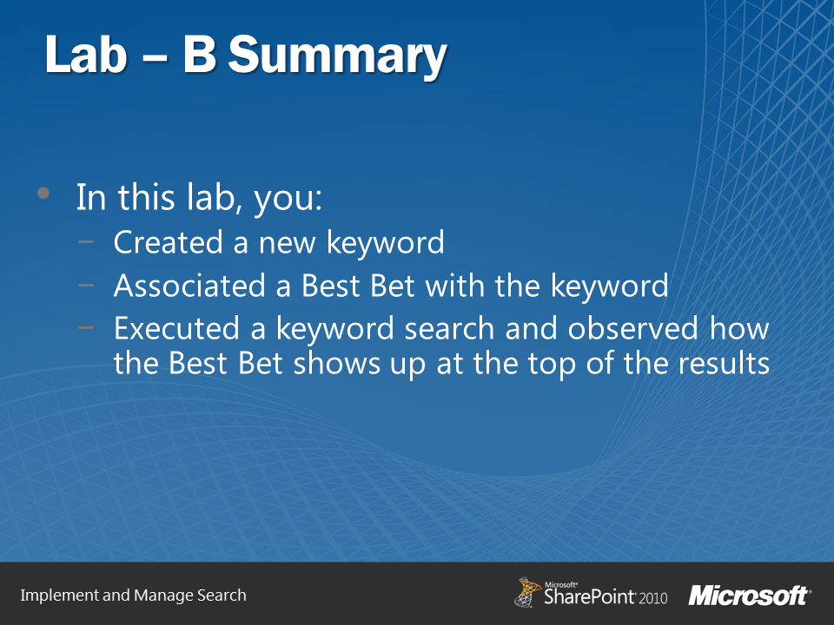
In this lab, you learned how to create a keyword and associate a Best Bet document with the keyword. You also observed how when a user searches on a given keyword, the Best Bet shows up at the top of the search results. This helps the user find the most relevant information quickly.

