Lab B (Module 6)
Working with Tags and Comments

This document is provided “as-is”. Information and views expressed in this document, including URL and other Internet Web site references, may change without notice. You bear the risk of using it.
This document does not provide you with any legal rights to any intellectual property in any Microsoft product. You may copy and use this document for your internal, reference purposes.
© 2011 Microsoft. All rights reserved.

Contents
Task 1: Add Tags and Comments to a Document Set 3
Task 2: Add a Note Board Web Part to a Document Set Welcome Page 4
Task 3: Add a Tag Cloud Web Part to a Document Set Welcome Page 6
Task 4: Run the Timer Job to Process the Tags 6
Exercise 5: Manage Tags and Comments from the Central Administration Site 7

In this lab you add comments and tags to the existing document sets located in the M&A site. Comments are added using a modified Welcome page that contains a Note Board Web Part and Tag Cloud Web Part.

Task 1: Add Tags and Comments to a Document Set
In this task you add a tags and a note to an existing documents set.
- Using Internet Explorer, navigate to the Mergers and Acquisitions site located at http://intranet/ECMForTheMassesV3/MandA/. This URL is included as a favorite in the student demo image.
- In the left Quick Launch pane, select New Mergers and Acquisitions library.
- Select the Blue Yonder Acquisition document set link to open the document set.
- In the upper-right corner of the web page, click the I Like It Social Ribbon button .
- In the upper-right corner of the web page, click the Tags & Notes Social Ribbon button.
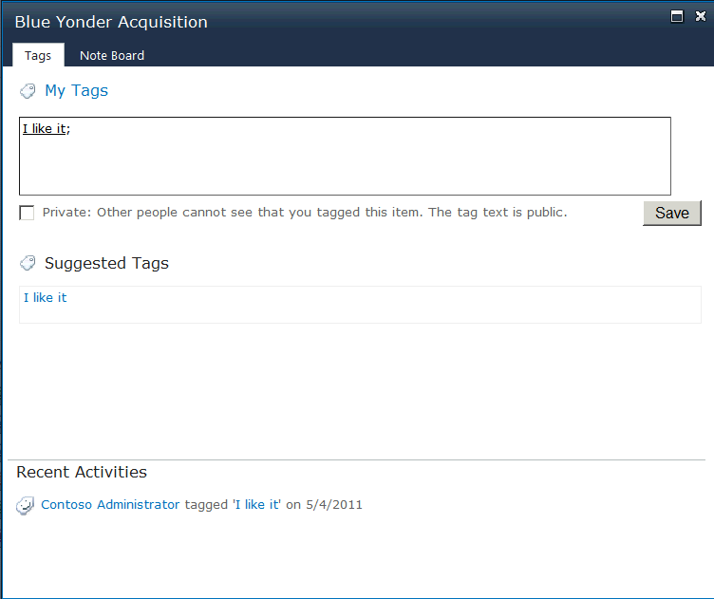
- Click in the tag text box, and type Camera. Notice the suggested tags display for selection.
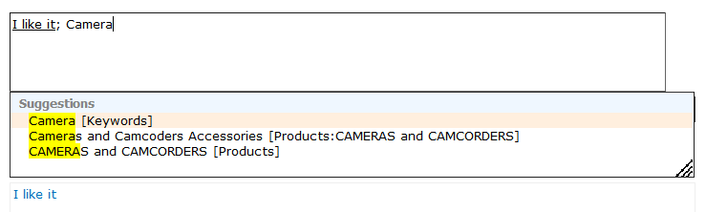
7. Select Camera [Keywords].
8. Enter the new tag named ECM Demo.
9. Click the Save button.
10. Select the Note Board tab.
11. Click in the text box and enter a comment.
12. Click the Post button to save the comment.
13. In the top-right corner of the dialog, close the dialog by clicking the X.

Task 2: Add a Note Board Web Part to a Document Set Welcome Page
In this task you add a Note Board Web Part to the Welcome page of an existing document set.
- Using Internet Explorer, navigate to the demo library at http://intranet/ECMForTheMassesV3/MandA/. This URL is included as a favorite in the student demo image.
- In the left Quick Launch pane, to open the library,select New Mergers and Acquisitions library.
- To open the document set’s Welcome page, select the Blue Yonder Acquisition document set link.
- To open the Welcome page in edit mode, click Site Actions and select Edit Page.
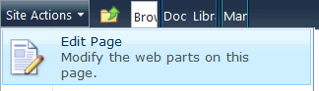
- Copy the address for the Welcome page from the Internet Explorer address bar. This should be done from the Welcome page while in edit mode.
- Click the Add a Web Part link located in Zone 3.
- In the Categories pane on the left side of the gallery, select the Social Collaboration category.
- Select Note Board in the Web Parts pane.
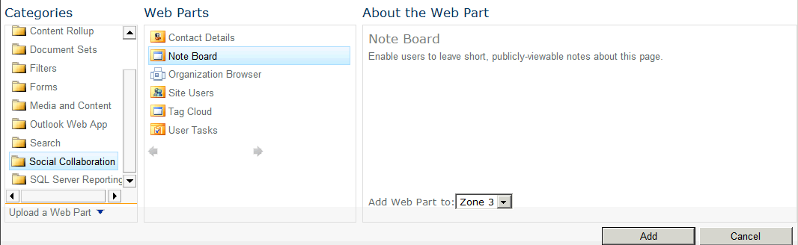
- To add the Web Part to Zone 3, click the Add button.
- Hover over the new Web Part, and select the drop-down arrow located in the right top section of the Web Part. Select Edit Web Part to display the Web Part’s property pane.
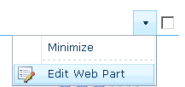
- In the Property Pane on the right side of the web page, expand the Custom Properties section.
- Paste the URL copied in step 4 into the URL for Note text box.
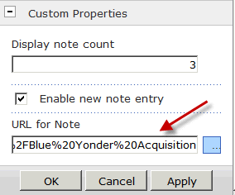
- Remove all URL parameters from the address except for ID, FolderCTID, List, and RootFolder.
Note:If this URL is incorrect the embedded Note Board comments and the Tags and Notes Note Board comments for the Welcome page will not be coordinated.
- Select the Page ribbon tab.
- Click Stop Editing ribbon button.
- To open the document set’s Welcome page, select the Blue Yonder Acquisition document set link.
- Verify the Note Board Web Part is located in the Welcome page and displays the comment entered from Task 1.
- Click in the Note Board and add a comment.
- Click Post to add the comment.

Task 3: Add a Tag Cloud Web Part to a Document Set Welcome Page
In this task you add a Tag Cloud Web Part to the document set Welcome page to display tags associated with the document set.
- Using Internet Explorer, navigate to the demo library located at http://intranet/ECMForTheMassesV3/MandA/. This URL is included as a favorite in the student demo image.
- In the left Quick Launch pane, to open the library, select New Mergers and Acquisitions library
- To open the document set’s Welcome page, select the Blue Yonder Acquisition document set link.
- To open the Welcome page in edit mode, click Site Actions and select Edit Page.
- To open the Welcome page in edit mode, Click Site Actions and select Edit Page.
- Click the Add a Web Part link in Zone 1.
- In the Categories pane on the left side of the gallery, select the Social Collaboration category.
- In the Web Parts pane, select Tag Cloud.
- Click the Add button to add the Web Part to Zone 1.
- Hover over the new Web Part and select the drop-down arrow in the right-top section of the Web Part. Select Edit Web Part to display the Web Part’s property pane.
- Set the Show Tags property to Under the Current URL By All Users value.
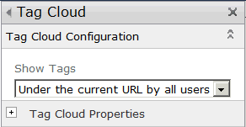
- Click OK.
- Select the Page ribbon tab.
- Click the Stop Editing ribbon button.
- Select the Blue Yonder Acquisition document set link to open the document set’s Welcome page.
- Verify the Tag Cloud Web Part is located in the Welcome page.
- Note: Depending on the when the two timer jobs execute, all the tags might not be available immediately.

Task 4: Run the Timer Job to Process the Tags
In this task you run the Social Data Maintenance Job to process the newly created tag.
- On the Start menu, point to All Programs, Microsoft SharePoint 2010 Products, andSharePoint 2010 Central Administration.
- In the Monitoring section,click Check Job Status link.
- In the Timer Links section in the left column, click the Job Definition link.
- Use the paging control located at the bottom of the Job Definition page to move to the page containing the User Profile Service Application - Social Data Maintenance Job link.
- Click the User Profile Service Application - Social Data Maintenance Job link.
- Click Run Now button.

Exercise 5: Manage Tags and Comments from the Central Administration Site
In this exercise you use the User Profile Service to find and remove notes and tags.
- On the Start menu, point to All Programs, Microsoft SharePoint 2010 Products, andSharePoint 2010 Central Administration.
- In the Application Management section, click the Manage service applications link.
- Click the User Profile Service Application link.
- Click the Manage Social Tags and Notes link located in the My Site Settings section.
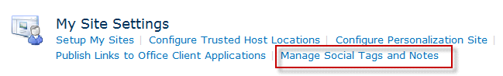
- In the Type drop-down control, Select Tags.
- In the User control, enter administrator.
- Click the Find button.
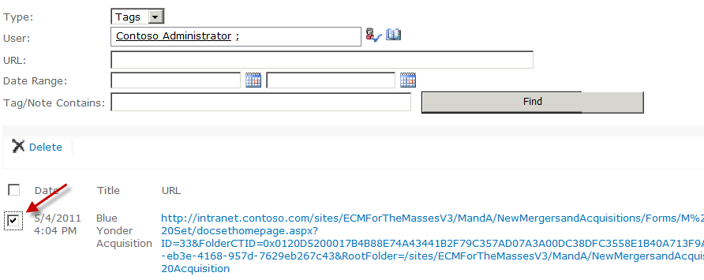
- Select the check box associated with a Blue Yonder Acquisitioncreated in Task 1.
- Click the Delete link.
- Click OK to confirm the deletion of the tag.
- In the Type drop-down control, SelectNotes.
- in the User control, enter administrator.
- Click the Find button.
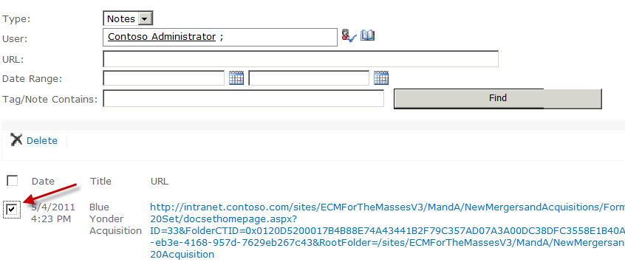
- Select the check box associated with the comment created in Task 1.
- Click the Delete link.
- Click OK to confirm the deletion of the comment.

