Lab B (Module 5)
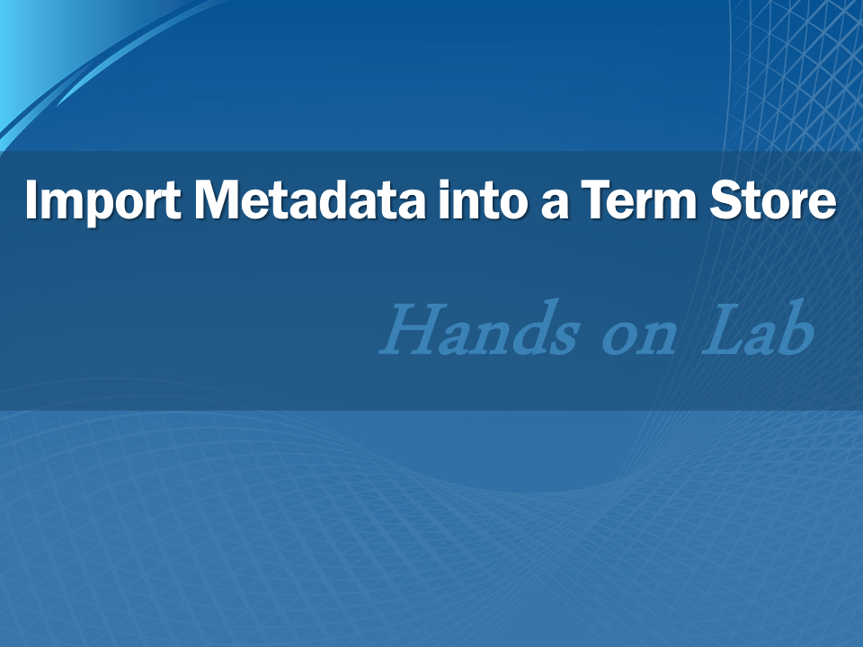

This document is provided “as-is”. Information and views expressed in this document, including URL and other Internet Web site references, may change without notice. You bear the risk of using it.
This document does not provide you with any legal rights to any intellectual property in any Microsoft product. You may copy and use this document for your internal, reference purposes.
© 2011 Microsoft. All rights reserved.

Contents
Task 1: Create the Import File 3
Task 2: Import the Term Set 3
Task 3: Apply Imported Terms to a List Item 4
Lab Summary 7

In this lab, you import a term set and terms into a term store.

Task 1: Create the Import File
In this task you create an import file for the term set.
- Click Start > Run.
- Enter notepad and click OK.
- Enter the following text on the first line:
"Term Set Name","Term Set Description","LCID","Available for Tagging","TermDescription","Level 1 Term","Level 2
Term","Level 3 Term","Level 4 Term","Level 5 Term","Level 6 Term","Level 7 Term"
- Enter the following text on the second line:
"Sites","Locations where the organization has offices",,TRUE,,,,,,,,
- Enter the following text on lines 3–8:
,,1033,TRUE,,"North America",,,,,,
,,1033,TRUE,,"North America","Washington",,,,,
,,1033,TRUE,,"North America","Washington","Redmond",,,,
,,1033,TRUE,,"North America","Washington","Seattle",,,,
,,1033,TRUE,,"North America","Washington","Tacoma",,,,
,,1033,TRUE,,"North America","Massachusetts","Cambridge",,,,
- Save the file as TermSet.csv.

Task 2: Import the Term Set
In this task, you import a term set into the term store.
- In Central Administration, under Application Management, select Manage service applications.
- Click Managed Metadata Service 1.
- Locate the Managed Metadata Service 1 term store, click the drop-down list, and select New Group.
- Enter Imported Terms as the group name.
- Select the Imported Terms group and click Import Term Set.
- Browse and select the TermSet.csv file.
- Click OK.
- Expand the Sites node and ensure that the terms have been imported into the term store.
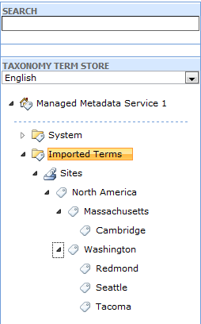

Task 3: Apply Imported Terms to a List Item
In this task, you use the imported terms to add a location to a contact list item.
- Open http://intranet.contoso.com in Internet Explorer.
- From the Site Actions menu, select More Options.
- Click Contacts and enter Company Contacts in the Name field.
- Click Create.
- Select the List tab and click the List Settings option in the Ribbon.
- Click Create Column.
- Enter Employee Location in the Column name field and select Managed Metadata as the column type.
- In the Term Set Settings section, expand the Managed Metadata Services 1 node, expand Imported Terms, and select Sites.
- Click OK.
- Return to the Company Contacts list default view, select the Items tab, and click New Item.
- Enter a name in the Title field and click the tag icon next to the Employee Location field.
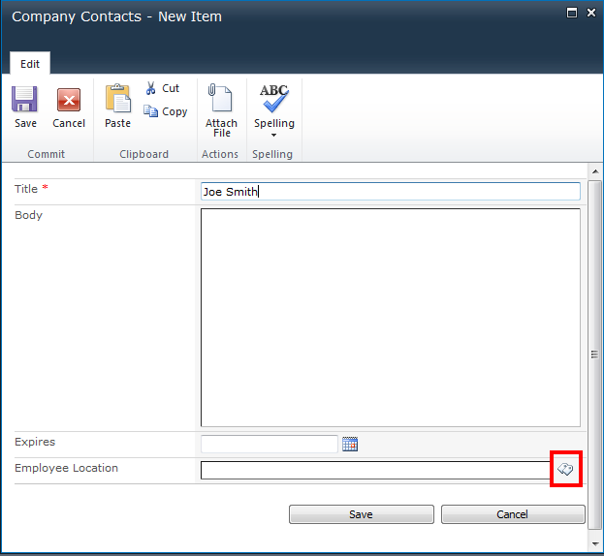
- Expand the terms, click Redmond, and click Select.
- Click Save.
- The contact item is created using the imported term.
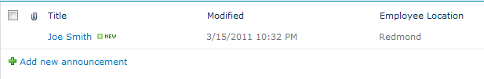

Lab Summary
