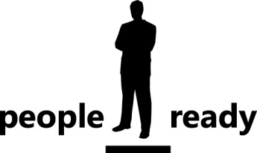

Project Portfolio Management
Doing the Right Things Right
Published: August, 2008
For the latest information, please see http://www.epmconnect.com
Contents
Introduction 1
What is Project Portfolio Management? 2
Who participates in PPM, and how? 3
The PPM Governance Lifecycle: Create, Select, Plan, Manage 4
Overview 4
Create 6
Select 7
Plan 8
Manage 10
Building a Roadmap for Success 12
Overview 12
PPM Capability Maturity Model 12
Creating a Roadmap 13
The Microsoft EPM Solution 14
Overview 14
Manage and control all types of work 15
Improve visibility and insight to enhance decision-making 15
Effectively communicate and collaborate with all stakeholders 16
Evolve with a scalable and configurable platform 16
Conclusion 17

Introduction
This paper introduces definitions, concepts, and frameworks for Project Portfolio Management (PPM); describes how the Microsoft Enterprise Project Management (EPM) Solution supports PPM; and provides initial guidance to executives and business leaders for PPM implementation planning.

Large organizations have a need for well defined and effective IT Governance. Frequently, IT executives are tasked with:

- balancing demand from varying sets business customers
- maintaining alignment with overall business objectives
- delivering global stability while providing localized value
- delivering value within exacting financial and resource constraints

PPM is a critical Governance capability that addresses all of these challenges.
The Microsoft EPM Solution is based upon Microsoft Office Project technology. Over the past 12 years, Microsoft Office Project has evolved from a desktop software product to a comprehensive family of network-based solutions.

Evolution of Microsoft Office Project
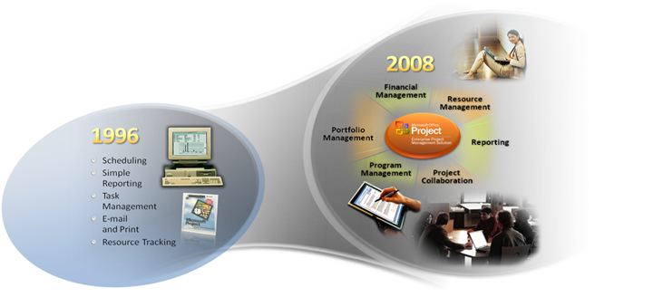

For additional details about the Microsoft EPM Solution and to find resources for PPM implementation, please visit the EPMConnect website at http://www.epmconnect.com. EPMConnect puts the resources of hundreds of Microsoft Enterprise Project Management partners at your fingertips, enabling you to quickly locate the right solutions and services and connect with the ideal EPM partner for your needs.

What is Project Portfolio Management?
Project Portfolio Management (PPM) is the continuous process of
identifying, selecting and managing a portfolio of projects in alignment with key performance metrics and strategic business objectives.
PPM is about “doing the right things right”. For the purposes of this document, the following definitions are provided:
- “Things” refers to: work efforts, projects, and programs. Work efforts are the tasks and activities required to operate a business. A project – according to the Project Management Institute (PMI) definition – is “a temporary endeavor undertaken to create a unique product or service”. A program is “a group of related projects managed in a coordinated way to obtain benefits and control not available from managing them individually. Programs may include elements of related work outside the scope of the discrete projects in a program.” (PMI).
- “Doing the right things” refers to prioritizing and selecting programs and projects to achieve your organizational objectives.
- “Doing things right” means delivering high quality projects or programs

By further breaking down these simple statements there are some interesting questions that arise.

“Doing the right things” is Governance enabled by Portfolio Management
- What are the “right things”?
- Are we doing things that we should not be doing?
- Are there things we should be doing that we’re not?
- How can we improve our decision-making?

“Doing things right” is Execution enabled by Project Management / Work Management
- What is the right way to do something?
- How do I make sure we do things right?
- How can we improve what we do?

One overarching question is: What is the impact of improving portfolio management vs. project management? The following diagram shows the relationship between portfolio management, project management, and overall potential value that an organization can deliver:

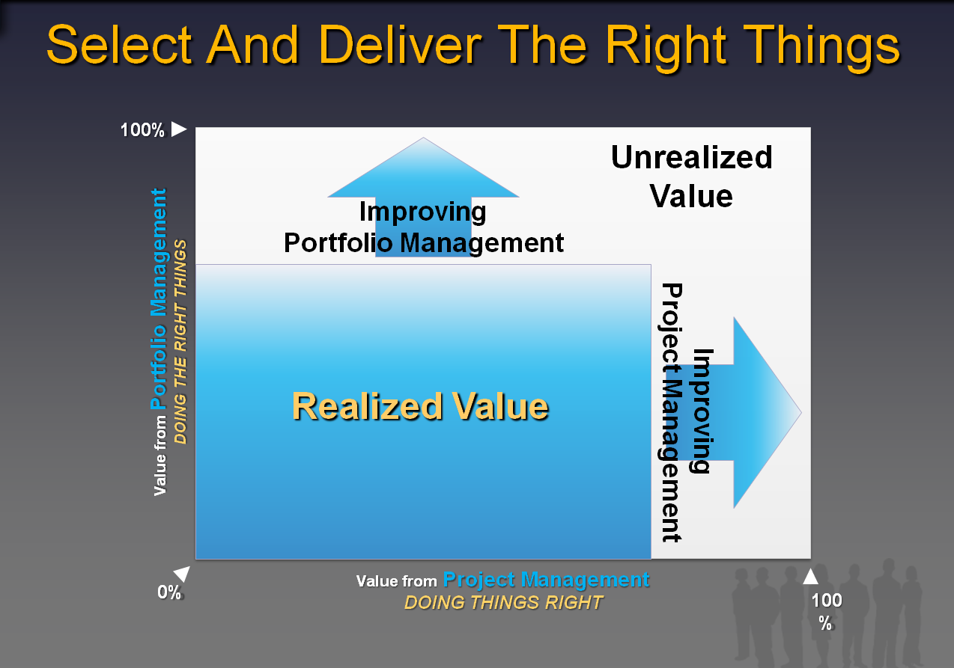

In this example, the current portfolio management capabilities are at 66% with 100% representing a perfect ability to select the right projects. The project management capabilities are at 75%, with 100% representing a perfect ability to deliver projects on time, on scope, and on budget. With these assumed these levels of capability, an organization is only realizing 50% of total potential value from its efforts.

PPM is comprised of two equally important disciplines; project management and portfolio management. The benefits of project management are more clearly understood. Traditional project management is a discipline that helps organizations to effectively realize business value, by delivering projects and programs on time and within budget. Less is known about portfolio management. Many people believe that portfolio management just involves effective reporting across project portfolios. This is certainly an important aspect, but portfolio management also helps organizations to identify business value and ensure they are investing in the optimal project portfolios. In other words, portfolio management helps you to select the right things and project management ensures you execute and deliver the projects on time and within budget. Successful organizations invest in improving both disciplines.

Who participates in PPM, and how?
PPM is for organizations that have large numbers of investments, and a need for improved governance or execution. It is generally the concern of three groups of people within an organization: executives, managers, and project teams.
- Executives – includes executives and portfolio managers. Executives have the responsibility to set strategy and direct the organization to meet its objectives. Frequently, there is a Portfolio Manager involved in supporting executives to organize and operate PPM.
- Managers – includes the Project Management Office (PMO), Resource Managers, and Project Managers. This group is responsible for the planning and successful execution of projects and programs.
- Project Teams – are the set of people assigned to a project to perform tasks and produce deliverables.
The following pyramid diagram shows these three groups in the context of PPM. To the right of the triangle, major components and benefits of PPM are shown. Core PPM processes are shown to the right of the triangle.
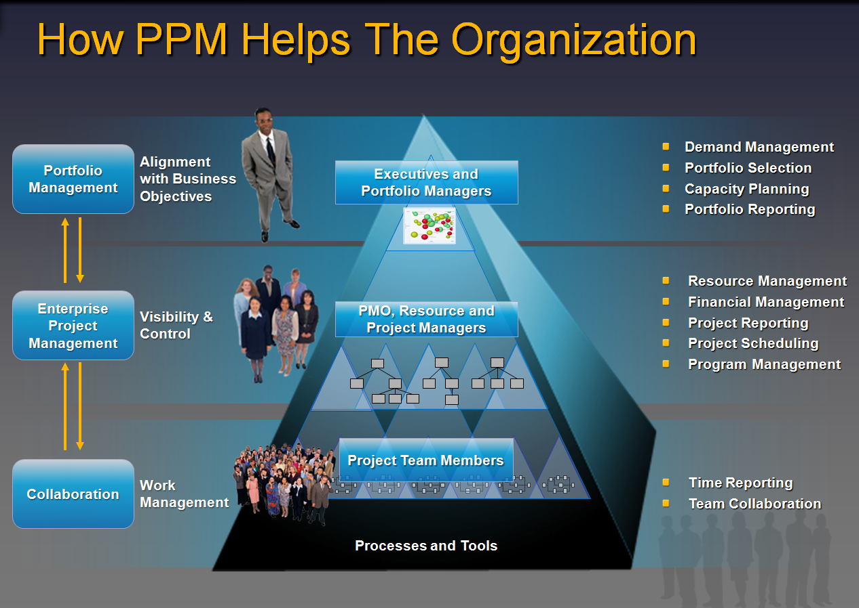

The PPM Governance Lifecycle: Create, Select, Plan, Manage

Overview
Assigning the right resources to the right activities at the right time – in other words, alignment – is the ultimate goal of business governance. An organization’s strategy, operational structure, execution process and technical expertise are all tested when resource assignments are made. Portfolios, programs and projects are all formal expressions of resource assignment decisions. Accordingly, a systematic approach to collecting, selecting, planning and managing them is key to a high-quality IT Governance process.
Portfolios, programs and projects all share a common lifecycle. This lifecycle is formed around four key PPM gates, ‘Create → Select → Plan → Manage’.

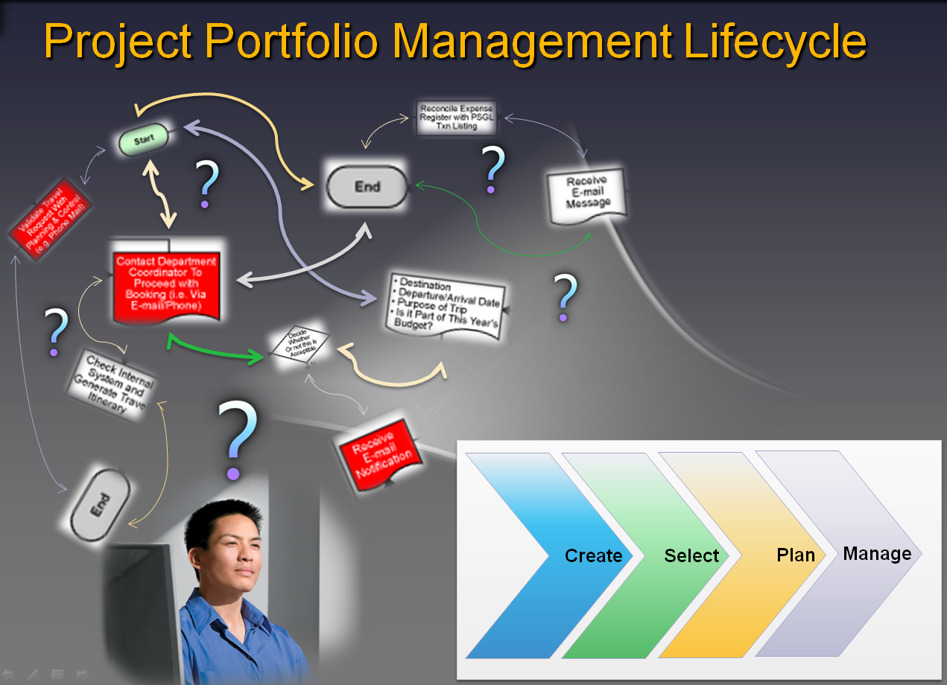
- Create: Standardized intake process and data collection structures for formation of the project portfolio inventory. Formal definition of strategic goals and objectives to support portfolio prioritization and selection.
- Select: Repeatable process for prioritization of the project portfolio. Decision-making for progression, suspension or rejection of work requests.
- Plan: Scheduling and resource assignment processes for the entire project portfolio, supported by detailed project planning.
- Manage: Ensuring successful project delivery, ongoing project tracking and reporting; and portfolio realignment
This simple framework can serve as a foundation for evaluating and improving governance practices. Organization-wide adoption of the ‘Create, Select, Plan, Manage’ lifecycle leads to consistent definition and common understanding of its underlying core processes:

- Demand Management – starts with having standard methods and structures for capturing all work ranging from simple support or change requests, to large complex projects and programs. Demand Management also includes definition of workflow for proper categorization, evaluation and characterization of the work request.
- Portfolio Selection – is the process of evaluating a portfolio of project requests, prioritizing the requests and approving or rejecting requests. To determine the best combination of projects, portfolio managers should use multiple criteria and analyses, including strategic, financial and risk. A portfolio selection that maximizes the portfolio’s value (as determined by the relevant criteria) given budget or resource constraints is considered “Optimized”.
- Capacity Planning – is a continuous process of evaluating an organization’s resources and performance to determine its capacity for production of work. It includes setting utilization targets for defined sets of people – usually by title and/or skill set. It also includes a collection of project metrics to understand productivity and subsequent adjustment of utilization targets. Proactive capacity planning allows organizations to finalize a release roadmap that maximizes resource utilization
- Resource Management – is about the assignment of resources to projects and tasks. For large organizations, this is typically an elaborate process that includes shuffling of resources to meet demands of project delivery schedules and project priorities.
- Financial Management – exists at both the project and portfolio levels. At the project level, financial management is the estimation of project costs and benefits, and tracking project expenditures against the project budget. At the portfolio level, financial management focuses on gaining visibility into spend (committed, planned and discretionary) and tracking the overall project portfolio budget.
- Project Scheduling – includes developing accurate project schedules; and defining repeatable best practice efforts. These two activities reinforce efforts to understand interdependencies between project schedules.
- Time Reporting – provides structures and methods for individual reporting of time spent on projects or tasks by resources. This information feeds project and portfolio reporting and provides visibility into the actual work progress, current work status and remaining work.
- Team Collaboration – in PPM, is the structured sharing of information to support knowledge sharing, change management, communication of schedule milestones, issues and risk management.
- Portfolio Reporting – provides visibility of the project portfolio to executives and functional leaders. To support sound decision-making and operational efficiency, a common view of projects and priorities is essential. By having executives, PMOs, and project managers share a common view of the organization, inefficiencies due to conflicting information are minimized and discussions can be focused on value-adding portfolio analysis.
- Project Reporting – helps to ensure consistent tracking of projects and efficient communication of project objectives and status.
- Program Management – can be viewed as management of large initiatives comprised of multiple projects. Programs should be aligned with an organization’s strategy and the results of a program are produced through the delivery of its projects
By examining the core processes within the context of each major lifecycle step (Create, Select, Plan, Manage), definitions of key benefits and capabilities emerge.

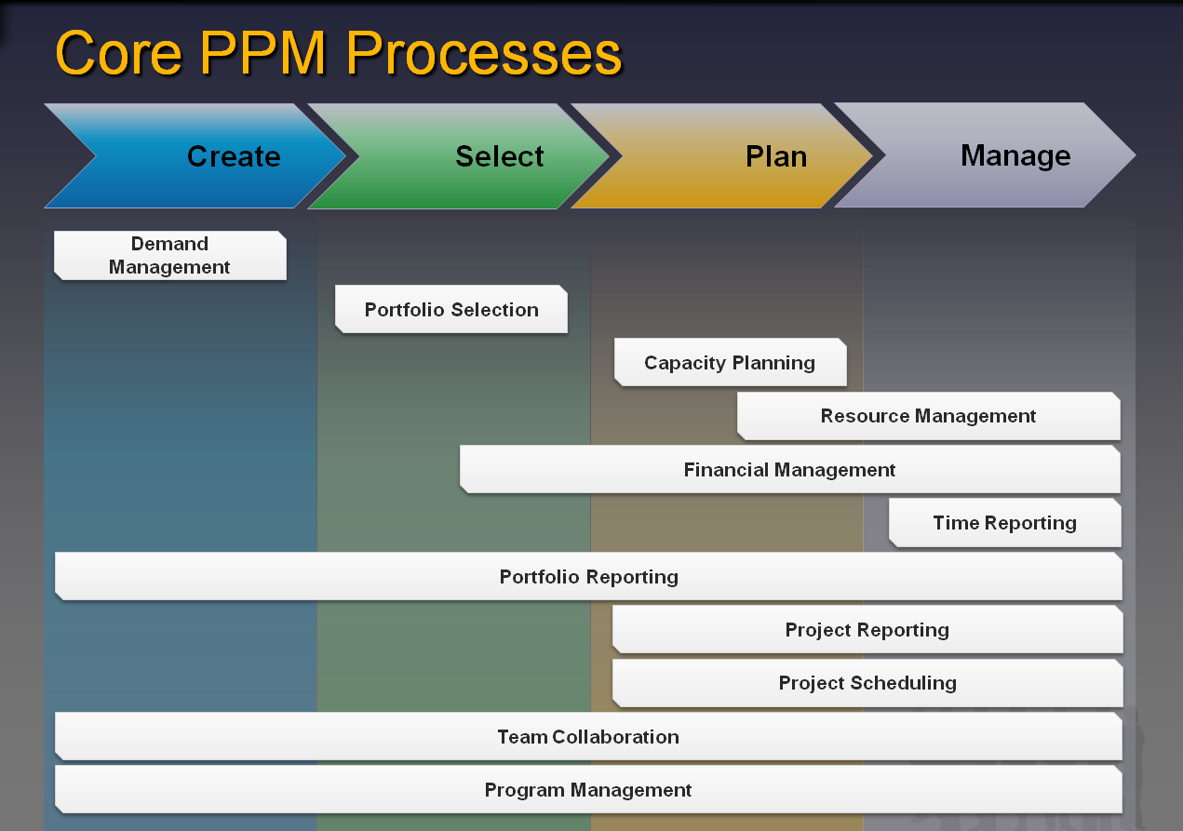
Core PPM Processes Overview

Create
The Create lifecycle phase encompasses activities for the definition of strategic goals and metrics, and intake of work demand. The most relevant core PPM processes in the Create step are:
- Demand Management – Definition of business case structure, business case creation and workflow to support evaluation of work requests
- Portfolio Reporting – During the Create phase, portfolio reporting includes reports that provide visibility of all demand captured within a planning cycle. Information conveyed in the portfolio reports help to characterize the overall portfolio inventory
- Team Collaboration – During the Create phase, informal teams or communities can collaborate to share ideas and capture project requests. For example, a team might identify a gap in operations then request a project to address the gap. Executives and PMOs can communicate with managers and teams to publicize corporate goals, significant events and upcoming PPM reviews
- Program Management – Similar to projects, program definitions can be formed during the Create phase. Some organizations define programs as part of an annual budget allocation cycle. Each program definition represents a high-level business objective that can be broken down into more specific business objectives. Throughout the budget year, programs objectives are pursued by creating projects that each address a subset of the program objectives. This facilitates delegation of governance control to the program level.
Key benefits and capabilities:
- Capture all requests, from work orders to discretionary projects – Consolidating requests in a single central repository provides visibility and control to your organization’s entire workload. This is required for maintaining a single source of truth for work demand and for making informed allocation decisions
- Standardize metrics, valuation criteria and templates – Standardization allows for consistent methods in evaluation and decision-making. Structured templates, consisting of standard metrics and valuation criteria, support an end-to-end flow of information throughout the PPM process. This flow ranges from business case creation to portfolio and project reporting
- Control investment through governance workflow – The proper evaluation of business cases includes validation of the information provided by the appropriate authority; business case review by key stakeholders; and approval from the appropriate governing bodies. Routing and tracking business cases can be simplified through structured workflows. These review and approval processes can vary depending upon the investment type (e.g., big or small project) requiring a unique review and approval workflow for each type

Select
After a project portfolio inventory has been formed in the Create lifecycle phase, the Select phase is next. It includes all activities related to go/no-go decision-making and the prioritization of requested programs and projects. The most relevant core PPM processes for the Select phase are:
- Portfolio Selection – Key metrics in a project portfolio inventory are used to collate the project portfolio into analysis sets; examine project valuation (e.g., strategic, financial); and perform analyses (e.g., constraints, what-if’s). The analyses are used by a governance committee to select the investments that best align with the organization’s strategic priorities
- Financial Management – Budgetary constraints are key inputs for the Select phase. Decisions made during the phase also feed financial planning as programs and projects are approved and budget allocations are made
- Portfolio Reporting – Reporting supports portfolio selection discussions by providing a common and consistent view of the entire project portfolio to decision-makers. Information reported during the Select phase includes: project ranking based on varying valuation criteria (e.g., strategic alignment, financial valuation), and charting to show the results of constraint and what-if portfolio analyses
- Team Collaboration – As prioritization and selection discussions take place, there is an exchange of questions and answers between executives, PMOs, project managers and other stakeholders. Good collaboration during this exchange yields a deeper understanding of and improved confidence in the project portfolio information. This includes efficiently handling portfolio data Q&A, pressure testing key assumptions and socialization of decisions
- Program Management – During the Select phase, this includes activities for the prioritization of programs and the inclusion of program-oversight in the go/no-go project decision-making process. Different organizations have different approaches for managing the portfolio-program-project relationship. Some may take the approach of prioritizing programs before identifying projects. Prioritizing programs is accomplished by analyzing the portfolio of programs. This can be done in addition to analyzing the project portfolio
Key benefits and capabilities:
- Objectively prioritize business drivers and drive consensus – Open discussion of business strategy and prioritizing strategic objectives with governance bodies contributes to a better aligned organization and leads to more effective decision-making discussions
- Derive varying priority scores to evaluate competing investments – By comparing objective priority scores (e.g., financial valuation, strategic alignment score) across projects, fact-based decision-making discussions are made possible
- Identify portfolios that align with strategy and maximize ROI – Maximizing portfolio return starts with optimizing the selection of projects to pursue. Portfolio selection that includes consideration of strategic alignment and financial return helps ensure that long-term health is not compromised for short-term gain
- Adopt a rational rather than emotional portfolio selection methodology – With structured project portfolio valuation criteria, discussing points of contention can be focused on specific key factors. The overall structure and visibility of the entire project portfolio illuminates the impact of forcing in pet projects as the implications of tradeoffs quickly surface
- Utilize advanced portfolio analytical techniques to reach the efficient frontier – For any investment level there is an optimal selection of projects that will yield the greatest value. Mapping the maximum portfolio value (e.g., strategic value or financial value) for a range of investment combinations is called the ‘efficient frontier’. Advanced portfolio analysis employs this concept to measure the impact of project selection decisions as well as the impact of breaking constraints (e.g., what-if we had $2M more to spend?)

Plan
The Plan lifecycle phase includes activities to both plan and also perform resource assignment. This can be viewed from two perspectives – a portfolio perspective and a project perspective. From a portfolio perspective, activities during the Plan phase revolve around overall capacity planning and maintenance of project portfolio delivery schedule. From a project perspective, the Plan phase involves detailed project planning and assignment of named resources to the project. The most relevant core PPM processes for the Plan phase are:
- Capacity Planning – This is a key component of the Plan phase. It includes: identifying peaks and valleys in overall resource demand by skill level; evaluating resource supply by skill level; adjusting the project portfolio delivery schedule to minimize resource deficits and surpluses; and finalizing headcount decisions.
- Resource Management – Rules of engagement are needed to perform named resource assignment at a project level. This includes how specific, named resources are matched to work demand; how their availability is forecasted; how assignments are made and communicated; and how resource conflicts are resolved. These rules are exercised and enforced through resource management.
- Project Scheduling – During the Plan phase, an approved project is scheduled to start on a specific date, when a baseline plan is established. To establish a baseline plan, first a detailed plan is created. This is accomplished by defining the project’s work breakdown structure (WBS); identifying dependencies and constraints associated with the WBS; and defining detailed resource requirements (e.g., by skill or name). Based on this detailed plan, resource assignments and the overall project schedule are both finalized. At this point, the detailed plan becomes the baseline plan. This baseline is the foundation for ongoing schedule management.
- Financial Management – During the Plan phase, financial management is primarily concerned with forecasting spend and aligning spend with budgets. Project-level planning and forecasting is an essential input to the overall spend forecast. This includes with well-formed project schedules, resource estimates and cost estimates.
- Portfolio Reporting – Portfolio-level reporting during the Plan phase includes resource utilization forecasts to identify resource under/over utilization; overviews of project schedules to view timing of overall project portfolio delivery; and spend forecasts
- Project Reporting – Project-level reporting starts during the Plan phase with the formation of a Project Charter. Project charters detail the scope, objectives, schedule and resources needed for successful project execution. At the project’s end, project performance can be measured by comparing project results with estimated benefits from the Project Charter
- Team Collaboration – Planning the start of projects requires tight coordination between decision-makers (executives via PMOs), project managers, resource managers and project team members. Collaboration is needed to ensure the clarity of decisions, priorities and resource assignments
- Program Management –Similar to the overall planning of the portfolio schedule, organizations that define programs will develop program schedules. A program schedule is assembled from the schedules of the individual project within the program. During the Plan phase, detailed plans for the program’s underlying projects are created and baselined
Key benefits and capabilities:
- Identify gaps between overall resource availability and demand at the skill level – Predicting resource utilization is a key input for capacity planning. Without proper capacity planning, an organization will have very limited capability to pursue long term strategic initiatives. This is a portfolio-level capability
- Finalize and release roadmap and headcount requirements to maximize resource utilization – A release roadmap communicates the results of capacity planning and provides direction to project managers and resource managers. Using the release roadmap, project managers can coordinate resources assignments and clarify priorities with resource managers. This is a key step where decisions and priorities translate into an actual schedule. Resource managers and project managers need this visibility to avoid resource conflicts. This is a benefit across all divisions within the organization
- Search for team members with availability and assign to project – With the appropriate resource management capabilities in place, project managers can quickly assess the fit and availability of resources to projects and project tasks and make specific named resource assignment decisions. This is a key point where the detailed project planning, resource management, and portfolio decisions and priorities converge and transition into action
- Finalize plan and baseline before moving into execution – Establishing a baseline plan is critical to ongoing management of a project. With a baseline plan, expectations are set across all project stakeholders

Manage
The Manage lifecycle phase includes activities to support the delivery of projects and to track the progress of projects. Quality delivery of projects is typically measured by the project’s performance in delivering on scope, within budget and on schedule. Naturally, tracking of projects is focused on monitoring forecasted deviations in scope, budget and schedule. The most relevant core PPM processes in the Manage phase are:
- Resource Management – During the Manage phase, resource management primarily occurs at the project level and involves the on/off-boarding of project team members and assignment of resources to tasks
- Project Scheduling – Relative to the project schedule baseline, schedule tracking and schedule forecasting take place on an ongoing basis throughout project execution. This is another key component for managing successful project delivery
- Financial Management – Tracking of actual project spend, and forecasting future project spend is required to ensure a project is working within its financial constraints. It also contributes to tracking overall portfolio performance
- Time Reporting – Reporting of actual time spent on a project allows project managers to track progress. Tracking of remaining budget and forecasting estimates to complete helps to provide an overall picture of progress and to anticipate project issues
- Portfolio Reporting – Managing the execution of an entire project portfolio depends on tracking the entire project portfolio’s status and removing the obstacles hindering the project teams. Periodic, succinct and accurate portfolio reporting is vital to high-quality portfolio management. Typically, portfolio reporting is the foundation for leadership team meetings throughout the budget year. This includes overall project portfolio status, budget status, scope status and schedule status
- Project Reporting – Project managers are responsible for communicating the progress and status of their project to multiple stakeholders: project sponsors, beneficiaries, divisional managers and the project team. Standardized project status reports promote easier and clearer communication to and between stakeholders
- Team Collaboration – Collaboration reduces execution risk and fosters project success. Today, project teams usually exist within a matrix organizational structure. In these structures each team member has multiple reporting lines and affiliations: to their project team; functional division; or region. Consequently, sharing of knowledge and resolution of project issues and risks can take circuitous routes. Furthermore, in global organizations, teams are frequently challenged with working across large geographic regions and time zones. Good collaboration within a project team, across functional divisions and across regions is essential for expediting issue resolution and for effective knowledge sharing throughout the organization
- Program Management – Overall health of a program is dependent on the status of the projects within it. Similarly, changing scope or priority of a program will have a broad impact on all of its projects
Key benefits and capabilities:
- Collaborate to effectively deliver selected projects – During project execution, there are always minor deviations from plans due to situational changes or the emergence of issues. Collaboration helps to address and avoid these deviations by bringing the right people together to work on a task or issue. Effective collaboration is a pre-requisite for a high performing team
- Proactively monitor portfolio performance and visualize trends – Visibility into the overall project portfolio performance provides executives with a mirror of their organization and a true picture of what the organization is doing to realize its strategy. This is an important perspective that feeds recalibration of priorities and goals
- Drill down to the project level to assess risks, issues, and status – This facilitates better coordination within the project team and with project stakeholders
- Track and compare budget, actual and forecast values and make corrective actions to improve project performance – Tracking and forecasting project activities enables a project team to identify deviations from plan and to take corrective action
- Re-optimize the portfolio to maintain alignment with business strategy – An organization’s business context fluctuates as the delivery of the project portfolio progresses. Market forces can produce new priorities; business health can change assumptions about dollar or resource constraints; killed projects affect both resources availability and strategic alignment. Periodic, ongoing re-optimization of the project portfolio is needed to ensure project portfolio delivery continues to be aligned with the organization’s strategy

Building a Roadmap for Success

Overview
The advantage of understanding and using the ‘Create → Select → Plan → Manage’ governance lifecycle is that it provides a simple framework for improving PPM capabilities. After evaluating your organization’s capability maturity for each phase in the ‘Create → Select → Plan → Manage’ framework, you can identify areas for improvement by assessing your current state and defining your future state. Furthermore, this assessment can be organized into three areas of evaluation – people, process, and tools.
Dividing the landscape of PPM into the areas of lifecycle, capability maturity and assessment dimensions allows for the definition of an initial, workable set of PPM implementation activities. Subsequent phases of activities can also be planned using the same framework. Typically, a phased approach for implementation is needed to allow for proper adoption across a large enterprise.

PPM Capability Maturity Model
Planning a PPM implementation starts with an assessment of current PPM capabilities. Capabilities can be evaluated within each phase in the ‘Create → Select → Plan → Manage’ framework. Defining a desired future state using the same framework helps to identify areas for improvement. The following diagram shows an example of a “PPM Capability Maturity Model”. The example shows, for each PPM lifecycle step, a current state assessment of an organization’s capability maturity from “Initial” to “Optimized”. The stages of maturity are based on the Carnegie-Melon SEI Capability Maturity Model (CMM).

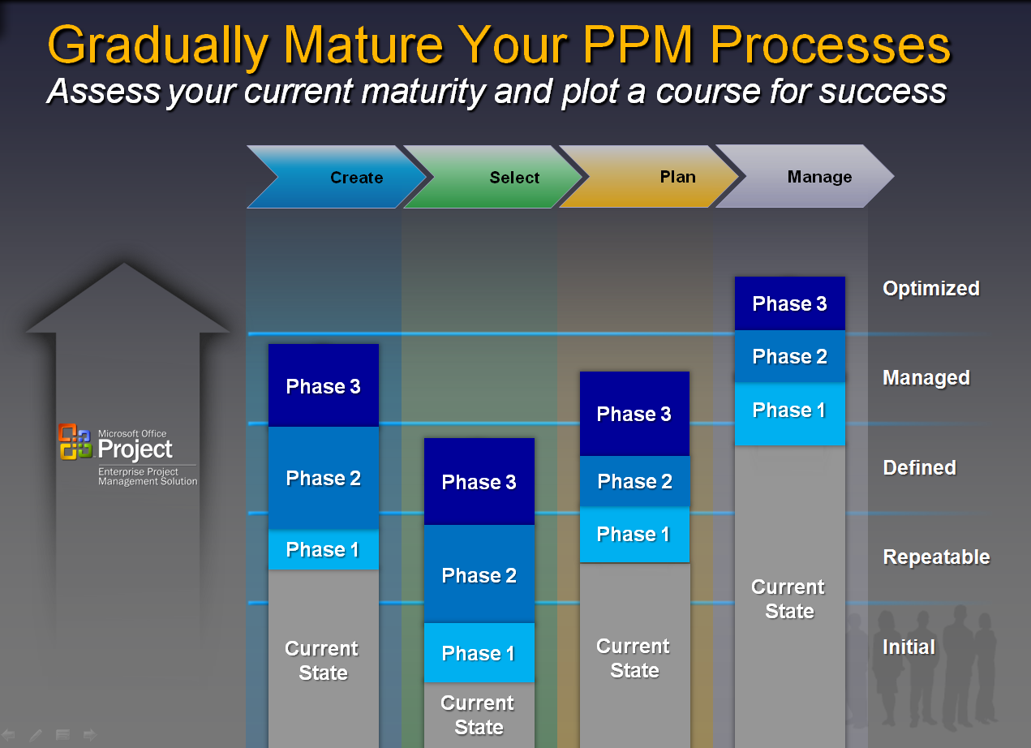
Example Maturity Assessment and Future State Definition

As described in the above example, implementation of the PPM future state definition can be planned as a multi-phased implementation. With a phased approach, an organization can “right-size” their PPM implementation efforts. For example, it’s not necessary for an organization to reach the highest levels of maturity across all areas. A phased approach also allows time for the organization to absorb change.
The Microsoft EPM Solution provides a flexible solution architecture that can be tailored to match the objectives in each phase of a multi-phased PPM deployment.

Creating a Roadmap
Using the PPM Capability Maturity Model from the previous section, the gaps between current state and desired future state will indicate where implementation efforts need to be focused. Wider gaps will require more effort for designing the solution, engaging stakeholders in change and training. Before determining the scope of PPM implementation phases, an organization should envision an overall roadmap. Typically, a PPM implementation roadmap presents one of two general paths: top down, or bottom up.
A top down approach – portfolio management first, project management next – is applicable for organizations with a greater need for overall visibility and control of investments versus a need for improved project execution practices. A top-down approach might follow this path: Implementing Create and Select processes first (rolling-out MS Office Portfolio Server mostly for Executives and Managers) and then Plan and Manage processes (rolling-out MS Office Project Server and Project Professional for Team Members and Project Managers)
Conversely, a bottom up approach – project management first, portfolio management next – is more applicable for organizations that require more support for project execution and have less need for portfolio management. A bottom up approach could be: Implementing Plan and Manage processes first (rolling-out MS Office Project Server and Project Professional mostly for Managers and Team Members) and then Create and Select processes (rolling-out MS Office Project Server and Project Professional for Executives)

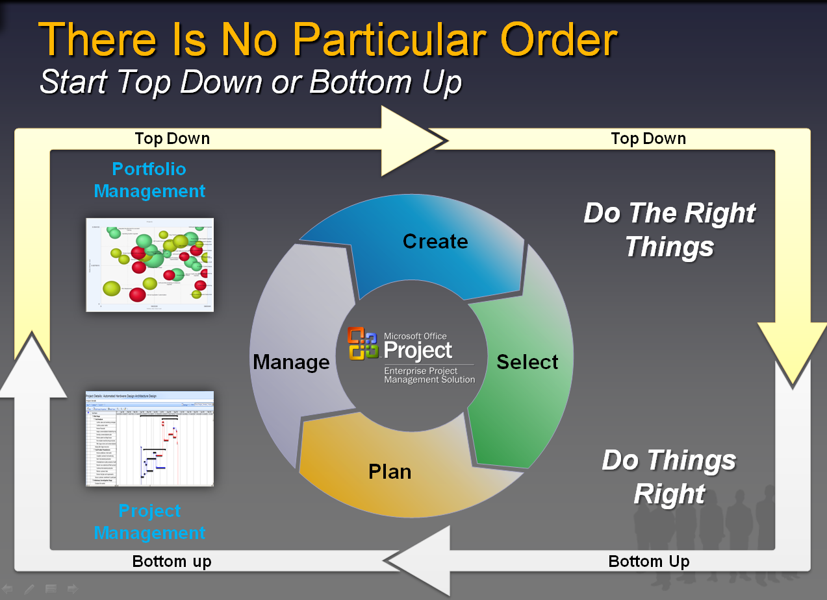
There are generally two approaches to implementing the
entire MS EPM Solution – top down & bottom up.

The Microsoft EPM Solution

Overview
The Microsoft Office Enterprise Project Management (EPM) Solution is an end-to-end collaborative project and portfolio environment. The Office EPM Solution helps your organization gain visibility, insight and control across all work, enhancing decision-making, improving alignment with business strategy, maximizing resource utilization and measuring and helping to increase operational efficiency.
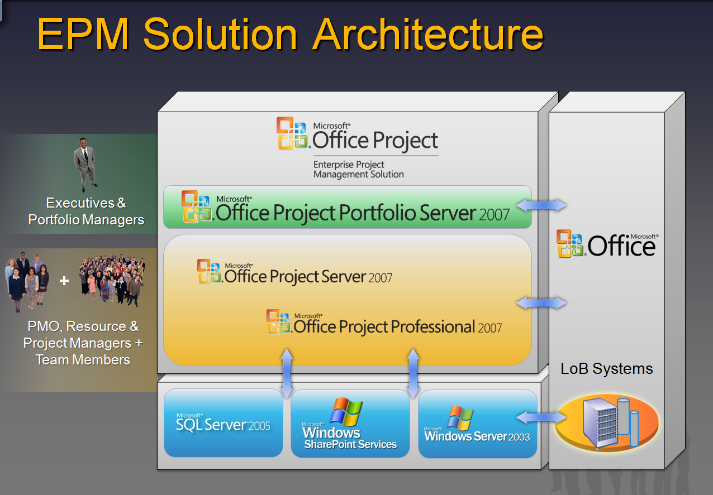
The Office EPM Solution includes the following products from the Microsoft Office Project 2007 family to provide organizations with an end-to-end project portfolio management (PPM) solution:
- Microsoft Office Project Professional 2007: Microsoft Office Project Professional 2007 includes all the capabilities in Microsoft Office Project Standard 2007. Office Project Professional 2007 gives you robust project management tools with the right blend of usability, power and flexibility, so you can manage projects more efficiently and effectively. You can stay informed, control project work, schedules and finances, and keep project teams aligned, while becoming more productive through powerful reporting options, integration with familiar Microsoft Office system programs, guided planning, wizards and templates. In addition, Office Project Professional 2007 provides EPM capabilities when connected to Microsoft Office Project Server 2007
- Microsoft Office Project Server 2007: Microsoft Office Project Server 2007 is the flexible platform that supports the resource management, scheduling, reporting, and collaboration capabilities in the Office EPM Solution. Office Project Server 2007 enables organizations to store project and resource information centrally and consistently. It also integrates with Microsoft Windows SharePoint Services 3.0 for file management and collaboration capabilities, helping team members to work together more effectively. Further, based on their roles, users can access data and functionality via the Internet with Microsoft Office Project Web Access
- Microsoft Office Project Portfolio Server 2007: Microsoft Office Project Portfolio Server 2007 is a top-down portfolio management solution that helps organizations to realize their potential by identifying, selecting, managing, and delivering portfolios that best align with their business strategy. Office Project Portfolio Server 2007 integrates with Office Project Server 2007 to provide organizations with an end-to-end project portfolio management solution, accessed via Microsoft Office Project Portfolio Web Access

Manage and control all types of work
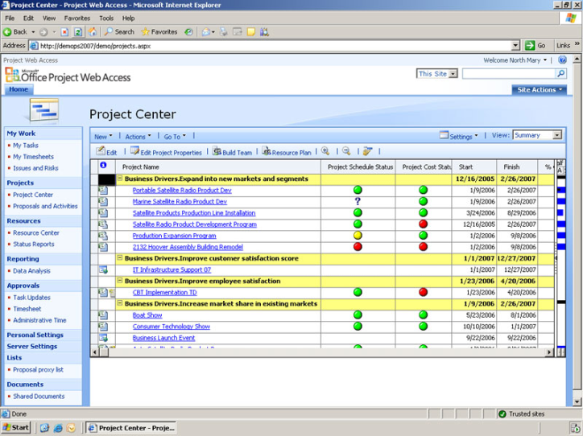
- Standardize and communicate a governance framework across the organization
- Consolidate essential data for all business and IT investments in a centralized repository
- Effectively deliver project and program portfolios that help maximize return on investment
- Gain transparency and control across your existing application portfolios
- Manage work from simple proposals to complex programs of projects
An example of the Project Center view in
Office Project Web Access

Improve visibility and insight to enhance decision-making
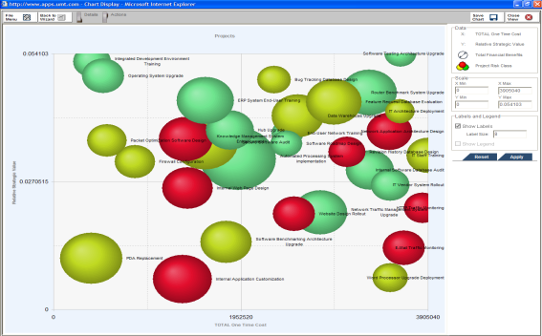
- Objectively prioritize, optimize and select the project portfolio that aligns with your business strategy and maximizes return on investment
- Proactively predict cost, resource and schedule overruns through key performance indicators (KPIs)
- Create custom views (such as Dashboards or Scorecards) and reports to gain transparency across all projects, programs and application portfolios
- Analyze information, and then use predefined reports or create a custom report to expose project-related information
An example of bubble chart showing project strategic value vs. costs
Office Project Portfolio Server 2007.

Effectively communicate and collaborate with all stakeholders
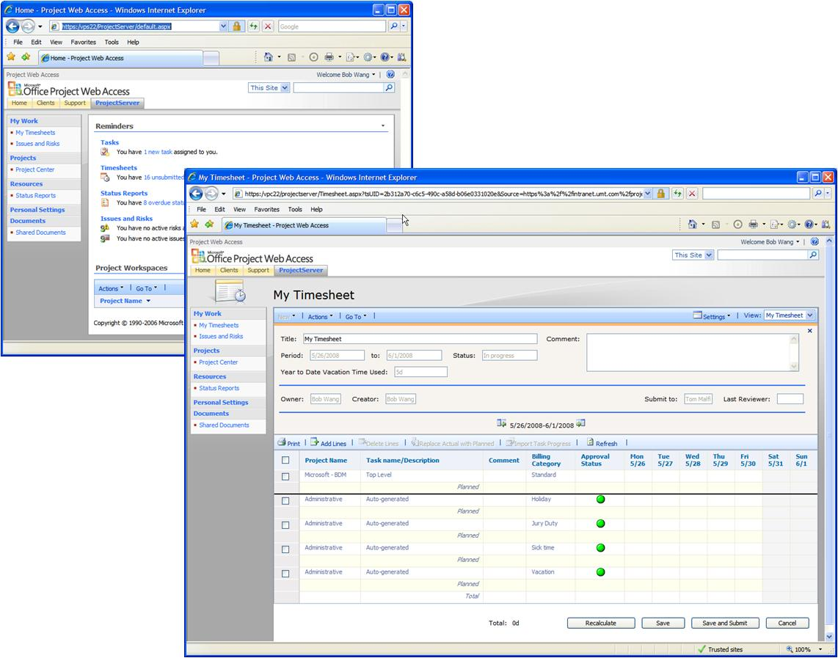
- Effortlessly collaborate and share essential information through team project workspaces that use Windows SharePoint Services
- Keep teams aligned through task assignments and timesheet reporting
- Confidently initiate, plan and track projects whether in or out of the office
- Use built-in integration to communicate project-related information through Microsoft Office system applications
An example home page with personalized content
and links to project workspaces and a personalized time sheet

Evolve with a scalable and configurable platform
- Take advantage of embedded best practices and templates to simplify configuration and deployment and quickly realize a return on investments
- Effectively integrate and share data with line-of-business solutions
- Scale up and out with confidence using the newly redesigned server architecture
- Tap into all of the Project Web Access capabilities through their exposure as Web services
- Incorporate business processes by using the Windows Workflow Service support for the Office Project Server 2007 new event model
- Develop custom solutions using a Microsoft .NET Framework–based server application programming interface (API) and server-side scheduling engine

The Microsoft Office EPM Solution Architecture

Conclusion
The Microsoft Office Enterprise Project Management (EPM) Solution is an end-to-end collaborative project and portfolio environment. The Office EPM Solution helps your organization gain visibility, insight and control across all work; thus enhancing decision-making, improving alignment with business strategy, maximizing resource utilization, as well as measuring and increasing operational efficiency.

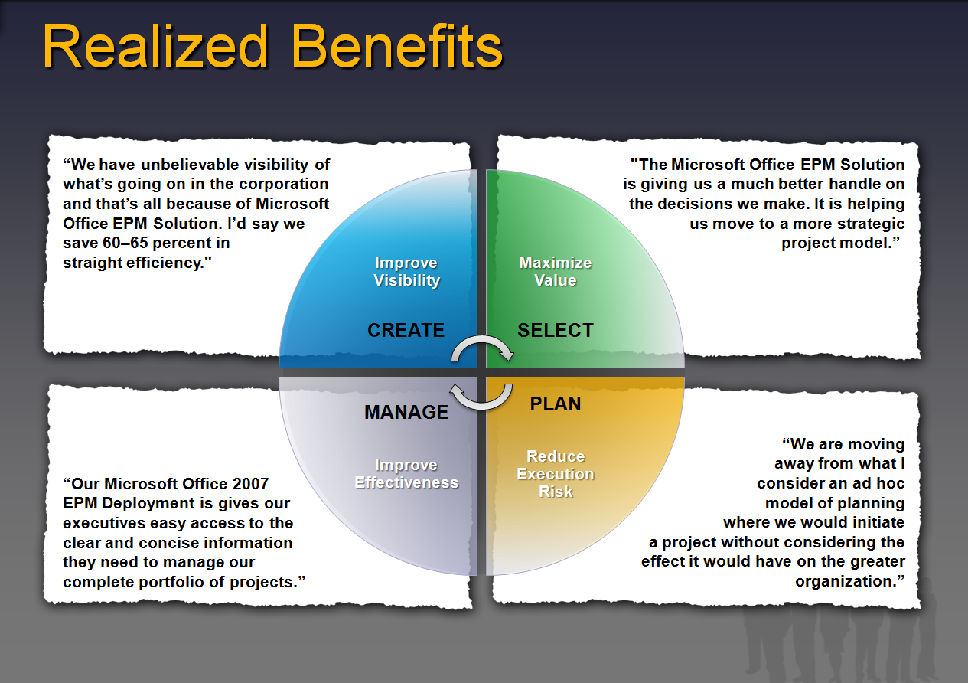

The information contained in this document represents the current view of Microsoft Corporation on the issues discussed as of the date of publication. Because Microsoft must respond to changing market conditions, it should not be interpreted to be a commitment on the part of Microsoft, and Microsoft cannot guarantee the accuracy of any information presented after the date of publication.
This white paper is for informational purposes only. MICROSOFT MAKES NO WARRANTIES, EXPRESS OR IMPLIED, IN THIS
DOCUMENT.
Complying with all applicable copyright laws is the responsibility of the user. Without limiting the rights under copyright, no part of this document may be reproduced, stored in, or introduced into a retrieval system, or transmitted in any form or by any means (electronic, mechanical, photocopying, recording, or otherwise), or for any purpose, without the express written permission of Microsoft Corporation.
Microsoft may have patents, patent applications, trademarks, copyrights, or other intellectual property rights covering subject matter in this document. Except as expressly provided in any written license agreement from Microsoft, the furnishing of this document does not give you any license to these patents, trademarks, copyrights, or other intellectual property.
© 2001 Microsoft Corporation. All rights reserved.
The example companies, organizations, products, domain names, e-mail addresses, logos, people, places, and events depicted herein are fictitious. No association with any real company, organization, product, domain name, e-mail address, logo, person, place, or event is intended or should be inferred.

