**Digital Civility Index (DCI) – Brazil**



Microsoft conducted research among adults and teenagers in 14 countries to study the level of civility across various online interactions. These results expand on the behavioral component of Microsoft’s Computer Safety Index (MCSI) by examining the extent of negative civil and personal safety interactions and their consequences.

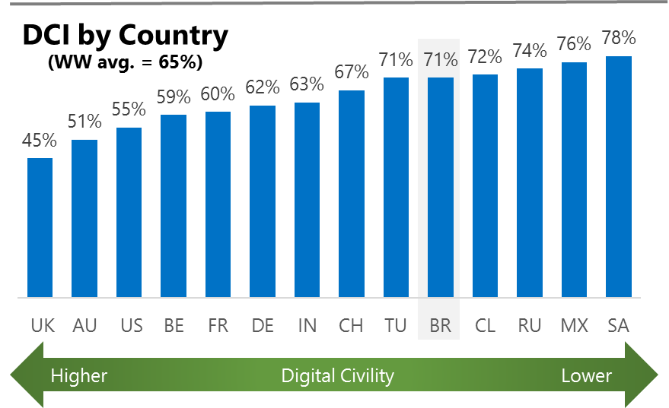The Digital Civility Index (DCI) measures consumers’ lifetime exposure to online risks. Online risks were divided into four categories: Behavioral, Intrusive, Reputational and Sexual. Each category consisted of several individual risks. DCI scores were calculated by using the percentage of consumers who were exposed at some point in time to at least one of 17 different online risk(s). **Lower scores equate to lower online risk exposure and a higher Digital Civility**.

**Brazil ranked 10th in DCI**

71% of Brazilians said they were exposed to an online risk in the past. Most online risks in Brazil were at or above the international average. A notable exception was Treated mean (14%, 23%) which had a lower likelihood of occurrence in Brazil.

**Intrusive**

* Unwanted contact (52%) was the primary driver of Intrusive risks and had the highest score of any online risk by a wide margin. Incidence of unwanted contact was significantly higher than international.

**Behavioral**

* Trolling (23%) and Online Harassment (22%) were the top Behavioral risks with both being slightly higher than the international average.

**Sexual**

* Sexual risks (38%, 29%) were higher than the international average. The difference was driven mostly by Sexual solicitation (22%).
* Unwanted sexting (received or sent, 27%) was the most common sexual risk in Brazil followed by Sexual solicitation (22%).

**Reputational**

* Doxing (15%) was the most common Reputational risk in Brazil.



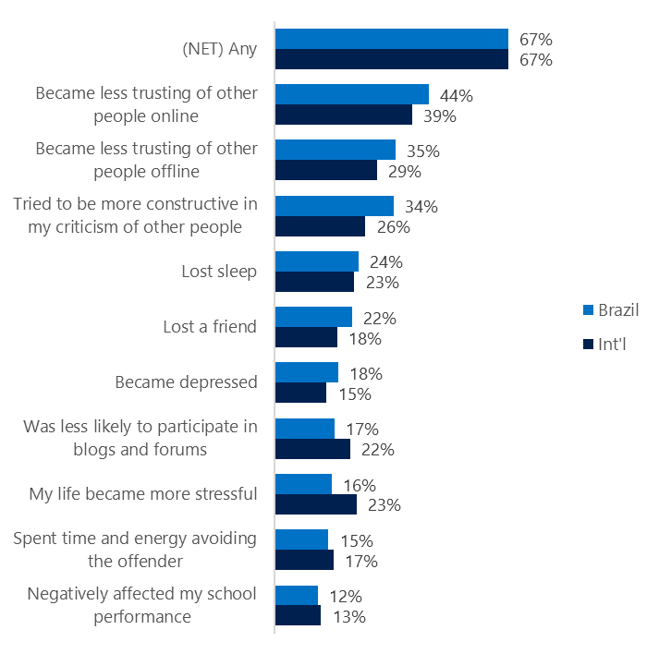**People became less trusting of others**

**Top 10 consequences**

**(Happened to me)**

67% of Brazilians reported a consequence after being exposed to an online risk. This was equal to the international average.

* The biggest consequence from online risk exposure was a loss of trust both online (44%) and offline (35%). The loss of trust was felt more strongly in Brazil than outside the country.
* 34% tried to counterbalance negative outcomes by being more constructive in their criticism of others. This was significantly higher than the international average (26%).
* Brazilians were less likely to experience more stress (16%, 23%) or to Reduce their participation in blogs and forums (17%, 22%) than international.

**Online risks prompted strong concerns**

65% of consumers in Brazil were much more or more concerned about online risks overall. This concern was echoed much less strongly outside the country (International, 48%).

Looking one year ahead, Intrusive risk (72%) garnered the most concern by Brazilians and was higher than international by 17-points. Concern for Reputational (69%) and Behavioral (68%) risks were nearly as high as Intrusive risks and were equally above their respective international averages.

* Brazilians reported having greater concerns across all online risks compared to international.
* Doxing (59%), Damage to personal reputation (54%) and Discrimination (53%) generated the most concern among Brazilians.
* Consumers expressed the second highest level of concern about Reputational risks (69%) even though it had the lowest incidence (happened to me) of the four online risk categories.

**Four in ten experienced an online risk in the past month**

* 42% of Brazilians experienced their most recent online risk within the past week or month.
* 14% said the most recent online risk happened within the past week.
* 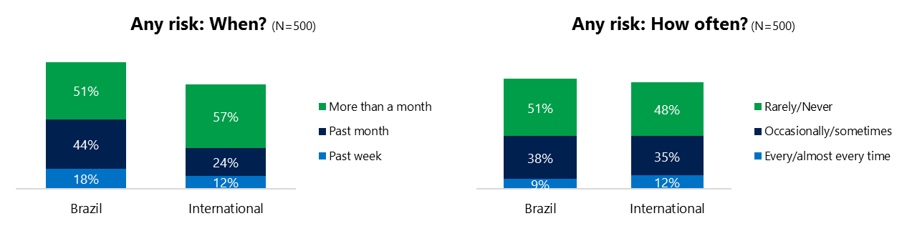9% reported online risks happened every or almost every time compared to 12% internationally.

**Demographics**

**Age**: Not surprisingly, youth (ages 13-17) were found to have a greater number of interactions online than adults (183, 152).[1] Yet, higher interactions among youth did not translate into higher rates of online risk for themselves (66%, 76%), but did for family and friends (60%, 28%). This suggests that youth may have underreported their exposure to online risks and were more willing to share their negative online experiences.

Adults were more likely to experience Intrusive (66%, 51%) and Sexual risks (45%, 31%). It was more common for youth to experience Behavioral risks (46%, 30%).

Youth were more likely to take actions (89%, 85%) and know where to get help if needed than adults (50%, 33%).**Gender**:Males and females reported similar levels of online interactions (170, 166)[2] but males said they had significantly greater exposure to online risks (75%, 67%). The higher incidence of risk for males was driven by Behavioral and Sexual risks.

There were no significant differences by gender on the level of concern, actions taken and having met the perpetrator of the risk.

Females were more pessimistic than males about the future of safety (93, 81)[3] but shared a similar view about the future of civility one year from now.

1. Past year interactions (% more minus % less x 100 +100)
2. Ibid.
3. Lower scores = felt more civil, safer (% worse - % better) x 100+100