Downloading Microsoft Software Assurance
E-Learning Content Files
Common questions answered for Benefits Administrators
The purpose of this document is to guide the organization’s Software Assurance Benefits Administrator through the process of downloading Microsoft E-Learning content files.

Questions and Answers
Q. What are Microsoft E-Learning downloads?
A. In addition to the access and use of some online E-Learning courses, Software Assurance customers are also entitled to download some Microsoft E-Learning content files for use behind their organization’s corporate firewall.
Q. What does it cost to obtain this content?
A. Microsoft E-Learning downloads are provided at no charge to Software Assurance customers. You can either download them from the Volume Licensing Service Center (VLSC) website or order the learning kit of CDs for a small shipping and handling charge. Contact your large account reseller (LAR) to order the learning kits.
Q. Is all of the Software Assurance E-Learning content available for download?
A. No. Only the Applications and Systems courses are available for download. The Server courses are available only online (no charge) or via a hosted AICC integration with a learning management system (fee required) due to the sophistication of the virtual labs contained in the courses.
Q. What are the requirements for using this content?
A. You will need a SCORM 1.2 conformant learning management system (LMS) if you would like to track the results of your learners.

SCORM (Shareable Content Object Reference Model)
• SCORM is a set of standards for building, hosting, and displaying e-learning content created by the Department of Defense under the Advanced Distributed Learning project. (www.adlnet.gov).
• The Microsoft E-Learning content has been tested for SCORM conformance using the ADL Conformance Test Suite.
• Microsoft E-Learning has provide SCORM content-only files for Microsoft® Office 2003, the 2007 Microsoft Office system, Windows® XP, Windows Vista®, and other products. (See Appendix B for a complete listing of courses currently available.)

Q. How do I download the content?
A. You must be a Software Assurance Benefits Administrator for your organization or be given the rights to download Microsoft E-Learning content by your administrator.
Go to the Volume Licensing Service Center (VLSC) site, located at https://www.microsoft.com/licensing/servicecenter/home.aspx, and sign in using your Microsoft account.
If you require assistance from the VLSC support team, please go to this link and open a support ticket:
https://www.microsoft.com/licensing/servicecenter/Help/Contact.aspx
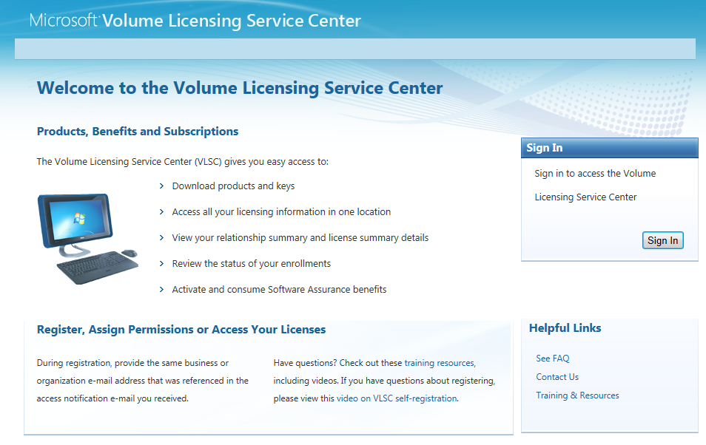

After you sign in, click on the Downloads and Keys tab. Next, on the left menu, select Software Assurance. 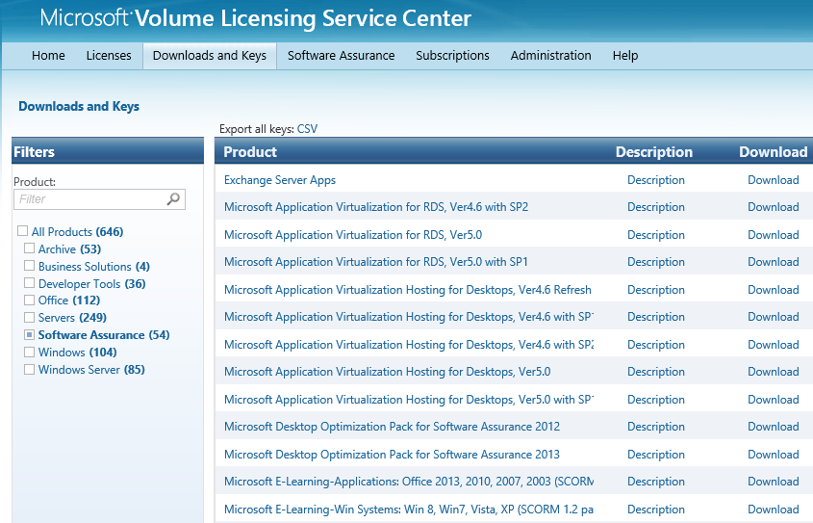
Click on the Download link for the learning content you want to review:

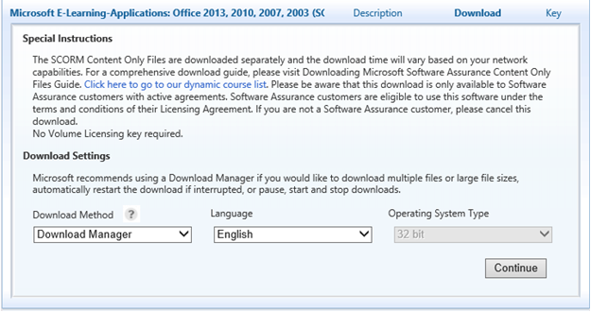
Select your language, and then click Continue.

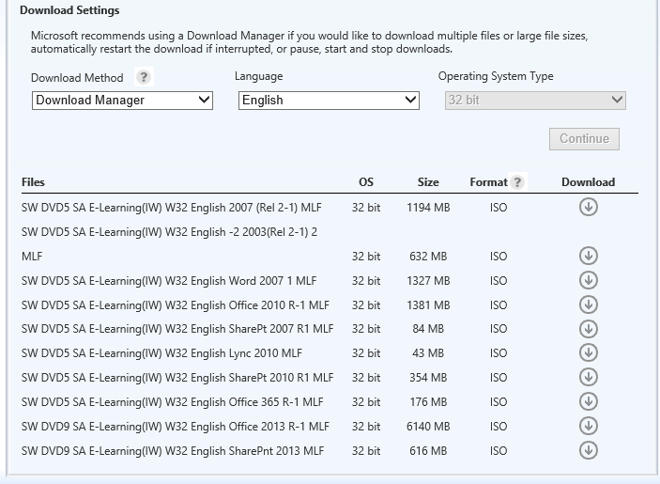
Click on the download arrow next to the batch of courses that you are interested in obtaining.
Note: The Download Manager will resume if interrupted. The web browser download will need to begin again if interrupted.

You need to install an ActiveX control for the download process.
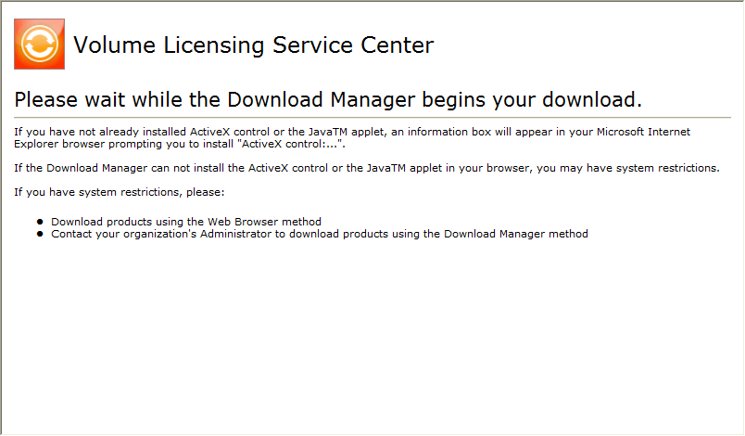

Browse to the folder where you want to store the download, and then click Save.
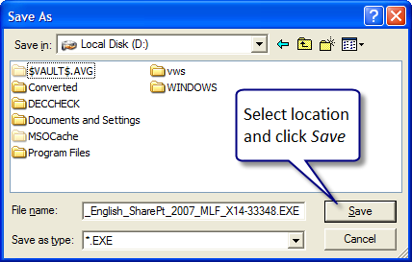

The Download Manager displays the files that are being downloaded and shows the progress.
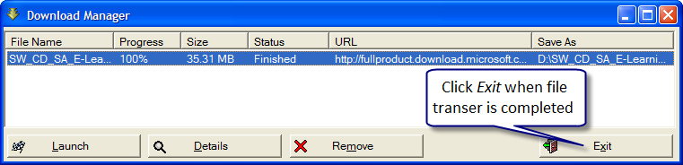
The downloaded file is an .iso file. Most customers prefer using WinRAR (www.rarsoft.com) to unpack the file and access the course zip files. This functionality is built in to Windows 8, so if you’re running that operating system you don’t need WinRAR.

Q. Does Microsoft provide support for my LMS?
A. Microsoft recognizes that some customers have an internal LMS and prefer to host the Software Assurance E-Learning in-house. With such a large number of LMS systems available in the industry, Microsoft is unable to provide support on loading these files into any specific LMS. If you are choosing to host the Software Assurance E-Learning, you should contact your LMS provider for support on loading these files. Once loaded, if you need support regarding how the courses are playing, you can send an email to scormhlp@microsoft.com.
Q. Does Microsoft offer an LMS?
A. No, although a community supported SharePoint Learning Kit (SLK), originally developed by Microsoft, is available at http://www.codeplex.com/SLK. This is a community-supported LMS. Microsoft does not provide support for the SLK.
Q, How do I determine the course titles that are within the .iso file I have downloaded?
A. Inside of each .iso file there is a file named readme.txt. This file contains the titles that correspond to the numbers on each of the zip packages.

