Using SharePoint List Data in PowerPivot
SQL Server White Paper

Writer: Uday S. Unni
Technical Reviewers: John Hancock, Kasper de Jonge, Maxim Lukiyanov

Published: June 2011
Applies to: SQL Server 2008 R2

Summary: One of the many features of Microsoft SQL Server PowerPivot is the range of data sources that can be used to import data. Anything, from Microsoft SQL Server relational databases, Oracle databases, and Microsoft Access databases, to text documents, can be used as data sources in PowerPivot. In this paper, I explain one of the data sources that people are frequently excited about – SharePoint list data in the form of Atom feeds. This white paper goes on to explain the different ways you can import SharePoint list data into PowerPivot, what types of lists are supported, various components that need to be installed to use this feature, and where to get those components.

Copyright

This document is provided “as-is”. Information and views expressed in this document, including URL and other Internet Web site references, may change without notice. You bear the risk of using it.
Some examples depicted herein are provided for illustration only and are fictitious. No real association or connection is intended or should be inferred.
This document does not provide you with any legal rights to any intellectual property in any Microsoft product. You may copy and use this document for your internal, reference purposes.
© 2011 Microsoft. All rights reserved.

Contents
1
Introduction 4
Requirements 4
Importing Into PowerPivot for Excel 7
Importing using PowerPivot for SharePoint 9
Supported Lists 10
Common Errors and Resolutions 10
Conclusion 11

Introduction
As is common in many scenarios, teams have their own Microsoft SharePoint site with various lists to store and view documents, keep track of schedules, and maybe even keep track of team rosters. The traditional way to get this data was to import the data into Microsoft Excel using the Excel feature. But it did not provide users with a way to add to the data or model it. In SharePoint 2010, list data can be exposed in the form of an Atom feed. PowerPivot provides a way to import this data into a table within the PowerPivot environment.

Requirements
This method of getting list data is only applicable to SharePoint 2010. In order to get the list data in the Atom format, you need to install SharePoint 2010. After installing SharePoint, you need the ADO.NET runtime on the Web Front End of your SharePoint farm. The ADO.NET runtime converts the list data into the Atom format. The SharePoint Server admin should install the ADO.NET runtime on the Web Front End (WFE). The ADO.NET runtime can be installed from the following locations, depending on the version of Windows Server you are running:
http://go.microsoft.com/fwlink/?LinkId=221066: Windows Server 2008 R2
http://go.microsoft.com/fwlink/?LinkId=195068: Windows Server 2008
After the runtime is installed, you can access the list data from SharePoint. Figure 1 shows a Task list on a SharePoint site, which keeps track of the work items in a particular improvement.
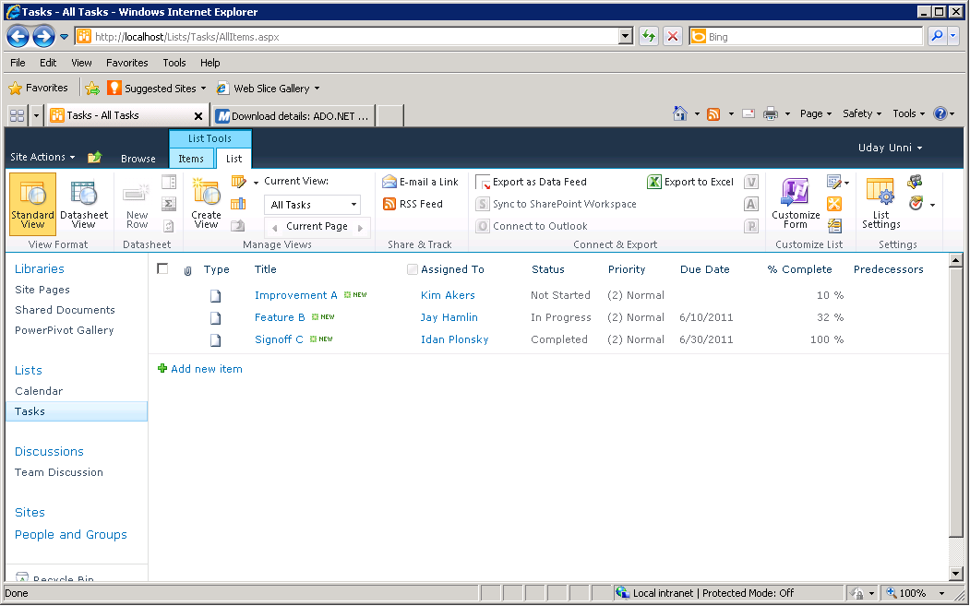
Figure 1: Task list in SharePoint

Users can access the Atom format of this list using a URL in the following format: http://<sharepointsite>/_vti_bin/ListData.svc.
This directs users to a page like the one shown in Figure 2. The page contains all the list information in SharePoint in the Atom format. If you append the name of the list to the end of the URL, users see a page like the one shown in Figure 3, which contains all the data associated with that particular list.
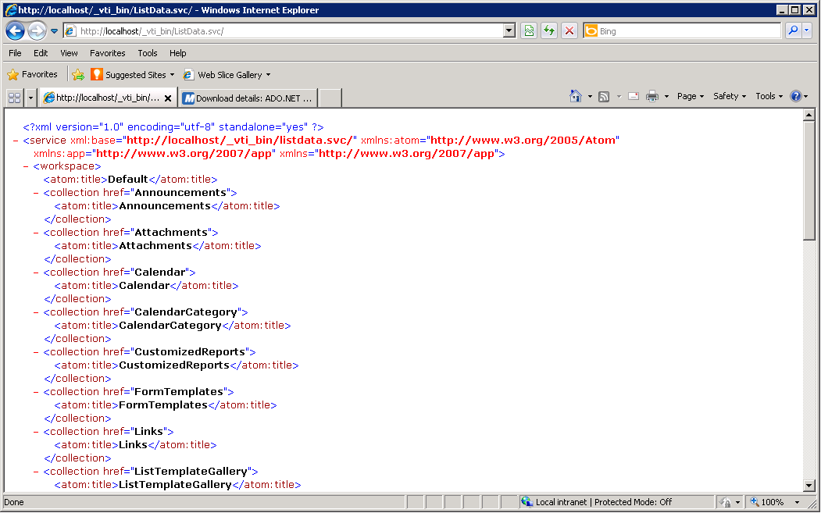
Figure 2: Using the URL, you can get a list of all the SharePoint lists that are exposed as Atom on this particular SharePoint site
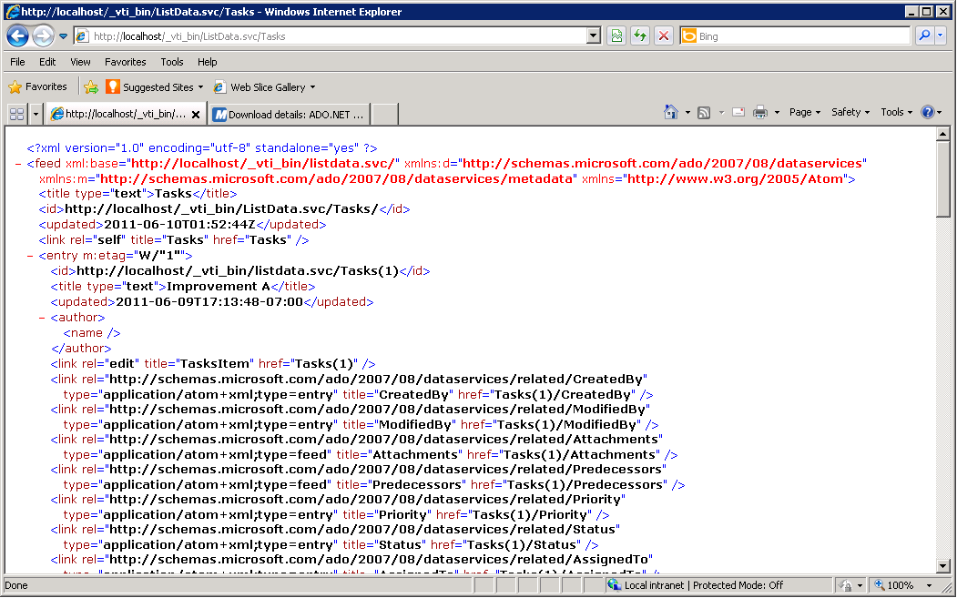
Figure 3: Atom data from the Tasks list using the URL http://<sharePointsiteName>/_vti_bin/ListData.svc/<ListName>

Importing Into PowerPivot for Excel
Using the method this section describes, you can import data in the PowerPivot client, by using the Data Feed option. In Excel, to open the PowerPivot window, on the PowerPivot tab, click PowerPivot Window Launch. On the Home tab, in the Get External Data group, click From Data Feeds, as shown in Figure 4.
Figure 4: PowerPivot window with the ribbon containing the From Data Feeds button
The Table Import Wizard opens, as shown in Figure 5. In the Data Feed URL box, type or browse to the URL you used earlier.
To verify that you have access to the SharePoint site on your machine that you are running PowerPivot in Excel on, click Test Connection in the Table Import Wizard. If the feed URL is valid and your machine has access to the SharePoint site, the test connection should succeed.
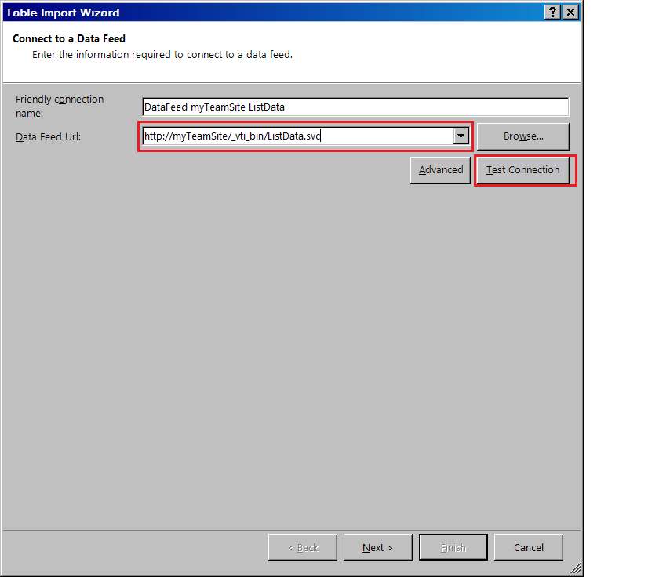
Figure 5: Table Import Wizard
When you click Next, the next page of the wizard appears, displaying the list data.
The URL to the service document (that is, the one that ends in ListData.svc) provides you with a collection of tables that represent each of the lists on the SharePoint site. If you want to import data from multiple lists, you should use the service document. If you are interested in only a single list, you can select that one list, or in the previous window use the URL with the list name appended at the end. For example, if your SharePoint site is http://myTeamSite, the URL to the service document would be http://myTeamSite/_vti_bin/ListData.svc. If you are interested only in the Tasks list on your team site, you would use http://myTeamSite/_vti_bin/ListData.svc/Tasks.
After you select your data, you are in the PowerPivot world. Follow the steps in the Table Import Wizard to display your data in the PowerPivot window. After the import is complete, you can slice, dice, and model away.

Importing by Using PowerPivot for SharePoint
If SharePoint is on your machine and you have the ADO.NET runtime installed, you can import data using the method mentioned in the previous section. If you are a PowerPivot for SharePoint user, you have a SharePoint farm with a Web Front End (WFE) and an Application Server on which the Analysis Services engine runs. Things get even easier in this case. If you have the PowerPivot solution deployed on your SharePoint farm, you can import data directly from the list, just by clicking Export as Data Feed.
PowerPivot for SharePoint just makes things easier by providing you with the Export as Data Feed button, as shown in Figure 6.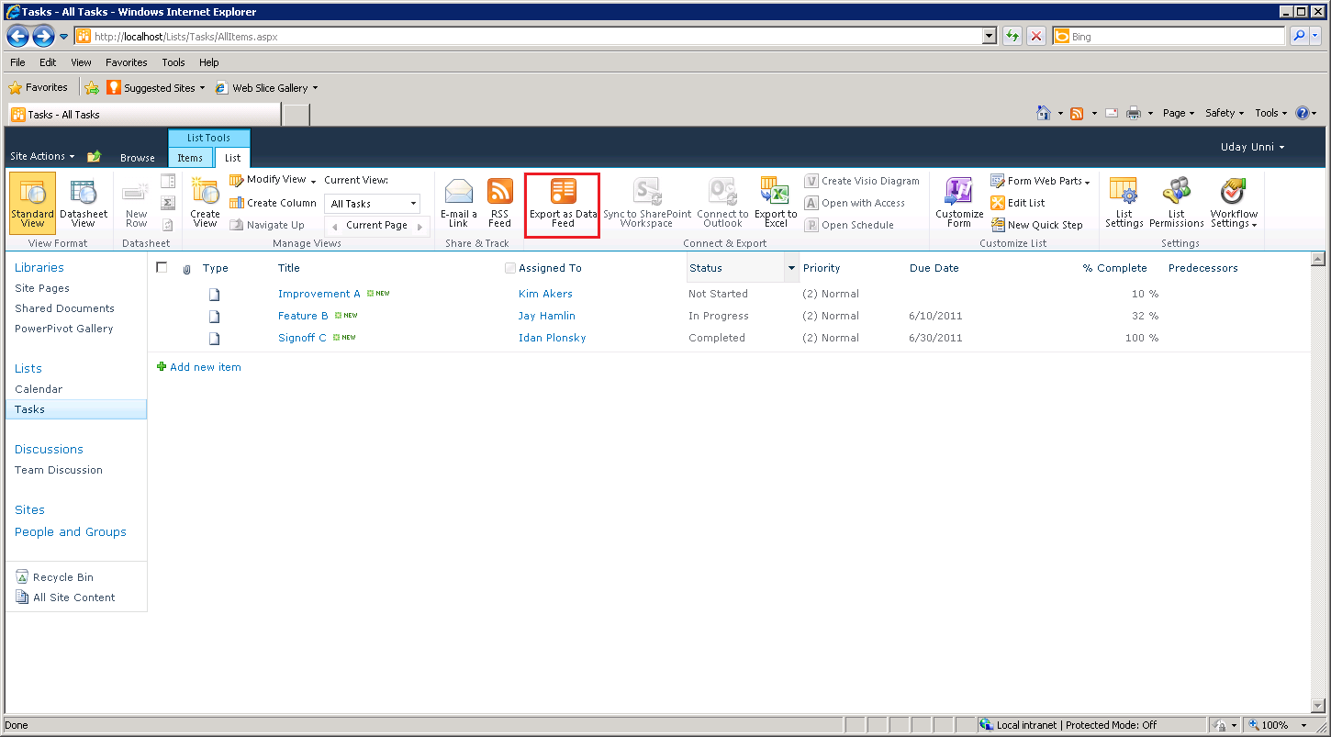
Figure 6: Export as Data Feed button on the SharePoint list
Clicking this button opens Excel and the PowerPivot window with the URL to the SharePoint list feed displayed. From there, if you go through the whole Import Wizard, your list data appears in PowerPivot. If you have PowerPivot installed, you can still access the URL and use that to import your data.

Supported Lists
The following lists are supported in Atom format for SharePoint:
- Announcements
- Calendar
- Links
- Tasks
- Contacts
- Custom lists
- Custom lists in DataSheet view
- Issue tracking
- Project tasks
- Discussion boards
In addition to these lists, document libraries are also supported, like:
- PowerPivot Gallery
- Shared Documents

Common Errors and Resolutions
- If you do not see the Export as Data Feed button, the PowerPivot solution is not deployed on your SharePoint site. If you deploy the PowerPivot solution at the farm level, you should be able to see the button.
- If you are using Microsoft Office 365, you cannot access list data in the Atom format. This is a current limitation.
- If the button is visible but unavailable, the ADO.NET runtime is not installed on your machine. Installing the runtime and refreshing the page should cause the button to become available.
- If you do not have PowerPivot for SharePoint, and your URL is returning a HTTP 404 error, you do not have the ADO.NET runtime installed. Installing the runtime and refreshing the page should provide the data to you.
- In the PowerPivot window, while previewing or filtering the data, if you see the following message, you need to install the ADO.NET runtime on the SharePoint Web Front End (WFE).
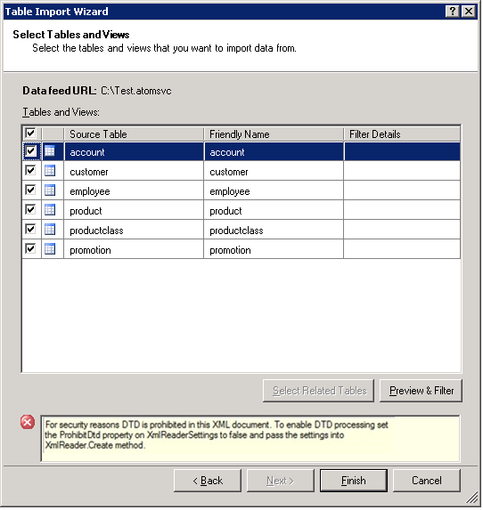
Figure 7: The ADO.NET runtime needs to be installed on the WFE for the SharePoint machine

Conclusion
Importing SharePoint list data is a common task among users, and in SQL Server 2008 R2, you can import this data efficiently and easily. You can import schedule data from the Calendar list, task data from the Tasks list, and all other relevant data from any of your other lists; combine it all together in a PowerPivot model; and then create a report. In SQL Server 2008 R2, the immense power that Atom feeds provide is integrated into PowerPivot.
For more information:
http://www.microsoft.com/sqlserver/: SQL Server Web site
http://technet.microsoft.com/en-us/sqlserver/: SQL Server TechCenter
http://msdn.microsoft.com/en-us/sqlserver/: SQL Server DevCenter

Did this paper help you? Please give us your feedback. Tell us on a scale of 1 (poor) to 5 (excellent), how would you rate this paper and why have you given it this rating? For example:
- Are you rating it high due to having good examples, excellent screen shots, clear writing, or another reason?
- Are you rating it low due to poor examples, fuzzy screen shots, or unclear writing?
This feedback will help us improve the quality of white papers we release.
Send feedback.

