

**Microsoft Office 365 for Enterprises**

Volume Licensing Activation Guide

Published: August 2011

© 2011 Microsoft Corporation. All rights reserved.

Microsoft provides this material solely for informational purposes. MICROSOFT MAKES NO WARRANTIES, EXPRESS, IMPLIED, OR STATUTORY, AS TO THE INFORMATION IN THIS DOCUMENT. Customers should refer to their licensing agreements for a full understanding of their rights and obligations under Microsoft’s Volume Licensing programs. The value and benefit gained through use of Microsoft software and services may vary by customer. In the case of any discrepancy between these terms and the terms of your Volume Licensing Agreement, the terms of the Volume Licensing Agreement control.

Table of Contents

Microsoft Office 365 for Enterprises – Volume Licensing 1

Activation - Customer Scenarios and Email 2

New Online Services Customer 2

Office 365 for Enterprises Trial Customer 2

BPOS-S/Office 365 for Enterprises Bypass Customer 2

Activation Email – Customer Contact Information 2

Activation Email - Sign In vs. Sign Up Options 3

Activation – Step-by-step process per scenario 4

New Online Services Customer 4

Office 365 for Enterprises Trial Customer 8

BPOS-S/Office 365 for Enterprises Bypass Customer 12

# Microsoft Office 365 for Enterprises – Volume Licensing

Microsoft® Office 365 for Enterprises delivers the power of cloud productivity to businesses of all sizes, helping to save time and money and free up your valuable resources. Microsoft Office 365 for Enterprises combines the familiar Microsoft Office desktop suite with cloud-based versions of Microsoft’s next-generation communications and collaboration services—including Microsoft Exchange Online, Microsoft SharePoint® Online, and Microsoft Lync™ Online—to help users be productive from virtually anywhere via the Internet.

With Office 365 for Enterprises, Microsoft has made improvements in the activation and provisioning of accounts for customers who have purchased the Microsoft Office Business Productivity Standard Suite (BPOS-S) or Office 365 using Volume Licensing Agreement programs for Enterprise, Campus or Schools directly from Microsoft or indirectly through a Microsoft channel partner.

**This guide is intended to provide Microsoft Office 365 for Enterprises customers with a thorough understanding of the basic activation process when purchasing their online services using their Microsoft Volume Licensing Agreement.**

For further information not covered in this document, Customer’s can submit an online service request via the [Microsoft Online Portal](https://mocp-support.custhelp.com/cgi-bin/mocp_support.cfg/php/enduser/ask.php?p_sid=pf_3), or in the US and Canada, call the support center directly at: **1-866-676-6546** and select option **#2** (6am PST to 6pm PST – Monday through Friday). For international customers, please find the hours and contact information [here](http://www.microsoft.com/online/help/en-us/mocp/index.html?page=html%2F0d8eb4c2-77c5-4dd8-b66c-9f1de7451e24.htm)

# Activation - Customer Scenarios and Email

This document is intended to provide clarification regarding the following three major activation scenarios for customers who are purchasing Office 365 for Enterprises using Microsoft Volume Licensing.

New Online Services Customer

New online services customers who are purchasing Office 365 for Enterprises who have never previously opened an Office 365 trial account, nor have ever purchased online services from Microsoft.

Office 365 for Enterprises Trial Customer

Office 365 for Enterprises Trial customers are those who are actively using an Office 365 Trial Account *(no subscription fee)* and want to transition their Office 365 Trial Account over to a fully activated Office 365 production account *(subscription fee).* This trial transition can either be made (a) *with* trial data and settings being retained or (b) *without* preserving trial data and settings.

BPOS-S/Office 365 for Enterprises Bypass Customer

BPOS-S/Office 365 for Enterprises Bypass customers are those who in the past have purchased BPOS-S through their Volume Licensing but *never activated* their BPOS-S online services. These inactive services are automatically “bypassed” and transitioned to Office 365 for Enterprises online services.

Activation Email – Customer Contact Information

Each of the above three scenario’s begins with Microsoft sending the customer an “activation” email informing the customer how to formally activate their online services. The default contact at the customer’s organization for receiving the activation email is the Online Services Manager (OSM). The Online Services Manager is the individual listed on the customer’s Volume Licensing enrollment form. If the Online Services Manager’s contact information needs to be updated, please go to <https://www.explore.ms/publichome.aspx>  in order to update the Contract Information Change Request Form. Any updates to the Contract Information Change Request Form will not automatically activate an email being resent.

If the enrollment form does not designate an Online Services Manager, the activation email will be sent to either the Volume License Service Center (VLSC) Online Administrator or the Notices Contact & Online Administrator identified on the enrollment.

**NOTE:** All purchase orders for online services must include the correct contact information for the Online Services Manager and/or the VLSC Administrator, otherwise the notification email could be sent to the wrong individual within the customer’s organization.

Activation Email - Sign In vs. Sign Up Options

When the customer receives the activation email, depending on their activation scenario they are given the choice to either ‘Sign In’ or ‘Sign Up’. **This is a one time, irreversible action so its important to understand the differences between these two options before any action is taken.** Below are the appropriate options based on the three activation scenario’s previously stated above:

New Online Services Customer

When a new online services customer purchases Office 365 for Enterprises via their Enterprise Agreement (EA), and has *never* participated in an Office 365 Trial, they should use the **Sign Up** option from the link in the activation email.

Office 365 for Enterprises Trial Customer

If a trial customer chooses to *retain* their Office 365 for Enterprises trial data, settings and their existing *onmicrosoft.com* domain during their transition from trial to a paid subscription, they will need to choose **Sign In**. Choosing this option will allow the customer to transition their trial subscription over to the licensed production subscription.

If a trial customer wants a wholly new Office 365 for Enterprises subscription when they transition from their existing trial to a newly created paid subscription, they will need to choose **Sign Up** option from the link in the activation email.

BPOS-S/Office 365 for Enterprises Bypass Customer

Customers who in the past have purchased BPOS-S through their Volume Licensing but never activated their BPOS-S online services are referred to as “bypass” customers because those inactive services are automatically “bypassed” and converted to Office 365 for Enterprises online services. “Bypass” customers can either **Sign Up** just ike a new customer or they can choose to **Sign In**.

*Note: This option does not apply to any BPOS-S trial customers.*

# Activation – Step-by-step process per scenario

## New Online Services Customer

When a new online services customer purchases Office 365 for Enterprises via their Enterprise Agreement (EA), and has *never* participated in Office 365 Trial, to purchase and activate their Office 365 for Enterprises subscription, the following 7 step process is executed.

1. Microsoft or Microsoft Partner enters volume licensing order.
2. Customer receives “Activation” email (Figure 1) and selects option #2 – “Sign up”

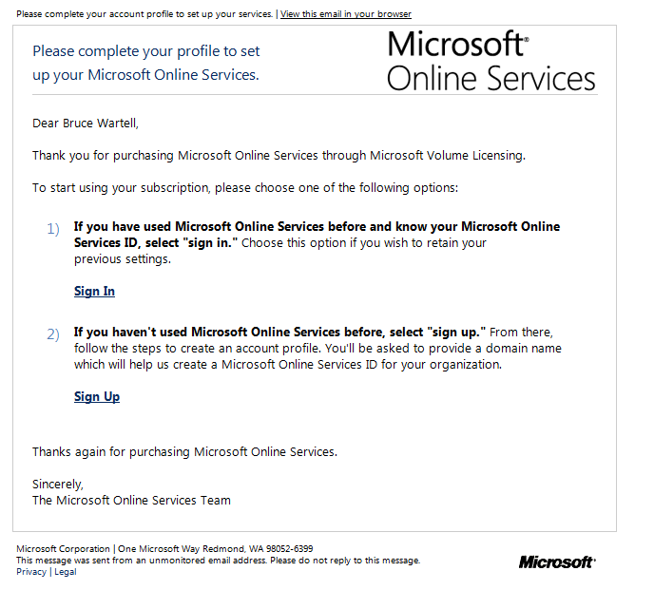

**Click Sign Up…**

Figure 1. **Current** Microsoft Online Services Volume Activation email.

1. Customer creates and activates a new Account Profile (Figure 2)

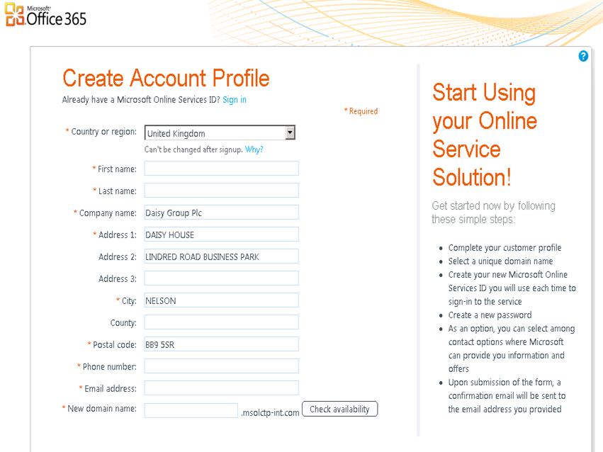

Figure 2. Microsoft Online Services Account Profile Creation.

1. Customer adds New Microsoft Online Services ID (Figure 3)

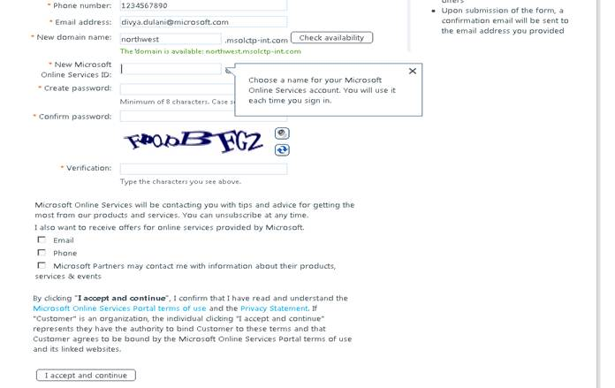

*Figure 3. Microsoft Online Services ID.*

1. Customers receives profile creation acknowledgement (Figure 4)

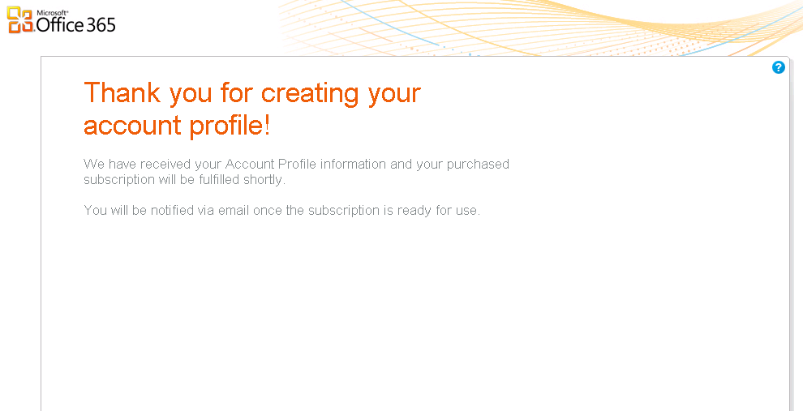

*Figure 4. Microsoft Online Services Account Profile Creation Acknowledgement.*

1. Customer receives provisioning confirmation email for services they have purchased. SharePoint Online (Plan 2) is an example. (Figure 5)

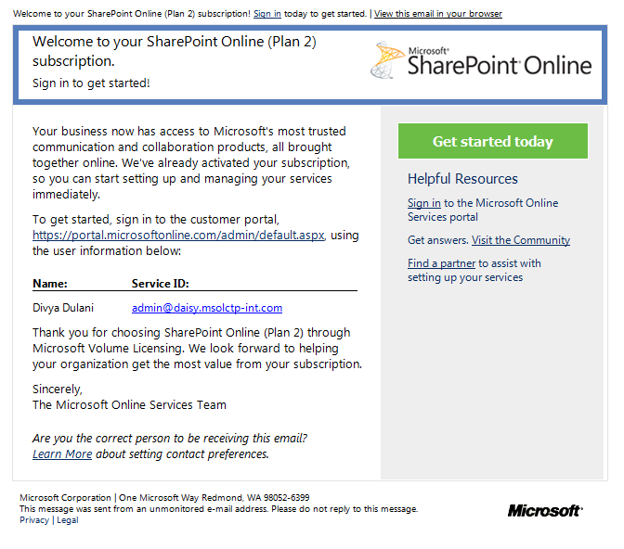

*Figure 5. Microsoft Online Services Provisioning Confirmation email.*

1. Customer reviews the created subscriptions (Figure 6)

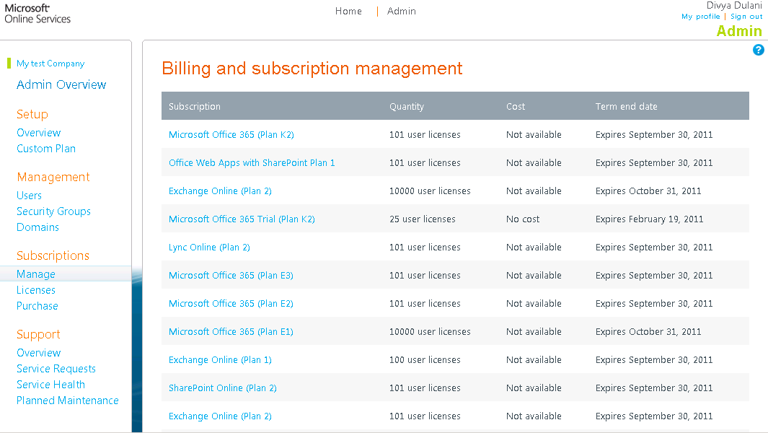

Figure 6. Microsoft Online Services Billing and subscription management page.

1. Customer reviews subscription details (Figure 7)

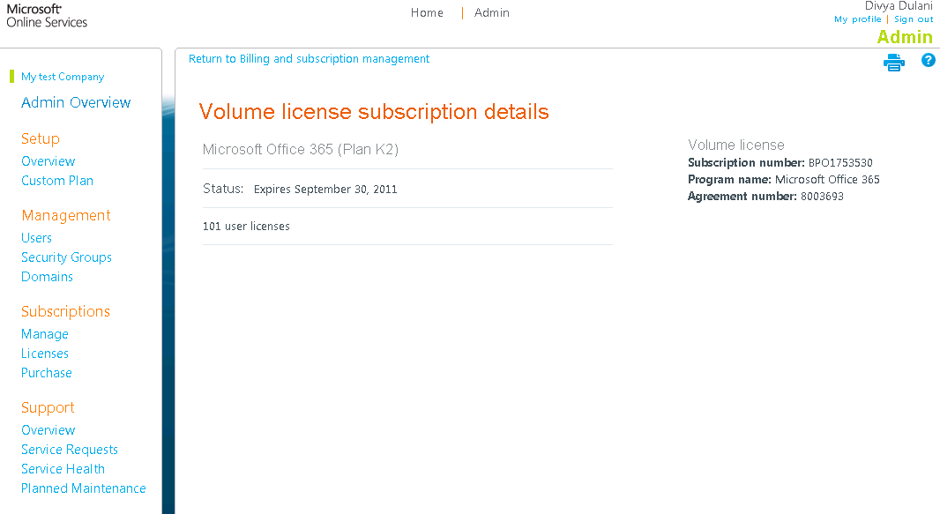

Figure 7. Microsoft Online Services Volume license subscription details page.

## Office 365 for Enterprises Trial Customer

The Office 365 for Enterprises 30-day trial allows customers to experience Office 365 for enterprises first hand prior to committing to a paid subscription. Identical in functionality to the paid subscription but limited to 30 days, customers are advised to convert their trial subscription over to a fully activated production account. Microsoft will advise customers before any data is deleted after the 30-day trial ends.

When transitioning from a trial to a paid subscription, the customer can choose to retain their trial data and settings, or they can elect to make the transition without preserving their trial data and settings.

If a trial customer chooses to *retain* their Office 365 for Enterprises trial data, settings and their existing *onmicrosoft.com* domain during their transition from trial to a paid subscription, they will need to **Sign In**. Choosing this option will allow the customer to convert their trial subscription over to the licensed production subscription.

If a trial customer wants a wholly new Office 365 for Enterprises subscription when they transition from their existing trial to a newly created paid subscription, they will need to choose **Sign Up**.

To transition from Office 365 for Enterprises trial to a paid Office 365 for Enterprises subscription, while retaining their trial data and settings, is accomplished in the following 6 steps:

1. Microsoft or Microsoft Partner enters volume licensing order.
2. Customer receives “Activation” email and selects Option 1 – “Sign In”



**Click Sign In…**

1. Customer signs in & provides existing account subscription information

The customer is then directed to the Online Services sign in page and signs in with their Online Services ID and password. Once signed in, the customer receives an acknowledgement that their exisiting tenant information is being associated with their Volume Licensing information.

**NOTE:** If the customer does not remember existing customer account profile information, they should contact Microsoft Support to obtain credentials. Customer’s can submit an online service request via the [Microsoft Online Portal](https://mocp-support.custhelp.com/cgi-bin/mocp_support.cfg/php/enduser/ask.php?p_sid=pf_3), or in the US and Canada, call the support center directly at: **1-866-676-6546** and select option **#2** (6am PST to 6pm PST – Monday through Friday). For international customers, please find the hours and contact information [here](http://www.microsoft.com/online/help/en-us/mocp/index.html?page=html%2F0d8eb4c2-77c5-4dd8-b66c-9f1de7451e24.htm)

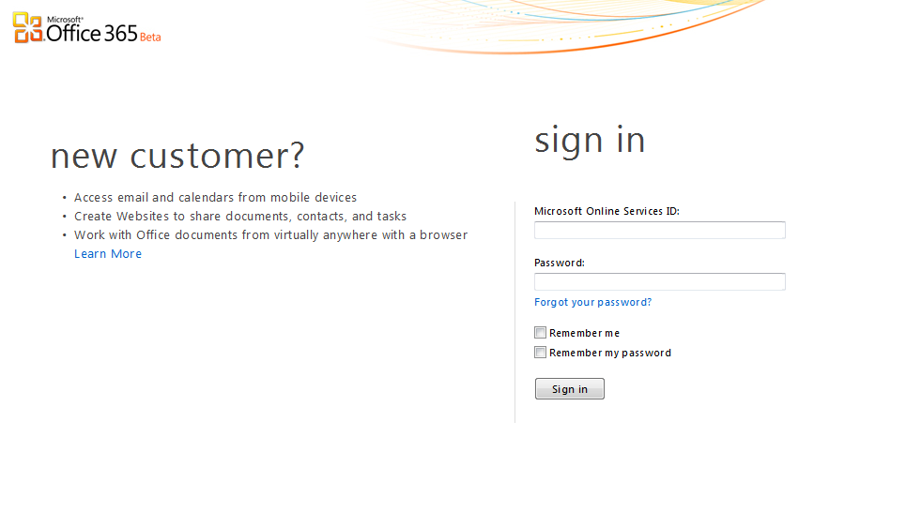

divya@dulani.msolctp-int.com

*

**Customer signs in**

1. Customer receives provisioning confirmation email



1. Customer reviews the created subscriptions



1. Customer views subscription details



## BPOS-S/Office 365 for Enterprises Bypass Customer

For customers who in the past have purchased BPOS-S through their Volume Licensing Agreement but *never activated* their BPOS-S online services, these inactive subscriptions will automatically be “bypassed” and transitioned over to being an Office 365 for Enterprises paid subscription.

“Bypass” customers can either **Sign Up** just like a new online services customer, or they can **Sign In**. Once signed in or signed up, the customer receives an acknowledgement that their existing account information is being associated with their Volume Licensing information.

This process to convert inactive BPOS-S subscriptions to Office 365 was completed in July 2011.