Hands-On Lab

Introduction to Test Planning with Microsoft Test Manager 2015

Lab version: 14.0.25123.0
Last updated: 5/27/2016

TABLE OF CONTENT
Introduction to Test Planning with Microsoft Test Manager 2015 1
Overview 3
Prerequisites 3
Exercises 3
Exercise 1: Creating and Configuring a Test Plan 4
Exercise 2: Adding Test Suites and Test Cases to a Test Plan 11
Exercise 3: Creating and Adding Requirements to a Test Plan 16
Exercise 4: Managing Tests Using the Test Hub 21

Overview
Microsoft Test Manager 2015 can be used to organize your test plans, author and manage your test cases, and run manual tests. In this lab, you will be introduced to test planning in Microsoft Test Manager.
This hands-on-lab is one out of a number of labs that deal with Microsoft Test Manager 2015. The recommended order to complete the labs in is as follows:
  - Introduction to Test Planning with Microsoft Test Manager 2015
  - Introduction to Test Case Management with Microsoft Test Manager 2015
  - Authoring and Running Manual Tests using Microsoft Test Manager 2015
  - Introduction to Platform Testing with Microsoft Test Manager 2013

Prerequisites
In order to complete this lab you will need the Visual Studio 2015 virtual machine provided by Microsoft. For more information on acquiring and using this virtual machine, please see this blog post.

Exercises
This hands-on lab includes the following exercises:
  - Creating and Configuring a Test Plan
  - Adding Test Suites and Test Cases to a Test Plan
  - Creating and Adding Requirements to a Test Plan

Estimated time to complete this lab: 60 minutes.

Exercise 1: Creating and Configuring a Test Plan
In this exercise, you will learn how to create and configure a new test plan in Microsoft Test Manager. This test plan can be used, for instance, to test the new release of your software.
  - Log in as Julia Ilyiana (VSALM\Julia). All user passwords are P2ssw0rd.
  - Launch Microsoft Test Manager from the taskbar. Microsoft Test Manager allows testers to work with test plans, author and organize manual test cases, execute test cases, file bugs, and post results back to Team Foundation Server.
    - 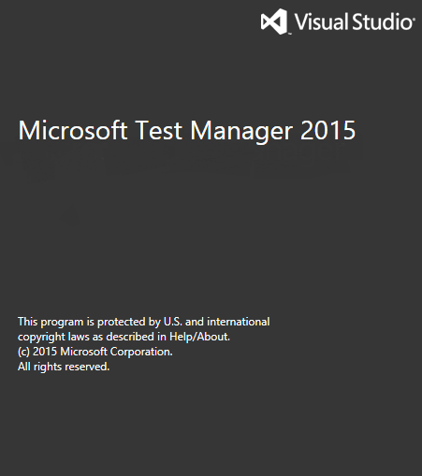
    - Figure 1
    - Microsoft Test Manager splash screen

  - Select the activity center drop down from the top menu that currently shows Testing Center. The Testing Center is used to work with manual test cases and other general test case management. Lab Center is used to work with physical or virtual testing labs. For this lab, we will focus on the Testing Center.
    - 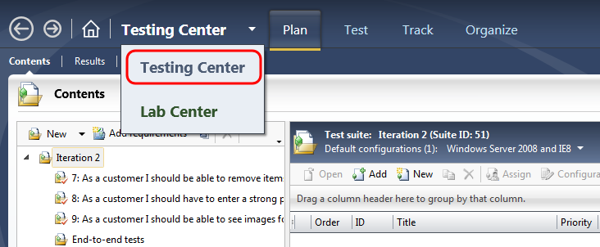
    - Figure 2
    - Testing Center showing the Plan activity

  - Click the Home button next to the activity center dropdown to open the Testing Center window.
    - Figure 3
    - Open the Testing Center window using the Home button

  - In the Testing Center window, click Add to add a new test plan.
    - 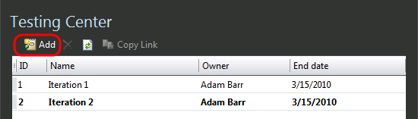
    - Figure 4
Adding a new test plan

  - For Plan name, enter “Release 2.0”.
  - For Area path, choose Tailspin Toys\Web site.
  - For Iteration, choose Tailspin Toys\Iteration 2.
  - Click Add to continue.
    - 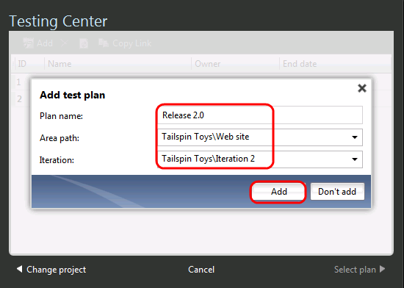
    - Figure 5
Adding a new test plan

  - In the Testing Center window, select the newly created Release 2.0 test plan and then click Select Plan to open it.
    - 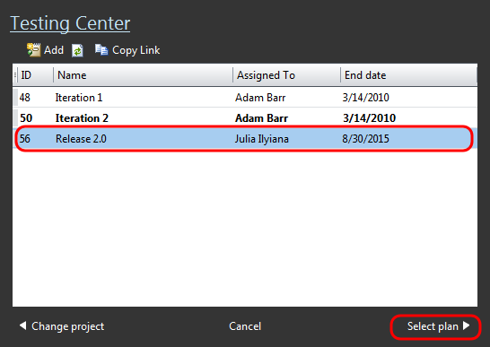
    - Figure 6
    - Selecting a test plan

  - Select the Properties tab to view the plan’s properties. The test plan properties window allows you to edit the basic properties like name, area path, iteration, state, and so on.
    - 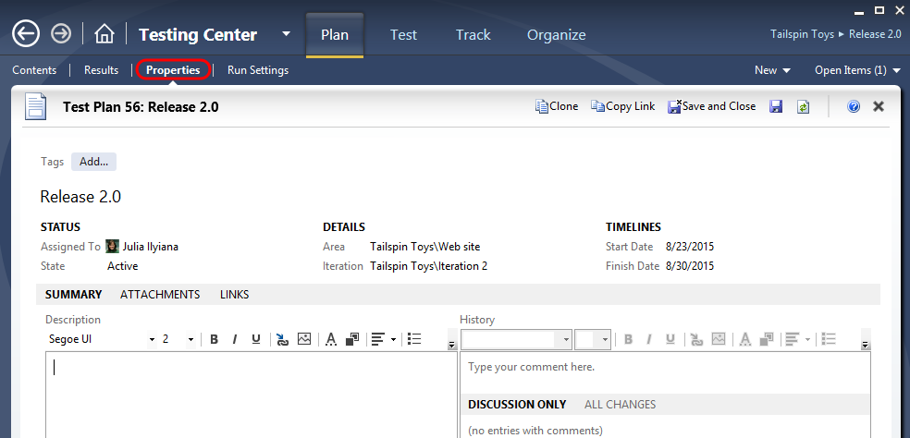
    - Figure 7
    - Test plan properties window

  - Select the Run Settings tab to view the plan’s run settings. The Run Settings section allows you to specify how manual and automated test runs should be setup, what test environment to use, and even the specific build to test against.
    - 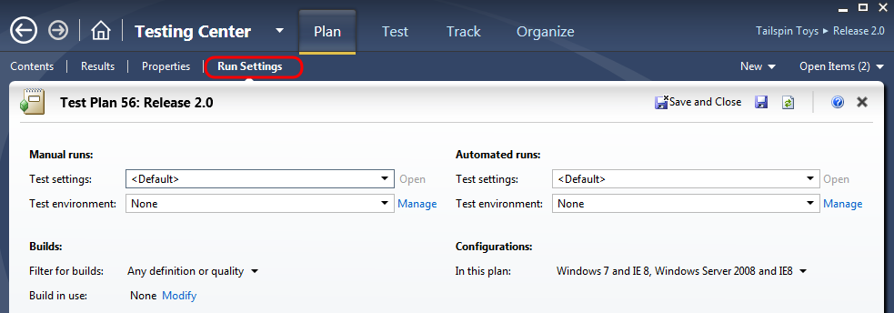
    - Figure 8
    - Test plan run settings window

  - In the Manual Runs section, choose Lightweight Diagnostics for the Test settings option and click Open to open the Test Settings window.
    - 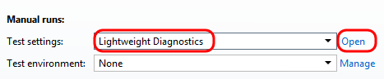
    - Figure 9
    - Adjusting manual test run settings

  - In the test settings window, select the Data and Diagnostics step to configure the Data Diagnostic Adapters to use during testing.
    - 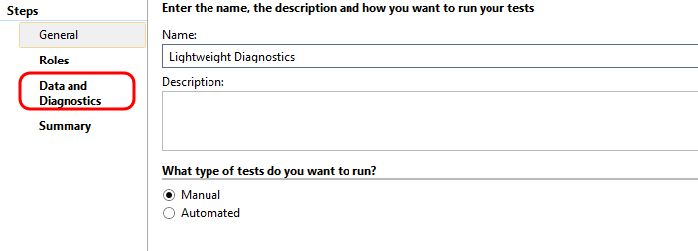
    - Figure 10
    - Test settings window

  - Select the Action Log, IntelliTrace, System Information, and Screen and Voice Recorder diagnostic data adapters (some may already be selected), then click Finish to close the test settings window and return to the test plan properties window.
    - 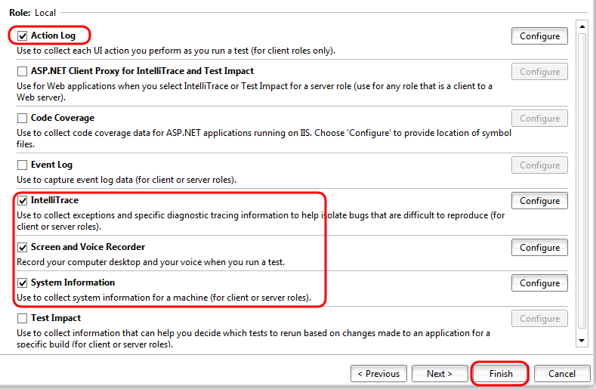
    - Figure 11
    - Selecting data diagnostic adapters

  - Click Save to save the test plan.
    - 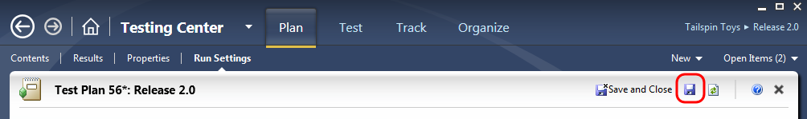
    - Figure 12
    - Location of Save button

    - Note: The test plan needs to be saved before selecting a build.

  - In the Builds section, click Modify next to the Build in use label. The selected build will be used when recording test results or filing bugs.
    - 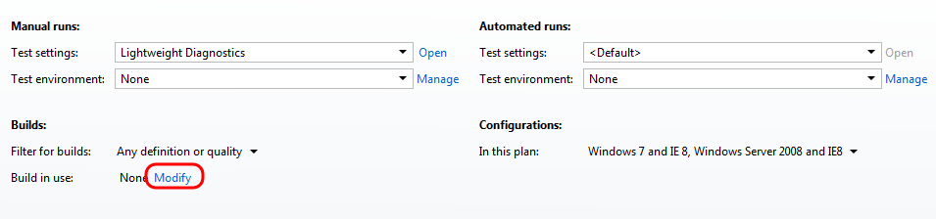
    - Figure 13
    - Selecting the build to use during test runs

  - In the Assign Build window, select the first available build labeled Tailspin Toys – Iteration 2_20100318.6 (Latest) and click Assign to Plan.
    - 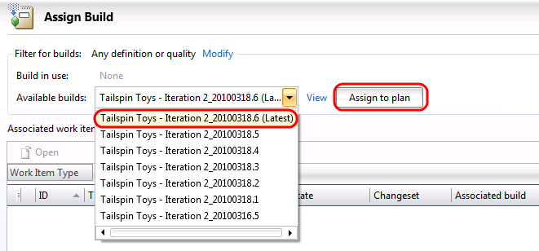
    - Figure 14
    - Assigning a build to the test plan

  - Click the Close button () to exit the Assign Build window. Be careful not to close the main Test Manager window. This will bring you back the Test Plan properties window.
    - 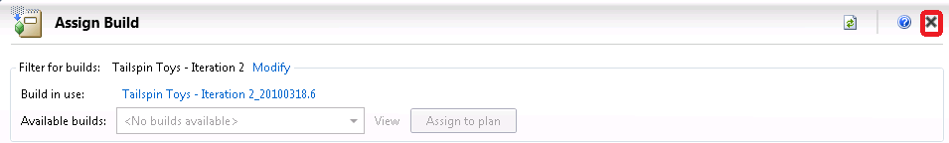
    - Figure 15
    - Location of Close button

  - Test configurations describe which platforms to test against during test runs. In the Configurations section, select the drop down that currently shows “Windows 7 and IE 8, Windows Server 2008 and IE8”, and select all available configurations.
  - Click Apply to continue.
    - 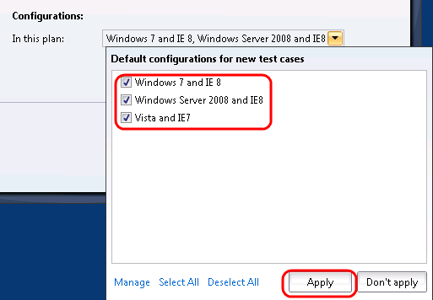
    - Figure 16
    - Location of Apply button

  - Click Save and Close to save and close the new test plan.
    - 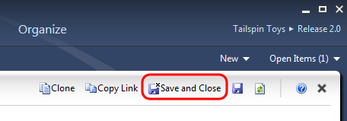
    - Figure 17
    - Location of Save and Close button

Exercise 2: Adding Test Suites and Test Cases to a Test Plan
In this exercise, you will learn how to add test suites and existing test cases to a test plan.
  - In Microsoft Test Manager, select the Plan tab and then select its Contents child tab to view the new Release 2.0 test plan if it is not already open.
    - 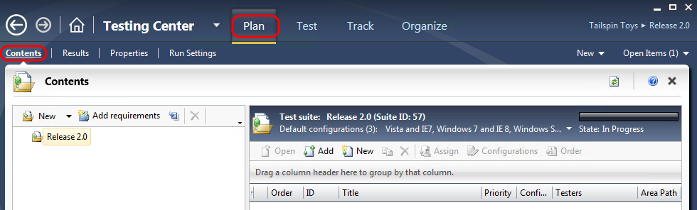
    - Figure 18
    - Test plan contents window for Release 2.0

  - Create a manual test suite by right-clicking the Release 2.0 node and selecting the New suite option from the context menu.
    - 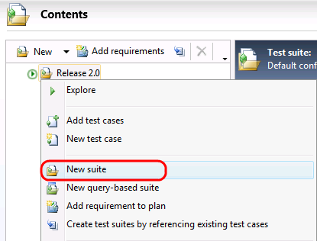
    - Figure 19
    - Creating a new test suite

  - Enter Regression Test as the suite name and press the Enter key to accept.
    - 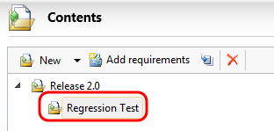
    - Figure 20
    - Providing a descriptive name for the new test suite

  - Select the Regression Test suite in the left pane and click Add in the right pane to add existing test cases.
    - 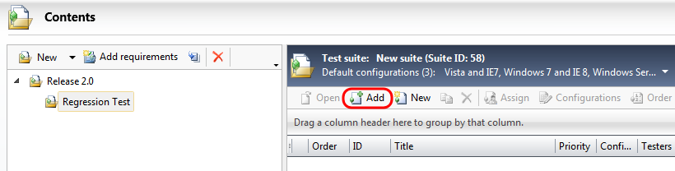
    - Figure 21
    - Location of the Add button

  - In the Add Test Cases to Suite window, click Run to see all of the test cases for the current team project.
    - 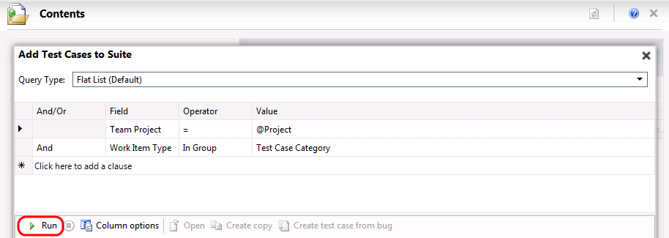
    - Figure 22
    - Run query to find test cases to add to new test suite

  - Select test cases with ID = 40 and 41 and then click Add test cases to add them to the new Regression Test suite.
    - 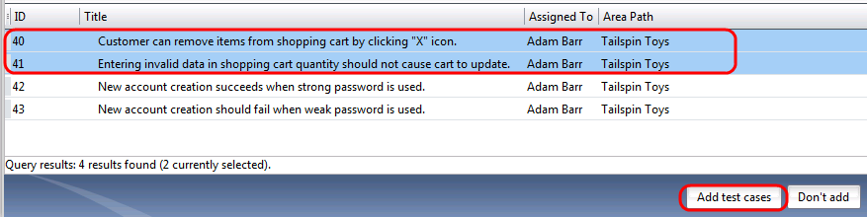
    - Figure 23
    - Adding test cases

    - 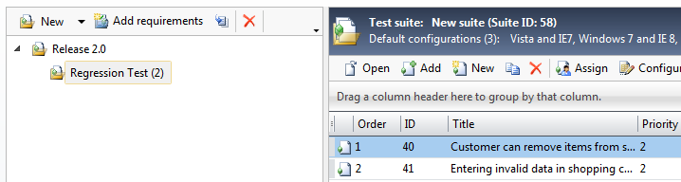
    - Figure 24
    - Test cases added to new test suite

  - Now let’s add another type of test suite to the test plan. Right-click the Release 2.0 node and select New query-based suite from the context menu. Query-based test suites allow work item queries to be constructed in order to gather test cases, as you will see shortly.
    - 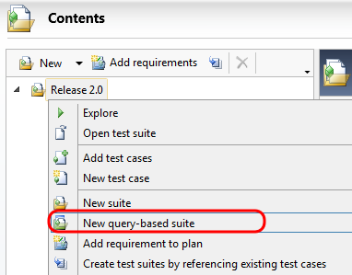
    - Figure 25
    - Adding a query-based test suite

  - In the Create a Query-Based Suite window, enter “Tailspin Toys Suite” as the Name.
    - Figure 26
    - Entering a name for the new test suite

  - Select the grid row labeled Click here to add a clause (the row showing * at the beginning) to add a new query clause that restricts work items to those under the Tailspin Toys area path. Use the values shown in the following screenshot.
    - 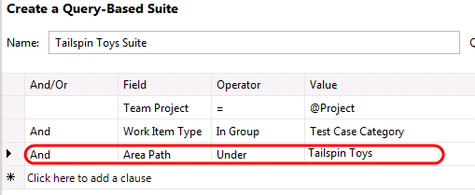
    - Figure 27
    - Creating query to select test cases

  - Click Run to see the results of this query.
    - 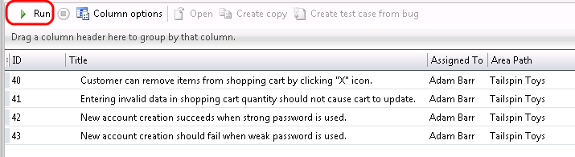
    - Figure 28
    - Location of Run button

  - Click Create test suite to create this query-based test suite and return to the test plan contents window.
    - 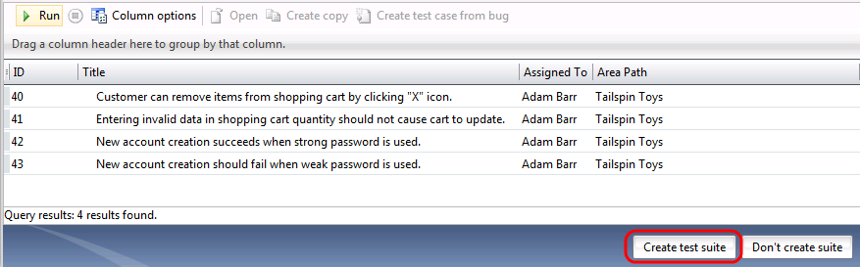
    - Figure 29
    - Location of Create test suite button

  - You should now see that the Release 2.0 test plan now has two test suites in it. The icon for the query-based test suite named Tailspin Toys Suite differs from the manual test suite named Regression Test. Query-based test suites dynamically determine test cases that are listed based on the defined query.
    - 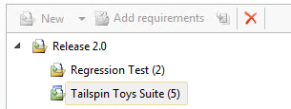
    - Figure 30
    - Test plan showing the two new test suites

    - Note: In this lab environment, you will see a limited number of test cases. This may result in the re-use of test cases across multiple test suites.

Exercise 3: Creating and Adding Requirements to a Test Plan
In this exercise, you will learn how to create a new requirement and add that requirement to your test plan. You will also learn how to create a new test case for the new requirement.
  - In Microsoft Test Manager, select the Plan tab and then select its Contents child tab to view the new Release 2.0 test plan if it is not already open.
    - 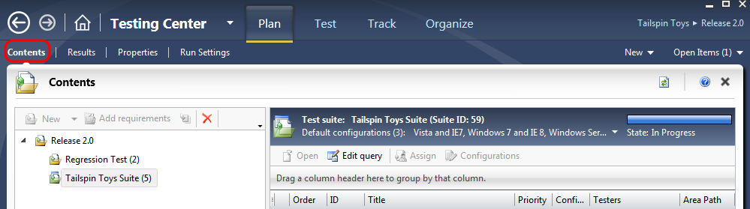
    - Figure 31
    - Test plan contents window for Release 2.0

  - Create a new user story work item by selecting the New drop down box and selecting User Story.
    - 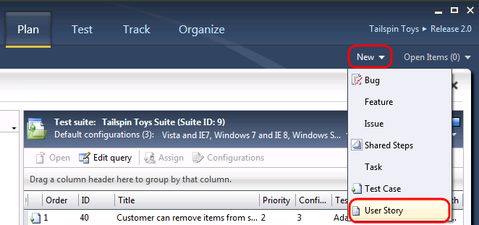
    - Figure 32
    - Creating new user story work item

  - For the Title of the user story, enter “As a consumer, I want to be able to add a coupon code to my purchase”.
  - For the Risk of the user story, select the “2-Medium” option from the dropdown box.
  - Click Save and Close to continue.
    - 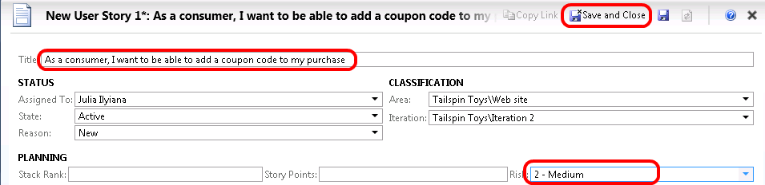
    - Figure 33
    - Define and save a new user story

  - In the test plan contents window, select the Release 2.0 node and then click Add Requirements to add a new requirement to the plan.
    - 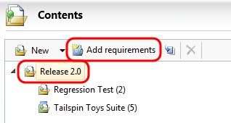
    - Figure 34
    - Adding a new requirement to the test plan

  - In the window titled “Add existing requirements to this test plan”, click Run to see the results of this query. You should see the new user story that we just created.
    - 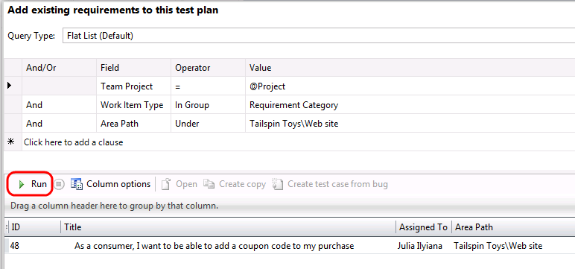
    - Figure 35
    - Adjusting the query to help find the recently created user story

  - Select the user story and then click Add requirements to plan. This will close the window and return to the test plan contents window.
    - 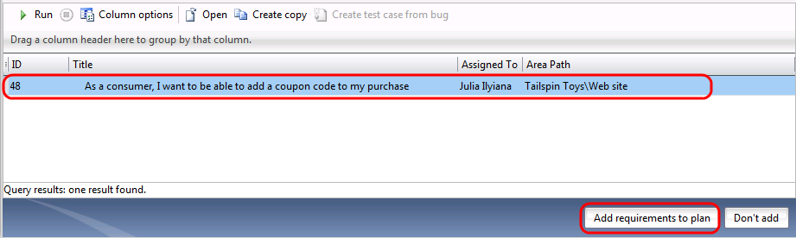
    - Figure 36
    - Selecting and adding the new user story as a requirement

  - In the test plan contents window, you should now see a new requirements-based test suite listed. In the right pane, there are options to either link existing test cases or create new test cases.
  - Click New in the right pane to create a new test case.
    - 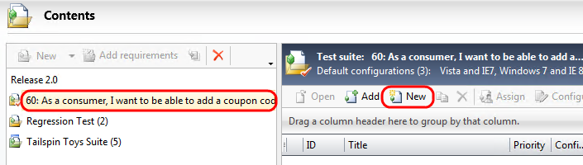
    - Figure 37
    - Creating a new test case for the user story requirement

  - For the Title of the new test case, enter “Add coupon code during checkout”. Note that the Area and Iteration values in the Classification section have already been correctly pre-populated.
    - 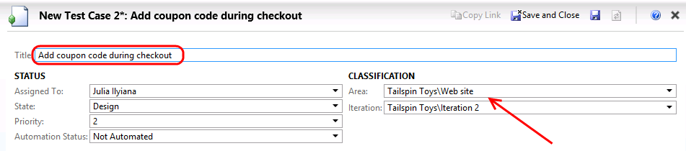
    - Figure 38
    - Creating new test case and assigning properties

  - Enter the Steps for the new test case as shown in the screenshot below.
    - 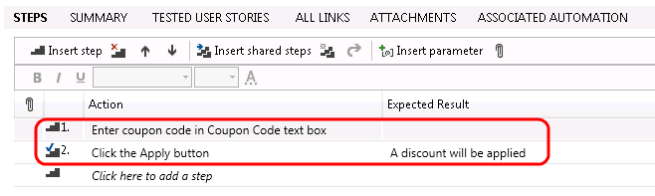
    - Figure 39
    - Creating steps for new test case

  - Click Save and Close to save the new test case and return to the test plan contents window.
    - 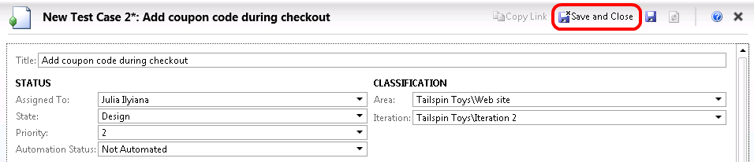
    - Figure 40
    - Location of Save and Close button

  - In the test plan contents window, you should now see the new test case that was added to the requirement-based test suite.
    - 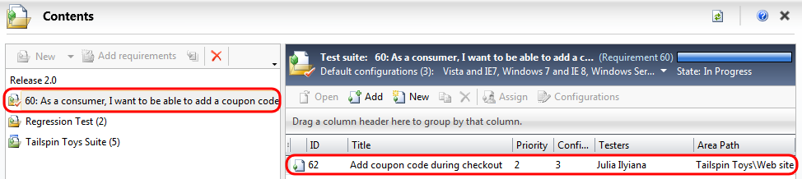
    - Figure 41
    - Requirement-based test suite showing the new test case

Exercise 4: Managing Tests Using the Test Hub
In this exercise, you will learn how to create a new requirement and add that requirement to your test plan. You will also learn how to create a new test case for the new requirement.
  - Open Internet Explorer and click the TFS TT Portal bookmark at the top of the window.
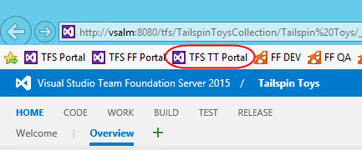
  - Select the Test tab to open the Test hub.
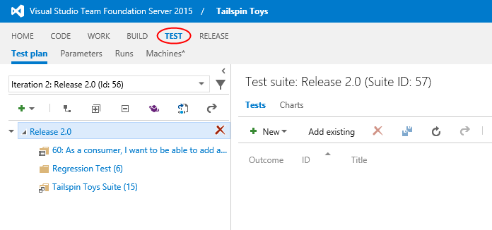
  - Select test suite 60 from the left panel to view all of the child test cases.
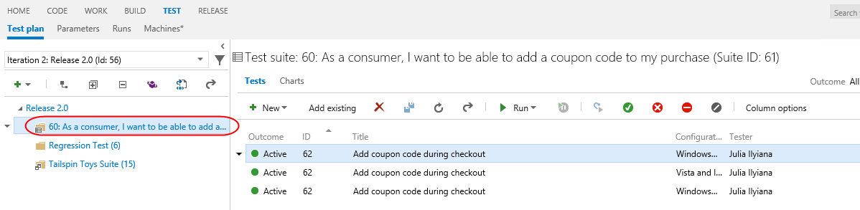
  - You can also view all of the test cases in the child test suites within a plan. Select the Release 2.0 plan and click the Show tests from child suites button to view all of the test cases under this node.
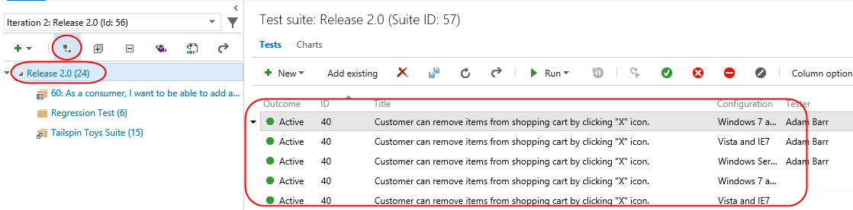
  - You can also create new test plans from the portal. Click the Add drop down and select Test plan.
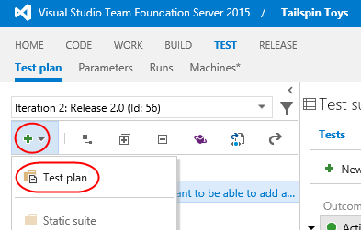
  - Enter the name “Database tests” and set the Area Path to “Tailspin Toys\Database”. Set Iteration to “Tailspin Toys\Iteration 3” and click Create.
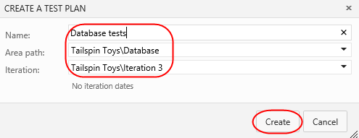
  - Now that the new test case has been created, you can begin to add test cases. If you have a lot of test cases to add, the grid approach might be the easiest process. Click New | New test case using grid.
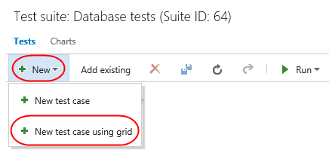
  - Enter a single test case with one step and result. This test case will be designed to confirm that the expected database automation runs at midnight, as scheduled. Set the Title to “Overnight automated maintenance”, Step Action to “Set click to midnight”, and “Step Expected Result” to “Midnight automation runs”. You can add multiple test cases if you like. If you have multiple steps for a given case, just add those to the following rows, leaving the Title field blank, and they’ll be rolled up to the current case. Click Save to save the new test case.
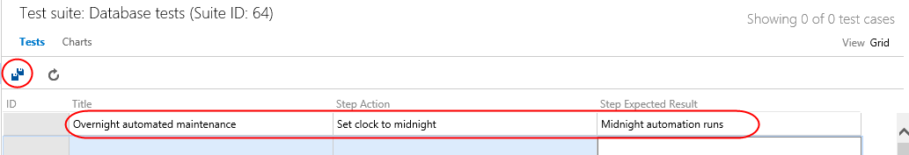
  - Click Grid to toggle back to the List view.
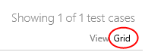
  - While the database automation case covers an important feature, it’s pretty incomplete. For example, it’s designed to confirm something happens at midnight, but doesn’t include other times. Rather than adding in additional tests to cover those scenarios, we can create a shared parameter that includes the time to test. Then we’ll go back and update the test to accept this parameter for each iteration. Select the Parameters tab and click the New shared parameter button.
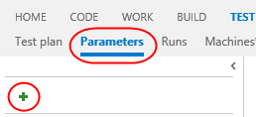
  - Set the new parameter’s name to time and add three values: 11PM, 12AM, and 1AM. Click the Save button to confirm.
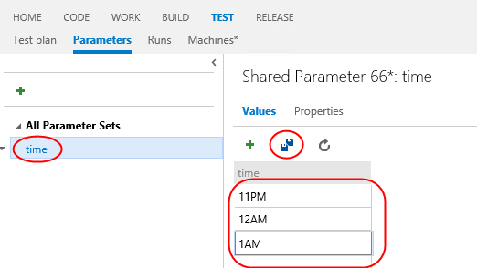
  - Return to the test plan view by selecting the Test plan tab. Double-click the first test case to open it. Note that there are two test cases shown for the one test created earlier because each represents the same test on a different configuration.
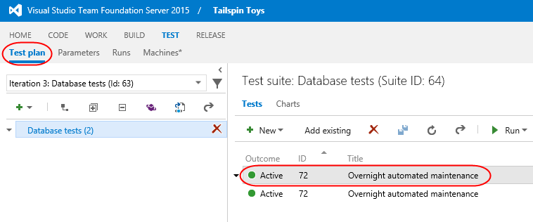
  - Scroll down in the test case editor and click Add a shared parameter set.
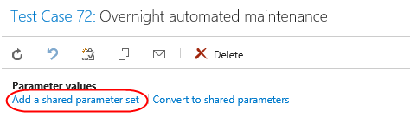
  - Locate the shared parameter created earlier and click OK to add it.
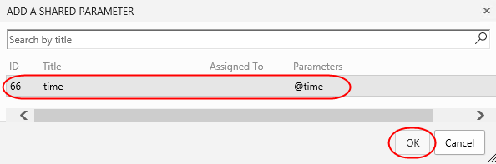
  - Now that the parameter is known to the test, update the Action and Expected result to include “@time” such that the tests make sense when the time is replaced with one of the values added earlier. Click Save and close.
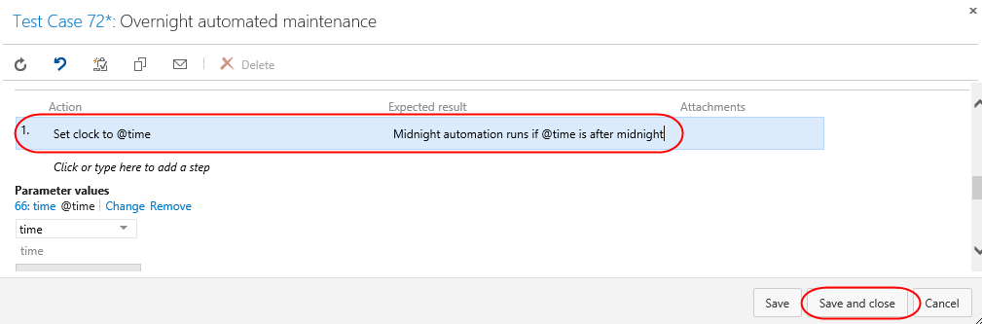
  - Right-click the first test case and select Run test.
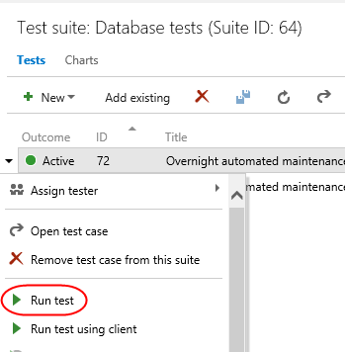
  - On the first iteration, the test window uses a time of 11PM. Click next to move to the next iteration.
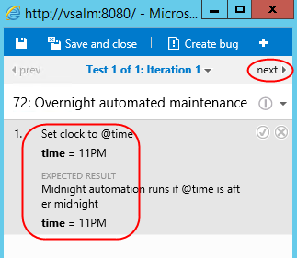
  - Note that the second time of 12AM is provided for this iteration. Close the window to cancel the rest of the process.
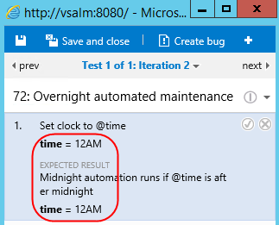
  - To make test management easier, you can filter which test plans are made available in the navigation. Expand the dropdown to see which plans are currently included.
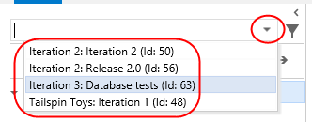
  - To edit how these plans are filtered, click the Filter test plans button.
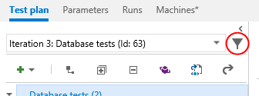
  - Update the second clause’s Value to Tailspin Toys\Database and click Run query. This new query should only return the single plan fitting the parameters, which is the one created in this exercise. Click Ok.
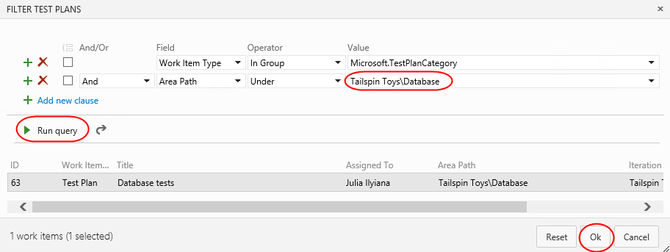
  - Expand the test plan dropdown and note that only the single expected plan is shown now.
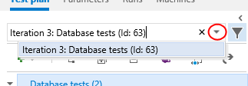
  - In addition to creating and managing test plans, you can also easily delete test plans. Click the dropdown button next to the only test plan and select Delete. Confirm when asked.
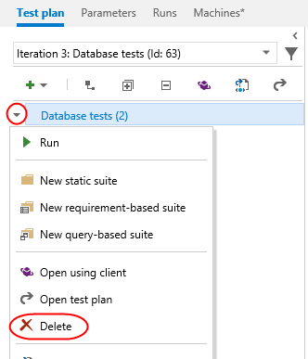

To give feedback please write to VSKitFdbk@Microsoft.com
Copyright © 2016 by Microsoft Corporation. All rights reserved.

