System Center Data Protection Manager 2010 delivers unified data protection for Windows servers and clients as a best-of-breed backup & recovery solution from Microsoft, for Windows environments.

DPM 2010 provides the best protection and most supportable restore scenarios from disk, tape and cloud -- in a scalable, manageable and cost-effective way.

There is a better way!
  - www.microsoft.com/DPM

  - TechNet.microsoft.com/DPM

  - blogs.technet.com/DPM

  - DPMINFO@microsoft.com

  - Twitter @SCDPM

If your company relies on Microsoft® server technologies, who will you trust to maximize its protection and recovery?

Database administrators, e-mail managers, and other IT implementers and developers are looking for a better way to protect and recover data from key business applications like:

Windows® file shares

Windows client data

Windows system state

Hyper-V™

SQL Server™

SharePoint® products and technologies

Microsoft Exchange Server

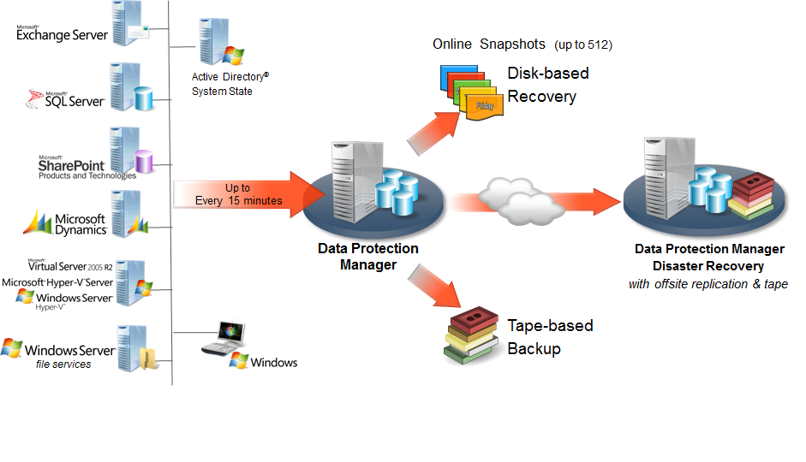
DPM 2010 enables continuous data protection for Microsoft application, virtualization and file servers to seamlessly integrated secondary disk, tape and cloud.
DPM 2010 continues to raise the standard for Windows backup and recovery:

Continuous Data Protection – DPM protects core Windows Server workloads by continuously monitoring data for changes at a block or byte-level (depending on workload), using technology and later replicating those changes capturing data changes with application-aware byte-level agents, providing an easy-to-manage and robust disk/tape back end platform, and one-click lossless application recovery.

Rapid and Reliable Recovery – DPM enables IT administrators & end-users to easily recover data in minutes from easily accessible disk instead of locating and restoring from less-reliable tapes.

Advanced Technology for Enterprises of all sizes – DPM brings together the best aspects of CDP real-time protection with traditional tape backup/restore to provide a comprehensive disk to disk to tape data recovery solution.
Maximizing protection of Microsoft workloads with Microsoft backup & recovery

DPM 2010 is designed for the application stakeholder, a SQL or Exchange Administrator or an IT generalist and uses wizards and workflows to help ensure that you can protect your data – without requiring an advanced degree, training or certification in storage and backup technologies.

DPM 2007 presents the data to be protected in the same context as users access it. This empowers you to select databases, or storage groups, or farms, or virtual machines, or file shares for protection – with DPM then determining the files and components to protect.

DPM agents use Volume Shadowcopy Services (VSS) to ensure that data is protected and restored using only methods that were designed by and supported from the application workloads themselves, such as the Exchange VSS writer or transactional SQL log-based backups.

Meeting Customers’ Needs

Common Microsoft customer questions about their existing backup:

“Who can help me restore?”

During a crisis, as part of the data recovery, many customers are frustrated when bringing in multiple support organizations to help restore their data. The third-party backup vendor may say that the data restored successfully. But, Microsoft Product Support Services may say that the data appears un-mountable. And the systems integrator, the database administrator or the lone IT professional can be stuck in the middle.

Having a Microsoft backup product protecting a Microsoft SQL Server, Exchange Server or SharePoint platform means that customers don’t have to worry about misunderstandings between vendors when restoring their data.
“My backup product does some things well, but protecting my advanced Exchange configuration isn’t one of them.”

Because third-party backup products try to back up a wide variety of applications, it can be difficult to protect every application well, particularly with flexible applications like mirrored SQL Server databases or a CCR/DAG under Exchange Server.

Microsoft is dedicated to making sure that our backup solution is one of the very best for protecting our application workloads. Microsoft protects our own enterprise servers with DPM, beginning early in the beta process. This helps ensure that no DPM build will go to a customer that Microsoft IT hasn’t signed off as tested in our own demanding production environment.

Take a look at how DPM 2010 can protect your Windows Server® infrastructure

Microsoft is committed to listening to our customers and partners – to help shape the products and services that we offer. While most customers currently have some form of tape backup, there are many who are discontent with the current offerings, either looking for better support of key business applications like Microsoft Exchange 2010, SharePoint 2010 or Hyper-V 2008 R2, or looking for better than nightly protection to a medium other than tape.

Whether you are a midsized business or a large enterprise, if you depend on Microsoft Server-based platforms to manage and deliver information within your company, take a look at how DPM 2010 can help you protect your business critical data.

For more information about Microsoft System Center Data Protection Manager, visit www.microsoft.com/DPM .
For information on the System Center family of IT management technologies for midsized organizations and enterprises, visit www.microsoft.com/SystemCenter.

This data sheet is for informational purposes only. MICROSOFT MAKES NO WARRANTIES, EXPRESS OR IMPLIED, IN THIS SUMMARY.
The example companies, organizations, products, domain names, e-mail addresses, logos, people, places, and events depicted herein are fictitious. No association with any real company, organization, product, domain name, e-mail address, logo, person, place, or event is intended or should be inferred. (Use this only if fictitious content appears.)

