

Hands-On Lab

SharePoint 2010:

***Custom Publishing Artifacts***

Lab version: 1.0.0

Last updated: 7/18/2011

**Virtual Machine Logon Details:**

UserName: Administrator, Password: pass@word1

This document is provided “as-is”. Information and views expressed in this document, including URL and other Internet Web site references, may change without notice. You bear the risk of using it.

This document does not provide you with any legal rights to any intellectual property in any Microsoft product. You may copy and use this document for your internal, reference purposes.

© 2011 Microsoft. All rights reserved.

Contents

Overview 3

Exercise 1: Creating the site 4

Task 1 – Running setup and creating the site 4

Exercise 2: Creating a custom navigation provider 5

Task 1 – Deploying the project 5

Task 2 – Verifying the results 7

Overview

* 1. This lab will walk you through creating a custom navigation for a SharePoint site.
  2. Estimated time to complete this lab: **15 minutes**.

### Materials

This Hands-On Lab contains resources in the following folders.

Setup Files: **c:\mslabs\SharePoint2010\WCM\09_CustomPublishingArtifacts \Setup**

Lab Resources : **c:\mslabs\SharePoint2010\WCM\09_CustomPublishingArtifacts \Resources**

Exercise 1: Creating the site

Task 1 – Running setup and creating the site

* 1. To complete this lab you must start afresh with a basic publishing site. Your customizations and any work from previous labs will be removed.
  2. In the Setup folder run the **install.ps1** file. You can run from a Windows PowerShell command prompt or by right-clicking on the file in Windows Explorer and selecting **Run with PowerShell.**  See Figure 1.
     1. 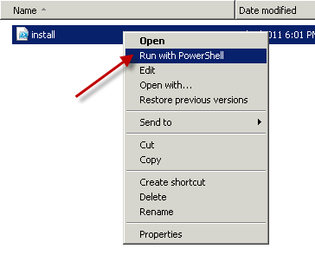
     2. Figure
     3. Running PowerShell.

This will install a feature in the web at http://demo2010a:8080/ for this lab. See Figure 2.

* + 1. 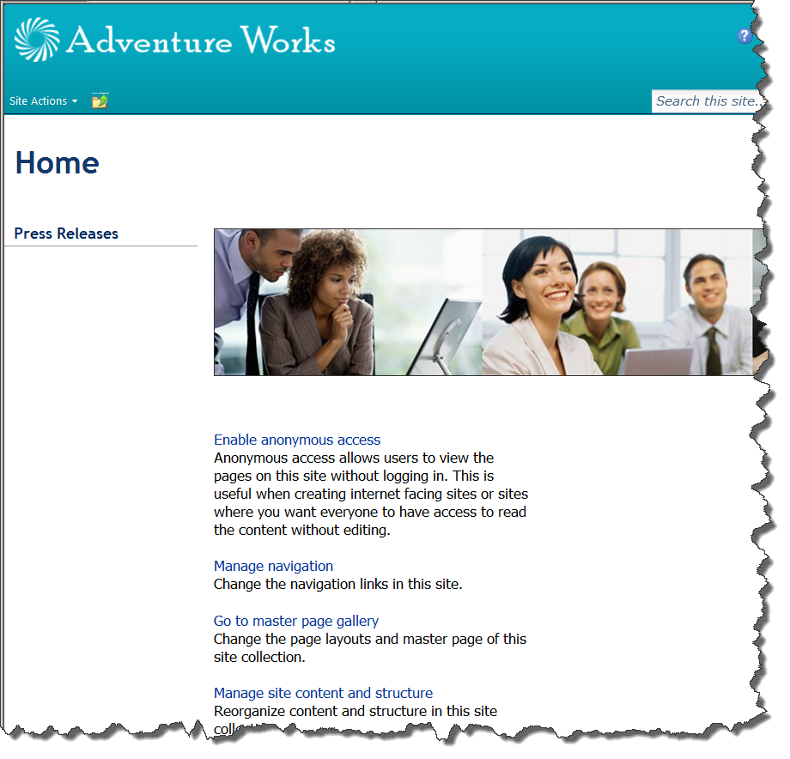
    2. Figure
    3. Publishing Portal site created

Exercise 2: Creating a custom navigation provider

Task 1 – Deploying the project

* 1. Open the solution at **Resources\** folder using Visual Studio 2010.
  2. Open the **CustomNavigationProvider.cs** file if it isn’t already open. You can open this by double-clicking on the file from the **Solution Explorer.**
  3. Note the code in Figure 8.
     1. 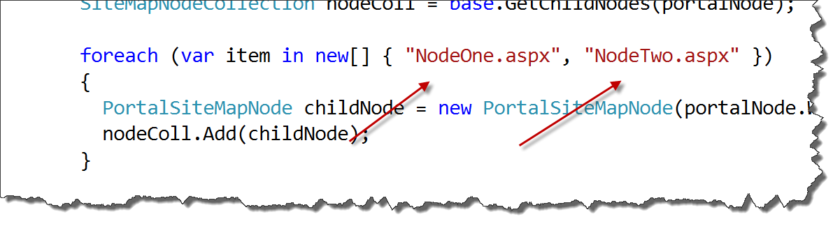
     2. Figure
     3. Adding Extra nodes

This is where you could implement logic to get additional nodes for the site map. Feel free to change these strings for your own purposes.

* 1. Right-clickon the **CustomNavigationProvider** in the **Solution Explorer** and select **Deploy.**  See Figure 9.
     1. 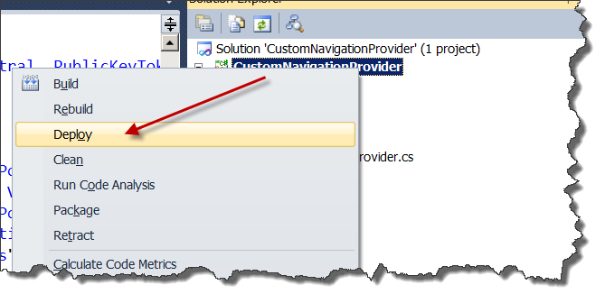
     2. Figure
     3. Deploying the Custom Navigation Provider
  2. In **Visual Studio 2010** select **File | Open** and browse to **C:\inetpub\wwwroot\wss\VirtualDirectories\8080** and open the **web.config** file.
     1. Note: Your web.config might be in a different folder depending on your machine configuration. If you don’t find the 8080 folder, use IIS Manager to determine the path of the site you are deploying to.
  3. Find the **sitemap** section under the **system.web** section.
  4. Change the value of the **name** attribute from **CustomNavigationProvider** to **CurrentNavigation.** Make sure to comment out the original **CustomNavigationProvider** line using XML comments (<!-- -->)**.** See Figure 10.
     1. 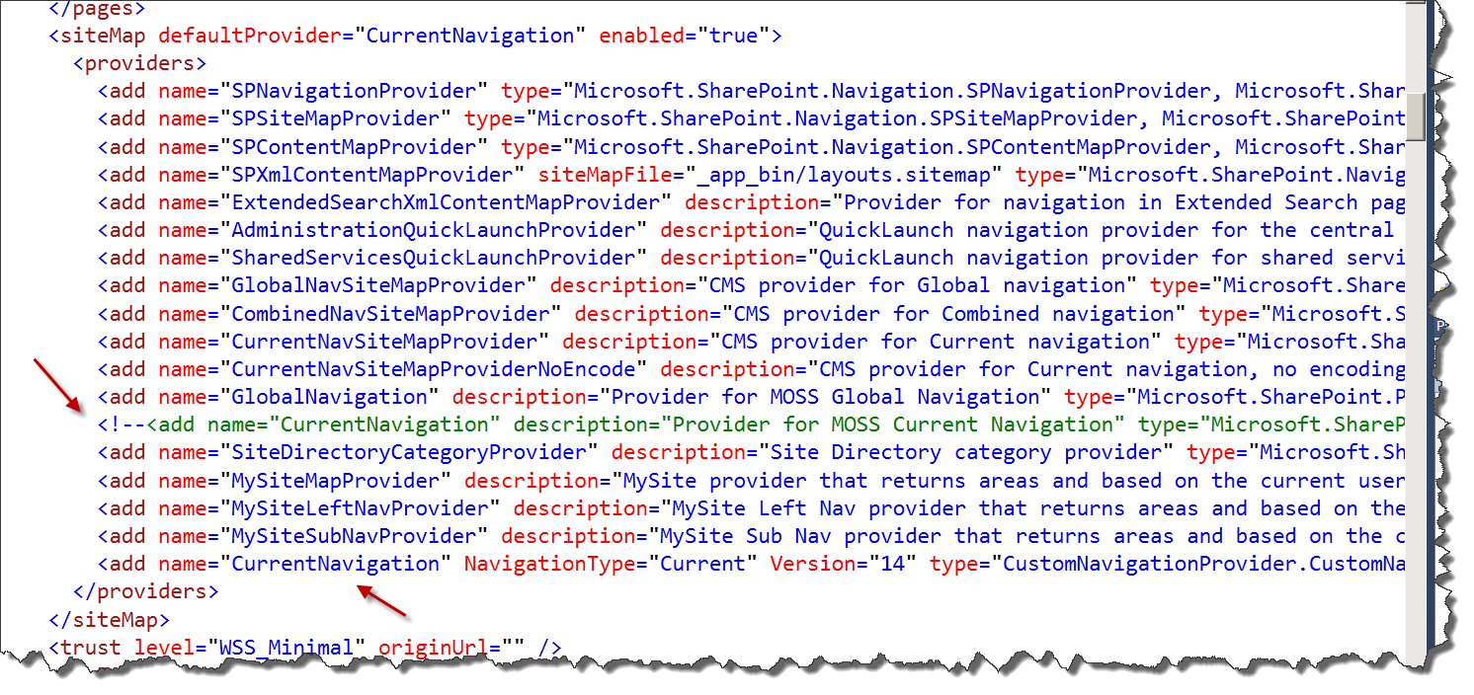
     2. Figure
     3. web.config after changes
     4. **Note:** The CustomNavigation provider add element was added by the project’s feature receiver.

Task 2 – Verifying the results

* 1. Open the site at <http://demo2010a:8080/>
  2. You should see something similar to Figure 11.
     1. 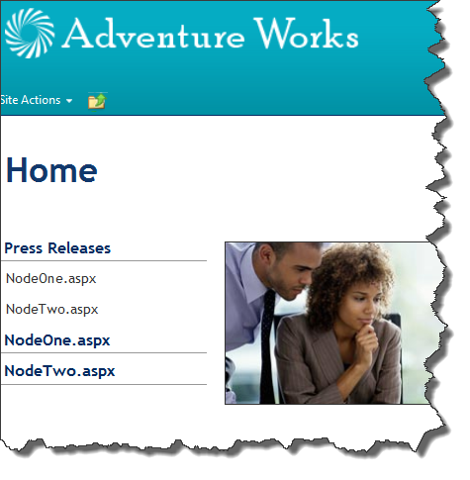
     2. Figure
     3. Added navigation nodes