

Hands-On Lab

SharePoint 2010:

***Content Query Web Part***

Lab version: 1.0.0

Last updated: 7/18/2011

**Virtual Machine Logon Details:**

UserName: Administrator, Password: pass@word1

This document is provided “as-is”. Information and views expressed in this document, including URL and other Internet Web site references, may change without notice. You bear the risk of using it.

This document does not provide you with any legal rights to any intellectual property in any Microsoft product. You may copy and use this document for your internal, reference purposes.

© 2011 Microsoft. All rights reserved.

Contents

Overview 3

Exercise 1: 5

Task 1 – Setting up for the lab 5

Task 2 - Creating the content type 5

Exercise 2: Creating the page layout 13

Task 1 - Creating the page layout 13

Exercise 3: Creating pages 19

Task 1 – Running the utility 19

Exercise 4: Using the Content Query Web Part 22

Task 1 – Adding the CQWP 22

Lab Summary 28

Overview

* 1. This lab will walk you through creating a page content type and associated page layout and reusing the page content type on another page.
  2. Estimated time to complete this lab: **30 minutes**.

### Materials

* 1. This Hands-On Lab contains resources in the following folders.
  2. Setup Files: **c:\mslabs\SharePoint2010\WCM\07_ContentReuse\Setup**.
  3. Lab Resources: **c:\mslabs\SharePoint2010\WCM\07_ContentReuse\Resources**.



Exercise 1:

* 1. In this exercise you will be creating a custom Content Type that you will base a page layout on.

1. Task 1 – Setting up for the lab
   1. Open a file browser and navigate to c:\mslabs\SharePoint2010\WCM\07_ContentReuse\Setup.
   2. Right click the **install.ps1** file and select the **Run with PowerShell** menu option. See Figure 1.
      1. 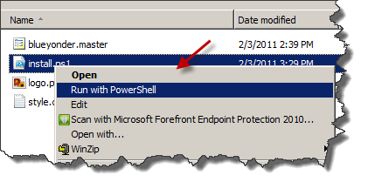
      2. Figure
      3. Running PowerShell.

This will install a feature in the web at http://demo2010a:8080/ for this lab

To ensure that the setup has run correctly, navigate to http://demo2010a:8080/_layouts/ManageFeatures.aspx and check that the following features are activated:

* BlueYonderMasterFeature
* HolidayPageContentType Feature1
* WCMAddImages Feature1

Task 2 - Creating the content type

* 1. Open Internet Explorer and navigate to <http://demo2010a:8080/_layouts/settings.aspx>.
  2. On the **Site Settings** page, click on the **Site content types** link under the **Galleries** section. See Figure 2.
     1. 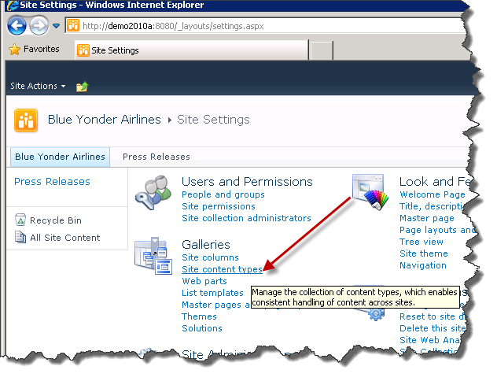
     2. Figure
     3. Site content types link
  3. On the **Site Content Types** page click the **Create** link. See Figure 3.
     1. 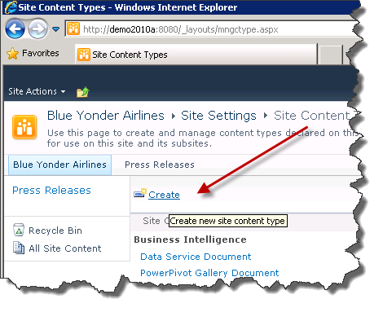
     2. Figure
     3. Create link in Site Content Types page
  4. Set the **Name** text field to HolidayPageContentType on the **New Site Content Type** page**.**
  5. Set the **Description** text field to a description that makes sense to you (use your creativity here).
  6. Select **Publishing Content Types** as the content type group, and **Page** as the **Parent Content Type.**
  7. Clickthe radio button next to **New Group** under the **Group** section and type Blue Yonder Page Content Types. Your page should look like Figure 4.
     1. 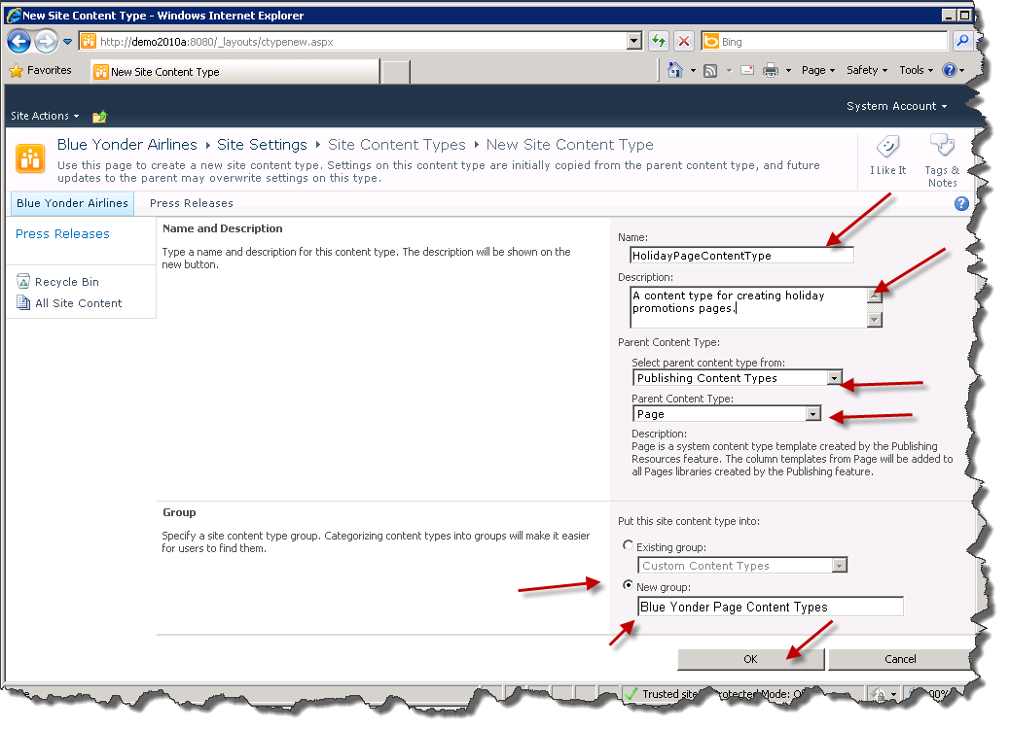
     2. Figure
     3. New Site Content Type page
  8. Click **OK** once you are satisfied with your selections.

Now you will add a new column to this newly created content type.

* 1. On the content type page that appears after you click **OK**,scroll down under the **Columns** section and click **Add from new site column.** See Figure 5.
     1. 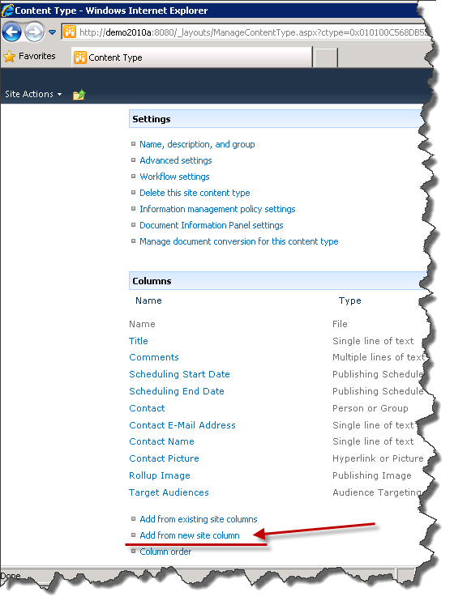
     2. Figure
     3. Add from new site column link
  2. Type HolidayTextin the **Column name** text box.
  3. Select **Full HTML content with formatting and constraints for publishing** as the column type.
  4. Click the radio button next to **New Group** and type Blue Yonder Holiday Columnsas the value of the **New Group** text.
  5. Verify that your page looks similar to Figure 6.
     1. 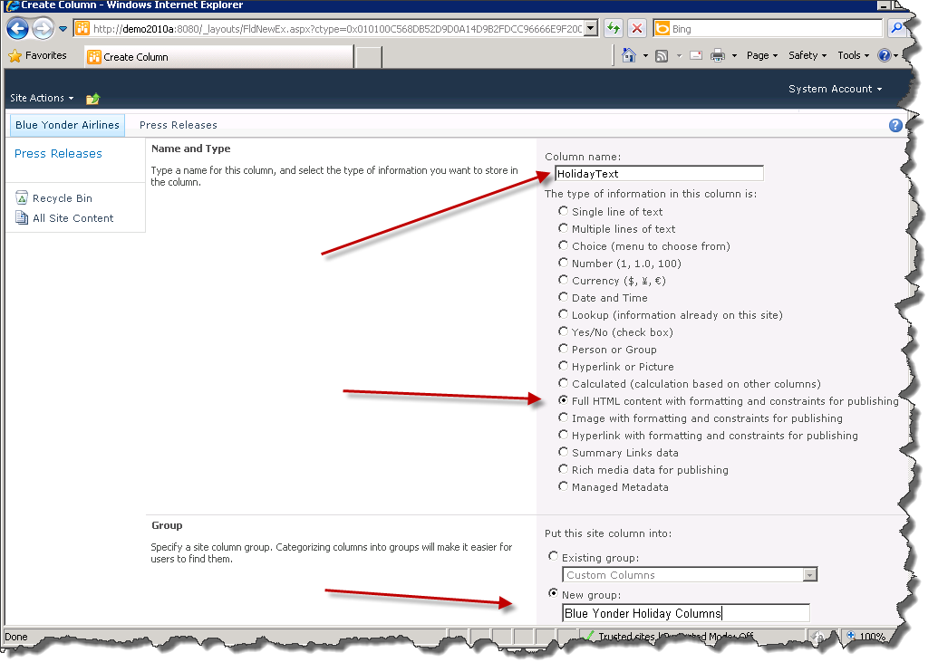
     2. Figure
     3. New site column
  6. Scroll to the bottom of the page and click **OK.** This will return you to the Content Typepage. Verify that the column was added to **HolidayPageContentType** by comparing the Content Type page to Figure 6.

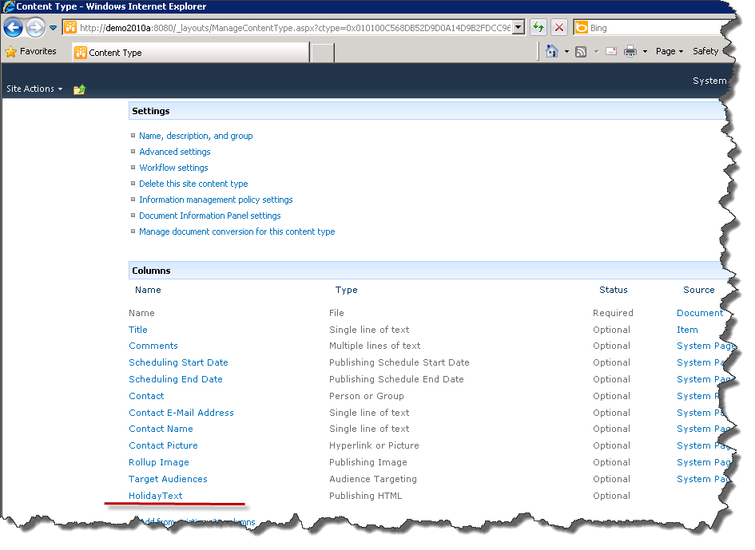

* + 1. Figure
    2. HolidayText column added
  1. Add another column with the following information.  
     Column name : HolidayImage.  
     Type: **Image with formatting and constraints for publishing*.***Group: **Blue Yonder Holiday Columns.**
  2. Scroll to the bottom of the page and click **OK.**

The columns in your new content type should now match those displayed in Figure 8.

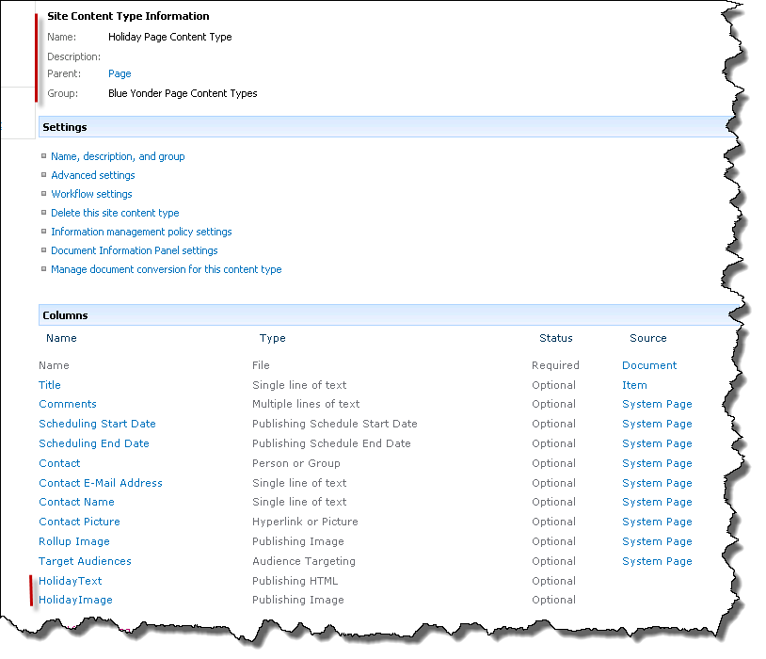

Figure

*HolidayPageContentType description*

Exercise 2: Creating the page layout

* 1. In this exercise you will be creating the page layout that will determine the rendering of your page data based on the custom Content Type you created in the earlier exercise.

Task 1 - Creating the page layout

* 1. Open **Microsoft SharePoint Designer 2010 (SPD)** by going to **Start | All Programs | SharePoint | Microsoft SharePoint Designer 2010.**
  2. In SPD click the **Open Site** button. In the Site Name text box type http://demo2010a:8080/ and click **Open** twice**.** See Figure 9.
     1. 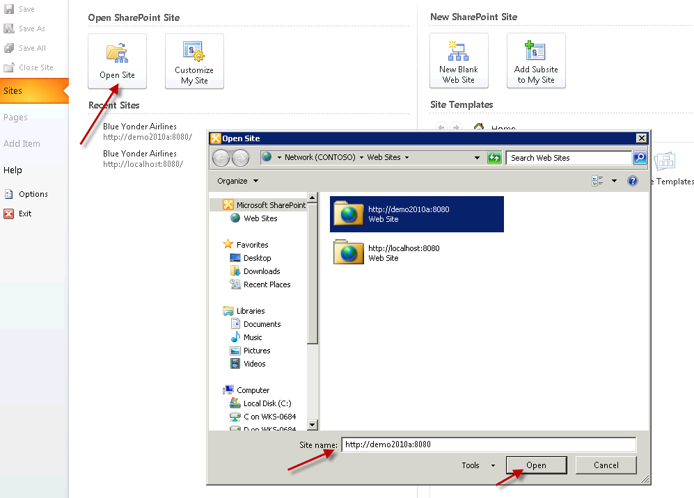
     2. Figure
     3. Opening site in SPD
  3. Click on the **Page Layouts** node in the **Site Objects** toolbar on the left then click the **New Page Layout** button in the ribbon. See Figure 10.
     1. 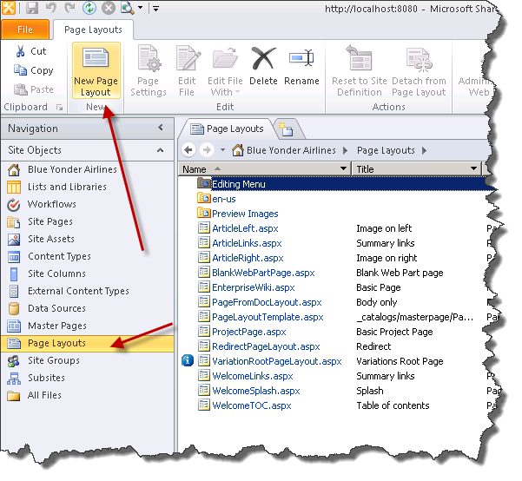
     2. Figure
     3. New Page Layout button
  4. When the **New** dialog appears **Blue Yonder Page Content Types** should be the selected group, and **HolidayPageContentType** should be selected as the **Content Type Name.** If these aren’t already selected select them from the respective combo boxes.
  5. Type Holidayas the **URL Name** and Holiday Page Layoutas the **Title.** See Figure 11.
     1. 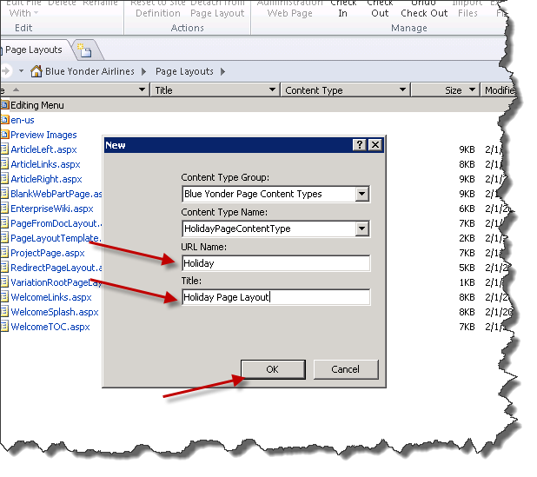
     2. Figure
     3. New page layout dialog
  6. Click **OK** to add the new page layout to your publishing site. Once the page layout is added SPD will display it in the designer.
  7. Click on the **Insert** ribbon, and then click the **SharePoint** button. Click the **Show Toolbox…** item to display the SharePoint controls toolbox. See Figure 12.
     1. 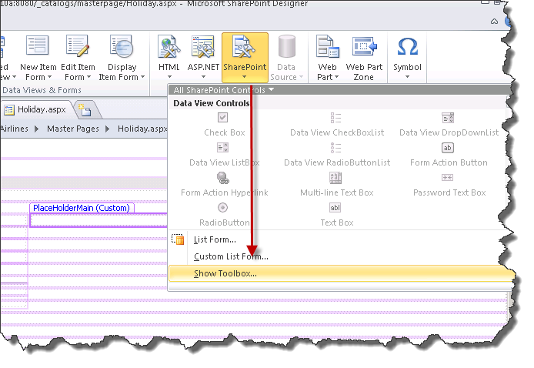
     2. Figure
     3. Show Toolbox
  8. Scroll down and expand the **Content Fields** section in the Toolbox by clicking on the **+** icon. If you can’t see anything in this section, click the **Refresh** link. See Figure 13.
     1. 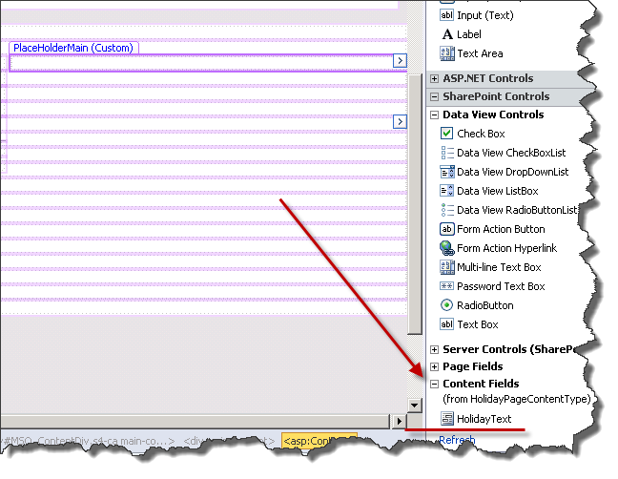
     2. Figure
     3. Expanding Content Fields
  9. Double-click the **HolidayText** control on the Toolbox to add the control into the **PlaceHolderMain** content section.
  10. **Note:** This works so long as your cursor is in that section – if it isn’t either place your cursor in that section or drag and drop the **HolidayText** control onto the design surface inside of the **PlaceHolderMain** area.
  11. Do the same with the **HolidayImage Content field.** At the end your page layout should look like Figure 14.
      1. 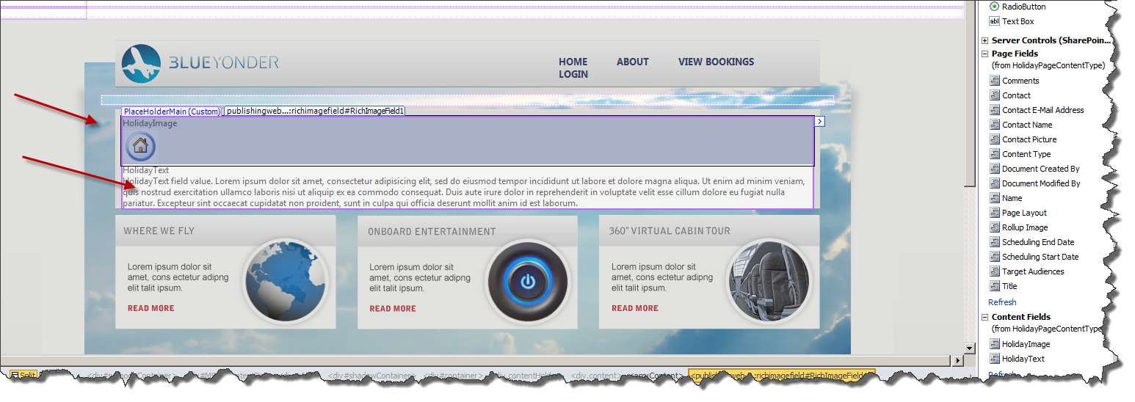
      2. Figure
      3. Page Layout with two fields
  12. Clickthe **Save** button **(CTRL+S)** to save the page layout.

Exercise 3: Creating pages

* 1. In this exercise you will run a .NET program that has been written to add publishing pages automatically to your publishing site.

Task 1 – Running the utility

* 1. Open a command prompt and cd to the **c:\mslabs\SharePoint2010\WCM\07_ContentReuse\Resources** folder.
  2. Run the **AddHolidayPages.exe** utility passing in http://demo2010a:8080 as a parameter. See Figure 13.
     1. 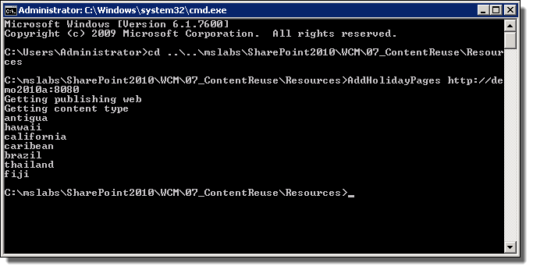
     2. Figure
     3. Running AddHolidayPages
  3. Return to your web browser and navigate http://demo2010a:8080/Pages/Forms/AllItems.aspx

The page should look similar to Figure 16.

* + 1. 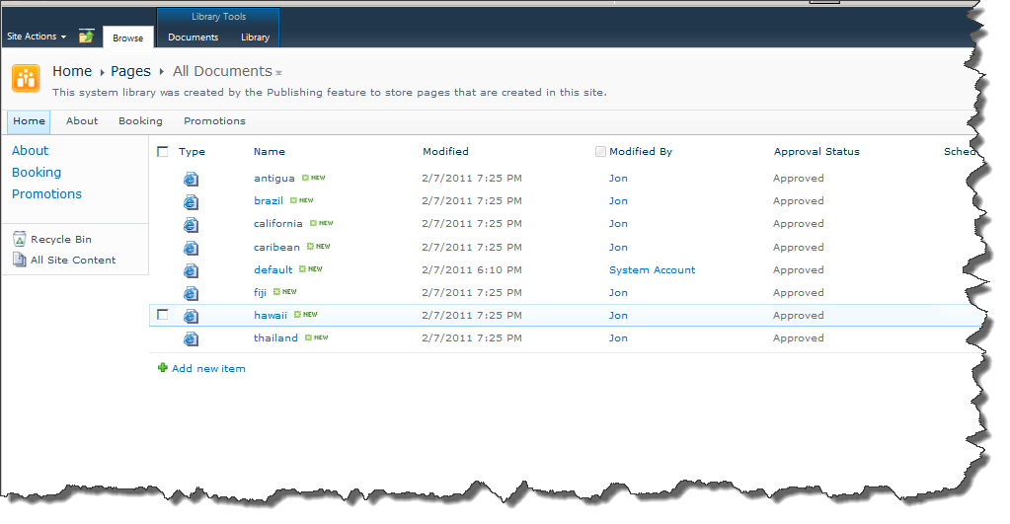
    2. Figure
    3. Pages Added to library
  1. Click on **Antigua** from the list. You should see something similar to Figure 17.
     1. 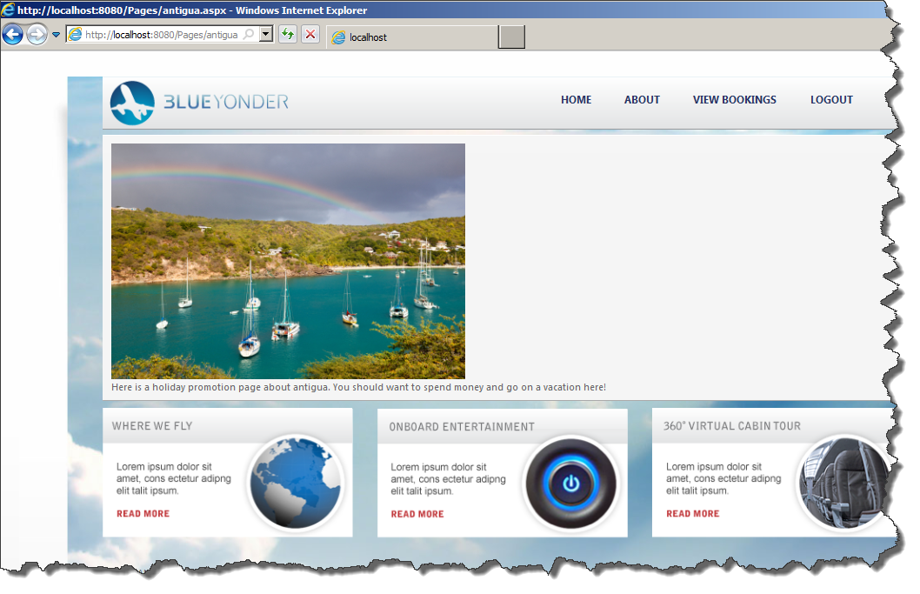
     2. Figure
     3. Added holiday page
     4. **Note:** The utility is pulling a list of images from a library of images that was installed with the lab setup (via a WSP/Feature). It is then creating new pages automatically based on that data. This is something you may use in a medium to large WCM site.

Exercise 4: Using the Content Query Web Part

* 1. In this exercise you will be using the Content Query Web Part (CQWP) to surface the holiday pages on another page.

Task 1 – Adding the CQWP

* 1. In **SPD** open **All Files** inthe **Site Object** menu and expand **Pages.**
  2. Right-click on the **default.aspx** page in the list and select **Edit File in Advanced Mode.** See Figure 18.
     1. 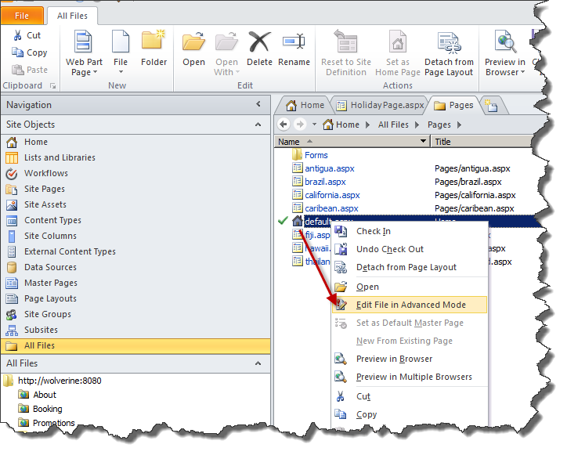
     2. Figure
     3. Editing in Advanced mode
  3. SPD knows that it can’t edit this file, so click **Edit in Browser** when the dialog appears. See Figure 19.
     1. 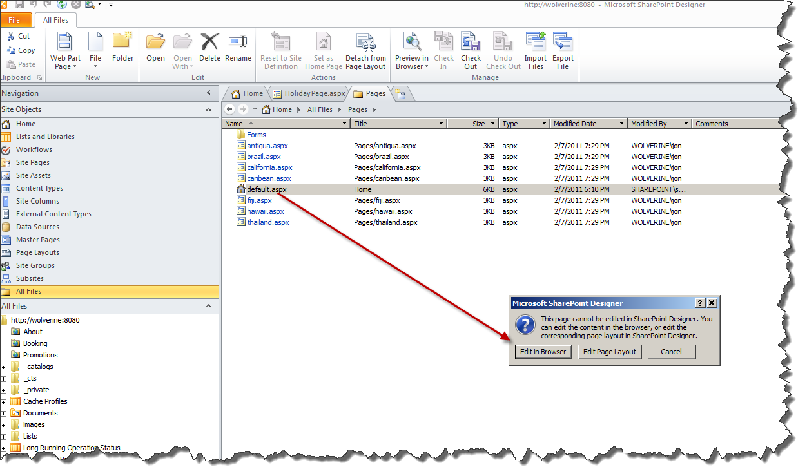
     2. Figure
     3. Edit in Browser Option

We are doing this because the edit button and the ribbon are hidden in the branded web page, but SPD enables us to work around this typical WCM page limitation.

* 1. Select **Yes** when asked if you want to check out the file. See Figure 20.
     1. 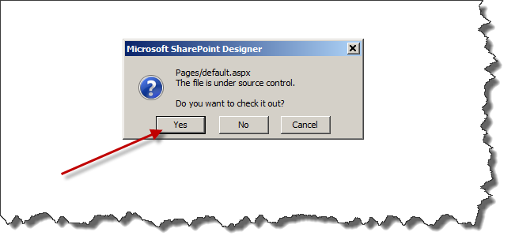
     2. Figure
     3. Check out dialog
  2. Once the page is displayed in edit mode, scroll down to one of the web part zones, and click **Add Web Part.** Once the list of web parts appears pick the **Content Query** web part from the **Content Rollup** category and then click **Add.** See Figure 21.
     1. 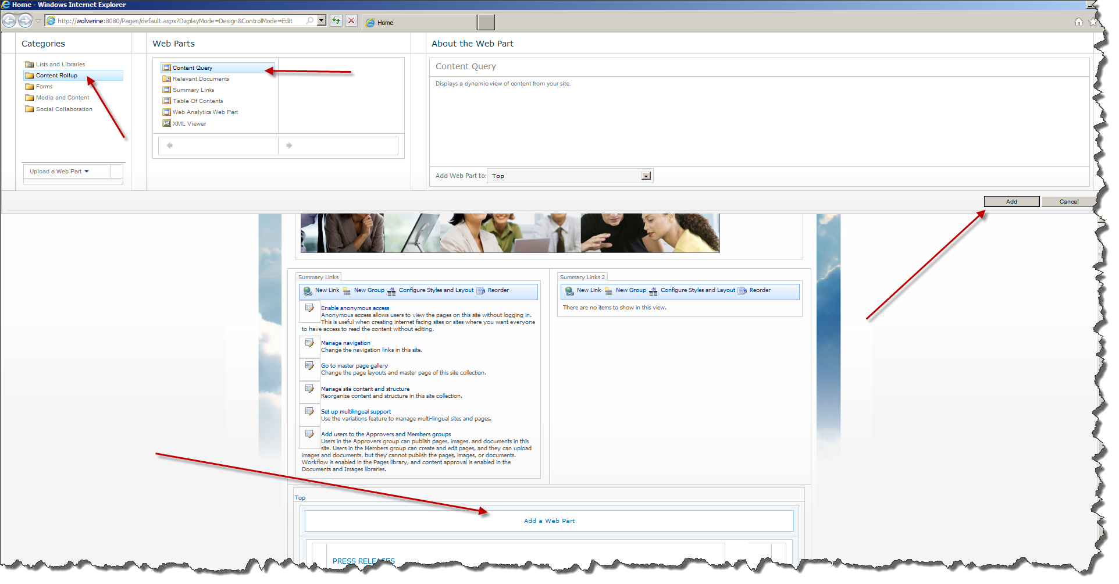
     2. Figure
     3. Adding web part
  3. Click on the new web part’s smart tag and select **Edit Web Part.** See Figure 22.
     1. 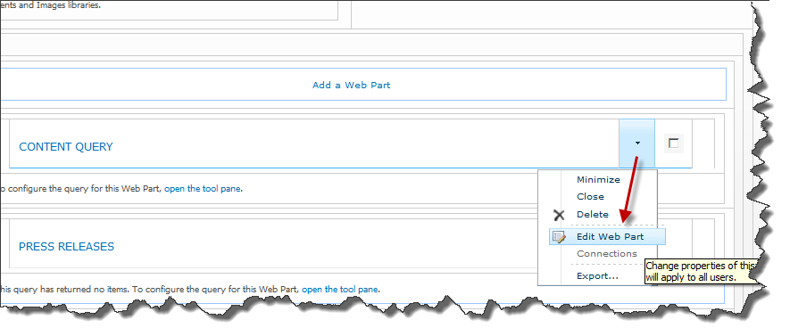
     2. Figure
     3. Edit Web Part

The web part properties will appear in the upper right portion of the screen.

* 1. Expand the **Query** properties section and select **Blue Yonder Holiday Content Types** and the **HolidayPageContentType** in the **Content Types** section. This limits the query to only those pages that use the content type. See Figure 23.
     1. 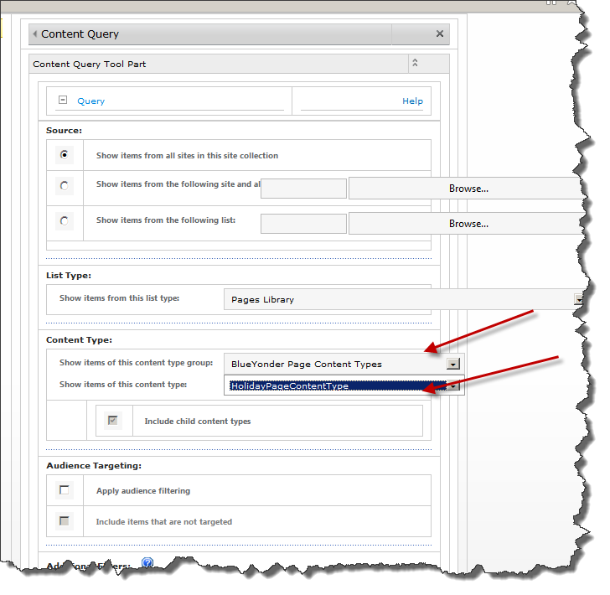
     2. Figure
     3. Setting content types
  2. Scroll down and expand the **Presentation** properties section.
  3. Under **Fields to Display** type HolidayImage; as the **Image** field, and HolidayText;as the **Description** field**.** See Figure 24.
     1. 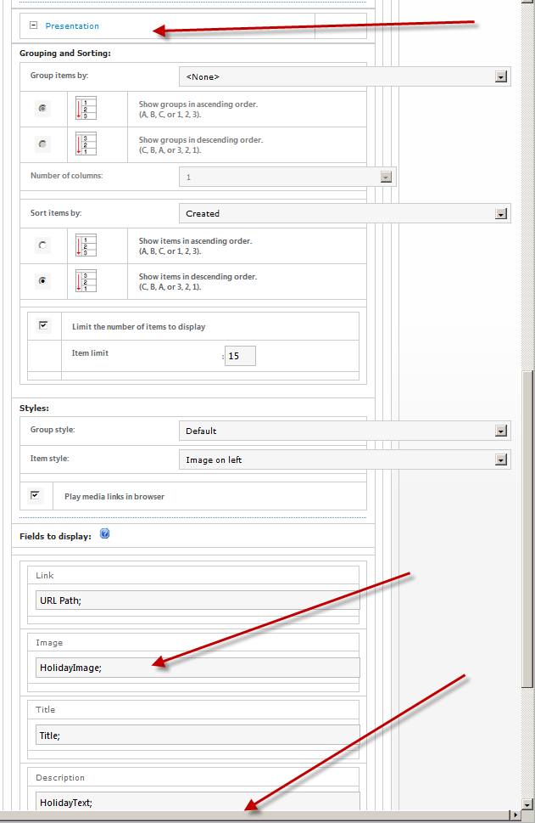
     2. Figure
     3. Changing the CQWP properties to display
  4. Now scroll down and click **OK** on the web part property editing UI.
  5. You should see something similar to Figure 25.
     1. 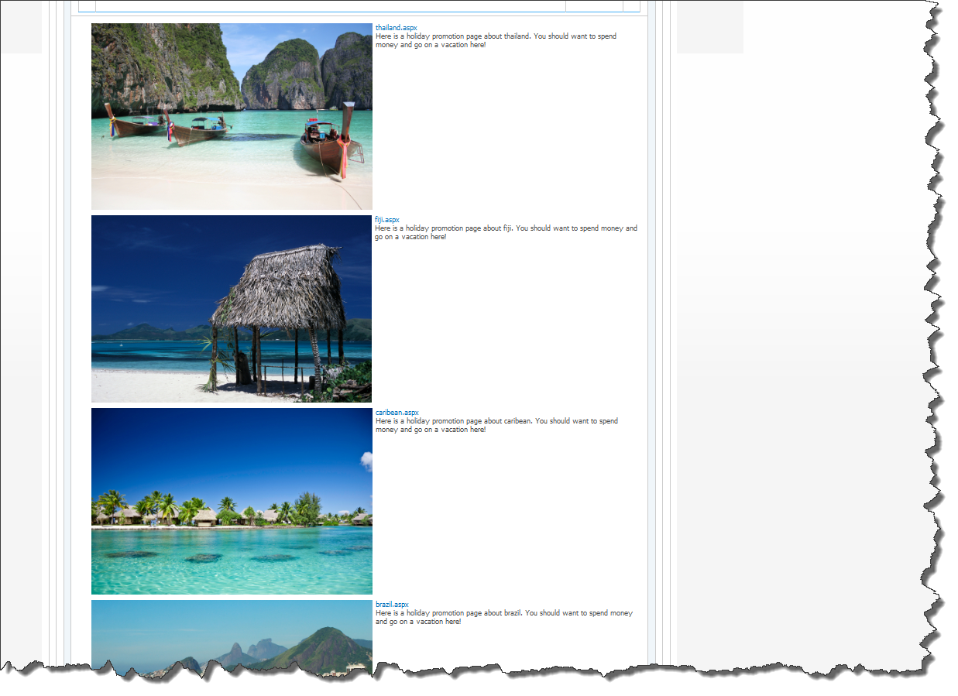
     2. Figure
     3. Content Query Web Part Added
  6. Click the **Blue Yonder** logo or the **Home** link at the top of the page to exit editing mode. See Figure 26.
     1. 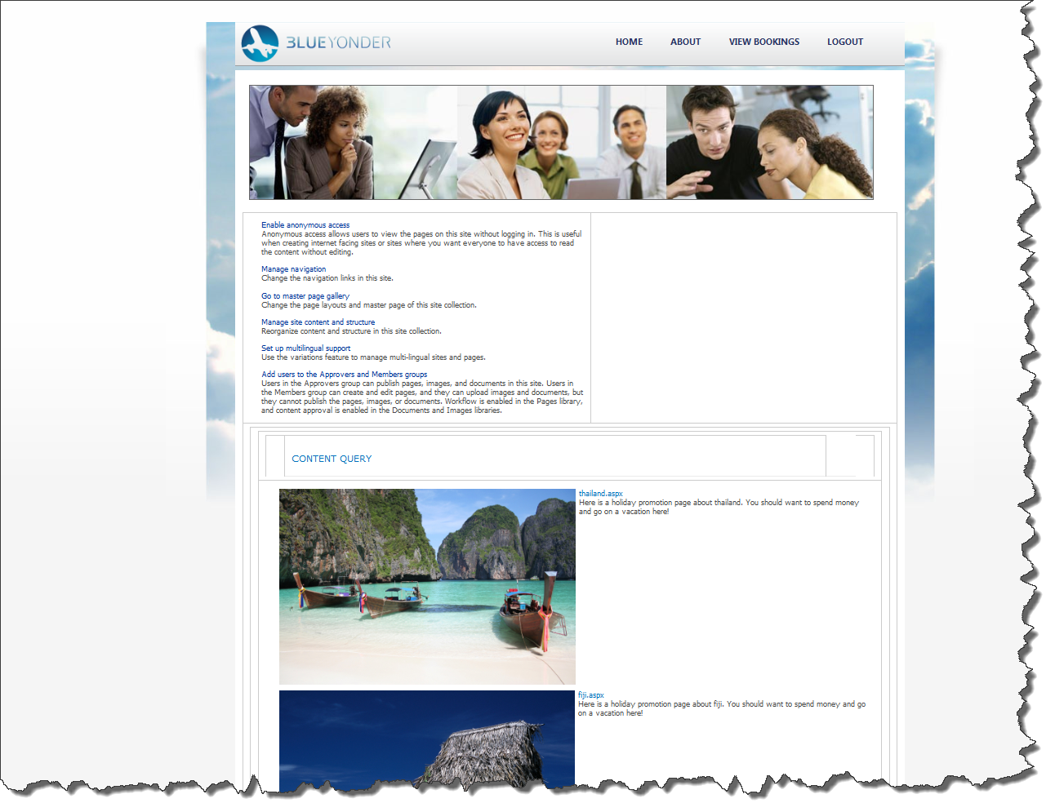
     2. Figure
     3. Home page after edits

# Lab Summary

* 1. **In this lab, you performed the following exercises:**
* Created a custom site content type.
* Created a custom page layout based on your custom site content type.
* Reused the custom site content type in another page.