

Hands-On Lab

SharePoint 2010:

***CSS and MasterPages***

Lab version: 1.0.0

Last updated: 7/18/2011

**Virtual Machine Logon Details:**

UserName: Administrator, Password: pass@word1

This document is provided “as-is”. Information and views expressed in this document, including URL and other Internet Web site references, may change without notice. You bear the risk of using it.

This document does not provide you with any legal rights to any intellectual property in any Microsoft product. You may copy and use this document for your internal, reference purposes.

© 2011 Microsoft. All rights reserved.

Contents

Overview 3

Exercise 1: Creating the Site, Site Collection 4

Task 1 – Creating the site 4

Exercise 2: Creating a Master Page 11

Task 1 – Creating the Master Page 11

Exercise 3: Adding custom CSS to SharePoint 20

Task 1 – Adding the CSS file 20

Lab Summary 26

Overview

* 1. This lab will walk you through creating a “blank” SharePoint Master Page, as well as how to add a CSS file to your site and reference it from the Master Page.
  3. Estimated time to complete this lab: **30 minutes**.

### Materials

* 1. This Hands-On Lab contains resources om the following folder
  2. Setup Files: **c:\mslabs\SharePoint2010\WCM\02_CSS_MasterPage\Resources**.



Exercise 1: Creating the Site, Site Collection

* 1. In this exercise, you will create the SharePoint site that will have the Blue Yonder branding elements applied to it.

**Note**: You can skip this task and move on to Exercise 2 if you already have a site created at port 8080.

Task 1 – Creating the site

* 1. Open the SharePoint 2010 Central Administration web site by going to **Start | All Programs | Microsoft SharePoint 2010 Products | SharePoint 2010 Central Administration.**
  2. **Note:** Select **Yes** if a User Account Control (UAC) dialog appears asking if you would like to give this program permissions.
  3. Once the SharePoint 2010 Central Administration page is open, click on the **Manage web applications** hyperlink under the **Application Management** section. See Figure 1.
     1. 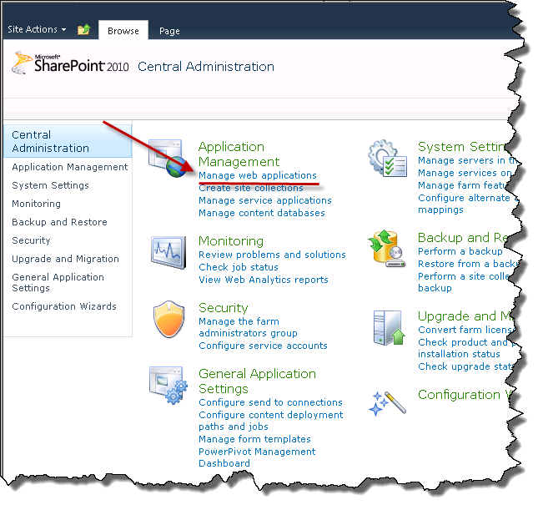
     2. Figure
     3. Manage web applications link
  4. On the Web Applications Management page, click the **New** button in the ribbon. See Figure 2.
     1. 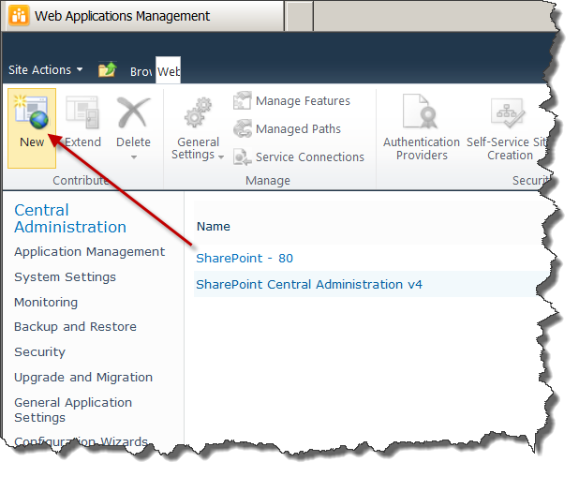
     2. Figure
     3. New Web Application button in the Ribbon
  5. On the **Create New Web Application** dialog, change the name of the web site to BlueYonderAirlines and the **Port** to 8080. See .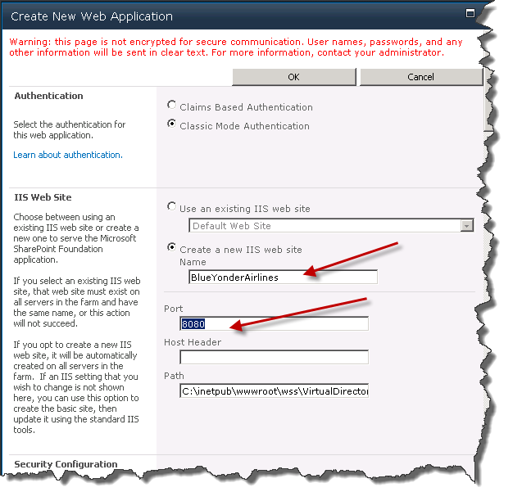
     1. Figure
     2. Create New Web Application dialog
  6. Click OK at the top of the **Create New Web Application** window**.** This will create a new Web Site and Application Pool to host the Blue Yonder Airlines Web Site.
  7. Once the Web Application has been created, click on the **Create site collection** hyperlink in the **Application Created** dialog. See Figure 4.
     1. 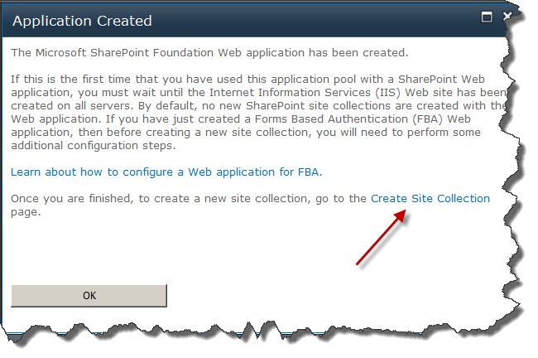
     2. Figure
     3. Create Site Collection hyperlink
  8. **Note:** A **Create site collections** link can also be found on the Application Management page of the SharePoint 2010 Central Administration application.
  9. In the **Create Site Collection** dialog, change the **Title** of the Site Collection to Blue Yonder Airlines in the **Title and Description** section**.**
  10. Click the **Publishing** tab in the **Template Selection** section and then select **Publishing Portal.**
      1. **Note:** You can use any site template and just enable the Publishing features using the Publishing Portal; this site template is just a shortcut to get the Publishing functionality.
  11. Type administrator in the **User name** text box in the **Primary** **Site Collection Administrator** section.
  12. Verify that your **Create Site Collection settings** match the settings illustrated in Figure 5, then click **OK**.
      1. 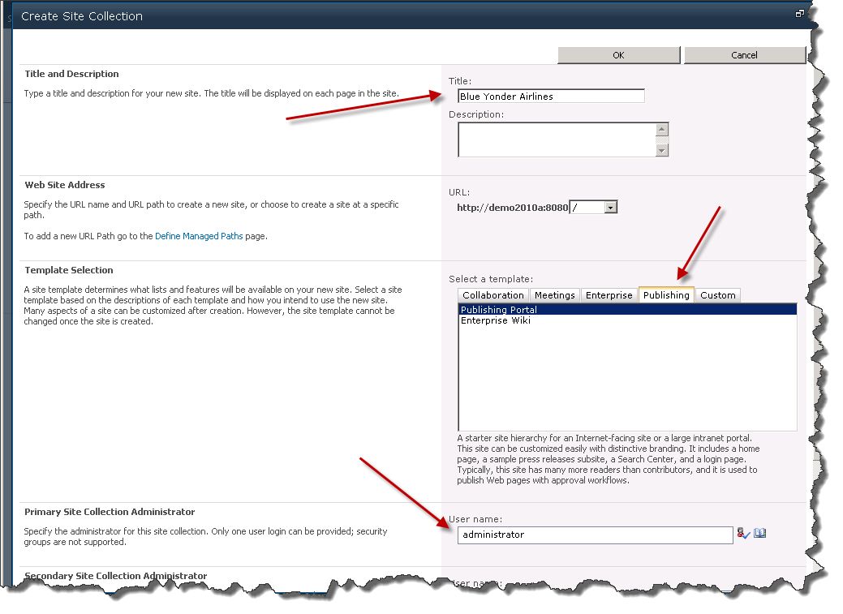
      2. Figure
      3. Configured Create Site Collection dialog
  13. Once the **Top-Level Site Successfully Created** dialog appears, click the Web site hyperlink in that dialog to go directly to your new site. You should see something similar to Figure 6.
      1. 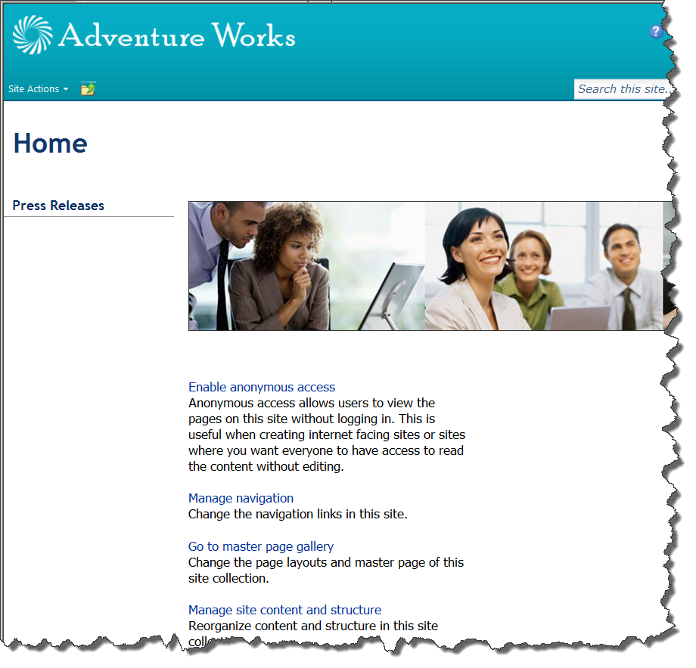
      2. Figure
      3. Publishing Portal site created

Exercise 2: Creating a Master Page

Task 1 – Creating the Master Page

* 1. Navigate to the **C:\MSLabs\SharePoint2010\WCM\02_CSS_MasterPage\Resources** folder using Windows Explorer. The folder contains a single file named **StarterPublishing**. See Figure 7.
     1. 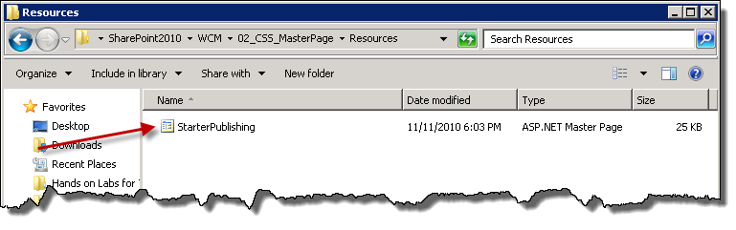
     2. Figure
     3. Starter Master Page
  2. Open **StarterPublishing** in Visual Studio.
  3. Select all the text (**Edit | Select All** or **CTRL+A**)and then a copy it (**Edit | Copy** or **CTRL+C**).
  4. Closethe instance of Visual Studio.
  5. Open Microsoft SharePoint Designer 2010 (SPD) by going to **Start | All Programs | SharePoint | Microsoft SharePoint Designer 2010**.
  6. In SPD click the **Open Site** button, in the **Site name** text box type http://demo2010a:8080/ and click **Open** twice. See Figure 8.
     1. 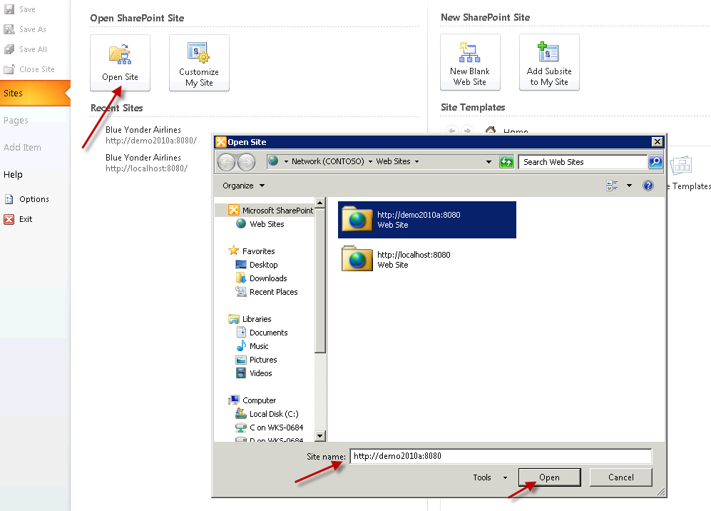
     2. Figure
     3. Opening site in SPD
  7. Select **Master Pages** in the **Site Objects** pane and then click the **Blank Master Page** button in the ribbon. See Figure 9.
     1. 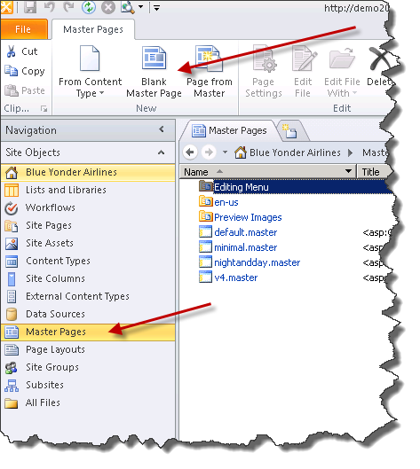
     2. Figure
     3. Creating a new Blank Master Page using SPD
  8. Rename the new master page blueyonder.master**.** See Figure 10.
     1. 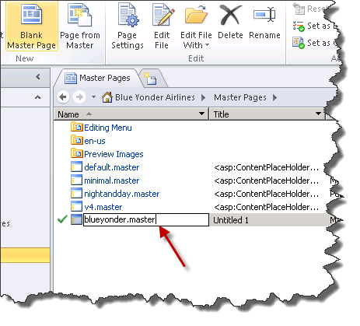
     2. Figure
     3. Renaming the Master Page
  9. Right-click **blueyonder.master** and **Edit File in Advanced Mode**. See Figure 11.
     1. 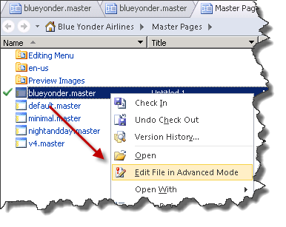
     2. Figure
     3. Advanced Mode command
  10. Clickthe **Code** tab at the bottom of the editor window. Select all the text (**Edit | Select All** or **CTRL+A**)andpaste over the selected text (**Edit | Paste** or **CTRL+V**). Finally, click the **Save** button. See Figure 12.
      1. 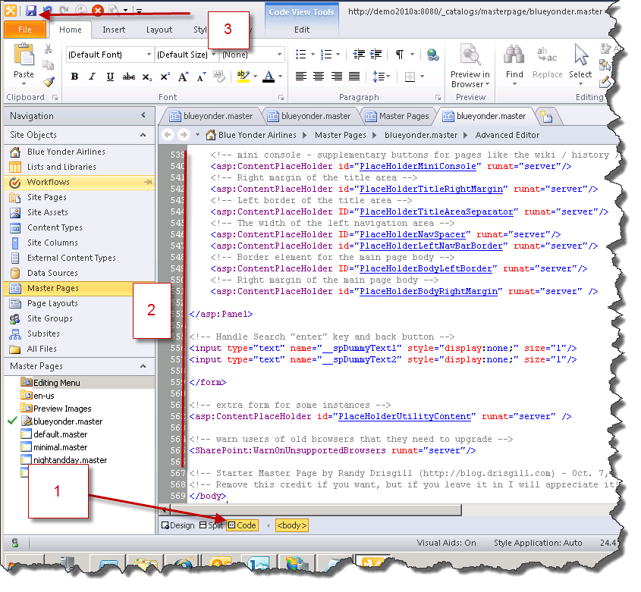
      2. Figure
      3. Saving new starter master page.
  11. Right-click **blueyonder.master i**n the **Master** Pages pane and then click **Set as Custom Master Page.** See Figure 13.
      1. 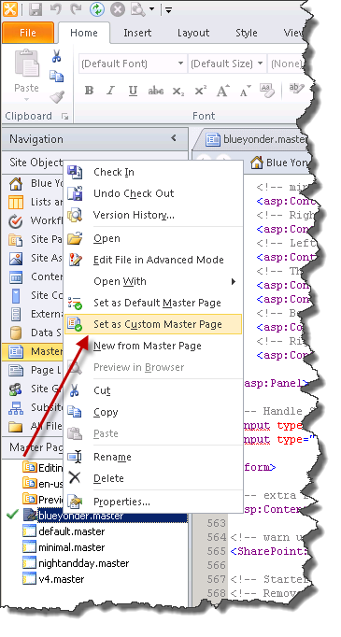
      2. Figure
      3. Setting blueyonder.master as the Custom Master Page
      4. **Note:** The Default Master Page applies to system pages as well as Pages that will be displayed to the user as part of the site. For branding purposes, you generally only want to change the Custom Master Page.
  12. Navigate to http://demo2010a:8080/ in Internet Explorer (or click refresh (**F5**) if you still have it open in your browser). You should see something similar to Figure 14.
      1. 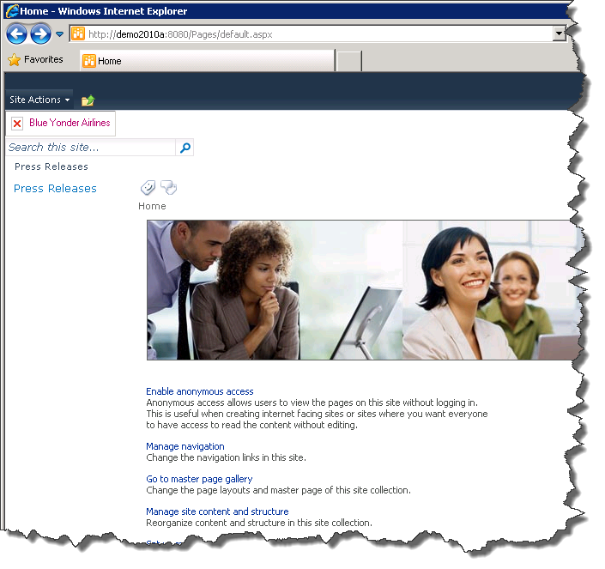
      2. Figure
      3. Custom “Blank” master page
  13. Open SPD and in the **BlueYonder.master** editor window go to line 389. (**CTRL+G** will bring up the Goto line dialog).

Add the Visible=“false” attribute-value pair to the **asp:ContentPlaceHolder** control element. This prevents the search control from rendering when the master page is used. See Figure 15.

* + 1. 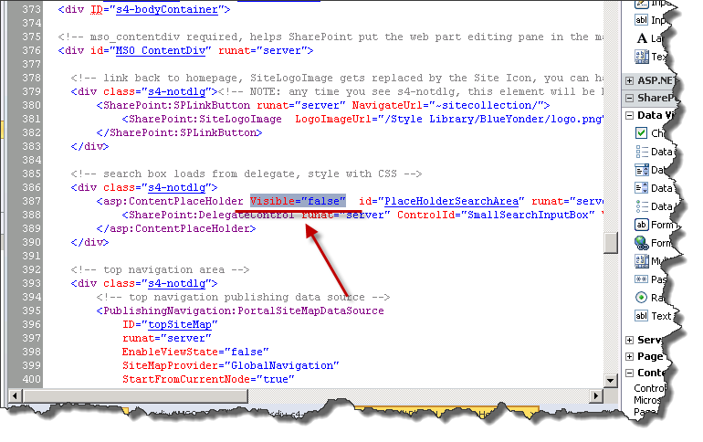
    2. Figure
    3. Adding Visible=”false”
  1. **Save** the file (**CTRL+S).**
  2. Click **Refresh (F5)** in Internet Explorer**.** You should see a page similar to Figure 16. Notice that the search box is now hidden.
     1. 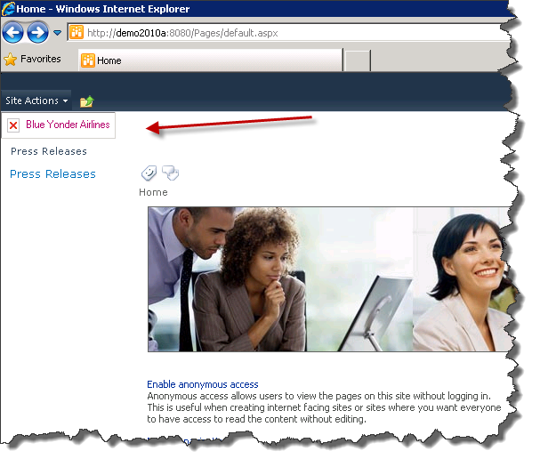
     2. Figure
     3. Page without search

Exercise 3: Adding custom CSS to SharePoint

* 1. In this exercise you will be adding a custom CSS file to the SharePoint site.

Task 1 – Adding the CSS file

* 1. In SharePoint Designer (SPD) select **All Files** from the **Site Objects** pane then select **Style Library** from the editing tab. See Figure 17.
     1. 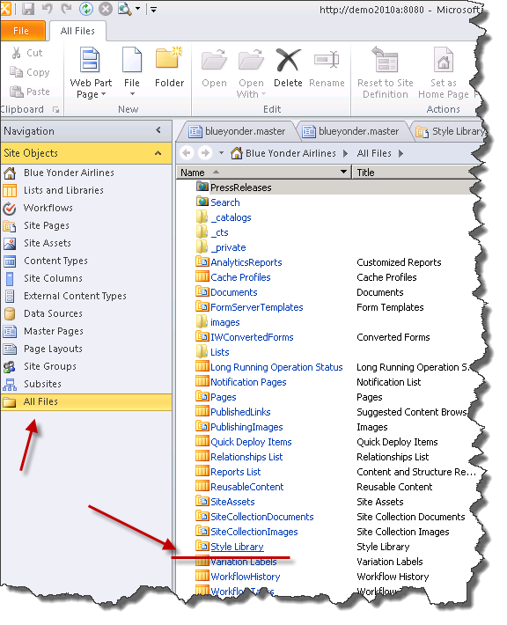
     2. Figure
     3. Opening Style Library
  2. With the Style Library tab open create a new folder by clicking the **Folder** button in the ribbon, and then rename the folder BlueYonder**.** See Figure 18.
     1. 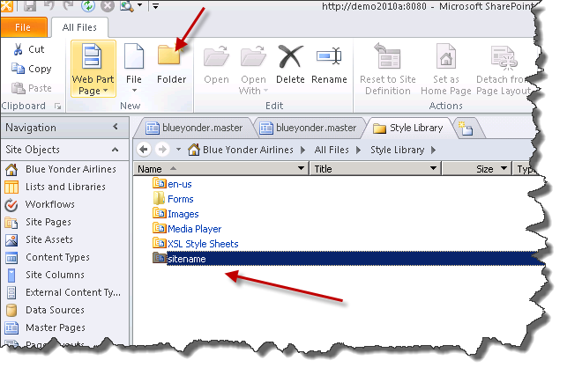
     2. Figure
     3. Adding a new folder
  3. Click on the newly created folder.
  4. With the **BlueYonder** tab open, click the **File** button in the ribbon, select **CSS** from the list of file types that can be add. See Figure 19.
     1. 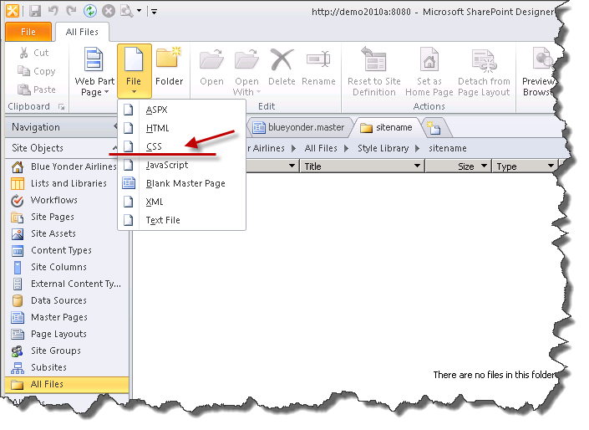
     2. Figure
     3. Adding a CSS file
  5. Rename the file style.css**.** See Figure 20.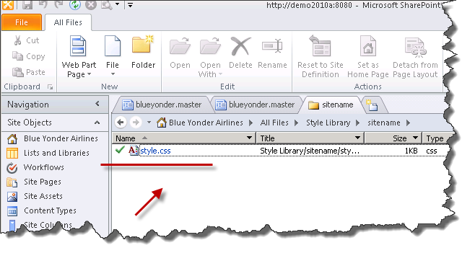
     1. Figure

CSS file renamed.

* 1. Open style.css in the SPD CSS editor by double-clicking on the icon beside the filename.
  2. Create a new CSS class selector named myClassSelectorcontaining a background attribute with a value of fuchsia. See Figure 21.
     1. CSS
     2. .myClassSelector
     3. {
     4. background:fuchsia;
     5. }
     6. 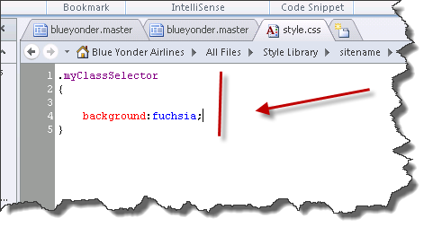
     7. Figure
     8. Custom CSS
  3. Save the CSS file.
  4. In SPD, click the **blueyonder.master** editing tab, scroll to line *75*, and note the **CssRegistration** control element that SPD has added to the master page. In particular, note that the **After** attribute specifies that your new style sheet should be loaded after the corev4.css style sheet. See Figure 22.
     1. 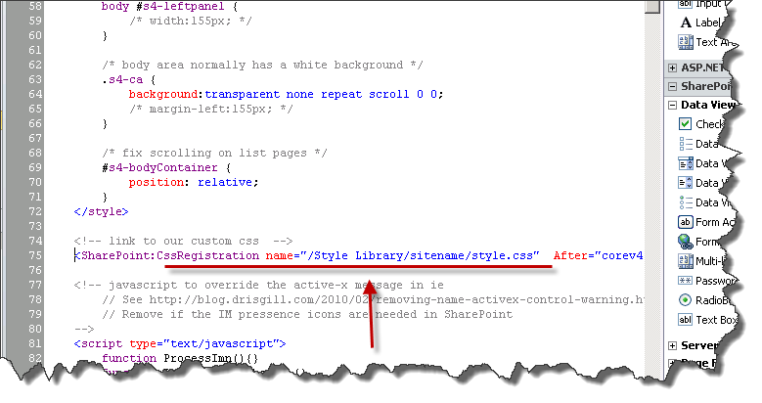
     2. Figure
     3. CssRegistration Control
     4. **Note:** If you add CSS files with other names (which is likely in a real environment) you will need to add your own CssRegistration control for each file. This example is following a common convention, but note that **style.css** isn’t a special filename.
  5. Scroll down to the opening **<body>** tag in the master page (line 97).
  6. On line *98* add an html **div** element with the **class** attribute set to *myClassSelector* and add the string “Testing CSS!” as the content of the div element, as shown in the following code example.
     1. HTML
     2. <div class="myClassSelector">Testing CSS!</div>

See Figure 23.

* + 1. 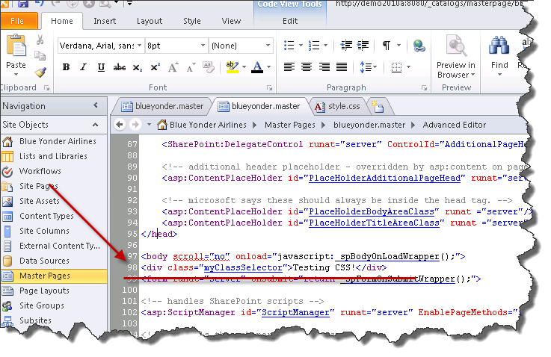
    2. Figure
    3. Adding div
  1. Save the file.
  2. Go back to Internet Explorer and refresh the page. You should see something similar to Figure 24.
     1. 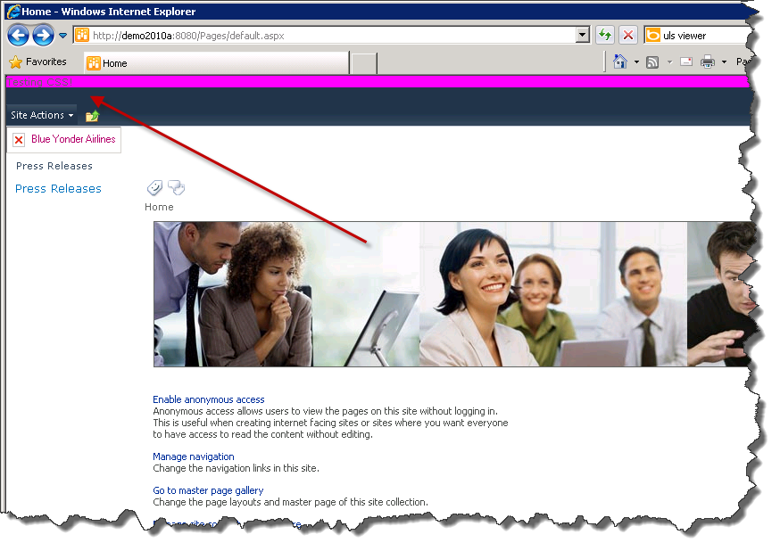
     2. Figure
     3. Testing CSS

# Lab Summary

* 1. **In this lab, you performed the following exercises:**
  + Created a Web Application.
  + Created a Site collection.
  + Created and modified a site MasterPage.
  + Added a custom CSS file to the MasterPage.