HOMEGROUP OVERVIEW

Abstract
This white paper provides an overview of HomeGroup, a new feature in Windows 7.
HomeGroup takes the headache out of sharing files and printers on a home network. It is a collection of two or more computers in the home that are automatically set up for easy sharing of music, pictures, video, and document libraries, as well as any connected printers with others in your home. It also allows you to stream media to devices. An explanation of general scenarios and basic technical data is included.
Version 1.0.0 – August 1, 2009
The information contained in this document represents the current view of Microsoft Corporation on the issues discussed as of the date of publication. Because Microsoft must respond to changing market conditions, it should not be interpreted to be a commitment on the part of Microsoft, and Microsoft cannot guarantee the accuracy of any information presented after the date of publication.
This White Paper is for informational purposes only. MICROSOFT MAKES NO WARRANTIES, EXPRESS, IMPLIED OR STATUTORY, AS TO THE INFORMATION IN THIS DOCUMENT.
Complying with all applicable copyright laws is the responsibility of the user. Without limiting the rights under copyright, no part of this document may be reproduced, stored in or introduced into a retrieval system, or transmitted in any form or by any means (electronic, mechanical, photocopying, recording, or otherwise), or for any purpose, without the express written permission of Microsoft Corporation.
Microsoft may have patents, patent applications, trademarks, copyrights, or other intellectual property rights covering subject matter in this document. Except as expressly provided in any written license agreement from Microsoft, the furnishing of this document does not give you any license to these patents, trademarks, copyrights, or other intellectual property.
© 2009 Microsoft Corporation. All rights reserved.
Microsoft®, Windows®, Windows Vista®, Windows XP® are either registered trademarks or trademarks of Microsoft Corporation in the United States and/or other countries.
Apple®, Mac®, and Mac OS® are trademarks of Apple Inc., registered in the U.S. and other countries.
Ubuntu® is a registered trademark of Canonical Ltd.

Contents
1 Requirements 4
1.1 Software 4
1.2 Hardware 4
2 Introduction 5
2.1 What is HomeGroup? 5
2.2 Sharing in previous Windows Operating System releases 6
2.2.1 Sharing in Windows XP 6
2.2.2 Sharing in Windows Vista 6
2.2.3 Sharing in Windows 7 7
2.3 HomeGroup Usage Scenarios 8
2.3.1 Joining a new Windows 7 PC to a Home network enable easy sharing: 8
2.3.2 Easy to participate in sharing when adding a second Windows 7 PC: 8
2.3.3 Easy to discover and access shared content in the home: 8
2.3.4 Easy to protect and hide my private stuff from others in the home: 8
2.3.5 Easy to collaborate within the home: 9
2.4 What is shared by default in the Homegroup? 9
3 Technical Overview 11
3.1 Homegroup Architecture 11
3.1.1 HomeGroup Services 11
3.1.2 HomeGroup Technological Dependencies 11
3.1.3 HomeGroup Security 12
3.2 HomeGroup Activity by Scenario 14
3.2.1 Network Identification & Homegroup Discovery 14
3.2.2 Homegroup Creation 14
3.2.3 Homegroup Joining 18
3.2.4 Sharing content with the Homegroup 23
3.2.5 Default Permissions to Homegroup Shared Resources 26
3.2.6 Homegroup support for Media Streaming 28
3.2.7 Homegroup support for printing 29
3.2.8 Changing the Homegroup Password 30
3.2.9 Leave a Homegroup 33
4 Publicly accessible HomeGroup Development Surface 34

Requirements

Software
Windows® 7 Client Operating System
All versions of the Windows 7 Client Operating System can participate in a HomeGroup.
Only Windows 7 Home Premium, Professional, Enterprise or Ultimate can create a homegroup. All versions of Windows 7 can join a homegroup that has already been created on your home network

Hardware
HomeGroup requires connection to a local area network and requires all your PC’s and compatible media devices to be on the same subnet. For full functionality and highest quality experience, Microsoft recommends a Windows certified router.
You can learn more about Windows compatible routers here.

Introduction
HomeGroup is a new feature in Windows 7 that allows you to connect two or more PCs running Windows 7 and easily share your Music, Pictures, Video, and Document libraries as well as printers with others in your home. The new “Share with” menu in Windows Explorer also provides a speedy way to share additional libraries, files and folders or to keep private the content you don’t want anyone else to see. HomeGroup also automatically sets up sharing so that all media shared with the homegroup is accessible from Windows Media Player, Windows Media Center, and other compatible media devices in the home.
This document provides a high-level overview of how HomeGroup works, its key usage scenarios, and how it uses Windows technologies to deliver on the promise of easy, open sharing within the home.
Note: Windows 7 still continues to support legacy modes of sharing as available in Windows Vista® and Windows XP® in addition to HomeGroup. For more details on how to share content from Windows 7 with Windows XP, Windows Vista, Mac OSX® or Ubuntu®, please review the following white paper.

What is HomeGroup?
HomeGroup configures a collection of Windows 7 PCs on the same home network to know about and trust each other. Within this collection of PCs, general access to shared data is implicit and automatic once you become a member making it easy to discover, search for, and use files on multiple PCs, as well as print to connected printers. HomeGroup is not about “sharing” per se(“discretionary sharing” requires specifying “what and whom” to share with, whereas for HomeGroup, the “what and whom” are essentially automated to everyone in your home), it is about easy access to the shared data on all the PCs in your home. The act of joining a homegroup enables access to selected data between other PCs in your home that are part of the homegroup. The approach that is used is modeled upon simple human behaviors such as:
- People don’t allow strangers into their homes and usually lock their exterior doors. Those people that are within the confines of the home are typically considered to be trusted. Thus, all members of a homegroup are treated equally, with all members having the same access by default.
- Within the home, doors to rooms are not usually locked, allowing members of the household to have free access. Social norms prevent most people from snooping in areas they shouldn’t. However, there are inevitably some places people do not want others looking, so locks can be added to rooms or drawers. Similarly, in a homegroup is easy to restrict access to content that you don’t want shared in a homegroup.
In line with above, HomeGroup optimizes sharing by default for open access between the trusted groups of PC’s, which serves the mainstream audience with basic to intermediate skills. However, it does not preclude additional needs for discretionary access to data, which is important to a significant set of users and is enabled using legacy methods that have been in Windows for a long time. However, the main goal of HomeGroup is to provide the largest set of users with a simple, convenient, and intuitive method by which to share files and printers in the home.

Sharing in previous Windows Operating System releases
It is important to understand the changes we’ve made in Windows 7 in light of the evolution of file and printer sharing in previous releases of the Windows operating system. This section details the evolution of file and printer sharing across several versions of Windows, the key changes that affected the eventual design for HomeGroup, and the tradeoffs that were made along the way.

Sharing in Windows XP
In addition to NTFS, Windows XP introduced “user profiles” to the general customer base. This allowed users on the same PC to separate and enjoy their own settings, customizations, and user experience. While Windows 9x had some semblance of profiles, the level of profile isolation and control was new to consumers in Windows XP. Windows XP even encouraged users to create individual user accounts early on in the out-of-box experience (OOBE). This matched the needs of a typical (Windows XP timeframe) home, where PC prices were still relatively high, and several family members typically shared one PC in the home.
To address sharing in the home, the focus was on “intra-PC” sharing. A “shared folder” was introduced such that all users on the same PC could easily access files from each other. Users who co-used the PC, but needed to hand files to another user on the same box, would drag a copy of the file into the Shared Documents folder. This Shared Documents folder appeared conveniently in My Computer in every user’s session and was easily available for transferring files and collaboration. This was the beginning of what we now know as “public folder” sharing.
General network sharing, on the other hand, was turned off by default. A Windows XP user had to explicitly share a file/folder to the network, which ended up turning on a feature called simple file sharing. While the new file system (NTFS) in Windows XP included features that allowed individual users access/permissions to be set on files and folders, NTFS was not widely adopted when Windows XP was first released. Users and PC manufacturers were more comfortable with supporting the easier FAT and FAT32 equivalents. As such, none of the unique benefits of NTFS and per-file access control were experienced by regular users.
Turning on simple file sharing used the same sharing model that existed since Windows 9x, in which all local file shares were just opened up to anyone on the network. Simple file sharing was also referred to as “forced guest” sharing. All connections to view resources on your local Windows XP PC would be treated as though they were the guest account. The benefit of this was that it was simple to set up (almost no setup, just share a file/folder), and worked with or without NTFS. However, the risk of users accidentally or purposefully accessing your files without your knowledge was high, and even higher on unsecured wireless networks. User awareness of security and the need to ensure their PCs were safe from infection also led to a well-documented change of approach in building operating systems, starting with Windows XP Service Pack 2.

Sharing in Windows Vista
File and printer sharing changed significantly in Windows Vista to incorporate security as a key focus.
While the Windows XP model of simple file sharing was easy to set up, it exposed the user to too much risk, and the decision was made in Windows Vista to lock down sharing and have it default to a more secure model. The result was the introduction of password protected sharing.
Password protected sharing removed “forced guest” as the default and replaced it with a model that requires usernames and passwords for all share access. As such, it was no longer possible to easily make a share available to ‘Everyone’ on the network with anonymous access. The new default setting also affected printer sharing as printers were no longer shared out anonymously; they required a username/password to access. This change ensured that no user data could be inadvertently accessed over the network.
Windows Vista also heralded the mainstream adoption of NTFS. To bring one of the key benefits of NTFS, access control, to users, the File Sharing wizard was developed for Windows Vista. This wizard put a friendly face on top of the previous security property pages (also known as the Access Control List UI [ACL UI]), and allowed users to easily give sharing roles to specific users on the same PC. It also enabled users to share individual files instead of complete folders. This was known as “in place” file sharing. New technologies like access based directory enumeration made their debut to help polish the sharing experience. Using access based directory enumeration, users only saw shared resources on the network they had access to when viewing a folder path. The key scenario this enabled was sharing “foo.txt” in a directory, and ensuring that “bar.txt” in the same directory wasn’t seen by another user accessing the directory – this level of control was not possible in Windows XP.
Windows Vista also flattened the user’s profile namespace for the system. Instead of having one My Documents folder to store everything they had, music, videos, and pictures were promoted to be full peers of documents. Each user on the PC had several peer level folders, organized by content, in their user profile. This provided a cleaner model for storing user content on the PC. No longer would your music collection be mixed in with your Excel spreadsheets. It would also allow you to give access to one type of content without giving access to others. In addition, public sharing was overhauled. It not only changed its name and location on the hard disk to “Public”, but it also had an organizational structure (music/videos/pictures) that mirrored the kind of content users would share publicly on a local PC.
Vista made sharing more secure with password protected sharing. The namespace also made content on the PC easier to organize and share out. However, setting up a multi-PC household to share files and printers required more work on Windows Vista than it had on Windows XP and the improved security resulted in a usability trade-off.

Sharing in Windows 7
Windows has featured file and printer sharing for several releases, but discovering and successfully using these features have remained challenging for most users. As a result, many users resort to emailing files to themselves or to others in their homes just to print to another printer in the home or to give another user access to their files. . Sharing the internet remained the only perceived value they had from home networking. In Windows 7, with HomeGroup, the goal is to really embrace easy sharing for the masses by making it discoverable, intuitive, and contextual to use network enabled functionality like printing, sharing, and moving or accessing files and media between PCs in a home.
HomeGroup achieves this by reducing the steps and technical knowledge required for configuring file sharing and network printing on each PC within the home to one simple step. Furthermore, that one step is user friendly and does not require any understanding of the underlying technology to successfully complete. It makes it discoverable, intuitive and contextual to enable printing and file access between PCs and embodies the philosophy that “Windows should help me do what I want to do.” Users are provided with a single password which they can give others in the home to also join the homegroup. In addition, the feature provides users with a higher degree of confidence when giving access to their data, as it defaults to member PCs in their homes, rather than “everyone,” and it protects users from exposure to dangers that they don’t (and don’t need to) understand.

HomeGroup Usage Scenarios
Some typical HomeGroup scenarios for easy sharing within the home are described below:

Joining a new Windows 7 PC to a Home network enable easy sharing:
- As part of connecting to an existing wireless network at home during the out-of-box-experience, Windows 7 automatically enables the right switches and functionality using HomeGroup to allow Bob to easily share his content with other Windows 7 PC’s or compatible devices in his home. Bob no longer needs to worry about determining how to set up sharing or what switches he might have to set. None of his personal content is shared by default with others and all he now needs to determine is what he wants to share with others.

Easy to participate in sharing when adding a second Windows 7 PC:
- When Amy joins her Windows 7 PC to the home network, as part of the connection experience, Windows 7 asks Amy if she wants to join the homegroup created by Bob. Amy selects which of her libraries she wants to share with others in her home and enters the homegroup password provided to her by Bob. Upon confirmation of the password, her PC seamlessly joins the homegroup and she is not required to perform any additional steps to enable sharing between their Windows 7 PCs.

Easy to discover and access shared content in the home:
- Amy downloads a new music album onto her Windows 7 PC. Once the download is complete, Bob can easily find that new album on any of his homegroup PCs such as the Media Center PC in the living from within Windows Explorer, Windows Media Player, or Windows Media Center. Bob doesn’t need to know about network (UNC) paths, file shares, PC names, etc. to find the shared content. He finds the album in Windows Media Center’s shared music pivot view and starts listening to the album on his living room stereo.

Easy to protect and hide my private stuff from others in the home:
- Bob is planning a surprise birthday party for Amy and the party list and invitations are stored in Bob’s documents folder on his PC. Although Bob’s document folder is shared with the homegroup, Bob is able to select the party-specific folders or even individual files and make them private. He is confident that although Amy will be able to access other shared documents from his PC, the party invitations won’t be visible to her.

Easy to collaborate within the home:
- Bob is reviewing the tax documents shared by Amy from her Windows 7 PC and notices a few errors. He tries to make the corrections on the original files but realizes that Amy has only given him read access to the content. He asks Amy to grant him full access so that he can make the relevant changes. It is very easy for Amy to change the access privileges on her shared documents library by selecting the ‘Share With: Homegroup (Read/Write)’ option in Windows Explorer to provide Ben with full write access to the content.

What is shared by default in the Homegroup?
When a user manually creates or joins a homegroup to enable easy sharing in Windows 7, HomeGroup preselects the user’s media libraries as well as any connected printers to share with others in the home. This includes the user’s Pictures, Music and Video libraries and all scopes within those libraries. In addition to these pre-selected libraries, the user can also share his or her Documents library with the homegroup if desired, but it isn’t pre-selected for sharing by default. The user can choose to select or deselect any library (or printers) when creating or joining a homegroup.
- Once shared, any other member of the homegroup will be able to view all content within each of those individual libraries by default but will not be able to modify or delete any content in them.
- The Public folders are always shared with the Homegroup with ‘Read/Write’ privileges to allow for a default accessible network save location on homegroup PC’s. This makes it easy for one member of the homegroup to give files to another member by simply copying the files to their public folder location.
- The following is a list of default user libraries, their scopes, and the share level access preselected for sharing with the homegroup when creating or joining a homegroup:

Library Name | Default Scope | Default Folder Path | Access Rights
Pictures | My Pictures  Public Pictures | %Username%\Pictures  %Public%\Pictures | Read  Read/Write
Music | My Music  Public Music | %Username%\Pictures  %Public%\Pictures | Read  Read/Write
Videos | My Videos  Public Videos | %Username%\Pictures  %Public%\Pictures | Read  Read/Write

- The user can also use the ‘Share with’ menu option in Windows Explorer to change the shared libraries from the default ‘Read only’ setting and give others in the homegroup full Read/Write access to all content within the libraries.

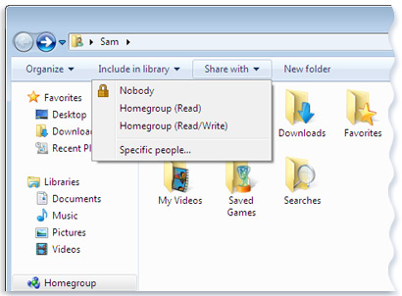
Figure 1: 'Share with' menu in Windows Explorer

- The user can also choose to share any additional library, folder or even individual files with the homegroup from their PC by selecting the item and using the above ‘Share with’ menu in Windows Explorer.

Technical Overview
The goal of this is section of the document is to provide the reader with a more detailed technical overview of HomeGroup; this includes details on the homegroup architecture, services, additional technology dependencies and configuration details.
HomeGroup configures well-documented technologies to enable end-to-end connectivity in the home without requiring significant time investment, technical knowledge, or visits to multiple areas in Control Panel. Some of these technologies existed in previous versions of Windows, and some are brand new for Windows 7. Aside from obvious fundamental dependencies on components such as Ethernet and wireless networking, HomeGroup uses Peer-to-Peer Networking, Point and Print, Server Message Block 2.0 (SMB), Windows Media Player Network Streaming Services, and Function Discovery including the Web Services on Devices (WSD) provider to deliver an easy to use sharing experience.

Homegroup Architecture
This section is a general overview of HomeGroup architecture and technology dependencies.

HomeGroup Services
HomeGroup has two core services that are enabled when connected to a Home network that work to configure a Windows 7 PC for homegroup membership. The services are:
- HomeGroup Listener Service
- HomeGroup Provider Service
The HomeGroup Listener Service runs as LocalSystem. It is responsible for making local PC changes associated with configuration and maintenance of the homegroup-joined PC. The Listener Service completes tasks such as creation and administration of the HomeUsers Security Group (which includes all local interactive users on the PC), file and printer sharing, and managing the context of homegroup connections between member PCs.
The HomeGroup Provider Service runs as LocalService and performs networking tasks associated with configuration and maintenance of the homegroup. The Provider service completes tasks such as advertising a homegroup to the network, detecting and validating homegroup advertisements from other PCs, joining the homegroup, securely transporting homegroup messages between member PCs on the network, monitoring network connectivity, interacting with the Network Location Manager, and providing information to Windows Explorer regarding the homegroup state.

HomeGroup Technological Dependencies
As shown in the diagram below, HomeGroup depends on the following well-documented technologies to perform specific tasks as described in the following sections.
- Windows Peer to Peer Networking
- Function Discovery & Web Services on Devices
- Windows Explorer
- Compatible Media Application (for example, Windows Media Player)
- Server Message Block (SMB)
- Windows Print Spooler
- Security Accounts Manager

A high-level HomeGroup architecture diagram showing the interaction of HomeGroup services with other mentioned components appears below.
Figure 2: HomeGroup architectural diagram

HomeGroup Security
HomeGroup enables secure sharing and access between PCs in the home without requiring users to set individual passwords on their local accounts. All a user needs is a valid HomeGroup password to join a PC to an existing homegroup and, once joined, all members within a homegroup are treated equally. HomeGroup doesn’t enable members to manage specific policies or settings remotely between PCs. However, Windows 7 takes several steps to defend the homegroup and content shared within it from non-members.
- All homegroup-specific messages between homegroup members are sent through a shared peer group and HomeGroup implicitly relies on SSL to provide encryption and data integrity for record transportation.
- Since Windows Explorer uses SMB to connect to other homegroup PCs, HomeGroup implicitly uses documented Windows authentication protocols to identify users on each PC.
  - Content shared with the homegroup via SMB is only accessible by members of that homegroup over the network.
  - To accomplish this, HomeGroup creates a ‘HomeUsers’ security group on every PC joined to the homegroup. Any content shared with the homegroup is shared with this group, limiting access to valid homegroup members only.
- HomeGroup relies on standards defined by the DLNA (Digital Living Network Alliance) to share and render media to compatible devices and PCs on the network. Authentication is accomplished by a combination of MAC (Media Access Control) address and UDN (Unique Device Name).
- HomeGroup uses Point and Print to install and access printers around the home. Shared homegroup printers with trustworthy (driver signed) printer driver packages are installed automatically on behalf of the user without requiring administrator-level privileges. Other shared homegroup printers with non-signed driver packages require explicit action and administrator privileges to install.
  - Just as with shared content, printers are shared and accessible by valid members of the homegroup only.
It is important to note that the ‘Guest’ User Account on a PC is not considered to be a member of the homegroup and cannot access any content shared within the homegroup other than a shared printer. As a result, you can feel confident that when Guest users log onto homegroup PCs, they won’t be able to see any of your shared content.

HomeGroup Activity by Scenario
This section of the document walks the user through various activities that a user can perform with HomeGroup and the actions performed by HomeGroup on behalf of the user to complete that scenario. The typical set of activities may involve the user creating a homegroup on their first Windows 7 PC and then eventually adding more PCs to the homegroup. They may also choose to stick with the default homegroup sharing settings or share or un-share more content with the homegroup. If the homegroup password is compromised, they may choose to reset the password. They may make a PC leave the homegroup so it no longer can access any content on the homegroup before they donate or recycle it. This section goes into detail on what happens during each one of these scenarios.

Network Identification & Homegroup Discovery
When a Windows 7 PC successfully connects to a network, several characteristics are examined to determine if it is a known network location. If the network is previously unknown (and not identified as a domain-authenticated network), users are prompted to select a profile for that network location. Valid selections are Home, Work, and Public. If the user sets a “Home” network profile for the location, Core Networking and Network Discovery ports are opened in the firewall and HomeGroup examines the network for an existing homegroup.
- If no homegroup is detected during the out-of-box experience, one may be auto-created by that PC.
  - No user content is shared in this specific scenario and only the Public folders and any attached printers will be shared with the newly created homegroup.
- If no homegroup is detected when joining a new Home network from the Windows desktop, the user will be prompted to create a homegroup on that network.
  - Although defaults will be pre-selected for the user on what to share (Pictures, Music, and Videos Libraries + Printers), the user can choose what they want to share before creating the homegroup.
  - At this point, they also have the ability to cancel homegroup creation.
  - If they choose to create, they will be shown the homegroup password that they can use to add other PCs to the homegroup.

Homegroup Creation
A homegroup may be created on any home network where one does not already exists. There are four ways to initiate homegroup creation:
- Within the Out of box Experience (OOBE) when a Win7 PC is first connected to a network and “Home” is selected as the network type.
  - If no homegroup is detected during the out-of-box experience, one may be auto-created by that PC.
  - No user content is shared in this specific scenario and only the Public folders and any attached printers will be shared with the newly created homegroup.
- After selecting “Home” from the Network Location Wizard when joining a new network, the wizard will prompt the user to create a homegroup if no other homegroup is detected on the network as shown below in figure 3.:
  - Although defaults will be pre-selected for the user on what to share (Pictures, Music, and Videos Libraries + Printers), the user can choose what to share before creating the homegroup, as shown in the image below.
  - At this point, the user can also cancel homegroup creation.
  - If they choose to create, they will be shown the homegroup password that they can use to add other PCs to the homegroup.

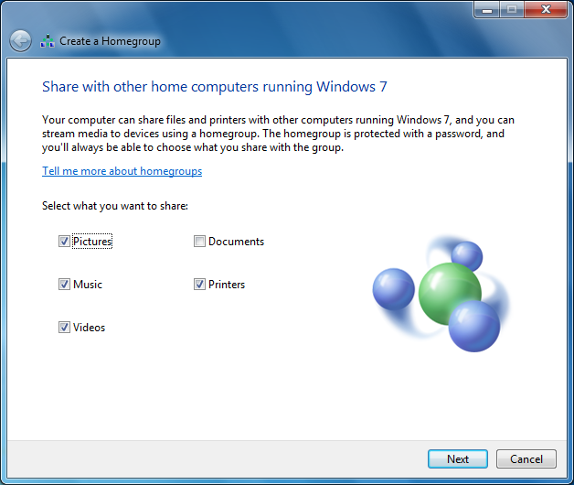
Figure 3: HomeGroup create wizard

- By navigating to the Homegroup node within Windows Explorer while on a Home network, the option to “Create” a homegroup will be presented to the user if no other homegroup is detected on that home network as shown below in figure 4.
  - As above, the user can choose what they want to share in this scenario.

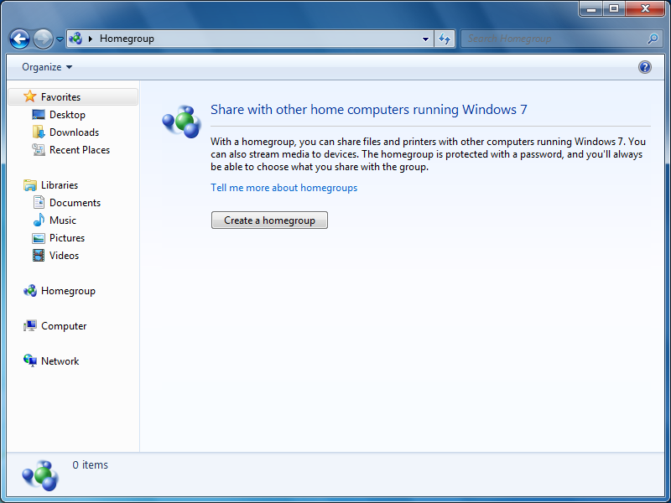
Figure 4: Homegroup node in Windows Explorer

- By navigating to HomeGroup in Control Panel, an option to create a homegroup will be presented if no existing homegroup is detected on the home network as shown below in figure 5.
  - As above, the user can choose what they want to share in this scenario.

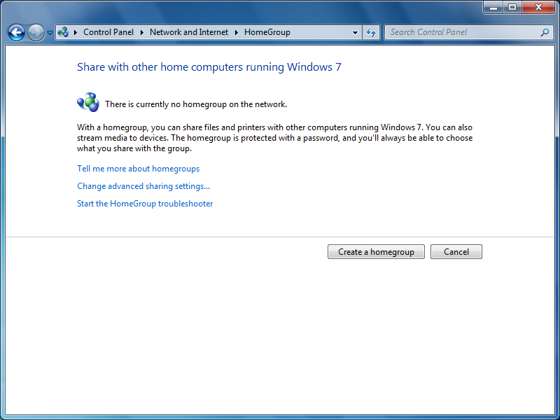
Figure 5: HomeGroup control panel
Once the user decides to create a homegroup and determines what they want to share with others, the homegroup services perform several tasks on behalf of the user:
- The homegroup is created on the local PC and secured with a strong auto-generated password. The password is provided to the user.
- Firewall ports required by HomeGroup to successfully function are opened. These include ports for:
  - Peer to Peer Grouping
  - Peer Name Resolution Name Protocol
  - Media Streaming
  - SMB (File/Printer Sharing)
  - Core Networking Discovery
For more detailed information on the TCP/UDP ports required for homegroup to function, please review the Homegroup and Firewall Interaction white paper.
- The homegroup is then advertised on that local home network to allow other PCs to discover and join it.
  - This is described as the ‘Homegroup invitation’ which includes:
    - The name of the homegroup creator
    - The number of PCs that belong to the group
    - A Peer Group Invitation for the homegroup
    - The time the homegroup was created
- A homegroup account (HomeGroupUser$) is created on the local PC.
  - This account is used by all members of the homegroup for authentication to access shared resources across PCs.
- A local security group for the HomeGroup (HomeUsers) is created on the local PC.
  - All local users (except Guest) are added to the HomeUsers Security Group.
- Libraries and printers as selected by the user are shared appropriately with the HomeUsers group.
- The shared libraries and printers on the local PC are then advertised on the network to make them discoverable by future homegroup members.
- Public folders are shared with the Homegroup to allow for a default network save location on every homegroup PC.
- Windows Media Streaming Services are enabled to allow streaming of the user’s media to future homegroup members in Windows Media Player or to other authorized DLNA-compliant media receivers.

Homegroup Joining
Whenever a new PC is connected to a home network, the PC will automatically try to discover an existing homegroup on that network. If the home network already has a homegroup present, the user may be asked to join that existing homegroup in the following scenarios:
- Within the Out of box Experience (OOBE) when the Windows 7 PC is first connected to the network and “Home” is selected as the network type as shown below in figure 6.
  - If a homegroup is detected on the network, the user will be asked if they want to join that homegroup by providing the homegroup password.
  - They will also have the ability to verify what they want shared with the homegroup as part of joining it.
  - They can also skip the join process if they choose to do so and can join the homegroup at a later time from the desktop, as described in the following scenarios.
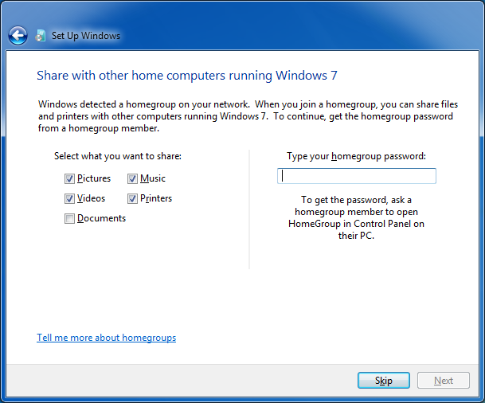
Figure 6: HomeGroup join wizard during Windows setup

- After selecting “Home” from the Network Location Wizard when joining a new network on the Windows desktop, the wizard will ask the user if they want to join the existing homegroup on that home network as shown below in figure 7.
  - Although defaults will be pre-selected for the user on what to share (Pictures, Music, and Videos Libraries + Printers), the user can choose what they want to share before creating the homegroup as shown in the image below.
  - At this point, the user can also cancel the process of joining the homegroup.
  - If they choose to join, they will be asked to provide the appropriate homegroup password to authenticate them to the homegroup.

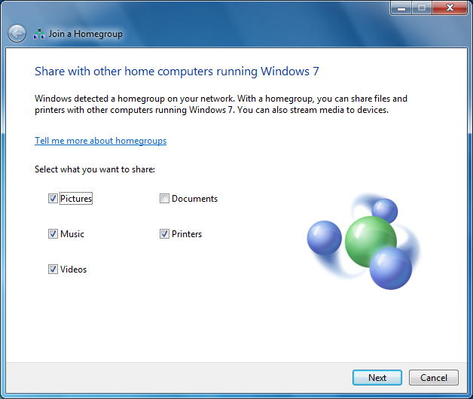
Figure 7: HomeGroup join wizard

- By navigating to the Homegroup node within Windows Explorer while on a Home network, the option to “Join” an existing homegroup will be presented to the user if one is detected on that home network as shown below in figure 8.
  - As above, the user can choose what they want to share in this scenario once they opt to join.

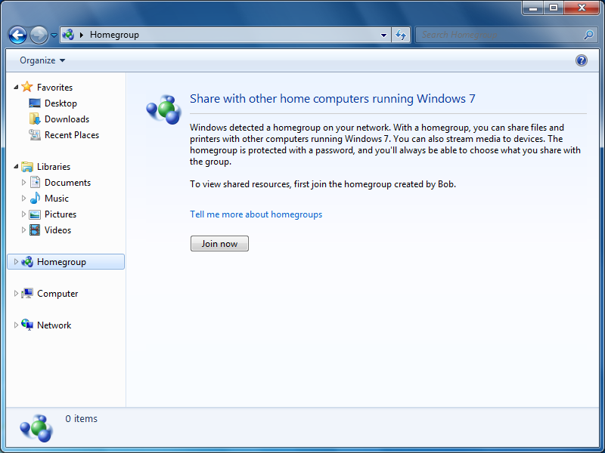
Figure 8: Homegroup node in Windows Explorer

- By navigating to the Control Panel under HomeGroup, an option to join a homegroup will be presented if one is detected on the home network as shown below in figure 9.
  - As above, the user can choose what they want to share in this scenario once they opt to join.
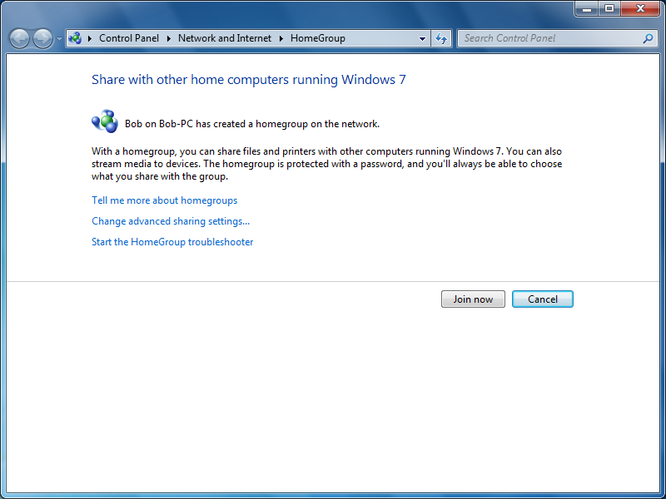
Figure 9: HomeGroup control panel

Homegroup join scenarios
Before the user is asked to join an existing homegroup on the home network, HomeGroup performs some key checks to determine if it is valid to ask the user to join that group. As a result, when the a PC joins the new home network and discovers the existing HomeGroup invitation on that network, the HomeGroup Provider Service examines the invitation for several pieces of information:
- The name of the homegroup creator
- The number of PCs that belong to the group
- A Peer Group Invitation for the homegroup
- The time the homegroup was created
Using this data in the homegroup invitation, the HomeGroup service then determines whether or not to show the join experience to the user based on the following:
- If the current PC is not a member of any homegroup, Windows will always prompt the user to join the discovered homegroup.
- If the current PC is already a member of another homegroup, and is the only member of that homegroup (for instance, the group was auto-created during the Windows 7 Out Of Box Experience by this PC), HomeGroup will then further examine the date the newly discovered homegroup on the network was created to determine which group is newer.
  - If HomeGroup determines that the discovered homegroup on the network was created more recently than the one on this PC, HomeGroup will ask the user to join that newly discovered homegroup.
  - This design helps mitigate the case of a home network unintentionally being partitioned into more than one homegroup, preventing PCs from sharing with one another.
- If the current PC is already a member of another homegroup with more than one member, HomeGroup will ignore the newly discovered homegroup on the network since it is already a member of a fully functioning homegroup, and the user won’t be asked to join it. The PC will still continue to be a part of that original homegroup.
  - It is important to note that at this point you will have two independently functioning homegroups on that same network and users from one homegroup will not be able to see the ones from another.
  - If the user on the current PC wants to join the other homegroup, they can do so by leaving their existing homegroup and then joining the other homegroup from the homegroup control panel.

What happens as part of the Join Process?
Once the correct password is supplied by the user and authentication is successful to join the discovered homegroup, the HomeGroup Provider Service joins the PC to the shared peer group as specified in the homegroup invitation and retrieves information from it. The HomeGroup Provider and Listener Services use the information from the peer group, plus user sharing preferences supplied during the join user experience, to complete several tasks:
- Firewall ports necessary for HomeGroup functionality are opened
  - Peer to Peer Grouping
  - Peer Name Resolution Name Protocol
  - Media Streaming
  - SMB (File/Printer Sharing)
  - For more detailed information on the TCP/UDP ports required for homegroup to function, please review the Homegroup and Firewall Interaction white paper.
- The homegroup is re-advertised to all PCs on the local network to facilitate future joining with an updated homegroup invitation
  - The number of PC’s in the homegroup is incremented and reflected in the new invitation.
- A homegroup account (HomeGroupUser$) is created on the local PC
  - This account is used by all members of the homegroup for authentication to access shared resources across PCs
- A local security group for the HomeGroup (HomeUsers) is created on the local PC
  - All local users (except Guest) are added to the HomeUsers Security Group
- Libraries and printers as selected by the user are shared appropriately to the HomeUsers group
- Both the shared libraries and printers on the local PC are then advertised on the network to make them discoverable by future homegroup members.
- Public folders are shared with the homegroup to allow for a default network save location on every homegroup PC.
- Windows Media Streaming Services are enabled to allow streaming of the users media to future homegroup members in Windows Media Player or to other authorized DLNA compliant media receivers.
- This includes automatically authorizing MAC addresses and UDN’s of other current homegroup member PC’s for Windows Media Streaming.
- MAC addresses and UDN of the local PC are communicated to other PCs in the homegroup for authorization as well.
- New entries are added to the user credential store on the current PC to allow seamless authentication for shared resources on other homegroup members using the HomeGroupUser$ account.
  - One new entry is added for each member PC in the homegroup.
  - The HomeGroupUser$ account name and password credentials are written against each target in the credential store associated with a member PC.
After completion of the above steps, the PC will have successfully joined the existing homegroup on the network and will be able to access all content shared with that homegroup.

Sharing content with the Homegroup
When a user shares content with the homegroup either during the homegroup create/join process, from the HomeGroup control panel or from Windows Explorer, HomeGroup:
- Shares the selected resources with other homegroup members by sharing the resource with the ‘Homegroup Users’ security group.
  - This is achieved by applying the respective ACL for the ‘Homegroup Users’ security group to the resource in the local file system.
- Creates a UNC share (if one does not exist) to expose the resource so that it can be accessed on the local home network.
- Advertises the shared resource on the network to other homegroup members using Function Discovery (the same technology used to advertise the homegroup itself).

When another homegroup member PC receives the share resource message on that local home network, it:
- Receives and parses these share messages received from other homegroup member PCs.
- Renders the shared resource within Windows Explorer to provide homegroup users on that PC with easy discovery and access to the shared resource as shown below.
- Only users currently sharing content in the homegroup are shown under homegroup in Windows explorer using the format ‘<username> (computername)’
  - For e.g. in the image below, user Bob on Bob-PC is currently sharing content with the homegroup
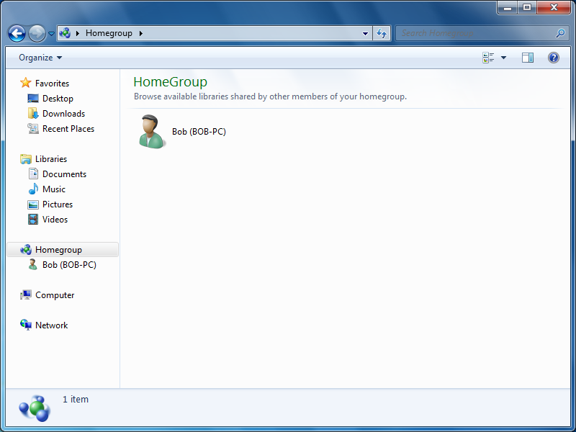
Figure 10: Homegroup node in Windows Explorer showing users currently sharing
- Libraries and folders shared with the homegroup appear under a user’s name.
  - Known libraries (Music, Pictures, Videos, and Documents) appear with corresponding well known icons.
  - User-defined libraries appear in the Homegroup folder with a generic library icon.
  - Shared folders appear in the Homegroup folder with a generic network folder icon.

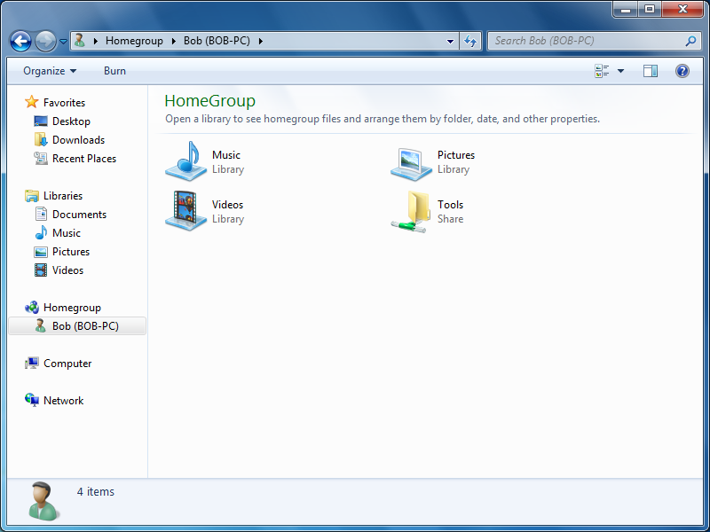
Figure 11: Homegroup showing content shared by user

- When the user then initiates a request to access a shared resource such as a library from the Homegroup folder, the connection request is handled by Windows Explorer, which hands off the connection request to SMB to complete the request.
- Based on user preference, SMB will attempt to connect to the remote PC using one of two credentials for authentication:
  - HomeGroup Credentials (default option): The connection will be made using the ‘HomeGroupUser$’ account for authentication.
  - User specified Credentials (advanced option): The user’s current username and password or one they provide to Windows on request for authorization. This is typically a local account synchronized by the user with the same username and password across all PCs in the home (a common configuration among highly technical users and enthusiasts), or another username and password, supplied by the user when the connection is made (or stored by the user in the credential manager).

The end-to-end behavior related to the sharing experience, publishing of the shared resource to the homegroup, and access by another homegroup member is depicted in the diagram below.
Figure 12: HomeGroup Share Discovery

Default Permissions to Homegroup Shared Resources
This section will describe the default permissions when resources are shared to the homegroup in different scenarios. The most common ways for a user to share resources with the homegroup are:
- Electing to share libraries or printers when creating or joining a homegroup, as discussed in previous sections
- Via the sharing choices available in HomeGroup in Control Panel
- Via the Share With menu in Windows Explorer
- Via the context menu that can be invoked by right-clicking any appropriate resource in Windows Explorer and clicking the Share With menu

Resources shared via Homegroup create/join or from the homegroup control Panel:
When the user’s music, pictures, video and document libraries are shared with the homegroup during the homegroup create/join process or from HomeGroup in Control Panel:
- The user’s libraries are always shared with Read-only access.
  - As a result, other homegroup members can view such content but can’t modify or delete it in any way.
- They also have the ability to un-share any previously selected resource in this way by visiting HomeGroup in Control Panel and deselecting the resources they no longer want to share, then saving their changes.

Resources shared by the user using the ‘Share With’ menu:
When any resource, such as a library, folder or even an individual file is shared by the user using the ‘Share With’ menu from the command bar or the context menu in Windows Explorer:
- The user can define what access other homegroup members should have once the selected resource is shared.
- They can share the resource with just Read-only access or provide full access by giving Read/Write access to the shared resource as shown below.

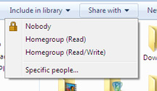
Figure 13: Adjusting sharing permissions from Windows Explorer

- They can also un-share any selected resource by using the ‘Nobody’ option from the ‘Share With’ menu, ensuring that no one other than themselves can access that resource.

How are Public folders shared in a homegroup?
It is important to note that the Public folders on a PC are automatically shared with the homegroup with full Read/Write access for other homegroup members during the homegroup create/join process as described in previous sections.
  - As a result, other homegroup members can view, edit, or delete any content stored in the Public folders.
  - This allows a default save location on every PC in the homegroup so that other homegroup members can give the user a file.
  - The user can disable this behavior by disabling Public folder sharing in Advanced Sharing Settings (accessible from either HomeGroup or Network and Sharing Center in Control Panel).
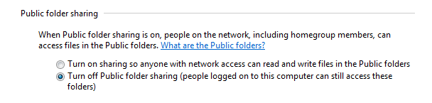
Figure 14: Public folder sharing setting in Advance Sharing Settings Control Panel

What shares on a PC does Homegroup expose by default on the network?
To help facilitate sharing, HomeGroup pre-creates a ‘Users’ share (\\<MachineName>\Users) to allow sharing of content from within the User profile and Public folders on a homegroup-connected PC.
- The share and access rights are defined below based on whether the ‘Password Protected sharing’ setting is ON or OFF:
Share Name | Remote Path | If Password protected sharing is: | Access Rights
Users | \\<Machinename>\Users | Off | Authenticated Users: Full Control  Administrators: Full Control
Users | \\<Machinename>\Users | On(Default) | Everyone: Full Control  Administrators: Full Control

- It is important to also note that if the user shares content with the homegroup outside of their user profile directory (i.e. typically the C:\Users\ location), a new UNC share will be created specifically for that folder to expose the shared content on the network.
- For example, if the user shares a ‘D:\Foo’ folder from a secondary volume on that PC with the homegroup with Read/Write access, HomeGroup will create a \\<Machinename>\Foo\ on the PC to enable network access to the D:\Foo folder by other homegroup members.

Homegroup support for Media Streaming
In addition to making shared content available through SMB over the local network, HomeGroup does also streamline the process of enabling media streaming in the home on a homegroup PC. When the user’s Music, Pictures, and Video libraries are shared with the homegroup, they are also made automatically available for streaming over the network to other homegroup members through the Windows Media Streaming service. As a result, any other member of the homegroup, in addition to being able to access that media content in Windows Explorer, is also able to seamlessly access that content in Windows Media Player or any other compliant media software (for e.g. a DLNA complaint software) from their PC. Moreover, by making a member PC a media receiver via the ‘Stream’ button in Windows Media Player, any homegroup PC will also be able to “Play To” that homegroup PC seamlessly without requiring further setup or authentication.
It is easy to enable devices like photo frames, game consoles (such as the Xbox 360), and media receivers (like the Roku Soundbridge) to access shared media. For setup, we have reduced all the UI within Windows that deals with these devices to one simple checkbox ‘Share my pictures, music, and videos with devices on my home network’ in the HomeGroup and Sharing Control Panel as shown below:
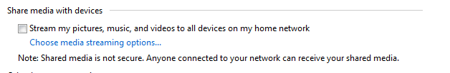

Homegroup support for printing
HomeGroup printing makes it simple to print from any PC to any printer in the homegroup. USB printers installed on a homegroup PC which opted to share printers with others (the default sharing state) are automatically advertised on the network for discovery by all PCs in the homegroup. Once discovered, HomeGroup will automatically attempt to install the shared printer for the other members to use.
- Homegroup printers with trustworthy printer driver packages are installed silently on behalf of the user.
- For printers that do not have a trustworthy driver package available, HomeGroup uses a balloon tip in the notification area and the HomeGroup Control Panel to inform users of this case and that HomeGroup requires an administrator to approve the printer install.
Once installed, a homegroup printer will automatically become the default printer for all users on the PC unless a previous default printer was selected on that network. This makes printing between homegroup members intuitive and obvious, and it matches user expectations of a simple networking experience.
The flow for a typical shared printer advertisement and install is shown below:
Figure 15: Homegroup printers install workflow

Changing the Homegroup Password
HomeGroup uses a strong shared password of random letters and numbers to secure the group. HomeGroup also supports a user changing the default password to a more readily remembered one if they choose to do so. It also provides them the ability to regenerate another strong password if the previous one has been compromised. This functionality is exposed in the Homegroup Control Panel via the ‘Change homegroup password’ link.
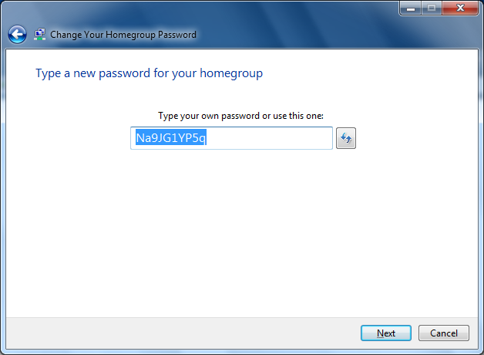
Figure 16: Homegroup password change wizard
On a password change, the HomeGroup Provider and HomeGroup Listener Services complete several actions to invalidate access granted to members of the HomeGroup using the old password. This is consistent with user expectations when changing a password for an online mail account or other website to prevent unauthorized access. As a result, on a homegroup password change, the HomeGroup services take actions that can be essentially broken down into two key tasks:
1) Stop any existing homegroup member from accessing shared content on the PC till they can provide the new password. This includes:
- Disconnect any currently active network connections from other homegroup members to the PC
- De-authorize all other homegroup PCs for media streaming access
- Depart the old Peer Group that was being used for the homegroup
- Change the password for the HomeGroupUser$ account that was being used for authentication for shared resources
- Remove all homegroup credentials from the credential manager
2) Re-configure the homegroup so existing or new members can join it with the new password. This includes:
- Create a new Peer Group to be used by the homegroup
- Update the HomeGroup invitation with:
  - The name of the homegroup user who reset the password
  - The new size of the group
  - The new Peer Group Invitation
  - The time the HomeGroup was created
  - Information identifying the message originates from a member of the homegroup

Actions taken by other homegroup members on a password change
When the homegroup password is changed by a member, all other existing homegroup members will see the new homegroup invitation advertised as described above on that network. Homegroup on their PCs will parse the new homegroup invitation and inform the users on those PC that the password has changed. The HomeGroup Provider and Listener Services on the members PCs will also complete several actions in relation to the password change. These include:
- Verify that the message originates from a valid homegroup member
- Disconnect any currently active network connections from other homegroup members to the PC
- De-authorize all other homegroup PCs for media streaming access
- Depart the old Peer Group that was being used for the homegroup
- Delete the HomeGroupUser$ account
- Remove all homegroup credentials from the credential manager
Homegroup then informs the users that they must enter the new password in order to gain renewed access to the homegroup. This password change notification is shown to them from
- Within Windows Explorer when Homegroup is selected in the navigation pane
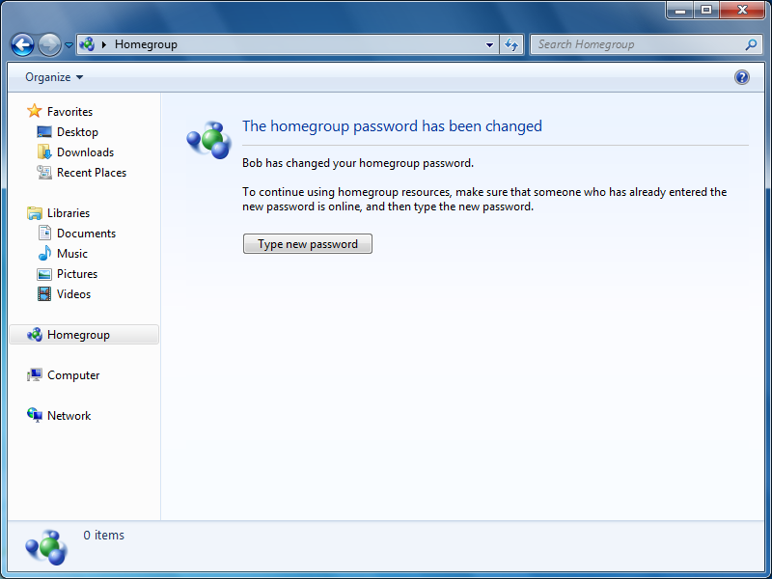
Figure 17: Update homegroup password page in Windows Explorer
- In the HomeGroup Control Panel.
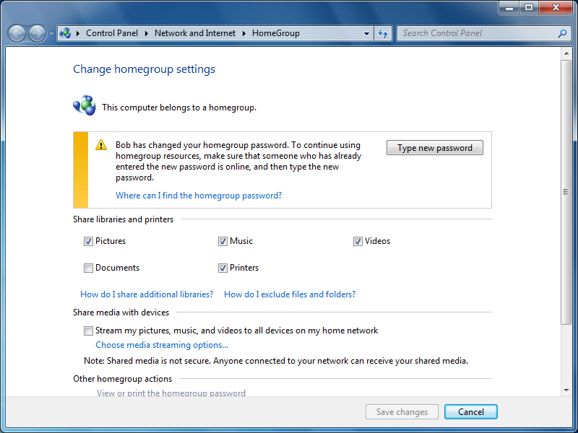
Figure 18: Update homegroup password via HomeGroup control panel
Appropriate instructions appear in both the Control Panel, under HomeGroup, and within the Homegroup folder in Windows Explorer on how they can provide the new password to gain access.

Note: It is recommended to have online all members of the homegroup that you intend to keep in the homegroup after the homegroup password is changed to ensure that they receive the new homegroup invitation and can rejoin the homegroup successfully.

Leave a Homegroup
A user may choose to leave the homegroup they are connected to at any time. Users may decide to leave a homegroup because they’ve moved to a new location and the old homegroup is no longer available. Users may also choose to leave a homegroup if a newer homegroup was created while their PC was not online and their PC was previously a member of a homegroup of more than one member. When a homegroup is departed, the HomeGroup Provider and Listener Services complete several actions to ensure that members from the previous homegroup can no longer access content on this PC. This includes:
- Close all firewall ports for several services used by the homegroup for example:
  - Peer to Peer Grouping
  - Peer Name Resolution Name Protocol
  - SMB (File/Printer Sharing)
- Stop publishing all homegroup-related messages on the home network including those for previously shared content for all users on that PC
- Delete the homegroup account (HomeGroupUser$)
- Delete the homegroup local security group (HomeUsers)
- De-authorize MAC addresses and UDNs of previous homegroup members to prevent them from accessing streamed media content
- Remove all previously added homegroup entries from the credential manager
- Disconnect all open homegroup SMB connections

Note: It is important to note that leaving a homegroup departs the entire PC and all other users on that PC from the homegroup and not just the individual user who performed the depart action.

Publicly accessible HomeGroup Development Surface
HomeGroup exposes public methods that determine a PC's homegroup membership status and also provides the ability to display the HomeGroup sharing wizard and retrieve the sharing options the user selected for sharing via the HomeGroup interface.
Details on the interface and its usage is readily accessible from MSDN at http://msdn.microsoft.com/en-us/library/dd378348(VS.85).aspx
A sample is also provided for developers from http://msdn.microsoft.com/en-us/library/dd940362(VS.85).aspx.

Not available in some versions of Windows.
Details of network Identification are outside the scope of this white paper. Interested readers may refer to the MSDN documentation on the Network List Manager.
Specifics of Windows Peer-to-Peer networking are outside the scope of this white paper. Interested readers may find more information by referring to the Introduction to Peer-to-Peer Networking on MSDN.
More information on DLNA architecture standards is available here.
More information on Point and Print Security is available here.
Details of Network Identification are outside the scope of this white paper. Interested readers may refer to the MSDN documentation on the Network List Manager.
Beginning with Windows 7, users may choose to opt out of seeing this prompt. In this case, the profile may be set in Network and Sharing Center.
As an aside, HomeGroup uses Function Discovery for advertising and discovery of homegroup resources on the network. Full discussion of the implementation details are outside the scope of this white paper.
By default, this firewall rule is enabled when a user selects the “Home” network profile. This rule is necessary for HomeGroup functionality and is included here for completeness.
The Guest account is not included in the HomeUsers Security Group in order to enforce basic expectations of privacy on the home network. Administrators wishing to create a low privileged account capable of accessing homegroup resources can create a new account and add it to the “Guest” security group.
Windows Explorer uses these advertisements to find printers and shares on remote homegroup PCs.
In this context, “Everyone” refers to the specific security group in Windows. This group includes all users and guests but does not include “Anonymous” access.
HomeGroup is a true Peer-to-Peer feature of Windows 7 --- once a member of a homegroup, all PCs are capable of advertising the group and communicating with any existing or new members
The Guest account is not included in the HomeUsers Security Group in order to enforce basic expectations of privacy on the home network. Administrators wishing to create a low privileged account capable of accessing homegroup resources may create a new account and add it to the “Guest” security group.
Windows Explorer uses these advertisements to find printers and shares on remote homegroup PCs.
In this context, “Everyone” refers to the specific security group on the Windows. This group includes all users and guests but does not include “Anonymous” access.
Configurable under “HomeGroup Connections” in the Control Panel under Advanced Sharing Settings.
Microsoft does not recommend disabling password protected sharing.
For more information, please review the section 3.2.3.1 Homegroup join scenarios.
Note that firewall ports for Windows Media Streaming are not closed when a PC leaves the homegroup. This is because another device in the home might be accessing media streaming.
The SMB shares themselves remain intact, although they will be inaccessible when the firewall ports are closed by HomeGroup.

