Microsoft Corporation
Microsoft Office 2010 at Work
Get to know Office 2010’s new security enhancements
By Nancy Buchanan
March, 2010

Get to know Office 2010’s new security enhancements
I am old enough to remember when “Undo” was a revolutionary new feature in office productivity software. These days we have come to expect more. In this article, you will learn about new and improved features in Microsoft Office 2010 that help keep your work safe and accessible only by those you want to see it.
By default
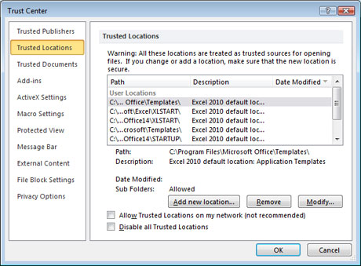
If someone sends you a document created in Office 2010 applications such as Word and Excel, you will notice that you cannot edit them immediately; they are opened in Protected View. For example, when you receive an e-mail with a Word document or Excel spreadsheet attached, a warning appears in the document asking you to confirm that you really do want to open it for editing, as illustrated to the left in Excel 2010.
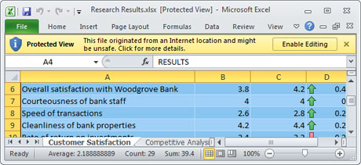
Protected View is on by default in Office 2010 programs to prevent your computer from opening any harmful macros or viruses or other unwanted content. Only when you click Enable Editing is the document opened and any macros contained therein are executed. For example, if you open an e-mail with an attachment, Protected View gives you the opportunity to stop something bad from happening if the source of the attachment is not someone you know and trust.
Because there are times when you need to open documents repeatedly that are from sources you trust, Office 2010 programs have a Trust Center to allow you to choose what publishers, locations, and documents to open ready-to-edit instead of in Protected View.

The Trust Center is accessed in the Info area of the new Microsoft Office Backstage™ view in Office 2010 programs. The Backstage view brings together the tools and features you need to prepare, share, and print your document, all in one convenient view.
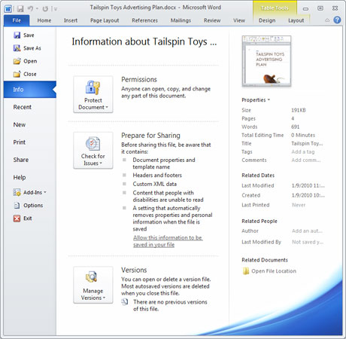

Work together with more security
Working together is made easier in Office 2010 programs because you can save documents to a free online file storage service called Windows Live SkyDrive. For example, if you are working together with a group of people on a spreadsheet, or want to share the spreadsheet with someone outside your company, you can sign up for a Windows Live SkyDrive account and then create a folder for your project. You can then invite specific Windows Live users to have permission to open that folder and either view, or view and edit, the documents contained therein. When it comes time to save documents to your online folder, you can do so directly within Word 2010, Excel 2010, PowerPoint 2010, or OneNote 2010.

The great part about saving files to Windows Live SkyDrive is that visitors to your online folder can view the documents in Web-based companions to Word 2010 (Microsoft Word Web App), Excel 2010 (Microsoft Excel Web App), PowerPoint 2010 (Microsoft PowerPoint Web App), and OneNote 2010 (Microsoft OneNote Web App). And, if authorized by you, they can even make light edits to them. As illustrated to the right, an Excel 2010 spreadsheet looks like an Excel 2010 spreadsheet when viewed online in the Excel Web App.
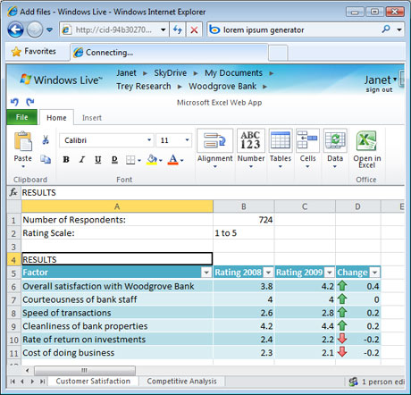
For business users with access to SharePoint 2007 or SharePoint 2010 intranet sites, you can save from Office 2010 programs directly to these sites. I use this functionality frequently when I have finished with a document and am then ready to “publish” it for others to access.
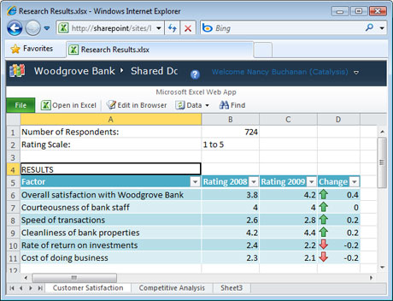
When I save Excel 2010 spreadsheets to a SharePoint 2010 site, site visitors that click on them automatically view them in the Excel Web App, as illustrated to the left.
The Excel Web App and OneNote Web App, whether accessed from Windows Live SkyDrive or from a SharePoint 2010 site, also allow more than one person to edit documents at the same time, while indicating who else is in the file and what changes they have made.
Business users accessing documents that are stored on a SharePoint 2010 server can simultaneously edit Word 2010, PowerPoint 2010, and OneNote 2010 documents. When each person saves the file, their changes are indicated.

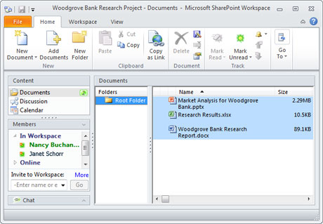
Another way to work together with more protection is with Microsoft Office SharePoint Workspace 2010 (formerly called Groove). You can create a SharePoint workspace, as illustrated to the right, to give specific named users access to local or downloaded versions of the documents on a SharePoint site. SharePoint Workspace 2010 takes care of synchronizing all changes made to the local versions of files with the server versions. SharePoint workspaces are perfect for cases where you need safe storage of documents on a SharePoint 2010 site, but need to be able to work with them offline.
You can also use SharePoint Workspace 2010 to create Groove workspaces. They allow you to share and synchronize documents across a named group of people without synchronizing them to a SharePoint site.
For example, if you are collaborating on a marketing plan with an agency, you can create a Groove workspace to share documents among all virtual team members, even if they don’t have access to your corporate SharePoint sites. Groove workspaces are also a great way to share documents that are too large to upload to SharePoint sites, such as video or print-ready artwork files.
Choose your permission level
Documents you create with Office 2010 programs can be restricted at the document level through the Info area of the Backstage view, as illustrated below.
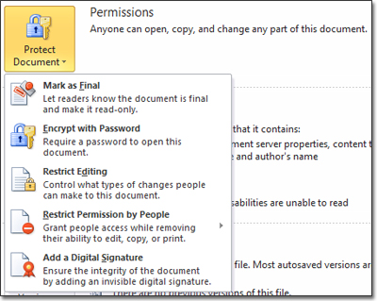
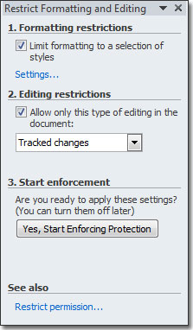
You can mark the document as final so that no more edits can be made to it. Or you can require a password in order to open a document. Or you can restrict editing, as illustrated to the right.
For example, if you are sending a carefully formatted document to a group of people who know enough about styles and formatting to be dangerous, you can restrict the ability of reviewers to change any or all styles in the document. Or you can allow reviewers to make changes to the document only if the Tracked Changes feature is turned on so that you can easily see what they changed.
If you save documents to SharePoint 2010 intranet sites, you can also restrict access to your files. If you save a document to a document library on a SharePoint site, by default the SharePoint site permissions control access to your document. In other words, if someone has rights to the SharePoint site in which the document library is hosted, then they would have the same rights to your document.
Individual document libraries on SharePoint 2010 sites can have unique permissions from the rest of the site. For example, if you only want your documents to be accessible by a small group of people, you can choose to set up your document library with unique permissions, then remove everyone you don’t want to have rights, and add everyone you do want to have rights, as illustrated here.
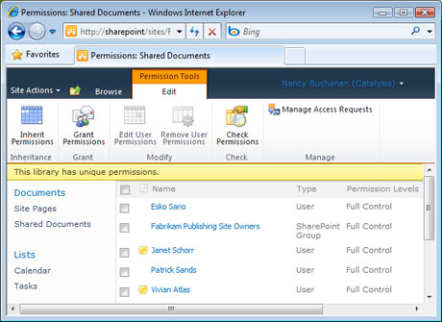
Changing permissions on document libraries on SharePoint 2010 sites can be a great way to restrict your important documents.

Recover from a problem
If you’ve ever experienced the shock of realizing that your laptop battery died before you had a chance to save a document, you will love Recover Draft Versions.

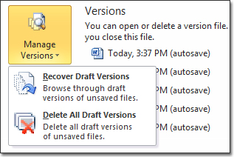

Recover Draft Versions in Excel 2010, Word 2010, and PowerPoint 2010 allows you to pick which of the saved draft versions you want to restore in case of a problem. For example, if someone reviewing the document accidentally deletes part of it, you can easily revert back to a specific previous version that was saved before the accident happened.
Protect access to your files today
You can start keeping your important files safe and password-protected today by using Office 2010 programs. Use the Trust Center to:
- establish when to open files that are ready-to-edit,
- work together privately online with Office Web Apps,
- use security enhancements at the file or document library level,
- collaborate via SharePoint Workspace 2010 workspaces, and
- rest assured knowing that you can now recover specific draft versions if needed.
About the author
Nancy Buchanan is a freelance marketing consultant who specializes in customizing SharePoint intranet sites and developing content for product launches at Microsoft. Before moving to a rural island community in Washington state with her family in 2002, she was a product manager at Microsoft for eight years. She has been in high-tech sales and marketing in the Pacific Northwest for more than 25 years.

