Compelling Solutions for PC Gamers by Using Windows SideShow
May 28, 2009
Abstract
This paper provides information about opportunities for hardware and software developers to respond to the growing demands of PC gamers by using the Windows® SideShow® platform. The paper provides ideas for hardware and software solutions for gamers.
This information applies to the following operating systems:
Windows Server® 2008 (with Desktop Experience installed)
Windows Vista®
Windows 7
References and resources discussed in this paper are listed at the end.
For the latest information, see:
http://www.microsoft.com/whdc/device/sideshow/Gaming_Solutions.mspx

Disclaimer: This is a preliminary document and may be changed substantially prior to final commercial release of the software described herein.

The information contained in this document represents the current view of Microsoft Corporation on the issues discussed as of the date of publication. Because Microsoft must respond to changing market conditions, it should not be interpreted to be a commitment on the part of Microsoft, and Microsoft cannot guarantee the accuracy of any information presented after the date of publication.

This White Paper is for informational purposes only. MICROSOFT MAKES NO WARRANTIES, EXPRESS, IMPLIED OR STATUTORY, AS TO THE INFORMATION IN THIS DOCUMENT.

Complying with all applicable copyright laws is the responsibility of the user. Without limiting the rights under copyright, no part of this document may be reproduced, stored in or introduced into a retrieval system, or transmitted in any form or by any means (electronic, mechanical, photocopying, recording, or otherwise), or for any purpose, without the express written permission of Microsoft Corporation.

Microsoft may have patents, patent applications, trademarks, copyrights, or other intellectual property rights covering subject matter in this document. Except as expressly provided in any written license agreement from Microsoft, the furnishing of this document does not give you any license to these patents, trademarks, copyrights, or other intellectual property.

Unless otherwise noted, the example companies, organizations, products, domain names, e-mail addresses, logos, people, places and events depicted herein are fictitious, and no association with any real company, organization, product, domain name, email address, logo, person, place or event is intended or should be inferred.

© 2009 Microsoft Corporation. All rights reserved.

Microsoft Windows Vista, Windows 7, Windows Server, and SideShow are either registered trademarks or trademarks of Microsoft Corporation in the United States and/or other countries.

The names of actual companies and products mentioned herein may be the trademarks of their respective owners.
Document History
Date | Change
May 1, 2009 | First publication.
May 28, 2009 | Revised art for Figures 2 and 3.

Contents
What Is Windows SideShow? 4
The Booming Gaming Market 4
Opportunities for SideShow-compatible Devices 4
Opportunities for SideShow Gadgets 5
More Space on the Main Display for Game-playing Action 5
Feeling Like They’re in the Game 7
Accessing Game Maps and Menus without Pausing the Game 8
Accessing Other Programs without Pausing the Game 9
How to Get Started 10

What Is Windows SideShow?
The Windows SideShow platform enables devices to communicate with computers that are running Windows. Windows SideShow-compatible devices can include personal electronics, home entertainment components, household appliances, and even office equipment. Gadgets, which are small programs designed to run on the SideShow platform, send and receive content between the computer and a device.
SideShow-compatible devices have a wide variety of display, processing, and interaction capabilities. Microsoft has designed the Windows SideShow platform to be flexible and extensible by allowing hardware vendors and manufacturers to add Windows SideShow support to new and existing devices.
Some common capabilities of the SideShow platform include sending timely information, such as e-mail messages, calendar reminders, headlines, stock quotations, traffic updates, and weather updates, from the computer to a device with an auxiliary display. Users can even browse that content on some devices while the computer is asleep or turned off.
The platform also supports scenarios other than content consumption. For example, some SideShow-compatible devices, such as remote controls, can send commands to programs that are running on the computer and to other devices and systems that are connected to the computer. For example, the Media Center gadgets enable users to browse the program guide, schedule recordings, and browse and play recorded TV shows by using buttons or a touch screen.
The Windows SideShow platform offers opportunities to create unique and compelling solutions for the gaming market by connecting computers running Windows Vista and Windows 7 to SideShow-compatible devices.

The Booming Gaming Market
In 2007, revenue reached $11 billion for PC gaming.1 According to a recent study, gamers spent an average of $200 on game software and $50 on hardware per year.2 Gamers are known to purchase games, peripherals, and electronic devices that can enhance the gaming experience. With 250 million PC gamers worldwide,1 hardware manufacturers and game developers have the potential to profit in the booming gaming market by using the Windows SideShow platform.

Opportunities for SideShow-compatible Devices
The Windows SideShow platform provides an opportunity for hardware manufacturers to build SideShow-compatible devices that have an auxiliary display. The auxiliary display can be an external display, such as a smaller and more affordable monitor, or it can be built into a keyboard, laptop, cell phone, or other device. These devices are capable of running in conjunction with a full size computer monitor to enhance the gaming experience.
In a gaming study in January 2009, gamers expressed interest in a SideShow-compatible monitor instead of a full size computer monitor to save desk space. The desired size was approximately 6.4 inches. Gamers also wanted touch screen capability, and preferred widescreen displays that can rotate1.
The SideShow-compatible monitor could easily be attached or moved to various sides of a computer, primary monitor, or laptop. For example, a gamer can attach or place the SideShow-compatible monitor near his or her primary monitor. The gamer can mount more than one SideShow-compatible monitor, or use a SideShow-compatible keyboard or phone to view additional information. Wireless SideShow-compatible monitors that connect using Wi-Fi or Bluetooth provide gamers even more flexibility to position it.
For more information about building devices with the Windows SideShow platform, go to:
http://www.microsoft.com/whdc/device/sideshow/default.mspx

Opportunities for SideShow Gadgets
Windows SideShow provides a great opportunity for game developers to add value to the game-playing experience by creating gadgets. By responding to the needs of gamers, these gadgets might help game companies gain a competitive edge.
Gamers are interested in streamlining the way they play to maximize their performance and playing experience. Often, gamers must navigate complex menus to perform many secondary tasks, which can reduce actual playing time. Or consider that many gamers operate in a world where a few seconds can mean the difference between winning and losing. Using the Windows SideShow platform, game developers can extend a gamer’s display space to an auxiliary display by using gadgets. A gamer could then perform these secondary tasks with fewer interruptions to playing time.
To learn more about creating Windows SideShow gadgets, go to the Windows SideShow API Reference at:
http://msdn.microsoft.com/en-us/library/cc982247.aspx
Gamers expressed interest in the following gadget opportunities in a gaming study2:
- More space on the main screen for game-playing action.
- Feeling like they’re in the game.
- Accessing game menus without pausing the game.
- Accessing other programs without pausing the game.

The following sections discuss these gadget opportunities in greater detail.

More Space on the Main Display for Game-playing Action
In many video games, there are items that gamers need to play the game, including statistics, life and magic meters and dials, and in-game chat messages to help them accomplish game tasks. This information often appears along the border of the screen, as shown in Figure 1.
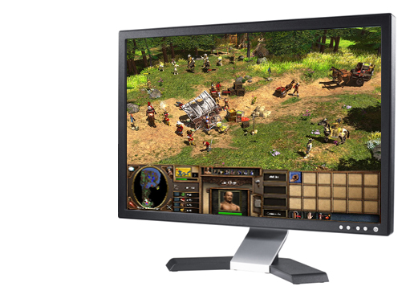
Figure 1. Menus and items on the primary monitor
Although this information doesn’t interrupt game play, it can reduce display space and affect the game playing experience. By reducing the number of items onscreen, you may create a richer game experience.
Research showed that gamers were very interested in viewing statistics, such as health and ammunition levels for the character they were playing, on an auxiliary display. This would free space on the main display. They were also interested in seeing in-game chat messages on the auxiliary device. Figure 2 shows an example of how moving the items from the main display to the auxiliary display can improve the game experience.
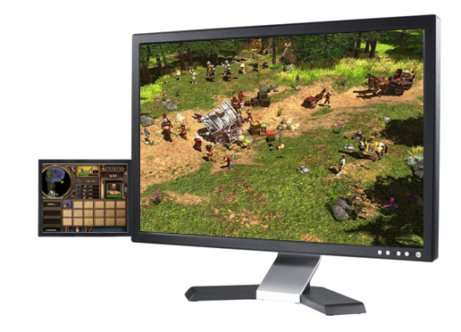
Figure 2. Menus and items on a SideShow-compatible monitor on the left

Feeling Like They’re in the Game
Gamers are also interested in opportunities that would make them feel like they were in the game. For example, an auxiliary display above your main display could show an instrument panel while playing a flight simulator game. Or, in a racing game, an auxiliary display to the left of your main display can give you a rear view, just like a side mirror on your car, as shown in Figure 3.
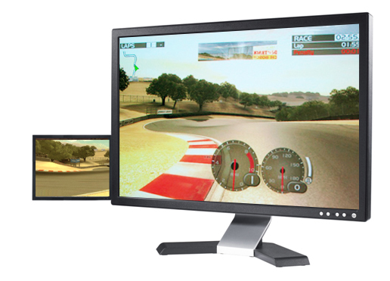
Figure 3. The SideShow-compatible monitor on the left showing a rear view just like the side mirror of your car

Accessing Game Maps and Menus without Pausing the Game
Gamers frequently must pause a game to view maps or change items, such as weapons or clothing. To avoid pausing game play, auxiliary displays can show maps and items on the auxiliary display so that gamers can view the maps in real time while playing the game. For example, the auxiliary display can show weapons, and if the gamer needs a specific sword to beat an enemy, he or she can change it without pausing the game. Figure 4 illustrates an example of an auxiliary display showing a map.
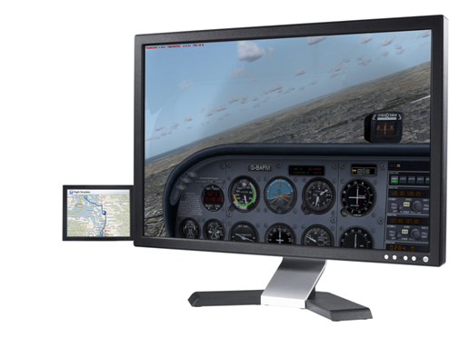
Figure 4. A SideShow-compatible monitor on the left showing a map of the area in a flight simulator game

Accessing Other Programs without Pausing the Game
In addition to in-game tasks that require pausing the game, gamers often perform game tasks using other programs. Some common tasks are:
- Accessing walkthroughs and discussion boards to help them get through certain parts of the game.
- Reading game notes about enemies in the game.
- Using other programs that allow them to chat, send e-mail, and talk to the people who they’re playing with.

Sometimes, gamers also want to perform tasks outside of the game while they are playing. For example, if a gamer likes to listen to music while playing, they don’t want to interrupt playing time to change the song. With the auxiliary display, gamers can:
- Display the songs that are playing.
- Have a way to control their music playback.
- Read notifications about their e-mail, calendar, and other tasks.

Figure 5 illustrates now playing information displayed on an auxiliary display for a song that is playing from Windows Media Player.

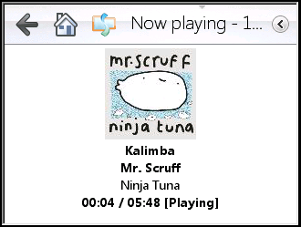
Figure 5. An auxiliary display showing now playing information

How to Get Started
For more information about developing SideShow devices and gadgets, see the Windows Hardware Developer Central (WHDC) website for Windows SideShow at:
http://www.microsoft.com/whdc/device/sideshow/default.mspx
At the WHDC website for SideShow, you can learn more about building devices by using the .NET Micro Framework, Windows CE, or other operating systems. You can also find information about writing gadgets.

