Webcam Video Fidelity Tests
June 16, 2012
Abstract
This paper describes a procedure for testing the image fidelity of webcams. This paper is for developers and testers of webcams.
This information applies for the following operating systems:
Windows 7
Windows Vista
References and resources discussed here are listed at the end of this paper.
For the latest information, see:
http://www.microsoft.com/whdc/device/media/Webcam_VidTests.mspx

The information contained in this document represents the current view of Microsoft Corporation on the issues discussed as of the date of publication. Because Microsoft must respond to changing market conditions, it should not be interpreted to be a commitment on the part of Microsoft, and Microsoft cannot guarantee the accuracy of any information presented after the date of publication.

This White Paper is for informational purposes only. MICROSOFT MAKES NO WARRANTIES, EXPRESS, IMPLIED OR STATUTORY, AS TO THE INFORMATION IN THIS DOCUMENT.

Complying with all applicable copyright laws is the responsibility of the user. Without limiting the rights under copyright, no part of this document may be reproduced, stored in or introduced into a retrieval system, or transmitted in any form or by any means (electronic, mechanical, photocopying, recording, or otherwise), or for any purpose, without the express written permission of Microsoft Corporation.

Microsoft may have patents, patent applications, trademarks, copyrights, or other intellectual property rights covering subject matter in this document. Except as expressly provided in any written license agreement from Microsoft, the furnishing of this document does not give you any license to these patents, trademarks, copyrights, or other intellectual property.

Unless otherwise noted, the example companies, organizations, products, domain names, e-mail addresses, logos, people, places and events depicted herein are fictitious, and no association with any real company, organization, product, domain name, email address, logo, person, place or event is intended or should be inferred.

© 2012 Microsoft Corporation. All rights reserved.

Microsoft, Windows, Windows Server, and Windows Vista are either registered trademarks or trademarks of Microsoft Corporation in the United States and/or other countries.

The names of actual companies and products mentioned herein may be the trademarks of their respective owners.
Document History
Date | Change
May 4, 2009 | First publication
March 26, 2012 | Added detailed entries for Daylight and Tungsten illumination as well as information on Low and High light levels.

Contents
Introduction 4
Test Environment 4
Test Measurements 8

Introduction
The tests described in this document measure the video-imaging characteristics of webcams and similar video capture devices. Currently these tests are not required for any Windows® Logo Program. They are provided for industry preview and set to auto-pass. However, Microsoft® strongly recommends that partners run these tests to get preliminary assessments for webcam devices, and to provide Microsoft with feedback on test settings and results.
These tests are not fully automated because they require special settings and actual video capture of a test chart (see Figure 1). You can order the Microsoft Webcam Image Quality Test Chart (QA-79-P-RM) at Applied Image Inc. (http://www.aig-imaging.com/microsoft.html).
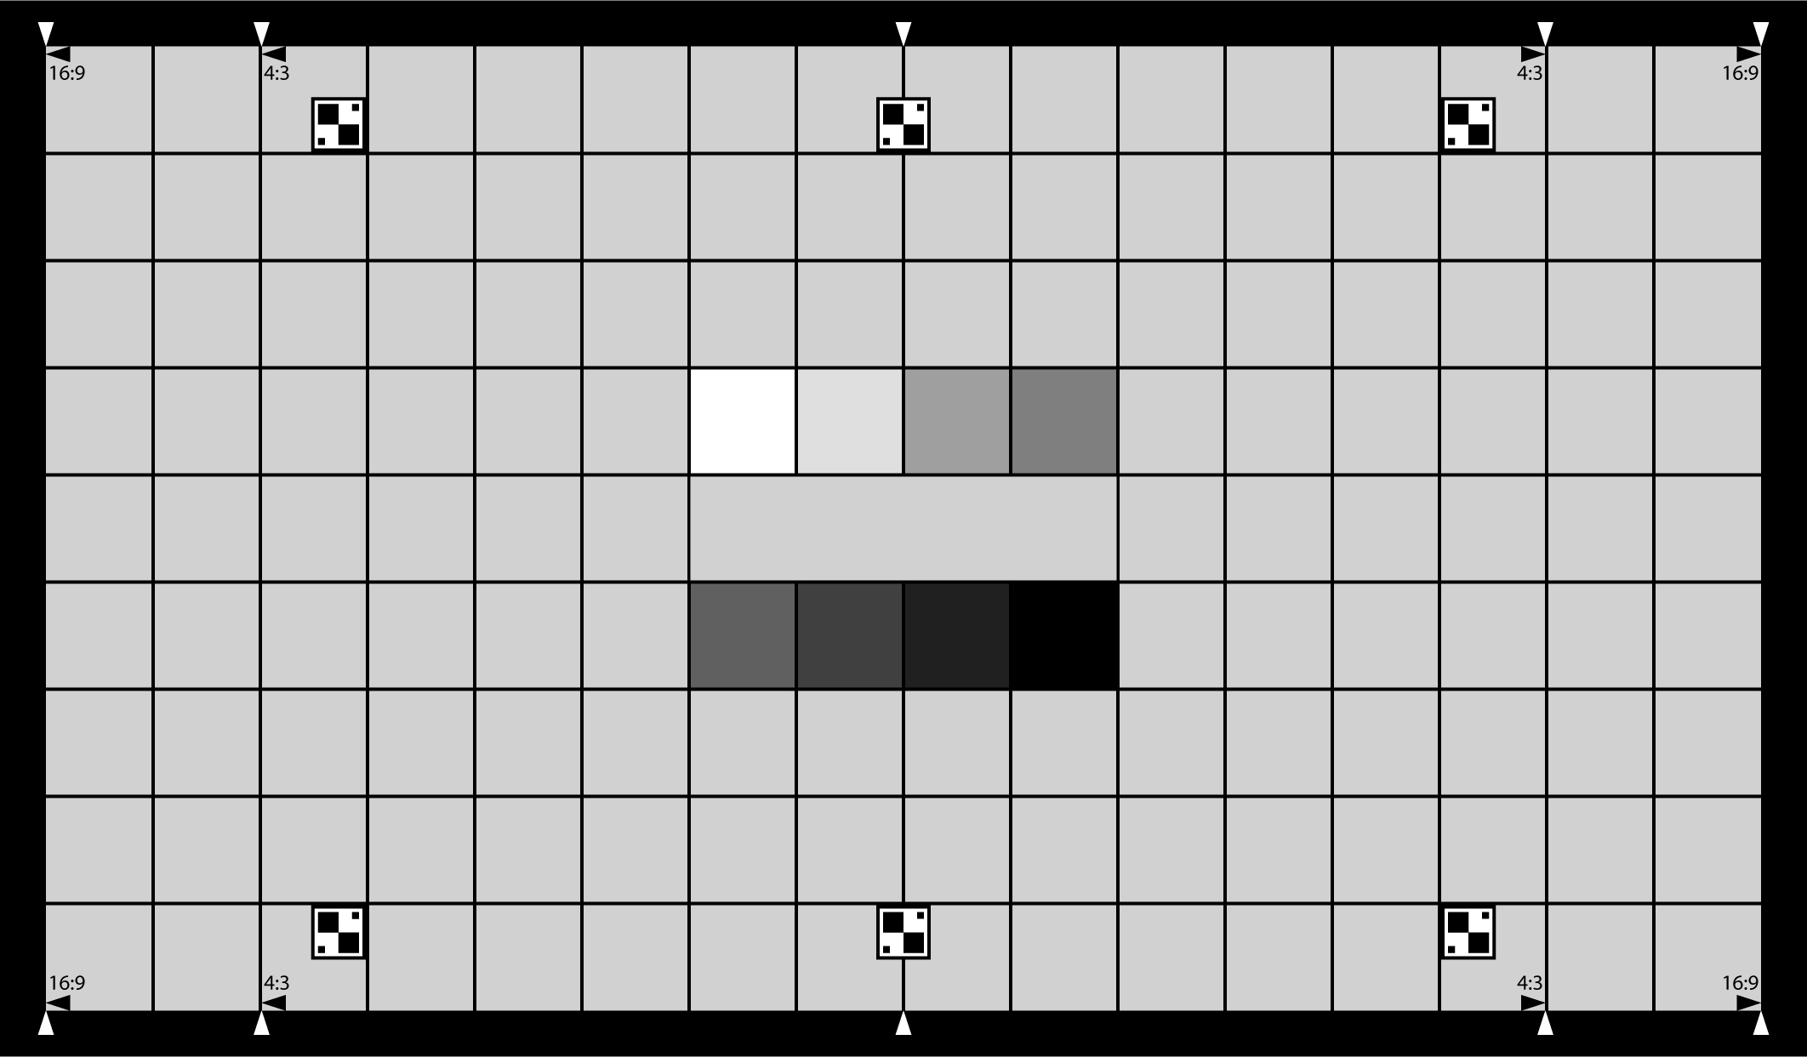
Figure 1. Test chart. The chart consists of a spectrally neutral 18% reflectance background interspersed with a regular uniform grid pattern. Markers have been placed denoting common aspect ratios for use with aspect ratio and distortion measurements. In the center of the chart there are two rows each consisting of eight patches increasing incrementally in optical density (OD).
The markers on this chart are referred to as NW, NN, NE, SE, SS, and SW, clockwise, starting with upper-left marker. Image recognition is used to define positions of NW, NN, NE, and SE. The position of NW is the lower-right corner of the NW marker; the position of NN is the bottom midpoint of the NN marker; the position of NE is lower-left corner of the NE marker; and the position of SE is upper-left corner of the SE marker.

Test Environment
The fidelity tests require a special environment. The webcam should be positioned so that entire area of test chart, including the markers, is visible in the capture preview. The webcam should be placed close enough so that the test chart occupies as much of the image as possible. The test chart should appear with minimum tilt and distortion. The test environment should exclude uncontrolled light sources such as daylight or regular interior lights. Ideally there should be two ISO-compliant light sources placed at 45 degree angles to the test chart. These light sources should have controlled light temperature and intensity. They should be positioned to provide adequate uniform light for the test chart, with minimize glare and reflection. Each test measurement is taken for four light settings:
4.1.3.1 Daylight Illumination
A simulated daylight source with a CCT between 5000K and 6500K is required. The source can be high-intensity discharge (HID), daylight-balanced fluorescent, or filtered tungsten. Reference sources are D50, D55, and D65.

4.1.3.2 Tungsten Illumination
A tungsten source with a CCT between 2800K and 3200K is required. This should ideally be a tungsten lamp, but for simplicity filtered daylight is acceptable. Reference Source, A or Planckian Black Body 2800K-3200K.

4.1.4 Light Levels
Two light levels must be utilized to represent average bright and average dark scenes. The measurements must be taken with an appropriate light meter making use of an integrating dome. The lux levels shall be varied without changing the color temperature. This can be achieved with mechanical dimming, filters over the camera lens, or filters over the lights.

4.1.4.1 Low Light Level
The light level measured at the target shall be 35 ±5 Lx.

4.1.4.1 High Light Level
The light level measured at the target shall be 310 ±10 Lx.
Figure 2 shows an approximate sample test environment.
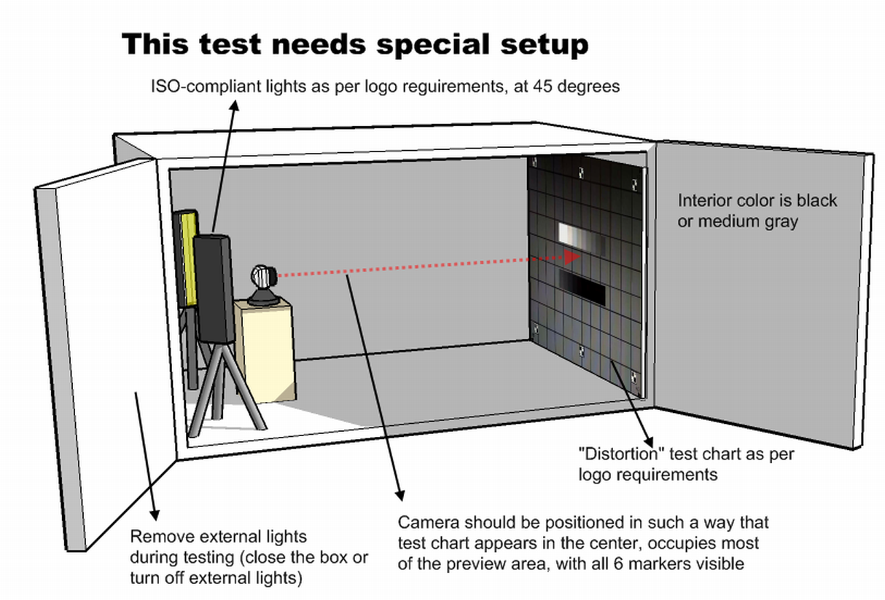
Figure 2. Sample test environment.
To run the tests
The tests are part of the Shell98-based Blink application, which is included in the Windows Logo Kit.
- Set up the test environment as described earlier in this document.
- Start Blink.
- On the Tests menu, click Select tests. In the Select Tests dialog box, in Available Test Cases, click (22.0.0) Video Fidelity test. Click Add, and then click OK.
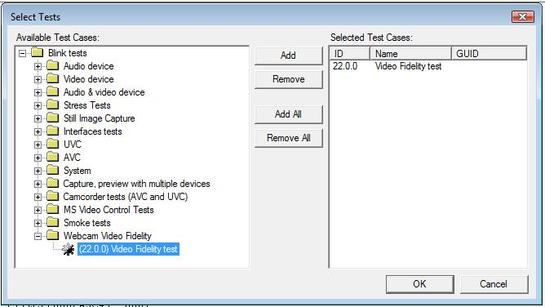
- On the Tests menu, click Run. The following dialog box appears.
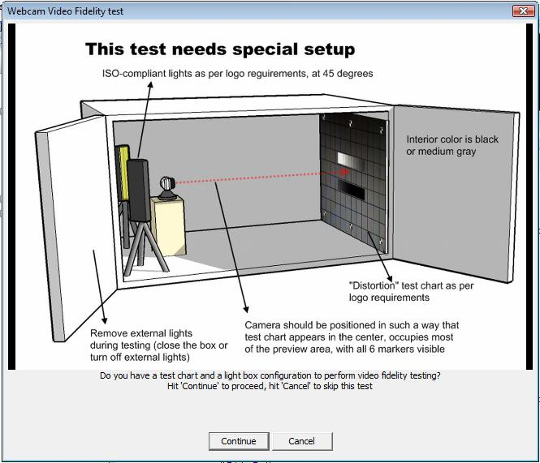
- Click Continue. The following live preview window and dialog box appears.
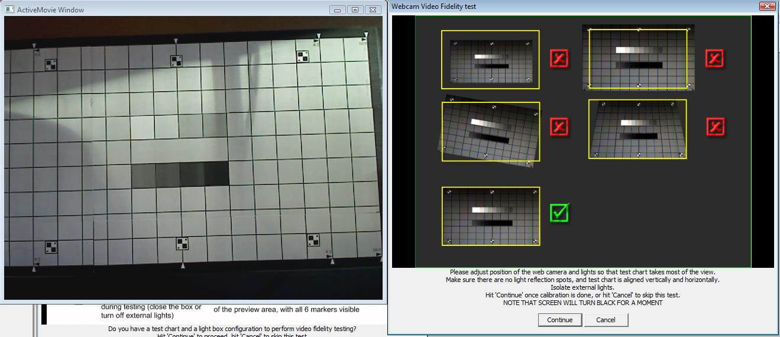
- Calibrate the camera position so that the image appears straight and minimally distorted, and the test chart occupies as much of the image as possible. Make sure that all markers are visible. Click Continue. The following message box appears
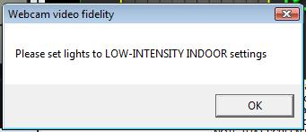
- Ensure proper lighting and click OK. Your desktop will turn black for a few seconds while the application makes a snapshot. The test dims the desktop to prevent distortions from monitor light.
The test will analyze the images. Depending on image size and quality, this analysis might take as long as three minutes. When the analysis is complete the following dialog appears. Magenta crosses indicate recognized markers; the green rectangle indicates the measured area; yellow squares should lie within grid cells.
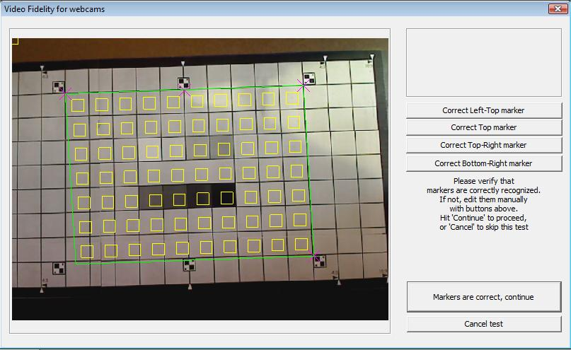
- If markers are not recognized correctly, you can manually modify them. Click the corresponding Correct marker button to enter editing mode. The following dialog appears.
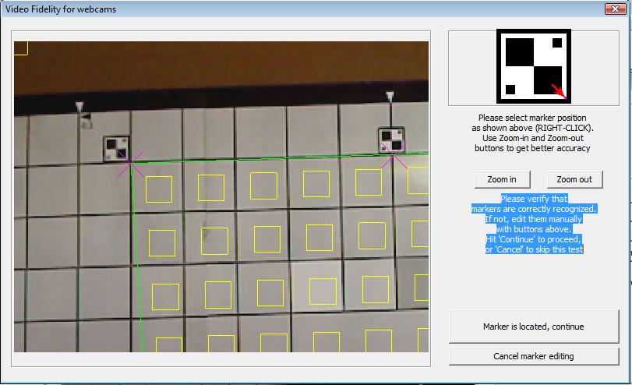
The red arrow shows the correct position for each marker (in this case, for the NW marker). To pan the image, hold down the left mouse button and drag the image. To zoom in or out, click Zoom in or Zoom out. To set a new marker position, right-click the desired location on the image. When you are done, click Marker is located, continue.
- If necessary, repeat step 8 for other markers.
- Click Markers are correct, continue. The test application performs the test measurements.
- Repeat steps 6–10 for all light conditions.

The test fails if any parameter in any light condition fails. Use the log to identify problems.
Test snapshots are saved in the test application folder as VideoFidelity_Snapshot_Light_condition.bmp. These snapshots are overwritten each time the test is run, so rename them or save them in another location if you want to save the snapshots for a particular test run.

Test Measurements
The fidelity tests measure the following basic image quality parameters:
- Aspect ratio. This test measures the ratio of distances NW-NE and NE-SE. It should equal 10/7 or 1.429. The test allows for 5 percent deviation from this value, so the allowed range is 1.353 to 1.495.
- Geometric distortion. This test measures the ratio of distances NN-SS to NE-SE. It should equal 1. The test allows for 3 percent deviation from this value, so the allowed range is 0.97 to 1.03.
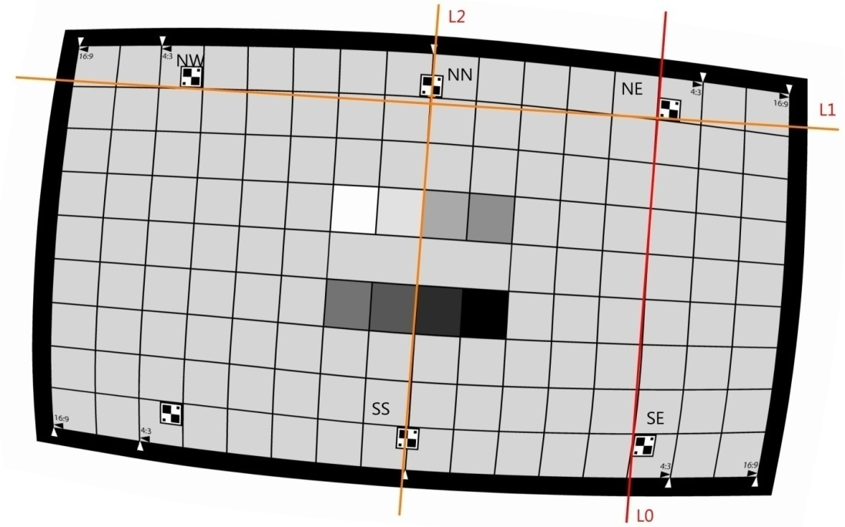
Because the test does not identify the position of SS directly, it uses the following calculation:
  - Let A = measured distance NE-SE.
  - Let L0 be a line through NE and SE.
  - Let L1 be a line through NW and NE.
  - Let L2 be a line parallel to L0 that passes through NN.
  - Let P = the distance from NN to the intersection of L1 and L2.
  - If NN is on or above L1, let S = 1; If NN is below L1, let S = -1.
  - Calculate distance NN-SS as A + 2 * S * P.
- Exposure accuracy/radiometry. This test calculates the average green, red, and blue color components within central area of the test chart (the gray area between the intensity bands). The test requires:
  - 115<=avg(Green)<=215
  - abs(avg(Red)–avg(Green))<20
  - 15<avg(Green)–avg(Blue)<20
The first requirement indicates correct lightness transfer and the other two indicate correct color transfer.
- Exposure uniformity and color balance. These tests ensure that the image preserves light balance and color balance, that is, that the image appears uniformly lit and colored. It calculates averages for green (G), red (R), and blue (B) over 20-pixel-by-20-pixel regions of all 62 grid cells (cells within the markers, not including the gradients in the center).It then calculates the standard deviation for each color channel (R, G, B) and requires that sqrt(stddev(G)^2+stddev(R-G)^2+stddev(G-B)^2)<15.0 .

