Enhancing the Television Experience by Using Windows SideShow
May 1, 2009
Abstract
The Windows® SideShow® platform provides hardware and software developers unique opportunities to create compelling solutions for television viewers. This paper provides information for hardware manufacturers that are interested in adding the SideShow platform to TV sets, universal remote controls, and set-top boxes, and software developers that are interested in creating SideShow gadgets for TV scenarios.
This information applies to the following operating systems:
- Windows Server® 2008 (with Desktop Experience installed)
- Windows Vista® (Home Premium, Business, Enterprise, and Ultimate)
- Windows 7
For the latest information, see:
http://www.microsoft.com/whdc/device/sideshow/TVExperience.mspx

Disclaimer: This is a preliminary document and may be changed substantially prior to final commercial release of the software described herein.

The information contained in this document represents the current view of Microsoft Corporation on the issues discussed as of the date of publication. Because Microsoft must respond to changing market conditions, it should not be interpreted to be a commitment on the part of Microsoft, and Microsoft cannot guarantee the accuracy of any information presented after the date of publication.

This White Paper is for informational purposes only. MICROSOFT MAKES NO WARRANTIES, EXPRESS, IMPLIED OR STATUTORY, AS TO THE INFORMATION IN THIS DOCUMENT.

Complying with all applicable copyright laws is the responsibility of the user. Without limiting the rights under copyright, no part of this document may be reproduced, stored in or introduced into a retrieval system, or transmitted in any form or by any means (electronic, mechanical, photocopying, recording, or otherwise), or for any purpose, without the express written permission of Microsoft Corporation.

Microsoft may have patents, patent applications, trademarks, copyrights, or other intellectual property rights covering subject matter in this document. Except as expressly provided in any written license agreement from Microsoft, the furnishing of this document does not give you any license to these patents, trademarks, copyrights, or other intellectual property.

Unless otherwise noted, the example companies, organizations, products, domain names, e-mail addresses, logos, people, places and events depicted herein are fictitious, and no association with any real company, organization, product, domain name, email address, logo, person, place or event is intended or should be inferred.

© 2009 Microsoft Corporation. All rights reserved.

Microsoft, SideShow, Windows, Windows Server, and Windows Vista are either registered trademarks or trademarks of Microsoft Corporation in the United States and/or other countries.

The names of actual companies and products mentioned herein may be the trademarks of their respective owners
Document History
Date | Change
May 1, 2009 | First publication

Contents
What Is Windows SideShow? 4
The Market for Combining TV Viewing and Computer Usage 5
How SideShow Can Enhance TV Viewing 6
Control Media Playback 6
Display Alerts While Watching TV 6
Check Live Fantasy Sports Statistics While Watching a Sports Game 7
Vote or Shop on TV 8
Integrating SideShow into TV-Related Hardware 9
How to Get Started 9

What Is Windows SideShow?
Windows SideShow is a platform that enables devices to communicate with computers that are running Windows. SideShow-compatible devices can include personal electronics, home entertainment components, household appliances, and even office equipment. Gadgets, which are small programs designed to run on the SideShow platform, send and receive content between the computer and a device.
SideShow-compatible devices have a wide variety of display, processing, and interaction capabilities. Microsoft has designed the Windows SideShow platform to be flexible and extensible by allowing hardware vendors and manufacturers to add Windows SideShow support to new and existing devices.
Some common applications of the SideShow platform include sending timely information from the computer to the device, such as e-mail messages, calendar reminders, headlines, stock quotations, traffic updates, and weather updates. Users can browse that content even while the computer is in sleep mode or turned off.
The platform also supports scenarios other than content consumption. For example, some SideShow-compatible devices, such as remote controls, can send commands to programs that are running on the computer and to other devices and systems that are connected to the computer.
The Windows SideShow platform offers opportunities to create unique and compelling scenarios for TV viewers by linking computers and TV viewing through SideShow-compatible TV sets, universal remote controls, and set-top boxes.
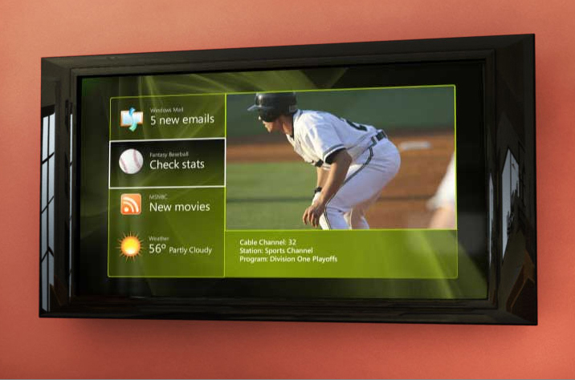 Figure 1. A TV displaying information from programs on the user’s computer

The Market for Combining TV Viewing and Computer Usage
In 2008, the Nielsen Company conducted research to measure the simultaneous use of television and the Internet. Nielsen found that nearly 31 percent of in-home Internet activity occurs while the user is watching TV.
The research also revealed that the most frequent Internet users are also among the most frequent television viewers. The top 20 percent of Internet users spent more time (more than 4 hours per day) watching television than TV viewers who did not use the Internet at all. More than 80 percent of people who watched television and used the Internet in the month studied did both activities simultaneously some of the time.
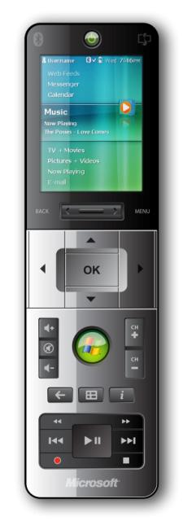
Figure 2. An example of a remote control with SideShow capabilities

How SideShow Can Enhance TV Viewing
SideShow can combine computer and Internet usage with TV viewing to create rich experiences for consumers. Because developers can create SideShow gadgets for specific scenarios, there are many opportunities for using SideShow to enhance TV viewing. The following scenarios explore some of the ways TV viewing could be enhanced by adding SideShow capabilities to televisions, set-top boxes, and remote controls:
- Display RSS feeds while watching TV.
- Display alerts while watching TV.
- Control media playback.
- Check live fantasy sports statistics while watching a sports game.
- Vote or shop on TV. Display RSS Feeds While Watching TV

TV viewers can use a SideShow gadget to display RSS feeds on their TVs while they are watching a TV show. The RSS feeds can be anything that viewers subscribe to—news, sports, financial reports, weather forecasts, and more. Viewers could use a remote control to access the feed. The RSS content could appear in a corner of the TV screen so it doesn’t interfere with the TV program that the user is watching.

Control Media Playback
TV viewers who use a SideShow-compatible remote control with a media player gadget can control media from their computer in addition to the entertainment content on their television. Viewers can play music from their computer, even when their TV is turned off; display a picture slide show or play videos on their TV; and view a media guide on the display of a SideShow-compatible remote control. The remote control could also display the same gadgets that are shown on the television or set-top box, thus providing another outlet for content.

Display Alerts While Watching TV
Viewers could use a SideShow gadget to display personal alerts on the TV screen while watching TV programming. The alerts, which could come from the viewer’s computer calendar or task list, can be anything a viewer wants as a reminder – from showing a list of household chores to making a reservation at a restaurant.
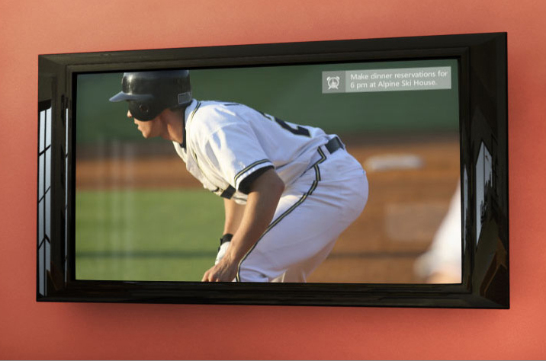
Figure 3. A TV displaying a personal alert on top of a TV program

Check Live Fantasy Sports Statistics While Watching a Sports Game
Playing fantasy sports is popular in the United States. The Fantasy Sports Trade Association estimates that nearly 27 million people in the United States play some form of fantasy sports. Numerous sports websites cater to sports fantasy enthusiasts. Typically, the sports websites provide a user with a team webpage that shows the statistics of their players.
SideShow can help combine fantasy sports with watching sports on TV. A SideShow gadget could be developed to enable fantasy sports participants to view the statistics for their team while they watch a sporting event, such as a baseball game, on TV. When a viewer’s chosen player scores a run, the statistics for the fantasy sports game are updated in real time.
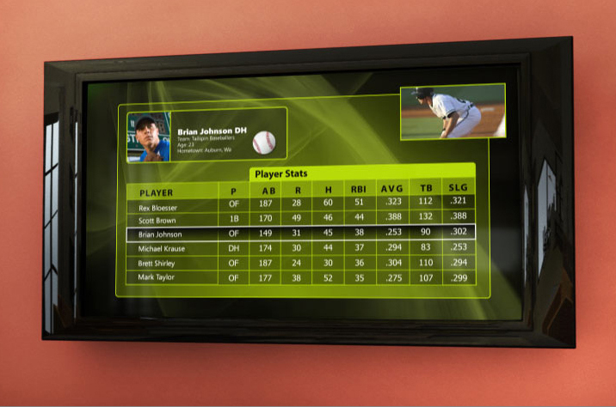
Figure 4. A gadget displays updated player statistics while a baseball game is broadcast live.

Vote or Shop on TV
Talent shows that air on TV today have become increasingly popular, due in part to audience participation. These shows often ask the audience to vote for their favorite contestant. A SideShow gadget could be used to feature pictures of the contestants, and viewers could use a remote control to select the contestant they like best. Viewers could also vote for contestants on other reality TV shows and music videos by using their TV.
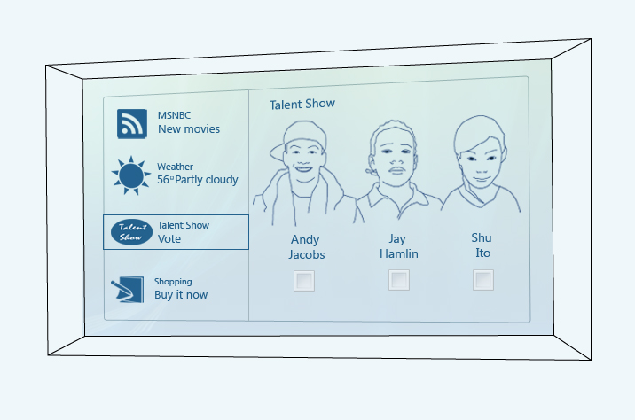
Figure 5. Viewers could use a SideShow gadget to vote for a favorite contestant on a talent show.
Shopping is another possible scenario for providing TV viewers the opportunity to interact with their TV. For example, a viewer could use a remote control with SideShow to purchase an item that appears on the TV.

Integrating SideShow into TV-Related Hardware
Whether the SideShow platform is integrated into a TV set or a set-top box, the experience is the same for the user: the TV or set-top box receives content from the computer, and then displays it on the TV. Viewers use an accompanying remote control to interact with the displayed content.
The scenarios for a SideShow-compatible set-top box are the same as for a SideShow-compatible TV—the difference is in the implementation. With the proliferation of rich, interactive set-top boxes (such as DVRs) that have network connections, adding SideShow functionality to a set-top box could require little more than writing some additional software.
A remote control with SideShow empowers viewers to control media that is played from their computer in addition to controlling their TV. A remote control can also display the same gadgets that appear on the TV.

How to Get Started
For more information about developing SideShow-compatible devices and gadgets to implement these or other solutions, see the Windows Hardware Developer Central website for Windows SideShow at:
http://www.microsoft.com/whdc/device/sideshow/default.mspx
You can learn more about building devices by using the .NET Micro Framework, Windows CE, or other operating systems. You can also find information about writing gadgets.

Nielsen Media Research, 2008.
Fantasy Sports Trade Association, 2009.

