Licensing Management Series
A Guide to Assessing SharePoint Server Licensing
October 2011

This document gives Microsoft® Volume Licensing customers an overview of licensing for Microsoft SharePoint® Server 2010, SharePoint Server 2007, and SharePoint Server 2003, as well as guidance on how to assess the licenses needed. Please refer to the Product Use Rights (PUR) document for detailed guidance.
The Software Usage Tracker, a tool in the Microsoft Assessment and Planning (MAP), collects and reports server and client use of common deployments of SharePoint Server. Using this data, and following the step-by-step instructions on the pages that follow, you can calculate the number of SharePoint Server licenses (but not licenses for SharePoint for Internet Sites) and client access licenses (CALs) you need.
Terms of Use
This document is for informational purposes only and is subject to change. It cannot be considered a source of definitive Microsoft licensing guidance.
This document does not supersede the use rights to any product defined in your Microsoft agreement. Nor does it supersede anything in the Volume Licensing Agreement, Product Use Rights, Product List, OEM EULA, or any other terms of use for products. Product licensing, program licensing, and business rules are subject to change.

Contents
SharePoint Server Licensing Requirements 1
Server Licensing 1
Client Access Licensing (CAL) 2
Additional CAL specifications 3
Other Licensing Requirements 3
SharePoint Server and Windows Server 3
SharePoint Server and Microsoft SQL Server 4
How to Assess Your Licensing Requirements 5
1 Set Up Your MAP Scan 5
Guidelines to ensure a more accurate usage count 6
2 Generate a SharePoint Server Usage Report 6
3 Count Your Server Licenses 8
4 Count Your CALs 8
Convert MAP usage data into a license count 8
Make manual adjustments 10
References and Resources 11
References 11
License Management Series 12

SharePoint Server Licensing Requirements
SharePoint Server has two licensing models: server-plus-CAL and server-only.
- The server-plus-CAL model licenses access to internal content (for example, intranets) hosted on a SharePoint Server. You must acquire a server license for the server hosting the content, and a client access license (CAL) for each user or device that access that server.
- The server-only licensing model licenses the use of SharePoint for creating or hosting external content for users who are external to your organization—those who are not employees, on-site contractors, and the like. This licensing model requires a Microsoft SharePoint for Internet Sites (FIS) license, but does not require CALs for users or devices that access the server.
This license can be used for both anonymous Internet sites and authenticated extranet sites where no content, information, or application is accessible exclusively to individuals inside your organization. In other words, if internal users can access content, external users must also have access.
Note For more information on licensing SharePoint FIS, refer to Microsoft Product Use Rights and the Volume Licensing Brief, Microsoft SharePoint Server 2010 for Internet Sites.
SharePoint products are available only through Microsoft Volume Licensing agreements and not through retail channels. Eligible Volume Licensing agreements include Open License, Select License, and Enterprise Agreement (EA).

Server Licensing
A SharePoint Server license entitles you to run one instance of SharePoint on a given server. A running instance is defined as loading SharePoint into memory and executing one or more of its instructions.
Three different SharePoint Server license keys are available: SharePoint Server Standard, SharePoint Server Enterprise, and SharePoint FIS. It is important to note that these keys are distinct from the installation package. There is a single installation package—that is, a single set of binary files—but three server license keys for each edition that unlock different features for users to access, when assigned with the appropriate CAL. Hence, those needing Enterprise functionality would use the SharePoint Enterprise key to unlock those features; those needing only Standard functionality would unlock it using the SharePoint Standard key.

Client Access Licensing (CAL)
In addition to the server license, SharePoint client access licenses (CALs) are required to access SharePoint directly or indirectly for content limited to internal use—that is, not available to external users. These CALs may be licensed by device or by user to give access to any edition of SharePoint of the same or earlier version. (You cannot use an earlier version CAL to access a later version server.)
- A Device CAL licenses anyone using that device to access SharePoint. A Device CAL makes the most economical and administrative sense for an organization with many users for one device, such as shift workers who share the same PC to access SharePoint.
A User CAL licenses a person to access servers running SharePoint from any device. If the number of users is fewer than the number of devices, a User CAL is the most economical choice. For example, it makes sense for an organization with employees who access the corporate network from multiple devices—for example, from laptops, cell phones, or home computers.
There are two types of CALs available: Standard and Enterprise.

Standard CAL features
The Standard CAL licenses access to the core capabilities and features of SharePoint:
- Sites
- Communities
- Content
- Search (excluding FAST Search)
- Composites (excluding Access Services and InfoPath® Services)
You can acquire a Standard CAL as a standalone purchase, as part of SharePoint Online Standard User Subscription License (SL), or in one of these suites: Core CAL Suite, Enterprise CAL Suite, or Business Productivity Online Standard Suite User SL.

Enterprise CAL features
The Enterprise CAL is an “additive” CAL, and you can purchase it only after you have acquired the Standard CAL. Together, these enable access to all of the Standard CAL capabilities as well as the following Enterprise features:
- Search, including rights to access FAST Search Server for SharePoint. (You must purchase FAST Search Server for SharePoint separately.)
- Composites, including Access Services and InfoPath Services.
Insights, including PerformancePoint® Services, Excel® Services, and Visio® Services.
To deploy the Enterprise features on a server or server farm, you apply an Enterprise license key to an existing SharePoint Standard installation.
- After you have activated Enterprise functionality, all users can access those features, you must upgrade all clients or devices accessing the Enterprise features that server or farm to Enterprise CALs. (Note that this upgrade is one-way; once you have activated Enterprise functionality on a server, the only way to return to Standard functionality alone is to reinstall SharePoint and lose access to Enterprise functionality.)
SharePoint cannot distinguish the type of CAL held by any given user or device. So if Standard CAL functionality alone is required for a subset of users, Microsoft recommends deploying a separate server with only Standard features enabled. This ensures that Standard CAL users don't access Enterprise features.

Additional CAL specifications
Affiliation. Your SharePoint CALs are valid only for your SharePoint servers; they do not license access to the SharePoint systems of non-affiliated organizations. (Affiliation is defined in your Volume Licensing Agreement.)
Version. CALs must be the same version or later than the server software being accessed.
Mixing Device and User CALs. Unless your Volume Licensing Agreement specifies otherwise, you may mix Device and User CALs in a single environment, but you must assign individual CALs to either a device or a user. However, mixing User and Device CALs adds complexity to license management, so Microsoft generally recommends against it.
Reassigning CALs. You may:
- Permanently reassign your Device CAL from one device to another, or your User CAL from one user to another.
- Temporarily reassign your Device CAL to a loaner device while the first device is out of service, or your User CAL to a temporary worker while the primary user is absent.
Reassign CALs to another user or device only once every 90 days.
Shared accounts. If you are licensing with User CALs, two users who access SharePoint through the same account will each require a CAL.

Other Licensing Requirements

SharePoint Server and Windows Server
Because SharePoint can only be installed on the Windows Server® operating system, you must purchase the appropriate Windows Server licenses. Windows Server is licensed separately from SharePoint Server, typically through the server-plus-CAL model.
Users who access SharePoint need a Windows Server CAL, except when:
- A user anonymously accesses SharePoint from the Internet.
Windows Server access is licensed with a Windows Server External Connector, which is available only for external users for use off-site. (Internal users must have CALs.)
SharePoint Foundation Server 2010 (previously known as Windows® SharePoint Services) is a free add-on to Windows Server that supplies basic SharePoint functionality. To use it as a free standalone product, you do not need SharePoint server licenses or CALs. However, when Windows Server is the foundation for SharePoint Foundation, SharePoint Server and SharePoint FIS, you will need Windows Server licenses and CALs, as outlined above.
Note For complete information on licensing for Windows Server, refer to the Windows Server 2008 R2 Licensing Overview.

SharePoint Server and Microsoft SQL Server
A key technical prerequisite for deploying SharePoint server is SQL Server®, which hosts SharePoint databases. A single SQL Server infrastructure can be used to host data for any combination of applications, including multiple SharePoint server farms, as long as you meet SQL Server licensing requirements. SQL Server is licensed (and purchased) separately from SharePoint Server, and uses two licensing models: server-plus-CAL and processor.
Every user of every version of SharePoint counts as a user of SQL Server that hosts the SharePoint database. Such multiplexing means that every user and device also needs to be licensed for access to SQL server. For SQL server licensed as server-plus-CAL, each user and device accessing SharePoint will require a CAL for SQL server. There are two exceptions to these guidelines:
- You do not need a SharePoint Server license for systems hosting SQL Server software if SharePoint Server components are installed on different hardware than SQL Server.
- You do not need a SQL server license when you install SharePoint on a single server with a built-in database—for example, if you are deploying a small number of websites and you want to minimize administrative overhead.
If you install SharePoint components on the same hardware as a full SQL Server database, you can use SQL to host other databases for other servers, as long as SharePoint and the other servers do not share the same SQL database. (That could create a multiplexing situation.) This exception applies only to full SQL Server databases and not to SQL Server Express, SQL Server Embedded, or the SQL Server Desktop Engine.
Note For more information:
- SQL Server 2008 R2 Licensing.
Multiplexing—Client Access License (CAL) Requirements.

How to Assess Your Licensing Requirements
To help you assess your licensing requirements, Microsoft has developed a Software Usage Tracker. Part of the Microsoft Assessment and Planning (MAP) Toolkit, it collects and reports server and client use of common deployments of SharePoint.
In this section you’ll find step-by-step instructions to help you generate those reports and learn specifically how to determine your SharePoint licensing obligations. Use MAP to assess your license requirements as follows:
- Set up your MAP scan.
- Generate a SharePoint Server usage report.
- Count your server licenses.
- Count your CALs.
Completing this assessment requires network administration expertise and permissions, as well as licensing expertise. If licensing compliance and network administration responsibilities fall to different people in your organization, they will need to work together to complete this assessment correctly.
Note It is important to understand that the Software Usage Tracker only provides a software usage report. It does not create a licensing report. And although the guidance offered in this section may be helpful, it is not definitive. It does not replace or supersede the legally defined use rights in your Product Use Rights (PUR) document.

1 Set up Your MAP Scan
In this first step, you will tell MAP what to scan. To complete it, you need server administration expertise and permissions.
- Download the MAP Toolkit
- To configure your MAP deployment, follow the Getting Started Guide and Software Usage Tracker Guide instructions built into the MAP installation.

Guidelines to ensure a more accurate usage count
If licensing compliance falls to others in your organization, you may want to work with them to make sure you consider the points below in setting up the scan.
Make sure your configuration is complete. MAP scans usage only on servers and network segments identified during configuration. Incomplete configuration will give you incomplete results.
Scan over a time period when your operating system environment is running the maximum number of servers and virtual machines. MAP only counts servers running at the time it scans. If the number of users and devices fluctuates seasonally, run the scan in your busiest season.
Scan during the 90 days when you have maximum usage, and make sure your scan covers a full 90 days to get the most accurate CAL count. Because you can assign CALs every 90 days, evaluating the usage during the past 90 days determines how many CALs you need.
Scan servers with different license obligations separately. The Software Usage Tracker Guide explains how to exclude network segments or specific devices from the scan. So your scan data will be useful:
- Configure your network scan range to take licensing variations of products into account. Scan only servers with similar licensing, since you’ll apply that licensing logic to the results. Exclude servers subject to different licensing obligations, like Development or Test servers licensed under the MSDN® developer program.
- Make sure to exclude any SharePoint FIS servers from the scan to avoid over-counting your CAL requirements. (MAP cannot distinguish deployments licensed with SharePoint Server and SharePoint FIS.)
- Make note of network segments that you exclude due to licensing variations to ensure that you correctly account for licensing later. For example, make sure that you have MSDN licenses for servers licensed under MSDN programs or External Connectors if you have Windows Server deployed as an anonymous web server.

2 Generate a SharePoint Server Usage Report
Before you begin, make sure to review the SharePoint Server licensing requirements outlined in the first part of this guide. In this section, you run the MAP scan, which generates a report on your servers running SharePoint.
- Run the MAP assessment.
- In the Software Usage Tracker, click Software Usage Summary to see the number of:
- Servers (both physical and virtual) running each edition of SharePoint.
- Unique users and devices accessing Standard and Enterprise SharePoint Servers.
Note The default date range is 90 days. To change this range, click Configure Date Range in the Actions pane.
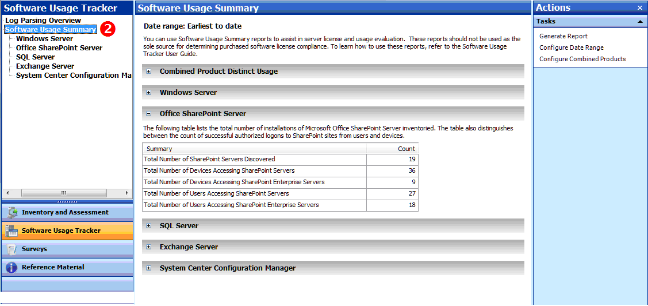
- Under Software Usage Summary, click SharePoint Server.
- In the Actions pane, click Generate Report to create a Microsoft Office Excel® spreadsheet for the servers listed. The spreadsheet gives a breakdown by edition and version number, and a count of users and devices.
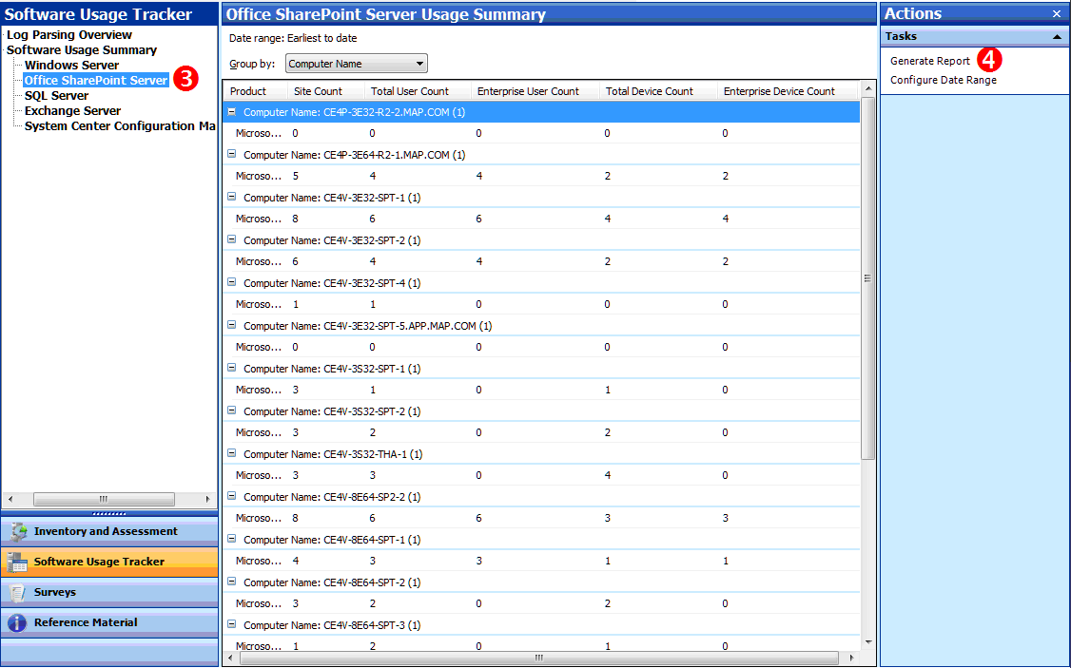

3 Count Your Server Licenses
After you have generated the report in MAP, determining the number of servers for SharePoint Server is straightforward.
- In MAP, click View, and then click Saved Reports and Proposals.
- Open the SharePoint Server Usage Tracker report—the Excel spreadsheet that you generated in Step 4 above.
- The Server Summary tab of the Excel report lists the number of servers discovered of each version discovered.
 | Total  servers discovered | Total Enterprise servers | Total  sites | Total  unique  users | Total  unique  devices
SharePoint Server 2010 | 7 | 3 | 10 | 12 | 18
SharePoint Server 2007 | 8 | 5 | 45 | 9 | 12
SharePoint Server 2003 | 4 | 0 | 8 | 6 | 6

Example
If the Server Summary gave you the information shown in the Total servers discovered column above, you would need the server licenses indicated for a total of 19 server licenses.

4 Count Your CALs
There are two steps to counting CALs. First you get the usage data from the MAP scan and convert the usage numbers into a license count. Then you manually correct the license count for situations that MAP cannot track.

Convert MAP usage data into a license count
- In MAP, click View, and then click Saved Reports and Proposals.
- Open the SharePoint Server Usage Tracker report—the Excel spreadsheet that you generated previously.
- The Overview tab of the Excel report lists the number of devices and users accessing Standard and Enterprise features of SharePoint.

Summary | Details
Total Number of SharePoint Servers Discovered | 19
First Reporting Date | 2010.03.04
Last Reporting Date | 2010.06.02
Number of Log Files Analyzed | 80
Earliest Log Date | 2010.03.04
Latest Log Date | 2010.06.02
Total Number of Devices Accessing SharePoint Servers | 36
Total Number of Devices Accessing SharePoint Enterprise Servers | 9
Total Number of Users Accessing SharePoint Servers | 27
Total Number of Users Accessing SharePoint Enterprise Servers | 18
As you convert the usage numbers into a license count, take note of the following:
- Total Number of Devices (or Users) Accessing SharePoint Servers indicates the number of unique devices or users accessing servers with Standard CAL features. Because the use of SharePoint Enterprise CAL features also requires a SharePoint Standard CAL, this number represents the total SharePoint Standard CALs required. (The number of SharePoint Standard CALs must equal or exceed the number of users and devices accessing SharePoint.)
- Total Number of Devices (or Users) Accessing SharePoint Enterprise Servers indicates the number of unique devices or users accessing servers with Enterprise CAL features. This number represents Enterprise CALs requirements only, and does not include Standard CAL requirements. (The number of SharePoint Enterprise CALs must equal or exceed the number of users and devices accessing SharePoint servers with Enterprise features.)
- CAL versions. The version of your SharePoint Standard and Enterprise CALs must be the same as or later than the most recent version of SharePoint that you have deployed.

Example
If the Overview gave the information shown above, you would need:
36 Standard Device CALs.
9 Enterprise Device CALs.
27 Standard User CALs.
18 Enterprise User CALs.

Make manual adjustments
MAP does not detect all usage, so some must be counted manually. After you have a CAL count from the Software Usage Tracker, review the special cases below to make sure the count accurately reflects your use. MAP does not track:
- Obscured IP address. Devices that access SharePoint from a network segment that obscures its IP address using Network Address Translation (NAT).
- Changing IP address. Devices whose network IP addresses change through Dynamic Host Configuration Protocol (DHCP).
- Servers that are not running. MAP counts only servers that are running at the time it scans.
- Multiplexing. Indirect access that is routed through another device is not counted individually but still requires a CAL. You may deploy network architectures that use hardware or software to reduce the number of devices or users that directly access the software on a server. However, this does not reduce the number of CALs required to access SharePoint. A CAL is required for each device or user that is connected to the multiplexing or pooling software or hardware front end.
Note For more information, see Multiplexing—Client Access License (CAL) Requirements.
- Shared accounts. MAP counts accounts that are shared by more than one person once. However, each user needs a User CAL, so you must count additional users of the same account manually.

References and Resources

References
- For more information on virtualization and SharePoint, read Licensing Microsoft Server Products in Virtual Environments:
microsoft.com/downloads/details.aspx?FamilyID=9ef7fc47-c531-40f1-a4e9-9859e593a1f1
- Microsoft SharePoint 2010:
sharepoint.microsoft.com/Pages/Default.aspx
- How to buy and license SharePoint 2010:
sharepoint.microsoft.com/en-us/buy/Pages/default.aspx
- Microsoft Volume Licensing—SharePoint Server:
http://www.microsoftvolumelicensing.com/userights/ProductPage.aspx?pid=80
- Client Access Licenses:
microsoft.com/licensing/about-licensing/client-access-license.aspx
- Microsoft Assessment and Planning Toolkit (MAP):
microsoft.com/map
- Software Asset Management (SAM):
microsoft.com/sam/en/us/default.aspx
- Microsoft Product Use Rights: microsoftvolumelicensing.com/userights/DocumentSearch.aspx?Mode=3&DocumentTypeId=1
- In-depth information about licensing, see Licensing Briefs:
microsoft.com/licensing/about-licensing/volume-licensing-briefs.aspx

License Management Series
This guide is one in a series of five in-depth “how-to” guides. They can help you generate and interpret MAP Toolkit Software Usage Tracker reports that you can use to calculate how many server licenses and CALs you need.
Refer to the Guidance for MAP Toolkit Software Usage Tracker page to download the other license management guides in the series:
- Assessing Windows Server Licensing
- Assessing Exchange Server Licensing
- Assessing SQL Server Licensing
Assessing System Center Configuration Manager Licensing
© 2011 Microsoft Corporation. All rights reserved.
This document is for informational purposes only. MICROSOFT MAKES NO WARRANTIES, EXPRESS OR IMPLIED, IN THIS DOCUMENT. This information is provided to help guide your authorized use of products you license; it is not your agreement. Your use of products licensed under your Volume Licensing agreement is governed by the terms and conditions of that agreement. In the case of any conflict between this information and your agreement, the terms and conditions of your agreement control. Prices for licenses acquired through Microsoft resellers are determined by the reseller.

microsoft.com/licensing/about-licensing/product-licensing.aspx
microsoft.com/licensing/about-licensing/volume-licensing-briefs.aspx#tab=2
microsoft.com/windowsserver2008/en/us/licensing-R2.aspx
microsoft.com/sqlserver/2008/en/us/licensing.aspx
microsoft.com/licensing/about-licensing/volume-licensing-briefs.aspx#tab=2
go.microsoft.com/fwlink/?LinkId=194787
microsoft.com/licensing/about-licensing/volume-licensing-briefs.aspx#tab=2
microsoft.com/sam/en/us/briefs.aspx

