Microsoft Private Cloud Fast Track is a reference architecture designed to help build private clouds by combining Microsoft software with Nutanix® technology to decrease the complexity, risk, and time involved in deployment. The Fast Track program provides faster deployments, reduced risk, and lower cost of ownership by delivering validated, pre-configured solutions.

Microsoft Private Cloud Fast Track

Private Cloud Benefits
Reduced Total Cost of Ownership  Increase utilization, decrease administrative burden on IT staff, and leverage existing investments. | - Provide self-service IT, which helps IT staff focus on  strategic functions  - Virtualization facilitates an increase in utilization,  improving systems availability  - Integrate with existing public and private cloud resources
Performance, Security, and Control  Deliver greater bandwidth, lower latency, and more consistent experience worldwide. | - Redundant and scalable architecture helps IT departments set up solutions with 99.999 percent uptime or greater  - More tightly control access, location, and transfer  policy for data  - Utilize custom costing and cost recovery models for chargeback
Nutanix Web-Scale Advantage  Turn-key Nutanix makes your journey to the cloud effortless | - Deploy a complete solution quickly in hours with turnkey infrastructure validated for Private Cloud Microsoft Fast Track Reference Architecture  - Start small and linearly scale infrastructure performance and capacity in minutes, paying only as you grow.  - Run multiple workloads on a single, fast, converged-infrastructure platform.  - Cost-effectively meet SLAs with VM-centric backups and disaster recovery, and non-disruptive upgrades.  - Support VMaaS with Windows Azure Pack and reduce administrative overhead by hundreds of hours per year.

Key Features
Faster Deployment | Reduce complexity with pre-configured, partner-led solutions
Increase flexibility | Offer choice in virtualization and private cloud offerings
Reduce Risk | Deploy out-of-the-box offerings with reduced risk and  greater confidence

Fast Track’s validation guidance also includes the usage of Windows Azure Pack for Windows Server 2012 R2. Azure Pack provides a solution that enables a single pane of glass for enterprises to deliver Windows Azure technologies into the private cloud, facilitating a rich, self-service, multi-tenant cloud with Windows Azure-consistent experiences and services.
Microsoft and Nutanix deliver on the promise of agile private cloud computing through an interoperable hardware and software platform based on standardized reference architectures coming in different sizes. A private cloud from Nutanix can greatly reduce time-to-value for virtualization infrastructure investments because it unites shared compute and storage with network resources.

Nutanix Paired with Microsoft Fast Track
Designed for virtualization and the cloud, the Nutanix Virtual Computing Platform combines compute and storage with state of the art 10GbE networking to bring the benefits of web-scale environments, such as Microsoft Azure, to the enterprise. This turnkey solution deploys in hours and is the perfect representation of Microsoft Private Cloud Fast Track reference architecture.

Converging Compute and Storage
- Get the performance of the state-of-the-art Intel processors and large memory footprints for your demanding VMs running on Hyper-V in the industry’s densest form factors.
- Leverage Nutanix Software-Defined Storage to consolidate SSD and HDD across all nodes in a single, automatically tiering storage pool and eliminate the need for a separate SAN—cutting down on complexity and costs.
- Benefit from the fast storage performance of local SSDs and large storage capacity of the entire cluster. Additionally benefit from storage efficiency features, including compression and deduplication, to increase the effective capacity of the performance and capacity tiers using all system resources.
- Avoid overprovisioning and eliminate inaccurate planning by adding additional nodes in minutes as your needs require – allowing you to linearly scale and adopt a pay-as-you-grow model.
- Use a VMCaliber approach to cost-effectively deliver SLAs with VM-granular snapshots, cloning, and replication with VSS integration. Automate data protection with pre-defined and custom schedules.
- Ensure highest uptimes for your critical applications with the shared-nothing Nutanix Distributed File System, which eliminates any single points of failure and ensures data integrity by replicating data within a cluster.

Network
Nutanix Virtual Computing Platform leverages your existing Ethernet environment – using redundant 10 Gigabit Ethernet for cluster and VM network traffic. It eliminates the need for dedicated costly network infrastructure.
- Leverage both Microsoft Hyper-V virtual and best-in-class physical networking infrastructure to create a secure and scalable environment.
- Benefit from linear scaling of network connectivity across the nodes – scaling availability as your needs change.

Management
The Nutanix Prism management framework complements Microsoft Windows Server 2012 R2 with Hyper-V and System Center by intuitively organizing and presenting information at-a-glance for one or multiple Virtual Computing Platforms.
- Leverage efficient Nutanix VMcaliber cloning integration with offloaded data transfer (ODX) to deploy VMs for tasks such as development and test.
- Use the Nutanix Windows Powershell toolkit and Prism REST APIs to create custom scripts for tasks such as automated deployment, reporting, or even failover for Microsoft Private Cloud.
- Integrate with Windows Azure Pack to create an on-premise Microsoft Azure cloud and deliver VMs including webservers, databases, and Enterprise Service Bus (ESB) as a service.

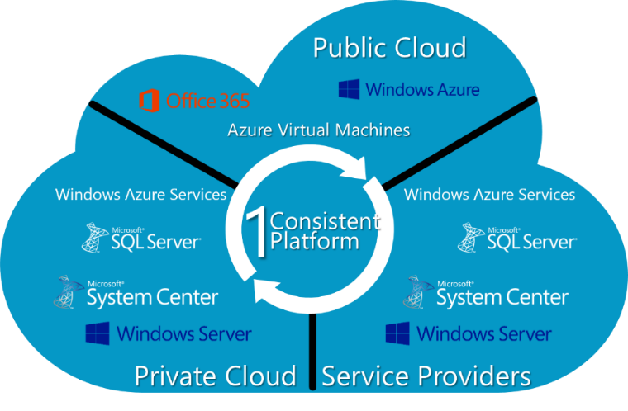
Private Cloud Fast Track Reference Architecture
The Nutanix Business-Ready Configuration is pre-engineered, tested, and optimized for virtualization. It supports the operating system, virtualization, and management capabilities offered by Windows Server 2012 R2, Hyper-V, and System Center 2012 R2.

Private Cloud Technologies

Windows Server 2012 R2 Hyper-V
With Windows Server 2012 R2, it is now easier than ever for organizations to take advantage of the cost savings of virtualization and make the optimum use of server hardware investments by consolidating multiple server roles as separate virtual machines. This technology:
- Improves virtualization density and makes optimal use of server hardware investments by consolidating multiple server roles as separate virtual machines. These virtual machines use Hyper-V to efficiently run multiple operating systems such as Microsoft Windows, Linux, and others in parallel, on a single server.
- Extends virtualization capabilities with more features, greater scalability, and built-in reliability mechanisms.

System Center 2012 R2
A cloud and data center management solution, Microsoft System Center 2012 R2 builds on the core capability provided by Windows Server 2012 R2. It delivers a flexible, cost-effective private cloud infrastructure in a self-service model, while using existing data center hardware and software investments. This solution delivers the following capabilities:
- Infrastructure provisioning: Enable enterprises and service providers to provision an infrastructure that meets their key requirements.
- Automation and self-service: Facilitate the agility enterprise owners need while providing datacenter administrators the tools they need to drive cost-effectiveness and IT control.
- Infrastructure monitoring: Provide a single toolset to monitor infrastructure resources across on-premises, service provider, and Windows Azure environments.
- Application performance monitoring: Provide the deep insight necessary to deliver predictable application SLAs to application owners.
- IT service management: Provide the necessary service management processes to help enterprise IT deliver services in a flexible manner.

Nutanix Web-Scale Solution
Nutanix Virtual Computing Platform brings the benefits of web-scale infrastructure using a linearly scaling approach that combines compute and storage. SSDs and HDDs are consolidated by the Nutanix Controller VM and shared back across all hosts running Hyper-V using SMB 3.0.
Converged Nutanix Virtual Computing Platform NX-Series:
- Provides the ability to start small with 3-node configurations and scale to 100s of systems per cluster.
- Includes a variety of configurations for enterprise data center and remote/branch offices – enabling you to deploy in hours.
- The Software-Defined Storage model eliminates the need for separate storage systems along with the associated complexity.
- Enables linear scaling of performance – simply add additional nodes – without any overhead or manual turning.
- Provides built-in availability with no single points of failure – for no data loss, even when an entire node goes down.
- Includes VMCaliber functionality for data protection and consumer-grade simplicity, eliminating hundreds of hours of management overhead.
- Provides integration with System Center and Windows Azure Pack, enabling you to bring Microsoft Azure on-premises and deliver Platform as a Service offerings.

Network Stack:
- Includes support for 10-Gigabit Ethernet connectivity, for high-performance data delivery.
- Leverages your existing network stack, including managed, high-performance modular Layer 2/3 solutions for resource mobility and access, helping to protect investments.
- Provides the ability to choose network infrastructure new deployments, based on high port density switches with flexible external I/O choices that connect to your existing infrastructure.

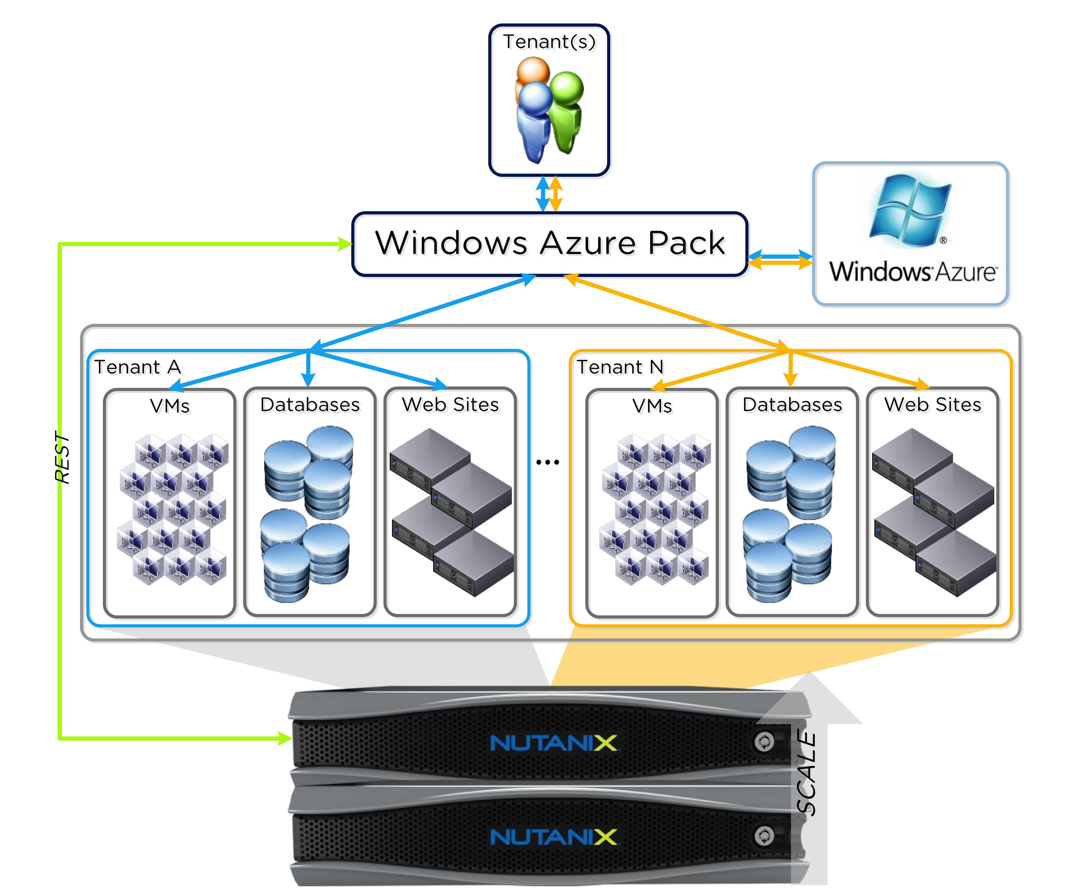

Fast Track Solution
Nutanix Private Cloud Fast Track Validated Solutuon  Nutanix is the right partner to help you get the functionality and benefits of web-scale IT for Microsoft Private Cloud, without upfront investments or overhead. | - Start with a comprehensive assessment and planning workshop through Microsoft and Nutanix.  - Leverage validated Nutanix reference architectures for both Microsoft Private Cloud and Windows Azure Pack to design your environment.  - Deploy with confidence, using Nutanix Deployment Services.  - Get started on your journey with a demonstration of the Nutanix Virtual Computing Platform.

More Information and Next Steps
- http://www.microsoft.com/en-us/server-cloud/fast-track.aspx
- http://www.nutanix.com/microsoft/

