Hands-On Lab

Unit Testing, Code Coverage and Code Clone Analysis with Visual Studio 2015

Lab version: 14.0.23107.0
Last updated: 8/12/2015

TABLE OF CONTENT
Unit Testing, Code Coverage and Code Clone Analysis with Visual Studio 2015 1
Overview 3
Prerequisites 3
About the Fabrikam Fiber Scenario 3
Exercises 3
Exercise 1: Unit Testing 4
Exercise 2: Code Coverage 17
Exercise 3: Code Clone Analysis 22

Overview
In this lab, you will learn about how the unit testing engine in Visual Studio is extensible and opens the door for 3rd party unit testing adapters such as NUnit and xUnit.net. In addition, you will see some of the improvements made to code coverage support. You will also learn about how the code clone capability goes hand-in-hand with delivering high quality software by helping you identify blocks of semantically similar code which may be candidates for common bug fixes or refactoring.

Prerequisites
In order to complete this lab you will need the Visual Studio 2015 virtual machine provided by Microsoft. For more information on acquiring and using this virtual machine, please see this blog post.

About the Fabrikam Fiber Scenario
This set of hands-on-labs uses a fictional company, Fabrikam Fiber, as a backdrop to the scenarios you are learning about. Fabrikam Fiber provides cable television and related services to the United States. They are growing rapidly and have embraced Windows Azure to scale their customer-facing web site directly to end-users to allow them to self-service tickets and track technicians. They also use an on-premises ASP.NET MVC application for their customer service representatives to administer customer orders.
In this set of hands-on labs, you will take part in a number of scenarios that involve the development and testing team at Fabrikam Fiber. The team, which consists of 8-10 people, has decided to use Visual Studio application lifecycle management tools to manage their source code, run their builds, test their web sites, and plan and track the project.

Exercises
This hands-on lab includes the following exercises:
  - Unit Testing
  - Code Coverage
  - Code Clone Analysis

Estimated time to complete this lab: 30 minutes.

Exercise 1: Unit Testing
In this exercise, you will learn about the unit testing story in Visual Studio 2015.
  - Log in as Julia (VSALM\Julia). All user passwords are P2ssw0rd.
  - Launch Visual Studio 2015 from the taskbar and open Team Explorer. You should now be connected to the FabrikamFiber team project. If you are not automatically connected to the FabrikamFiber project, select the Connect to Team Projects button () to do so.
  - In Team Explorer – Home, double-click on the first FabrikamFiber.CallCenter.sln solution.
    - 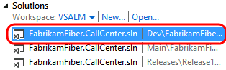
    - Figure 1
    - Loading Fabrikam Fiber solution

  - Press Ctrl + Shift + B to build the solution.
  - Open the Test Explorer window from Test | Windows | Test Explorer. Note that discovered tests are initially set to the Not Run state.
    - 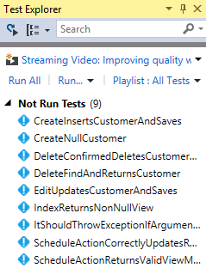
    - Figure 2
    - Test Explorer window

  - Select the Run All link to execute all discovered unit tests.
    - 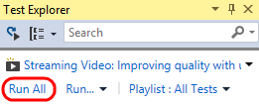
    - Figure 3
    - Running all unit tests

    - Note: Visual Studio also provides Continuous Test Runner functionality that can be enabled with the Test | Test Settings | Run Tests After Build option. With this option selected, tests will always run after builds.

  - Expand the Passed Tests group (if necessary) and double-click on the test with the name CreateInsertsCustomerAndSaves to open the source code.
    - 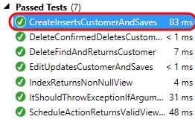
    - Figure 4
    - Navigating to a test method that uses MSTest

  - In the CustomersControllerTest.cs file that opens, note that the test method uses the expected TestMethod attribute used by MSTest to mark unit tests.
    - 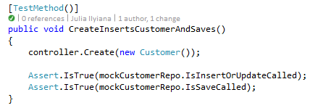
    - Figure 5
    - MSTest unit test code

Note: The test status indicator just above the method definition is a CodeLens indicator. It tells us that the last run was a success. You can learn more about the CodeLens feature in the “Collaboration Experiences for Development Teams using Team Foundation Server 2015” lab.

  - In the Search box at the top of the Test Explorer window, enter “index” and note the available search filters.
    - 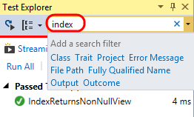
    - Figure 6
    - Searching within Test Explorer

  - In the search results, double-click on the only test listed with the name IndexReturnsNonNullView to open the source code.
    - 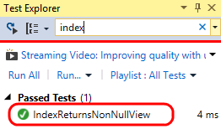
    - Figure 7
    - Navigating to a test method that uses XUnit

  - In the HomeControllerTest.cs file that opens, you can see that the IndexReturnsNonNullView test actually uses the XUnit testing framework. Both the xUnit framework and the test runner that integrates with Test Explorer can be added to a project via NuGet.
    - 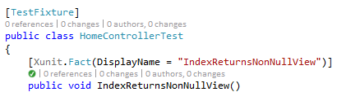
    - Figure 8
Example of a XUnit test in Visual Studio

  - Select X button to clear the current search box in Test Explorer.
    - 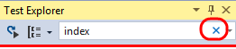
    - Figure 9
    - Location of X button to clear search box

  - Note that results are grouped by test outcome by default, with execution times listed.
    - 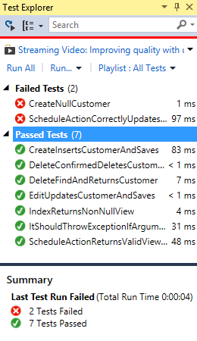
    - Figure 10
    - Test run results

  - Test execution performance has been given some additional attention in recent versions. Take note of the execution times and then select the Run… button followed by the Repeat Last Run option. Note the difference in execution time.
    - 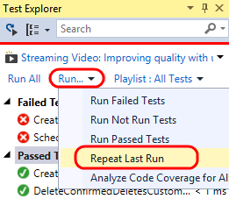
    - Figure 11
    - Repeating the last test run

    - Note: The execution times that you see will be different from those shown in the screenshots. The first time you run unit tests they will execute more slowly than on subsequent runs as the tests and testing engine are being loaded for the first time.

    - 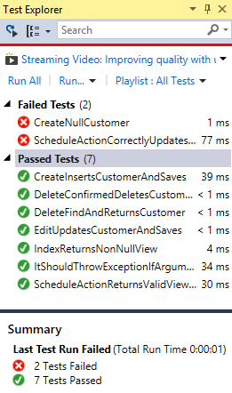
    - Figure 12
    - Second test run without changes to tests is faster

  - Single-click the failed test named “ScheduleActionCorrectlyUpdatesRepositories” to view a summary of test results.
    - 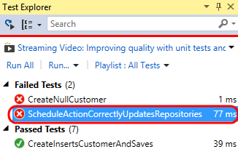
    - Figure 13
    - Selecting the failed test

    - Note: You can also right-click on test results and use the Copy command to copy details to the clipboard. This would be useful when sending an email, for example.

  - The summary view of the failed test run shows that an ArgumentNullException exception occurred during the test run and even provides the stack track at the time of the exception. Note that we can follow links to go directly to the source code for the test or to points within the stack trace. Select the source link to go to the source code for the test method.
    - 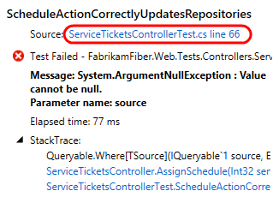
    - Figure 14
    - Navigate to the source of the test method

    - 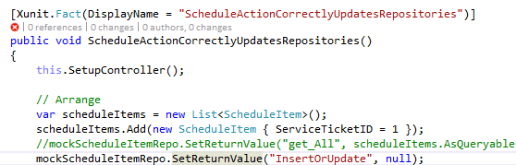
    - Figure 15
    - Initial view after navigating to source of the test method

  - Find the line of code that is commented out and un-comment it. Assume that this is the root cause for the failed test.
    - 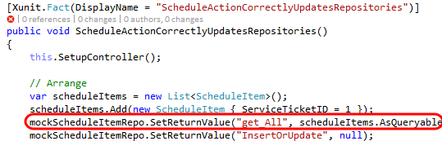
    - Figure 16
    - Fixing the root problem of the failed test

  - Press Ctrl+S to save your changes.
  - Right-click on the failed test in Test Explorer and select Run Selected Tests to make sure that the problem is fixed.
    - 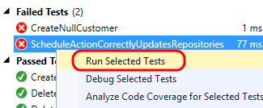
    - Figure 17
    - Running the failed test again to validate fix

  - So far, we have seen how to run all discovered tests, search for specific tests, and group by test outcome. Now let’s take at a few other ways that you can organize and navigate unit tests to make unit testing easier. For some motivational context, remember how long you needed to wait for the coded UI test to complete, and then imagine that there are many more of those. It would be nice if the tests were organized such that you could easily avoid kicking off those tests without having to be careful of the tests that you select.
  - To start with, there are a number of useful grouping options. Right-click somewhere within the Test Explorer window and select Group By | Class.
    - 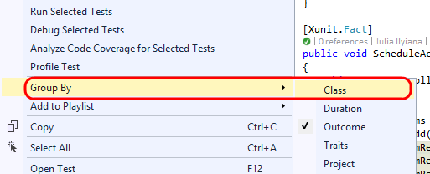
    - Figure 18
    - Grouping tests by class

  - Assuming that tests are well organized within descriptive class names, this can make it much easier to select and run tests. For example, you could select just the tests from the CustomersControllerTest class and run them.
    - 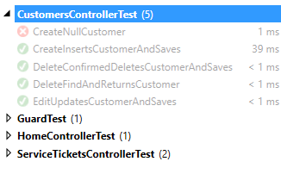
    - Figure 19
    - Grouping tests by class

  - Right-click somewhere within the Test Explorer window and select Group By | Project.
    - 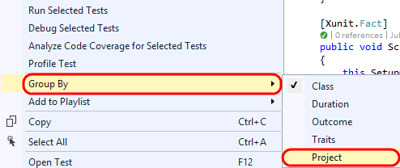
    - Figure 20
    - Grouping tests by project

  - Grouping tests by project would obviously be useful for navigating and running tests at the project level.
    - 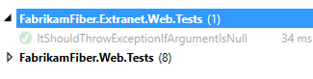
    - Figure 21
    - Grouping tests by project

  - You can also use traits in your test code to provide custom grouping. Let’s say that we want to group all coded UI tests together. Open CodedUITest1.cs from the FabrikamFiber.Web.UITests project.
    - 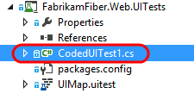
    - Figure 22
    - Loading test code

  - Un-comment the CodedUITest attribute from the top of the CodedUITest1 class definition.
    - 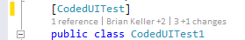
    - Figure 23
    - CodedUITest attribute

  - Add the TestCategory attribute to the CodedUITestMethod1 method with a category of “UI”.
    - 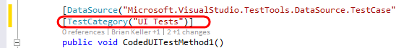
    - Figure 24
    - Adding custom trait to test method

  - Build the solution by pressing Ctrl+Shift+B.
  - Right-click within Test Explorer and select Group By | Traits.
  - With the coded UI tests categorized appropriately, it is now easy to select and run just the UI tests if desired.
    - 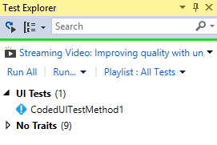
    - Figure 25
    - Test Explorer window showing tests grouped by traits

  - You can also create sets of tests called playlists. This provides custom grouping without the need to modify your unit testing code. Right-click on the CodedUITestMethod1 test and select Add to Playlist | New Playlist.
    - 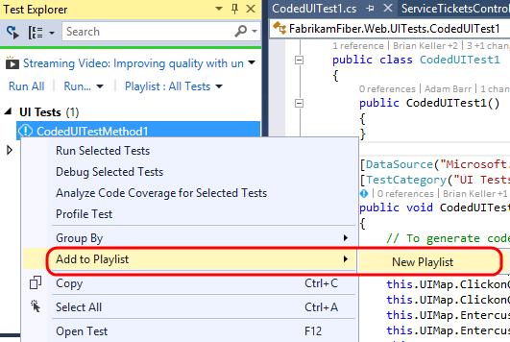
    - Figure 26
    - Creating a new test playlist

  - Enter “UI Tests” for the playlist file name and then select Save.
    - 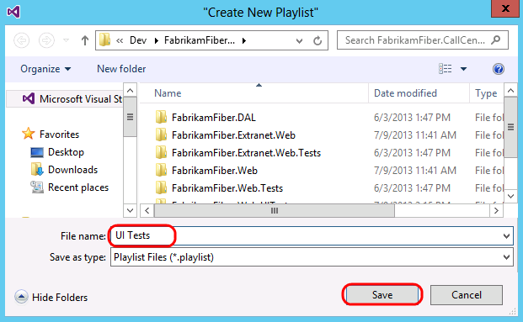
    - Figure 27
    - Saving a new test playlist

  - Select the Playlist drop-down and then select the “UI Tests” playlist.
    - 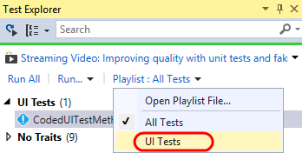
    - Figure 28
    - Selecting a test playlist

  - With just the “UI Tests” playlist selected, you will only see those specific tests shown in Test Explorer, making it much easier to focus on a particular selection of tests.
    - 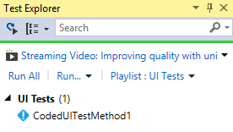
    - Figure 29
    - Test playlist selected

  - Test playlists are simple XML files that define the individual tests to include. For example, here is what the “UI Tests” XML looks like (loaded in Visual Studio editor).
    - 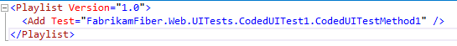
    - Figure 30
    - Contents of a test playlist

  - Playlists can be shared with team members via a team website, emailed, and even added to source control if desired. To load a playlist file, you would select the Playlist drop-down and then select the Open Playlist File option. You do not need to do this for this lab.
    - 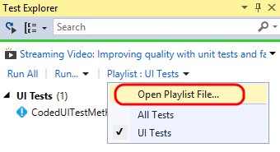
    - Figure 31
    - Opening a playlist

Exercise 2: Code Coverage
In this exercise, you will learn about code coverage features that make it easier to use and integrate into the development cycle.
  - You should already have the Test Explorer window open from the previous exercise, but go ahead and open it if necessary (from Test | Windows | Test Explorer).
  - Return to the default playlist that includes all tests by selecting the Playlist drop-down and then selecting the All Tests option.
    - 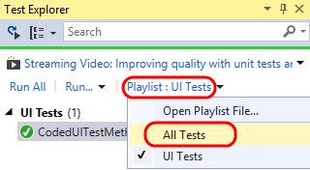
    - Figure 32
    - Selecting the All Tests playlist

  - To analyze code coverage for all tests, select the Run drop-down and then select the Analyze Code Coverage for All Tests option. This will initiate the process of building, testing, and gathering code coverage results.
    - 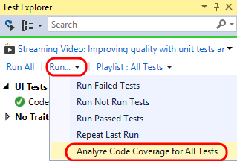
    - Figure 33
    - Analyzing code coverage

  - You can view the results in the Code Coverage Results windows to get an idea of the Covered/Not Covered statistics for all of the tests. In the screenshot below, note that coverage is measured in blocks of code by default, where a block is code with exactly one entry and exit point.
    - 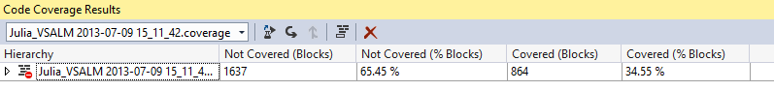
    - Figure 34
    - Code coverage results summary

    - Note: If you would like to see the results in terms of lines, you can do that by right-clicking in the Code Coverage Results window and selecting the Add/Remove Columns option.

  - Expand the root node of the code coverage result to view the coverage broken down by assembly. By default, we see all assemblies that are loaded during the test run (and for which a .pdb file is available).
    - 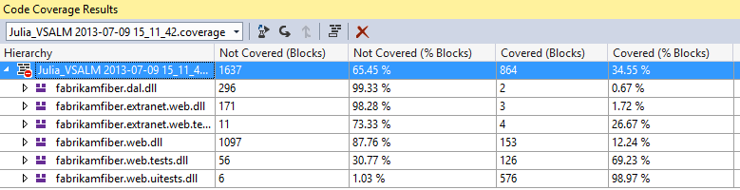
    - Figure 35
    - Code coverage results by assembly

    - Note: You can customize control over which assemblies are selected for code coverage analysis by writing a .runsettings file. For more information, see the MSDN article Customizing Code Coverage Analysis.

  - Expand the fabrikamfiber.web.dll node to view the coverage broken down by namespace. This allows us to see that, although we do have some test coverage of the controller classes, the test team has a lot of work to do in order to provide coverage to the other namespaces.
    - 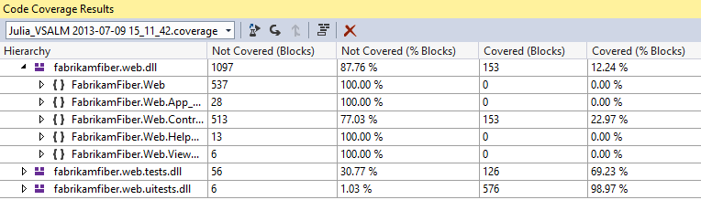
    - Figure 36
    - Code coverage results for namespaces within assembly

  - Expand the FabrikamFiber.Web.Controllers namespace node to view the coverage broken down by class. This shows that the HomeController class is covered well and that the EmployeesController currently has no coverage.
    - 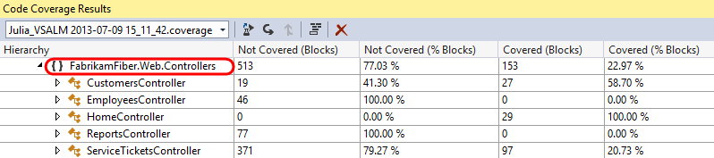
    - Figure 37
    - Code coverage results for classes within namespace

  - Finally, let’s drill down into the class nodes to see coverage down to the method level by expanding the CustomersController class node.
    - 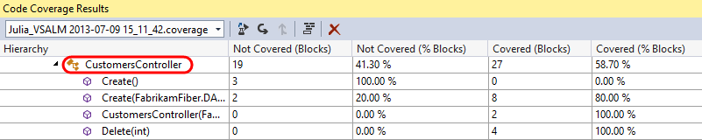
    - Figure 38
    - Code coverage results for methods

  - Double-click on the Create(FabrikamFiber.DAL.Models.Customer) constructor to navigate to the source code to visualize the block coverage.
    - 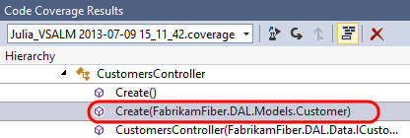
    - Figure 39
    - Navigating to source

  - In the editor window for SourceController.cs, you can see that the code highlighted blue represents the block that was covered by tests whereas the red represents the block that was not covered.
    - 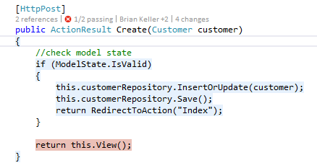
    - Figure 40
    - Source view showing code coverage coloring

  - It is also possible to get code coverage for a specific selection of tests. In the Test Explorer window, select the CreateInsertsCustomerAndSaves test method, right-click, and then select Analyze Code Coverage for Selected Tests.
    - 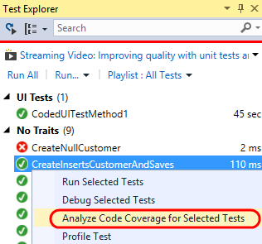
    - Figure 41
    - Analyze code coverage for specified tests

  - Once test execution completes for the selected test, expand the code coverage node and note that only the assemblies loaded during test execution are shown with statistics.
    - 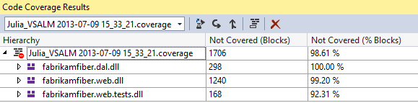
    - Figure 42
    - Code coverage results

  - It is also easy to navigate between different code coverage results by using the drop-down in the Code Coverage Results window. Go ahead and select the first code coverage results file.
    - 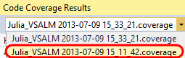
    - Figure 43
    - Selecting specific code coverage results

  - Let’s say that we want to use these code coverage results in a report or simply share them externally. To do that, click on the Export Results button.
    - 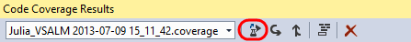
    - Figure 44
    - Exporting code coverage results

  - In the Save Coverage Data as XML window, you could save the code coverage data to an XML file, but for the purposes of this lab, go ahead and simply Cancel out of the dialog and continue on to the next exercise.
    - 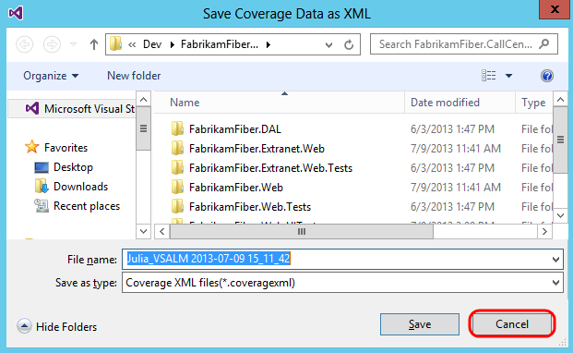
    - Figure 45
    - Saving code coverage results to file

Exercise 3: Code Clone Analysis
In this exercise, you will learn about the Code Clone analysis feature that looks for semantically similar code using a heuristic search technique, rather than simply searching for exact matches.
  - Select Analyze | Analyze Solution for Code Clones from the main menu in Visual Studio.
    - 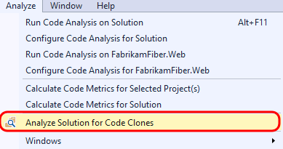
    - Figure 46
    - Analyze solution for code clones

  - Once the analysis is complete, the Code Clone Analysis Results window will show clone candidates grouped by match strength. Expand the Strong Match group to expose the two files that had a strong match.
    - Figure 47
    - Viewing the strong file matches

  - Each line shows the class and method, specific file, and lines that were determined to be strong matches. If you mouse over each match, a snippet of code gives you quick glance at some of the matching code.
    - 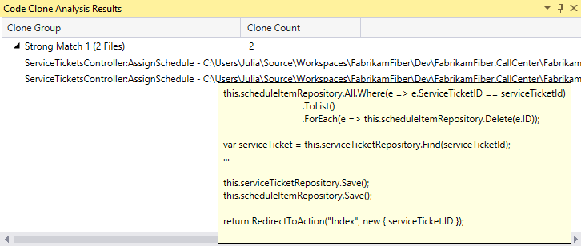
    - Figure 48
    - Mouse over results to see details

  - Double-click on each match to open them in code editor windows, and then right-click on the title tab for one of them and select New Horizontal Tab Group from the context menu.
    - 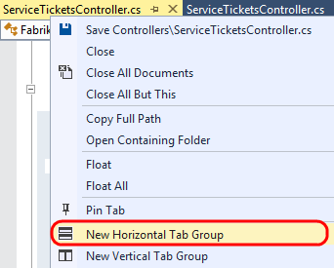
    - Figure 49
    - Opening both files for comparison

  - Scroll through the code to locate the AssignSchedule method for each file and note that it is identical except for the last line that calls the RedirectToAction method. This indicates that this method is a good candidate for refactoring. This kind of broad search is particularly useful when looking for code that can be refactored for easier maintenance in the future.
    - 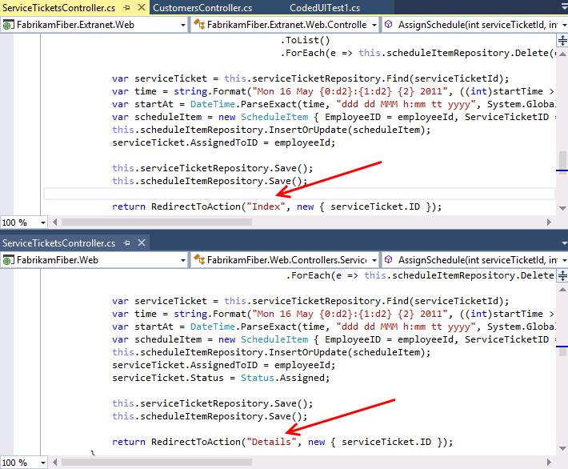
    - Figure 50
    - Comparing the strong match from the code clone analysis

  - Select Window | Close All Documents from the main menu to clear up some screen real estate space.
  - You can also narrow the focus of the search for code clones if desired. In Solution Explorer, navigate to Controllers folder of the FabrikamFiber.Web project and open CustomersController.cs in the code editor.
    - 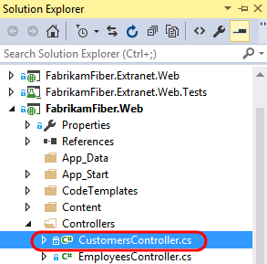
    - Figure 51
    - Opening the CustomersController.cs source file

  - Scroll down to the Create method that takes a Customer parameter and select the three lines of code within the first “if” statement.
    - 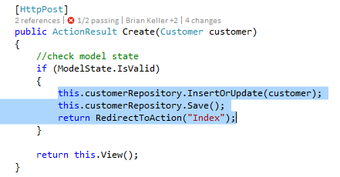
    - Figure 52
    - Selecting code for a code clone analysis

  - Right-click on the selected lines of code and then select the Find Matching Clones in Solution option from the context menu.
    - 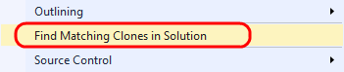
    - Figure 53
    - Finding matching clones for the selected code

  - After the search is complete, the Code Clone Search Results window shows snippet matches of varying strength.
    - 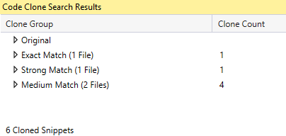
    - Figure 54
    - Results of code clone search

  - Expand all of the clone groups to expose the discovered matches, including the original clone group. You may want to increase the size of the Code Clone Search Results window so that you can see all matches at a glance.
    - 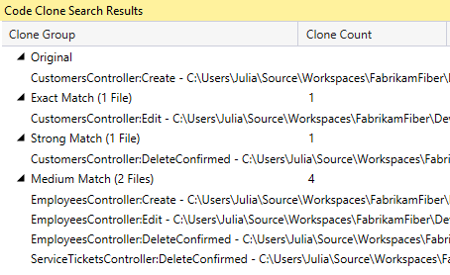
    - Figure 55
    - Code clone results with groups expanded

  - Hold the mouse cursor over the original code snippet to remind ourselves what the code clones are being compared to.
    - 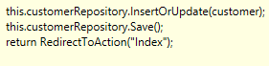
    - Figure 56
    - Original code snippet
  - Hold the mouse cursor over the Exact Match result and note that the Edit method uses exactly the same code as the code from the Create method.
  - Hold the mouse cursor over the Strong Match result and note that the only difference is that the first line is a call to a Delete method.
    - 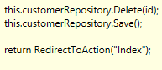
    - Figure 57
    - Code snippet result with strong match to original
  - Hold the mouse cursor over the first Medium Match result and note that the snippet is similar to the original, but now we are working with an entirely different object (now employeeRepository).
    - 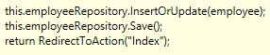
    - Figure 58
    - Code snippet result with strong match to original
  - In summary, there are three main scenarios where the identification of code clones may be useful to developers:
    - Identification of candidates for code refactoring
    - Bug fixes or enhancements are made in code and the developer wants to see if there are other similar locations that should be updated
    - As a learning tool for a new developer starting work on a new team project, e.g. the developer adds code to update a customer record and wants to see if there are practices used by the rest of the codebase such as using a Try… Catch block

To give feedback please write to VSKitFdbk@Microsoft.com
Copyright © 2015 by Microsoft Corporation. All rights reserved.

