Hands-On Lab

Introduction to Platform Testing with Microsoft Test Manager 2015

Lab version: 14.0.23107.0
Last updated: 8/5/2015

TABLE OF CONTENT
Introduction to Platform Testing with Microsoft Test Manager 2015 1
Overview 3
Prerequisites 3
Exercises 3
Exercise 1: Creating New Test Configurations for Test Plans 4
Exercise 2: Assigning Test Configurations to Existing Test Cases 9
Exercise 3: Assigning Test Cases to a Tester Based on Test Configurations 12
Exercise 4: Filtering Tests and Viewing Test Configurations when Analyzing Test Runs 13

Overview
Microsoft Test Manager 2015 can be used to organize your test plans, author and manage your test cases, and run manual tests. This lab will introduce you to working with platform testing configurations in Microsoft Test Manager.
This hands-on-lab is one out of a number of labs that deal with Microsoft Test Manager. The recommended order to complete the labs in is as follows:
  - Introduction to Test Planning with Microsoft Test Manager 2015
  - Introduction to Test Case Management with Microsoft Test Manager 2015
  - Authoring and Running Manual Tests using Microsoft Test Manager 2015
  - Introduction to Platform Testing with Microsoft Test Manager 2015

Prerequisites
In order to complete this lab you will need the Visual Studio 2015 virtual machine provided by Microsoft. For more information on acquiring and using this virtual machine, please see this blog post.

Exercises
This hands-on lab includes the following exercises:
  - Creating New Test Configurations for Test Plans
  - Assigning Test Configurations to Existing Test Cases
  - Assigning Test Cases to a Tester Based on Test Configurations
  - Filtering Tests and Viewing Test Configurations when Analyzing Test Runs

Estimated time to complete this lab: 60 minutes.

Exercise 1: Creating New Test Configurations for Test Plans
In this exercise, you will learn how to use Microsoft Test Manager to create new test configurations and assign them to a test plan.
  - Log in as Julia (VSALM\Julia). All user passwords are P2ssw0rd
  - Launch Microsoft Test Manager from the taskbar. Microsoft Test Manager allows testers to work with test plans, author and organize manual test cases, execute test cases, file bugs, and post results back to Team Foundation Server.
    - 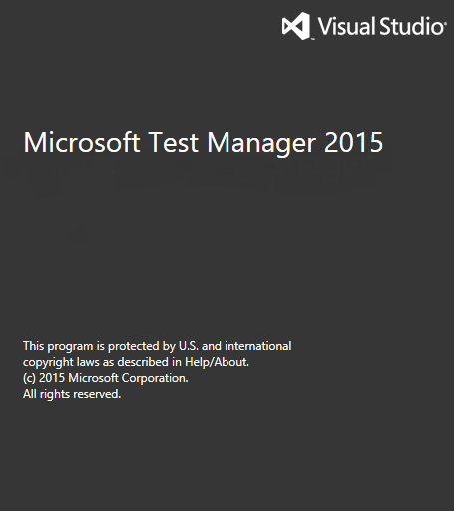
    - Figure 1
    - Microsoft Test Manager splash screen

  - If not already connected, connect to the Iteration 2 test plan from the Tailspin Toys team project. You can change this selection by clicking on the Home button.
    - 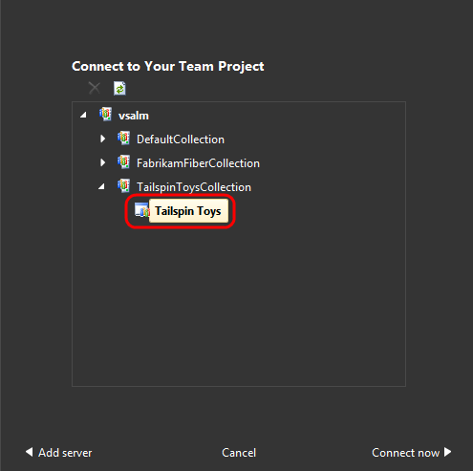
    - Figure 2
    - Connecting to Tailspin Toys team project

    - 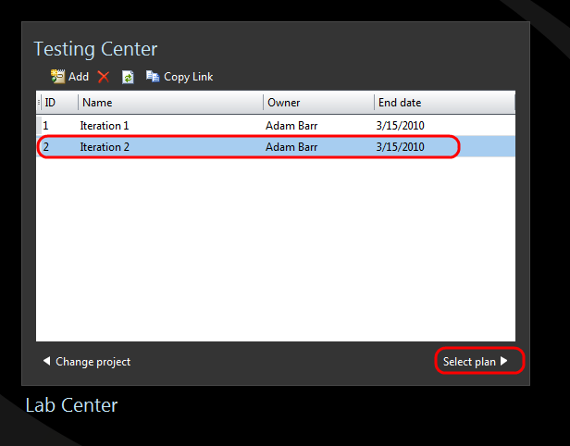
    - Figure 3
    - Connecting to Iteration 2 test plan

    - Figure 4
    - Location of currently selected team project and test plan

  - Select the Organize tab at the top of the window and then select the Test Configuration Manager link.
    - 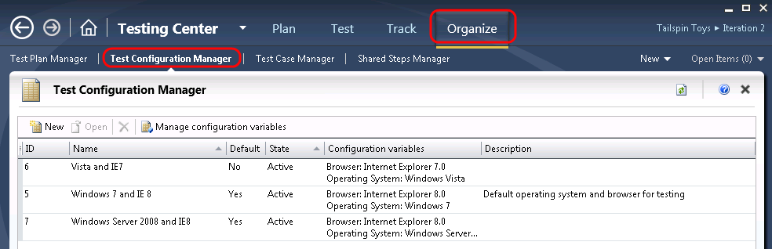
    - Figure 5
    - Test Configuration Manager window

  - Select the New button to create a new test configuration.
    - 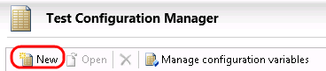
    - Figure 6
    - Location of New button

  - For Name, enter “Windows Server 2008 and Firefox 3.0”.
  - In the Configuration variables grid, select the Add dropdown box and select Operating System.
    - 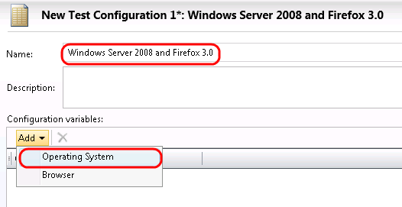
    - Figure 7
    - Location of Add button

  - Change the default Windows 7 value to Windows Server 2008.
  - Select the Add dropdown box again and select Browser. Change the value to Firefox 3.0 if necessary.
    - 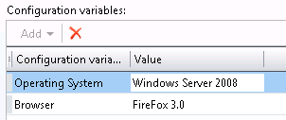
    - Figure 8
    - Adjusting values of Configuration variables

  - Select the Save and Close button to save the new test configuration.
    - Figure 9
    - Location of Save and Close button

  - The Test Configuration Manager window should now show the new test configuration.
    - 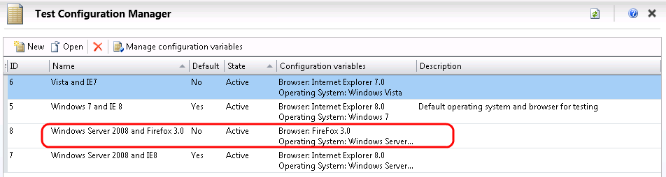
    - Figure 10
    - Test Configuration Manager window showing new configuration option

  - Select the Plan tab at the top of the window and then select the Run Settings link to view the test plan properties for Iteration 2.
    - 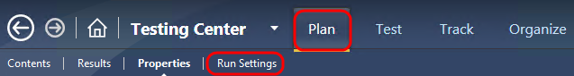
    - Figure 11
    - Location of Plan and Properties buttons

  - Locate the Configurations section and click the dropdown box to view all available platform configurations. This shows the default configurations for new test cases.
    - 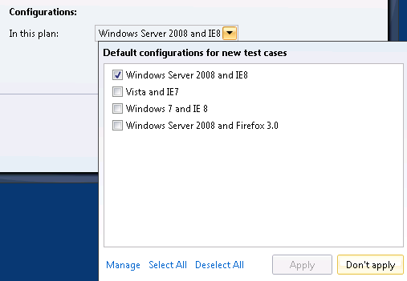
    - Figure 12
    - Configuring configuration options

  - Select the new test configuration named “Windows Server 2008 and Firefox 3.0”, then select the Apply button to save the changes.
    - 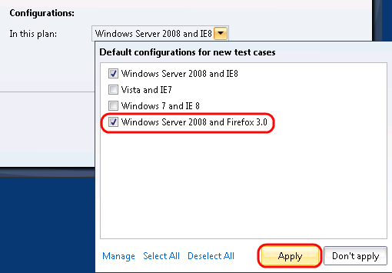
    - Figure 13
    - Selecting new default configuration options for new test cases

  - Select the Save and Close button to save the changes to the test plan configuration.
    - Figure 14
    - Location of Save and Close button

Exercise 2: Assigning Test Configurations to Existing Test Cases
In this exercise, you will learn how to assign test configurations to existing test cases.
  - In Microsoft Test Manager, select the Plan tab and then select the Contents link to open the project plan contents window.
    - 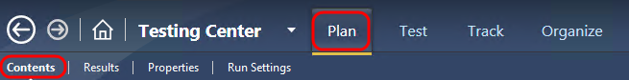
    - Figure 15
    - Test plan contents window for Iteration 2

  - Select test suite 7 to view its test cases.
  - Select test case with ID = 40, titled “Customer can remove items from shopping cart by clicking “X” icon”.
    - 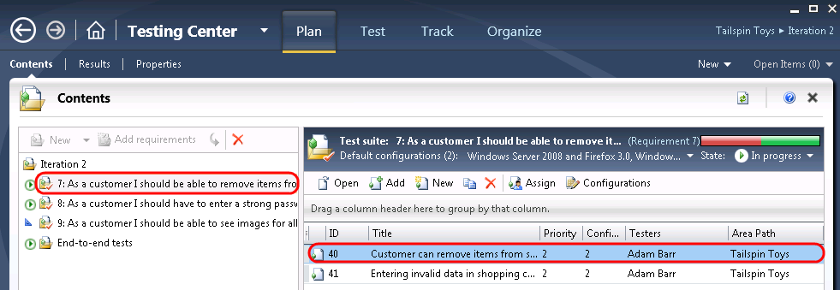
    - Figure 16
    - Selecting a specific test case to adjust configurations

  - Select the Configurations button.
    - 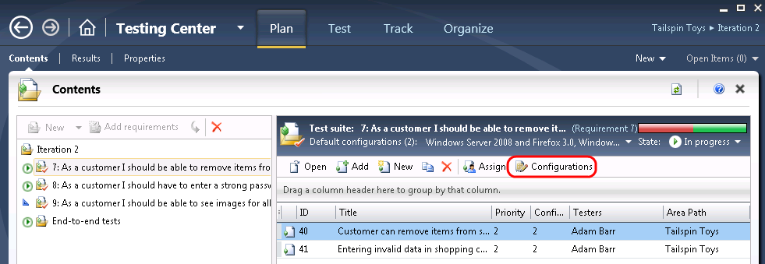
    - Figure 17
    - Location of Configurations button

  - Select the Configurations drop down for the test case, then select the Windows Server 2008 and Firefox 3.0 option, and finally select the Apply button.
    - 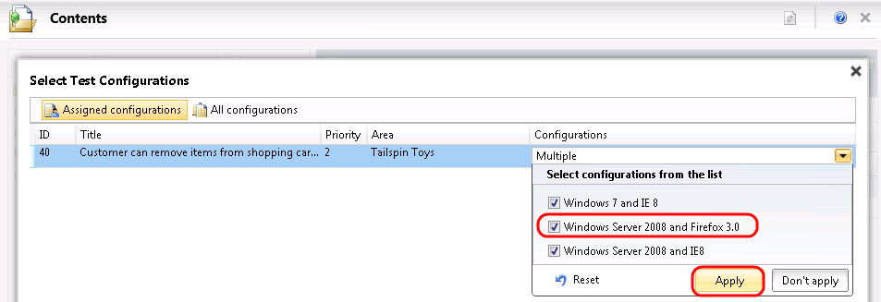
    - Figure 18
    - Selecting the new configuration option

  - Select the Close button to close the Select Test Configuration view.
  - Select the Test tab at the top of the window and then select the Run Tests link.
    - 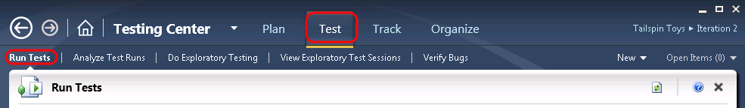
    - Figure 19
    - Run Tests window

  - Select test suite 7 to view all of the assigned test cases, and note that there is a new active test case permutation listed corresponding to test case 40 with the new Windows Server 2008 and Firefox 3.0 configuration.
    - 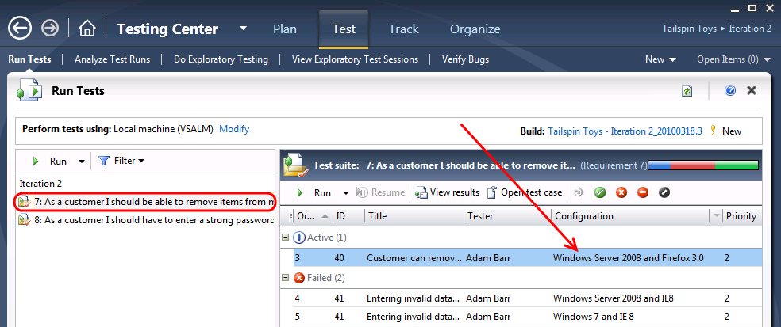
    - Figure 20
    - Test activity automatically recognizes the need for more testing

Exercise 3: Assigning Test Cases to a Tester Based on Test Configurations
In this exercise, you will learn how to assign test cases to different testers based on test configurations.
  - In Microsoft Test Manager, select the Plan tab and then select the Contents link to open the project plan contents window.
    - 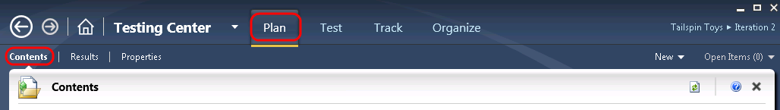
    - Figure 21
    - Test plan contents window for Iteration 2

  - Select test suite 7 if not already selected to view its test cases.
  - Select test cases 40 and 41 (hold down Ctrl) and then select the Assign button to begin assigning testers.
    - 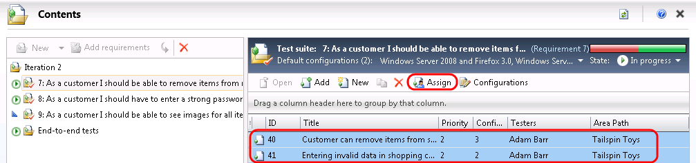
    - Figure 22
    - Selecting test cases to assign testers

  - In the Assign Testers window, test cases are shown with all assigned configurations. Note that each test case and configuration combination can be assigned to a different tester. Select the Tester dropdown box next to the row for ID = 40 and Configuration = “Windows Server 2008 and Firefox 3.0” and select Julia Ilyiana as the responsible tester.
  - Select the Save Assignments button to save your changes.
    - 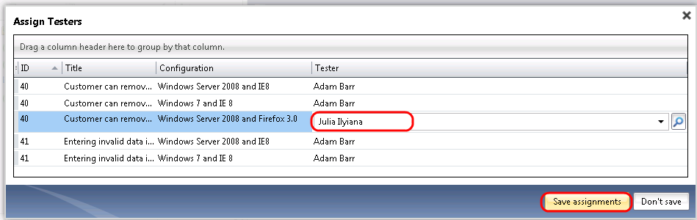
    - Figure 23
    - Location of Save Assignments button

Exercise 4: Filtering Tests and Viewing Test Configurations when Analyzing Test Runs
In this exercise, you will learn how to filter test runs and view test configurations when analyzing test runs.
  - In Microsoft Test Manager, select the Test tab and then select the Run Tests link.
  - Select test suite 7 to view all of the assigned test cases. At this point, no filtering should be applied so you should see all test suites and their associated test cases.
    - 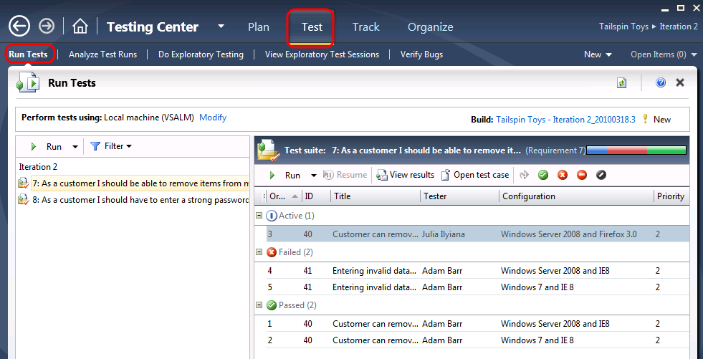
    - Figure 24
    - Viewing test cases

  - Select the Filter dropdown box to see all available filter options and select the Windows Server 2008 and IE8 configuration.
  - Select the Set Filter button.
    - 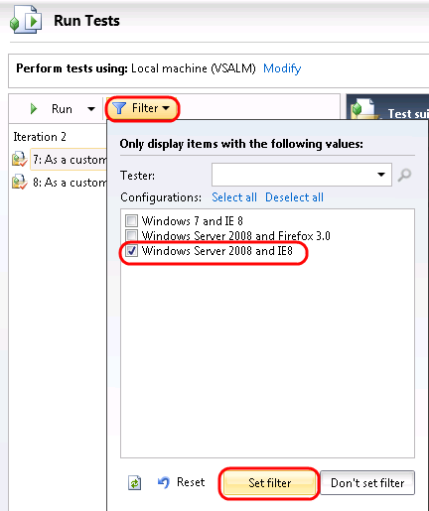
    - Figure 25
    - Filtering by test configuration

  - Once the configuration filter is applied, only test cases that are assigned to one of the filtered configurations are shown.
    - 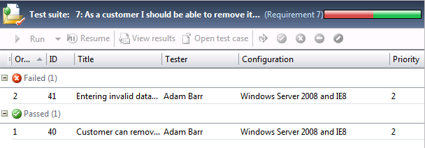
    - Figure 26
    - Test cases filtered by test configuration

  - Select one of the test runs and select the View Results button. It does not matter which one you select.
    - 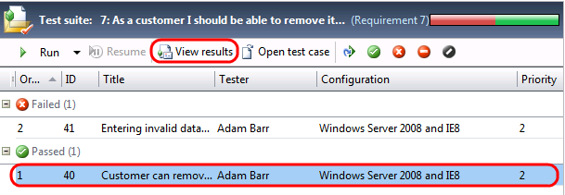
    - Figure 27
    - Viewing results for a test case

  - In the test results window for the test run that you opened, note that the associated configuration is shown.
    - 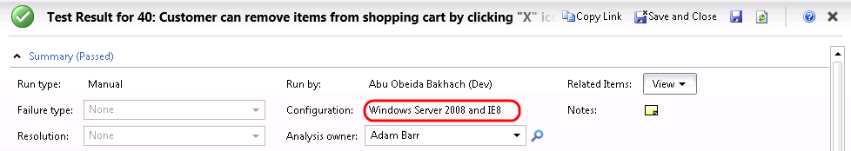
    - Figure 28
    - Test results always show the configuration that was used

  - Select the Analyze Test Runs link.
    - Figure 29
    - Location of Analyze Test Runs link

  - Use the Start date range dropdown to select the All option. Use the View dropdown to select the Manual runs option.
    - 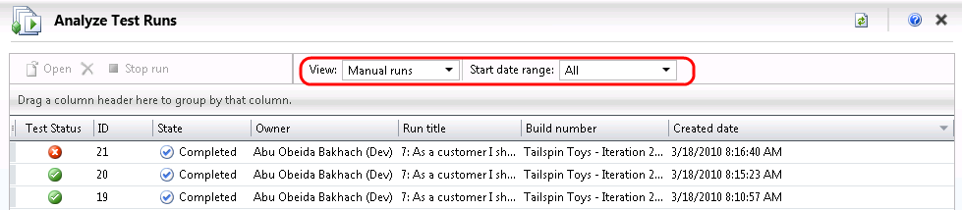
    - Figure 30
    - Adjusting drop down boxes values

  - Select one of the test runs and then select the Open button to load the test run details. It does not matter which one you select.
    - 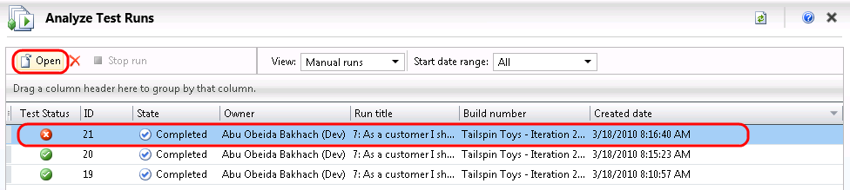
    - Figure 31
    - Opening a specific test run

  - Expand the Tests section of the test run details. Note that the associated test configuration was also recorded here.
    - 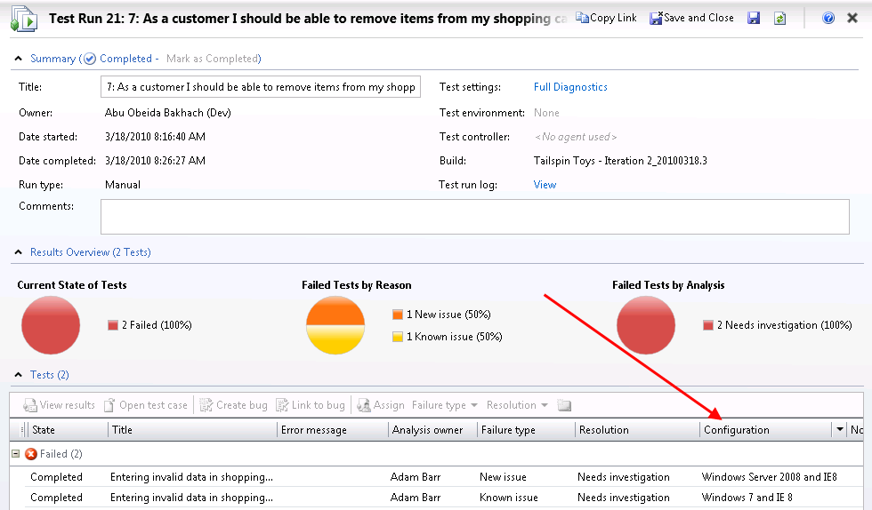
    - Figure 32
    - Results of test run showing configuration that was used
To give feedback please write to VSKitFdbk@Microsoft.com
Copyright © 2015 by Microsoft Corporation. All rights reserved.

