Hands-On Lab

Agile Planning and Portfolio Management with Team Foundation Server 2015

Lab version: 14.0.23107.0
Last updated: 9/22/2015

TABLE OF CONTENT
Agile Planning and Portfolio Management with Team Foundation Server 2015 1
Overview 3
Prerequisites 3
About the Fabrikam Fiber Scenario 3
Exercises 3
Exercise 1: Agile Project Management 4
Task 1: Team Foundation Server Web Portal 4
Task 2: Working with the Backlog 8
Task 3: Team Capacity Planning 16
Task 4: Working with the Task Board 20
Exercise 2: Agile Portfolio Management 26
Task 1: Configuring Team Hierarchy and Area Paths 26
Task 2: Portfolio Management 31
Exercise 3: Flexibility of Agile Tools 40
Task 1: Introduction to Kanban Tools 40
Task 2: Work Item Tagging 59
Exercise 4: Work Item Charting 64
Task 1: Creating and Sharing Work Item Charts 64

Overview
In this lab, you will learn about the agile planning and portfolio management tools and processes provided by Team Foundation Server 2015 and how they can help you quickly plan, manage, and track work across your entire team. You will explore the product backlog, sprint backlog, and task boards which can be used to track the flow of work during the course of an iteration. We will also take a look at how the tools have been enhanced in this release to scale for larger teams and organizations.

Prerequisites
In order to complete this lab you will need the Visual Studio 2015 virtual machine provided by Microsoft. For more information on acquiring and using this virtual machine, please see this blog post.
Important note:
This lab requires you to use the default state of the virtual machine, before any modifications are made to work items or source in TFS. If you followed the “Working with the Visual Studio 2015 ALM Virtual Machine.docx” instructions, you should already have a snapshot/checkpoint of the virtual machine before working with it for the first time. Apply this snapshot/checkpoint before starting this lab.

About the Fabrikam Fiber Scenario
This set of hands-on-labs uses a fictional company, Fabrikam Fiber, as a backdrop to the scenarios you are learning about. Fabrikam Fiber provides cable television and related services to the United States. They are growing rapidly and have embraced Windows Azure to scale their customer-facing web site directly to end-users to allow them to self-service tickets and track technicians. They also use an on-premises ASP.NET MVC application for their customer service representatives to administer customer orders.
In this set of hands-on labs, you will take part in a number of scenarios that involve the development and testing team at Fabrikam Fiber. The team, which consists of 8-10 people, has decided to use Visual Studio application lifecycle management tools to manage their source code, run their builds, test their web sites, and plan and track the project.

Exercises
This hands-on lab includes the following exercises:
  - Agile Project Management
  - Agile Portfolio Management
  - Flexibility of Agile Tools
  - Work Item Charting

Estimated time to complete this lab: 45 minutes.

Exercise 1: Agile Project Management
In this exercise, you will learn how to use Team Foundation Server 2015 to manage your product backlog, create work items, break work items into tasks, assign tasks to team members, and track progress using the task board. This overview will demonstrate the basic project management tools that small- to medium-sized development teams can utilize for product development.
Note: The team project used in this lab uses a Scrum process template, but the core features demonstrated apply to all process templates.

Task 1: Team Foundation Server Web Portal
  - Log in as Julia Ilyiana (VSALM\Julia). All user passwords are P2ssw0rd.
    - Note: In order to fully demonstrate the ALM features in this lab, we will first set the virtual machine to a specific date that lines up with a pre-configured, in-flight iteration. This lab needs to be walked through using the original virtual machine state (without any modifications made to source or work items), otherwise you will see errors.
  - Right-click on the ConfigureALMDemo.bat file on the Desktop and then select “Run as administrator”. This will set the date and time in the virtual machine to be a specific date that lines up with the demonstration data.
  - Launch Internet Explorer from the taskbar and select the TFS FF Portal button from the favorites bar at the top.
    - Figure 1
    - Launching the web portal

    - Note: There is also a Web Portal link in the Team Explorer window within Visual Studio.
    - 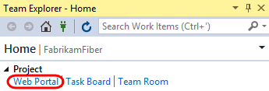

  - Select the team drop-down box in the top-right corner of the portal and select the Browse All option.
    - 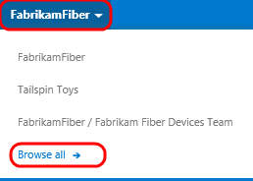
    - Figure 2
    - Browsing teams

  - This view shows that the Fabrikam Fiber collection has one project in it named FabrikamFiber. This project contains a few different teams, with the Fabrikam Fiber Leadership Team being set as the default team for the project. We will take a closer look at teams in a later exercise.
    - Note: This lab refers to this default team as both the leadership team and the management team. They both refer to the same team.

    - 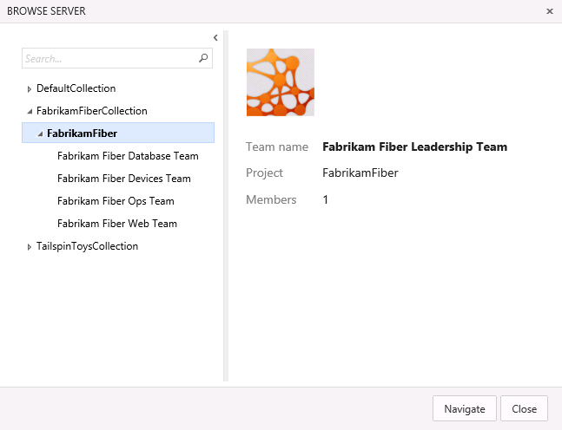
    - Figure 3
    - Browsing teams

  - Select the Fabrikam Fiber Web Team and then select the Navigate button.
    - 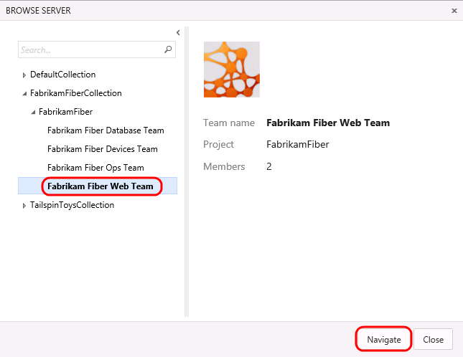
    - Figure 4
    - Navigating to a different team

  - The Home view for the Fabrikam Fiber Web team provides a high-level overview of the current iteration (Sprint 3) including team workload versus capacity, burndown of tasks over time, and team favorites, which can include a configurable assortment of work item queries, build definitions, and version control paths. In addition, there are links to quickly create new work items and bugs, load the backlog, task board, initiate requests for feedback, and so on.
    - 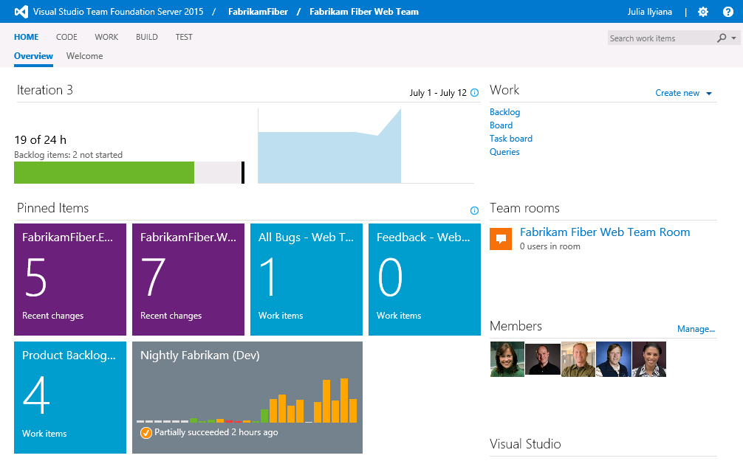
    - Figure 5
    - Fabrikam Fiber team home view

    - Note: Team favorites can be added or removed from within the web portal. For example, navigate to the Build tab to assign build definitions as a team favorite. In addition, team favorite work item queries can be modified from within Visual Studio.
    - Each team can have different team favorites listed, different work capacity, and even different work items. The determining factor on where a work item will show up is governed by the Area field.

  - As you can see under the Members section, there are several members listed in this team. Teams are a concept that were originally introduced in Team Foundation Server 2012 to make it easier to manage, assign, and track work.

Task 2: Working with the Backlog
  - Navigate to the backlog by selecting the Backlog link under the Work section.
    - Figure 6
    - Navigating to the backlog

  - The product backlog helps define the work that needs to be done. Once you have a backlog, you can use it to help manage when that work gets done, as well as associate items on the backlog with check-ins, acceptance tests, or other criteria.
    - 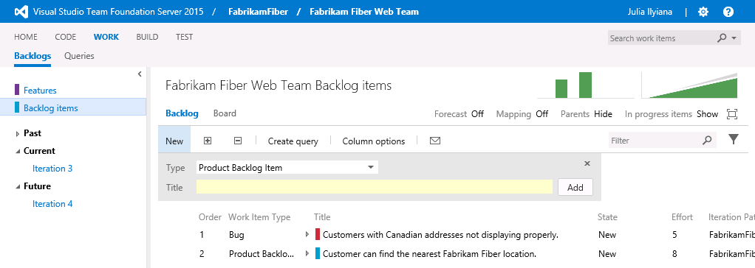
    - Figure 7
    - Product backlog view

    - Note: The Current iteration shown in the tree on the left side of this screen is Iteration 3. Team Foundation Server uses the current date and time to determine the current iteration. The virtual machine you are using has been set to use a date of July 9, 2013 for purposes of this lab.

  - Imagine that the VP of Fabrikam Fiber has requested that a new user story be implemented for the customer-facing service portal. This new user story will enabled customers to see weather-related service outages. This user story is being designated as high-priority because many customers requested it and customer service indicated that it would greatly reduce phone support during outages.
  - Select the last row of the product backlog and then create a new Product Backlog Item with the title “Customer should see weather-related outages on portal.”
    - 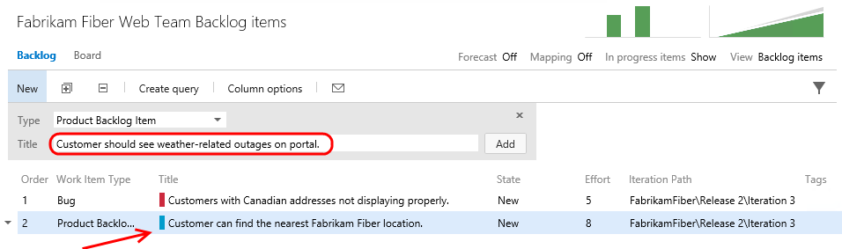
    - Figure 8
    - Adding a new user story to the product backlog

    - Note: New work items are generally inserted above the selected location. The exception is that if you select the last work item, the insertion will be after the selected location.

  - Select the Add button to add the new user story to the backlog.
    - 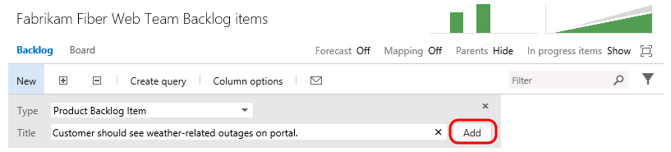
    - Figure 9
    - Adding a new user story to the product backlog

  - Work items on the product backlog are ordered based on priority, with high priority items at the top. Our new work item has a high priority, so move it to the top of the list by dragging and dropping it into place.
    - 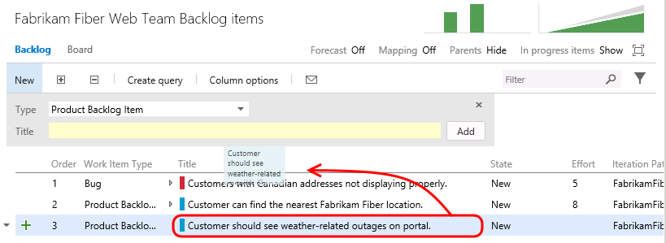
    - Figure 10
    - Increasing the priority of the new user story

  - Let’s edit the new user story to assign it to the appropriate product owner and record an initial estimate of expected effort. Double-click on the new user story.
    - 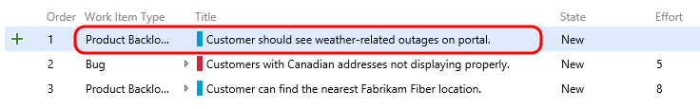
    - Figure 11
    - Editing the new user story

  - Assign the new item to Brian Keller (the product owner for the Fabrikam Fiber Team), set the state to Approved, and set an initial effort of ‘8’. Select the Save and Close button.
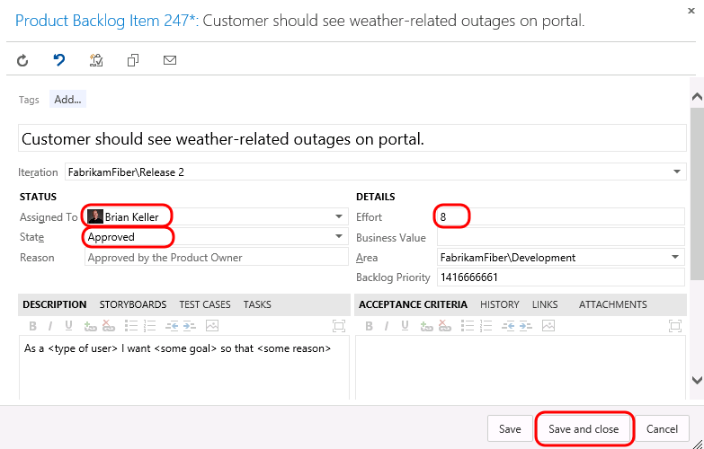
    - Figure 12
    - Assigning the new user story and estimating effort

    - Note: Each team may choose to define the Effort value as they see fit, using a unit of story points, hours, days, or number of sodas required. The point here is that this measure is a relative value with respect to other work items. Work will be broken down into hours later.
    - Note: A popular planning approach that helps to eliminate groupthink and considers input from all team members is known as planning poker. You can read more about it at http://en.wikipedia.org/wiki/Planning_poker.

  - Assign the new user story to the current iteration, Iteration 3, by dragging and dropping it as shown below.
    - 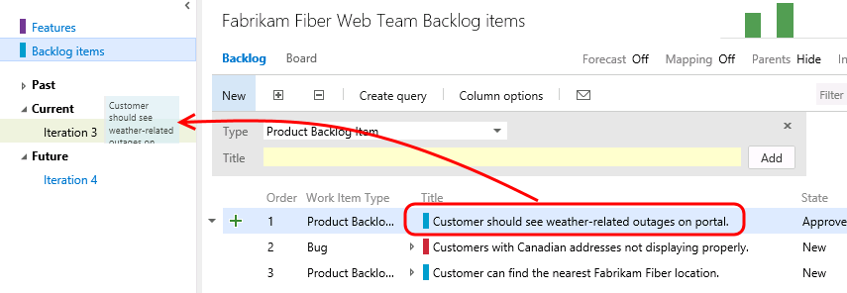
    - Figure 13
    - Assigning the new user story to the current iteration

    - Note: If you are a Scrum purist, you are probably cringing at the fact that we just added new work to a mid-flight iteration. While this is something you might never do in the real world, this is a shortcut taken for purposes of this lab in order to simplify the workflow and still show you all of the aspects of the project management interface. Well, that, and the VP told you to.

  - Look at the Iteration Path for the new user story to make sure that it is assigned to Iteration 3 as expected. This user story will remain on the product backlog until the work has been completed.
    - 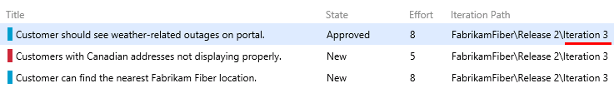
    - Figure 14
    - Assigning the new user story to the current iteration

  - The product backlog view also provides a velocity chart that shows the amount of work that the team has undertaken in each sprint, with the current sprint breaking that down further to differentiate between work in progress and work completed. Click on the mini chart in the upper-right corner to load the larger view.
    - 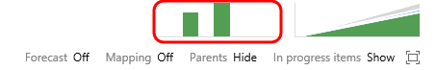
    - Figure 15
    - Location of velocity chart

  - During Iteration 1, the team completed 35 story points worth of effort. Iteration 2 was more productive with 49 story points completed. The current iteration, represented by Iteration 3, shows that we do not currently have any work items in the Committed state. Remember that these story points are a relative measure of effort that was agreed upon by the team.
    - 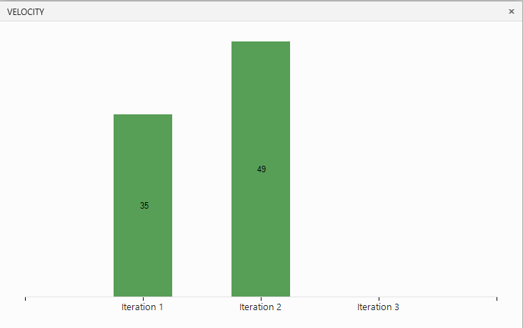
    - Figure 16
    - Velocity chart showing progress towards completing user stories

  - Press the Escape key to close the velocity chart.
  - The product backlog view also groups the past, current, and future iterations by their assigned dates. Select the Iteration 3 link so that we can break down work and assign it to the appropriate team members.
    - 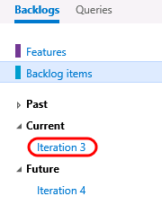
    - Figure 17
    - Navigating to the current backlog

  - Before we break down the new user story, let’s take a quick tour of this iteration backlog view. To start with, it shows all user stories and associated tasks that are assigned to the selected iteration, regardless of state.
    - 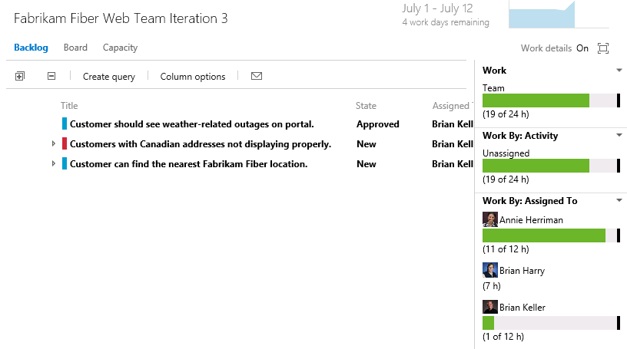
    - Figure 18
    - Current iteration backlog view

  - At a glance, you can see that the current iteration runs from July 1 to 12, with four work days remaining. Just to the right of the current iteration date range, there is a small graph showing the burn down of the remaining work.
    - Figure 19
    - Burn down graph

  - Click on the burn down graph to view it. The graph shows remaining work over the course of the iteration.
    - 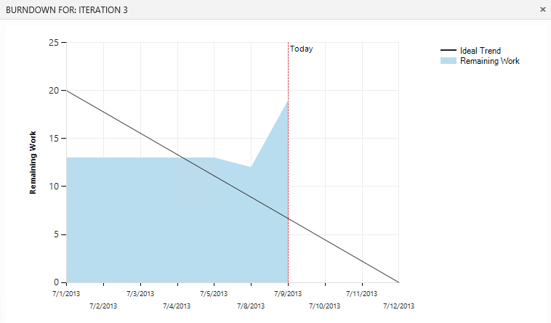
    - Figure 20
    - Enlarged burn down graph

  - Press the Escape key to close the burn down graph.

Task 3: Team Capacity Planning
  - Locate the overall Work bar that shows how close to capacity we are for the current iteration based on the total of the Remaining Work for the tasks in this iteration and based on the total capacity for the team. It looks like we are okay now, but we still haven’t broken the new user story into tasks for the team yet.
    - 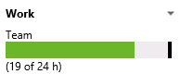
    - Figure 21
    - Overall remaining work with respect to team capacity

  - Select the Capacity link to look at the team capacity details.
    - 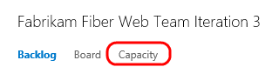
    - Figure 22
    - Location of Capacity link

  - The capacity view allows us to specify the number of hours per day that each team member will be working on this project, days off per team member, and overall team days off. These capacity settings apply to the current iteration. You can optionally use the activity column to describe the disciplines that each team member specializes in. When tasks are broken down by activity as well, it can provide another view across your team’s capacity to determine if, for example, you have enough people working on documentation to meet the demands for this iteration. For now, leave the capacity settings unmodified.
    - 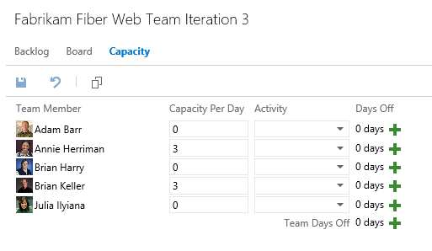
    - Figure 23
    - Team capacity settings

  - Return to the Backlog view for the current iteration.
    - 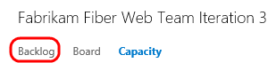
    - Figure 24
    - Location of Contents tab

  - Let’s say that the decision is made to proceed with committing to the new work item. Return to the Iteration 3 backlog view. Select the button with the ‘+’ symbol in it to the left of the new user story to add a new task. This will become a child task of the user story and will be used to help describe the implementation details required to complete this user story.
    - 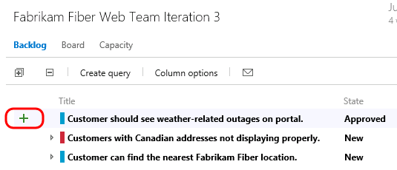
    - Figure 25
    - Location of the button used to create new tasks

  - For the new task, enter “Consume OData feed for weather alerts” for the Title, assign it to Brian Keller, and set the Remaining Work to 8 hours. Select the Save and Close button.
    - 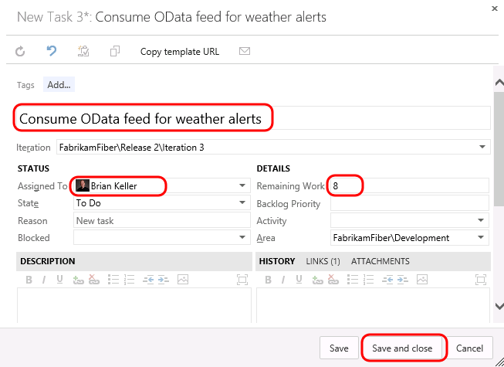
    - Figure 26
    - Creating a new task

  - Note that the new task was added as a child of the user story and that the overall team work bar has turned red, indicating that we have too much work assigned based on capacity.
    - 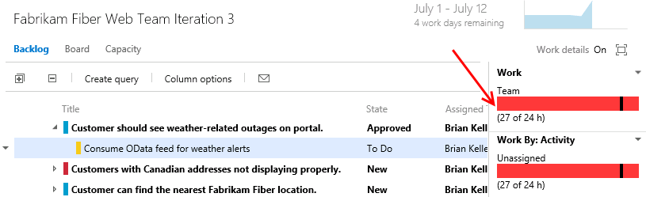
    - Figure 27
    - Insert Caption

  - It looks like the bug has not been worked on yet, so this may be a good candidate to reschedule for a future iteration so that the team can get back on track given their additional workload. Drag and drop the bug onto Iteration 4 on the left-hand side of the window.
    - 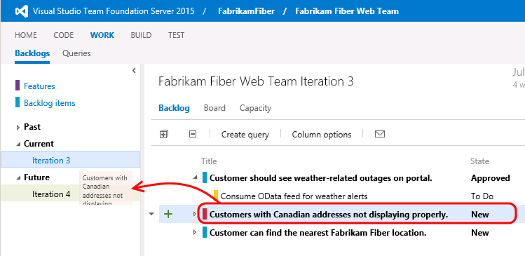
    - Figure 28
    - Using drag and drop to re-assign work to different iterations

  - Take another look at the overall Work bar once again to make sure it is now green. This means that we are within the current team capacity. Just don’t tell the VP, or he might find another high-priority request for us to work on!
    - 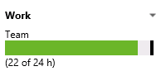
    - Figure 29
    - Remaining work for current iteration is within team capacity

Task 4: Working with the Task Board
  - Now that we have finished breaking down the work and assigning it to team members, let’s take a look at the task board that will be used in the next stand-up team meeting to report and record progress. Select the Board link from Iteration 3.
    - 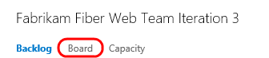
    - Figure 30
    - Task board link

  - By default, the task board shows all tasks for the current iteration, grouped by product backlog item and by the current state. Drag and drop the “Consume OData feed for weather alerts” task to the In Progress column.
    - 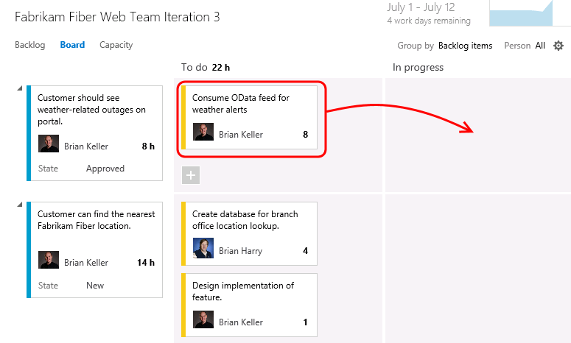
    - Figure 31
    - Drag and drop tasks on the task board to move them between states

    - Note: The task board is touch enabled as well. This will not work within this virtual machine, but you might want to put in your request now for that nice wall-mounted touch-screen monitor you’ve been wanting for your team.
    - Note: Team Foundation Server 2015 has introduced numerous enhancements to the cards shown for tasks and Kanban views including styling, use of avatars, and even responsive layout based on browser size.

  - Single-click on the ‘8’ value shown on the “Consume OData feed for weather alerts” task and change the Remaining Work to 5 to simulate Brian working on the task during the day.
    - 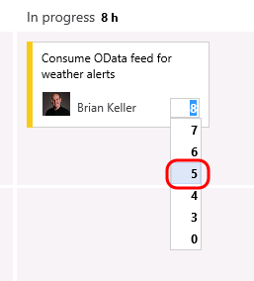
    - Figure 32
    - Updating remaining work for a task

  - The new high-priority task is now in progress with an estimated 5 hours of work left to go.
    - 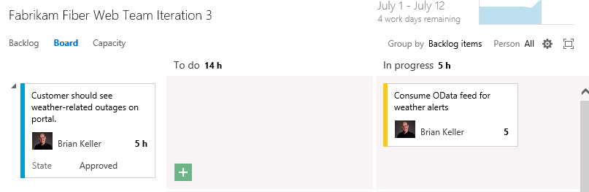
    - Figure 33
    - Task board

  - Drag and drop the task titled “Create database for branch office location lookup” to the Done column to record that work as completed. Note that the remaining work is automatically reduced to 0.
    - 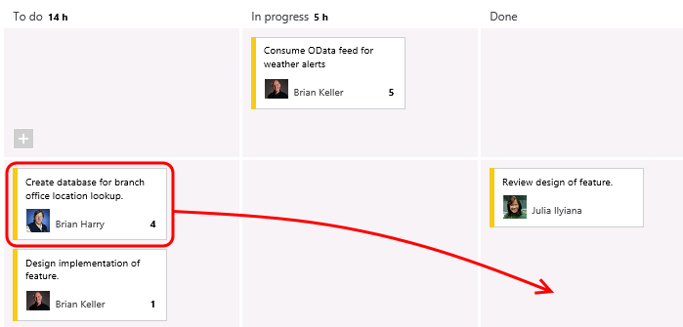
    - Figure 34
    - Completing a task with the task board

  - Notice that the burn down chart in the top-right corner is automatically updated after you made changes on the task board. Click on the burn down chart and note that there is about 15 hours of effort left in order to complete the work for the iteration.
    - 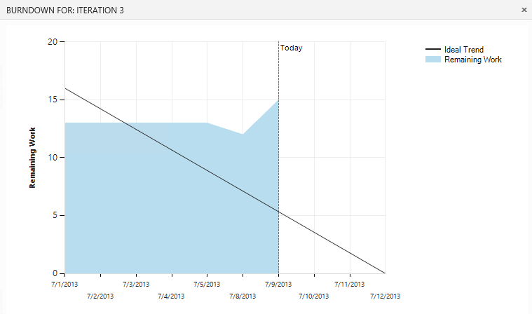
    - Figure 35
    - Burn down chart

  - Close the burn down chart.
  - Note that each row representing a work item shows a rollup of hours remaining, which is a sum of remaining work for all child tasks. In addition to that, each column representing a status has a rollup of remaining work, giving you a good idea how much work the team is actively working on right now.
    - 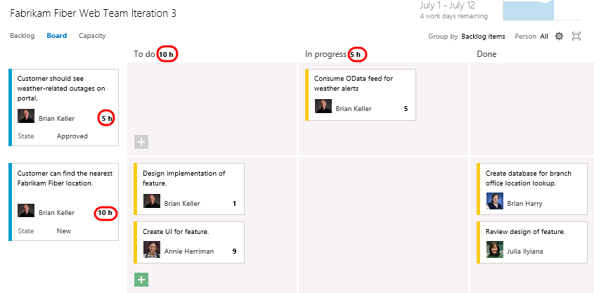
    - Figure 36
    - Task board showing rollup of hours

  - The task board also group by team members. Select the People grouping option in the top-right of the task board view.
    - 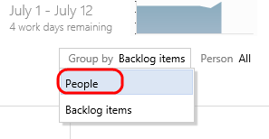
    - Figure 37
    - Group tasks by people

  - This view makes it easy to see what team members are currently working on and how much effort remains for each for the remainder of the current iteration.
    - 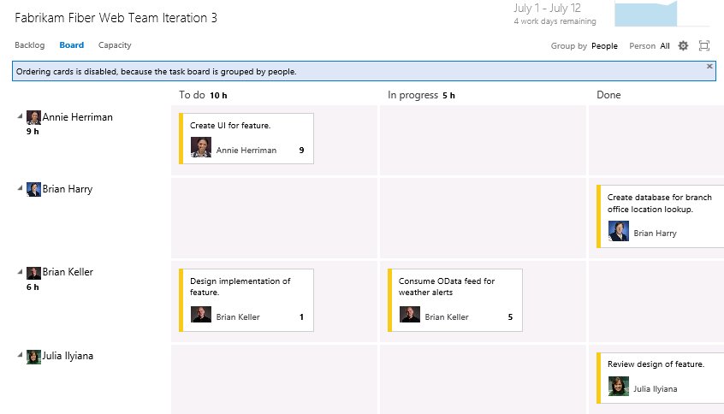
    - Figure 38
    - Grouping tasks by people

  - Select the Backlog Items link to return to the backlog portfolio for the team.
    - 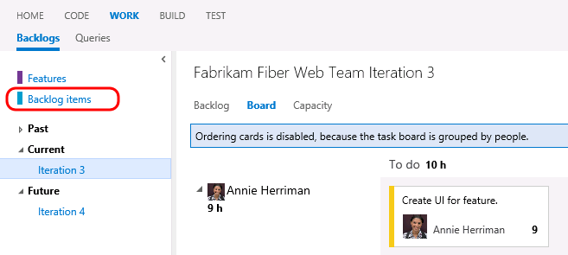
    - Figure 39
    - Backlog view

Exercise 2: Agile Portfolio Management
In this exercise, you will learn about some of the agile portfolio management capabilities provided by Team Foundation Server. These capabilities allow larger organizations to understand the scope of work across several teams and see how that work rolls up into broader initiatives. In this exercise, you will explore how multiple teams at Fabrikam Fiber can collaborate together to work on features.

Task 1: Configuring Team Hierarchy and Area Paths
  - Let’s start out by taking a look at the Fabrikam Fiber project from the top-down, in a manner that would typically be associated with a management role.
  - Select the gear icon in the top-right corner of the web portal. This opens the administration pages in a new tab.
    - 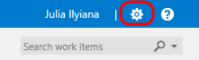
    - Figure 40
    - Loading administration site

  - Navigate to the FabrikamFiber project node.
    - 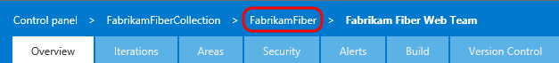
    - Figure 41
    - Navigate to project node

  - The FabrikamFiber project has five teams, with the Fabrikam Fiber Leadership Team assigned as the project default.
    - 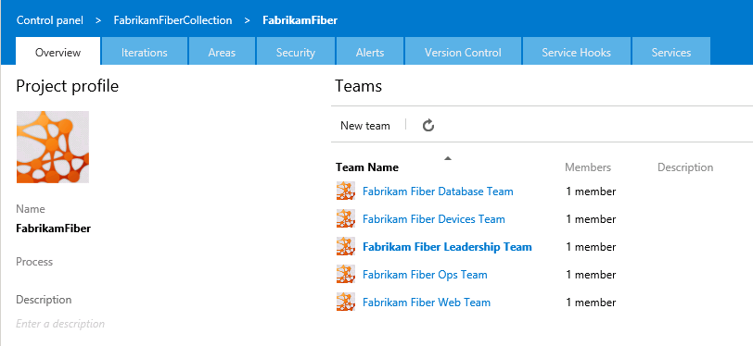
    - Figure 42
    - Fabrikam Fiber teams

  - Select the Areas tab.
    - 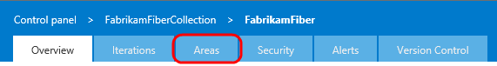
    - Figure 43
    - Areas tab

  - The management team currently owns the Development area and all sub-areas. This gives them visibility into the backlog of all teams, even for work items that are not mapped to features. Optionally, the management team could also choose to not include sub-areas, thereby removing work items from their product backlog view as soon as they are assigned to one of the teams.
    - 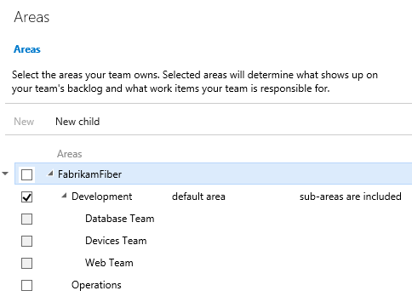
    - Figure 44
    - Area configuration for management team

  - Select the Overview tab.
    - 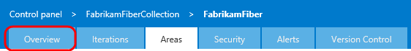
    - Figure 45
    - Overview tab

  - Select the Fabrikam Fiber Database team link.
    - 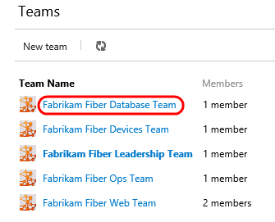
    - Figure 46
    - Fabrikam Fiber Database Team link

  - Select the Areas tab.
    - 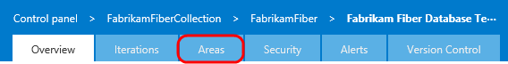
    - Figure 47
    - Areas tab

  - The Database team is currently configured to see work items from just the root Development area and the Database Team sub-area. This allows them to see backlog items created by the management team and ones specifically assigned to their team. With this kind of structure, each team can work independently on its own backlog, defined by its area path, unrelated to the other team’s work.
    - 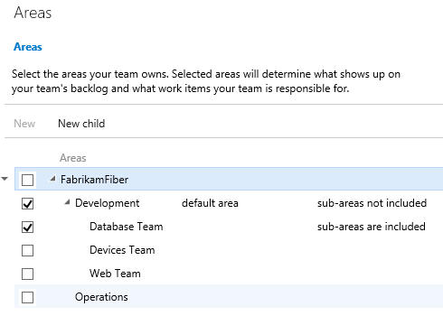
    - Figure 48
    - Area configuration for Database team

  - Close the administration tab in Internet Explorer to return to the web portal.
  - Navigate to the Fabrikam Fiber Leadership Team.
    - 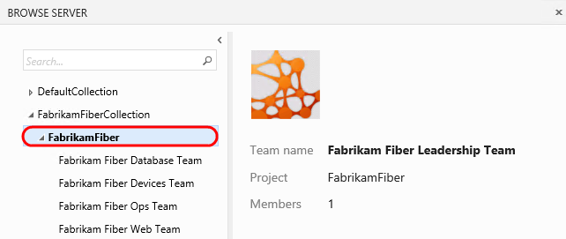
    - Figure 49
    - Navigating to management team

Task 2: Portfolio Management
  - Switch to the Backlog view if necessary.
    - 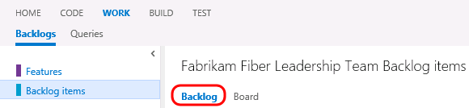
    - Figure 50
    - Returning to Backlog view

  - The leadership team can see backlog items across all teams, including status and scheduled iteration.
    - 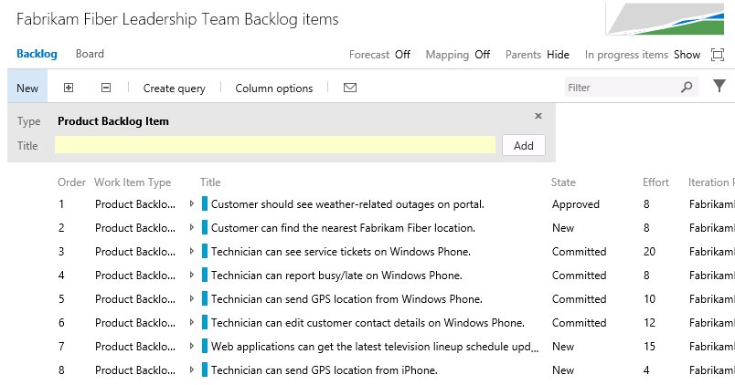
    - Figure 51
    - Backlog items for leadership team

  - The backlog view also includes the ability to toggle the display of in-progress work items. Toggle the “In progress items” link in the top-right corner of the backlog view and note that the Committed work items are no longer displayed. Toggle the link once again to view in-progress items before moving on.
    - 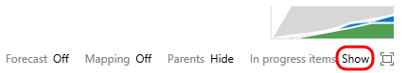
    - Figure 52
    - Location of link to show/hide in-progress items

  - Note that the in-progress work items are no longer displayed. Toggle the link once again to view in-progress items as before.
    - 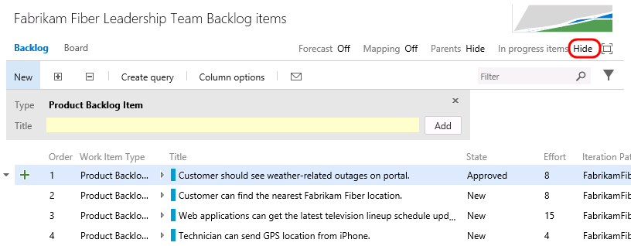
    - Figure 53
    - Location of link to show/hide in-progress items

  - Select the Features link to view the feature backlog.
    - 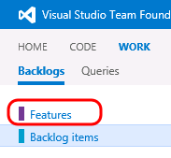
    - Figure 54
    - Viewing features backlog

  - This view shows the top-level features for the project. It is possible to drill down into backlog items and even individual tasks if desired. Select the Expand button to expand one level.
    - 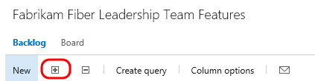
    - Figure 55
    - Expand button

    - 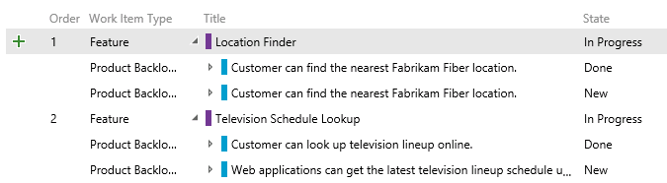
    - Figure 56
    - Expanded view

  - Click the Expand button once again to drill down into tasks.
    - 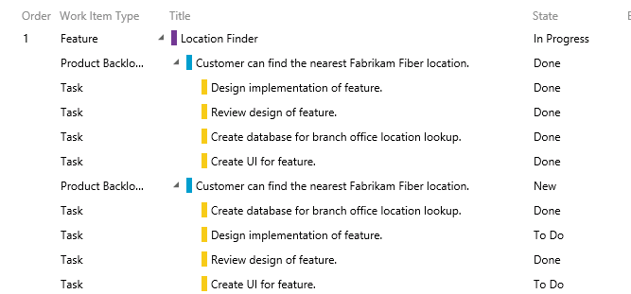
    - Figure 57
    - Expanded view

  - It is also possible to re-parent work items using drag-and-drop operations in the portfolio backlog view. Try this out by dragging and dropping one of the Product Backlog Items from one feature to another.
    - 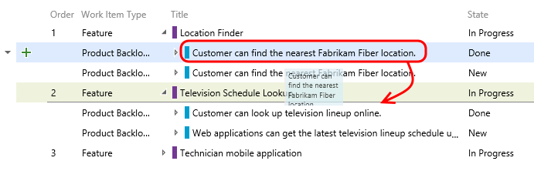
    - Figure 58
    - Re-parent work items using drag and drop

  - Note that this moved the Product Backlog Item as well as all of the child tasks. Drag the Product Backlog Item back to its original feature.
  - The child work items are always shown for the leadership team, regardless of which team they are assigned to. To see this more clearly, let’s add the Area Path column to the view.
  - Select the Column Options button.
    - 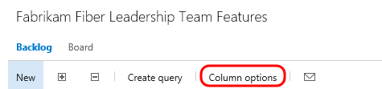
    - Figure 59
    - Column Options button

  - Double-click on Area Path from the available columns and then select OK.
    - 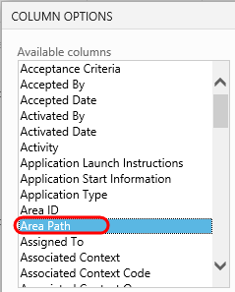
    - Figure 60
    - Add Area Path column

    - 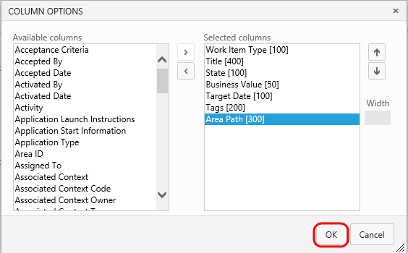
    - Figure 61
    - Add Area Path column

  - If you look at the area path column for different product backlog items, you can see that they are assigned to different teams. The ability to drill down into the various backlogs gives the management team the desired level of visibility into the breakdown and implementation of features.
    - 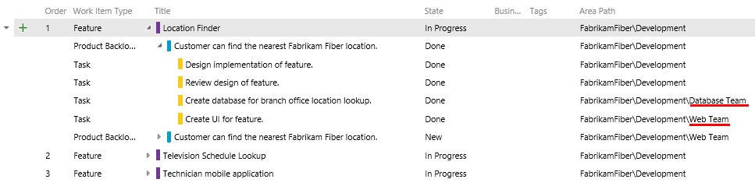
    - Figure 62
    - Area path column showing assigned teams

  - Now let’s take a look at how to create a new feature and then link it to a work item that will be assigned to one of the agile teams. Create a new feature titled “Reporting for technicians and services” and then select the Add button.
    - 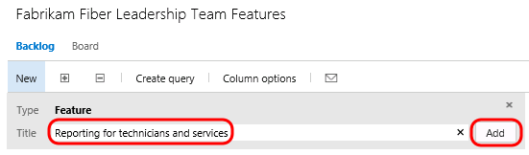
    - Figure 63
    - Creating new feature

  - Select the green ‘+’ button that is on the left-hand side of the new Feature.
    - 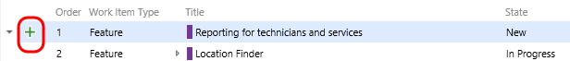
    - Figure 64
    - Adding new PBI

  - Create a new Product Backlog Item named “Modify databases to support on-demand reporting for technician activity”. Assign it to the database team lead, Adam Barr. Set the Area to the Database team so that it shows up on their backlog. Finally, select the Save and Close button.
    - 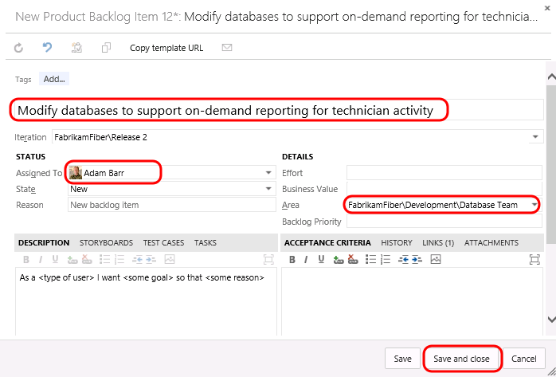
    - Figure 65
    - Adding new PBI

    - Note: In the event that you create items on the backlog, you can also easily map them to parent Features using by enabling the Mapping feature and then dragging and droping.
    - 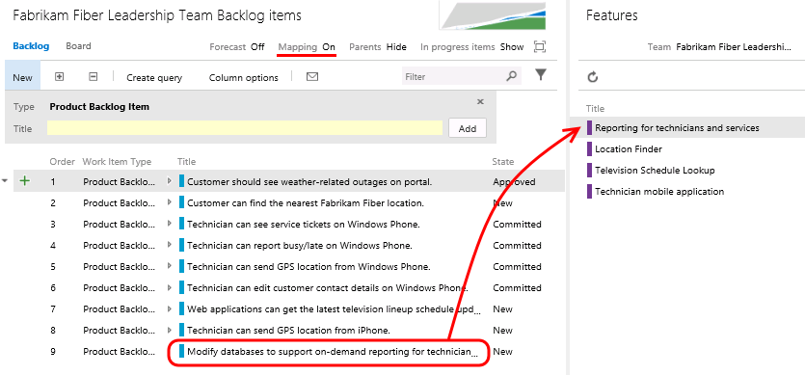

  - Now let’s load the web portal for the database team. Navigate to the Fabrikam Fiber Database Team.
    - 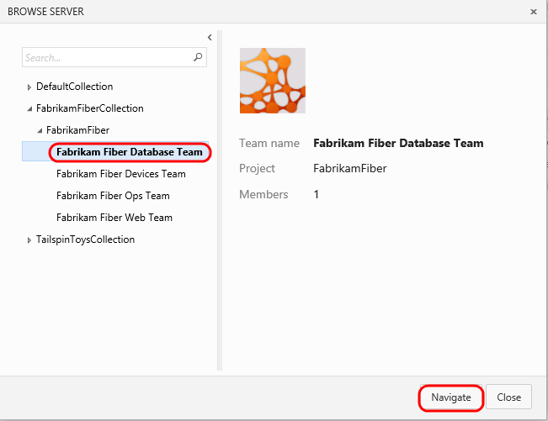
    - Figure 66
    - Navigate to database team

  - You should now be looking at the backlog for the database team.
    - 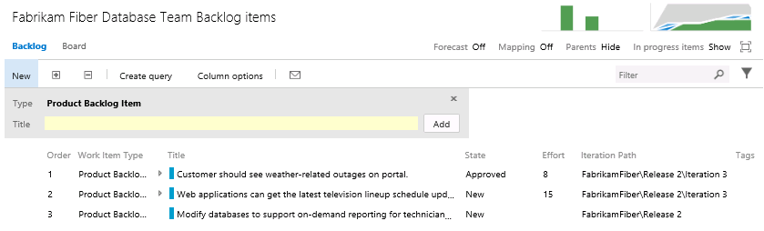
    - Figure 67
    - Backlog Items link

  - Although this team may normally only want to view their backlog items, they may also want to see how those backlog items fit in to the bigger picture. Toggle the Parents option that is currently set to Hide.
    - Figure 68
    - Toggle display of parent nodes

  - Note that the backlog view now shows parent Feature items.
    - 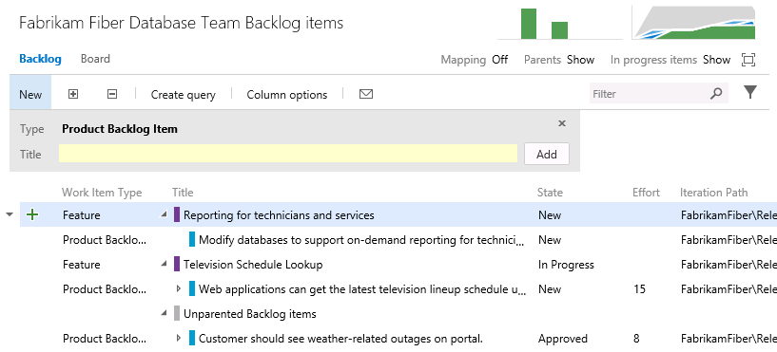
    - Figure 69
    - Backlog showing parent features

  - To get a more complete view of their organization’s overall work, the database team can also view the Features backlog. Select the Features link.
    - 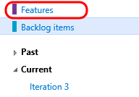
    - Figure 70
    - Features backlog

  - Select the Expand button twice in order to expand the features backlog two levels. Note that it is easy to distinguish between work that the database team is contributing to or is assigned, and work that is assigned to other teams, by looking at the colored bar. If the bar is hollow (not filled in), this means that the work is assigned to a different team.
    - 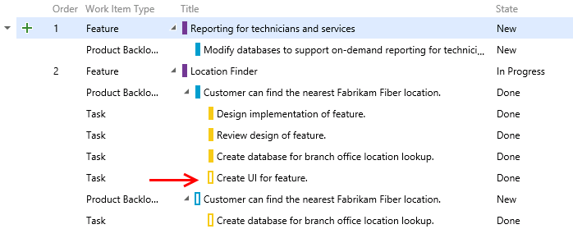
    - Figure 71
    - Viewing work assigned to team vs. other teams

Exercise 3: Flexibility of Agile Tools
In the previous exercise, you learned about how Team Foundation Server can scale to meet the needs of larger teams working towards common goals. This approach requires that everybody in the organization uses the same team project within Team Foundation Server and therefore the same process template (which defines the way work items and their workflows are defined). Understanding this, Microsoft has begun to allow individual teams to customize certain aspects of the ways in which they manage and track their work without requiring centralized changes to their process templates.
In this exercise, you will learn more about Kanban and how it contributes to the flexibility of the agile toolset. You will also learn about work item tagging. Both of these features can be utilized and customized independently by different teams, without making changes to the underlying process template.

Task 1: Introduction to Kanban Tools
  - The Kanban board was first introduced with Team Foundation Server 2012 Update 1. Kanban is a process improvement tool that can be used in an incremental fashion regardless of the current software development methodology that you are using. It assists with the throttling and tracking of work and illustrates the delivery of value over time to the project stakeholders. Each backlog has its own Kanban board, and each team has its own view of that.
  - Navigate to the Fabrikam Fiber Devices Team.
    - 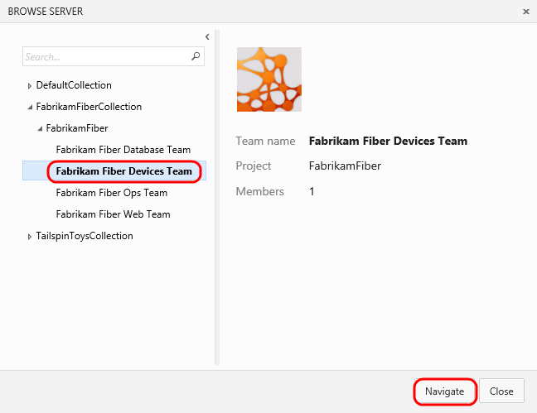
    - Figure 72
    - Navigate to devices team

  - Navigate to the backlog Kanban board for this team.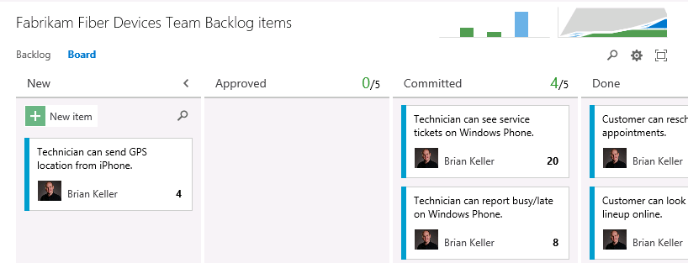
    - Figure 73
    - Kanban board

  - The Kanban board shows the top backlog items across all states and iterations, allows you to move items between states, and allows you to set Work In Progress (WIP) limits for each state. One of the primary reasons for using Kanban and limiting work in progress is that it helps identify bottlenecks in your development process and minimize lead time for new features. Let’s say that the devices team is not delivering finished work as quickly as desired, and that it is suspected that the underlying issue may have to do with taking on too many tasks at once at the beginning of each sprint (and the associated context-switching tax). If we are more careful about the number of tasks that we commit to, perhaps we can better focus our efforts.
  - Let’s lower the Work In Progress limit for the Committed state to see what the Kanban board looks like when too much work has been committed to at once. Right now, the limit is 5 work items.
    - 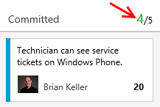
    - Figure 74
    - WIP limit

  - Select the Configuration button (it has a gear icon) and then select the Columns option.
    - 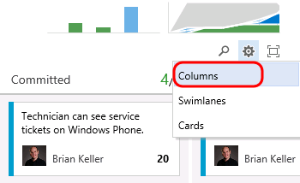
    - Figure 75
    - Customize Columns button

  - Change the Work In Progress limit (WIP) to be 3 for the Committed column and then select the OK button.
    - 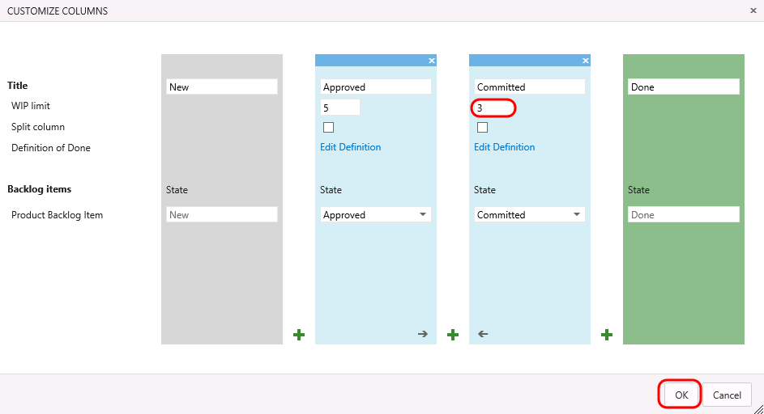
    - Figure 76
    - Setting WIP limit

  - On the Kanban board, column headers will provide an indication when a Work In Progress limit is exceeded. In this case, the Committed column shows us that we have exceeded the limit.
    - 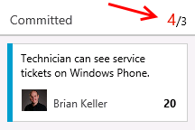
    - Figure 77
    - WIP limit exceeded

    - Note: Work In Progress limits provide feedback when appropriate but they do not prevent a team from taking on additional work. You need to actively check the Kanban board in order to discover that you are exceeding set limits.

  - Starting with Team Foundation Server 2015, it is now possible to configure the Kanban boards to show (or hide) bugs as desired. This is something that was previously available at the project level through process template configuration. Click the gear icon in the top-right to open the administration page and then navigate to the Settings tab for the Fabrikam Fiber Devices Team.
    - 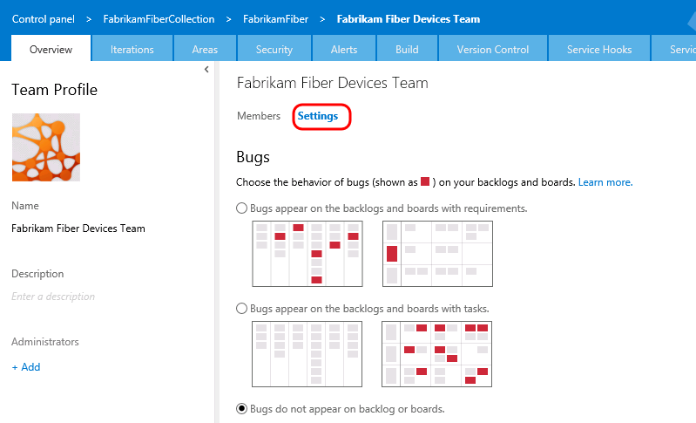
    - Figure 78
    - Team settings

  - Change the Bugs option so that “Bugs appear on the backlogs and boards with requirements”.
    - 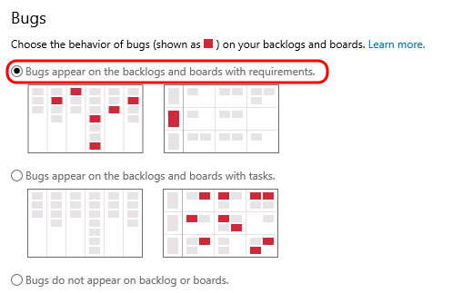
    - Figure 79
    - Configuring bugs to show up on backlogs and board views

  - Return to the Kanban board view for team and refresh the page.
  - Click the New Item button and then select Bug.
    - Note: Adding new cards and inline editing are two new features in Team Foundation Server 2015.
    - 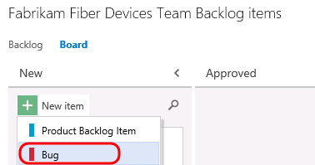
    - Figure 80
    - Adding a new bug directly on the Kanban board

  - Add a new bug description of your choosing and then press Enter to save.
    - 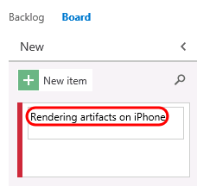
    - Figure 81
    - Adding new bug

  - Assign the bug to Adam Barr directly on the Kanban card.
    - 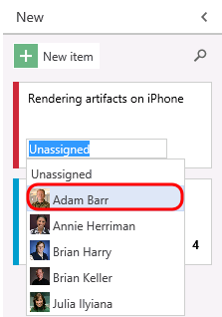
    - Figure 82
    - Assigning bug directly on card

  - Also new to Team Foundation Server 2015 is the ability to reorder the backlog priority from the Kanban board. In the Committed column, drag the bottom card to the top of the column.
    - 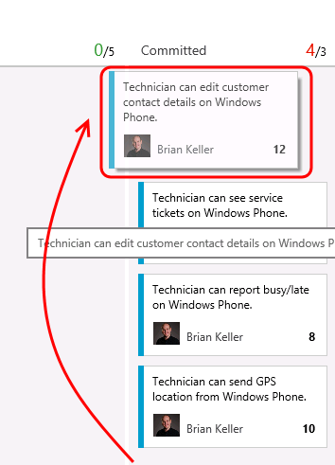
    - Figure 83
    - Reorder cards

  - Filtering on the Kanban board is another new feature of Team Foundation Server 2015. Click the Search button and then search for “technician”.
    - 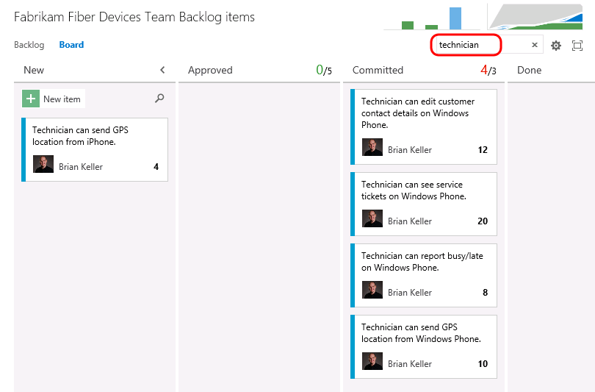
    - Figure 84
    - Kanboan board search filter

  - Clear the search box.
    - Note: The New column has an additional search filter box that only applies to work items in the New state, which is useful when you want to search for something from your backlog without losing context of other work items.

  - Let’s say that the devices team has decided that they want to add in a column that represents work that has been tested on a physical device. This is the only team that would desire to keep track of such a state, and they can easily add this to their Kanban board.
  - Select the Configuration button and then select the Columns option.
  - Here you can add, remove, delete, and even rename columns to better suit your team workflow. However, you are still subject to restrictions put in place by the underlying process template, so you must map columns to valid work item states and respect the valid state transitions.
  - Select the green ‘+’ button that is located between the Committed and Done columns.
    - 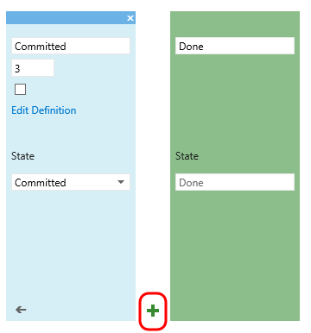
    - Figure 85
    - Adding a new column

  - In the new column, enter a name of “Device Tested”. This Kanban customization is done per team, so the Device team’s decisions are not automatically imposed on the other development teams.
    - 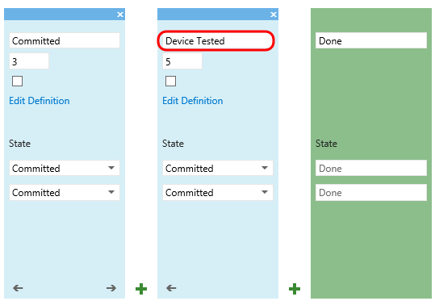
    - Figure 86
    - Adding a new column

    - 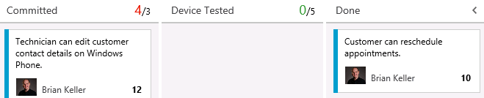
    - Figure 87
    - Kanban board showing customizations for team

  - You can also modify what your team considers to be the meaning of Kanban columns. This will help teams to stay on the same page on when a work items should be moved to the next state. Select the Edit Definition link for the Device Tested column.
    - 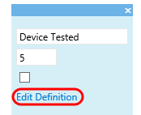
    - Figure 88
    - Edit column definition

  - Here you can define the definition of “done” for this column using plain text or Markdown. Provide a message such as “Has been tested on Android, Windows Phone, and iPhone” and then select OK.
    - 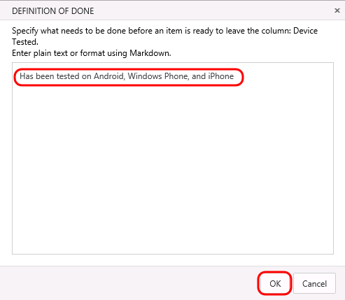
    - Figure 89
    - Adding definition of “done”

  - Select OK to save customized columns.
  - Note that the new Kanban column is shown. If you click on the informational icon shown to the right of “Device Tested” heading, you will see the definition of “done” for this custom column.
    - 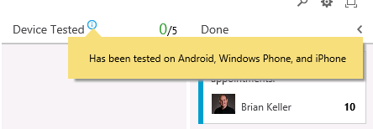
    - Figure 90
    - Custom Kanban column with definition of “done” displayed

  - Kanban support also adds a new graph to the backlog views called the Cumulative Flow Diagram. Click on the small diagram to open it.
    - 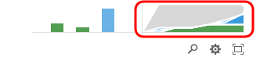
    - Figure 91
    - Cumulative Flow Diagram location

  - The Cumulative Flow Diagram (CFD) shows the amount of work is various states over time for the selected team. The horizontal axis shows lead time and the vertical axis shows work in progress.
    - 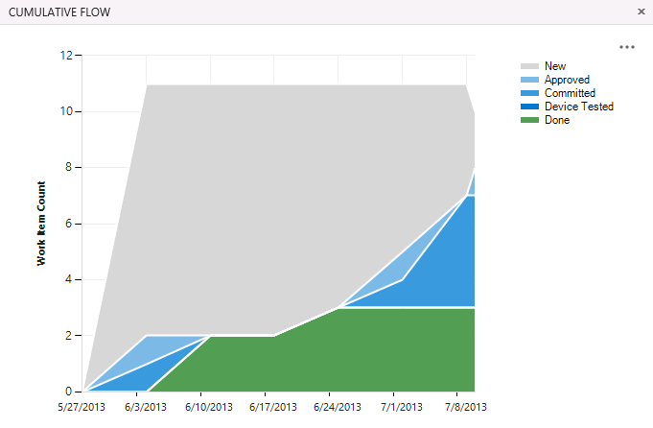
    - Figure 92
    - Cumulative Flow Diagram

    - Note: The CFD shown above does not necessarily represent an ideal scenario where a team is providing continuous output. More typically and ideally, you would see bands of color representing all states increase over time like the following diagram.
    - 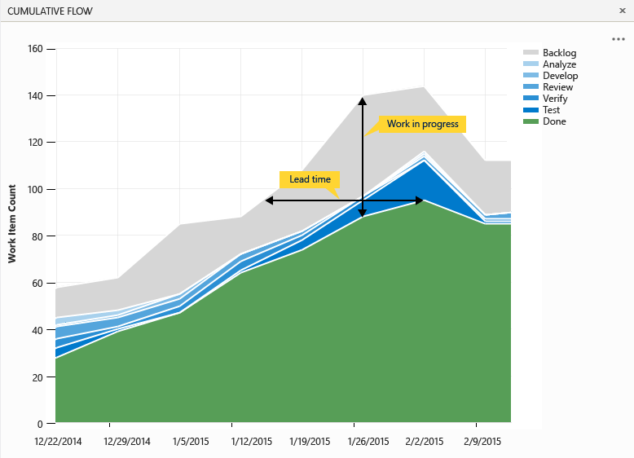

  - Press the Escape key to close the CFD.
  - Another key enhancement to the Kanban and Taskboards in 2015 is some additional configurability options. Select the Configure button followed by the Cards option.
    - 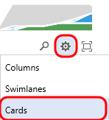
    - Figure 93
    - Configure cards

  - Here you can configure each work item type to show ID number, Assigned To field, Effort, Tags, or other fields that you wish to show. These options are configured per team, giving each team the flexibility it needs to manage its own workflow.
  - Select the option to “Show ID” and then click Save.
    - 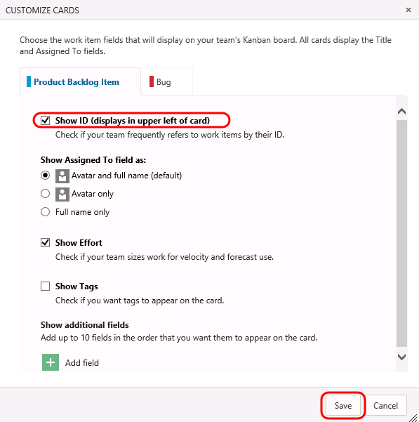
    - Figure 94
    - Configuration options

    - 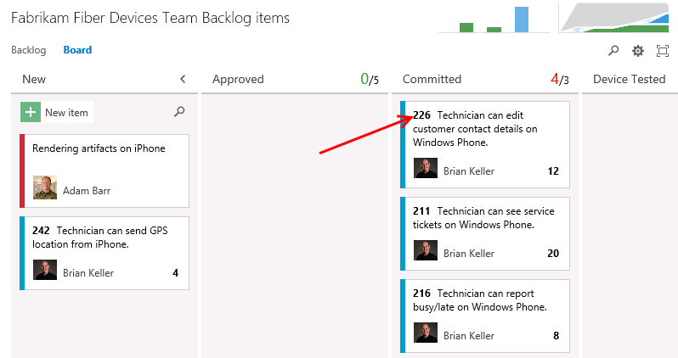
    - Figure 95
    - Kanban board showing ID

  - The concept of swim lanes is also new in 2015. These horizontal lanes can be added to Kanban boards to further categorize work, with a common use of this to create an “expedite” lane for high-priority work that needs to skip through the normal workflow. Select the Configure button followed by the Swimlanes option.
    - 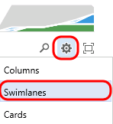
    - Figure 96
    - Configure swim lanes

  - Kanban boards only have a single swimlane by default, you can add in as many lanes as you want. For example, you can use them to categorize items by severity (expedite, normal), departments, tiers, and so on. Add in a new swimlane named “Expedite”.
    - 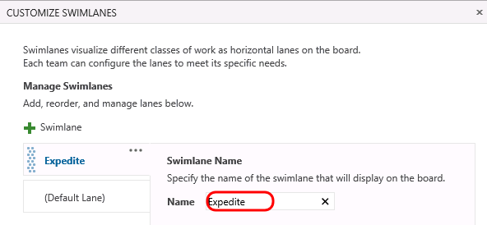
    - Figure 97
    - Adding new swimlane

  - Rename the default lane to “Normal” and then select OK.
    - 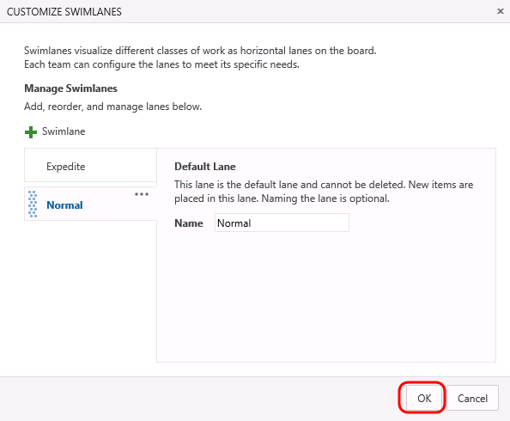
    - Figure 98
    - Customizing swimlanes

  - Expedite one of the work items using drag and drop.
    - 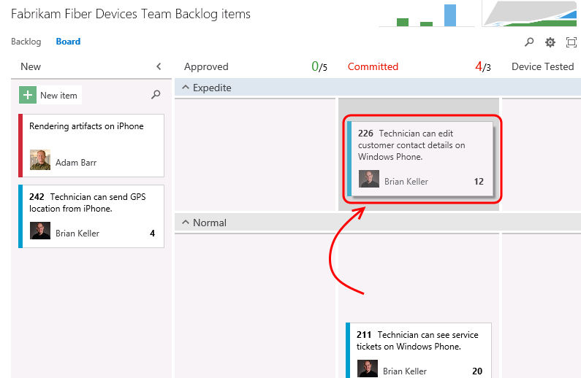
    - Figure 99
    - Drag and drop cards to change swimlanes

  - For additional information on using the Kanban board, please see “Kanban basics”.

Task 2: Work Item Tagging
  - Work item tagging, first introduced in Team Foundation Server 2012 Update 2, allows you to easily categorize and query and filter lists of work items.
  - Navigate to the Fabrikam Fiber Leadership Team.
    - 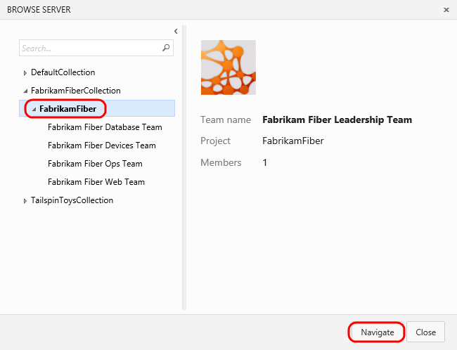
    - Figure 100
    - Navigating to management team

  - Navigate to the Backlog Items view.
    - 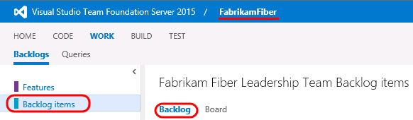
    - Figure 101
    - Backlog Items list

  - Let’s say that a cross-team initiative is put in place to give customer facing work items higher priority. Also imagine that the product backlog is quite large, such that visually searching through all titles and assigning them to sprints and teams is quite time consuming. One way to help with this is to create work item tags and then filter the list of work items.
  - Note that a number of work item tags are already in place.
    - 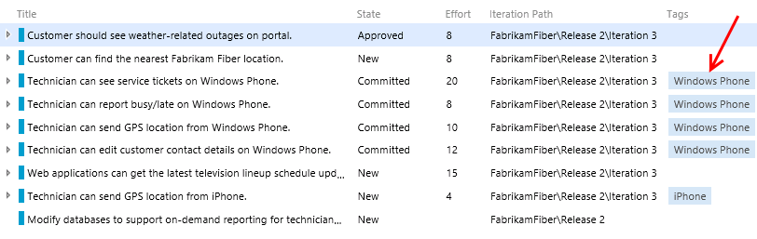
    - Figure 102
    - Backlog showing work item tags

  - Double-click on the work item titled “Customer should see weather-related outages on portal”.
  - Select the Add… button to add a tag.
    - 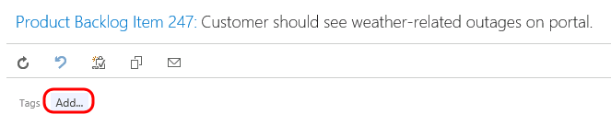
    - Figure 103
    - Add button

  - Enter the text “Customer” and then select Save and Close.
    - 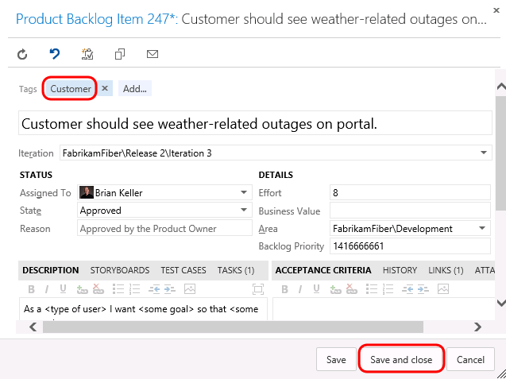
    - Figure 104
    - Adding ‘Customer’ tag

  - Repeat the process of tagging any work items that appear to be customer facing. You should end up with something like the following screenshot, but there is no need to match it exactly.
    - Note: You can create work item queries that include tags.

    - 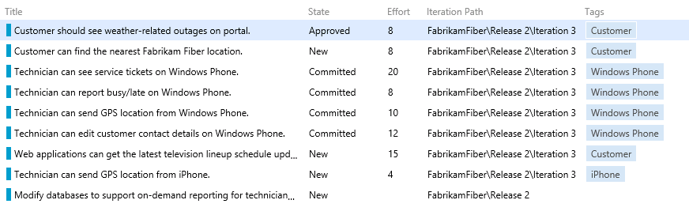
    - Figure 105
    - New work item tags

  - With the desired tagging in place, select the Filter button in the top-right corner of the backlog list.
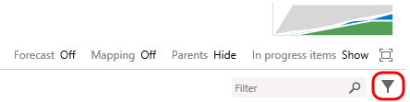
    - Figure 106
    - Filter button

  - Select the Customer tag to filter by just that tag.
    - 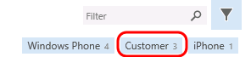
    - Figure 107
    - Filtering by work item tag

  - With this filtered view, the teams will have a much easier time finding the work items that they should focus on first. Note that this filtering also disables the ability to add new backlog items, disables stack ranking and forecasting.
    - 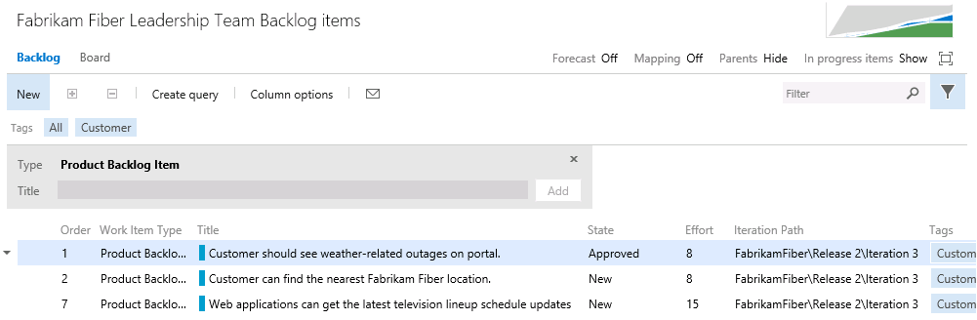
    - Figure 108
    - Filtered backlog view

    - Note: Additional filtering can be done by selecting another tag (if there are any in this filtered subset). To remove the filter, simply select the Filter button once again.

Exercise 4: Work Item Charting
In this exercise, we will demonstrate the work item charting capability of Team Foundation Server. Work item charting allows you to create visual chart representations of the data returned from TFS work item queries. This can be used to help better understand the state of projects.

Task 1: Creating and Sharing Work Item Charts
  - Navigate to the Fabrikam Fiber Leadership Team (if necessary).
    - Figure 109
    - Navigating to management team

  - Let’s say that the Fabrikam Fiber management team would like to better understand how tasks are broken down by user. Navigate to the work item queries section of the web portal.
    - 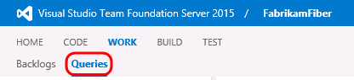
    - Figure 110
    - Work item queries view

  - Since these charts are based on work items, we first need to define a query that will return the data that we are interested in. Select the New drop-down button followed by the New Query option.
    - 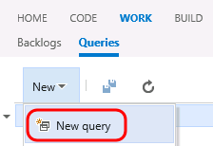
    - Figure 111
    - Creating a new work item query

  - The default query will select all work items in any state for the current project. We want to select just Tasks, so modify the value of clause for Work Item Type to be Task.
    - 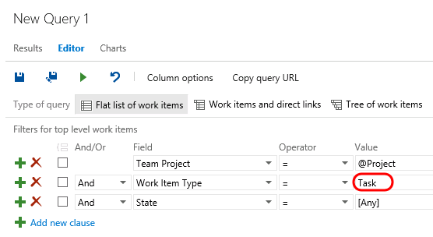
    - Figure 112
    - Querying for all tasks

  - Select the Save Query As button.
    - 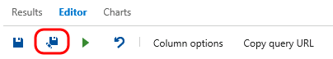
    - Figure 113
    - Saving new query

    - Note: Work item charts require the associated query to return a flat list of work items.

  - Name the query “All Tasks”, select the folder “Shared Queries”, and then select the OK button.
    - Figure 114
    - Naming new query

  - Select the Charts link.
    - 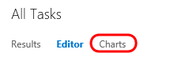
    - Figure 115
    - Charts link

  - First we will create a pie chart showing tasks by assigned user. Select the New Chart button.
    - 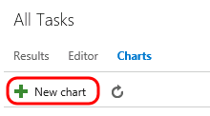
    - Figure 116
    - New Chart button

  - Title the chart “Tasks by User”, group by the Assigned To field, and then select the OK button.
    - 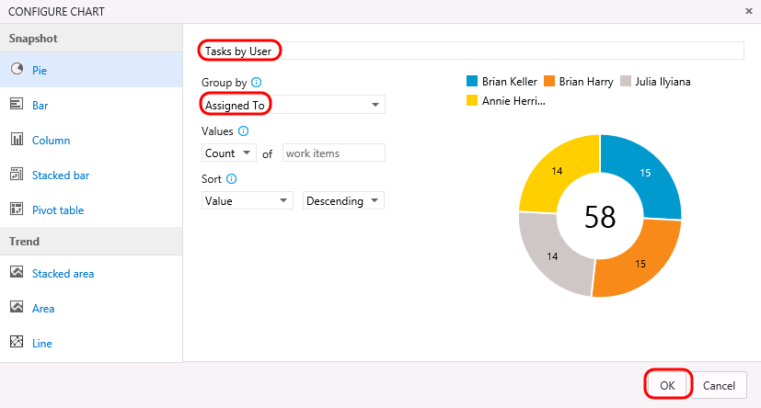
    - Figure 117
    - Creating new pie chart

  - Let’s create one more chart to help visualize the task progress for each team member. Select the New Chart button once again.
  - Select the Stacked Bar chart type. Note that this chart type requires you to specify two different fields for the rows and columns.
    - 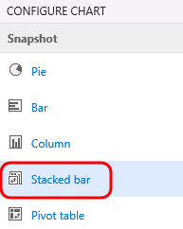
    - Figure 118
    - Creating a new stacked bar chart

  - Title the chart “Task State by User”, select the Assigned To field for the Rows, select the State field for the Columns, and finally select the OK button to create the chart.
    - 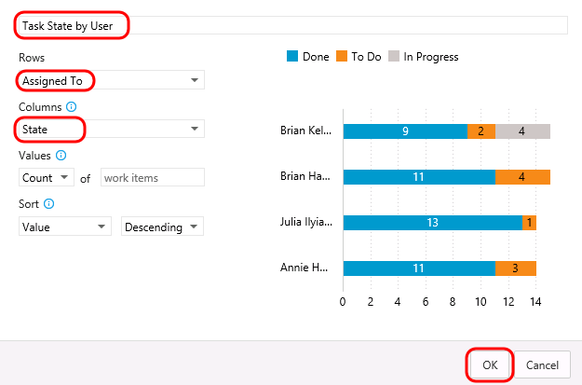
    - Figure 119
    - Creating a new stacked bar chart

    - 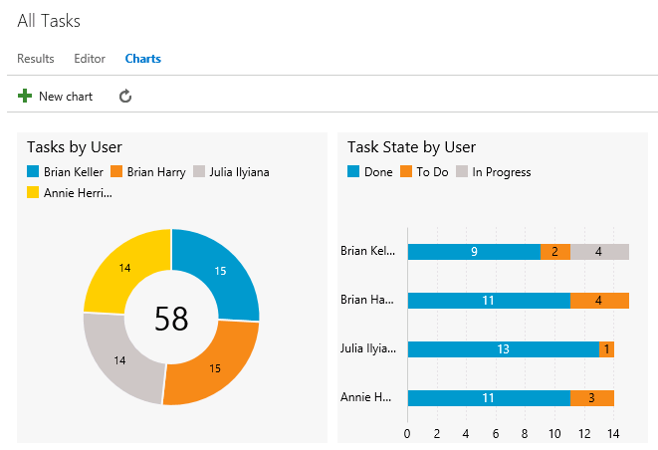
    - Figure 120
    - New task charts

  - You can add to the available grouping options by modifying the work item query and adding in additional display columns. Select the Editor link for the query.
    - 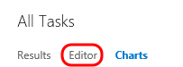
    - Figure 121
    - Editor link

  - Select the Column Options button.
    - 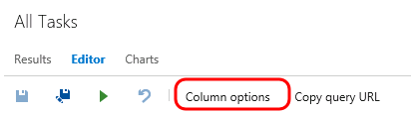
    - Figure 122
    - Column Options button

  - Select the Task item for the Work Item Type.
    - 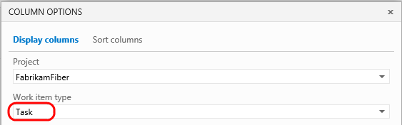
    - Figure 123
    - Filtering for Task fields

  - Double-click the Area Path option from the Available Columns list.
    - 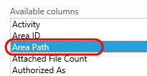
    - Figure 124
    - Selecting the Area Path field

  - Select the OK button.
    - 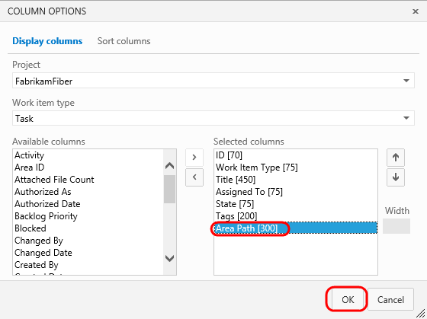
    - Figure 125
    - Selecting the Area Path field

  - Select the Save button.
    - 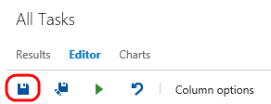
    - Figure 126
    - Saving modified query

  - Select the Charts link to return to the charts view and use your charting skills to create a pie chart showing tasks grouped by the Area Path field. Title the chart “Tasks by Team”, select the Area Path field for the Group By field, and finally select the OK button to create the chart. This gives the management team an idea of how the work is distributed amongst the teams.
    - 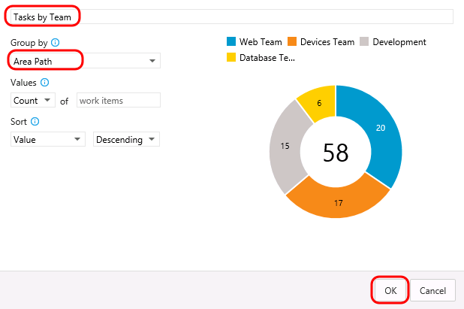
    - Figure 127
    - Creating new pie chart

  - These lightweight charts can also be pinned to the team homepage. Hover over the Tasks by Team chart and select the ellipses that appear in the top-right corner and then select the Pin to Homepage option.
    - 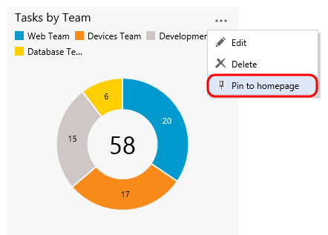
    - Figure 128
    - Task breakdown by team

  - Click the Home link to return to the leadership team’s homepage and view the pinned chart.
    - 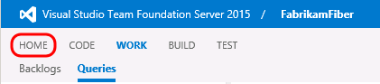
    - Figure 129
    - Home link

    - 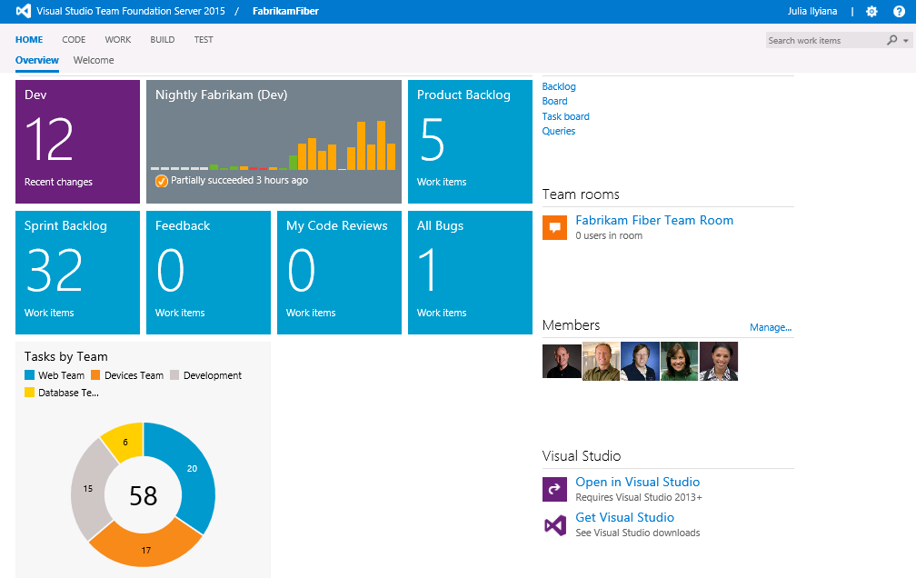
    - Figure 130
    - Team homepage showing pinned chart

    - Note: After completing this lab, the virtual machine will continue to run with the date & time that was set for demonstration purposes at the beginning of this lab. Don’t forget to reset the virtual machine to its original snapshot/checkpoint after you complete this lab.

To give feedback please write to VSKitFdbk@Microsoft.com
Copyright © 2015 by Microsoft Corporation. All rights reserved.

