START USING A LIST

A list is a place on a SharePoint site where you can share information with other people in your company. This is where you can store and share contacts, calendar appointments, tasks, or other sorts of information you need to track.

WHERE CAN I FIND A LIST?
- On your team site, look for the name of the list in the navigation, or click Settings > Site contents.
- Click the name of the list to open it. 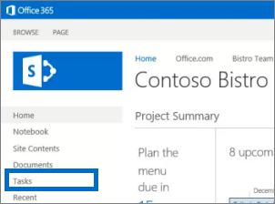
ADD AN ITEM TO A LIST
- In the list where you want to add an item, click new item.
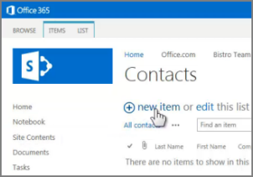
- Enter the information for the list item.
- Click Save.

ADD OR EDIT MULTIPLE ITEMS IN A LIST
- At the top of the list you want to edit, click edit.
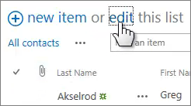
- Type information in the boxes.
- When you’re finished editing, click Stop editing.
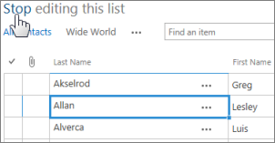
DELETE ITEMS IN A LIST
There are multiple ways to delete items in a list. Here’s the quickest way:
- Select the items you want to delete.
- Click Items > Delete Item.
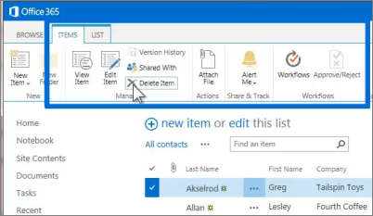

EDIT ALL THE DETAILS IN A LIST ITEM
- Select the item you want to edit, click the ellipses (…), and then click Edit Item.
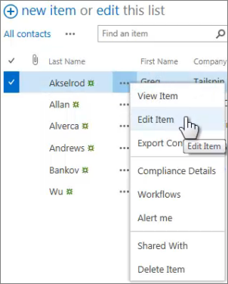
- Edit the information in the form that appears.
- When you’re finished editing, click Save.
SORT OR FILTER A LIST BY COLUMN HEADING AND SAVE THE VIEW
- In the list, point to the heading you want to sort or filter the list by, and then click the arrow that appears
- To sort by the heading, click A on Top or Z on Top.
- To filter, select the one or more check boxes.
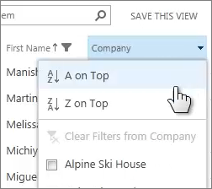
- To save the view you created, click SAVE THIS VIEW at the top of the list near the Search box.
CREATE A PERSONAL VIEW OF A LIST
- At the top of the list, click the ellipses (…) between the view names and the Search box, and then click Create View.
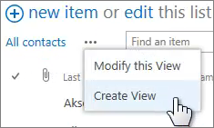
- Choose a view type or start from an existing view.
- On the Create View page, type a name for the view.
- Select the columns your want to appear, and use the position numbers to set the order of the columns.
- Set the sorting, filter, and other options, and then click Save.

SEE ALSO:
- Introduction to lists
http://office.microsoft.com/en-us/sharepoint-help/introduction-to-lists-HA102771955.aspx
- Add, edit, or delete list items
http://office.microsoft.com/en-us/sharepoint-help/add-edit-or-delete-list-items-HA102771938.aspx
- Create, change, or delete a view of a list or library
http://office.microsoft.com/en-us/sharepoint-help/create-change-or-delete-a-view-of-a-list-or-library-HA102774516.aspx
- Create, change, or delete a column in a list or library
http://office.microsoft.com/en-us/sharepoint-help/create-change-or-delete-a-column-in-a-list-or-library-HA102771913.aspx

