Employee quick start for Office 365
Are you new to Office 365 for business? Watch this video to learn about it. Then follow these steps.
Sign in  Go to Office.com and choose Sign in.  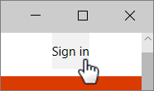  Type your Office 365 email address and password, then Sign in.  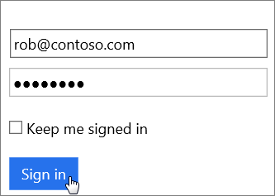  Tip You may be prompted to change your password. 8+ letters and numbers please. | Get Office  Choose Install Office 2016 in the upper right.  In Chrome, go to the download on the bottom of the page and choose Open.  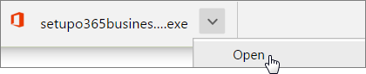  In Microsoft Edge/IE, choose Save then Run.  If asked to allow the app to make changes, choose Yes. Let Office setup begin.  On a Mac, open Microsoft Office_2016_Installer.pkg. | Set up Outlook  Open Outlook 2016 on your computer. In the Tell me field, type account then Add Account.  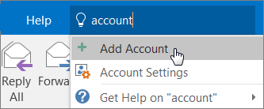  Type your name, email, and password then Next.  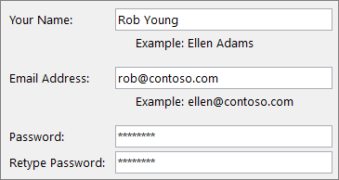  Tip To import your old email, export it to a PST file, then import it, like this.
Save to the cloud  Save documents to OneDrive from the Save As menu.  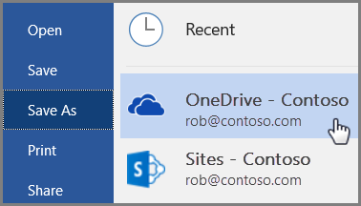  Or copy files from your Desktop or Documents to OneDrive.  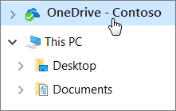  Tip You can also store files on sites in Office 365. | Share with others  Share your documents with others by choosing Share.  Type their email address, choose read or edit, include a message and Share.  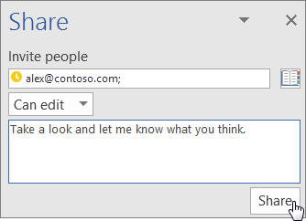 | Set up a phone  Get Outlook on your phone. Choose Get Started and add your email and password.  Or, open Outlook on an iOS or Android device and go to Settings.  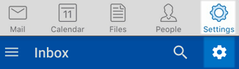  Choose Add Account then Add Email Account then type your email and password.  On a Windows Phone, choose Settings > Email + accounts > Add an account then Exchange.

What’s next?

View this guide online and share it with others. | Learn what else you can do with Microsoft Office.

