Work Smart by Microsoft IT

Get started: Microsoft Office 2010 user interface

**Customization note:** This document contains guidance and/or step-by-step installation instructions that can be reused, customized, or deleted entirely if they do not apply to your organization’s environment or installation scenarios. The text marked by yellow highlighting indicates either customization guidance or organization-specific variables. All of the highlighted text in this document should either be deleted or replaced prior to distribution.

You can use this guide to learn how to use the features of the ribbon and other elements of the Microsoft Office 2010 user interface (UI).

Topics in this guide include:

What’s new in the Office 2010 user interface

Navigating the Office 2010 user interface

Understanding the Ribbon

Understanding the Quick Access Toolbar

Understanding the Backstage view

Formatting pasted content by using Paste Live Preview

For more information

Using Microsoft Office Help

What’s new in the Office 2010 user interface

Some of the features that are new in the Office 2010 UI include:

* The ribbon is fully available in all applications, including Microsoft SharePoint Workspace 2010, the Microsoft OneNote 2010 note-taking program, the Microsoft Outlook 2010 messaging and collaboration client, Microsoft Project 2010, Microsoft Visio 2010 drawing and diagramming software, Microsoft Publisher 2010, and Microsoft Office Web Applications 2010.
* You can customize the ribbon in Office 2010 to create your own tabs and tab groups, and to add your favorite commands to them.
* In Office 2010, the Office Button has been redesigned and now looks like a tab named **File**. You can click this tab to switch the application to the Microsoft Office Backstage view to access commands for saving, sharing, and printing your work.
* When you paste content, you can use Paste Live Preview to make quick formatting adjustments.

The sections that follow describe these features in more detail.

Navigating the Office 2010 user interface

The following figure illustrates elements of the Office 2010 UI.  
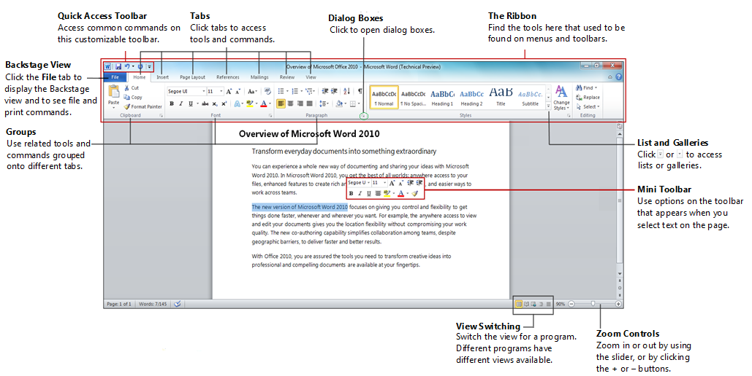

Understanding the ribbon

Tools and commands are organized on tabs that make up the ribbon for each application. Some tabs are always exposed; others appear only when you click items on the page.

Using the ribbon

To access a ribbon in Office 2010, click a tab that is related to your task. For instance, if you want to insert something into your file, click the **Insert** tab. By using the tools on the **Insert** tab, you can insert images, tables, links, and other items.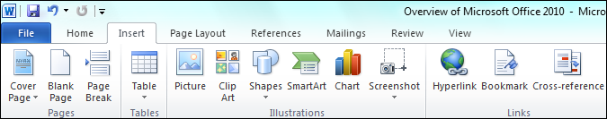

To access additional functionality, click the content that you want to modify. For instance, to change the style of a table, click to select the table, and the **Table Tools** options appear with additional tabs and commands to help you format your table.

TIP: To expand or collapse the ribbon, you can double-click a tab or use the **Expand**/**Minimize** icon in the upper-right corner of the ribbon (next to the **Help** icon).

To add a row to a table:

1. Click in a row in your table.
2. Under **Table Tools**, on the **Layout** tab, in the **Rows & Columns** group, click **Insert** **Above** to add a new row above the row that you selected.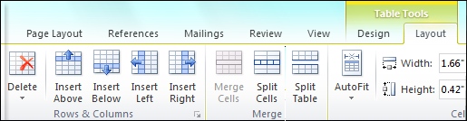

To apply a style to a table:

1. Click to select your table.
2. Under **Table** **Tools**, on the **Design** tab, in the **Table Styles** gallery, select a predefined style to apply to your table.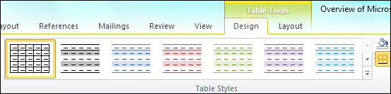

Customizing the ribbon

In Office 2010, you can customize the ribbon to include custom groups and custom tabs that contain the commands that you use most often.

To add a new tab to the ribbon:

1. Click the **File** tab to display the Backstage view, and then click **Options**.
2. In the *Application* **Options** dialog box, click **Customize Ribbon**.
3. Under **Customize the Ribbon**, click **New Tab**.
4. In the **Choose commands from** list, click each command that you want to add to your new tab, and then click **Add**.
5. Click **OK** to update the ribbon.

To add a new command group to the ribbon:

1. Click the **File** tab to display the Backstage view, and then click **Options**.
2. In the *Application* **Options** dialog box, click **Customize Ribbon**.
3. Under **Customize the Ribbon**, in the **Main** **Tabs** list, select one of the default tabs or a new tab that you have added, and then click **New Group**.
4. In the **Choose commands from** list, click each command that you want to add to the new group, and then click **Add**.
5. Click **OK** to update the ribbon.  
   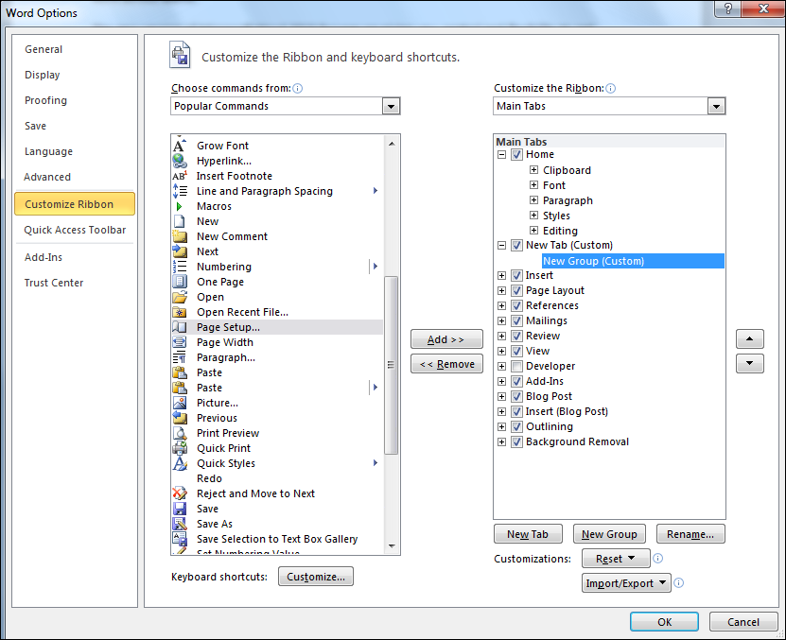

You can also perform the following actions from the *Application* **Options** dialog box:

* Click **Rename** to give the tab a customized name.
* Select your customized tab and use the upward **uparrow.PNG** and downward **downarrow.PNG** arrows to change its location on the ribbon.
* Click **Reset** to reset the ribbon to its default state.
* Right-click anywhere on the ribbon, and then click **Customize** to add new tabs or command groups to the ribbon.

NOTE: You can add commands only to new tabs that you create or to new groups that you add.

Using galleries

Galleries are collections of visual options. You can use them to modify elements on a page. To change a style by using galleries:

1. On your page, click the shape that you want to change.
2. Under **Drawing Tools**, on the **Format** tab, in the **Shape Styles** group, click the **More** arrow to display the **Shape Styles** gallery.  
   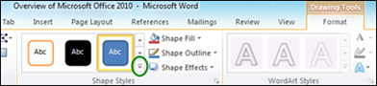
3. In the **Shape Styles** gallery, move your pointer over the gallery options to see a preview of the options on your page, and then click the style that you want.

Using the mini toolbar

Office 2010 displays a temporary mini toolbar that offers common formatting tools. The mini toolbar appears in the document window near selected text, and it disappears if you do not use it. To use the mini toolbar:

1. Select text in your file.
2. In the mini toolbar that appears, click the commands that you want.Page5 Mini Toolbar.png

Switching views and using the zoom control

In Office 2010, in the lower-right corner of the document window, you can find quick-access controls for switching views and zooming the page.

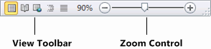

For the complete set of features that are related to views, click the **View** tab.

Opening a dialog box

Some of the tool sets—known as *groups*—on the ribbon have a small diagonal arrow in the lower-right corner. You can click this arrow to open a dialog box of commands that are related to the tool set.  
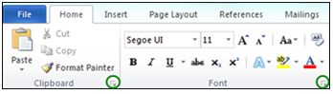

Minimizing the ribbon

You can minimize the ribbon to make more space available on your screen. To minimize the ribbon, double-click the active tab.

To restore the ribbon temporarily to access a command, click a tab. To restore the ribbon permanently, double-click a tab.

TIP: You can also press Ctrl+F1 to minimize and restore the ribbon.

Understanding the Quick Access Toolbar

The Quick Access Toolbar is a customizable toolbar from which you can access your favorite commands. It is a permanent part of the ribbon. By default, the Quick Access Toolbar is located above the ribbon and includes three commands: **Save**, **Undo**, and **Redo**.  
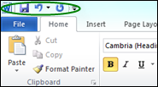

You can also add more commands to the Quick Access Toolbar.

Adding commands to the Quick Access Toolbar

Because the Quick Access Toolbar is always displayed, adding commands to it enables you to quickly access tools and commands that you use most often.

To add a command to the Quick Access Toolbar:

* 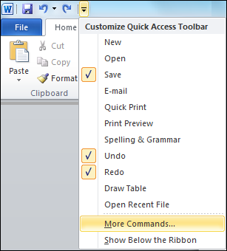Right-click any command on the ribbon, and then click **Add to Quick Access Toolbar**.

You can also follow this alternative procedure:

1. On the Quick Access Toolbar, click , and then click **More Commands**.
2. In the **Choose commands from** list, select a command set.

NOTE: Popular commands appear by default.

1. Click the command in the left pane, and then click **Add**.
2. Repeat this procedure until you have added all the commands that you need on the Quick Access Toolbar, and then click **OK**.

Moving the Quick Access Toolbar to below the ribbon

If the Quick Access Toolbar grows too wide after you add multiple commands, you can move it to below the ribbon where there is more room. To move the Quick Access Toolbar to below the ribbon:

* On the Quick Access Toolbar, click , and then click **Show Below the Ribbon**.  
  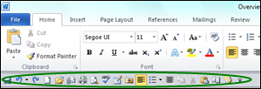

NOTE: You can also click  to move the Quick Access Toolbar back to its default location above the ribbon.

Understanding the Backstage view

In Office 2010, the Backstage view replaces the **File** menu. It includes new printing, publishing, and sharing features.

To display the Backstage view:

* Click the **File** tab in the upper-left corner of your document, next to the **Home** tab.

To exit the Backstage view:

* Click any tab at the top of the ribbon or click the image of your document in the upper-right corner.  
  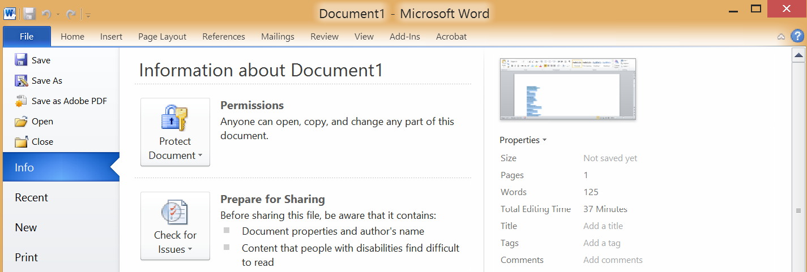

Printing a document

Printing options, previously spread across several commands (**Page Layout**, **Preview**, **Print**), are all contained in the Backstage view. To access printing options:

1. Click the **File** tab to display the Backstage view.
2. Click the **Print** tab, and then select from the available options. For example, in the **Pages** box, enter the page range that you want to print.  
   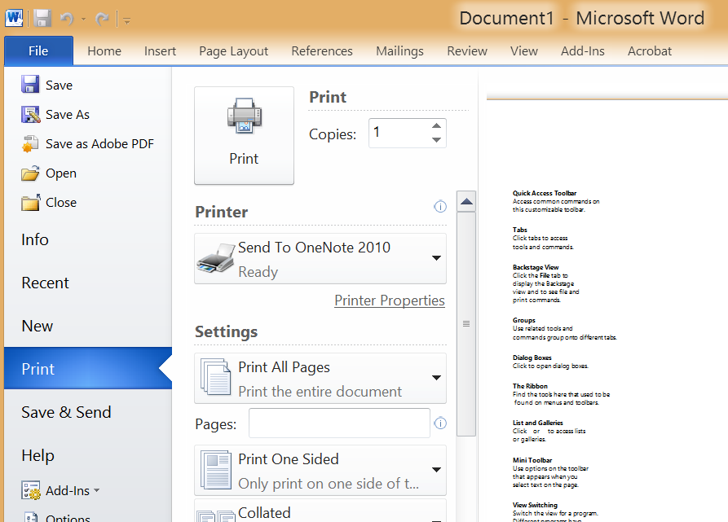

Preparing a document

To prepare a document for public consumption, you can assign metadata to the file, check for accessibility, or inspect the document to remove personal information or comments. To use the Backstage view to prepare a document:

1. Click the **File** tab to display the Backstage view.
2. Use the options on the default **Info** tab.  
   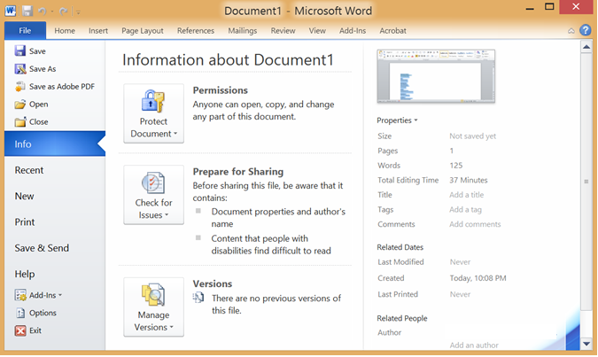

Sharing a document

You can instantly share a document with coauthors and other colleagues in Office 2010. You can either send the document by using an instant message or share the application on your desktop during an online meeting. To share a document by using the Backstage view:

1. Click the **File** tab to display the Backstage view.
2. Click **Save & Send**, and then select from the available sharing options.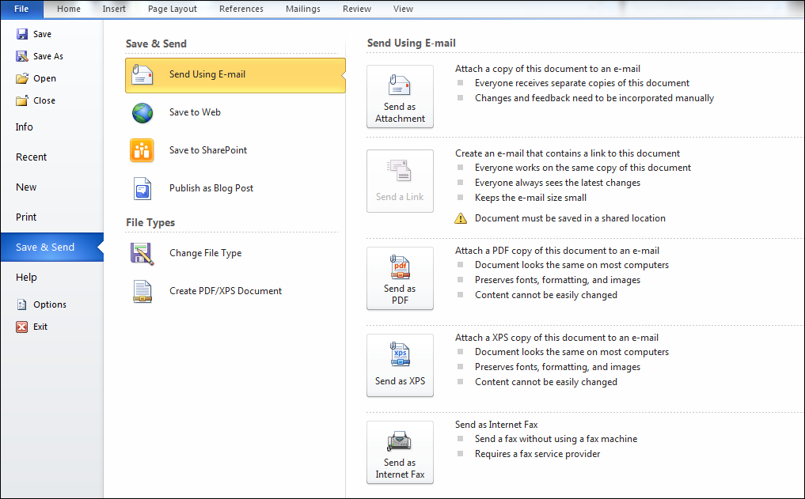

Formatting pasted content by using Paste Live Preview

You can save time by using the Clipboard to reuse content. Paste Live Preview provides context-sensitive formatting options that you can preview to decide how you want pasted content to look. To use Paste Live Preview:

1. Paste information into an application.
2. When **pastecontrol.PNG** appears, click it to display the **Paste Options** mini toolbar.
3. Point to each paste option to see a live preview of how the information that you pasted will be formatted. Click to select the option of your choice.  
   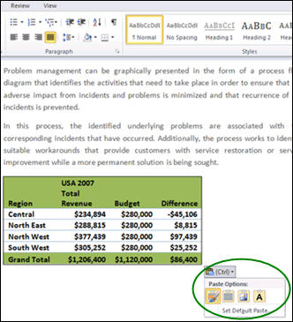

The context-sensitive options that Paste Live Preview provides depend on the Microsoft Office application and the content that you are pasting. For example, if you are working with a table in Microsoft Word 2010, paste options may include **Nest Table**, **Merge Table**, and **Insert as New Row**. If you are working in a cell in Microsoft Excel 2010 spreadsheet software, paste options may include **Formulas** and **Formulas & Number Formatting**.

The following table shows some common paste options.

| Paste option icon | Description |
| --- | --- |
| keepSourceFormatting24BigBrush.png | Keep source formatting |
| C:\Users\mirkom\Documents\office14\cutCopyPaste\sketches\icons\useDestinationFormatting24.png | Use destination style |
| C:\Users\mirkom\Documents\office14\cutCopyPaste\sketches\icons\useDestinationTheme24BigArrow.png | Paste as picture |
| C:\Users\mirkom\Documents\office14\cutCopyPaste\sketches\icons\picture24Faint.png | Paste as text only |
| C:\Users\mirkom\Documents\office14\cutCopyPaste\sketches\icons\link&KeepSourceFormatting24.png | Link and keep source formatting |
| C:\Users\mirkom\Documents\office14\cutCopyPaste\sketches\icons\link&useDestinationTheme24.png | Link and merge formatting |
| keepSourceFormatting24BigBrush.png | Ink |

Using Microsoft Office Help

Microsoft Office Help now opens in a separate browser window, so you can move the window around and resize it to suit your needs. To use Microsoft Office Help:

1. In the upper-right corner of an application window, click the **Help** button .
2. Do one of the following:

* Click a Help link in the **Browse Application support** list.
* In the **Search** list, click a preselected search term, and then in the results list, click a Help link.
* In the search box, type a search term, and then click **Search**. In the results list, click a Help link.

For more information

Getting Started with Office 2010

<http://office.microsoft.com/en-us/support/getting-started-with-office-2010-FX101822272.aspx>

Work Smart by Microsoft IT

http://aka.ms/customerworksmart

Modern IT Experience featuring IT Showcase

http://microsoft.com/microsoft-IT

This guide is for informational purposes only. MICROSOFT MAKES NO WARRANTIES, EXPRESS, IMPLIED, OR STATUTORY, AS TO THE INFORMATION IN THIS DOCUMENT. © 2014 Microsoft Corporation. All rights reserved.